Review Article

Greening the Future: Regenerative Agriculture for the Climate Crisis

ABSTRACT

|  |
| --- |
| Agriculture can both be a significant source and a potential sink of greenhouse gas emissions. Though agriculture has the capacity for carbon sequestration, the sector has not received considerable attention as a target for emissions reduction. The agricultural industry must adopt innovative approaches to meet the growing global food demand while reducing greenhouse gas emissions. Regenerative agriculture (RA) can be a promising strategy that concentrates on carbon sequestration, soil health and biodiversity. In this review, the current understanding of agriculture's contribution to climate change, the principles and practices of RA, and its potential for mitigation are integrated from various literature sources. This also attempts to highlight the need for systemic change in food production and discusses the challenges and opportunities in adopting regenerative practices globally. |

*Keywords: Regenerative agriculture, carbon sequestration, greenhouse gas emissions, soil health, biodiversity, climate change, sustainable food systems*

**1. INTRODUCTION**

Agriculture can both act as a source and sink for greenhouse gas emission reductions. Apart from its potential role in storing carbon in soils, agriculture has yet to receive substantial attention as a target for emissions reduction. However, one large and expanding source of emissions is agriculture. Agriculture must meet the demand for 50% more food while cutting emissions by one-third from 2010 levels to keep agriculture within its "fair share" of the total permissible emissions in a future where global temperatures have increased by 2°C. To keep global temperatures from rising by 1.5°C, these emissions will need to be further decreased by reforesting at least 585 million hectares of agricultural land that have become available due to productivity advances and a decline in demand. (Searchinger *et al.,* 2019).

The estimates come from Grain, an international non-profit research foundation that contributed to the U.N. It analyzed existing global emissions data to determine the extent of agriculture's emissions. From Fig. 1, it can be deduced that emissions from agriculture, land clearing for agriculture, the food systems, and food waste account to roughly half of all anthropogenic emissions. (Toensmeier, 2016.)

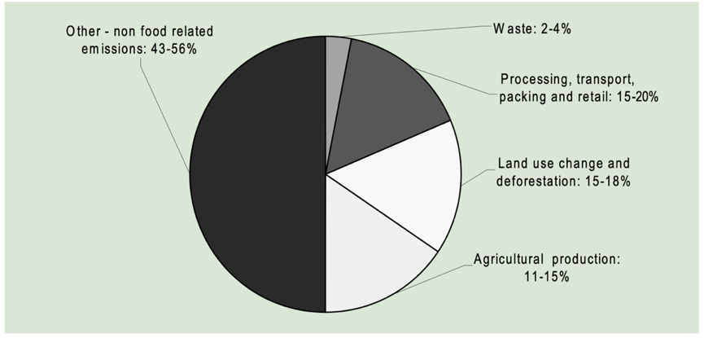

**Fig. 1**: **Role of the worldwide food production system in overall GHG emissions**

*Source: Molla, 2014*

The production of food, animal feed, and other commodities, as well as the marketplaces and supply networks that link producers and consumers, are all examples of how modern agriculture has changed the planet's landscape more than any other human activity. 80% of deforestation, 70% of freshwater consumption, and the loss of terrestrial biodiversity are directly related to global food systems. (UNCCD 2022). The durability and sustainability of our food systems would influence the effectiveness of the global land, biodiversity, and climate agendas.

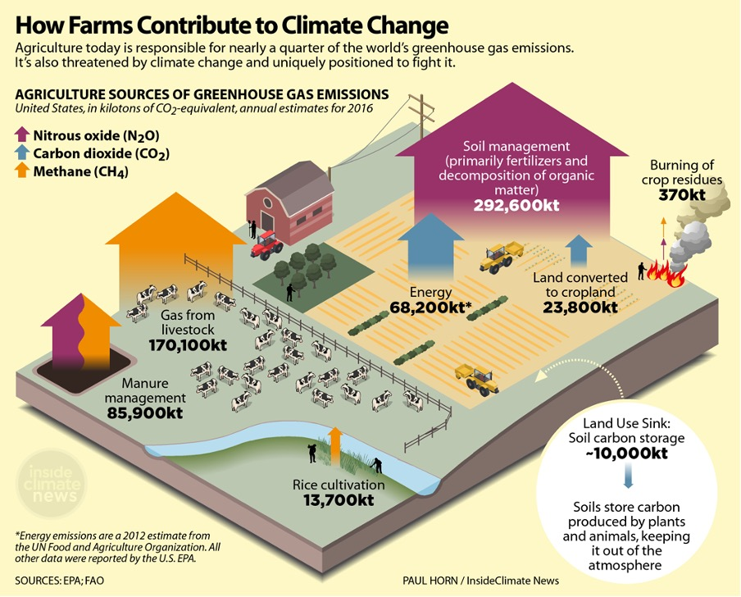

**Fig 2. Contribution of agricultural farms towards climate change**

*Source: Horn, 2018*

At the same time, during the previous century, the industrial and agricultural revolutions extensively disregarded the health and biodiversity of the soil below ground, which is the source of nearly all our food calories. The majority of carbon emissions resulting from land-use change are caused by the cultivation of rigorous monocultures and the clearing of forests and other ecosystems to produce food and other commodities.

During the Global Forum for Food and Agriculture conducted during 2022, agricultural ministers from around the world:

* Recognised that desertification, land degradation and drought pose immense threats to global food security, nutrition, and sustainable food systems across the world.
* Emphasised that healthy soils are crucial for producing sufficient nutritious and safe food, as well as for adapting to and mitigating climate change, and for ceasing and reversing biodiversity loss.
* Stressed that secure access to agricultural land through ownership, usage rights, and other legitimate forms of tenure is necessary for local and global food security.

In the IPCC Special Report on Climate Change and Land, nitrous oxides from fertiliser applications and methane generated by ruminant livestock are the most notable and significant portion of agricultural greenhouse gas emissions. Our food systems averaged 10.8 to 19.1 Gigatons of CO2 equivalent per year between 2007 and 2016. (Shukla *et al.,* 2019). Food systems are also the most significant cause of terrestrial biodiversity loss (UNCCD, 2022). Despite these harmful environmental effects, food systems may be revamped and rebuilt to support better biodiversity conservation, land restoration, and GHG mitigation. To achieve this, a set of methods collectively referred to as "regenerative agriculture" (RA) has been proposed (Newton *et al.,* 2020). These methods often involve the sequestration of carbon, an increase in biodiversity, and an improvement in soil health.

2. Regenerative agriculture

The term "regenerative agriculture" refers to practices that aim to promote soil health by restoring the soil's organic carbon content. The soils across the globe contain several times the amount of carbon as the atmosphere, functioning as a natural "carbon sink." However, soil carbon stocks have been decreasing globally due to factors such as the switching of native landscapes to croplands and overgrazing. One goal of regenerative practices is to utilise some of the carbon that plants have absorbed from the atmosphere to aid in the restoration of soil carbon.

**Table 1: Regenerative Agriculture: An Overview**

|  |  |
| --- | --- |
| Aspect | Details |
| Geographical Origins | North America, UK, Australia, New Zealand |
| Founding Actors | Farmers |
| Social – Ecological Triggers | Land degradation, Climate change |
| Challenge to industrial agriculture | Minimizing dependence on external inputs, ensuring sustainability and productivity of farm and land. |
| Status | Rapidly emerging as a dominant narrative, drawing on flaws of current sustainable agriculture discussions |

*Source: Bless, 2023*

**2.1 Definition**

The concept of “Regenerative Agriculture” was first introduced to the world by social scientist and author Medard Gabel in 1979. Later, organic farming advocate and publisher Robert Rodale (1983) defined Regenerative Agriculture as "one that, at increasing productivity levels, boosts our land and soil biological production base. It has a high level of inherent economic and biological stability. The environmental impact is minimal to none beyond the farmer's field boundaries. The food stuff produced is free from biocides. It provides for the productive contribution of increasingly large numbers of people during a shift towards reduced dependence on non-renewable resources."

Rodale further elaborated on the notion of regenerative organic farming to include options that incorporate a holistic approach, centring on environmental and social improvements without using chemical fertilisers and pesticides. (Khangura *et al*., 2023)

Since then, several researchers have proposed various definitions of Regenerative Agriculture (RA). Francis *et al.,* (1986) proposed that RA highlights the use of resources available on the farm while limiting the use of synthetic inputs. As noted by Duchin (2017), Project Drawdown uses the term to indicate an annual cropping practice that integrates at least four of the six sustainable practices, without unavoidably being organic. According to Sherwood and Uphoff (2000) and Rhodes (2017), RA is a system developed on biological principles that aims to enhance both productivity and environmental management.

Regenerative farming methods include no-till farming, in which farmers place seeds directly into the ground without tilling the soil, and the use of cover crops, which are trees or other plants planted to cover the ground after the primary crop has been harvested. Additional techniques include various crop rotations, such as multiple cropping, where three or more crops are planted in succession over multiple years, and crop rotations combined with animal grazing. Regenerative agriculture is sometimes defined as any method that uses less fertiliser or pesticides.

**3. PRINCIPLES OF REGENERATIVE AGRICULTURE**

**3.1 Minimize soil disturbance: no-tillage and minimum-tillage**

To maintain a stable soil ecosystem, it is essential to minimize soil disturbance as much as possible. A stable soil ecosystem is well-fed through plant materials grown within; the biology and the conditions for that biology to prosper are being optimized, and the bacterial, fungal, and total biomass are increased. The conventional mode of agriculture, where ploughing, tilling, and preparing seed beds are practised, works well in fresh lands that are much more resilient to disturbance, primarily because of their high carbon content. However, if the continuous use of conventional agricultural practices persists, there may be a precipitous decline in soil carbon.

Soil erosion, as well as conventional tillage practices, deplete SOC pools in agricultural soils. Therefore, transitioning from plough tillage to no-till or conservation tillage can enhance soil carbon storage by minimizing soil disturbance, shortening the fallow period, and integrating cover crops into the crop rotation. In arid and semi-arid regions, eliminating summer fallowing and implementing no-till with residue mulching improves soil structure, reduce bulk density, and increases infiltration capacity.

Soil disturbances from intensive tillage cause Carbon dioxide (CO2) fluxes to the atmosphere and water resources. (Sapkota *et al*., 2015). According to Yang *et al*., (2013), though minimal or no tillage is commonly used in certain nations to reduce costs and benefit areas in danger of soil and water erosion, using conservation tillage techniques may increase carbon sequestration, reducing the consequences of global warming.

As per the studies conducted by Smith *et al.* (1998), the implementation of conservation tillage practices in the European Union can capture approximately 23 Tg carbon per year. In the broader European context, which includes the former Soviet Union, this figure could reach 43 Tg carbon annually. Additionally, by adopting these practices, there is a potential reduction of up to 3.2 Tg carbon per year in fossil fuel emissions in agriculture. Smith *et al.,* 1998, reckoned that a complete transition to no-till agriculture could effectively offset all carbon emissions from fossil fuels generated by European agriculture.

**3.2 Maximise crop diversity: diversified rotation, cultivating legumes, cover crops and leys**

A monoculture is extremely rare in a natural environment. Because monocultures are easy to manage, modern agricultural methods rely on them. However, as other plant species connect with various soil creatures, feeding the natural soil food web, the diversity of crops grown above ground leads to the diversity of crops grown below ground. The soil food web functions optimally when numerous interactions between the various creatures involved in different nutrient cycles are present.

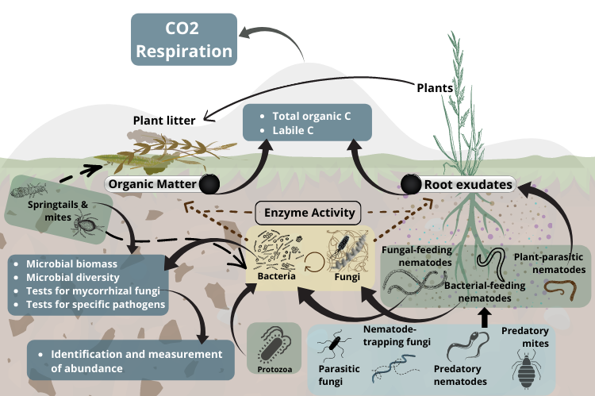

Fig 3: Soil food web

*Source:www.farmingforbetterclimate.org*

A soil food web represents the complex relationships between the diverse groups of fauna and flora found in soil. A healthy soil food web can provide:

|  |  |  |
| --- | --- | --- |
| * Decomposition of organic matter | * Nutrient cycling | * Retention of nutrients |
| * Bioturbation (the process of gases and water moving into and through the soil.) | * Disease suppression | * Decomposition of toxins |

Lin (2011) reported that diversifying crops can enhance resilience through several mechanisms. This includes boosting the capacity to control pest outbreaks and reduce the spread of diseases, which may become more severe under future climate conditions. Additionally, crop diversification is a buffer against the impacts of increased climate variability and extreme events on crop production.

**Table 2: Models of diversification in agricultural systems and the possible advantages for farmers facing climate change.**

|  |  |  |  |
| --- | --- | --- | --- |
| Diversification type | Nature of diversification | Advantages t | Examples |
| Enhanced structural diversity | Improves the structural diversity of crops in the field | Pest suppression | Harvesting alfalfa using strip-cutting helps natural enemies to move from harvested strips to adjacent non-harvested ones |
| Genetic variation in monoculture | Growing different varieties of a species in a monoculture | Disease suppression | Genetic diversity of rice varieties decreases fungal blast occurrence |
|  | Enhanced production stability | Improved genetic diversity showed positive correlation with average income and stability of income |
| Incorporate non-crop plants into the field for diversification | Planting weed strips or vegetation banks within and adjacent to crops | Pest suppression | Planting white and black mustard along the edges of sweet corn fields aided in capturing pests and kept them from entering the corn field |
| Crop rotations | Temporal diversity through crop rotations | Increased production | Enhancing diversity by using crop rotations of greater cover crop and nitrogen-fixing crops boosted the yield of the main crop |
| Polycultures | Cultivating multiple crop species within same field resulting spatial and temporal diversity | Climate change buffering | More ecologically complex systems with diverse wild varieties as well as temporal and spatial variations in crop, were better able to thrive under climate stress |
| Agroforestry | Growing crops and trees together; Pest suppression spatial and temporal diversity | Pest suppression | More shade enhanced the presence of natural enemies that help control pests/ larvae in crops |
| Climate change buffering | Increased shade cover resulted in improved crop protection from temperature changes and rainfall fluctuations |
| Mixed landscapes | Creation of larger-scale diversified landscapes with multiple ecosystems | Increased production | Combining organic farmland, crop rotation practices and managed grazing resulted in best strategies for diversity and profitability |

*Source: Lin (2011)*

The increasing severity of extreme temperatures, frequent and intense floods, cyclones, and other natural disasters resulting from climate change is a pressing issue. In this context, crop diversification emerges as a viable adaptation strategy. It serves to safeguard natural biodiversity, enhance the resilience of agroecosystems in the face of these challenges, mitigate environmental pollution, lower the risk of complete crop failure, decrease the prevalence of insect pests, diseases, and weed issues, and ensure the stability of food supplies. Additionally, it offers producers alternative avenues to generate income. (Lakhran *et al*., 2017)

Di Bene *et al*. (2016) employed a process-oriented model (RothC10N) along with a GIS-based spatial analysis approach to evaluate the sustainability of typical intensive cultivation systems in Southern Italy, focusing on changes in SOC stock and CO2 emissions over the long term. Results from SOC modelling indicated that present farming techniques did not ensure the sequestration of SOC in all cycles (4.29 Mg C ha-1). By employing management techniques such as retaining crop leftovers in the field and utilising irrigation for the summer crop wisely (6.73 Mg C ha-1), cropping systems can be made more sustainable.

**Table 3: Pros and Cons of crop diversification**

|  |  |
| --- | --- |
| **Pros** | **Cons** |
| * Increased crop yield * More efficient resource use * Suppression of weeds, pests and diseases * Draws in beneficial organisms * Enhances soil health * Boosts resilience to stressors * Reduced input expenses * Can decrease reliance on packaged fertilizers * Improved ecosystem services | * Crops may compete against each other for resources such as light, water and nutrients * Availability of herbicides and other sprays has limitations * Yield can be diminished if the competitive abilities of the crops differ * Harvesting can be difficult based on the type of crop cultivated |

**3.3 PRESERVE LIVING ROOTS ALL YEAR ROUND: LEYS AND COVER CROPS**

The third principle of regenerative agriculture emphasizes maintaining the presence of live roots in the soil the entire year. One approach to attain this is by integrating cover crops into the farming system. Cover crops are commonly cultivated between primary crop cycles to provide soil cover and sustain live plants in the soil during periods when cash crops are not being grown. Either planting cover crops can achieve this after the main harvest, or by under-sowing cash crops, such as grains, with perennial crops that will continue to provide soil cover after the harvest and into the subsequent season. (Khangura *et al*., 2023)

The living roots in the soil are crucial for supplying food for the organisms at the base of the soil food web. The biological interactions between plants and soil are closely related to plant roots and root exudates. They are the primary source of organic chemicals that plants emit. The exudates serve as an energy source for the soil biology of the rhizosphere and as a means of transmission for certain microbes.

**3.3.1 Benefits**

* Keeping living roots means that a plant exists above ground, which helps prevent soil erosion and offers opportunities for grazing and weed management for the subsequent crop.
* It aids in minimizing nutrient leaching during the winter season. Growing cover crops in the winter captures leftover nutrients (especially nitrogen) and retains them for the next crop as the catch crop breaks down.
* Root exudates serve as a significant energy source for the foundational food web and are vital for sustaining soil health.
* Living roots are essential for improving soil infiltration, lessening runoff, and the biology they support can enhance soil aggregation by producing polysaccharides, which act like adhesive to bind the soil together.

Typically, cover crops are cultivated in the intervals between primary crop seasons to maintain live plants on the soil during non-cash-cropping periods. Beyond their role in enhancing soil fertility, cover crops contribute to carbon sequestration. If widely adopted, the use of cover crops has the potential to decrease greenhouse gas emissions from agriculture by approximately 10%, a reduction comparable to that achieved through practices such as no-till farming and other cropping methods. (Kaye and Quemada 2017)

**3.4 MAINTAINING SOIL COVER THROUGHOUT THE YEAR: UTILIZING COVER CROPS, PERMANENT GRASSLANDS, WINTER STUBBLE AND RETURNING CROP RESIDUES TO THE FIELD**

Maintaining soil cover can be accomplished in several ways, such as using a layer of decomposed plant materials from residues like straw or growing a cover crop to protect the soil. Cover crops are non-cash crops that are cultivated between two cash crops. The main goal of cover crops is to provide a protective layer for the soil surface, acting as a barrier and enriching the soil.

Cover crops may fulfil the requirements of Ecological Focus Areas (EFA) or for agri-environmental schemes. The cultivation cost of cover crops can differ based on the species and mix chosen. While evaluating a crop and its impact throughout the entire rotation, it is essential to consider the costs and benefits of growing a cover crop.

According to Alvarez *et al.* (2017), the accumulation of soil carbon with cover crops has been linked to soil texture, with an increase in soil carbon more likely to occur in clay soils. Research in Argentina has indicated that cover crops planted on both fine- and coarse-textured soils accumulate more soil carbon. Additionally, cover crops can aid in eroded soils with low C content to accumulate more carbon. (Hassink, J., and Whitmore, A. P., 1997; Berhe *et al.,* 2007). The benefits are more significant with no-tillage due to a reduced rate of residue decomposition compared to conventional tillage.(Olson *et al*., 2014)

**3.5 INTEGRATE LIVESTOCK MANAGEMENT WITH IMPROVED GRAZING MANAGEMENT**

As reported by Seo *et al.* (2017), another commonly adopted regenerative agriculture technique is the integration of livestock into the farming system to enhance soil health and diversify returns, despite animal husbandry being generally blamed for contributing to methane emissions. Rotational grazing is favoured over continuous grazing to increase SOC and improve soil health (Byrnes *et al.,* 2018). Based on anecdotal reports, evidence suggests that implementing rotational grazing techniques may enhance soil organic carbon (SOC) levels in certain grasslands, especially those in arid and hotter regions. These reports indicated that targeted pasture management strategies can enhance carbon accumulation in the soil.

An analysis of 83 studies conducted globally through a meta-analysis by Abdalla *et al.* (2017)revealed that the influence of grazing intensity (GI) on soil organic carbon (SOC) levels varied depending on both climate zones and the specific type of grass. This suggests that it is advisable to tailor grazing intensity according to the unique climatic conditions of each region. A recent comprehensive study spanning six continents has demonstrated that the complex relationship between grazing intensity and climate in dryland areas plays a crucial role in determining rates of carbon sequestration, accumulation of organic materials and soil erosion. (Maestre *et al.,* 2022).

**4. PROS AND CONS OF ADAPTING REGENERATIVE AGRICULTURE**

Regenerative agriculture encompasses a set of agricultural approaches and guiding principles that aim to promote biodiversity, enhance soil quality, improve watershed health, and increase the soil's capacity for carbon sequestration. This, in turn, helps mitigate global warming. Farmers who adopt regenerative practices and principles in land management stand to enhance their livelihoods by reducing input costs, increasing profitability, and growing their income. Additionally, they can reduce their exposure to harmful agricultural chemicals.

Embracing regenerative agriculture holds the potential to secure a future that is both resilient to climate change and ensures food security. Moreover, there is a significant opportunity for the healthcare sector to leverage its influential voice and purchasing power to support the expansion of regenerative agriculture systems. Doing so can foster a food system that profoundly benefits human health and environmental well-being.

The major drawbacks of regenerative agriculture are:

* Producers will need to acquire new skills and expertise
* Reduced tilling might result in more weeds
* Certain farmers may offset by using more herbicides
* Possibility of yield reduction, influenced by crop type and microclimate
* The shift from conventional practices takes time

**5. COMPONENTS OF REGENERATIVE AGRICULTURE IN COMBATING CLIMATE CHANGE**

The four main components in regenerative agriculture which play a significant role in achieving carbon neutrality and mitigating climate change, are

**5.1 Carbon sequestration**

When executed correctly, preserving the vast stores of plant and soil carbon found in the world's remaining forests and wooded savannas, while simultaneously increasing agricultural productivity on existing land (known as a land-sparing approach), represents the most significant opportunity for climate mitigation within regenerative and other farming methods. To unlock these advantages, it is essential to implement these practices to enhance productivity and connect these improvements to governance and financial measures aimed at safeguarding natural ecosystems. (Searchinger and Ranganathan, 2020)

As reported by Teal and Burkart (2023) there is clear and indisputable field-based proof that regenerative farming methods can substantially enhance soil carbon storage. Naturally, the outcomes differ depending on the specific climate zones, soil varieties, and management approaches employed. However, it is now possible to create regionally suitable regenerative agricultural systems with a reasonably high level of confidence regarding their capacity for long-term carbon sequestration.

A comprehensive meta-analysis titled "Contributions of the land sector to a 1.5°C world" (Roe *et al.,* 2019) has estimated that cropland sequestration globally can contribute about 1.5 gigatons of CO2 per year, which amounts to roughly 55 gigatons of CO2 over a moderate saturation period lasting 35-40 years. This estimate does not consider practices such as composting municipal food waste (Silver *et al.,* 2018), tree cropping (Teske, 2019), implementing hedgerows and other cropland buffers, pasture restoration, or using biochar; all of these have the potential to enhance carbon removal on agricultural land. It is evident that regenerative agriculture, as a diverse set of practices adaptable to specific regions and crop types, has the potential to play a substantial role in addressing climate change, with the capacity to remove between 100 and 200 gigatons of CO2 by the end of this century.

**5.2 Reduced emissions**

As reported by Jarecki and Lal (2003), mitigating greenhouse gas (GHG) emissions in agriculture is closely linked to the enrichment and preservation of soil organic matter (SOM) levels. Agricultural soils have the potential to act as substantial carbon (C) sinks by boosting SOM concentrations. In contrast, when carbon gains and losses are balanced, natural ecosystems, such as forests or prairies, experience a substantial depletion of the previous carbon pool when they are converted into agricultural systems.

Alterations in the structure and trajectories of animal production systems are leading to shifts in the role of grazing systems in the overall climate impact. Historically, the expansion of grazing systems has driven deforestation and the subsequent release of CO2 into the atmosphere. However, the current global trend toward intensifying grazing systems will have complex effects on this balance (Godde *et al.*, 2018). For instance, productivity improvements may alleviate land pressures and reduce emissions per unit of milk and meat produced from grass-fed animals. Still, these enhancements could lead to trade-offs, such as increased nitrogen leaching. There is also the potential for higher overall greenhouse gas emissions when growth in animal numbers outweighs the mitigation benefits gained from efficiency improvements. Furthermore, adopting new technologies to reduce GHG emissions in production can impact the net greenhouse gas balance.

A unanimous consensus among scientists working in this field is that a range of practices exists that can mitigate greenhouse gas emissions linked to our existing agricultural system. These practices include minimizing food wastage, transitioning toward plant-based diets, enhancing nitrogen utilisation in crop cultivation, and reducing farm energy consumption. Importantly, these efficiency enhancements align seamlessly with the principles of regenerative agriculture. Therefore, a compelling question arises: why should the scientific community create artificial divisions that separate emission reductions from carbon sequestration? Regenerative agricultural practices can, and indeed should, achieve both objectives, especially when considering that the fundamental mechanism for enhancing soil health, a core agreement among all soil scientists, involves reintroducing organic matter into the soil. (Teal and Burkart, 2023), Balancing the global climate system has a variety of solutions. It is widely acknowledged that multiple diverse strategies, often called "wedges," to reduce GHG emissions and remove carbon from the atmosphere. Regenerative agriculture is undoubtedly one of these crucial strategies.

**5.3 Biodiversity and ecosystem health**

Regenerative agriculture has demonstrated its ability to positively influence various natural processes. Ecosystem services comprises of the benefits that humans derive from ecosystems, including provisioning, regulating, supporting, and cultural services. Regenerative agriculture offers numerous natural benefits. (Dinesh, *et al.,* 2023)

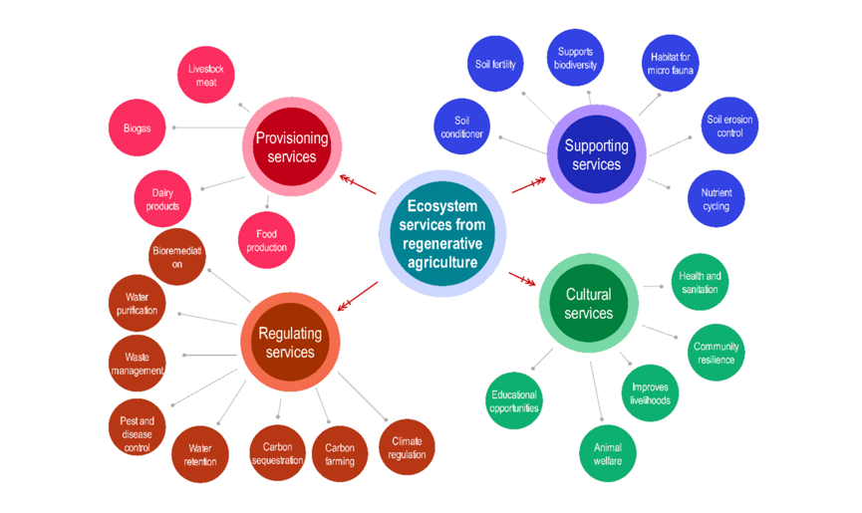

**Fig 4: Ecosystem services from regenerative agriculture**

*Source: Dinesh et al., 2023*

Ecosystems are resilient to environmental challenges, and regenerative agriculture seeks to build similar resilience into farming systems. Diverse crop rotations, mixed farming, and the integration of livestock can enhance a farm's resistance to pests, diseases, and extreme weather events. Regenerative agriculture frequently decreases or eliminates the utilization of synthetic chemicals such as pesticides and herbicides. This positively impacts ecosystems by diminishing chemical runoff and its detrimental consequences on aquatic life and pollinators. These techniques are frequently customized to suit a region's unique climatic and ecological conditions. This fosters a more sustainable and balanced coexistence between agriculture and the environment.

Regenerative agricultural practices promote biodiversity conservation by expanding the range and quantity of habitats available for beneficial insects and animals (O'Donoghue *et al*., 2022). These approaches involve incorporating cover crops, crop rotation, and reduced ploughing to establish a diverse and secure ecosystem. Additionally, sustainable farming methods decrease the reliance on synthetic fertilisers and pesticides, which can harm wildlife (Baweja *et al.*, 2020). Regenerative gardening techniques also contribute to the preservation of various forms of life, bolstering the resilience and equilibrium of the ecosystem.

Regenerative agriculture aims to integrate ecological principles into farming practices, fostering a mutually beneficial relationship with ecosystems. This endeavour aims to improve agricultural sustainability, preserve natural resources, and alleviate environmental consequences.

**5.4 Renewable energy integration**

Regenerative agriculture and the integration of renewable energy are two essential approaches to addressing environmental and sustainability challenges. They represent a holistic way to promote both sustainable food production and clean energy generation while mitigating the impacts of climate change. As Rana (2023) opined, photovoltaic panels have the potential to be installed on various agricultural structures, including barns, storage facilities, and greenhouses, to capture solar energy and generate electrical power. This sustainable energy resource can be utilized to energize essential farm functions, such as lighting, irrigation setups, machinery, and climate control systems for heating and cooling. Solar energy reduces dependence on fossil fuels, lowers energy-related costs, and mitigates greenhouse gas emissions. According to the International Renewable Energy Agency (IRENA), the share of renewable energy in the overall final energy consumption within the agricultural sector is projected to increase by 18 per cent by 2025.

The different ways in which the integration can be possible through solar, wind and biomass/bioenergy energy, where the farms can utilise these clean energy sources to fuel farm operations and lower their reliance on fossil fuels. Moreover, implementing clean energy technologies in farming operations reduces energy consumption and associated emissions and generates additional income by selling excess electricity back to the grid.

In short, integrating regenerative agriculture and renewable energy is a promising approach to achieving sustainability in food production and energy generation. It aligns with the broader goal of addressing climate change and promoting a more balanced and resilient agricultural sector.

As noted by Ranganathan *et al.,* 2020, the World Resources Institute recognized 22 solutions arranged into a five-course menu:

* Decrease the rising demand for food and other agricultural goods.
* Enhance food production without the need to extend agricultural land
* Conserve and restore natural ecosystems
* Enhance supply of fish sustainably
* Lower GHG emissions from agricultural practices

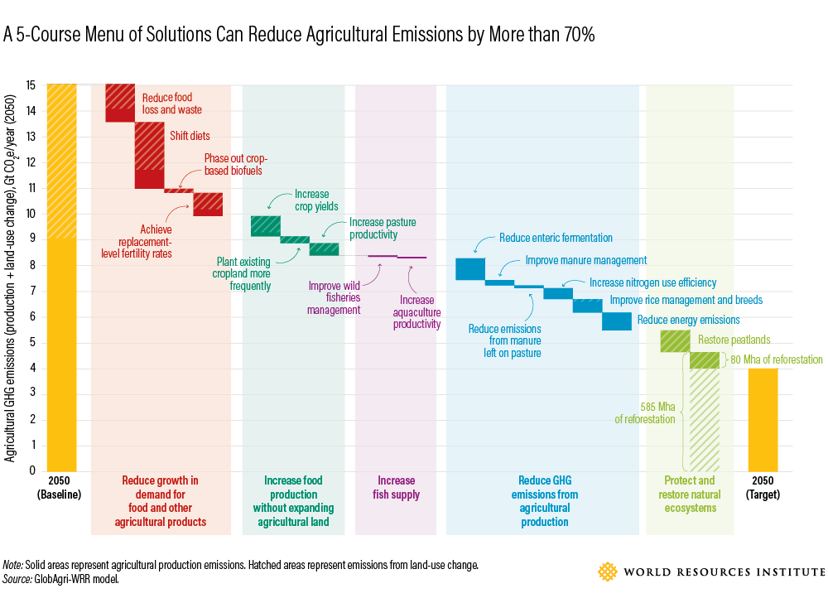

**Fig 5: A 5-course menu of resolutions that can lower agricultural emissions by over 70%**

*Source: World Resource Institute, 2018*

In the domain of agriculture, climate change is exhibiting its characteristic behaviour of exacerbating pre-existing issues to a critical degree. However, farmers employing regenerative techniques without disturbing the soil they are counteracting the effects of climate change by increasing organic matter.

**6. LIMITATIONS IN USING REGENERATIVE AGRICULTURE FOR CLIMATE CHANGE MITIGATION**

As Ranganathan *et al*. (2020) point out, the appraisal of mitigation strategies within the food and land sector indicates that the feasible potential, at best, appears to be restricted, mainly due to several challenges, including:

**6.1 Undecided Benefits:**

The current scientific knowledge regarding the mechanisms that maintain soil carbon sequestration is limited, resulting in ambiguity about whether regenerative practices lead to surplus carbon sequestration. One example of this uncertainty is the ongoing scientific debate regarding whether no-till farming, the primary practice advocated by regenerative agriculture followers for its climate benefits, actually leads to an increase in soil carbon when accurately assessed.

Research conducted on grazing lands has shown that the impact of grazing on soil carbon is complex, site-specific, and challenging to foresee. Nevertheless, grazing methods that promote increased grass growth typically result in some carbon sequestration. Even when these uncertainties are disregarded, the task of sustaining elevated soil carbon levels presents practical difficulties.

**6.2 Faulty Carbon Accounting**

To augment soil carbon content, it is essential to introduce carbon into the soil, which primarily originates from plants that have absorbed carbon from the atmosphere. However, when the carbon employed in this process would have otherwise been amassed or utilized elsewhere, it essentially relocates carbon from one location to another, without achieving any extra decrease in emissions. Assessments of the carbon advantages of soil carbon sequestration on a particular farm frequently overlook the emissions generated elsewhere due to off-farm effects. For instance, manure contains carbon and nutrients that were initially taken up by plants and then consumed by animals.

Hence, introducing manure into a field results in increased soil carbon levels at the specific location of application. However, due to the finite availability of manure worldwide, its utilization in one area typically involves obtaining it from another location, resulting in no net increase in carbon within the world's soils. Transforming cultivated land into grazing land can enhance soil carbon levels and may be a prudent choice in regions where crop cultivation yields marginal results. However, if the crops that are grazed are subsequently cultivated somewhere else by clearing forests or grasslands. This action would release carbon stored in the soils and vegetation of these natural ecosystems, potentially leading to an overall increase in GHG emissions.

The same necessity to substitute food production elsewhere arises when regenerative practices reduce the quantity of livestock or crops generated on a specific land area (and research on many practices has demonstrated varied effects on yields). Neglecting to account for these external effects, mainly when soil carbon benefits are asserted as carbon offsets, carries significant implications.

**6.3 Requirement for Huge Quantities of Nitrogen**

An additional constraint on soil carbon sequestration is the requirement for nitrogen, typically supplied as fertilizer. To maintain carbon within soils for an extended period, there is a consensus among scientists that it must be transformed into microbial organic matter. This conversion requires approximately one ton of nitrogen for every 12 tons of carbon sequestered, in addition to the nitrogen that is consumed and removed during growth. Incorporating more nitrogen into agricultural fields to increase soil carbon presents challenges, whether introduced through fertiliser or nitrogen-fixing legumes.

A substantial portion of the extra nitrogen introduced is likely to evade capture and be released into water systems, where it can increase algae growth and contribute to water pollution. Soils may also convert some of it into nitrous oxide, a potent greenhouse gas. Although many farmers across the globe apply more nitrogen than required, this practice is a response to the fact that some of the nitrogen they add escapes into the atmosphere and waterways.

To make better use of this nitrogen to enhance soil carbon, farmers must develop methods to minimise nitrogen loss. One approach is to plant cover crops, as their roots can seize nitrogen that might otherwise leach away, offering potential for creating stable soil carbon. Nevertheless, in the grand scheme, the nitrogen requirement presents a significant yet frequently overlooked constraint to achieving gains in soil carbon.

**6.4 Scaling Across Millions of Acres**

A recent investigation indicates that if cover crops were utilized on 85% of the annually farmed land in the U.S., they could capture approximately 100 million tons of carbon dioxide annually. This significant accomplishment could offset approximately 18% of emissions from U.S. agricultural production and 1.5% of the country's overall emissions. Although the use of cover crops is increasing in the United States, they currently account for less than 4% of U.S. farmland due to several challenges, including expense and the limited time frame for planting before winter arrives. While cover crops should be strongly encouraged for their ability to promote soil health, minimize nitrogen pollution, and provide climate benefits, their actual potential for enhancing soil carbon is still uncertain at this point.

**7. ROLE OF EXTENSION IN ENCOURAGING FARMER ADOPTION OF REGENERATIVE AGRICULTURE PRACTICES**

Regenerative agriculture can play a crucial role in helping farmers enhance the resilience of their production systems and address the challenges they face. At the same time, extension professionals must step up their role in disseminating and popularising regenerative agricultural practices. Some of the recommendations and policy requirements are given by Wilson *et al.,* 2023 are mentioned below

* Include regenerative agriculture in holistic climate strategies to boost climate resilience.
* Support and collaborate with trusted farmer organizations to establish and maintain farmer learning networks, encouraging greater awareness and inquiry about the benefits of RA practices.
* Universities should create undergraduate curricula for regenerative agriculture in crop and livestock production.
* Utilise in-person events, such as field days and farmer conferences, for effective engagement on the benefits of regenerative agriculture.
* The government should widen the pool of eligible Technical Service Providers.
* The private sector should invest in training agronomists and crop consultants to promote regenerative farming practices.
* Commission a study to assess how increased funding for expanded conservation will impact the demand for regenerative agriculture equipment like no-till drills and efficient irrigation systems.
* Experienced regenerative farmers can be encouraged to share their insights with peers through platforms like farm events, conferences, and social media, including podcasts.
* Invest in organisations with a proven track record in farmer learning networks for an effective transition to regenerative agriculture.

**8. POLICY REQUIREMENTS FOR ENCOURAGING REGENERATIVE AGRICULTURAL PRACTICES**

* Allocate more funding for state-designated programs that support agricultural experiment stations in researching and demonstrating regenerative agriculture practices.
* Private parties should promote regenerative agriculture by sourcing from regenerative farms.
* Transformation-promoting policies should enable regenerative and marginalised farmers to engage in new platforms for regulatory input and financial support in agriculture.
* The private sector should offer low-interest, multiyear (3-5 years) loans to support farmers adopting regenerative practices in key industries.
* Agricultural lenders should also expand their loan options for farmers who use regenerative practices.
* Both public and private sectors should incentivize the expansion and stability of cover crop seed supply chains, including cereal and legume seeds.

**Table 4. CASE STUDY-BASED COMPARATIVE ANALYSIS OF SOIL CARBON SEQUESTRATION AND CLIMATE-SMART AGRICULTURE ADOPTION**

|  |  |  |  |
| --- | --- | --- | --- |
| Aspect | Case study 1: Vermont, USA  (Wiltshire and Beckage, 2022) | Case study 2: Bihar, India  (Aryal *et al.,* 2018*)* | Case Study 3: Great Britain  (Jordan *et al.,* 2022*)* |
| Objective | Assess soil carbon sequestration potential via regenerative agriculture and afforestation using the Rothamsted Carbon Model | Examine factors influencing adoption of multiple climate-smart agricultural practices (CSAPs) in the Gangetic plains of Bihar | To estimate potential change in national soil carbon stock from the widespread adoption of regenerative agricultural practices |
| Study area | Vermont, USA  (13 ecoregions) | Gangetic plains of Bihar, India | Arable land across Great Britain |
| Methodology | Rothamsted Carbon Model based on empirical soil data, expert input and literature review across 13 ecoregions | Analysis of farmer survey data on CSAP adoption and influencing factors using Multivariate and ordered probit models | Rothamsted Carbon Model simulations calibrated with data from recent systematic reviews |
| Land use/ Practice type | Crops, hay, pasture: scenarios include rotational grazing, afforestation and conventional practices | Multiple CSAPs: crop diversification, minimum tillage, site-specific nutrient management etc. | Cover cropping, reduced tillage, ley-arable integration |
| Key findings | * All scenarios except business-as-usual sequester carbon * Rotational grazing: highest among regenerative, +5.3% SOC in 10 years * Afforestation: highest overall, +6.5% SOC in 10 years, continues for decades | * Adoption of CSAPs is interconnected * Factors: Demograhics, farm characteristics, market access, climate risk, extension services, trainings. * High temperature perception increases crop diversification/ minimum tillage adoption * Trainings boost adoption | * Cover cropping could increase soil organic carbon (SOC) by 10 t/ha over 30 years. * Ley-arable systems could increase SOC by 3-16 t/ha over 30 years, depending on the duration. * Reduced tillage intensity was found to have a minimal impact on soil carbon stocks. |
| Temporal dynamics | * Higher sequestration rates in initial decades post change; afforestation can substantially increase soil carbon stocks | * Not directly addressed; focus on adoption likelihood and intensity | * SOC increases over 30 years, with ley-arable systems showing variable sequestration based on ley duration |
| Policy/Practice recommendations | Regenerative practices, especially rotational grazing, and afforestation can substantially increase soil carbon stocks | Enhance extension services and training; promote integrated CSAP adoption through institutional support | Encourage cover cropping and ley-arable systems to achieve net zero emissions, address implementation challenges |
| Analytical innovation | Spatially explicit modeling across ecoregions; empirical initialization for accuracy | Use of multivariate and ordered probit models to analyse integrated vs. piecemeal CSAP adoption | Calibration of RothC with systematic review data for national-scale simulation. |
| Implications | Land management changes on significantly contribute to climate mitigation via soil carbon sequestration | Institutional and informational interventions are key to scaling up climate-smart practices for adaptation and mitigation | RA practices like cover cropping and ley-arable systems are viable for national carbon sequestration goals |

SOC: Soil Carbon Sequestration; CSAP: Climate-Smart Agricultural Practices

These three case studies elucidate that regenerative agriculture is crucial for enhancing soil carbon sequestration and building climate resilience in diverse agricultural contexts. Though case study 1 and case study 3 focus on the biophysical potential of RA practices, case study 2 focuses on the human dimension of their implementation. This study reveals that for the potential quantified in the other two studies to be realized, there must be a concerted effort to provide training, strengthen extension services, and understand the interconnected nature of practice adoption.

Together, these case studies illustrate a comprehensive view of regenerative agriculture. While modelling studies demonstrate what is possible in terms of environmental benefits, such as carbon sequestration, the socio-economic analysis clarifies how this potential can be unlocked on the ground. They show that the success of regenerative agriculture hinges on both a scientific understanding of soil dynamics and a nuanced appreciation of the local contexts and decision-making processes of farmers.

**10. CONCLUSION**

Regenerative agriculture, when approached from a systems perspective, harmonizes the requirement to generate sufficient and nourishing food with the imperative of rejuvenating the environment, effectively positioning farming as a solution to environmental challenges. This approach encompasses diverse farming and grazing methods aimed at restoring and sustaining soil health, primarily through the sequestration of soil organic carbon. (Lal, 2020)

Paustain *et al*. (2020) reported that scientific evidence unequivocally supports the idea that regenerative agricultural practices possess the biophysical capacity to contribute substantially to improving soil health and mitigating climate change. It is widely acknowledged that there are no singular solutions for lowering greenhouse gas (GHG) emissions and eliminating carbon dioxide (CO2). Instead, it is universally recognised that multiple solutions are necessary, each making a modest (5-10%) contribution. The preponderance of evidence suggests that regenerative agriculture can serve as one of these contributory solutions.

The rationale behind employing regenerative practices as a strategy for mitigating climate change involves extracting carbon dioxide from the atmosphere and keeping it as organic carbon within soils. Although techniques such as incorporating compost can enhance soil carbon levels, the viability of expanding such practices across extensive regions to significantly boost soil carbon and address climate change remains to be determined.

Adopting regenerative agricultural practices not only helps farmers address the immediate impacts of climate change, making their farms more resilient and adaptable to current circumstances, but it also empowers them to combat it proactively in the long term. This is achieved by contributing to a larger-scale solution to the predicament through carbon sequestration. However, the challenge lies in whether socio-economic and political obstacles can be surmounted to facilitate the widespread adoption of this transformative approach.

There should be a significant modification in the extension system to popularize regenerative agricultural practices, and the government should adopt new policies required to encourage these practices, such that farmers are willing to adopt them. The technical support providers may be trained as needed, as a lenient credit support system is required for marginalized farmers who practice regenerative agriculture.

COMPETING INTERESTS DISCLAIMER:

Authors have declared that they have no known competing financial interests OR non-financial interests OR personal relationships that could have appeared to influence the work reported in this paper.

**11. REFERENCES**

1. Searchinger, T., Waite, R., Hanson, C., Ranganathan, J., Dumas, P., Matthews, E., and Klirs, C. 2019. Creating a sustainable food future: A menu of solutions to feed nearly 10 billion people by 2050. Final report. Available on https://agritrop.cirad.fr/593176/1/WRR_Food_Full_Report_0.pdf [Accessed on 27 September 2023]
2. Toensmeier, E. 2016. The carbon farming solution: A global toolkit of perennial crops and regenerative agriculture practices for climate change mitigation and food security. Chelsea Green Publishing. 480.
3. Molla, R. (2014). How much of the world’s greenhouse gas emissions come from agriculture? https://grain.org/en/article/5272-how-much-of-world-s-greenhouse-gas-emissions-come-from-agriculture [Accessed on 29 September 2023]
4. UNCCD, 2022. The Global Land Outlook, second edition. United Nations Convention to Combat Desertification, Bonn. https://www.unccd.int/resources/global-land-outlook/glo2 [Accessed on 27 September 2023]
5. Horn, P. (2018). Inforgraphic: Why farmers are ideally positioned to fight climate change. https://insideclimatenews.org/news/24102018/infographic-farm-soil-carbon-cycle-climate-change-solution-agriculture/ [Accessed on 27 Septemeber 2023]
6. GFFA, 2022. 14th Berlin Agriculture Ministers’ Conference Final Communique. Sustainable Land Use: Food Security Starts with Soil. https:// www. bmel. de/ EN/ topics/ international-affairs/ global-forum for – food – and - agriculture/ gffa 2022-en. html [Accessed on 27 September 2023]
7. Shukla, P. R., Skea, J., Calvo Buendia, E., Masson-Delmotte, V., Pörtner, H. O., Roberts, D. C., and Malley, J. 2019. IPCC, 2019: Climate Change and Land: an IPCC special report on climate change, desertification, land degradation, sustainable land management, food security, and greenhouse gas fluxes in terrestrial ecosystems.
8. Newton, P., Civita, N., Frankel-Goldwater, L., Bartel, K., and Johns, C. 2020. What is regenerative agriculture? A review of scholar and practitioner definitions based on processes and outcomes. Front. sustain. food syst. 4: 194.
9. Bless, A. 2023, July 13. The promises of regenerative agriculture: How lessons from the past bring words of warning. https://www.tabledebates.org/blog/promises-regenerative-agriculture-how-lessons-past-bring-words-warning [Accessed on 29 September 2023]
10. Rodale, R. 1983. Learning to think regeneratively. Bull. Sci. Technol. Soc. 6(1): 6-13.
11. Khangura, R., Ferris, D., Wagg, C., and Bowyer, J. 2023. Regenerative Agriculture—A Literature Review on the Practices and Mechanisms Used to Improve Soil Health. Sustainability 15(3): 2338.
12. Francis, C. A., Harwood, R. R., and Parr, J. F. 1986. The potential for regenerative agriculture in the developing world. AJAA. 1(2): 65-74.
13. Duchin, F. 2017. Drawdown the Most Comprehensive Plan Ever Proposed to Reverse Global Warming. Science 356(6340): 811
14. Sherwood, S. and Uphoff, N. 2000. Soil health: research, practice and policy for a more regenerative agriculture. Appl. Soil Ecol. 15(1): 85-97.
15. Rhodes, C. J. 2017. The imperative for regenerative agriculture. Sci. Prog. 100(1): 80-129.
16. Sapkota, T. B., Jat, M. L., Aryal, J. P., Jat, R. K., and Khatri-Chhetri, A. 2015. Climate change adaptation, greenhouse gas mitigation and economic profitability of conservation agriculture: Some examples from cereal systems of Indo-Gangetic Plains. J. Integr. Agric. 14(8): 1524-1533.
17. Yang, X., Drury, C. F., and Wander, M. M. 2013. A wide view of no-tillage practices and soil organic carbon sequestration. Acta Agric. Scand. B. Soil Plant Sci. 63(6): 523-530.
18. Smith, P., Powlson, D.S., Glendining, M.J., and Smith, J.U., 1998. Preliminary estimates of the potential for carbon mitigation in European soils through no‐till farming. Global Change Biology 4(6): 679-685.
19. Farming for better climate (FFBC),n.d. Regenerative agriculture-Practical guides. Retrieved 28 September 2023 from https://www.farmingforabetterclimate.org/resource-category/practical-guide/page/5/
20. Lin, B.B., 2011. Resilience in agriculture through crop diversification: adaptive management for environmental change. Bio Sci. 61(3), pp.183-193.
21. Lakhran, H., Kumar, S. and Bajiya, Rohitash., 2017. Crop diversification: an option for climate change resilience. Trends Biosci, 10(2), pp.516-518.
22. Di Bene, C., Marchetti, A., Francaviglia, R., and Farina, R. 2016. Soil organic carbon dynamics in typical durum wheat-based crop rotations of Southern Italy. Ital. J. Agron. 11(4): 209-216.
23. Kaye, J.P. and Quemada, M. 2017. Using cover crops to mitigate and adapt to climate change. A review. Agron Sustain Dev. 37. pp.1-17.
24. Alvarez, R., Steinbach, H.S., and De Paepe, J.L. 2017. Cover crop effects on soils and subsequent crops in the pampas: A meta-analysis. Soil Tillage Re. 170: 53–65.
25. Hassink, J., and Whitmore, A. P. (1997). A model of the physical protection of organic matter in soils. Soil Sci. Soc. Am. J. 61(1); 131-139.
26. Berhe, A. A., Harte, J., Harden, J. W., and Torn, M. S. 2007. The significance of the erosion-induced terrestrial carbon sink. Bio Science. 57(4): 337-346.
27. Olson, K., Ebelhar, S. A., and Lang, J. M. 2014. Long-term effects of cover crops on crop yields, soil organic carbon stocks and sequestration. OPJSS. 4: 284-292
28. Seo, H.L.S., Filho, L.C.P.M. and Brugnara, D. 2017. Rationally Managed Pastures Stock More Carbon than No-Tillage Fields. Front. Environ. Sci. 5: 87.
29. Byrnes, R.C., Eastburn, D.J., Tate, K.W. and Roche, L.M. 2018. A Global Meta-Analysis of Grazing Impacts on Soil Health Indicators. J. Environ. Qual. 47:758–765.
30. Abdalla, M., Hastings, A., Chadwick, D. R., Jones, D. L., Evans, C. D., Jones, M. B., Rees, R.M., and Smith, P. 2018. Critical review of the impacts of grazing intensity on soil organic carbon storage and other soil quality indicators in extensively managed grasslands. Agric. Ecosyst. Environ. 253: 62-81.
31. Maestre, F. T., Le Bagousse-Pinguet, Y., Delgado-Baquerizo, M., Eldridge, D. J., Saiz, H., Berdugo, M., and Gross, N. 2022. Grazing and ecosystem service delivery in global drylands. Science 378(6622): 915-920.
32. Searchinger, T. and Ranganathan, J., 2020. INSIDER: Further explanation on the potential contribution of soil carbon sequestration on working agricultural lands to climate change mitigation. Available on https://www.wri.org/technical-perspectives/insider-further-explanation-potential-contribution-soil-carbon-sequestration-working? utm_ source=newsletter&utm_medium=email&utm_campaign=food&utm_content=2021-06-10 [Accessed on 27 September 2023]
33. Teal, N. and Burkart, K. 2023. Regenerative Agriculture can play a key role in combating climate change. Available on https://www.oneearth.org/regenerative-agriculture-can-play-a-key-role-in-combating-climate-change/ [Accessed on 27 September 2023]
34. Roe, S., Streck, C., Obersteiner, M., Frank, S., Griscom, B., Drouet, L., Fricko, O., Gusti, M., Harris, N., Hasegawa, T., and Hausfather, Z., 2019. Contribution of the land sector to a 1.5 C world. Nat. Clim. Change. 9(11): 817-828.
35. Silver, W. L., Vergara, S. E., and Mayer, A. 2018. Carbon sequestration and greenhouse gas mitigation potential of composting and soil amendments on California’s rangelands. CNRA. 62.
36. Teske, S., 2019. Achieving the Paris climate agreement goals: Global and regional 100% renewable energy scenarios with non-energy GHG pathways for +1.5 C and +2 C. Springer Nature. 491
37. Jarecki, M. K., and Lal, R. (2003). Crop management for soil carbon sequestration. Crit. Rev. Plant Sci. 22(6): 471-502
38. Godde, C.M., Garnett, T., Thornton, P.K., Ash, A.J., and Herrero, M. 2018. Grazing systems expansion and intensification: Drivers, dynamics, and trade-offs. Glob. Food Secur. 16: 93-105.
39. Dinesh, G.K., Karthika, P. and Anusha, B.S., 2023. Ecosystem services from regenerative agriculture. Available on https://doi.org/10.31219/osf.io/fa9gp [Accessed on 27 September 2023]
40. O’Donoghue, T., Minasny, B., and McBratney, A., 2022. Regenerative agriculture and its potential to improve farmscape function. Sustainability, 14(10): 5815.
41. Baweja, P., Kumar, S., and Kumar, G., 2020. Fertilizers and pesticides: Their impact on soil health and environment. Soil health 265-285.
42. Rana, D., 2023, Technology adoption is key to sustainable regenerative farming. Available on https://agriculturepost.com/opinion/technology-adoption-is-key-to-sustainable-regenerative- farming/#:~: text= Renewable%20 energy%20 integration& text= This%20renewable%20energy%20source%20can,and%20mitigates%20greenhouse%20gas%20emissions. [Accessed on 29 September 2023]
43. Ranganathan, J., Waite, R., Searchinger, T., and Zionts, J., 2020. Regenerative agriculture: Good for soil health, but limited potential to mitigate climate change. Available on: https://www.wri. org/ insights/ regenerative- agriculture- good- soil- health- limited- potential- mitigate- climate- change [Accessed on 27 September 2023]
44. World Resources Institute. Creating a Sustainable Food Future. In A Menu of Solutions to Feed Nearly 10 Billion People by 2050; World Resources Synthesis Report; World Resources Institute: Washington, DC, USA, 2018; p. 96
45. Wilson, K., Mercier, S. and Myers, R., 2023. Encouraging Farmer Adoption of Regenerative Agriculture Practices in the United States. https://globalaffairs.org/ sites/default/files/2023-08/RegenerativeAgriculture.pdf [Accessed on 05 October 2023]
46. Wiltshire, S. and Beckage, B. 2022. Soil carbon sequestration through regenerative agriculture in the US state of Vermont. PLOS Climate, 1(4), p.e0000021.
47. Aryal, J.P., Jat, M.L., Sapkota, T.B., Khatri-Chhetri, A., Kassie, M., Rahut, D.B. and Maharjan, S., 2018. Adoption of multiple climate-smart agricultural practices in the Gangetic plains of Bihar, India. Int. J. Clim. Chang. 10(3): 407-427.
48. Jordon, M.W., Smith, P., Long, P.R., Bürkner, P.C., Petrokofsky, G. and Willis, K.J. 2022. Can Regenerative Agriculture increase national soil carbon stocks? Simulated country-scale adoption of reduced tillage, cover cropping, and ley-arable integration using RothC. Sci.Total Environ. 825: 153955
49. Lal, R. 2020. Regenerative agriculture for food and climate. JWSS. 75(5): 123A-124A.
50. Paustian, K., Chenu, C., Conant, R., Cotrufo, F., Lal, R., Smith, P., and Soussana, J. F. 2020. Climate mitigation potential of regenerative agriculture is significant. Regenerative Agriculture Foundation June. Available On: https://searchinger.princeton.edu /sites/g/files/ toruqf4701/ files/ tsearchi/ files/paustian_ et_al._ response_ to_wri_soil_carbon_blog_.pdf [Accessed on 27 September 2023]