Short Research Article

Climatic Signals of Drying in a Himalayan Watershed: A Multi-Grid Precipitation Analysis

*Abstract*

This study examines precipitation trends over the Bhilangana river basin in the Garhwal Himalaya using reanalysis gridded data from TerraClimate for 35-year duration from 1990 to 2024. A number of statistical methods including the Mann-kendall test, Modified MK test, and Sen’s slope estimator was applied to monthly, seasonal, and annual time series across four representative grids at different elevation ranges. While no trends were statistically significant at the 95% confidence level, several consistent patterns emerged. The most pronounced declines were observed in the winter and pre-monsoon seasons, with Sen’s slope estimates revealing annual decreases up to -3.34 mm/year, particularly in high elevation grids. Strong negative Z-values in March and November (Z < -1.5) further support a shift toward drier conditions during transitional months. Meanwhile, post-monsoon and late monsoon months exhibited weak but spatially coherent positive trends, hinting at possible shifts in rainfall distribution. The absence of significant autocorrelation confirms the robustness of the trend analysis. Spatially, precipitation shows a clear elevation gradient and strong seasonal contrasts, with monsoon rainfall contributing over 60% of the annual total. Overall, while trends remain below the threshold of statistical significance, the results point to a gradual and emerging drying pattern with implications for hydrological sustainability, climate change, and water resource planning in the study area.

Keywords*: Himalayas, warming, trend, TerraClimate*

1. INTRODUCTION

Understanding climatic trends is essential for evaluating the impacts of global climate change on natural systems, water resources, agricultural productivity, and socio-economic resilience. According to the Intergovernmental Panel on Climate Change (IPCC, 2021), global surface temperatures have already risen by approximately 1.1 °C above pre-industrial levels and are projected to surpass 1.5 °C under most emission scenarios within the 21st century. The year 2023 was the warmest on record, with near-surface temperature anomalies nearing 1.45 °C, approaching the critical threshold set by the Paris Agreement (WMO, 2024). These warming trends have been linked to increased frequency and severity of extreme weather events such as heatwaves, floods, and droughts (Coumou & Rahmstorf, 2012; IPCC, 2021). India, with its monsoon-dependent agriculture and large rural workforce, remains particularly vulnerable to climatic fluctuations. Hence, long-term assessments of precipitation and temperature trends are crucial for ensuring food security, managing water resources, and formulating climate-resilient strategies (Ghosh et al., 2020; MoEFCC, 2022).

Several studies across India have documented hydroclimatic variability using long-term observational and reanalysis datasets. While early research by Pant and Kumar (1997) and Arora et al. (2005) recognized regional disparities in warming, more recent investigations such as Srivastava et al. (2020) and Kumar et al. (2020) highlight increasing spatial heterogeneity in both rainfall extremes and seasonality. Regional-scale assessments often reveal that climate responses vary sharply depending

on elevation, land use, and topographic influences emphasizing the need for high-resolution, basin-specific evaluations. To detect and quantify long-term climatic trends, non-parametric statistical methods are commonly used due to their robustness and distribution-free nature. The Mann-Kendall (MK) test (Mann, 1945; Kendall, 1975) is widely applied to assess monotonic trends in climate time series, and it performs well even in the presence of non-normally distributed data. However, serial correlation within time series can affect the reliability of MK results. To address this, the modified Mann–Kendall (m-MK) test by Hamed and Rao (1998) adjusts for autocorrelation by modifying the variance structure. Additionally, Sen’s slope estimator (Sen, 1968) is used in parallel to calculate the magnitude and direction of the trend, enhancing the interpretability of results.

In this context, the present study aims to conduct a comprehensive evaluation of long term precipitation trends in the Bhilangana River Basin, a climatically sensitive Himalayan sub-basin. Using TerraClimate gridded reanalysis data (Abatzoglou et al., 2018) from 1990 to 2024, this research analyzes monthly, seasonal, and annual time series of precipitation. The analysis integrates the Mann-Kendall test, its modified variant (m-MK), and Sen’s slope estimator to identify statistically significant trends, understand seasonal variability, and assess long-term climate behaviour across the basin.

1. **MATERIAL AND METHODS**
   1. **Study Area and Data Used**

The Bhilangana River Basin (Fig. 1), a prominent sub-basin of the Upper Ganga River Basin, is located in the state of Uttarakhand in the western Himalayan region of India. Covering an area of approximately 1,500 km², the basin extends between latitudes 30°32′71″N and 30°87′79″N and longitudes 78°48′22″E to 79°03′53″E. The topography ranges dramatically from 620 m to 6,640 m above mean sea level (amsl), encompassing lowland valleys to high-altitude glaciated terrain. The Bhilangana River originates from the Khatling Glacier at around 3,700 m amsl and flows southwest for nearly 80 km before joining the Bhagirathi River within the Tehri Reservoir. Post-confluence, it continues downstream as part of the larger Ganga River system. Geologically, the basin falls within the structurally active Garhwal Himalayan belt, dominated by the Garhwal Group of metamorphic rocks. Climatically, the basin is influenced by both the Indian summer monsoon and western disturbances, resulting in complex seasonal hydro-meteorological behaviour. The region receives the majority of its annual precipitation during the monsoon season (June to September), accounting for over 60% of total annual rainfall. However, winter precipitation, primarily as snow at higher elevations, is also hydrologically significant (Bookhagen & Burbank, 2010). The spatial distribution of precipitation varies with altitude, ranging from approximately 1,100 mm in high-altitude zones to over 2,100 mm in mid-elevation zones. The dataset used in the study is presented as in Table 1.

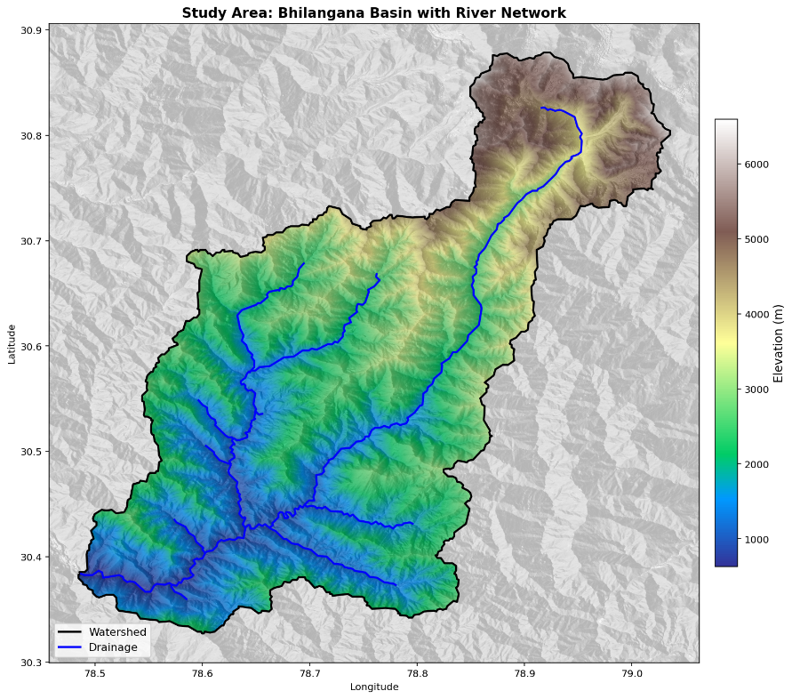

Fig.1. Study Area map of Bhilangana basin.

Table1. Dataset used in the study.

|  |  |  |  |  |
| --- | --- | --- | --- | --- |
| **S. No** | **Dataset** | **Parameter** | **Resolution** | **Link** |
| 1 | TerraClimate  Reanalysis | Precipitation | Monthly (4km) | <http://thredds.northwestknowledge.net:8080/thredds/catalog/TERRACLIMATE_ALL/data/catalog.html> |
| Selected grids | **Grid** | **Latitude** | **Longitude** | **Elevation(m)** |
| Grid1 | 30°23'43.0"N | 78°36'13.0"E | 800 |
| Grid2 | 30°31'13.0"N | 78°41'12.0"E | 2395 |
| Grid3 | 30°46'12.0"N | 78°56'12.0"E | 3810 |
| Grid4 | 30°48'40.0"N | 79°1'15.0"E | 5665 |
| 2 | ASTER | DEM | 30m | <https://catalog.data.gov/dataset/aster-global-dem> |

**2.2 Identification of the Auto-Correlation**

Autocorrelation presents a major challenge in the analysis and detection of trends in time series data. Its presence whether positive or negative can significantly influence the accuracy of statistical tests and the interpretation of trend results (Hamed and Rao, 1998). As emphasized by Bayazit and Onoz (2007), applying the Mann-Kendall test without accounting for autocorrelation can result in erroneous conclusions due to the high likelihood of falsely rejecting the null hypothesis. Autocorrelation violates the assumption of data independence, a key requirement for many statistical analyses, including trend detection. Ignoring this aspect may therefore produce misleading assessments regarding the existence of trends (Yue et al., 2002). Since the test is two-tailed, the alternative hypothesis suggests that the autocorrelation coefficient (𝑟ₖ) significantly differs from zero, whether in a positive or negative direction. According to Anderson (1954), if 𝑟ₖ falls outside the bounds of the confidence interval, serial correlation is deemed present; otherwise, the time series can be considered serially independent. In this study, to mitigate the influence of lag-1 autocorrelation in long-term time series and ensure robust trend detection, the modified Mann-Kendall (m-MK) test was applied. Therefore, this study initially examines the presence of serial correlation in all data series using the lag-k autocorrelation coefficient (𝑟𝑘) at a significance level of 0.05 for a two-tailed test (Eq. 1).

$r_{k}=\frac{\sum_{k=1}^{N-K}{(x_{t}-\overline{x_{t}})(x_{t+k}-\overline{x_{t+k}}})}{{\left[\sum_{k=1}^{n-k}{{(x_{t}-\overline{x_{t}})}^{2}{(x_{t+k}-\overline{x_{t+k}} )}^{2}}\right]}^{0.5}}$ (1)

where, 𝑟𝑘 represents the autocorrelation function of time series 𝑥𝑡 at lag k, 𝑥𝑡 denotes observed data time series, 𝑥 stands for the mean of time series 𝑥𝑡, 𝑁 is the total length of 𝑥𝑡 time series, k denotes the maximum lag.

**2.3 Mann–Kendall Test(MK)**

The value of statistical significance of the trend was computed at P = 0.05. MK statistics (S) can be calculated by Equation 2:

$S=\sum_{k=1}^{n-1}{\sum_{j=k+1}^{n}{sign(X_{j}-X_{k})}}$ (2)

Where n is the sample size, Xj and Xk are data values for the year j and k, such that (j-k) = 1; and

$sign\left(X_{j}-X_{k}\right)=\left\{\begin{aligned}+1,\text{ if } X_{j}-X_{k}>1 \\ 0 , \text{if } X_{j}-X_{k}=0 \\ -1, \text{if } X_{j}-X_{k}<1\end{aligned}\right.$ (3)

When there are ties found in the dataset, then the Var (S) is calculated as:

$Var\left(S\right)= \frac{1}{18}\left[n\left(n-1\right)\left(2n+5\right)-\sum_{k=1}^{n}{tk(tk-1)(2tk+5)}\right]$ (4)

Where n represents, number of tied values and $\sum{tk}$ symbolizes, the total sum of data in the kth group having a similar value. The standardized Mann–Kendall Zmk statistics are given as:

$Z_{mk}=\left\{\begin{aligned}\frac{s-1}{\sqrt{var(s)}}. . .if s>0 \\ 0. . .if s=0 \\ \frac{s+1}{\sqrt{var(s)}}. . .if s<0\end{aligned}\right.$ (5)

A positive value of Zmk denotes an increasing trend and a negative value of Zmk represents decreasing trend. To test null hypothesis (𝐻0), of no trend against the alternative hypothesis (𝐻𝑎), of an upward or descending pattern at the 𝛼 = 0.001, 𝛼 = 0.05 and 𝛼 = 0.01 level of significance, 𝐻0 is rejected if the estimation of 𝑍 is more prominent than 𝑍1−𝛼/2

**2.4 Modified Mann–Kendall Test(m-MK)**

The modified VAR(S) statistic can be estimated as (Hamed and Rao 1998) (Eq.6)

$VAR \left(S\right)= \left(\frac{n (n-1)(2n+5)}{18}\right) ×\left(\frac{n}{n_{e}^{*}}\right)$ (6)

Here, the correction factor $\left(\frac{n}{n_{e}^{*}}\right)$ is adjusted to the autocorrelated data as (Eq. 7)

$\left(\frac{n}{n_{e}^{*}}\right)=1+\left(\frac{2}{n^{3}-3n^{2}+2n}\right)\sum_{f=1}^{n-1}{(n-f)(n-f-1)(n-f-2)ρ_{e}(f)}$ (7)

$ρ_{e}(f)$ denotes the autocorrelation function between ranks of observations and can be estimated as Eq. (8)

$ρ_{e}\left(f\right)=2sin\left(\frac{п}{6} ρ_{e}(f)\right)$ (8)

**2.5 Sen’s Slope Estimator**

To determine the precise rate of change (change per unit time) in a hydro-meteorological time series data, Sen's slope estimator (Sen, 1968) is the optimal method. To derive an estimate of the slope 𝑄, the slopes of 𝑁 pairs of data are computed using the following equation (Eq. 9)

$T_{i}=\frac{x_{j}-x_{k}}{j-k} for i=1,2,3,….,n, j>k$ (9)

where, 𝑥𝑘 𝑎𝑛𝑑 𝑥𝑗 denote the values of data at time k, j and 𝑄𝑖 is the median slope respectively.

1. results and discussion

3.1 Annual and Seasonal statistics of Precipitation

The precipitation regime across the study area as shown in Table 2 reveals a clear spatial and seasonal gradient, with annual mean precipitation ranging from a low of 1108.75 mm in the high altitude Grid4 to a peak of 2188.80 mm in the mid elevation Grid2. The monsoon season dominates the annual total, contributing more than 60% of the yearly precipitation across all selected grids, with coefficient of variation (CV) values ranging from 23.10% to 26.34%, indicating moderate interannual variability. In contrast, the post-monsoon season contributes the least rainfall, with mean values ranging from 37.47 mm to 84.74 mm, but exhibits extremely high variability, with CVs between 85.65% and 103.39%, reflecting erratic and unpredictable precipitation events during this transitional period. The pre-monsoon season, while contributing moderately to the annual precipitation, shows high variability, with CVs from 51.02% to 56.99%, suggesting unstable early-season convection. Winter precipitation, though relatively lower in amount (138.88 mm to 291.37 mm), plays a critical role in snow accumulation, especially in higher elevation grids. Its CVs (~48–50%) indicate a moderately stable pattern, likely associated with western disturbance-driven snowfall. Notably, the standard deviation values in all seasons closely align with their respective means, reinforcing that the spread of precipitation is consistent with average seasonal patterns across all grids.

Table 2. Descriptive statistics of selected grids of the study area.

|  |  |  |  |  |  |
| --- | --- | --- | --- | --- | --- |
| **Grid/Precipitation** | | **Grid1** | **Grid2** | **Grid3** | **Grid4** |
| Annual | Mean | 1572.71 | 2188.80 | 1957.57 | 1108.75 |
| CV | 19.13 | 19.15 | 21.97 | 21.31 |
| Std | 300.94 | 419.19 | 429.99 | 236.28 |
| Monsoon | Mean | 908.43 | 1240.38 | 766.95 | 531.67 |
| CV | 23.10 | 23.56 | 24.95 | 26.34 |
| Std | 209.82 | 292.23 | 191.38 | 140.06 |
| Post-Monsoon | Mean | 69.80 | 84.74 | 79.42 | 37.47 |
| CV | 103.39 | 99.66 | 85.65 | 87.54 |
| Std | 72.17 | 84.45 | 68.03 | 32.80 |
| Pre-Monsoon | Mean | 121.41 | 181.04 | 224.52 | 70.23 |
| CV | 51.02 | 51.12 | 54.38 | 56.99 |
| Std | 61.94 | 92.54 | 122.09 | 40.02 |
| Winter | Mean | 140.93 | 208.43 | 291.37 | 138.88 |
| CV | 49.73 | 49.37 | 48.53 | 48.70 |
| Std | 70.08 | 102.89 | 141.41 | 67.63 |

**3.2 VALUES OF AUTO-CORRELATION COEFFICIENTS (r1) AT LAG-1**

The lag-1 auto-correlation coefficients (r₁) as shown in fig.2 were analysed to evaluate the presence of serial correlation within the precipitation time series, an important diagnostic step before applying trend detection techniques like the Mann-Kendall test. Significant serial correlation can distort trend results by inflating the likelihood of detecting a trend when none exists. For the 35-year dataset, the critical threshold for r₁ at the 95% confidence level is ±0.298. At the monthly scale, most r₁ values ranged between -0.25 and 0.24, indicating minimal or no significant autocorrelation. However, June approached the critical threshold with r₁ values near -0.30 in several series, hinting at potential serial correlation during the early monsoon phase. This suggests that June precipitation may be influenced by antecedent conditions, possibly due to persistent climate drivers like pre-monsoon atmospheric circulation or land-surface feedbacks such as soil moisture. At both the seasonal and annual scales, r₁ values were well below the significance limit, confirming the absence of strong autocorrelation and no evidence of long-term persistence in the precipitation time series at broader temporal scales.

**3.3 MANN-KENDALL Z-STATISTICS, P VALUE AND SEN’S SLOPE ASSESSMENT**

The Mann-Kendall Z-statistics, along with Sen’s slope estimates and P-values as shown in fig.3, were used to assess precipitation trends from 1990 to 2024 across selected grids. Although no trends met the 95% significance threshold (|Z| > 1.96), several consistent patterns suggest emerging hydro climatic shifts. The most prominent drying signals appear during the winter season, with Z-values ranging from -1.51 to -1.90, indicating widespread and consistent declines in winter precipitation. Similarly, March and November exhibit strong negative monthly Z-values across all four grids (Z < -1.3 to -1.6), reinforcing the trend of reduced precipitation during the cold and transitional periods. The annual Z- values also reflect a uniform drying trend, with all selected grids showing negative values from -1.08 to -1.63, supporting moderate evidence of long-term decline in total annual precipitation. Seasonal analysis reveals notable decreases in pre-monsoon rainfall, with Z-values between -0.73 and -1.42, suggesting early-season moisture deficits that could impact sowing periods and snowmelt dynamics. In contrast, the post-monsoon season shows slightly increasing trends (Z ≈ +0.23 to +0.46), though not statistically significant, potentially associated with delayed monsoon withdrawal or increased atmospheric moisture. Monsoon precipitation, while dominant in total volume, exhibits mixed signals, with near-zero to weakly positive Z-values (-0.36 to +0.05), reflecting high variability rather than consistent change. Meanwhile, months like October and September show modest increasing trends (Z ≈ +0.54 to +0.91), further hinting at a temporal shift in rainfall intensity or distribution. Overall, despite the lack of statistical significance, the persistence of negative Z-values during winter, pre-monsoon, and annually, points to a broad but emerging drying pattern, which could have significant implications for snowpack development, baseflow contributions, and seasonal water security in the study area. Similarly, none of the grids exhibit statistically significant trends at P = 0.05, Grids4 and Grid3 present borderline P-values during the Winter season (≈ 0.06). This pattern suggests that while the strength of evidence is not overwhelming, there may be subtle climatic signals developing, particularly during winter. These could be linked to changing snowfall regimes, delayed snowmelt, or increasing winter temperatures, all of which have hydrological implications in high-altitude Himalayan basins. Moreover, the consistency of relatively lower P-values in December and winter months across multiple grids adds to the credibility of a seasonal signal that may not yet be statistically robust but is scientifically meaningful and worth monitoring.

The Sen’s slope analysis of precipitation for the selected grids reveals a consistent and pronounced drying trend across all seasons, particularly during the winter and pre-monsoon periods. Grid 3 exhibits the strongest annual decline (-3.34 mm/year), with a sharp drop during winter (-3.35 mm/year), reflecting the weakening of western disturbances, which are vital for snow and glacier accumulation in the Himalayan region. Similarly, Grid 2 shows an annual trend of -2.99 mm/year, with a notable decrease in pre-monsoon (-0.69 mm/year) and winter (-2.09 mm/year) precipitation, suggesting reduced early-season moisture crucial for water storage. Grid 4 follows this behaviour with -2.59 mm/year annually and strong declines in March (-1.05 mm/year) and winter (-2.51 mm/year). Even Grid 1, though slightly less extreme, indicates significant drying, especially in the monsoon (-0.65 mm/year) and winter (-1.36 mm/year). Interestingly, isolated positive trends during August or June (Grid3 with +1.00 mm/year in August) hint at potential shifts in rainfall intensity or delayed monsoon peaks, but these are insufficient to counterbalance the widespread decrease. Overall, these patterns signal a systematic reduction in precipitation across seasons, especially in cold and dry months, posing serious implications for glacier mass balance, water security, and hydrological sustainability in these vulnerable high-altitude basins.

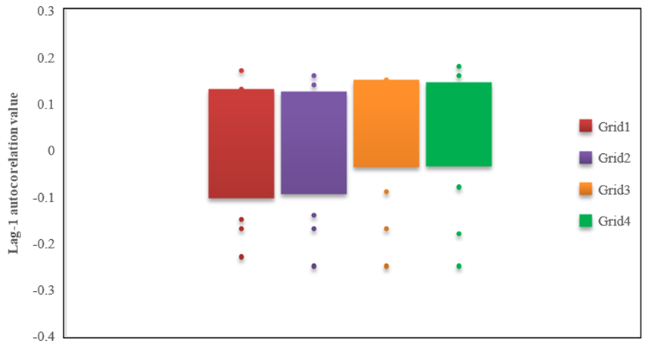Fig.2. Box plot showing lag-1 autocorrelation values for precipitation.

Fig.3. Box plot showing Sen’s slope and P values for precipitation.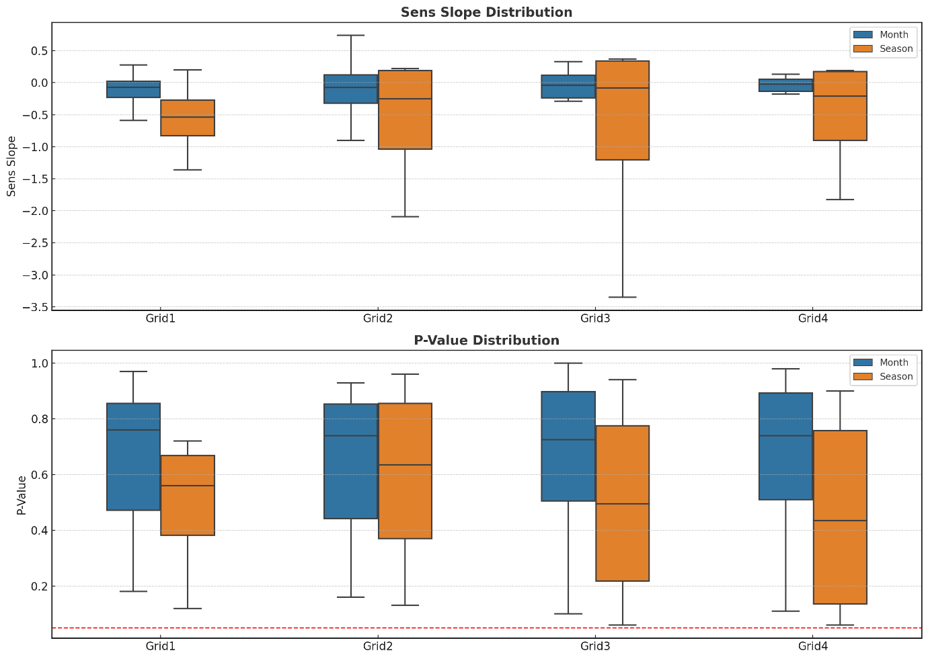

1. **CONCLUSIONS**

The comprehensive analysis of precipitation trends across the Bhilangana basin over the 1990–2024 period reveals a clear and emerging pattern of hydro climatic change, marked by spatial variability, seasonal contrasts, and subtle yet consistent indicators of drying. While the absence of statistically significant trends (at P= 0.05) underscores the complexity of precipitation dynamics in this Himalayan region, the convergence of multiple lines of evidence, negative Mann-Kendall Z-values, declining Sen’s slope estimates, and borderline P-values points to a gradually intensifying reduction in precipitation, particularly during the winter and pre-monsoon seasons. Grids3 and Grid4 exhibit the most pronounced declines, closely tied to weakening western disturbances and early-season moisture deficits. Additionally, the modest positive trends observed in late monsoon months (e.g., August, September, and October) hint at possible seasonal shifts in rainfall distribution, potentially influenced by changes in monsoon dynamics or warming-driven moisture retention. The lack of significant autocorrelation further validates the reliability of the detected trends, indicating that the time series are not biased by persistence effects. Despite moderate interannual variability during the monsoon season, the high variability in post-monsoon and pre-monsoon periods, coupled with consistent drying signals, highlights the growing unpredictability and seasonality of rainfall in the region. Collectively, these findings suggest a transition toward a drier and more variable precipitation regime, with critical implications for snow accumulation, glacier mass balance, baseflow generation, and water availability during the dry season. As such, these observed patterns, though not statistically conclusive, are scientifically robust and demand closer monitoring to support adaptive water resource planning and climate-resilient hydrological management in this ecologically sensitive Himalayan basin.

**COMPETING INTERESTS DISCLAIMER**

Authors have declared that they have no known competing financial interests or non-financial interests or personal relationships that could have appeared to influence the work reported in this paper.

**REFERENCES**

Abatzoglou, J. T., Dobrowski, S. Z., Parks, S. A., & Hegewisch, K. C. (2018). TerraClimate, a high resolution global dataset of monthly climate and climatic water balance from 1958–2015. Scientific Data, 5, 170191. <https://doi.org/10.1038/sdata.2017.191>

Akhoury, I., & Avishek, K. (2020). Climate variability and its impact on agriculture in Jharkhand, India. Theoretical and Applied Climatology, 139(1), 681–694.

Anand, A., Dinesh, A. S., Srivastava, P. K., Chaudhary, S. K., Varma, A. K., & Kumar, P. (2022). Rainfall rate estimation over India using global precipitation measurement’s microwave imager datasets and different variants of fuzzy information system. Geocarto International, 37(21), 6213–6231.

Anderson, R. L. (1954). The problem of autocorrelation in regression analysis. Journal of the American Statistical Association, 49(265), 113–129.

Arora, M., Goel, N. K., & Singh, P. (2005). Evaluation of temperature trends over India. Hydrological Sciences Journal, 50(1), 81–93.

Basistha, A., Sarkar, A., & Srivastava, K. (2007). Spatial variability of daily rainfall regime in the Indian region using a GIS technique. Theoretical and Applied Climatology, 86(1), 33–45.

Bhambri, R., Bolch, T., Chaujar, R. K., & Kulshreshtha, S. C. (2011). Glacier changes in the Garhwal Himalaya, India, from 1968 to 2006 based on remote sensing. Journal of Glaciology, 57(203), 543–556. <https://doi.org/10.3189/002214311796905604>

Coumou, D., & Rahmstorf, S. (2012). A decade of weather extremes. Nature Climate Change, 2(7), 491–496.

Das, J., & Bhattacharya, S. K. (2018). Trend analysis of long-term climatic parameters in Dinhata of Koch Bihar district, West Bengal. Spatial Information Research, 26, 271–280.

Dimri, A. P., et al. (2021). Climate change over the Himalayas: Recent observations and future projections. Climate Dynamics, 56(3–4), 1103–1122.

Dobhal, D. P., Mehta, M., Srivastava, D., & Chaturvedi, R. K. (2013). Chamoli flash flood: A study on Bhilangna River valley in Uttarakhand Himalaya. Current Science, 105(2), 249–251.

Feng, X., Porporato, A., & Rodriguez-Iturbe, I. (2013). Changes in rainfall seasonality in the tropics. Nature Climate Change, 3(9), 811–815.

Ghosh, S., Das, D., Kao, S. C., & Ganguly, A. R. (2020). Lack of uniform trends but increasing spatial variability in observed Indian rainfall extremes. Nature Climate Change, 6, 850–855.

Hamed, K. H., & Rao, A. R. (1998). A modified Mann–Kendall trend test for autocorrelated data. Journal of Hydrology, 204(1–4), 182–196.

Hamilton, J. P., Whitelaw, G. S., & Fenech, A. (2001). Mean annual temperature and total annual precipitation trends at Canadian biosphere reserves. Environmental Monitoring and Assessment, 67, 239–275.

Hussain, M., & Mahmud, I. (2019). pyMannKendall: A Python package for non-parametric Mann Kendall family of trend tests. Journal of Open Source Software, 4(39), 1556.

IPCC. (2021). Climate Change 2021: The Physical Science Basis. Contribution of Working Group I to the Sixth Assessment Report of the Intergovernmental Panel on Climate Change. Cambridge University Press.

Jayanta, D., Tapash, M., Piu, S., & Kumar, B. S. (2020). Variability and trends of rainfall using non-parametric approaches: a case study of semi-arid area. Mausam, 71(1), 33–44.

Kendall, M. G. (1975). Rank Correlation Methods (4th ed.). Charles Griffin.

Kothawale, D. R., Rajeevan, M., & Kumar, K. K. (2016). Recent trends in pre-monsoon daily temperature extremes over India during 1970–2015. Climate Dynamics, 49(3), 1459–1474.

Kumar, V., Jain, S. K., & Singh, Y. (2010). Analysis of long-term rainfall trends in India. Hydrological Sciences Journal, 55(4), 484–496.

Kumar, V., Jain, S. K., & Singh, Y. (2020). Analysis of long-term rainfall trends in India. Hydrological Sciences Journal, 65(14), 2407–2419. <https://doi.org/10.1080/02626667.2020.1764560>

Malik, A., & Kumar, A. (2020). Spatio-temporal trend analysis of rainfall using parametric and non-parametric tests: Case study in Uttarakhand, India. Theoretical and Applied Climatology, 140, 183–207.

Mamta, M., Jain, R., & Arya, D. (2020). Temporal trends of climatic indices and their potential impact on hydrological components in semi-arid region of Haryana, India. Journal of Earth System Science, 129(1), 1–11.

Mann, H. B. (1945). Nonparametric tests against trend. Econometrica, 13(3), 245–259.

MoEFCC. (2022). India: Third National Communication to the United Nations Framework Convention on Climate Change. Ministry of Environment, Forest and Climate Change, Government of India.

Pant, G. B., & Kumar, K. R. (1997). Climates of South Asia. John Wiley & Sons.

Pingale, S. M., Khare, D., Jat, M. K., & Adamowski, J. (2014). Spatial and temporal trends of mean and extreme rainfall and temperature for the 33 urban centers of the arid and semi-arid state of Rajasthan, India. Atmospheric Research, 138, 73–90.

Sen, P. K. (1968). Estimates of the regression coefficient based on Kendall’s tau. Journal of the American Statistical Association, 63(324), 1379–1389.

Sharma, R., Ghosh, S., & Vaze, J. (2018). Rainfall and temperature variability and their impacts on runoff in the Himalayan river basins. Environmental Research Letters, 13(8), 084005. <https://doi.org/10.1088/1748-9326/aad210>

Srivastava, A. K., et al. (2020). Warming and rainfall variability in India based on daily gridded data. [Journal reference to be confirmed].

WMO. (2024). State of the Global Climate 2023. World Meteorological Organization. Retrieved from [https://public.wmo.int](https://public.wmo.int/)

Yue, S., Pilon, P., & Cavadias, G. (2002). Power of the Mann–Kendall and Spearman’s rho tests for detecting monotonic trends in hydrological series. Journal of Hydrology, 259(1–4), 254–271.