**Bio-Mass: A great source of non-fossil energy and its contribution in reducing green house gases**

Abstract :

**Biomass**, the [weight](https://www.britannica.com/science/weight) or total quantity of living organisms of one [animal](https://www.britannica.com/animal/animal) or [plant](https://www.britannica.com/plant/plant) [species](https://www.britannica.com/science/species-taxon) (species biomass) or of all the species in a [community](https://www.britannica.com/science/community-biology) (community biomass), commonly referred to a unit area or volume of [habitat](https://www.britannica.com/science/habitat-biology). The weight or quantity of organisms in an area at a given moment is the standing crop. The total amount of c produced by living organisms in a particular area within a set period of time, called the primary or secondary [productivity](https://www.britannica.com/science/biological-productivity) (the former for plants, the latter for animals), is usually measured in units of [energy](https://www.britannica.com/science/energy), such as gram [calories](https://www.britannica.com/science/calorie) or kilojoules per [square](https://www.britannica.com/technology/square-tool) metre per year. Measures of weight—e.g., tons of [carbon](https://www.britannica.com/science/carbon-chemical-element) per square kilometre per year or gigatons of carbon per year—are also commonly recorded.

In a different though related sense, the term *biomass* refers to plant materials and animal waste used especially as a source of fuel.

The objective of this study is to estimate the average availability of bio-mass in India in year 2010 and prediction in year 2025 with the help of high resolution imagery through Google Earth Engine and GIS, also estimating release of Co2 into atmosphere, if the same bio-mass is not utilized. The range of average above ground bio-mass(agb) in 2010 varies from 0.5338 - 93.644, below ground bio-mass(bgb)1.015- 22.474 , and Total bio mass (TBM) 1.5488- 116.118 kg*C/m^2 as computed from MODIS. Corresponding Total Bio_Mass quantity in year 2010 is 4.39179 Billion Ton and Co2 release in atmosphere is 11.539218400000001 Billion Ton .However, the Gross Primary Production is 4.79646005 Billion Ton. However, prediction was made with NASA imagery in conjuction with Vegetation indices, Land Cover and FPAR/LAI, the results obtained are in the range of average above ground bio-mass(agb) in 2010 varies from 0.000 – 79, below ground bio-mass(bgb)0.000-   
22, and Total bio mass (TBM) 0- 101 Mg/Ha. Corresponding Total Bio_Mass quantity in year 2010 is 4.112982692983341Billion Ton and Co2 release in atmosphere is 13.25737496044534 Billion Ton. However, predicted figures in year 2025: the above ground bio-mass(agb ) 85.73578643798828Mg/Ha, below ground bio-mass(bgb) 22.05862045288086 Mg/Ha, and Total bio mass (TBM) 4.83646174936528 Billion Ton. Correlation and R-squared values are 0.9882423543764696 and 0.9766229509835477.

Keywords: Living organisms, species biomass, Organic material, NPP, GPP,Remote Sensing and GIS.

Introduction:

India's arable land area of 1,597,000 km2 (394.6 million acres) is the second largest in the world, after the United States. Its gross irrigated crop area of 826,000 km2 (215.6 million acres) is the largest in the world, followed by US and China. Of the 160 million hectares of cultivated land in India, about 39 million hectares can be irrigated by groundwater wells and an additional 22 million hectares by irrigation canals. In 2010, only about 35% of agricultural land in India was reliably irrigated. About 2/3rd cultivated land in India is dependent on [monsoons](https://en.wikipedia.org/wiki/Monsoon_of_South_Asia) [17,18].

Land-surface process (LSP) models describe the physiological and biophysical processes of soil and vegetation, including ecosystem Net Primary Productivity (NPP). Models of this type have assumed greater importance in recent years, and are now commonly incorporated to global climate models (Cox et al., 1999, Cramer et al., 2001). Land-surface process (LSP) models are also analysed in their own right to understand better the global carbon cycle (Kimball et al., 1997a, Kimball et al., 1997b, Potter et al., 2003).

Net Primary Productivity (NPP), or the production of plant biomass, is equal to all of the carbon taken up by the vegetation through photosynthesis (called Gross Primary Production or GPP) minus the carbon that is lost to respiration.

NPP = GPP - respiration

In terrestrial systems, NPP is often calculated by determining the carbon storage increment. Therefore, using the data from your sample site along with the biomass and carbon storage equations, aboveground NPP can be calculated by taking the difference in carbon storage of each individual tree between years, and summing the resulting values to get plot NPP.

NPP is one of the most frequently measured ecosystem processes, because it is central to the storage and accumulation of carbon in ecosystems, as well as the yield of usable products (lumber, etc.). From the NPP calculation, you can also calculate the annual CO2 uptake from your sample site using the instructions at the end of this document [19,20].

Annual CO2 uptake can be calculated using simple math and a bit of chemistry knowledge. Use the equation below to calculate CO2 uptake from NPP.

CO2 Uptake (g/m2/yr) = NPP (g/m2/yr) * 3.664

Equation Rational

A carbon dioxide molecule is made up of one carbon and two oxygen atoms.

From the periodic table we know the atomic weight of a carbon atom = 12.011 and the atomic weight of an oxygen atom = 15.999. Therefore the atomic weight of a CO2 molecule = 12.011 + 2*15.999 = 44.009.

We then find the ratio of CO2 to C, which is 44.009/12.011 = 3.664.

The carbon dioxide uptake of your sample site plot is equal to the carbon stored that year (i.e. NPP) * 3.664.

As the global community transitions towards more sustainable energy sources, bioenergy has emerged as a promising solution, particularly for countries with substantial agricultural resources like India. With its vast reserves of organic waste and residues, India holds significant potential to transform biomass into clean, renewable energy.

India’s increasing population, rapid urbanisation, and industrial expansion have dramatically escalated energy demands. Traditionally, this growing need has been met through fossil fuels, leading to soaring import costs and contributing significantly to carbon emissions. The environmental and economic challenges posed by such reliance have spurred the Indian government to set ambitious targets, such as producing 5 million metric tonnes of green hydrogen annually by 2030.

One of the most promising technologies to achieve these targets is **biomass gasification**, which offers a renewable and low-carbon solution to meet India’s energy requirements. Biomass can be converted into multiple forms of energy, such as biogas, ethanol, and biodiesel, which are crucial for transportation, electricity generation, and heating. Unlike fossil fuels, bioenergy is considered carbon-neutral, as the carbon dioxide (CO2) released during its combustion is offset by the CO2 absorbed by plants during their growth.

**Biomass feedstocks** are organic materials derived from agricultural residues, forestry by-products, purpose-grown energy crops, and organic waste (e.g., municipal solid waste, sewage sludge). These feedstocks represent a rich, underutilised source of renewable energy that could contribute significantly to India’s energy mix. However, one of the key challenges is optimising the energy density of these raw materials. Wet biomass, for instance, contains high moisture levels, which reduce its energy efficiency and require additional energy for evaporation.

The solution lies in **biomass palletisation**. This process involves drying the biomass to reduce its moisture content to 10-15%, followed by grinding to reduce the size of the material for easier compression. The final step is the palletisation itself, where the material is compressed against a heated die. This step softens the biomass’s natural lignin, which acts as a binding agent, forming dense energy pellets. These pellets can then undergo torrefaction – a thermal process that further enhances their energy density, combustion properties, and shelf life.

The Indian government has introduced policies to promote **co-firing** of biomass pellets in coal-fired power plants. Substituting up to 20% of coal with biomass in such plants not only reduces carbon emissions but also increases farmers’ incomes by creating a viable market for agricultural residues.

Several technologies have been developed to convert biomass into energy, each offering unique benefits. Below are some of the key technologies used in bioenergy production:

**Gasification**:  
Biomass gasification is a process that converts organic materials into **syngas** (a mixture of carbon monoxide, hydrogen, and other gases) by heating them in a low-oxygen environment. The two primary types of gasification are:

**Thermal Gasification**: In this process, biomass is heated in the presence of limited oxygen to produce syngas, which can be further converted into electricity, heat, and even biofuels such as ethanol and methanol.

**Oxy-fuel Gasification**: Here, oxygen is used instead of air, resulting in a higher concentration of carbon monoxide and hydrogen in the syngas. This is particularly useful for producing **green hydrogen** – a key component of India’s future energy plans.

**Pyrolysis**:  
Pyrolysis involves heating biomass in the absence of oxygen, breaking it down into bio-oil, biochar, and syngas. The bio-oil produced can be refined into hydrocarbon fuels like diesel, gasoline, and jet fuel. Pyrolysis is a versatile technology, providing options for both solid fuel and liquid fuel production, depending on the operating conditions.

**PlasmaGasification**:  
Plasma gasification utilises extremely high temperatures (above 2,000°C) to convert organic materials into syngas or other valuable products. This advanced technology is efficient in waste-to-energy conversion, producing high yields of syngas, which can be further processed into hydrogen or other fuels. A significant advantage of this method is that it destroys pathogens, reduces emissions, requires less conversion time, and allows for the recovery of nutrients(Harshita Negi et al).

# Literature Review:

The quantification, mapping and monitoring of biomass are now central issues due to the importance of biomass as a renewable energy source in many countries of the world. The estimation of biomass is a challenging task, especially in areas with complex stands and varying environmental conditions, and requires accurate and consistent measurement methods. To efficiently and effectively use biomass as a renewable energy source, it is important to have detailed knowledge of its distribution, abundance, and quality. Remote sensing offers the technology to enable rapid assessment of biomass over large areas relatively quickly and at a low cost (*Lalit Kumar, et al*).

Developed regression equations to estimate aboveground biomass of individual trees as a function of diameter at breast height, total height, wood density, and Holdridge life zone (sensu Holdridge 1967).

With the point intercept method, contacts are registered between plants and the tips of narrow pins passed into the vegetation. The summed number of contacts over a large number of pin positions has been used to estimate plant cover and leaf areas. This study shows that number of point intercepts also correlates highly with biomass. The intercepts can, therefore, be used as a regression variable to predict the mass of both stems and leaves in plant stands(S Jonasson - Oikos, 1988 – JSTOR).

Use GIS to assess biomass in Peninsular Malaysia, a country with very good inventories and maps, and in Continental South/Southeast Asia, a region with very sparse inventory information. In the later case, GIS is used to model forest biomass using a suite of map layers that most influence biomass(Sandra Brown etal).

The visible bands of the Landsat Thematic Mapper (TM) sensor were used in an empirical assessment of seagrass biomass on shallow banks near Lee Stocking Island in the Bahamas. The TM bands were transformed to minimize the depth-dependent variance in the bottom reflectance signal. Regression analyses were performed between the transformed bands and field measurements of seagrass standing crop (above-ground biomass). Regression equations using spectral data accounted for up to 80 per cent of the variability in seagrass biomass.( ARMSTRONG, R. A. (1993). Remote sensing of submerged vegetation canopies for biomass estimation. *International Journal of Remote Sensing*, *14*(3), 621–627. <https://doi.org/10.1080/01431169308904363>)

The texture parameters of two high-resolution (10 m) optical sensors (Advanced Visible and Near Infrared Radiometer type 2 (AVNIR-2) and SPOT-5) in different processing combinations for biomass estimation. Multiple regression models are developed between image parameters extracted from the different stages of image processing and the biomass of 50 field plots, which was estimated using a newly developed “allometric model” for the study region. The results demonstrate a clear improvement in biomass estimation using the texture parameters of a single sensor(. E. Nichol and M. L. R. Sarker, "Improved Biomass Estimation Using the Texture Parameters of Two High-Resolution Optical Sensors," in *IEEE Transactions on Geoscience and Remote Sensing*, vol. 49, no. 3, pp. 930-948, March 2011, doi: 10.1109/TGRS.2010.2068574. )

Combined field sampling with remote sensing data and calculated five vegetation indices (VIs). Using this combined information, quantified a remote sensing estimation model and estimated biomass in a temperate grassland of northern China.( Yunxiang Jin, et al).

To estimate above-ground biomass of tropical secondary forest from canopy spectral reflectance using satellite optical data. Landsat Thematic Mapper data were acquired concurrent with field surveys conducted in secondary forest fallows near Manaus, Brazil and Santa Cruz de la Sierra, Bolivia. Measurements of age and above-ground live biomass were made in 34 regrowth stands. Satellite data were converted to surface reflectances and compared with regrowth stand age, biomass and structural variables. Among the Brazilian stands, significant relationships were observed between middle-infrared reflectance and stand age, height, volume and biomass (Steininger,M. K., doi: 10.1080/014311600210119).

# Methodology

## **Data and Methodology:**

Google earth Engine platform and GIS have been utilized to process the satellite imageries in the following manner.

NASA Collection

NASA Collection

MODIS Data Collection

NDVI,EVI

LAI,FPAR

Below Ground Biomass(abg)

Above Ground Biomass(abg)

Extracting GPP

Extracting NPP

Land Cover

Release of Co2 in atmosphere

DEM

Below Ground Biomass(abg)

Correlation

0.98824235437646

R Square Value

0.97662295098354

Prediction of BioMass in 2025

Smile Random Forest Model

Fig 1. Google earth Engine platform and GIS utilized to process the satellite imageries

The dataset of NASA provides temporally consistent and harmonized global maps of aboveground and belowground biomass carbon density for the year 2010 at a 300-m spatial resolution. The aboveground biomass map integrates land-cover specific, remotely sensed maps of woody, grassland, cropland, and tundra biomass. Input maps were amassed from the published literature and, where necessary, updated to cover the focal extent or time period. The belowground biomass map similarly integrates matching maps derived from each aboveground biomass map and land-cover specific empirical models. Aboveground and belowground maps were then integrated separately using ancillary maps of percent tree cover and landcover and a rule-based decision tree. Maps reporting the accumulated uncertainty of pixel-level estimates are also provided.

Aboveground living biomass carbon density includes carbon stored in living plant tissues located above the earth’s surface (stems, bark, branches, twigs). It does not include leaf litter or coarse woody debris that was once attached to living plants but have since been deposited and are no longer living. Belowground living biomass carbon density includes carbon stored in living plant tissues located below the earth’s surface (roots). This does not include dead and/or dislocated root tissue, nor does it include soil organic matter. Woody cover includes any vegetation whose biomass is primarily composed woody biomass (e.g. trees and shrubs). Herbaceous cover includes any vegetation whose biomass is primarily composed of leaf-like matter (e.g. grasses and many crops)( Spawn, S.A., Sullivan, C.C., Lark, T.J. et al. Harmonized global maps of above and belowground biomass carbon density in the year 2010. Sci Data 7, 112 (2020). [doi:10.1038/s41597-020-0444-4](https://doi.org/10.1038/s41597-020-0444-4),Spawn, S.A., and H.K. Gibbs. 2020. Global Aboveground and Belowground Biomass Carbon Density Maps for the Year 2010. ORNL DAAC, Oak Ridge, Tennessee, USA.)

The MODIS product provides information about annual Gross and Net Primary Productivity (GPP and NPP) at 500m pixel resolution. Annual NPP is derived from the sum of all 8-day Net Photosynthesis(PSN) products (MOD17A2H) from the given year. The PSN value is the difference of the Gross Primary Productivity (GPP) and the Maintenance Respiration (MR) (GPP-MR)( Running, S., Zhao, M. (2021). *MODIS/Terra Net Primary Production Gap-Filled Yearly L4 Global 500m SIN Grid V061* [Data set]. NASA EOSDIS Land Processes Distributed Active Archive Center. Accessed 2025-05-06 from <https://doi.org/10.5067/MODIS/MOD17A3HGF.061>)

The MODIS vegetation indices (VIs) will provide consistent, spatial and temporal comparisons of global vegetation conditions that will be used to monitor the Earth's terrestrial photosynthetic vegetation activity for phenologic, change detection, and biophysical derivation of radiometric and structural vegetation parameters. The MODIS vegetation index (VI) products will play a major role in several EOS studies as well as be an integral part in the production of many global and regional biospheric models and biogeochemical cycles. Currently, satellite-derived vegetation indices are being integrated in interactive biosphere models as part of global climate modelling (Sellers et al. 1994; Raich and Schlesinger, 1992; Fung et al., 1987; Tans et al., 1990) and production efficiency models (Prince et al., 1994; Prince, 1991). They are also used for a wide variety of land applications, including natural resource management, agriculture, the Global Health and Human Monitoring Program (NASA, 1988), and operational Famine Early Warning Systems (Prince and Justice, 1991; Hutchinson, 1991).

The simple ratio (SR) was the first index to be used (Jordan, 1969), formed by dividing the NIR response by the corresponding ‘red’ band output, SR= X nir/ X red (1) where X can be digital counts, at- satellite radiances, top of the atmosphere apparent reflectances, land leaving surface radiances, surface reflectances, or hemispherical spectral albedos. However, for densely vegetated areas, the amount of red light reflected approaches very small values and this ratio, consequently, increases without bounds. Deering (1978) normalized this ratio from -1 to +1, with the normalized difference vegetation index (NDVI), by ratioing the difference between the NIR and red bands by their sum; NDVI = X nir − X red /X nir + X red

Canopy background influences on vegetation indices are also atmosphere-sensitive, Huete and Liu (1994) found background influences on the NDVI to decrease greatly with increases in atmospheric aerosol contents and that at a horizontal visibility of 5km (turbid atmosphere), background influences became nearly zero. This was also observed with satellite imagery (Qi et al., 1993). Consequently, canopy background problems to become more pronounced in MODIS-NDVI imagery due to the improved atmospheric correction algorithms being implemented. A feedback problem is evident whereby the improvement of one form of noise increases other forms of noise. Liu and Huete (1995) developed a feedback-based approach to correct for the interactive canopy background and atmospheric influences, incorporating both background adjustment and atmospheric resistance concepts. This enhanced, soil and atmosphere resistant vegetation index (EVI) was simplified to: EVI = 2 ⋅ ( ρ nir − ρ red ) (L + ρ nir + C 1 ρ red + C 2 ρ blue ) where ρ is ‘apparent’ (top-of-the-atmosphere) or ‘surface’ directional reflectances, L is a canopy background adjustment term, and C1 and C2 weigh the use of the blue channel in aerosol correction of the red channel (Huete and Liu, 1996)( *ASTER Mount Gariwang image from 2018 was retrieved on YYYY_MM_DD from https://lpdaac.usgs.gov, maintained by the NASA EOSDIS Land Processes Distributed Active Archive Center (LP DAAC) at the USGS Earth Resources Observation and Science (EROS) Center, Sioux Falls, South Dakota. 2018,*[*https://lpdaac.usgs.gov/resources/data-action/aster-ultimate-2018-winter-olympics-observer/*](https://lpdaac.usgs.gov/user_resources/data_in_action/aster_ultimate_2018_winter_olympics_observer)*.)*

MODIS combined Leaf Area Index (LAI) and Fraction of Photosynthetically Active Radiation (FPAR) product is an 8-day composite dataset at 500m resolution.

Leaf Area Index (LAI) can be estimated using the Enhanced Vegetation Index (EVI) and a simple linear equation. The formula is typically: LAI = (3.618 * EVI) - 0.118.

Photosynthetically Active Radiation (FPAR) in Google Earth Engine typically involves using vegetation indices like NDVI and then applying a linear or non-linear transformation to estimate FPAR. The specific formula depends on the vegetation type and the satellite sensor used. Some common formulas include:

* **NDVI-based FPAR:** fPAR = 1.24 * NDVI - 0.168 (Winter wheat)
* **Red Edge NDVI-based FPAR:** fPAR = 1.25 * Red Edge NDVI - 0.10; fPAR = fPARmax * f(NDVI) (Corn, Soybean)
* **NDVI-based FPAR with limits:** fNDVI = max(min((ndvi - 0.1) / (0.9 - 0.1), 1), 0) (Grassland, farmland, forest

**Results and Discussions:**

From the below generated graphs, it is comprehended that NPP(Net Primary Production) and GPP(Gross Primary Production) have been increased over a period of time till 2022, afterward a slight reduction has been seen.

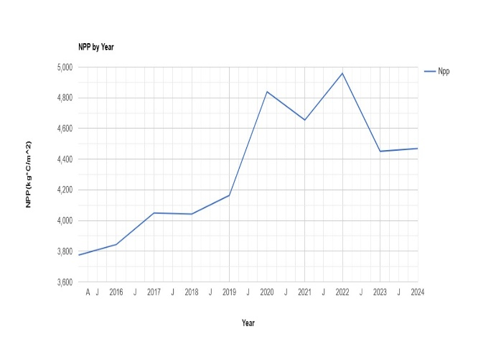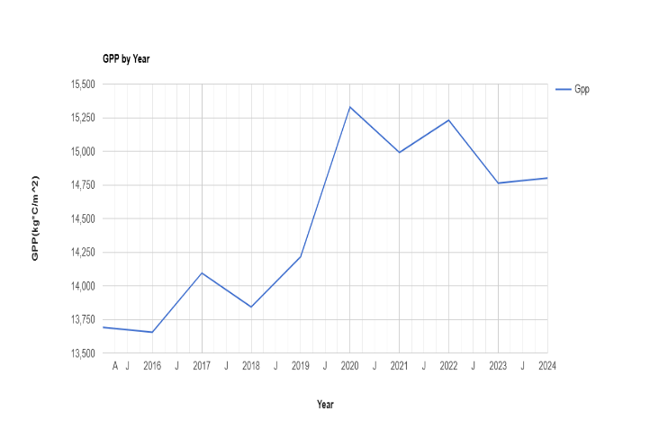

Fig.2 Net Primary Production and Gross Primary Production

Maps of Net Primary Production(NPP) and Gross Primary Production(GPP) in Kg*C/cm^2 are shown below.

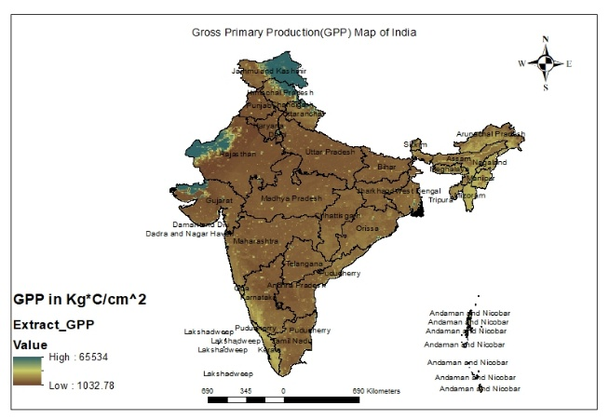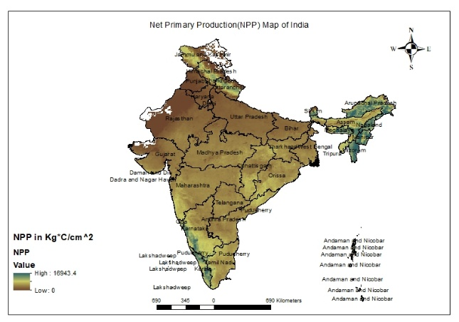

Fig.3 Gross and Net Primary Production map of India

NPP in Billion_Ton was 1.574675 in year 2022

GPP in Billion_Ton was 4.79646005 in year 2022

CO2 release to atmosphere in year 2022 was 13.25737496044534 Billion Ton

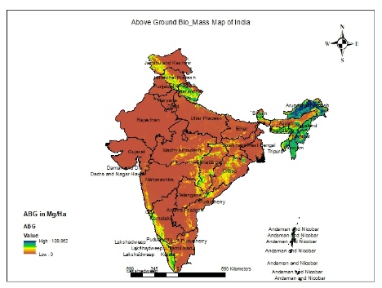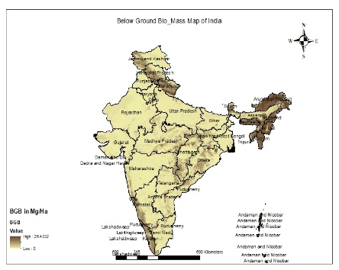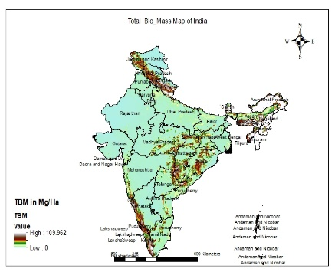

a b c

Fig.4a : Above Ground Bio_Mass in Mg/Ha

Fig.4b : Below Ground Bio_Mass in Mg/Ha

Fig.4c : Total Bio_Mass in Mg/Ha

Above Ground Bio_Mass in Billion Ton : 3.3245442783757557

Below Ground Bio_Mass in Billion Ton : 1.0672484713077333

Total Bio_Mass in Billion Ton : 4.391792749772013

Smile Random Forest Model was prepared on NASA/ORNL using vegetation indices, Leaf Area index,Fpar, Land Cover and Dem as independent variable. The base data for the year 2010 has been considered and with the help of the model, prediction for above ground, below ground and total bio mass has been made for the year,2025. The relevant graphs are given below:

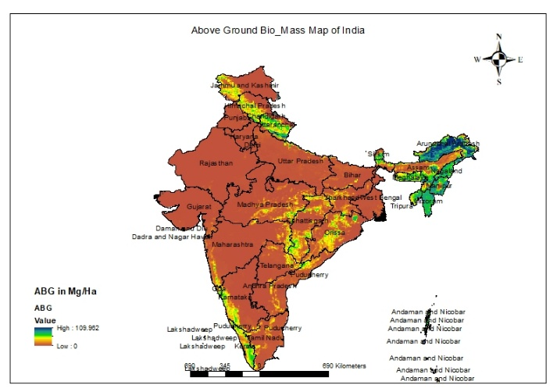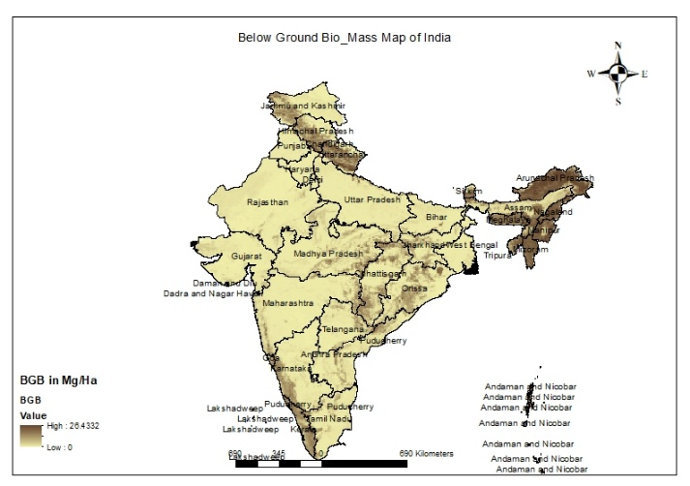

a b

Fig.5a : Original Above Ground Bio_Mass in Mg/Ha

Fig.5b : Original Below Ground Bio_Mass in Mg/Ha

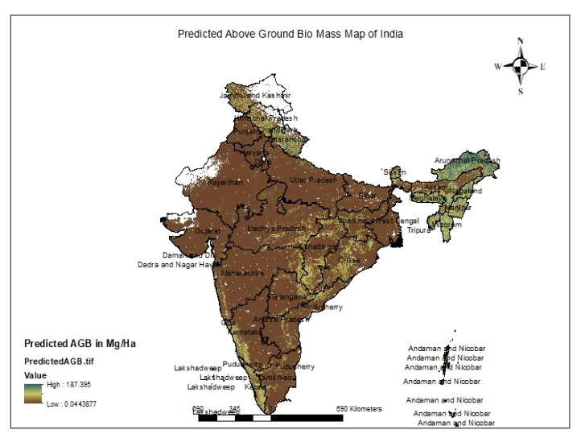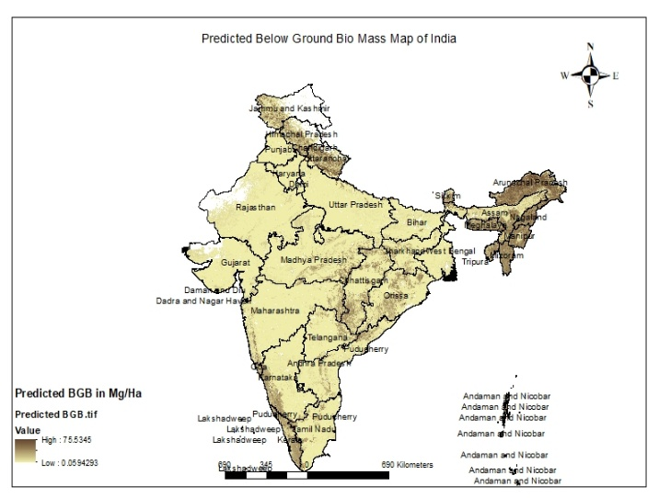

a b

Fig.6a : Predicted Above Ground Bio_Mass in Mg/Ha

Fig.6b : Predicted Below Ground Bio_Mass in Mg/Ha

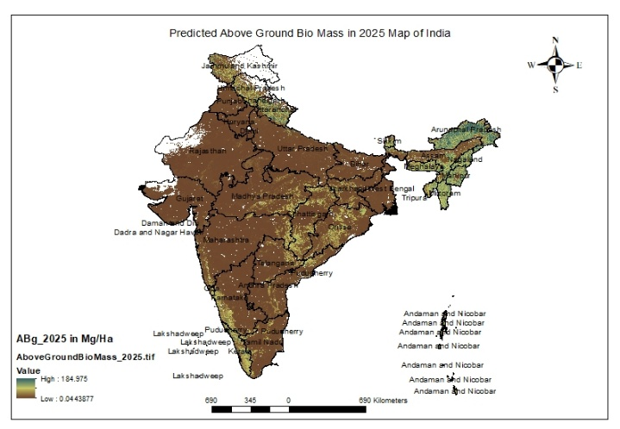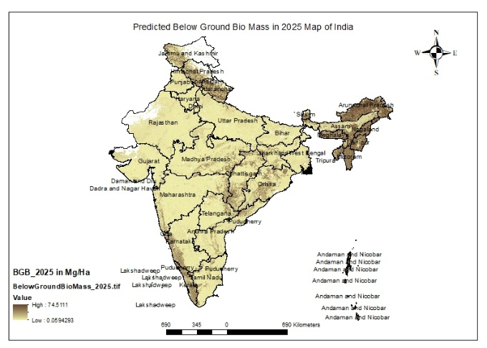

a b

Fig.7a : Predicted Above Ground Bio_Mass in Mg/Ha in year 2025

Fig.7b : Predicted Below Ground Bio_Mass in Mg/Ha in year 2025

Above Ground Bio_Mass in Billion Ton in 2025 : 3.642135978144324

Below Ground Bio_Mass in Billion Ton in 2025 : 1.194325771220956

Total Bio_Mass in Billion Ton in 2025 : 4.83646174936528

**Model Parameters for base data :**

**Correlation : 0.9882423543764696**

**R-Squared value : 0.9766229509835477**

**Parameters for predicted model:**

**Correlation : 0.9790501792925359**

**R-Squared value : 0.9585392535727467**

**Table 1** **Random Forest Model data**

|  |  |  |  |  |  |  |
| --- | --- | --- | --- | --- | --- | --- |
| Sr.No. | MODIS imagery | | NASA/ORNL Imagery | | Smile Random Forest Model | |
| 1. | AGB (Billion Ton) | - | AGB (Billion Ton) | 3.3245442783757557 | AGB (Billion Ton) | 3.642135978144324 |
| 2. | BGB (Billion Ton) | - | BGB (Billion Ton) | 1.0672484713077333 | BGB (Billion Ton) | 1.194325771220956 |
| 3. | TBM (Billion Ton) | 4.79646005 | TBM (Billion Ton) | 4.391792749772013 | TBM (Billion Ton) | 4.83646174936528 |

# Conclusion:

Remote sensing, being an advanced technology, is quite useful for quick and reliable estimations of vegetation biomass and carbon over large areas. Furthermore, remote sensing is also useful for stratification of forests and in selection of proper sample plots for enumeration which is otherwise not possible through conventional methods,(G. M. DEVAGIRI1 et al)

The study conducted in various manner suggest that Above Ground, Below Ground and Total Bio_mass suggests that abundance of Bio_Mass is in the Himalayas region, North East region, eastern part of India and Western ghats of India.

The results from all the methodologies are more or less similar, however the results obtained through Smile Random Forest Model are well established as the model parameters are quite robust.

Further, Co2 released to atmosphere in case of non-utilization of available bio mass would be around 13.25737496044534 Billion Ton , which will be equivalent to 13 Billion carbon credits. Each carbon credit typically represents one MT of CO2 equivalent (CO2e) emissions. The price of these credits can vary significantly depending on the market (voluntary or compliance) and other factors

Biomass can be directly converted into power production through methods like direct combustion, gasification, pyrolysis, and anaerobic digestion. These methods can be used to generate electricity, heat, or biofuels. Biomass can also be used as a supplementary fuel for existing power plants, a process called co-firing. Thus , The available bio mass potential in India can generate power around 2.5GW/hour.

# Future Research Direction

Future studies must be conducted in the direction of more advanced and efficient technologies so that further Co2 emission can be minimized during processing of bio mass. Effective conversion processes must be developed so that maximum energy efficiency can be achieved with minimum damage to environment.

**COMPETING INTERESTS DISCLAIMER:**

Authors have declared that they have no known competing financial interests OR non-financial interests OR personal relationships that could have appeared to influence the work reported in this paper.

# References :

1. Cramer, W., Bondeau, A., Woodward, F.I., Prentice, I.C., Betts, R.A., Brovkin, V., Cox, P.M., Fisher, V., Foley, J.A., Friend, A.D. and Kucharik, C., 2001. Global response of terrestrial ecosystem structure and function to CO2 and climate change: results from six dynamic global vegetation models. *Global change biology*, *7*(4), pp.357-373.
2. Amthor, J.S., Chen, J.M., Clein, J.S., Frolking, S.E., Goulden, M.L., Grant, R.F., Kimball, J.S., King, A.W., McGuire, A.D., Nikolov, N.T. and Potter, C.S., 2001. Boreal forest CO2 exchange and evapotranspiration predicted by nine ecosystem process models: Intermodel comparisons and relationships to field measurements. *Journal of Geophysical Research: Atmospheres*, *106*(D24), pp.33623-33648.
3. Kumar, L. and Mutanga, O., 2017. Remote sensing of above-ground biomass. *Remote Sensing*, *9*(9), p.935.
4. Brown, S., Gillespie, A.J. and Lugo, A.E., 1989. Biomass estimation methods for tropical forests with applications to forest inventory data. *Forest science*, *35*(4), pp.881-902.
5. Jonasson, S., 1988. Evaluation of the point intercept method for the estimation of plant biomass. *Oikos*, pp.101-106.
6. Negi, H., Suyal, D.C., Soni, R., Giri, K. and Goel, R., 2023. Indian scenario of biomass availability and its bioenergy-conversion potential. *Energies*, *16*(15), p.5805.
7. Brown, S., 1997. *Estimating biomass and biomass change of tropical forests: a primer* (Vol. 134). Food & Agriculture Org.
8. Armstrong, R.A., 1993. Remote sensing of submerged vegetation canopies for biomass estimation. *International Journal of Remote Sensing*, *14*(3), pp.621-627.
9. Nichol, J.E. and Sarker, M.L.R., 2010. Improved biomass estimation using the texture parameters of two high-resolution optical sensors. *IEEE Transactions on Geoscience and Remote Sensing*, *49*(3), pp.930-948.
10. Jin, Y., Yang, X., Qiu, J., Li, J., Gao, T., Wu, Q., Zhao, F., Ma, H., Yu, H. and Xu, B., 2014. Remote sensing-based biomass estimation and its spatio-temporal variations in temperate grassland, Northern China. *Remote Sensing*, *6*(2), pp.1496-1513.
11. Steininger, M.K., 2000. Satellite estimation of tropical secondary forest above-ground biomass: data from Brazil and Bolivia. *International journal of remote sensing*, *21*(6-7), pp.1139-1157.
12. Spawn, S.A., Sullivan, C.C., Lark, T.J. and Gibbs, H.K., 2020. Harmonized global maps of above and belowground biomass carbon density in the year 2010. *Scientific Data*, *7*(1), p.112.
13. Running, S. and Zhao, M., 2019. MOD17A3HGF MODIS/Terra net primary production gap-filled yearly L4 global 500 m SIN grid V006. *(No Title)*.
14. Raich, J.W. and Potter, C.S., 1995. Global patterns of carbon dioxide emissions from soils. *Global biogeochemical cycles*, *9*(1), pp.23-36.
15. Qi, J., Huete, A.R., Moran, M.S., Chehbouni, A. and Jackson, R.D., 1993. Interpretation of vegetation indices derived from multi-temporal SPOT images. *Remote Sensing of Environment*, *44*(1), pp.89-101.
16. Devagiri, G.M., Money, S., Singh, S., Dadhawal, V.K., Patil, P., Khaple, A., Devakumar, A.S. and Hubballi, S., 2013. Assessment of above ground biomass and carbon pool in different vegetation types of south western part of Karnataka, India using spectral modeling. *Tropical Ecology*, *54*(2), pp.149-165.
17. Gollakota, A. R., & Shu, C. M. (2023). Comparisons between fossil fuels and bio-fuels. In Bioenergy Engineering (pp. 67-85). Woodhead Publishing.
18. Klass, D. L. (2004). Biomass for renewable energy and fuels. Encyclopedia of energy, 1(1), 193-212.
19. Cao, Y., & Pawłowski, A. R. T. U. R. (2013). Biomass as an answer to sustainable energy. Opportunity versus challenge. Environment Protection Engineering, 39(1), 153-161.
20. Kwan, C. L. (2010). The Inner Mongolia Autonomous Region: a major role in China's renewable energy future. Utilities Policy, 18(1), 46-52.