**Original Research Article**

**The Proximate Analysis and water use efficiency of hydroponically cultivated fodder crops to mitigate climate change.**

**ABSTRACT**

**Aims: The Proximate Analysis and water use efficiency of hydroponically cultivated fodder crops to mitigate climate change.**

**Study Design:** Factorial Randomized block design (FRBD

**Place and Duration of Study**: The experiment was conducted at All India Coordinated Research Project for Dryland Agriculture, Dr. Panjabrao Deshmukh Krishi Vidyapeeth Akola during February- March 2023.

**Methodology**: The experiment was laid out in factorial randomized block design with two fodder crops *viz*: maize and cowpea seeds were taken as first factor, and second factor was four time of harvests (9th,11th,13th and 15th day after sowing).

**Results**: To assessing performance, maize taken as traditional and cereal crop to compare with cowpea. The experiment was laid out in factorial randomized block design with two factors. The two fodder crops *viz*: maize and cowpea seeds were taken as first factor, and second factor was four time of harvests as (9th,11th,13th and 15th day after sowing). It was observed that Maize recorded higher crude fibre content (13.07%), nitrogen free extract (66.62%), ether extract (4.36%) over cowpea whereas Cowpea recorded significantly higher ash content (3.85%), protein content (30.97%) and water use efficiency (462.94 kgm-3). Harvesting on 15th day has recorded higher values in crude fibre content (14.52%), ash content (4.26%), crude protein content (23.85%), ether extract (3.93%) in both crops maize and cowpea. Nitrogen free extract (64.37%) and water use efficiency (431.80 kgm-3) has recorded higher values on 9th day of harvesting.

**Keywords:** Hydroponics, low-cost technique, Greenhouse gases, Fodder crops, Nutritive value, Water use efficiency

**1. INTRODUCTION**

Agriculture and animal husbandry are always interlinked and interrelated in many ways viz., economically, culturally and religious ways. Livestock sector plays a significant role in the welfare of India’s rural population as it employs a major section of the countries labour force and also provides a large share of draft power being used to cultivate crop land” (Islam et al, 2016). “The livestock sector contributes 4.11% Gross domestic product (GDP) and 25.6% of total Agriculture GDP. About 20.5 million people depend on livestock for their livelihood. Total livestock population in India increased from 512.06 million in 2012 to 536.76 million in 2019, indicating a 4.8 Percentage change over the 19th Livestock census, 2012” (20th Livestock Census All India Report). “It is estimated that our country is facing a deficit of 11.24% in green fodder, 23.4% in dry fodder including crop reduce and 28.9% in concentrate feed ingredient availability” (IGFRI, 2022). “According to the Directorate of Economics and Statistics, DAC and FW, 2020, the area used for permanent pastures and other grazing land is 10.34 M ha. This area has been declining over time and the trend is projected to continue. The major constraints for fodder production by livestock farmers include small land holdings, uncertain rainfall, water scarcity or salinity, labor requirements, need for manure and fertilizers, longer growth periods (45-60 days), fencing against wildlife and natural calamities, lack of consistent fodder quality year-round, and the impact of climate change” (Naik et al., 2015). “The dry matter (DM) content and nutritive value of fodder could be reduced due to the temperature rise and increased CO2 concentration in the atmosphere from climate changes” (Chapman, 2012).

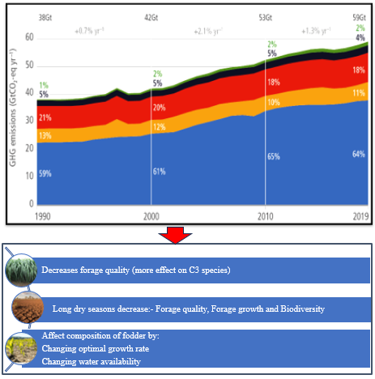

**Fig.1. Trends of increasing GHG and effects on fodder production**

**(Source: IPCC, 2021)**

**2. MATERIALS AND METHODS**

**Experimental site**

The experiment was conducted at All India Coordinated Research Project for Dryland Agriculture, Dr. Panjabrao Deshmukh Krishi Vidyapeeth Akola during February- March 2023. Due to scarcity of moisture and non-availability of green fodder in dryland condition considered these months for study. The experimental site is located at approximately 20.70°N latitude and 77.02°E longitude at elevation of 312.7 meters above mean sea level (MSL). The experiment was conducted using factorial randomized block design with two fodder crops *viz*: maize and cowpea seeds were taken as first factor, and second factor was four time of harvests (9th,11th,13th and 15th day after sowing).

**Construction of low-cost hydroponic structure and procedure of hydroponic grown fodder**

The hydroponic unit was constructed with PVC pipes. It was constructed to hold 48 trays. Each tray was made with vinyl fibre of dimensions 1.5 × 1 × 0.15 ft. Three holes of 1.5 mm were designed at both the sides. The unit consisted of humidifier and water spraying system with water tank of 100 litre capacity. Good quality seeds were taken and sun-dried. After drying the seeds were washed properly with 0.1% sodium hypochlorite solution to remove all the chaffs and contaminants. The washed seeds are soaked in the fresh water in the 1:2 proportion (1 part seeds and 2 parts water) in a container. The maize seeds were soaked for 24 hours, and cowpea seeds was soaked for 6 hours in tap water. After that water was drained and seeds were placed in a clean, wet gunny jute cloth for sprouting.

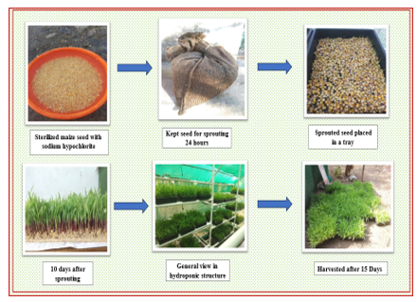

**Figure 2. Schematic view of the operation to be carried out for hydroponically grown crops**

After 24 hours, seeds were transferred to the trays. The automated fogging was adopted, and the automation was set at one minute for every two hours for maize and 30 seconds for every three hours for cowpea. All the observations were started taken from 9th day onwards at different time of harvesting. Quality parameter such as crude fibre content analyzed as per the method suggested Goering and Vansoest (1970) and AOAC. (2012).The data were statistically analyzed based on the procedure given by Gomez and Gomez (1984).

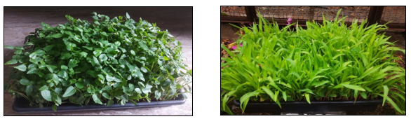

**Figure 3: Hydroponically produced fodder cowpea and Maize**

**3. RESULTS AND DISCUSSION**

The current study's findings, as well as relevant discussion, have been summarized under the following headings.

**Nutrient Composition influenced by hydroponically grown fodder crops and harvesting time**

The perusal of data in Table 1. shows that nutrient composition were significantly influenced by the fodder crops. Cowpea has recorded higher protein content (30.97 %) and ash content (3.85 %) than protein content (12.33%) and ash content (3.62 %) of maize. The increase in crude protein content in cowpea might be attributed to the loss in dry weight, particularly carbohydrates through respiration during germination and taken longer sprouting time. The increase in crude protein, linked to nitrogen content and more amino acid in legumes. (Brown *et al*., 2018). The sprouting process increases total ash content associated with the decrement of organic matter and increased mineral uptake by the plants. The organic matter present in the sprouted seeds was utilized for metabolic activities by seedlings which might have resulted in higher ash content (Bagavan and Harani 2023).

Maize has recorded higher ether extract (4.36 %), fibre content (13.07 %) and nitrogen free extract (66.62%) as compared to cowpea Whereas in cowpea found, ether extract, fibre content and nitrogen free extract are 2.53 %, 11.04 % and 51.60 % respectively. As days proceed to harvesting time from 9th to 15th day, the concentration of protein content, fibre content, ether extract content and ash content are increases whereas nitrogen free extract shows a decreasing trend. This might be attributed to the loss in DM particularly carbohydrates through respiration during germination and thus longer sprouting time is responsible for greater losses in DM and increase in protein content, Dung et al., (2010) supported to these results. A decrease in NFE% which could be attributed to the increase in the number and size of cell wall for the synthesis of structural carbohydrates. similar result reported by Sneath and Mclontosh, (2003); Fazaeli et al., (2012)

**Table-1 Nutrient composition (per cent dry matter basis) of hydroponics fodder crops as influenced by harvesting time**

|  |  |  |  |  |  |  |  |  |  |
| --- | --- | --- | --- | --- | --- | --- | --- | --- | --- |
| **Treatments** | **Protein**  **content**  **(%)** | **Ether**  **extract**  **(%)** | | **Fibre**  **content**  **(%)** | | **Nitrogen free**  **extract**  **(%)** | | | **Total**  **ash**  **(%)** |
| **Factor A- Crop** | | | | | | | | | |
| **C1- Maize** | 12.33 | | 4.36 | | 13.07 | | 66.62 | 3.62 | |
| **C2-Cowpea** | 30.97 | | 2.53 | | 11.04 | | 51.60 | 3.85 | |
| **SE (m) +** | 0.33 | | 0.05 | | 0.18 | | 0.57 | 0.07 | |
| **CD at 1%** | 1.01 | | 0.17 | | 0.54 | | 1.74 | 0.21 | |
| **Factor B – Harvesting time** | | | | | | | | | |
| **H1- Harvesting at 9th day** | 19.63 | | 2.88 | | 9.89 | | 64.37 | 3.18 | |
| **H2-Harvesting at 11th day** | 20.60 | | 3.36 | | 10.98 | | 61.52 | 3.55 | |
| **H3-Harvesting at 13th day** | 22.48 | | 3.63 | | 12.83 | | 57.10 | 3.93 | |
| **H4-Harvesting at 15th day** | 23.85 | | 3.93 | | 14.52 | | 53.42 | 4.26 | |
| **SE(m) +** | 0.47 | | 0.08 | | 0.25 | | 0.81 | 0.09 | |
| **CD at 1%** | 1.42 | | 0.24 | | 0.77 | | 2.41 | 0.29 | |
| **Interaction** | | | | | | | | | |
| **SE (m) +** | 0.66 | | 0.11 | | 0.36 | | 1.15 | 0.14 | |
| **CD at 1%** | NS | | NS | | NS | | NS | NS | |
| **GM** | 19.33 | | 3.45 | | 12.06 | | 59.11 | 3.74 | |

**Performance of hydroponic cultivated fodder crops and harvesting time to efficient use of water**

It has been observed from Table 2; cowpea has used water more efficiently than maize. To produce 1 kg of fodder, maize use 0.63 liters of water while cowpea transpire of 0.47 liter of per tray. The water use efficiency of fodder crops affected by harvesting time. As crop growth proceeds from 9th day of harvesting to 15th day of harvesting the water used per tray is 0.46 litre and 0.64 litre of water per tray on 9th day and 15th day of harvesting respectively. This might be due to the increase in dry matter accumulation in seedlings which has increased fresh biomass yield of the hydroponically grown maize and cowpea with respect to time, hence also the water requirement that influenced water use efficiency. Similar finding by Mahale et al., (2020).

**Figure 4: Water use efficiency of hydroponics fodder and its influenced by harvesting time**

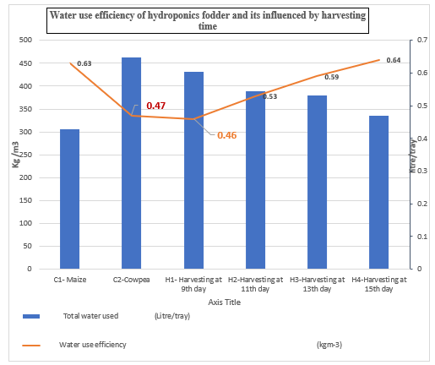

**4. CONCLUSION:**

From the above study, concluded that maize was found to be more nutritious in context of crude fibre, ether extract and nitrogen free extract than cowpea. However, Cowpea contains significantly more crude protein and total ash content hence recommended to grow along with non-legume crops in hydroponics. Being a legume crop, water requirement of cowpea is less than maize utilizing water more efficiently. In harvesting time, 15th day of harvesting has recorded higher nutrient composition while water use efficiency was found highest at 9th day of harvesting.`

**5. DISCLAIMER (ARTIFICIAL INTELLIGENCE)**

Author(s) hereby declare that NO generative AI technologies such as Large Language Models (ChatGPT, COPILOT, etc) and text-to-image generators have been used during writing or editing of this manuscript.

**6. REFERENCES**

Annual Report 2019. 20th Livestock Census All India Report. Ministry of Fisheries, Animal Husbandry and Dairying, Government of India, New Delhi.

AOAC. Official Methods of Analysis. Nineteenth edition. Association of Official Analytical Chemists, Washington DC, 2012: 684p.

Bagavan RP, Harani M. Hydrponics: A sustainable way of green fodder production. ICAR-Indian Veterinary Research Institute. Indian Farming. 2023;73(02)-4-10.

Brown D, Osinowo OA, Adeola AT and Adebiyi OA. Effects of feeding hydroponics maize fodder on performance and nutrient digestibility of weaned pigs. Applied Ecology and Environmental Research. 2018.16(3):2415-2422

Chapman SC, Chakraborty S, Dreccer MF. and Howden SM. Plant adaptation to climate change opportunities and priorities in breeding. Crop and Pasture Science. 2012; 63: 251-268.

DAC and FW, GOI. (2020). Agricultural Statistics at a Glance.

Dung DD, Godwin IR. and Nolan JV. Nutrient content and in Saccho degradation of hydroponic barleysprouts grown using nutrient solution or tap water. J.Anim. Vet.Adv. 2010; 9(18): 2432-2436.

Fazaeli H, Golmohammadi HA, Shoayee, AA, Montajebi N. and Mosharraf Sh. Performance of feedlot calves fed hydroponics fodder barley. J. Agr. Sci. Tech.Vol. 2011;13: 367-375.

Goering H. and P. Van Soest. Forage fiber analysis. Apparatus, reagents, procedures and some applications. Agric handbook. 1970; 379: 20.

Gomez KA. And Gomez AA. Statistical procedure for agricultural research. John Wiley and Sons, New York. 1984.p: 680.

IPCC Sixth Assessment Report (AR6), 2021. <https://www.ipcc.ch/assessment-report/ar6>.

Islam BM, Ahmed GU, Islam A, Khan SM. and Akter F. Assessment of nutrient content in grain, hydroponic and conventional fodder with focus on maize, wheat, and Sudan grass. International Journal of Biosciences. 2024; 24(3):187- 194.

Mahale D, Dhage SA, Gaikwad US, and Kandalkar YB. Water use efficiency and chemical composition of different forage crops under hydroponic condition. Trends in Biosciences*,* 2020;13(13):1003–1012.

Naik PK, Swain BK. and Singh NP. Production and utilization of hydroponics fodder. Indian Journal of Animal Nutrition. 2015; 32(1): 1-9.

Sneath R and Mclntosh F. 2003. Review of hydroponic fodder production for beef Cattle. Queensland Government, Department of Primary Industries, Dalby, Queensland

**Table – 3 Green fodder yield and Dry matter yield (kg m-2) of fodder maize and fodder cowpea as influenced by the time of harvest**

|  |  |  |  |  |  |  |  |  |  |  |  |
| --- | --- | --- | --- | --- | --- | --- | --- | --- | --- | --- | --- |
| **Treatments** | **Green fodder yield (Kg m-2)** | | | | | **Dry matter yield (Kg m-2)** | | | | | |
| **Time of harvest (days)** | | | | | **Time of Harvest (days)** | | | | | |
| **Crop** | **H1** | **H2** | **H3** | **H4** | **Mean** | **H1** | **H2** | **H3** | **H4** | **Mean** |
| **C1(maize)** | 18.69 | 20.16 | 24.19 | 25.63 | 22.17 | 1.97 | 2.24 | 2.65 | 2.95 | 2.45 |
| **C2(cowpea)** | 18.47 | 21.71 | 26.06 | 27.66 | 23.48 | 2.60 | 2.81 | 3.09 | 3.18 | 2.92 |
| **Mean** | 18.58 | 20.93 | 25.12 | 26.64 |  | 2.28 | 2.52 | 2.86 | 3.06 |  |
|  | **C** | **H** | **C×H** |  | **GM** | **C** | **H** | **CxH** |  | **GM** |
| **S.Em±** | 0.32 | 0.46 | 0.65 |  | 22.82 | 0.08 | 0.12 | 0.17 |  | 2.69 |
| **C.D. (p=0.01)** | 0.99 | 1.41 | NS |  |  | 0.26 | 0.37 | NS |  |  |

**Table-4 Water use efficiency of hydroponics fodder crops as influenced by harvesting time**

|  |  |  |
| --- | --- | --- |
| **Treatments** | **Total water used**  **(Litre/tray)** | **Water use efficiency**  **(kgm-3)** |
| **Factor A- Crop** | | |
| **C1- Maize** | 0.63 305.08 | |
| **C2-Cowpea** | 0.47 462.94 | |
| **SE (m) +** | 0.02 5.28 | |
| **CD at 1%** | 0.06 16.03 | |
| **Factor B – Harvesting time** | | | |
| **H1- Harvesting at 9th day** | 0.46 431.80 | |
| **H2-Harvesting at 11th day** | 0.53 389.35 | |
| **H3-Harvesting at 13th day** | 0.59 380.10 | |
| **H4-Harvesting at 15th day** | 0.64 334.78 | |
| **SE(m) +** | 0.03 7.47 | |
| **CD at 1%** | 0.08 22.67 | |
| **Interaction** | | | |
| **SE (m) +** | 0.04 10.57 | |
| **CD at 1%** | NS NS | |
| **GM** | 4.95 384.01 | |