**Analyzing the Accuracy of Medium Range Weather Forecasts for Vellayani, Kerala: A Case Study**

**ABSTRACT**

This study evaluates the accuracy of Medium-Range Weather Forecasts (MRWF) issued by the India Meteorological Department (IMD) for rainfall and temperature in Vellayani, Thiruvananthapuram, during 2022 and 2023 across four seasons. Various verification metrics, including Ratio Score, RMSE, Probability of Detection (POD), False Alarm Rate (FAR), Critical Success Index (CSI), and Bias Score (BAIS), were employed to assess forecast performance. Ratio Score and RMSE provided an overall accuracy assessment, with RMSE highlighting significant deviations. Event-based metrics such as POD, FAR, and CSI evaluated the accuracy of event-specific forecasts, while Bias quantified tendencies to over predict or under predict. Together, these metrics offered a comprehensive evaluation of forecast reliability. The results showed mixed accuracy. Maximum temperature forecasts improved slightly, from 49.04% accuracy in 2022 to 52.6% in 2023. But, overall accuracy for maximum and minimum temperature predictions declined, particularly during summer and winter, with a rise in non-usable forecasts for minimum temperatures. Rainfall forecasts revealed a decline in the summer ratio score (48.91 to 33.7) but improved during the southwest monsoon (54.1 to 59.2). Annual ratio scores remained stable, increasing marginally from 53.4 to 53.7. CSI and POD values indicated consistent monsoon performance but highlighted challenges during summer and the northeast monsoon. FAR improved in winter but increased in summer. These findings highlight significant challenges in forecasting during critical agricultural periods, underscoring the need to enhance predictive capabilities to support sustainable farming and resilience to climate variability in the region.

This analysis shows the importance of enhancing weather forecast precision during critical agricultural seasons. This will help to mitigate risks associated with climate variability. Improved predictive capabilities can address the increasing challenges posed by climate change, support sustainable farming practices and bolster the resilience of agricultural systems in the region.

***Keywords:***Medium-Range Weather Forecasts (MRWF), Agricultural seasons, forecast accuracy, Ratio Score, Root Mean Square Error (RMSE), Probability of Detection (POD), False Alarm Rate (FAR), Critical Success Index (CSI), Bias Score (BAIS).

**INTRODUCTION**

Agriculture in India is highly dependent on climatic conditions. The monsoons plays a significant role in determining the success of crop production (Bal & Minhas, 2017). The unpredictable and erratic nature of the monsoon presents significant challenges to farmers, who often face uncertainty in making informed decisions, such as when to sow crops, irrigate the fields, or apply fertilizers. This unpredictability complicates resource allocation and increases the risk of poor yields or crop failure. Hence, reliable weather and climate information are, indispensable for optimizing farming operations and reducing the risks associated with adverse weather events (Majumder & Kumar, 2019). One key tool in this regard is the Medium-Range Weather Forecast (MRWF), provide outlook for the upcoming 3-10 days. These forecasts are integral to the Agrometeorological Advisory Services (AAS), which offer region-specific guidance on agricultural activities like crop selection, sowing, irrigation, and pest management (Gadgil, 1987).

Improving forecast accuracy for agriculture is crucial due to its reliance on timely and reliable weather information for optimizing farming practices.Timely weather forecasts help farmers optimize resource use by enabling them to make informed decisions regarding irrigation, sowing, harvesting, and pest management, reducing the risks associated with unexpected weather changes. In a tropical, monsoon-dependent region, precise rainfall and temperature predictions are critical for ensuring the success of rain-fed agriculture and mitigating the impacts of droughts, floods, or extreme temperatures. Enhanced forecast accuracy also supports resource optimization, such as efficient water management during irrigation, which is vital in periods of water scarcity. Accurate forecasts help schedule fertilizer applications and pesticide use, minimizing wastage and reducing the environmental impact. Also, farmers conserve water, reduce operational costs, and improve the efficiency of farming practices. Studies have shown that access to reliable weather forecasts and AAS can reduce the cost of cultivation by 2 - 5% through more efficient resource management (Rathore & Parvinder, 2008).

Weather parameters determine the susceptibility of crops to pest and disease outbreaks, during crop development stages. Reliable weather predictions during critical agricultural periods, such as planting or harvesting seasons, reduce crop losses and improve productivity, contributing to food security. Improving forecast accuracy is essential for building resilience to climate variability and extreme weather events, which are becoming more frequent due to climate change. Institutions like the National Centre for Medium-Range Weather Forecasting (NCMRWF), India Meteorological Department (IMD), Indian Council of Agricultural Research (ICAR), and State Agricultural Universities (SAUs) work together to deliver AAS across various agro-climatic zones in India. These advisories are tailored to the specific needs of local farming communities and help mitigate the impacts of weather variability. Numerous studies have evaluated the reliability and accuracy of medium-range weather forecasts across India's diverse agro-climatic regions, highlighting their strengths and limitations (Tripathi et al., 2008; Lunagaria et al., 2009).

Better forecasts enhance the overall agricultural efficiency of the region, reduce financial risks, and support long-term planning in the face of climatic uncertainties. In the tropical climate of Kerala, where monsoon variability significantly influences agricultural productivity, understanding the accuracy of seasonal and annual weather forecasts is crucial. This study aims to Analyzing the Accuracy of Medium range Weather Forecasts for Vellayani, Thiruvananthapuram District, Kerala, during 2022-2023, with the broader goal of enhancing agricultural resilience to climate variability. A major constraint in farm planning and operations is the lack of reliable and timely agrometeorological advice (Chaubey et al., 2018). Weather-based AAS are essential for weather-adapted farm activities, and making farmers aware of the value of these advisories can enhance day-to-day farm management, reduce losses and increase production (Frisvold & Murugeshan, 2013; Rathore & Chattopadhyay, 2016). This analysis is particularly crucial for variables such as maximum temperature, minimum temperature, and rainfall across all seasons, as these factors play a critical role in agricultural productivity. The quantity and distribution of rainfall are vital because they directly influence crop yields and food security. Recent studies further emphasize the importance of accurate seasonal forecasting in optimizing agricultural outcomes, particularly under changing climate conditions

# MATERIALS AND METHODS

The study was conducted in the tropical monsoon region of Vellayani, Thiruvananthapuram, Kerala, an agricultural zone, located at 8.5°N latitude and 76.9°E longitude, with an elevation of approximately 29 meters above mean sea level. The dataset is stored in .csv format and includes weather data from 01-01-2022 to 31-12-2023. Medium-Range Weather Forecasts (MRWF) are issued regularly by the India Meteorological Department (IMD), New Delhi. These forecasts provide predictions for various meteorological parameters such as rainfall, cloud cover, maximum and minimum temperatures, relative humidity, wind speed, and wind direction. The forecast verification is performed using statistical tools and metrics like Ratio Score, **Probability of Detection (POD),** False Alarm Ratio (FAR), **Critical Success Index (CSI)** and **Bias Score (Bias) (Fig.1.)**

**Forecast Verification and Metrics**

The forecast validation study aligns with the standards established by the India Meteorological Department (IMD) and National Centre for Medium-Range Weather Forecasting (NCMRWF) standards. The forecasts are categorized across four distinct seasons: Summer (March-May), Southwest Monsoon (June-September), Northeast Monsoon (October-December), and Winter (January-February), in addition to the annual cycle. The usability percentage of the forecasts is computed by combining the manually collected weather data and the IMD weather forecasts. The accuracy of the rainfall forecasts was assessed as follows:

**Ratio Score**: This metric is used to quantify forecast accuracy, ranging from 0% (no accuracy) to 100% (perfect accuracy), calculated as the percentage of correct forecasts relative to the total forecasts issued.

Where,

Ratio score = Correct forecast ×100

Total no. of forecast

**Probability of Detection (POD)** – The **Probability of Detection (POD)** is a forecast verification skill score that measures the ratio of correctly predicted events (hits) to all observed events. It ranges from 0 to 1, where 1 signifies perfect detection without any missed events.

POD= $\frac{Hits (H)}{Hits \left(H\right)+Misses (M)}$

Where,

H represents the number of hits (correctly forecasted events).

M represents the number of misses (observed events not forecasted).

**False Alarm Ratio (FAR)**: The **False Alarm Ratio (FAR)** quantifies the proportion of forecasted events that were false alarms, without considering misses. It ranges from 0 to 1, where 0 indicates no false alarms, and is often used alongside the Probability of Detection to assess forecast performance.

FAR= $\frac{False alarms}{Hits+False alarms }$

Where,

False alarms - Forecasted events that did not occur

Hits - Correctly forecasted events

**Critical Success Index (CSI)** - The **Critical Success Index (CSI)**, also known as the Threat Score, is a metric used to evaluate the accuracy of event forecasts, accounting for hits, misses, and false alarms. It ranges from 0 to 1, where 1 indicates perfect accuracy. CSI ignores correct non-events, focusing only on forecasts of occurrence.

CSI= H

H+M+FAH​

Where,

H = Hits (correctly forecasted events)

M = Misses (observed events not forecasted)

FA= False alarms (forecasted events that did not occur)

**Bias Score (Bias)-** The **Bias Score (Bias)** for occurrence is a metric used in forecast verification to measure the tendency of a forecasting model to over-forecast or under-forecast the occurrence of an event. A Bias score of 1 indicates perfect calibration, meaning the forecast matches the observed frequency of events. Scores greater than 1 indicate over-forecasting, while scores less than 1 indicate under-forecasting.

Bias = Hits + False alarms

Hits +Misses

Where,

Hits - Correctly forecasted events

False alarms -Forecasted events that did not occur

Misses -Observed events not forecasted

**RESULTS AND DISCUSSION**

The ratio scores for rainfall forecasts in 2022 and 2023 provide a nuanced perspective on forecast performance across different seasons. Rainfall, being one of the most critical weather parameters, plays a vital role in agriculture. Timely and accurate rainfall forecasts are essential for optimizing crop production and resource utilization. Accurate predictions allow farmers to efficiently manage water, fertilizers, and other inputs, thereby reducing the risk of crop failure caused by water scarcity or excess rainfall (Wu and Chau, 2013). Beyond agriculture, rainfall forecasts are equally critical for water resource management, flood control, and disaster preparedness. An analysis of seasonal ratio scores reveals notable variability in forecast performance. During the summer season (Fig.2), the ratio score decreased significantly from 48.9 in 2022 to 33.7 in 2023, indicating reduced forecast reliability. In contrast, the southwest monsoon (SWM) exhibited improved forecast accuracy, with the ratio score increasing from 54.1 in 2022 to 59.2 in 2023. Similarly, the northeast monsoon (NEM) experienced a decline in forecast performance, with the ratio score dropping from 56.5 in 2022 to 46.7 in 2023. Winter forecasts, however, demonstrated a remarkable improvement, with the ratio score rising sharply from 62.7 in 2022 to 91.5 in 2023. This significant increase highlights enhanced predictive capability during the winter season. The higher accuracy observed during winter, followed by monsoon and pre-monsoon seasons, suggests that predicted rainfall during winter was closer to observed values compared to other seasons. Similar trends were reported by Vashisth et al. (2008). On an annual scale, the ratio scores remained relatively stable, showing a slight increase from 53.4 in 2022 to 53.7 in 2023. These findings underscore the variability in forecast performance across seasons, emphasizing the need for further investigation and improvement, particularly for summer and NEM forecasts.

The Critical Success Index (CSI) values for rainfall forecasts in 2022 and 2023 show notable variability across seasons (Fig.3) reflecting the forecast accuracy in detecting both hits and false alarms. During the summer, the CSI dropped significantly from 0.39 in 2022 to 0.21 in 2023, indicating a decrease in forecast accuracy. In contrast, the southwest monsoon (SWM) maintained a steady CSI of 0.54 for both years, demonstrating consistent performance in monsoon forecasting. The northeast monsoon (NEM) saw a slight decline from 0.50 in 2022 to 0.47 in 2023, while the winter season experienced a marked improvement, with the CSI increasing from 0.21 in 2022 to 0.44 in 2023. The annual CSI also showed a decrease, from 0.49 in 2022 to 0.43 in 2023, highlighting the need for enhanced accuracy, particularly in the summer and annual forecasts. These values suggest a mixed performance in forecast quality, with certain seasons like winter showing improvement, while others, especially summer, require better precision.

The Probability of Detection (POD) values for rainfall forecasts in 2022 and 2023 show a high level of accuracy across different seasons (Fig.4) During the summer, the POD improved slightly from 0.91 in 2022 to 0.94 in 2023, indicating consistent reliability in detecting rainfall events. For the southwest monsoon (SWM), the forecasts were nearly perfect, with a POD of 1 in 2022 and a slight decrease to 0.97 in 2023. However, the northeast monsoon (NEM) exhibited more variability, with a notable drop from 0.97 in 2022 to 0.77 in 2023, suggesting challenges in prediction accuracy for that season. Winter rainfall forecasts also showed reduced reliability in 2023, with a POD decrease from 0.86 in 2022 to 0.67 Overall, annual forecast accuracy remained strong, with a slight decline from 0.96 in 2022 to 0.89 in 2023. These variations highlight the need for improving forecast precision, especially for the NEM and winter seasons.

The False Alarm Rate (FAR) for rainfall forecasts in 2022 and 2023 presents critical insights into the reliability of predictive models across various seasons (Fig.5) In the summer, the FAR increased from 0.59 in (2022) to 0.78 in (2023), indicating a higher likelihood of false alarms, which could undermine confidence in rainfall predictions. For the southwest monsoon (SWM), the FAR remained relatively stable, decreasing slightly from 0.46 in 2022 to 0.45 in 2023, suggesting consistent performance in avoiding false alarms during this crucial rainfall period. The northeast monsoon (NEM) exhibited a marginal improvement, with the FAR decreasing from 0.49 in 2022 to 0.45 in 2023, indicating better reliability in forecasts. In contrast, the winter season experienced a significant reduction in the FAR, dropping from 0.78 in 2022 to 0.43 in 2023, which reflects a notable improvement in the accuracy of winter rainfall predictions. Overall, the annual FAR increased slightly from 0.49 in 2022 to 0.54 in 2023, emphasizing the need for enhanced forecasting techniques, particularly for summer and annual predictions, to reduce the occurrence of false alarms and improve overall forecast reliability. The Basis for Occurrence (BAIS) values for rainfall forecasts in 2022 and 2023 reveal significant variations in predictive accuracy across different seasons (Fig.6) In summer, the BAIS increased notably from 1.58 in 2022 to 2.39 in 2023, indicating a stronger ability to predict rainfall events during this period. Conversely, the southwest monsoon (SWM) experienced a decrease in BAIS from 1.85 in 2022 to 1.49 in 2023, suggesting a reduction in predictive reliability for monsoon rainfall. The predictions during the Southwest monsoon exhibited a higher degree of accuracy, a phenomenon consistent with the findings reported by Ajithkumar B. and Vysakh A. (2018). The northeast monsoon (NEM) showed an improvement in forecast accuracy, with BAIS rising from 1.44 in 2022 to 1.84 in 2023, highlighting enhanced predictive capability. However, the winter season exhibited a marked decline, with BAIS dropping from 0.73 in 2022 to a mere 0.13 in 2023, indicating a substantial decrease in forecast reliability during this critical period. The annual BAIS also reflected a slight decrease from 1.36 in 2022 to 1.32 in 2023. Overall, these findings underscore the fluctuations in rainfall forecast accuracy across seasons, particularly emphasizing the need for improvements in winter predictions to bolster the overall reliability of rainfall forecasts.

In 2022, the accuracy of correct forecasts for maximum temperature during the summer stood at 58.7%, which slightly declined to 55.4% in 2023. (Fig.7) This minor decrease reflects challenges in predicting summer temperatures during 2023. The proportion of usable forecasts improved in 2023, rising from 31.5% in 2022 to 37.0%. This increase indicates an enhancement in forecast applicability, despite the minor drop in correct predictions. Non-usable forecasts dropped from 9.8% in 2022 to 7.6% in 2023, reflecting a reduction in the number of forecasts that were inaccurate or not viable for practical use, suggesting better management of forecast uncertainties for the summer season. For the Southwest Monsoon, the correct forecasts saw a decline from 51.6% in 2022 to 45.9% in 2023 (Fig.8) suggesting potential challenges in predicting temperature variability during the Southwest Monsoon in 2023. Despite this decrease, usable forecasts increased substantially from 14.8% in 2022 to 34.4% in 2023. This improvement reflects enhanced forecast utility, making a larger portion of the predictions practical for decision-making. Non-usable forecasts showed a marked reduction from 33.6% in 2022 to 19.7% in 2023, indicating a significant decrease in forecasts that were not applicable. This improvement points to better reliability in temperature predictions for the Southwest Monsoon. For the North-East Monsoon (Fig.9) correct forecasts showed a slight improvement, increasing from 44.6% in 2022 to 47.8% in 2023, suggesting enhanced accuracy in predictions for the NEM season in 2023. Usable forecasts saw a small decrease from 40.0% in 2022 to 38.0% in 2023, indicating a slight reduction in the practical applicability of forecasts during the NEM season. Non-usable forecasts decreased from 18.5% in 2022 to 14.1% in 2023, reflecting an improvement in forecast precision, with fewer forecasts being deemed impractical or unusable.

The most significant improvement was observed in the winter season, where correct forecasts surged from 35.6% in 2022 to 69.5% in 2023 (Fig.10) reflecting a notable advancement in forecast accuracy for winter temperatures in 2023. However, usable forecasts declined from 40.7% in 2022 to 25.4% in 2023, suggesting that, despite the improvement in correct forecasts, fewer predictions were deemed practical for actionable use during the winter of 2023. Non-usable forecasts dropped significantly from 23.7% in 2022 to just 5.0% in 2023, representing a major improvement in reducing the number of inaccurate or inapplicable predictions. Annually, the overall accuracy of correct forecasts improved, rising from 49.0% in 2022 to 52.6% in 2023, indicating better performance in maximum temperature forecasting across all seasons. (Fig.11) Usable forecasts also saw an increase, from 28.8% in 2022 to 34.5% in 2023, suggesting that a higher percentage of forecasts were viable for practical use throughout the year. Non-usable forecasts decreased from 22.2% in 2022 to 12.9% in 2023, reflecting a significant reduction in the number of forecasts that were not reliable or useful. This comparison highlights the improvements and challenges faced in the accuracy and practicality of forecasts for maximum temperatures in Vellayani from 2022 to 2023.

In 2022, the accuracy of correct forecasts for minimum temperature during the summer season stood at 83.7%, but it drastically declined to 15.2% in 2023, highlighting significant challenges in predicting summer temperatures during that year. (Fig.12) Usable forecasts, however, improved from 8.7% in 2022 to 18.5% in 2023, despite the reduction in correct forecasts. In contrast, non-usable forecasts saw a sharp rise, increasing from 7.6% in 2022 to 66.3% in 2023, suggesting a notable decrease in forecast reliability for summer. During the Southwest Monsoon (SWM) season, (Fig.13) correct forecasts dropped from 84.4% in 2022 to 39.3% in 2023, indicating lower forecast accuracy in 2023. Nevertheless, usable forecasts improved significantly, rising from 14.7% in 2022 to 43.4% in 2023, reflecting an increase in the practical applicability of predictions. Non-usable forecasts increased from 0.8% in 2022 to 17.2% in 2023, indicating greater uncertainty in the forecast for the SWM season. The North-East Monsoon (NEM) season also showed a significant drop in correct forecasts, (Fig.14) decreasing from 80.4% in 2022 to 27.2% in 2023. Usable forecasts, however, improved markedly, increasing from 16.3% in 2022 to 45.7% in 2023. Despite this improvement, non-usable forecasts rose sharply, from 3.3% in 2022 to 27.2% in 2023, highlighting a decrease in the precision of predictions for this season. The winter season experienced the most pronounced challenges, with correct forecasts dropping from 55.9% in 2022 to just 8.5% in 2023, indicating significant difficulties in winter temperature predictions. (Fig.15) Usable forecasts also declined, from 32.2% in 2022 to 11.9% in 2023. Concurrently, non-usable forecasts increased dramatically, from 11.9% in 2022 to 79.7% in 2023, pointing to major issues in forecast reliability during the winter season. On an annual basis, (Fig.16) correct forecasts significantly decreases dropping from 78.6% in 2022 to 25.2% in 2023, reflecting a general decrease in forecasting accuracy across the year. Despite this, usable forecasts improved annually, rising from 16.4% in 2022 to 32.7% in 2023. However, non-usable forecasts also increased significantly, from 4.9% in 2022 to 42.2% in 2023, indicating heightened uncertainty and reduced reliability in temperature forecasts for 2023.

**CONCLUSION**

The overall accuracy of medium-range forecasts showed a slight improvement from 2022 to 2023; however, challenges remain, particularly in predicting summer temperatures and winter rainfall. The significant decline in the accuracy of maximum temperature forecasts, especially during the summer, raises concerns about the reliability of these forecasts for critical farming activities. In contrast, the winter season showed notable accuracy improvements, suggesting potential for enhanced agricultural practices during this time. The findings emphasize the need for continuous advancements in forecasting methods and effective communication of agrometeorological advisories to reduce uncertainty and optimize resource use. Addressing the variations in forecast accuracy across seasons is essential for building agricultural resilience to climate variability

**REFERENCE**

Ajithkumar B. and Vysakh A. 2018. Validation and assessment of agro advisories issued based on medium range weather forecast for Thrissur district of Kerala. *Int. J. Agric. Sci.* 10(15): 6824-6828

Bal, S.K. and Minhas, P.S., 2017, “Atmospheric Stressors: Challenges and Coping Strategies”,In: P.S. Minhas et al.(eds) Abiotic Stress Management for Resilient Agriculture, 9-50.Springer Nature Singapore Pte. Ltd

Chaubey, D., Prakash, V., Patel, A. B. and Yadav, T. C. (2018). Role of Agro- Meteorological Advisory Services on Risk Mitigation in Agriculture. *Int J. Pure App. Biosci*, *6*, 27-32.

Frisvold, G. B. and Murugeshan, A. (2013). Use of weather information for agricultural decision making. *Weather Clim Soc., 5,* 55-69.

Gadgil, S., 1987, “Monsoon variability and its relationship with agricultural strategies”,International Symposium on Climate Variability and Food Security in Developing Countries(249-267). Feb,5-7, New Delhi, India

Lunagaria, Mishra, M.M. and Pandey, S.K. 2009. Verification and usability of medium range weather forecast for Anand region. Journal of Agrometeorology (Special issue) 11: 228-233.

Majumder D and Kumar, B., 2019, “Quantitative and qualitative analysis of weather forecast and AAS on socio-economic statusof farmers of South East Bihar”,International Journal of Chemical Studies,7, 1, 384-389

Rathore, L. S. and Chattopadhyay, N. (2016). Weather and Climate Services for Farmers in India, WMO Bulletin, 65 (2). Available on [https://public.wmo.int/en/resources/bulletin/weather-and-climate-services-farmers-indiaaccessed on 16 September 2021](https://public.wmo.int/en/resources/bulletin/weather-and-climate-services-farmers-indiaaccessed%20on%2016%20September%202021).

Rathore, L. S. and Parvinder, M. (2008). Economic impact assessment of agro meteorological advisory service of NCMRF, Report no. NMRF/PR/01/2008;104. Published by NCMRWF, Ministry of Earth Sciences, Government of India, A-50 Institutional Area, Sector62, Noida, UP, India (201 307)

Tripathi, P, Mishra, S.R. and Mishra, S.K. 2008. Verification analysis of success probability and usability of medium range weather forecasting in Eastern U.P. Int. J. Agric. and Stat. Sci. 4: 437- 46.

Vashisth, A., Das, D. K., Bhagawati, Goutom and Sharma, P. K., 2008, “Accuracy of weather forecast for semi-arid climate of Delhi for Agricultural Management Practice”, *Journal Agricultural Physics*, 8, 51-58.

Wu CL, Chau KW. Prediction of rainfall time series using modular soft computing methods. Eng. Appl. Artif. Intell. 2013;26(3):997-1007.

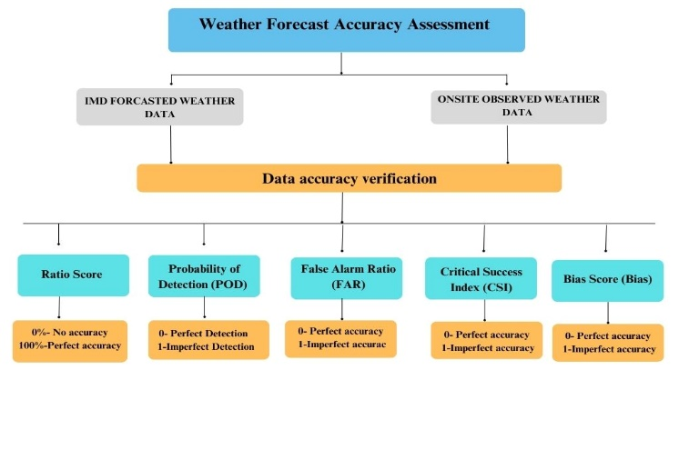

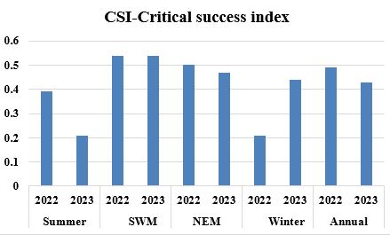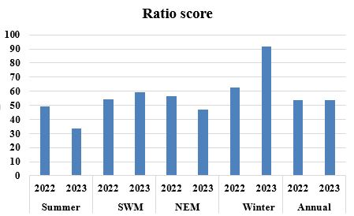

Fig.3. CSI-critical success index

Fig.1.Weather forecast accuracy assessment

Fig.2. Ratio score

Fig.2.

Fig.3.

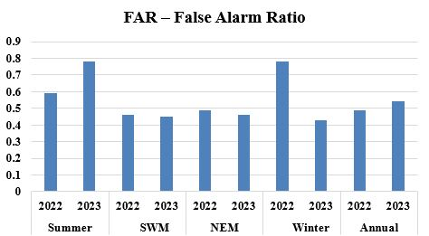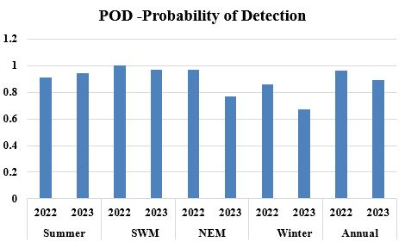

Fig.5. False alarm ratio

Fig.4. Probability of detection

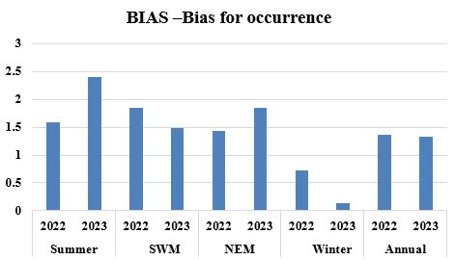

Fig.6. Bias for occurrence

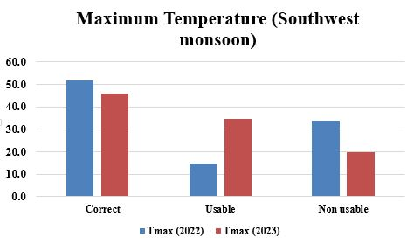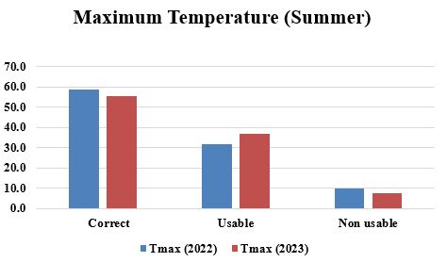

Fig.5.

Fig.4.

Fig.8. Bar graph showing Maximum temperature variation (Southwest monsoon)

Fig.7. Bar graph showing Maximum temperature variation (Summar)

Fig.10.

Fig.9.

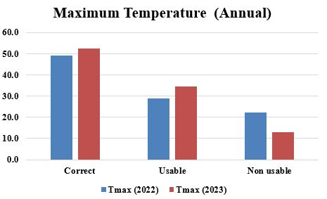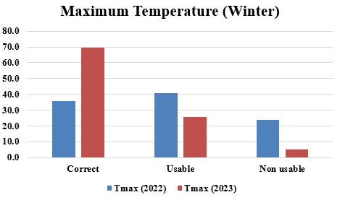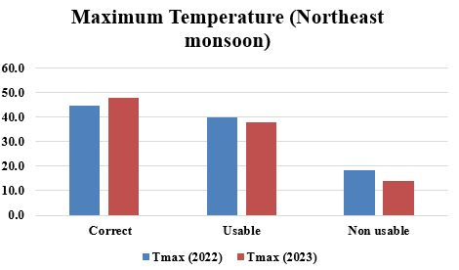

Fig.10. Bar graph showing Maximum temperature variation (Winter)

Fig.9. Bar graph showing Maximum temperature variation (Northeast monsoon)

Fig.11. Bar graph showing Maximum temperature variation(ANNUAL)

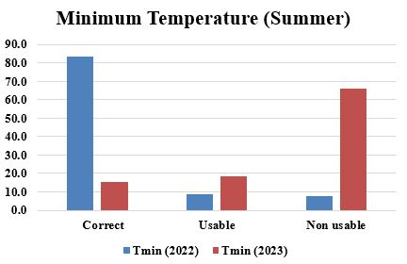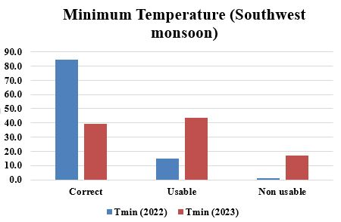

Fig.13. Bar graph showing Maximum temperature variation (SOUTHWEST MONSOON)

Fig.12. Bar graph showing Maximum temperature variation (SUMMER)

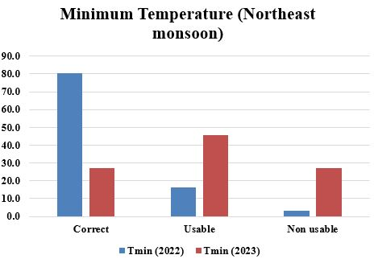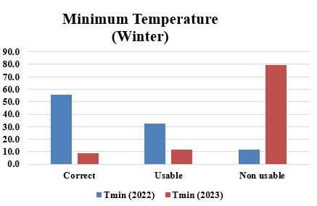

Fig.15. Bar graph showing Maximum temperature variation (WINTER)

Fig.14. Bar graph showing Maximum temperature variation (NORTHEAST MONSOON)

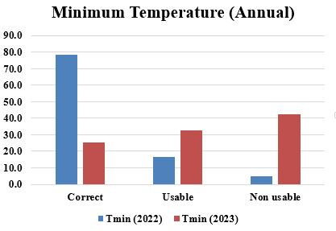

Fig.16. Bar graph showing Maximum temperature variation(ANNUAL)

##### 