***Original Research Article***

**Computational Evaluation of Some Schiff-Bases of Phenylisocytosine as Potent Inhibitors of *Plasmodium falciparum* Transketolase in Anti-Malarial Drug Discovery**

**ABSTRACT**

**Background:** The increasing prevalence of drug-resistant *Plasmodium falciparum* strains necessitates the development of novel antimalarial agents targeting alternative biochemical pathways.

**Aim:** This study investigated six Schiff bases of phenylisocytosine as potential inhibitors of *Plasmodium falciparum* transketolase, a key enzyme in the pentose phosphate pathway critical for parasite survival.

**Methodology:** An integrated computer-aided drug design comprising ligand-based and structure-based approaches was employed. Molecular docking analyses was conducted using AutoDock Vina and iGEMDock to evaluate binding affinities and interactions. Pharmacokinetic and toxicological profiling were evaluated using Lipinski’s Rule of Five and ADMET prediction via pkCSM and the ADMETLab 3.0 webserver. Molecular mechanics generalized Born surface area (MM/GBSA) calculations was performed using Schrondiger Maestro 12.5 to determine binding free energies. Molecular dynamics (MD) simulations was carried out using GROMACS 2023 to evaluate the stability, flexibility, and compactness of protein-ligand complexes over 50 nanoseconds.

**Results:** Molecular docking identified (E)-2-((3,4-Dimethoxybenzylidene)amino)-6-Phenylpyrimidin-4(1H)-One and (E)-2-((3-Hydroxybenzylidene)amino)-6-Phenylpyrimidin-4(1H)-One as the top-performing ligands with binding energies of -7.7 and -7.5 kcal/mol (AutoDock Vina) and -10.3 and -9.7 kcal/mol (iGEMDock Vina), respectively, outperforming oxythiamine binding energies of -5.2 kcal/mol (AutoDock Vina) and -7.1 kcal/mol (iGEMDock Vina). Pharmacokinetic evaluations confirmed favorable drug-likeness and low toxicity profiles for the selected Schiff bases. MM/GBSA calculations demonstrated strong binding free energies of -31.21 and -31.01 kcal/mol for these compounds, compared to -16.85 kcal/mol for oxythiamine. MD simulations validated their exceptional stability, with RMSD values of 0.313 and 0.277 nm, RMSF values of 0.142 and 0.130 nm, and compact ROG values of 2.997 and 3.007 nm, respectively. H-bonding analysis revealed consistent and strong interactions, further supporting the stability of these complexes.

**Conclusion:** The findings establish (E)-2-((3,4-Dimethoxybenzylidene)amino)-6-Phenylpyrimidin-4(1H)-One and (E)-2-((3-Hydroxybenzylidene)amino)-6-Phenylpyrimidin-4(1H)-One as promising candidates for further experimental validation. Their strong binding affinities, stability, and favorable safety profiles underscore their potential as novel antimalarial agents to combat drug-resistant malaria.

**Graphical Abstract**

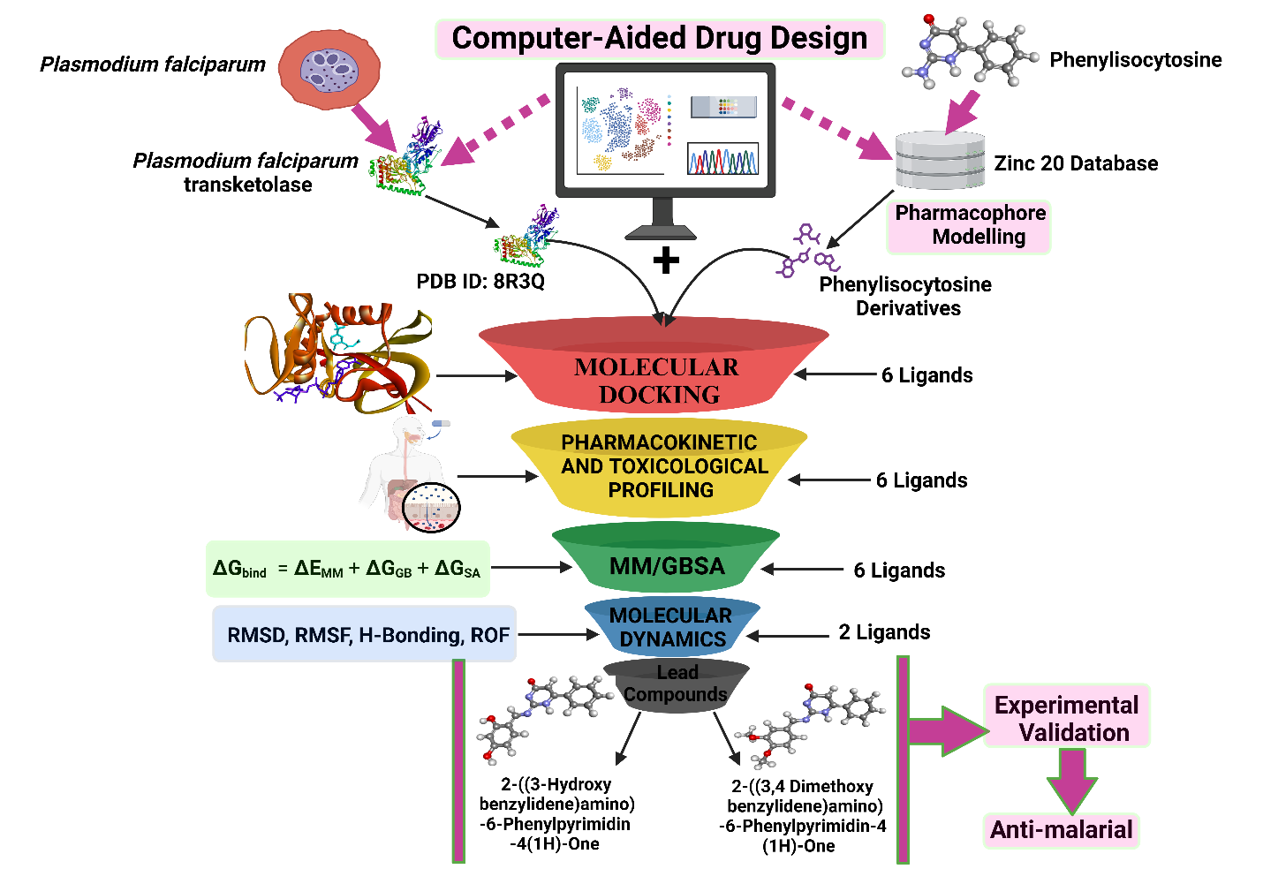

**Keywords**: Anti-malarial resistance, Computer-aided drug design, *Plasmodium falciparum* transketolase, Oxythiamine, Phenylisocytosine.

1. **INTRODUCTION**

Malaria remains a significant global health challenge, particularly in tropical and subtropical regions where Plasmodium falciparum is the primary cause of severe malaria [1]. Despite decades of progress, malaria continues to account for significant morbidity and mortality, especially in sub-Saharan Africa and Southeast Asia. The rapid emergence of resistance to artemisinin-based combination therapies (ACTs), the cornerstone of malaria treatment, underscores the urgent need for novel therapeutic strategies targeting drug-resistant strains [2, 3]. Recent reports from the World Health Organization (WHO) emphasize that drug resistance significantly contributes to ongoing malaria transmission and mortality, highlighting the critical need for innovative approaches in antimalarial drug discovery [4].

Historically, antimalarial drugs such as quinine, chloroquine, and sulfadoxine-pyrimethamine played pivotal roles in malaria control. However, the widespread resistance to these drugs, including the declining efficacy of ACTs, has prompted researchers to explore novel molecular targets within Plasmodium falciparum for drug development [5, 6, 7]. One promising avenue is the pentose phosphate pathway (PPP), a critical metabolic pathway in Plasmodium falciparum responsible for maintaining redox homeostasis and synthesizing essential nucleotides required for parasite proliferation [8]. Within the non-oxidative branch of the PPP, the transketolase enzyme has emerged as a highly attractive target for antimalarial therapy due to its indispensable role in parasite survival and its absence in human erythrocytes, offering a selective therapeutic window [9, 10]. Pyrimidine-based compounds have demonstrated significant potential as antimalarial agents due to their structural similarity to oxythiamine, a potent transketolase inhibitor [11]. While oxythiamine effectively inhibits Plasmodium falciparum transketolase, its clinical application is limited by severe adverse effects, such as nephrotoxicity and carcinogenicity. Phenylisocytosine, a pyrimidine-based compound, has demonstrated potent inhibitory activity against Plasmodium falciparum transketolase, making it a candidate of interest in antimalarial drug discovery [12].

Advancements in computational drug discovery have revolutionized the identification and optimization of potential drug candidates [13]. Structure-based drug design (SBDD) and ligand-based drug design (LBDD) have become pivotal tools in the identification of novel inhibitors, providing detailed insights into ligand-receptor interactions, binding affinities, and pharmacodynamic properties [14]. Techniques such as molecular docking, molecular mechanics-generalized Born surface area (MM-GBSA) calculations, and molecular dynamics (MD) simulations have further facilitated the prediction of binding stability and the dynamic behavior of drug candidates under physiological conditions [15]. This study integrates these computational methods to identify lead compounds with optimal drug-like properties by evaluating six Schiff bases of phenylisocytosine as potential inhibitors of *Plasmodium falciparum* transketolase. By targeting the non-oxidative branch of the PPP, this research aims to address the growing challenge of drug resistance and contribute to the development of next-generation antimalarial therapies.

**2.0** **METHODOLOGY**

**2.1 Preparation of target protein and determination of active site.**

The essential information on Plasmodium falciparum transketolase was sourced from the Protein Data Bank (PDB) (<https://www.rcsb.org>). The study utilized the homo-domain three-dimensional structure of Plasmodium falciparum transketolase, focusing on its domain D (PDB ID: 8R3Q) with a resolution of 1.88 Å (https://doi.org/10.2210/pdb8r3q/pdb).. Biovia Discovery Studio 2021 (<http://www.accelrys.com>) was employed to optimize the protein structure to eliminate unintended interactions that might compromise the virtual screening process [16]. The CASTp 3.0 web server was used to predict the active site of the target protein, enabling precise site-specific docking by accurately identifying potential drug interaction sites [17].

**2.2 Preparation of Ligands**

Oxythiamine, the reference drug, was retrieved from the PubChem database (<https://pubchem.ncbi.nlm.nih.gov/>). Pharmacophore modeling of phenylisocytosine was carried out using the ZINC20 database (<https://zinc20.docking.org/>), yielding six Schiff bases: 2-((3-hydroxybenzylidene)amino)-6-phenylpyrimidin-4(1H)-one, 2-((3,4-dimethoxybenzylidene)amino)-6-phenylpyrimidin-4(1H)-one, 2-((2,4-dihydroxybenzylidene)amino)-6-phenylpyrimidin-4(1H)-one, 2-((4-dimethylamino)benzylidene)amino)-6-phenylpyrimidin-4(1H)-one, 2-((4-methoxybenzylidene)amino)-6-phenylpyrimidin-4(1H)-one, and 2-((2-hydroxybenzylidene)amino)-6-phenylpyrimidin-4(1H)-one. These Schiff bases were optimized using Spartan 14 software before being saved in PDB format to enable compatibility with the iGEMDock and Molecular Operating Environment (MOE) docking algorithms. Open Babel was used to convert all ligands to PDBQT format for compatibility with the AutoDock Vina algorithm, facilitating an in-depth analysis of binding interactions [18].

**2.3 Molecular Docking Validation**

To enhance the accuracy of virtual screening, consensus scoring was applied using AutoDock Vina, iGEMDock, and MOE, each employing distinct algorithms [19-21]. These tools evaluated the binding affinity and interactions of the co-crystallized ligand, thiamine pyrophosphate, within the active site of the D-domain of Plasmodium falciparum transketolase. AutoDock Vina and iGEMDock produced consistent binding scores and structural conformations, establishing their reliability for primary docking. This consensus scoring approach minimized false positives and negatives, ensuring robust predictions of potential drug efficacy.

**2.4 Molecular Docking**

Molecular docking techniques were utilized to assess the binding interactions of oxythiamine and the six Schiff bases of phenylisocytosine with the Plasmodium falciparum transketolase enzyme (PDB ID: 8R3Q).

**2.4.1 AutoDock Vina**

AutoDock Vina was employed for structure-based virtual screening to predict ligand binding affinity to Plasmodium falciparum transketolase. Docking was conducted with an exhaustiveness level of 8 to thoroughly explore conformational space [22]. The grid box, defining the docking site, was positioned around the active pocket of the 8R3Q receptor with dimensions of 44 × 44 × 44 along the X, Y, and Z axes, and a spacing of 1Å centered on specific active pocket residues (Trp46, Ser47, Tyr48, Met50, Arg62, Asp63, His109, Thr111, Val114, Glu115, Tyr153, Asp160, Asn190, Ile194, Cys253, His266, Lys306, Asn310, Val427). Polar hydrogen atoms were added, and Gasteiger charges were applied before converting the protein structure to PDBQT format [12,22]. Eight docking conformations were generated for each ligand, scored using the London dG function, and the lowest-energy pose was selected for further analysis [23].

**2.4.2 iGEMDock**

Molecular docking was also conducted using iGEMDock version 2.1. The "prepare binding site" feature was used to define docking parameters, creating a grid with an 8.0 Å radius centered on the active site. Precision parameters included a population size of 800, 10 solutions, and 80 generations [20,23]. This setup enabled exhaustive exploration of binding orientations and affinities, providing robust validation.

**2.5 Physicochemical, Pharmacokinetic and Toxicological Evaluation.**

**2.5.1 Drug-likeness Prediction**

Lipinski’s Rule of Five (RO5) was used to evaluate the drug-likeness characteristics of the compounds [24]. This analysis was performed using pkCSM and ADMETLab 3.0, assessing essential molecular properties such as molecular weight (MW), octanol-water partition coefficient (logP), and hydrogen bond acceptors and donors [25,26]. The RO5 criteria help predict whether a compound exhibits pharmacological or biological activity suitable for oral administration [27].

**2.5.2 ADMET Prediction**

ADMET properties—Absorption, Distribution, Metabolism, Excretion, and Toxicity—were evaluated using pkCSM and ADMETLab 3.0 to determine clinical efficacy and safety [25,26]. Key parameters assessed included caco2 permeability, human intestinal absorption, P-glycoprotein inhibition, cytochrome P450 enzyme inhibition, half-life (t1/2), total clearance, acute oral toxicity, ames toxicity, carcinogenicity, hepatotoxicity, hematotoxicity, nephrotoxicity, and human ether-a-go-go related gene (hERG) inhibition [28-31]. SMILES strings of the ligands from PubChem were inputted into pkCSM and ADMETLab 3.0 for evaluation.

**2.6 Molecular Mechanics (MM-GBSA)**

MM-GBSA analysis was performed using the Prime MM-GBSA tool in Maestro version 12.5 to calculate the relative binding free energies of each ligand. The analysis decomposed energy contributions, including electrostatic interactions, van der Waals forces, hydrogen bonds, and solvation energies, to determine binding free energy [12,32]. The binding free energy (ΔG_bind) was calculated as:

**ΔGbind** ​ = **ΔEMM** ​+ **ΔGGB** ​+ **ΔGSA** ​

where **ΔEMM** represents molecular mechanical energy, **ΔGGB** is the polar solvation energy, and **ΔGSA** ​ is the nonpolar solvation energy. The results provided insights into ligand binding stability [22,32].

**2.7 Molecular Dynamic (MD) Simulation**

Molecular dynamics (MD) simulations were conducted to evaluate the structural binding stability, conformational dynamics, and interaction modes of the protein-ligand complexes [33]. These simulations, performed using GROMACS software version 2022, provided a detailed atomic-level understanding of the complexes under dynamic conditions [23]. Protein and ligand topologies were generated using CHARMM36 force fields, refined using GROMACS and CgenFF protocols, and placed within a dodecahedron box filled with SPC water molecules and counterions to create a neutralized environment [8,34].

To stabilize the system, iterative energy minimization was performed until the maximum force was reduced to below 100 kJ/mol/nm using steepest descent and conjugate gradient methods [22]. Equilibration was achieved using the Verlet algorithm for 100 picoseconds (ps) in the NVT ensemble, followed by the Berendsen algorithm for another 100 ps in the NPT ensemble. A 50-nanosecond (ns) production run was conducted with a 2 femtosecond (fs) time step. Post-simulation analysis using Xmgrace focused on Root Mean Square Deviation (RMSD), Root Mean Square Fluctuation (RMSF), Radius of Gyration (ROG), and Intermolecular Hydrogen Bonds [12,35]. These analyses provided critical insights into the interaction mechanisms and stability of the protein-ligand complexes under physiological conditions.

**3.0 RESULTS AND DISCUSSION**

**3.1 MOLECULAR DOCKING**

Molecular docking analysis provided critical insights into the binding interactions between Plasmodium falciparum transketolase (PDB ID: 8R3Q) and the ligands, including six Schiff bases of phenylisocytosine and the reference drug oxythiamine. Binding affinities, hydrogen bond interactions, and other stabilizing forces were evaluated using AutoDock Vina and iGEMDock, with the results summarized in Table 1, Figure 1, and Figure 2.

**Figure 1:** Binding energies of oxythiamine and the six Schiff-bases in Auto-dock vina and IGEM Dock.

The docking studies revealed that all six Schiff bases exhibited significantly stronger binding affinities compared to the reference drug oxythiamine. Oxythiamine demonstrated binding affinities of -5.2 kcal/mol (AutoDock Vina) and -7.1 kcal/mol (iGEMDock), forming hydrogen bonds with Met50, Asp63, and Asn310, along with additional interactions involving Ser47, Tyr153, and Lys306. These interactions, while stabilizing, indicate relatively weaker inhibition compared to the Schiff bases. The lower binding energies observed for oxythiamine align with its limited efficacy and adverse effects, such as nephrotoxicity and carcinogenicity, further limiting its utility as a direct antimalarial treatment (Table 1, Figure 2).

Among the Schiff bases, (E)-2-((3-hydroxybenzylidene)amino)-6-phenylpyrimidin-4(1H)-one displayed the highest binding affinity, scoring -7.7 kcal/mol (AutoDock Vina) and -10.3 kcal/mol (iGEMDock). It formed hydrogen bonds with Asp56, Asn108, Thr111, Val114, and Gly429 and interacted with residues such as Thr57, Arg62, His109, Lys112, and Pro514. These extensive interactions contribute to its strong stabilization within the enzyme’s active site. Similarly, (E)-2-((3,4-dimethoxybenzylidene)amino)-6-phenylpyrimidin-4(1H)-one showed robust binding affinities of -7.5 kcal/mol (AutoDock Vina) and -9.7 kcal/mol (iGEMDock), forming hydrogen bonds with Ala34, Asn190, and Ile192 while engaging additional residues such as Gln164 and Glu165. These interactions underscore its potential as a potent inhibitor (Table 1, Figures 1 and 2).

**Table 1:** Binding energies, interactions, and 2D structures of oxythiamine and the six Schiff-bases of phenylisocytosine.

|  |  |  |  |  |  |
| --- | --- | --- | --- | --- | --- |
| **Compound**  **Identifier** | **Binding energy**  **(AutoDock Vina)**  **Kcal/mol)** | **Binding energy**  **(iGEMDock) Kcal/mol)** | **H-bond interaction** | **Other Interaction** | **2-D structure** |
| Oxythiamine  (Standard Drug) | -5.2 | -7.1 | Met50, Asp63,  Asn310 | Ser47, Tyr153, Lys306 |  |
| (E)-2-((3-hydroxybenzylidene)amino)-6-phenylpyrimidin-4(1H)-one | -7.7 | -10.3 | Asp56, Asn108, Thr111, Val114, Gly429 | Thr57, Arg62, His109, Lys112, Gly113, Gly115, Asn338, Gly430, Pro514, His515 |  |
| (E)-2-((3,4-dimethoxybenzylidene)amino)-6-phenylpyrimidin-4(1H)-one | -7.5 | -9.7 | Ala34, Asn190, Ile192, Cys253, His266 | Asn69, His71, Leu121, Gly159, Asp160, Gly161, Gln164, Glu165, Asp188, Ile194, Thr193 |  |
| (E)-2-((2,4-dihydroxybenzylidene)amino)-6-phenylpyrimidin-4(1H)-one | -7.4 | -9.9 | Asp384, Ser386, Ser388 | Ser382, Leu385, Glu387, Tyr408, Arg410, Arg414, Phe411, Gly412 |  |
| (E)-2-((4-dimethylamino)benzylidene)amino)-6-phenylpyrimidin-4(1H)-one | -7.3 | -9.2 | Lys112, Tyr426 | His109 |  |
| (E)-2-((4-methoxybenzylidene)amino)-6-phenylpyrimidin-4(1H)-one | -7.2 | -9.5 | His4162 | Val413, Arg414, Phe441, Tyr444 |  |
| (E)-2-((2-hydroxybenzylidene)amino)-6-phenylpyrimidin-4(1H)-one | -7.2 | -9.4 | His71, Asp160, Ile192, Thr193, Ile194 | Ala34, Leu121 |  |

(E)-2-((2,4-dihydroxybenzylidene)amino)-6-phenylpyrimidin-4(1H)-one exhibited binding affinities of -7.4 kcal/mol (AutoDock Vina) and -9.9 kcal/mol (iGEMDock). It formed hydrogen bonds with Asp384, Ser386, and Ser388 and engaged with residues including Arg410, Phe411, and Gly412, contributing to its strong inhibitory potential. Meanwhile, (E)-2-((4-dimethylamino)benzylidene)amino)-6-phenylpyrimidin-4(1H)-one demonstrated binding affinities of -7.3 kcal/mol (AutoDock Vina) and -9.2 kcal/mol (iGEMDock), stabilizing through hydrogen bonds with Lys112 and Tyr426 and interactions with His109. Other Schiff bases, such as (E)-2-((4-methoxybenzylidene)amino)-6-phenylpyrimidin-4(1H)-one and (E)-2-((2-hydroxybenzylidene)amino)-6-phenylpyrimidin-4(1H)-one, also displayed strong binding affinities and interactions, further supporting their potential as inhibitors (Table 1).

The lower binding energies, equivalent to high binding affinities and extensive interaction profiles of the Schiff bases, position them as promising candidates for antimalarial drug development, particularly in overcoming drug resistance challenges. These findings align with previous studies that emphasize stable binding as a determinant of inhibitor efficacy and highlight their potential in addressing the limitations of current antimalarial therapies [12].

(2a)

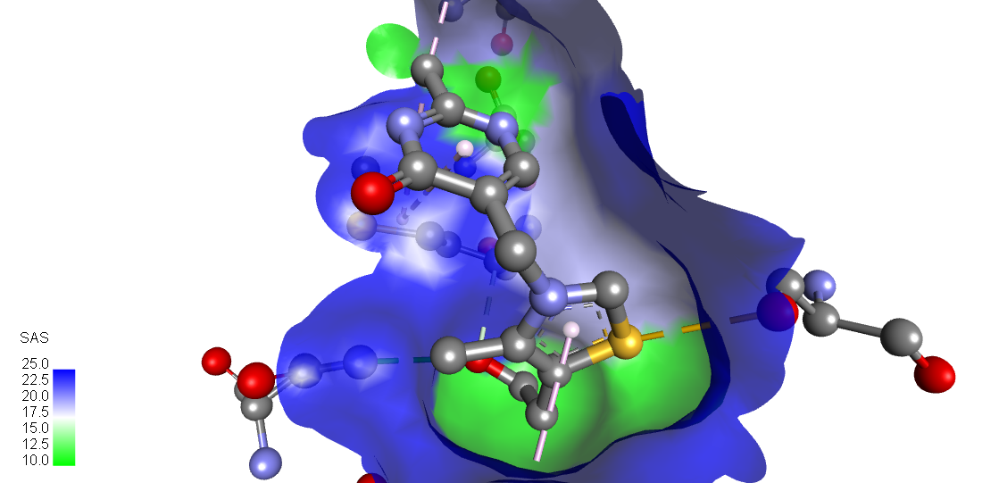

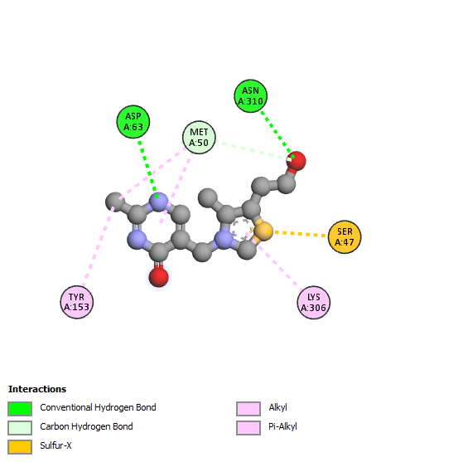

**8R3Q_OXYTHIAMINE**

(2b)

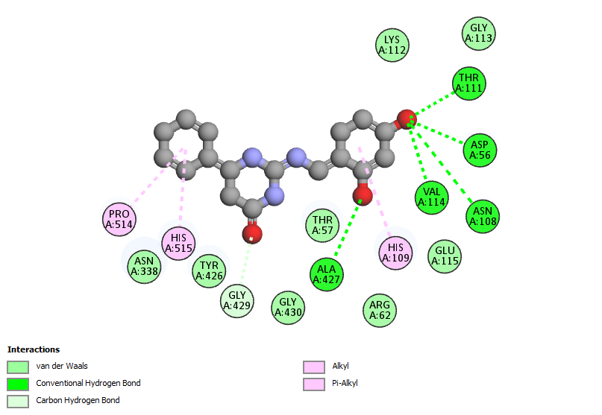

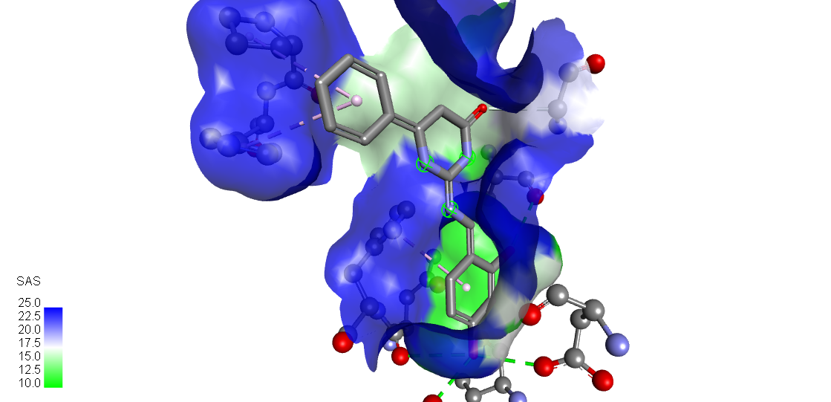

**8R3Q_2-_(E)-2-((3-HYDROXYBENZYLIDENE) AMINO)-6-PHENYLPYRIMIDIN-4(1H)-ONE**

(2c)

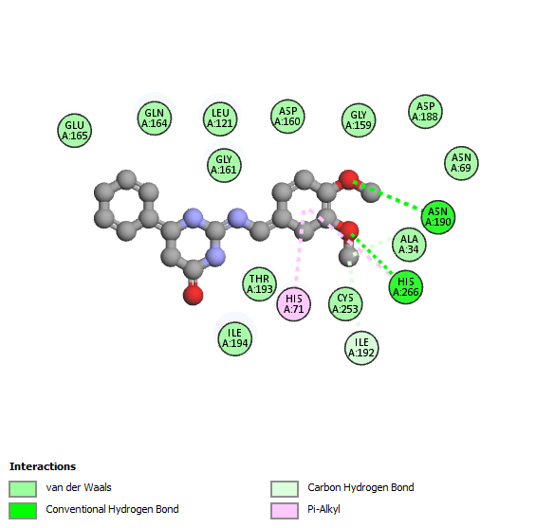

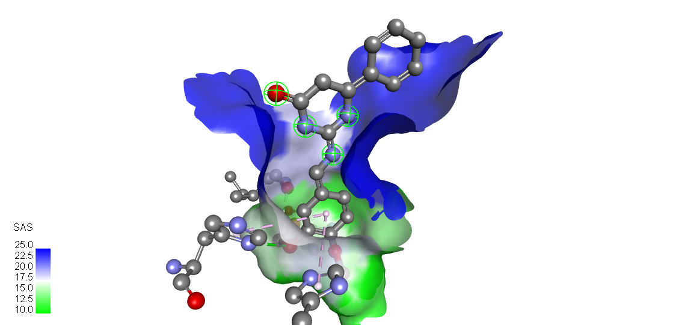

**8R3Q_(E)-2-((3,4-DIMETHOXYBENZYLIDENE)AMINO)-6-PHENYLPYRIMIDIN-4(1H)-ONE**

(2d)

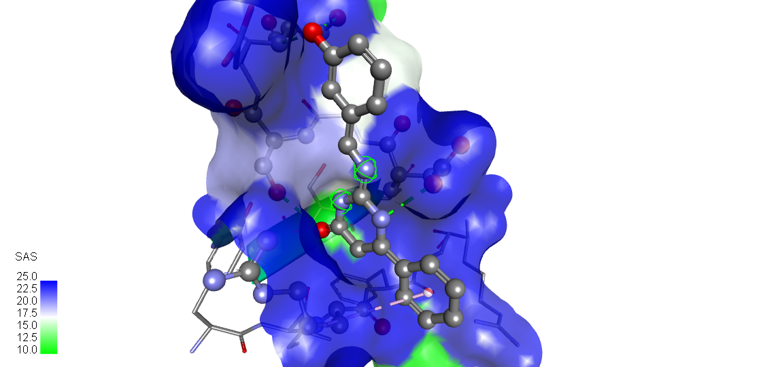

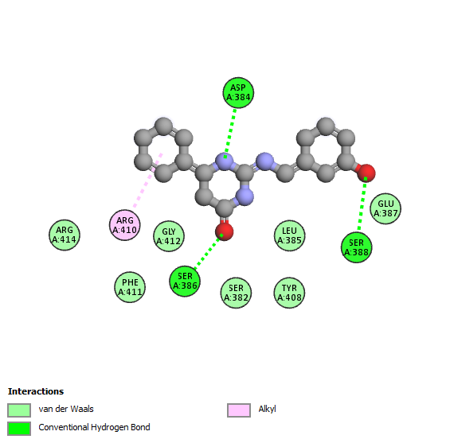

**8R3Q_(E)-2-((2,4-DIHYDROXYBENZYLIDENE)AMINO)-6-PHENYLPYRIMIDIN-4(1H)-ONE**

(2e)

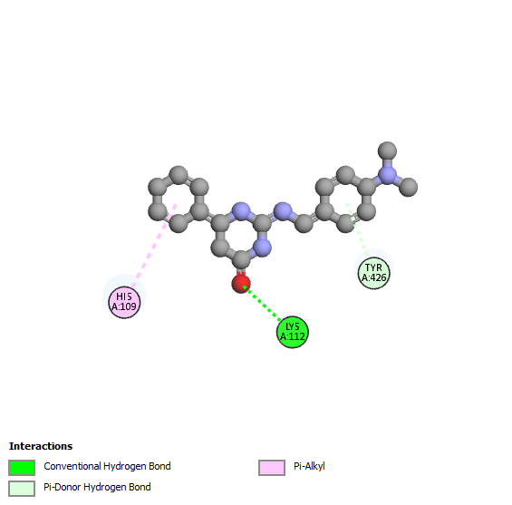

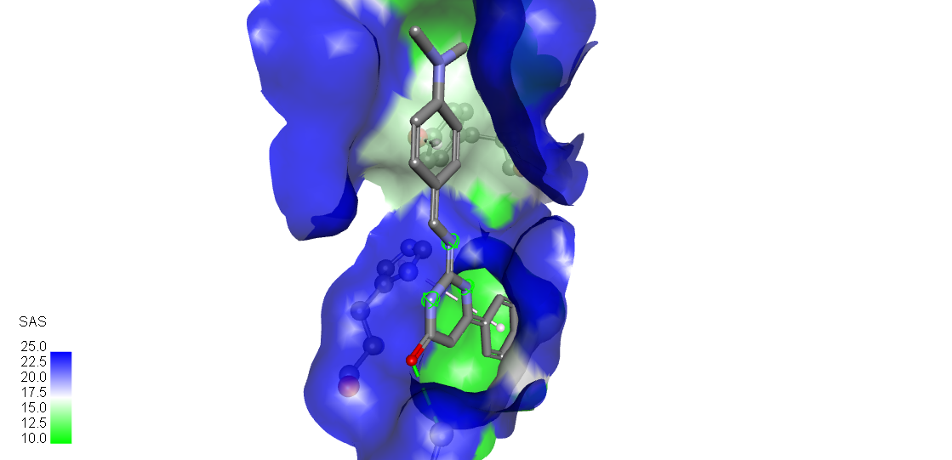

**8R3Q_(E)-2-((4-(DIMETHYLAMINO)-BENZYLIDENE)-AMINO)-6-PHENYLPYRIMIDIN-4(1H)-ONE**

(2f)

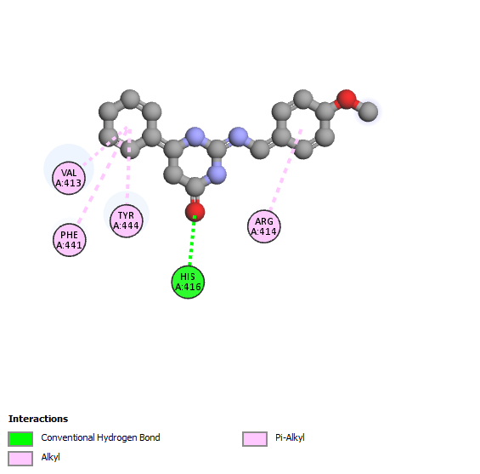

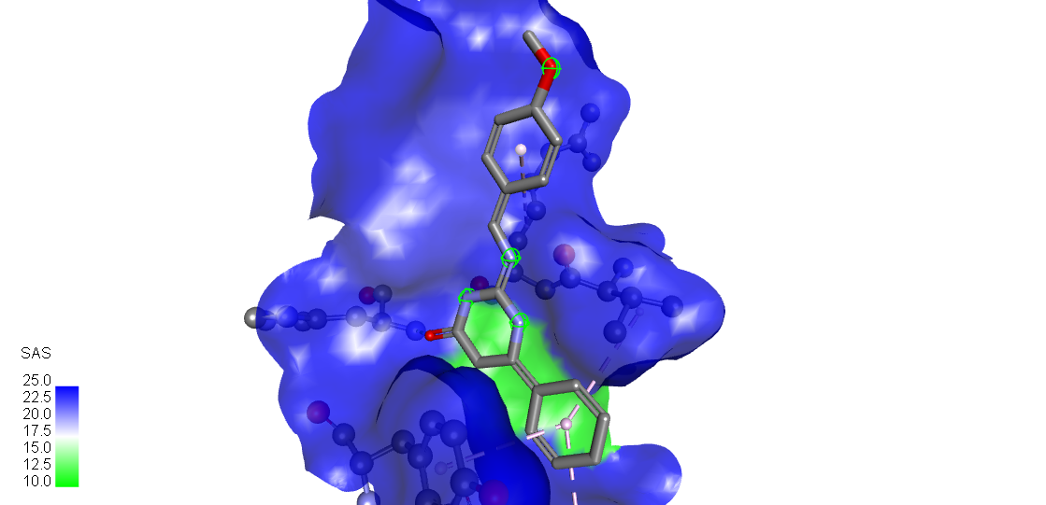

**8R3Q_(E)-2((4-METHOXYBENZYLIDENE)AMINO)-6-AMINO)-6-PHENYLPYRIMIDIN-4(1H)-ONE**

(2g)

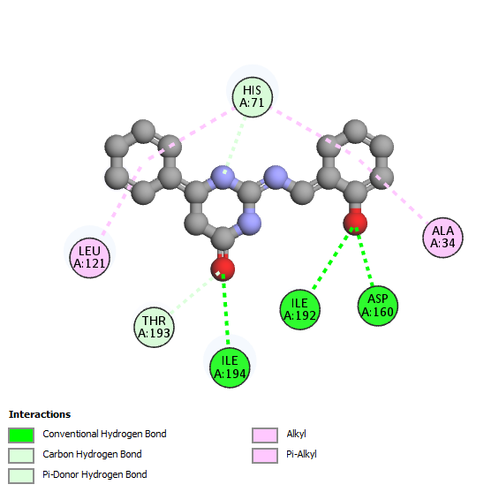

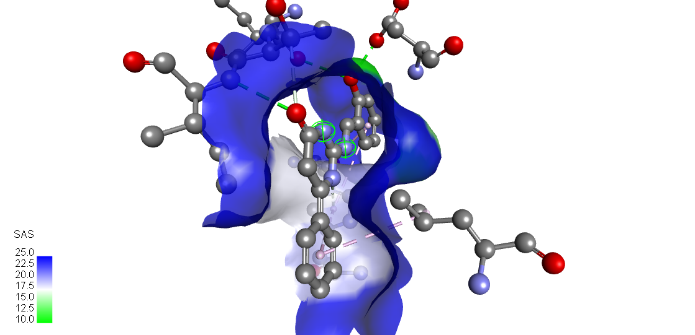

**8R3Q_(E)- _(E)-2-((2-HYDROXYBENZYLIDENE)AMINO)-6-PHENYLPYRIMIDIN-4(1H)-ONE**

**Figure 2:** Molecular interaction between oxythiamine and the six Schiff-bases at the active site of *plasmodium falciparum* transketolase (8R3Q) (A) Oxythiamine (reference drug) **(B)** (E)-2-(3-Hydroxybenzylidene) Amino)-6-Phenylpyrimidin-4(1h)-One **(C)** (E)-2-(3,4-Dimethoxybenzylidene) Amino)-6-Phenylpyrimidin-4(1H)-One **(D)** (E)-2-(2,4-Dihydroxybenzylidene) Amino)-6-Phenylpyrimidin-4(1H)-One **(E)** 8r3q_(E)-2-(4-(Dimethylamino)-Benzylidene)-Amino)-6-Phenylpyrimidin-4(1h)-One **(F)** (E)-2(4-Methoxybenzylidene) Amino)-6-Amino)-6-Phenylpyrimidin-4(1H)-One **(G)** (E)-2-(2-Hydroxybenzylidene) Amino)-6-Phenylpyrimidin-4(1H)-One. The structures were rendered using Biovia Discovery Studio 2021.

**3.2 PHYSICOCHEMICAL, PHARMACOKINETIC AND TOXICOLOGICAL EVALUATION.**

**3.2.1 Drug-Likeness**

Lipinski’s Rule of Five (RO5) was utilized to evaluate the drug-likeness of oxythiamine and the six Schiff bases of phenylisocytosine. RO5 provides a framework for predicting oral bioavailability, with ideal candidates exhibiting a MW below 500 Da, fewer than 5 hydrogen bond donors, fewer than 10 hydrogen bond acceptors, and a log P value below 5 to ensure optimal hydrophilicity-lipophilicity balance for absorption and distribution [27]. Table 2 summarizes the evaluated properties of oxythiamine and the Schiff bases.

**Table 2:** Drug-likeness (Rule of 5) evaluation and physicochemical properties of oxythiamine and the six Schiff bases of phenylisocytosine.

|  |  |  |  |  |  |
| --- | --- | --- | --- | --- | --- |
| **Ligands** | **Molecular**  **Weight** | **H-bond donor** | **H-bond acceptor** | **Log p** | **Inference** |
| **Compound ID** | **< 500** | **< 5** | **< 10** | **< 5** | **MEET R05** |
| Oxythiamine  (Reference Drug) | 266.1 | 2 | 5 | -0.977 | Accepted |
| (E)-2-((3-hydroxybenzylidene)amino)-6-phenylpyrimidin-4(1H)-one | 311.13 | 4 | 6 | 1.253 | Accepted |
| (E)-2-((3,4-dimethoxybenzylidene)amino)-6-phenylpyrimidin-4(1H)-one | 339.16 | 2 | 6 | 1.643 | Accepted |
| (E)-2-((2,4-dihydroxybenzylidene)amino)-6-phenylpyrimidin-4(1H)-one | 295.13 | 3 | 5 | 1.901 | Accepted |
| (E)-2-((4-dimethylamino)benzylidene)amino)-6-phenylpyrimidin-4(1H)-one | 322.18 | 2 | 5 | 1.96 | Accepted |
| (E)-2-((4-methoxybenzylidene)amino)-6-phenylpyrimidin-4(1H)-one | 309.15 | 2 | 5 | 1.849 | Accepted |
| (E)-2-((2-hydroxybenzylidene)amino)-6-phenylpyrimidin-4(1H)-one | 295.13 | 3 | 5 | 1.802 | Accepted |

Oxythiamine, the reference drug, adhered to RO5 criteria with a MW of 266.1 Da, 2 hydrogen bond donors, 5 acceptors, and a log P of -0.977. This high hydrophilicity, however, may limit passive membrane permeability. Among the Schiff bases, (E)-2-((3-hydroxybenzylidene)amino)-6-phenylpyrimidin-4(1H)-one displayed a MW of 311.13 Da, 4 hydrogen bond donors, 6 acceptors, and a log P of 1.253, suggesting an ideal hydrophilicity-lipophilicity balance. Similarly, (E)-2-((3,4-dimethoxybenzylidene)amino)-6-phenylpyrimidin-4(1H)-one demonstrated a MW of 339.16 Da, 2 hydrogen bond donors, 6 acceptors, and a log P of 1.643. The remaining Schiff bases also conformed to RO5, with MW between 295.13 Da and 322.18 Da and log P values ranging from 1.802 to 1.96. The results confirm that all compounds satisfy RO5 criteria, indicating their potential as orally bioavailable candidates. The balanced hydrophilicity-lipophilicity profiles of the Schiff bases suggest improved permeability and absorption compared to oxythiamine, which may require active transport for effective bioavailability. This is in alignment with previous studies, [12] highlighting the Schiff bases as strong contenders for further drug development.

**3.2.2 ADMET Evaluation**

The ADMET (Absorption, Distribution, Metabolism, Excretion, and Toxicity) properties of oxythiamine and the six Schiff bases were assessed to determine their pharmacokinetic and toxicological profiles. This evaluation highlights their potential clinical efficacy and safety, with key findings presented in Table 3. All Schiff bases exhibited excellent Caco-2 permeability and high human intestinal absorption, supporting their potential for effective oral bioavailability. Oxythiamine, however, showed poor Caco-2 permeability and limited absorption, highlighting its reduced passive uptake. Furthermore, all Schiff bases inhibited P-glycoprotein, potentially preventing drug efflux and enhancing intracellular retention. These findings position the Schiff bases as superior candidates in terms of absorption and distribution.

Metabolically, none of the Schiff bases inhibited critical cytochrome P450 enzymes, including CYP2D6, CYP3A4, CYP1A2, and CYP2C19, indicating a low likelihood of drug-drug interactions. In contrast, oxythiamine moderately inhibited CYP1A2, which could pose risks when combined with other drugs metabolized by this enzyme. The Schiff bases' favorable metabolic profiles suggest their safety in co-therapies and reduce concerns about adverse pharmacokinetic interactions. For excretion, the Schiff bases demonstrated excellent clearance rates and appropriate half-lives, minimizing risks of accumulation and toxicity. Oxythiamine, however, exhibited poor clearance and an extended half-life, increasing its likelihood of toxicity.

Toxicologically, the Schiff bases showed significant differences in their profiles. Oxythiamine displayed nephrotoxicity, posing a risk for kidney damage, and a higher risk of carcinogenicity. These findings align with its poor clearance, leading to potential bioaccumulation and associated toxic effects. (E)-2-((3-hydroxybenzylidene)amino)-6-phenylpyrimidin-4(1H)-one exhibited no nephrotoxicity, hepatotoxicity, or hematotoxicity, indicating a favorable safety profile. While it showed moderate AMES toxicity, the absence of significant toxic risks supports its potential as a safe candidate. (E)-2-((3,4-dimethoxybenzylidene)amino)-6-phenylpyrimidin-4(1H)-one also demonstrated no nephrotoxicity, hepatotoxicity, or hematotoxicity. Moderate AMES toxicity was observed, but its overall profile remains favorable compared to oxythiamine. (E)-2-((2,4-dihydroxybenzylidene)amino)-6-phenylpyrimidin-4(1H)-one showed minimal toxicological risks, with medium hepatotoxicity being the only area of concern. Its safety profile suggests a promising therapeutic window. (E)-2-((4-dimethylamino)benzylidene)amino)-6-phenylpyrimidin-4(1H)-one presented moderate risks for nephrotoxicity and hepatotoxicity. These findings suggest careful monitoring during further development. (E)-2-((4-methoxybenzylidene)amino)-6-phenylpyrimidin-4(1H)-one and (E)-2-((2-hydroxybenzylidene)amino)-6-phenylpyrimidin-4(1H)-one displayed similar profiles, with moderate hepatotoxicity but no nephrotoxicity, supporting their consideration as safe candidates.

The findings underscore the superior pharmacokinetic and safety profiles of the Schiff bases compared to oxythiamine. Notably, (E)-2-((3-hydroxybenzylidene)amino)-6-phenylpyrimidin-4(1H)-one and (E)-2-((3,4-dimethoxybenzylidene)amino)-6-phenylpyrimidin-4(1H)-one emerged as the best candidates due to their exceptional absorption, distribution, metabolism, excretion, and low toxicity profiles. Their favorable ADMET characteristics position them as leading candidates for antimalarial drug development, offering a safer and more effective alternative to oxythiamine [36]. These results provide a robust foundation for further experimental validation and clinical exploration.

**Table 3:** ADMET properties ofoxythiamine and the six Schiff-bases ofphenylisocytosine.

**G** = Excellent **B** = Good **R** = Poor

|  |  |  |  |  |  |  |  |  |  |  |  |  |  |  |  |  |  |
| --- | --- | --- | --- | --- | --- | --- | --- | --- | --- | --- | --- | --- | --- | --- | --- | --- | --- |
| **Ligands** | **Absorption**  **and**  **Distribution** | | | **Metabolism** | | | | | **Excretion and Toxicity** | | | | | | | | |
| **Compound**  **Identifier** | **Caco2 permeability** | **Human Intestinal absorption** | **P-glycoprotein Inhibitor** | **CYP2D6** | **CYP3A4** | **CYP1A2** | **CYP2C19**  **CYP2C19** | **CYP2C9** | **Half-life** | **Total Clearance** | **Nephrotoxicity** | **Acute oral toxicity** | **AMES toxicity** | **Carcinogenicity** | **HERG inhibitor** | **Hepatoxicity** | **Hema toxicity** |
| Oxythiamine  (Reference Drug) | R | R | G | G | G | B | G | B | 0.894 | B | G | R | G | R | G | G | G |
| (E)-2-((3-hydroxybenzylidene)amino)-6-phenylpyrimidin-4(1H)-one | G | G | G | G | G | G | G | G | 1.031 | G | G | B | B | G | G | G | G |
| (E)-2-((3,4-dimethoxybenzylidene)amino)-6-phenylpyrimidin-4(1H)-one | G | G | G | G | G | G | G | G | 0.782 | B | G | B | B | G | G | G | G |
| (E)-2-((2,4-dihydroxybenzylidene)amino)-6-phenylpyrimidin-4(1H)-one | G | G | G | G | G | G | G | G | 1.086 | G | B | B | B | B | G | B | B |
| (E)-2-((4-dimethylamino)benzylidene)amino)-6-phenylpyrimidin-4(1H)-one | G | G | G | G | G | G | G | G | 1.251 | B | B | B | B | B | G | B | B |
| (E)-2-((4-methoxybenzylidene)amino)-6-phenylpyrimidin-4(1H)-one | G | G | G | G | G | G | G | G | 0.878 | B | B | B | B | B | G | B | B |
| (E)-2-((2-hydroxybenzylidene)amino)-6-phenylpyrimidin-4(1H)-one | G | G | G | G | G | G | G | G | 0.763 | B | B | B | B | B | G | B | B |

**3.3 MOLECULAR MECHANICS-GENERALIZED BORN SURFACE AREA (MM-GBSA)**

MM-GBSA analysis was conducted to provide insights into the binding energies and stability of the ligand-protein complexes, with the results summarized in Table 4 and Figures 3a and 3b. This approach breaks down the binding free energy into key components, including van der Waals forces, hydrogen bonding, covalent bonding, and polar solvation energy. Understanding these components is critical for interpreting the interactions and stability of ligand-protein complexes. Table 4 highlights the binding energy contributions of oxythiamine and the six Schiff bases.

Van der Waals forces emerged as the most significant contributor to binding stability across all ligands. Oxythiamine demonstrated the strongest van der Waals interactions (-33.6 kcal/mol), enhancing its binding affinity; however, its high polar solvation energy (30.91 kcal/mol) resulted in a reduced overall binding energy of -16.85 kcal/mol. This indicates that substantial desolvation costs counteract the stability provided by van der Waals forces, weakening oxythiamine’s overall binding stability.

Among the Schiff bases, (E)-2-((3-hydroxybenzylidene)amino)-6-phenylpyrimidin-4(1H)-one exhibited the lowest overall binding energy (-31.21 kcal/mol), making it the most stable ligand. Despite its high polar solvation energy (43.29 kcal/mol), favorable van der Waals interactions (-23.22 kcal/mol) and hydrogen bonding (-3.95 kcal/mol) significantly contributed to its strong binding with the target protein. Similarly, (E)-2-((3,4-dimethoxybenzylidene)amino)-6-phenylpyrimidin-4(1H)-one showed robust stability, with an overall binding energy of -31.01 kcal/mol. This ligand exhibited the strongest van der Waals interactions (-37.27 kcal/mol) among the Schiff bases but faced high desolvation penalties (44.16 kcal/mol).

The other Schiff bases also demonstrated stable binding, with (E)-2-((2,4-dihydroxybenzylidene)amino)-6-phenylpyrimidin-4(1H)-one achieving an overall binding energy of -30.74 kcal/mol. Moderate van der Waals forces (-33.57 kcal/mol) and hydrogen bonding (-3.21 kcal/mol) contributed to its stability despite the high polar solvation energy (44.48 kcal/mol). (E)-2-((2-hydroxybenzylidene)amino)-6-phenylpyrimidin-4(1H)-one showed slightly lower stability (-27.96 kcal/mol) due to weaker van der Waals forces (-27.53 kcal/mol) and moderate desolvation penalties (37.62 kcal/mol). Meanwhile, (E)-2((4-methoxybenzylidene)amino)-6-amino)-6-phenylpyrimidin-4(1H)-one and (E)-2-((4-(dimethylamino)benzylidene)amino)-6-phenylpyrimidin-4(1H)-one exhibited comparable binding stabilities (-27.29 kcal/mol and -26.88 kcal/mol, respectively). These ligands faced higher desolvation penalties (59.8 kcal/mol and 67.23 kcal/mol, respectively), which reduced their overall stability despite strong van der Waals contributions.

The MM-GBSA results underscore the critical role of van der Waals forces in ligand-protein stability. While oxythiamine demonstrated strong van der Waals interactions, its high polar solvation energy limited its overall binding stability. In contrast, the Schiff bases, particularly (E)-2-((3-hydroxybenzylidene)amino)-6-phenylpyrimidin-4(1H)-one and (E)-2-((3,4-dimethoxybenzylidene)amino)-6-phenylpyrimidin-4(1H)-one, exhibited a balance of favorable interactions, making them the most stable ligands. Their low overall binding energies highlight their potential as effective inhibitors of Plasmodium falciparum transketolase. These findings provide a solid foundation for further optimization and experimental validation of these compounds as promising antimalarial agents [37, 38].

**Table 4:** MM-GBSA binding free energies of Oxythiamine and the six Schiff-bases of phenylisocytosine.

|  |  |  |  |  |  |
| --- | --- | --- | --- | --- | --- |
| **Ligands** | **MMGBSA ΔG**  **Bind H-bond**  **(Kcal/mol)** | **MMGBSA ΔG**  **Bind Covalent bond**  **(Kcal/mol)** | **MMGBSA ΔG**  **Bind Vander Waal Forces**  **(Kcal/mol)** | **MMGBSA ΔG**  **Bind Polar Solvation**  **(Kcal/mol)** | **MMGBSA ΔG**  **Overall Binding**  **energy (Kcal/mol)** |
| Oxythiamine | -3.12 | 2.75 | -33.6 | 30.91 | -16.85 |
| (E)-2-((3-Hydroxybenzylidene)Amino)-6-Phenylpyrimidin-4(1H)-One | -3.95 | 1.39 | -23.22 | 43.29 | -31.21 |
| (E)-2-((3,4-Dimethoxybenzylidene)Amino)-6-Phenylpyrimidin-4(1H)-One | -3.92 | 0.59 | -37.27 | 44.16 | -31.01 |
| (E)-2-((2,4-Dihydroxybenzylidene)Amino)-6-Phenylpyrimidin-4(1H)-One | -3.21 | 5.59 | -33.57 | 44.48 | -30.74 |
| (E)-2-((2-Hydroxybenzylidene)Amino)-6-Phenylpyrimidin-4(1H)-One | -3.88 | 2.45 | -27.53 | 37.62 | -27.96 |
| (E)-2((4-Methoxybenzylidene)Amino)-6-Amino)-6-Phenylpyrimidin-4(1H)-One | -2.75 | 15.17 | -35.38 | 59.8 | -27.29 |
| (E)-2-((4-(Dimethylamino)Benzylidene)Amino)-6-Phenylpyrimidin-4(1H)-One | -2.97 | 5.16 | -26.34 | 67.23 | -26.88 |

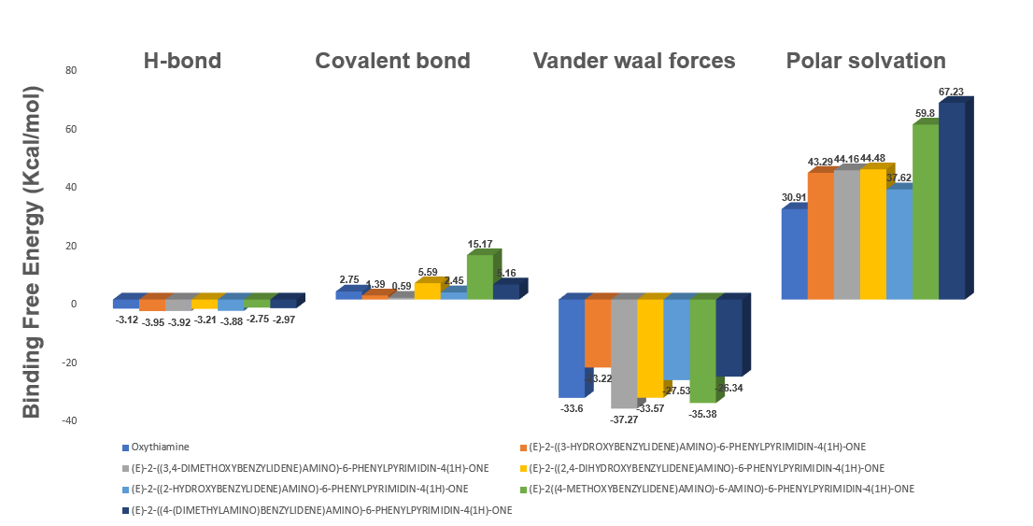

**Figure 3a:** MMGBSAΔG Bind H-bond, Covalent bond, Vander waal forces, and Polar solvation of Oxythiamine and the six Schiff-bases of phenylisocytosine in Maestro 12.5

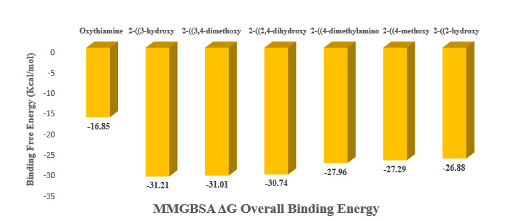

**Figure 3b:** MMGBSAΔG overall binding energy for Oxythiamine and the six Schiff-bases of phenylisocytosine in Maestro 12.5.

**3.4 SELECTION OF LEAD COMPOUNDS FOR MD SIMULATION.**

Based on the results of structure-based virtual screening (molecular docking and molecular mechanics) and ligand-based virtual screening, including Lipinski's Rule of Five and ADMET evaluation, two ligands, (E)-2-((3-hydroxybenzylidene)amino)-6-phenylpyrimidin-4(1H)-one and (E)-2-((3,4-dimethoxybenzylidene)amino)-6-phenylpyrimidin-4(1H)-one, were chosen for molecular dynamics (MD) simulations alongside the reference drug, oxythiamine. These ligands demonstrated exceptional pharmacokinetic profiles, satisfying drug-likeness criteria and exhibiting strong binding affinities during molecular docking studies. Their ability to form stable interactions with the target protein, coupled with favorable ADMET properties, highlights their potential as lead compounds for further exploration through MD simulations. These findings reinforce their viability as candidates for developing effective inhibitors against Plasmodium falciparum transketolase.

**3.5 MOLECULAR DYNAMICS (MD)**

MD simulations assessed the stability, flexibility, and interaction strength of the protein-ligand complexes over time, analyzing key parameters such as RMSD, RMSF, H-bond, and ROG (Table 5). These metrics provide insights into the complexes' behavior under physiological conditions [22,23].

**Table 5: Average values of RMSD, RMSF, H-bond, and ROG of all simulated complexes.**

|  |  |  |  |  |
| --- | --- | --- | --- | --- |
| **Compound Identifier** | **Average RMSD**  **values (nm)** | **Average RMSF**  **values (nm)** | **Average**  **H-bond**  **values (nm)** | **Average**  **ROG**  **values (nm)** |
| Oxythiamine | 0.47435 | 0.138127 | 0.08173 | 3.02291 |
| (E)-2-((3-Hydroxybenzylidene)amino)-  6-Phenylpyrimidin-4(1H)-One | 0.31394 | 0.14197 | 0.68383 | 2.99741 |
| (E)-2-((3,4-Dimethoxybenzylidene)Amino)-6-Phenylpyrimidin-4(1H)-One | 0.27671 | 0.12977 | 0.76031 | 3.00694 |

**3.5.1 RMSD**

RMSD values reflect the overall stability of the protein-ligand complex by measuring deviations in atomic positions over time [39]. Oxythiamine exhibited the highest RMSD value (0.474 nm), indicating significant conformational changes and less stability during the simulation. This suggests weaker interactions with the protein, resulting in greater flexibility and movement away from the initial binding site [12]. In contrast, (E)-2-((3,4-Dimethoxybenzylidene)amino)-6-Phenylpyrimidin-4(1H)-One showed the lowest RMSD value (0.277 nm), demonstrating the most stable complex with minimal deviations. (E)-2-((3-Hydroxybenzylidene)amino)-6-Phenylpyrimidin-4(1H)-One also exhibited strong stability with an RMSD value of 0.314 nm. These results highlight that both Schiff bases form more stable interactions with the target protein compared to oxythiamine.

**3.5.2 RMSF**

RMSF values provide insight into the flexibility of individual residues within the protein-ligand complex [40]. Oxythiamine had the highest RMSF value (0.138 nm), reflecting greater residue flexibility and weaker binding. Conversely, (E)-2-((3,4-Dimethoxybenzylidene)amino)-6-Phenylpyrimidin-4(1H)-One exhibited the lowest RMSF value (0.130 nm), indicating minimal fluctuations and strong interactions with the protein residues. (E)-2-((3-Hydroxybenzylidene)amino)-6-Phenylpyrimidin-4(1H)-One showed a slightly higher RMSF (0.142 nm) but maintained stable interactions. These findings further confirm that the Schiff bases form more rigid and stable complexes compared to oxythiamine.

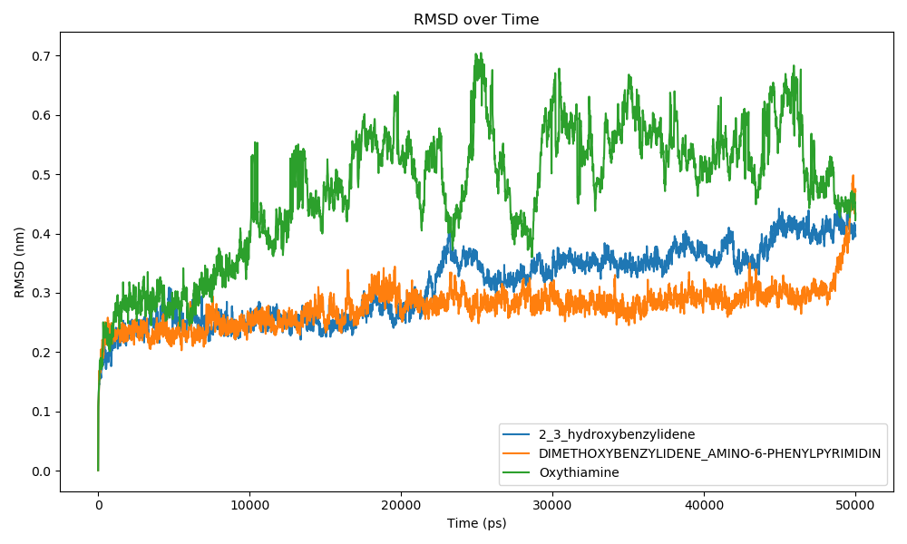

**Figure 4a**: RMSD Plot Showing the Stability of 2-((3-Hydroxybenzylidene)amino)-6-Phenylpyrimidin-4(1H)-One, 2-((3,4-Dimethoxybenzylidene)Amino)-6-Phenylpyrimidin-4(1H)-One, and Oxythiamine Over 50 ns of Molecular Dynamics Simulation.

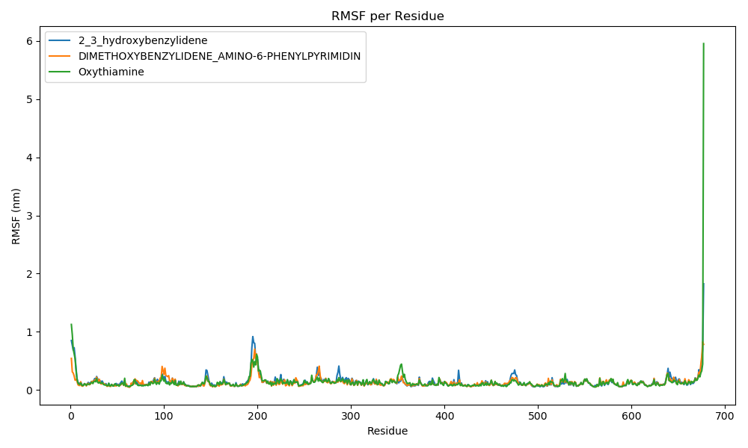

**Figure 4b**: RMSF Plot Showing the Stability of 2-((3-Hydroxybenzylidene)amino)-6-Phenylpyrimidin-4(1H)-One, 2-((3,4-Dimethoxybenzylidene)Amino)-6-Phenylpyrimidin-4(1H)-One, and Oxythiamine Over 50 ns of Molecular Dynamics Simulation.

**3.5.3 H-bonding**

Hydrogen bonding is crucial for stabilizing protein-ligand interactions [41]. Oxythiamine formed the fewest hydrogen bonds, with an average of 0.082, indicating weaker interactions and reduced stability. In comparison, (E)-2-((3,4-Dimethoxybenzylidene)amino)-6-Phenylpyrimidin-4(1H)-One formed the highest number of hydrogen bonds (0.760), followed by (E)-2-((3-Hydroxybenzylidene)amino)-6-Phenylpyrimidin-4(1H)-One (0.684). This higher number of hydrogen bonds suggests that the Schiff bases establish stronger and more consistent interactions with the protein, contributing to their overall stability.

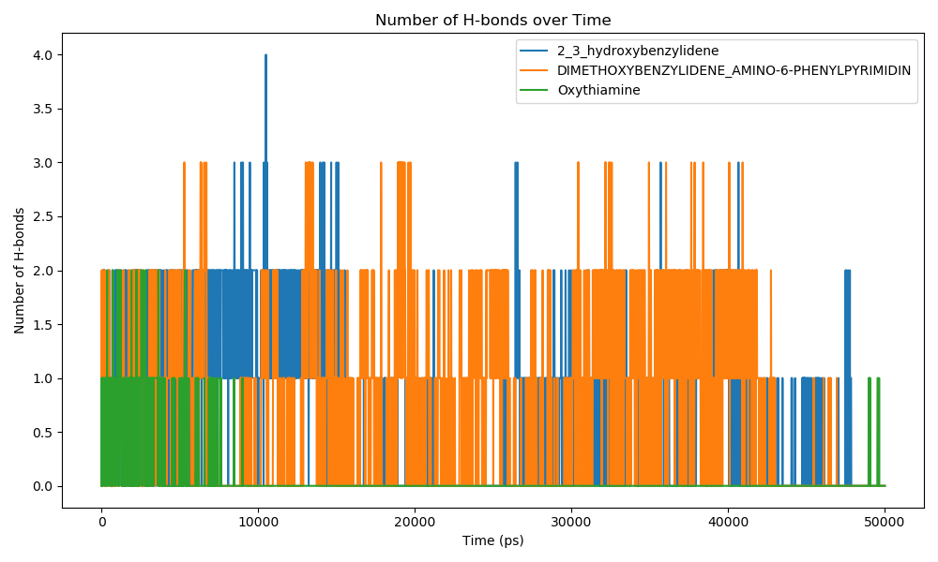

**Figure 4c**: H-bonding Plot Showing the Stability of 2-((3-Hydroxybenzylidene)amino)-6-Phenylpyrimidin-4(1H)-One, 2-((3,4-Dimethoxybenzylidene)Amino)-6-Phenylpyrimidin-4(1H)-One, and Oxythiamine Over 50 ns of Molecular Dynamics Simulation.

**3.5.4 ROG**

ROG values measure the compactness of the protein-ligand complex, with lower values indicating a more tightly packed structure [35]. Oxythiamine exhibited the highest ROG value (3.023 nm), suggesting a less compact and less stable complex. (E)-2-((3,4-Dimethoxybenzylidene)amino)-6-Phenylpyrimidin-4(1H)-One had a slightly lower ROG (3.007 nm), indicating a more compact and stable structure. (E)-2-((3-Hydroxybenzylidene)amino)-6-Phenylpyrimidin-4(1H)-One demonstrated the lowest ROG value (2.997 nm), highlighting its tightly bound and highly stable complex.

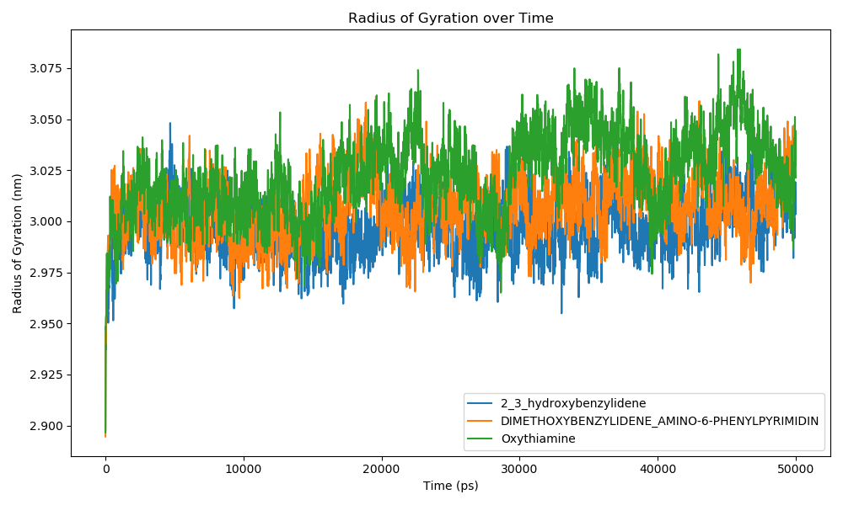

**Figure 4d**: ROG Plot Showing the Stability of 2-((3-Hydroxybenzylidene)amino)-6-Phenylpyrimidin-4(1H)-One, 2-((3,4-Dimethoxybenzylidene)Amino)-6-Phenylpyrimidin-4(1H)-One, and Oxythiamine Over 50 ns of Molecular Dynamics Simulation.

The MD simulation results demonstrate that (E)-2-((3,4-Dimethoxybenzylidene)amino)-6-Phenylpyrimidin-4(1H)-One and (E)-2-((3-Hydroxybenzylidene)amino)-6-Phenylpyrimidin-4(1H)-One consistently outperformed oxythiamine across all stability metrics. These Schiff bases exhibited superior RMSD, RMSF, H-bonding, and ROG values, confirming their strong and stable interactions with the target protein. Their favorable performance in MD simulations aligns with previous studies, [22, 42] reinforcing their potential as lead compounds for antimalarial drug development, warranting further experimental validation and optimization.

**4.0 CONCLUSION**

This study evaluated six Schiff bases of phenylisocytosine as potential inhibitors of Plasmodium falciparum transketolase, a critical enzyme in the pentose phosphate pathway. Comprehensive in silico analyses, including molecular docking, pharmacokinetic and toxicological profiling, molecular mechanics, and molecular dynamics simulations, identified (E)-2-((3,4-Dimethoxybenzylidene)amino)-6-Phenylpyrimidin-4(1H)-One and (E)-2-((3-Hydroxybenzylidene)amino)-6-Phenylpyrimidin-4(1H)-One as the most promising candidates. These compounds demonstrated superior binding affinities, stability, and favorable pharmacokinetic profiles compared to the reference drug oxythiamine, which exhibited weaker binding and notable limitations, including poor pharmacokinetics and significant toxicity risks. The identified Schiff bases lay a strong foundation for future experimental studies, including synthesis and validation through in vitro and in vivo evaluations, to confirm their therapeutic efficacy and safety. Advancing these compounds could contribute significantly to the development of next-generation antimalarial therapies, addressing the global challenge of drug-resistant malaria and improving health outcomes worldwide.

**DECLARATION OF GENERATIVE AI AND AI-ASSISTED TECHNOLOGIES IN THE WRITING PROCESS**

The authors affirm that no generative AI technologies or AI-assisted tools were employed at any stage during the preparation, writing, or editing of this manuscript. All content, including the conceptualisation, drafting, paraphrasing, grammatical structuring, and final revisions, was produced solely through the authors' original work and critical analysis. The manuscript reflects the authors’ independent intellectual contributions and adheres strictly to the standards of academic integrity, scientific rigour, and originality required for scholarly publication.

**REFERENCES**

1. Hawadak, J., Dongang Nana, R. R., and Singh, V. (2021). Global trend of *Plasmodium malariae* and Plasmodium ovale spp. malaria infections in the last two decades (2000–2020): A systematic review and meta-analysis. *Parasites and Vectors*, *14*(1), 297. <https://doi.org/10.1186/s13071-021-04797-0>
2. Oladipo, H. J., Tajudeen, Y. A., Oladunjoye, I. O., Yusuff, S. I., Yusuf, R. O., Oluwaseyi, E. M., ... and El-Sherbini, M. S. (2022). Increasing challenges of malaria control in sub-Saharan Africa: Priorities for public health research and policymakers. *Annals of Medicine and Surgery*, *81*, 104366. <https://doi.org/10.1016/j.amsu.2022.104366>
3. Alghamdi, J. M., Al-Qahtani, A. A., Alhamlan, F. S., and Al-Qahtani, A. A. (2024). Recent advances in the treatment of malaria. *Pharmaceutics*, *16*(11), 1416. <https://doi.org/10.3390/pharmaceutics16111416>
4. World Health Organization. (2024). Global malaria programme operational *strategy 2024-2030*. World Health Organization.
5. Belete, T. M. (2020). Recent progress in the development of new antimalarial drugs with novel targets. *Drug Design, Development and Therapy*, 3875-3889. <https://doi.org/10.2147/DDDT.S265602>
6. Amelo, W., and Makonnen, E. (2021). Efforts Made to Eliminate Drug‐Resistant Malaria and Its Challenges. *BioMed Research International*, *2021*(1), 5539544. <https://doi.org/10.1155/2021/5539544>
7. Kumar, S., and Mahato, R. P. (2024). Drug resistance and resistance reversal strategies in malaria parasite. *Journal of Microbiology, Biotechnology and Food Sciences*, *13*(5), e10384-e10384. <https://doi.org/10.55251/jmbfs.10384>
8. Fadare, O. A., Omisore, N. O., Adegbite, O. B., Awofisayo, O. A., Ogundolie, F. A., Adesanwo, J. K., and Obafemi, C. A. (2021). Structure based design, stability study and synthesis of the dinitrophenylhydrazone derivative of the oxidation product of lanosterol as a potential *P. falciparum* transketolase inhibitor and *in-vivo* antimalarial study. *In Silico Pharmacology*, *9*(1), 38. <https://doi.org/10.1007/s40203-021-00097-8>
9. Boateng, R. A., Tastan Bishop, Ö., and Musyoka, T. M. (2020). Characterisation of plasmodial transketolases and identification of potential inhibitors: An *in-silico* study. *Malaria Journal*, *19*, 1-19. <https://doi.org/10.1186/s12936-020-03512-1>
10. Hasan, M. A., Mazumder, M. H. H., Chowdhury, A. S., Datta, A., and Khan, M. A. (2015). Molecular-docking study of malaria drug target enzyme transketolase in *Plasmodium falciparum* 3D7 portends the novel approach to its treatment. *Source Code for Bbiology and Medicine*, *10*, 1-14. [DOI 10.1186/s13029-015-0037-3](https://d.docs.live.net/c28f4ced47f09daa/Desktop/EVERYTHING%20RESEARCH_2025/DOI%2010.1186/s13029-015-0037-3)
11. Fathoni, I., Ho, T. C., Chan, A. H., Leeper, F. J., Matuschewski, K., and Saliba, K. J. (2024). Identification and characterization of thiamine analogs with antiplasmodial activity. *Antimicrobial Agents and Chemotherapy*, *68*(12), e01096-24. <https://doi.org/10.1101/2024.07.18.604204>
12. Atanda, O. E., Olaniyan, L. W. B., Fadare, O. A., Ehigie, A. F., Adisa, T. A., Odunitan, T. T., Alabi, O. T., Omonijo, B. A., Aloba, G. O., and Ehigie, L. O. (2024). “*In-silico* evaluation of phenylisocytosine and its analogs as potent inhibitors of *Plasmodium falciparum* transketolase: A strategic approach in anti-malarial drug discovery”. *International Journal of Biochemistry Research and Review,* 33 (6):616-36. <https://doi.org/10.9734/ijbcrr/2024/v33i6941>.
13. Tiwari, A., and Singh, S. (2022). Computational approaches in drug designing. In *Bioinformatics* (pp. 207-217). Academic Press. <https://doi.org/10.1016/B978-0-323-89775-4.00010-9>
14. Bhunia, S. S., Saxena, M., and Saxena, A. K. (2021). Ligand-and structure-based virtual screening in drug discovery. In *Biophysical and Computational Tools in Drug Discovery* (pp. 281-339). Cham: Springer International Publishing. <https://doi.org/10.1007/7355_2021_130>
15. Fu, Y., Zhao, J., and Chen, Z. (2018). Insights into the molecular mechanisms of protein‐ligand interactions by molecular docking and molecular dynamics simulation: A case of oligopeptide binding protein. *Computational and mathematical methods in medicine*, *2018*(1), 3502514. <https://doi.org/10.1155/2018/3502514>
16. Jejurikar, B. L., and Rohane, S. H. (2021). Drug designing in discovery studio. 14 (2): 135-138. [10.5958/0974-4150.2021.00025.0](http://dx.doi.org/10.5958/0974-4150.2021.00025.0)
17. Tian, W., Chen, C., Lei, X., Zhao, J., and Liang, J. (2018). CASTp 3.0: Computed atlas of surface topography of proteins. *Nucleic Acids Research*, *46*(W1), W363-W367. <https://doi.org/10.1093/nar/gky473>
18. O'Boyle, N. M., Banck, M., James, C. A., Morley, C., Vandermeersch, T., and Hutchison, G. R. (2011). Open Babel: An open chemical toolbox. *Journal of Cheminformatics,* 3(1), 1-14. <https://doi.org/10.1186/1758-2946-3-33>
19. Huey, R., Morris, G. M., and Forli, S. (2012). Using AutoDock 4 and AutoDock vina with AutoDockTools: A tutorial. The Scripps Research Institute Molecular Graphics Laboratory, 10550(92037), 1000. <http://vina.scripps.edu.>
20. Hsu, K. C., Chen, Y. F., Lin, S. R., and Yang, J. M. (2011). iGEMDOCK: A graphical environment of enhancing GEMDOCK using pharmacological interactions and post-screening analysis. *BMC bioinformatics*, 12, 1-11. <https://doi.org/10.1186/1471-2105-12-S1-S33>
21. Scholz, C., Knorr, S., Hamacher, K., and Schmidt, B. (2015). DOCKTITE A highly versatile step-by-step workflow for covalent docking and virtual screening in the molecular operating environment. *Journal of Chemical Information and Modeling*, *55*(2), 398-406. <https://doi.org/10.1021/ci500681r>
22. Olaniyan, L. W. B., Ehigie, L. O., Ehigie, A. F., Emmanuel, O., Atanda, T. T. O., and Fakuade, A. A. (2024). *In silico* investigation of indenoimidazole derivatives as promising arsenal against methicillin resistant staphylococcus aureus through staphylococcal protein a inhibition. *European Journal of Biomedical*, *11*(6), 04-16. Issn 2349-8870
23. Oyedele, A. Q. K., Adelusi, T. I., Ogunlana, A. T., Adeyemi, R. O., Atanda, O. E., Babalola, M. O., ... and Boyenle, I. D. (2022). Integrated virtual screening and molecular dynamics simulation revealed promising drug candidates of p53-MDM2 interaction. *Journal of Molecular Modeling*, 28(6), 142. <https://doi.org/10.1007/s00894-022-05131-w>
24. Lipinski, C. A. (2004). Lead-and drug-like compounds: The rule-of-five revolution. *Drug discovery today: Technologies*, *1*(4), 337-341. <https://doi.org/10.1016/j.ddtec.2004.11.007>
25. Fu, L., Shi, S., Yi, J., Wang, N., He, Y., Wu, Z., ... and Cao, D. (2024). ADMETlab 3.0: An updated comprehensive online ADMET prediction platform enhanced with broader coverage, improved performance, API functionality and decision support. *Nucleic Acids Research*, gkae236. <https://doi.org/10.1093/nar/gkae236>
26. Pires, D. E., Blundell, T. L., and Ascher, D. B. (2015). pkCSM: Predicting small-molecule pharmacokinetic and toxicity properties using graph-based signatures. *Journal of Medicinal Chemistry*, *58*(9), 4066-4072. <https://doi.org/10.1021/acs.jmedchem.5b00104>
27. Chen, X., Li, H., Tian, L., Li, Q., Luo, J., and Zhang, Y. (2020). Analysis of the physicochemical properties of acaricides based on Lipinski's rule of five. *Journal of Computational Biology*, *27*(9), 1397-1406. <https://doi.org/10.1089/cmb.2019.0323>
28. Sucharitha, P., Reddy, K. R., Satyanarayana, S. V., and Garg, T. (2022). Absorption, distribution, metabolism, excretion, and toxicity assessment of drugs using computational tools. In *Computational approaches for novel therapeutic and diagnostic designing to mitigate SARS-CoV-2 infection* (pp. 335-355). Academic Press. <https://doi.org/10.1016/B978-0-323-91172-6.00012-1>
29. Wang, Y., Xing, J., Xu, Y., Zhou, N., Peng, J., Xiong, Z., ... and Jiang, H. (2015). *In silico* ADME/T modelling for rational drug design. *Quarterly Reviews of Biophysics*, *48*(4), 488-515. <https://doi.org/10.1017/S0033583515000190>
30. Daoud, N. E. H., Borah, P., Deb, P. K., Venugopala, K. N., Hourani, W., Alzweiri, M., ... and Tiwari, V. (2021). ADMET profiling in drug discovery and development: perspectives of *in silico*, *in vitro* and integrated approaches. *Current Drug Metabolism*, *22*(7), 503-522. <https://doi.org/10.2174/1389200222666210705122913>
31. Babalola, M. O., Ashiru, M. A., Boyenle, I. D., Atanda, E. O., Oyedele, A. Q. K., Dimeji, I. Y., ... and Imaga, N. A. (2022). *In vitro* analysis and molecular docking of gas chromatography-mass spectroscopy fingerprints of polyherbal mixture reveals significant antidiabetic miture. *Nigerian Journal of Experimental and Clinical Biosciences*, *10*(4), 105-115. <https://doi.org/10.4103/njecp.njecp_15_22>
32. Ajao, F. O., Ehigie, A. F., Odunitan, T. T., Atanda, O. E., Ayoola, P. B., and Olaniyan, L. W. (2024). “Computational exploration of psidii guajavae folium bioactive compounds as novel DPP-IV inhibitors for type 2 diabetes mellitus intervention”. *European Journal of Pharmaceutical and Medical Research.* ISSN: 2394-3211
33. Ehigie, L. O., Ojeniyi, F. D., Rashidat, A., Igbeneghu, C., Sulaimon, N., and Ehigie, A. F. (2022). Molecular docking and molecular dynamics simulation to investigate protein-ligand binding of potential drug candidates from vernonia amygdalina against wilms’tumor 1 (wt1) protein. *European Journal of Biomedical,* 9(8), 499-514. Issn 2349-8870
34. Kehinde, O. A. Q., Damilare, B. I., Ogunlana, A., Mojeed Ayoola, A., Opeyemi Emmanuel, A., and Temitope Ik, saac, A. (2022). Inhibitors of α-glucosidase and angiotensin-converting enzyme in the treatment of type 2 diabetes and its complications: A Review on *in silico* approach. *Pharmaceutical and Biomedical Research*, *8*(4), 237-258. <http://dx.doi.org/10.32598/PBR.8.4.1052.1>
35. Shukla, R., and Tripathi, T. (2020). Molecular dynamics simulation of protein and protein–ligand complexes. *Computer-aided drug design*, 133-161. <https://doi.org/10.1007/978-981-15-6815-2_7>
36. Vyas, V. K., Bhati, S., Patel, S., and Ghate, M. (2022). Structure-and ligand-based drug design methods for the modeling of antimalarial agents: A review of updates from 2012 onwards. *Journal of Biomolecular Structure and Dynamics*, *40*(20), 10481-10506. <https://doi.org/10.1080/07391102.2021.1932598>
37. Cheuka, P. M., Njaria, P., Mayoka, G., and Funjika, E. (2024). Emerging drug targets for antimalarial drug discovery: Validation and insights into molecular mechanisms of function. *Journal of Medicinal Chemistry*, *67*(2), 838-863. <https://doi.org/10.1021/acs.jmedchem.3c01828>
38. Atanda, O. E., Adesikun, A. A., Adeyeye, P. O., Oyewale, M. T., and Adeyemi, M. A. (2025). “*In silico* evaluation of *Allium sativum* derived phytochemicals reveals promising drug candidates for p53-MDM2 interaction in osteosarcoma therapy”. *Journal of Applied Life Sciences International* 28 (4):106-27. <https://doi.org/10.9734/jalsi/2025/v28i4702>
39. Majewski, M., and Barril, X. (2020). Structural stability predicts the binding mode of protein–ligand complexes. *Journal of Chemical Information and Modeling*, *60*(3), 1644-1651. <https://doi.org/10.1021/acs.jcim.9b01062>
40. Komarov, I. V., Bugrov, V. A., Cherednychenko, A., and Grygorenko, O. O. (2024). Insights into modeling approaches in chemistry: assessing ligand‐protein binding thermodynamics based on rigid‐flexible model molecules. *The Chemical Record*, *24*(2), e202300276. <https://doi.org/10.1002/tcr.202300276>
41. Bulusu, G., and Desiraju, G. R. (2020). Strong and weak hydrogen bonds in protein–ligand recognition. *Journal of the Indian Institute of Science*, *100*(1), 31-41. <https://doi.org/10.1007/s41745-019-00141-9>
42. Atanda, O. E., Oyewale, M. T., Adeyeye, P. O., Adesikun, A. A., and Adeyemi, M. A. (2025). “Integrated virtual screening of NPACT-derived phytochemicals as potential FGFR1 inhibitors for cholangiocarcinoma therapy: Molecular docking, ADMET, MM-GBSA, and molecular dynamics”. Journal of Advances in Biology and Biotechnology 28 (6):1399-1424. <https://doi.org/10.9734/jabb/2025/v28i62497>.