*Short Research Article*

Evaluation of Condensed Molasses Solubles (CMS) Nutrients as Hybrid Ducks

Feed Ingredients

ABSTRACT

|  |
| --- |
| Condensed Molasses Solubles (CMS) is a processed waste liquid by-product of the Monosodium Glutamate (MSG) industry which was found to contain organic material using the Single Cell Protein (SCP) method. The SCP method is a microbial fermentation process with organic industrial waste materials with the main component components of amino acids and minerals, becoming a solution to substitute feed ingredients that have begun to be pioneered in Indonesia. This study aims to evaluate the nutritional quality of CMS as a feed ingredient for hybrid ducks. This research was conducted as a solution to meet the demand for alternative feed protein due to increasing cost of animal feed costs and also as a solution to overcome the fluctuations of duct populations in Indonesia. The research was conducted by assessing the nutritional quality of CMS through proximate analysis, density, pH measurement, and microstructure observation using Scanning Electron Microscopy (SEM). The data obtained were analyzed descriptively. Proximate test assessment showed dry matter 64,08%, ash 4,79%, crude protein 39,86%, crude fat 1,16% and crude fiber 0,17%, density 1,211 g/ml, pH 3,99 and microstructure observation on CMS showed particle size of 160,5 µm. The results of this study indicate that CMS, derived from a by-product of Monosodium Glutamate (MSG) production, has a high protein content and significant bacterial inhibition. |

*Keywords: Condensed Molasses Solubles (CMS); Proximate Analysis; Density; pH; Microstructure*

1. INTRODUCTION

Feed is one of the crucial factors supporting the livestock business. The cost of feed, especially poultry, reaches 60-70% of the total cost of production. Protein sources are one of the components of poultry feed. Protein is used in the growth process and repair of damaged tissue. Protein source feed ingredients are relatively more expensive than other feed ingredients because the availability of protein source feed ingredients in Indonesia is not sufficient to meet imports from other countries. To reduce dependence on imports of protein source feed ingredients, the utilization of by-products of the monosodium glutamate (MSG) cooking spice processing industry.

The single cell protein developed in this study is Condensed Molasses Solubles (CMS). CMS has the characteristics of a liquid form, blackish color and has a distinctive odor. Sjofjan et al., (2020) high nutritional content such as vitamin B complex and amino acids are the advantages of single-cell protein so that it can be an alternative to replace protein sources from soybean meal and fish meal which are still imported. Single cell protein has a protein content that can reach 60%, low fat, a source of vitamin B-complex and has a complete amino acid composition (Samadi et al., 2012). The main amino acid content of PST is L-glutamate which is a type of amino acid found in protein that can increase the rate of consumption and growth. Single cell protein has a crude protein content of 30-45% for fungi, 40-60% for algae, 45-55% for yeast and 50-65% for bacteria, and has a nucleic acid content of 7-10% for fungi, 3-8% for algae, 6-12% for yeast and 8-12% for bacteria (Adedayo et al., 2011). Judging from the advantages above, this study aims to evaluate the nutrition of CMS so that it is suitable for use as a poultry feed ingredient.

2. material and methods

**2.1 Location and Time of Research**

The research was conducted from February 2025, the evaluation of CMS nutrition begins with proximate analysis, pH, and density conducted at the Animal Nutrition and Feed Laboratory, Faculty of Animal Science, University of Brawijaya. Next, microstructural observations were carried out at the Riset Terpadu Laboratory, University of Brawijaya.

**2.2 Material and Methods**

The research utilized Condensed Molasses Solubles (CMS) derived from the by-products of cooking spice industry by PT. Daesang Ingredients Indonesia. This study was a laboratory experiment conducted over one month to analyze the protein content of CMS using proximate analysis, density, pH, and microstructure observation using Scanning Electron Microscopy (SEM).

**2.3 Research Procedure**

**2.3.1 Proximate Analysis**

Method to determine the content of dry matter, crude protein (micro Kjeldahl method), crude fat and crude fiber with standard procedures AOAC (2005).

**2.3.2 Density Evaluation**

Aims to assess the quality of the material and minimize adulteration. Density is measured by pouring the material into a 1000ml container and then weighing it before and after. The calculation result is obtained by dividing the weight of the material by the volume of space it occupies (g/ml).

**2.3.3 pH Measurement**

pH was measured using a pH meter that had been calibrated with pH 4,7 and 10 buffer solutions following the SNI 06-6989.11-2004 method. After calibration, the pH meter electrode was dried with tissue and rinsed with distilled water. Then pH is measured with inserting the pH meter electrode into the bottle containing the sample until the scale stabilizes.

**2.3.4 Microstructure Observation**

Examinating using Scanning Electron Microscope (SEM) where feed samples were prepared on conductive carbon adhesive tape without sputtering. Specimens were visualized under a field emission scanning electron microscope (FESEM), with 100x magnification, 1.27mm working distance, and 10Kv.

**2.4 Observed Variables**

The variables observed were proximate tests (BK, Ash, PK, LK, and SK), Density, pH, and Microstructure Observation.

3. results and discussion

**3.1 Nutrient Content of CMS**

The results of the CMS proximate test can be seen in Table 1.

**Table 1. CMS nutrient content data**

|  |  |  |  |  |  |  |
| --- | --- | --- | --- | --- | --- | --- |
| Sample |  | DM | Ash | Crude Protein | Crude Fat | Crude Fiber |
| CMS |  | 64,08% | 4,79% | 39,86% | 1,16% | 0,17% |

Note: Results of the proximate analysis conducted in the Laboratory of Nutrition and Animal

Feed, Faculty of Animal Science, University of Brawijaya, Malang (2025)

The proximate analysis results of CMS reveal a dry matter content of 64.08%, ash 4.79%, crude protein 39.86%, crude fat 1.16%, and crude fiber 0,17%. CMS is a high protein source derived from the fermentation of monosodium glutamate (MSG) by single-cell microorganisms, both bacteria and yeast. This process results in the presence of glutamic acid, a non-essential amino acid that is acidic and a natural component in almost every food that contains high protein (Suhendra and Putri, 2020). The high protein composition in CMS positively contributes to the nutritional value needed in the growth process of microorganisms (Gianto, Suhandana, and Putri, 2017). The increase in crude protein occurs due to the addition of protein contributed by microbial cells due to their growth which produces single-cell protein products or microbial cell biomass containing 45-85% protein (Zhang et al., 2024).

**3.2 Density and pH of CMS**

Density and of measurements of CMS are as follows:

**Table 2. Density and pH CMS**

|  |  |  |
| --- | --- | --- |
| Sample | Density | pH |
| Condensed Molasses Solubles (CMS) | 1,211 g/ml | 3,99 |

Note: Results of the density and pH conducted in the Laboratory of Nutrition and Animal Feed,

Faculty of Animal Science, University of Brawijaya, Malang (2025)

Density tests are conducted to determine storage capacity, pile density and feed consumption. The nature of amba will be inversely proportional to the amount of fiber in the feed. Azzahra et al., 2022 stated that the higher the crude fiber, the more amba or density of the material is smaller. The result of CMS density test is 1,211 g/ml.

The pH analysis results of CMS reached 3,99 and was declared acidic. The decrease in pH occurs due to the metabolism of lactic acid bacteria during the fermentation process (Kasi et al., 2017), characterized by the production pf H+ ions as the final results of the fermentation process (Wulan, Meryandini, and Sunarti, 2017).

**3.3 Microstructure of CMS**

The result shown by SEM with magnifications of 100x, 250x, 500x, and 1000x regarding the microstructure of CMS are 160,5µm with uniform particle distribution characteristics.

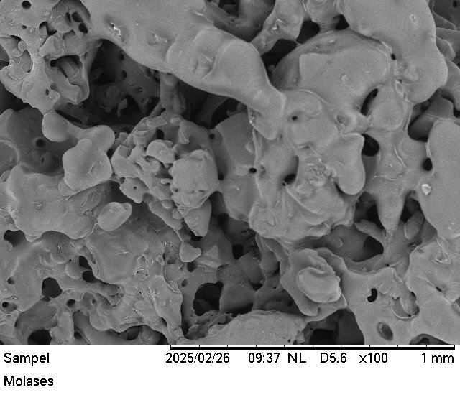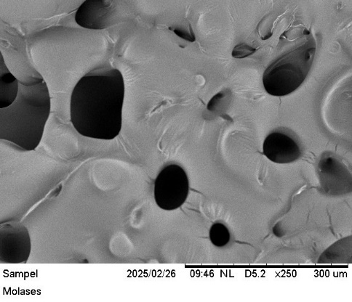

(a) (b)

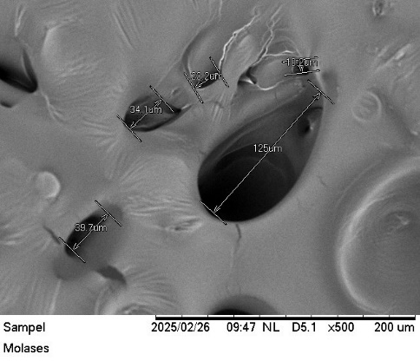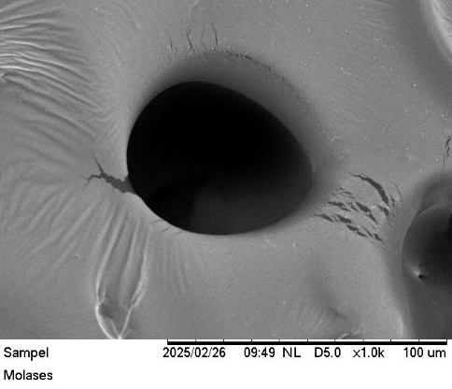

(c) (d)

**Figure 1. Results of the SEM microstructure of CMS at various magnifications (a) SEM magnification 100x of CMS (b) SEM magnification 250x of CMS (c) SEM magnification 500x of CMS (d) SEM magnification 1000x of CMS**

Note: Results of the microstructure test conducted in the Riset Terpadu Laboratory,

University of Brawijaya, Malang (2025)

The microstructure analysis of CMS aims to provide information on the freshness of feed ingredients through detection method of bacterial, fungal and insect infestation. Good quality feed ingredients will be able to maintain their quality so that macroscopic testing can distinguish individual components of mixed feed. Raamsdonk et al., 2004 stated that particle size is the basis for successful estimation of feed components such as in the identification of feed of mammalian, bird and fish origin. Observation of the microstructure of CMS using Scanning Electron Microscopy (SEM) showed an average particle size of 160,5 µm. According to Apriliyani et al., 2016 the diameter of the lumen of Magelang ducks reached 1698 µm, Tegal ducks reached 1666 µm and Pengging ducks 1621 µm. The larger the lumen diameter in the intestines, the more feed can be accommodated, thus maximizing the nutrient absorption process carried out by epithelial cells.

4. Conclusion

The evaluation analysis of CMS (Condensed Molasses Solubles) demonstrates its potential as a high-protein feed ingredients with beneficial nutritional and antimicrobial properties. CMS contains 39.86% crude protein and high level of glutamic acid, making it capable of meeting the nutritional needs of hybrid ducks. CMS has a microstructure with an average particle size og 160,5µm, which holds potential for improving nutrient absorption. It is acidic with a pH of 3,99 and has a density value at 1,211g/ml, supporting its shelf life. Based on this research, CMS is found to have strong potential as a protein-rich feed ingredients and as a sustainable alternative solution to support animal health and reduce the risk of microbial contamination in feed.

References

**References**

Adedayo, M. R., E. Ajibayo., A., J.K. Akintunde & A. Odaibo. (2011). Single Cell Protein: As Nutritional Enhancer. Advances in Applied Science Research, 2(5), 396-409.

Apriliyani, N. I., Djaelani, M. A., & Tana, S. (2016). Histological profile of duodenum of various local ducks in Semarang Regency. Biome: Scientific Periodical Biology, *18*(2), 144-150.

Azzahra, Y. R., Toharmat, T., & Prihantoro, I. (2022). Evaluation of Physical Characteristics of Pleurotus ostreatus Fungus Fermented Media as Alternative Animal Feed for Ruminants. Indonesian Journal of Agricultural Sciences, 27(3), 351–358.

Gianto, M. S., & Putri, R. M. S. (2017). Composition of amino acid content in golden sea cucumber (stichoupus horens) in the waters of Bintan Island, Riau Islands. Journal of Fisheries Product Technology, 6(2), 186-192.

Kasi, P.D., A. Ariandi & H.Mutmainnah. (2017). Antibacterial Test of Lactic Acid Bacteria Isolates Isolated from Sago Liquid Waste Against Pathogenic Bacteria. Journal of Tropical Biology, 5(3), 97-101.

Raamsdonk, L. W., Vancutsem, J., Zegers, J., Frick, G., Jorgenson, J. S., Pinckaers, V., ... & Paradies-Severin, I. (2004). The microscopic detection of animal proteins in feeds. *BASE*, 8(4), 241-247.

Samadi, M. Delima, Z. Hanum & M. Akmal. (2012). Effect of substitution Level of Single Cell Protein (Cj Prosin) in Commercial Feed on Broiler Chicken Performance. Agripet, 12(1), 7-15.

Sjofjan, O., Adli, D. N., Natsir, M. H., & Kusumaningtyaswati, A. (2020). Effect of Combination of Tumeric Flour (Curcuma Domestica Val.) and Probiotics on Broiler Intestinal Performance. Journal of Tropical Animal Nutrition and Feed Science, 2(1), 1-6.

Suhendra dan R.M.S. Putri. (2020). Amino Acid and Fatty Acid Study of Starfish Protoreaster Nodosus. Marinade. 3(1), 89-101.

Wulan, R., A. Meryandini & T.C. Sunarti. (2017). Potential of Tapioca Industry Liquid Waste as a Growth Medium for Lactic Acid Bacteria Pediococcus pentosaceus E. 1222. Journal of Biological Resources, 3(1), 27-33.

Zhang, Z., Chen, X & Gao, L. (2024). New strategy for the biosynthesis of alternative feed protein: Single-cell protein production from straw-based biomass. GCB Bioenergy,16(2), 1-18. doi: https://doi.org/10.1111/gcbb.13120

AOAC 2005. Official Methods of Analysis. Association of Official Analytical Chemists. Benjamin Franklin Station, Washington.

National Standardization Agency. 2004. Indonesian National Standard (SNI) 06-6989.11: Water and wastewater-Part 11: How to Test the Degree of Acidity (pH) Using a pH Meter. BSN, Jakarta

.