**Original Research Article**

**Assessment of the Collective Influence of Table Sugar Substitution and Hydrocolloid Stabilization on the Physicochemical, Bioactive, and Sugar Profiles of Kinnow (Kinnnow Mandarin) Nectar**

**ABSTRACT**

In this study, an attempt has been made to replace the table sugar with alternatives that offer additional health benefits to the host and not just the empty calories. Kinnow nectar has been prepared with 100% replacement of table sugar with honey and jaggery. The study also focuses on the effect of different hydrocolloids i.e. pectin, guar gum, xanthan gum, and CMC on the cloud stabilization and viscosity of kinnow nectar. Both Honey and jaggery kinnow nectar has been prepared using five different hydrocolloids selected on the basis of sensory evaluation i.e. T1 (Pectin - 0.5%), T2 (Guar Gum- 0.05%), T3 (Xanthan Gum- 0.05%), T4 (CMC- 0.05%) and T5 (CMC +Pectin + Guar Gum- 0.2+ 0.05+0.05%). Results indicated that along with the sensory acceptability of jaggery and honey based nectars, the nectars presented enhanced nutritional profile in comparison to sugar based nectar. Sugar profiling indicated variable monosaccharide composition of the different sweetener based kinnow nectars. All the prepared honey and jaggery kinnow nectar exhibited non- Newtonian flow behaviour along with increased cloud stability up to 25 days.

**Keywords:** Kinnow, CMC, jaggery, honey, viscosity, jaggery, HPLC

**Abbreviations**

**0 C:** degree Celsius

**mL:** millilitre

**h:** Hour

1. **Introduction**

Sugars are predominant throughout the plant kingdom and serve as natural sources of sweetness. Among the human population, sweetness is an essential component for pleasure, and to satisfy this desire, the employment of refined sugar in various fruit drinks has become a century-old practice. Currently, as a result of the overconsumption of refined sugars, millions of people are affected by type 2 diabetes and various other metabolic diseases globally. Those who survive often undergo a diminished quality of life and impaired bodily functions. This signifies the utmost need to replace the sugar from the diet and for this unrefined sugar such as jaggery and honey known as ‘a natural sweet substance’ that could be explored as an alternative for refined sugars in fruit beverages.

Unrefined sugars have been used since ancient times by many cultures around the world, most common is the jaggery (Gur) (Jaffe 2012). Jaggery is an unrefined non-centrifugal sweetener mainly produced by concentrating sugarcane juice. It contains sucrose along with reducing sugars, like glucose and fructose, and is potentially a rich source of minerals, vitamins and antioxidants. According to Codex Alimentarius (2001), “Honey is the natural sweet substance, produced by honeybees from the nectar of plants or from secretions of living parts of plants which the bees collect, transform by combining with specific substances of their own, deposit, dehydrate, store and leave in honeycombs to ripen and mature”. Jaggery and honey are also known for their medicinal properties and are considered to be a healthier option compared to refined sugar (Rao and Singh, 2022; Arshad et al 2022).

Owing to consumer-oriented demand for healthy drinks, replacement of the refined sugars in sugar sweetened beverages like fruit nectars could be a newer possibility for exploration and new product development. Citrus crops have attractive bright color, appealing taste and flavor that offers great potential to be used as a value-added product. Kinnow mandarin is one of the most important citrus crops of northern India comprising over 50 percent of the national produce. Popular citrus fruits such as mandarins, tangerine, grapefruits and lemons are rich sources of vitamin C, dietary fiber and polyphenols. Also, principal polyphenols such as Naringin, limonene and hesperidin that posse anticancer and anti-inflammatory properties are also associated with kinnow mandarin (Singla et al 2021). Therefore, the amalgamation of kinnow fruit with jaggery and honey into fruit nectar could serve as a potential option in the health drink market.

Cloud instability and precipitation of fruit pulp or juice particles during prolonged storage have been the most common concern associated with fruit-based beverages. Cloud loss is also objectionable to consumers who generally consider it as an indicator of quality loss (Beveridge 2002). Potential additives such as hydrocolloids are extensively employed in food industry for addressing the cloud instability within fruit beverages. Steric and electrostatic repulsion is the major principle of hydrocolloids that is imparting cloud stability to the juice particles; cloud particles consist of the nucleus composed of carbohydrates and proteins with positive charges encircled by negative charges of hydrocolloids which produce electrostatic repulsion forces between the negatively charged juice particles that keep them suspended (Staubmann et al 2023). Moreover, the addition of hydrocolloids also increases the viscosity of the beverage, contributing to richness in the mouthfeel (Lozano et al 2020).

Though hydrocolloid addition into various fruit beverages is a common practice among food technologists (Sairagul, et al 2021; Lozano et al 2020) but limited studies are available on the 100 percent replacement of sugar with jaggery and honey into fruit nectars (Walhekar et al 2018), especially into kinnow juice-based nectar. Hence, the aim of this study is to examine the impacts of substituting sugar and incorporating hydrocolloids into kinnow fruit nectar. The objective is to assess cloud stability and analyze the influence on the physicochemical and biochemical attributes of kinnow fruit nectar sweetened with jaggery and honey.

**2. Materials and methods**

**2.1 Raw Material**

Kinnow fruit was procured from Abohar, Punjab. Refined sugar and jaggery were procured from the local market. Honey of Sohna brand was purchased from Markfed group. Pectin, Xanthan gum, guar gum and CMC used were of the analytical grade, procured from sigma Aldrich (Mumbai, India). Other ingredients used in the analytical protocols were also of analytical grade.

**2.2 Processing of Kinnow Nectar**

Kinnow fruit was washed thoroughly and cut into halves. Juice extraction was carried out by the manual hand operated juice press machine (Kalsi, India). Pectin, CMC, xanthan gum, guar gum in the concentration 0.05-0.5% (w/v) were added to kinnow nectar. In this study, kinnow nectar has been prepared by incorporating three different sweeteners i.e. sugar, honey and jaggery. Different concentrations of three sweeteners were calculated in order to obtain the TSS (Total soluble solids) of 15 0 B. Mixed spice powder (Chaat masala) at 0.3% concentration was also added to provide tanginess to the nectar. Hydrocolloids were added during homogenization of nectar at 8500 rpm for 15 minutes. Selection of hydrocolloids was done on the basis of sensory evaluation and visual appearance. Both Honey and jaggery kinnow nectar has been prepared using five different hydrocolloids selected on the basis of sensory evaluation i.e. T1 (Pectin - 0.5%), T2 (Guar Gum- 0.05%), T3 (Xanthan Gum- 0.05%), T4 (CMC- 0.5%) and T5 (CMC +Pectin + Guar Gum- 0.2+ 0.05+0.05%). Immediate hot filling of pasteurized juice (85 0 C for 2 min) into glass bottles was done that were further pasteurized at 100 0 C for 10 minutes (In bottle pasteurization). These pasteurized bottles were cooled and stored at ambient conditions (14-25 0C).

**2.3 Physicochemical Analysis**

Fruit nectar was analyzed for total soluble solids (°Brix), titratable acidity (% citric acid), pH, ascorbic acid (mg/100 g), total sugars, and reducing sugars. TSS was measured using a digital refractometer (Erma, Tokyo, Japan); TA via titration with 0.1 N NaOH using phenolphthalein; and pH using a calibrated digital pH meter (Eutech, UK). Ascorbic acid was estimated using the 2,6-dichloroindophenol titration method. Sugars were determined by the Lane and Eynon method (AOAC, 2012).

Color of the nectar was measured using a calibrated portable colorimeter (CR-300 Chroma, Minolta, Japan) with D65 illuminant and 2° standard observer (Y = 93.35; x = 0.3152; y = 0.3212). CIE Lab values (L*, a*, b*) were recorded, and total color difference (ΔE) was calculated as per Wang et al. (2019).

**△E = $\sqrt{\left(L-Lo\right)2+\left(a-aO\right)2+\left(b-b0\right)2}$**

**2.4 Bioactive analysis**

Total phenolic content was measured using the Folin-Ciocalteu method (Wang et al., 2019) and expressed as gallic acid equivalents (GAE, mg/100 mL), based on a standard calibration curve. Total carotenoids were determined following Huang et al. (2013) and reported as β-carotene (μg/mL). Values represent the average of three replicates.

Antioxidant activity of kinnow nectar was evaluated using the DPPH assay. Samples were diluted in 80% methanol to concentrations ranging from 10 to 100 µg. For each, 1 mL of sample was mixed with 1 mL Tris-HCl and 2 mL DPPH reagent, then incubated in the dark for 30 minutes. Absorbance was measured at 517 nm, and DPPH scavenging activity was calculated accordingly.

DPPH (%) = Absorbance of control – Absorbance of sample X 100

Absorbance of control

The antioxidant values were expressed as IC 50 (mg/ml), the exact concentration required to cause a 50 percent inhibition of DPPH at 517 nm.

**2.5 Sedimentation Index (SI)**

Separation phase percentage was assessed through sedimentation stability, following the method of Fasolin and Da Cunha (2012). Kinnow nectar samples were placed in 25 mL graduated cylinders at 25 °C, and sedimentation height was recorded hourly using a millimeter scale. The sedimentation index (SI) was then calculated using the specified equation.

SI (%) = Ht / Ho x 100

Ht: Height of the sedimented pulp at time t, Ho: Height of the sedimented pulp at time (t =0)

**2.6 Cloudiness**

Cloudiness was determined by centrifuging 5 mL of Kinnow nectar at 3000 rpm for 10 minutes at 25 °C. The supernatant's absorbance was measured at 660 nm using a T-80 UV/VIS Double Beam Spectrophotometer, with distilled water as the blank (Oladunjoye et al., 2021).

**2.7 Determination of individual sugars by HPLC**

Individual sugars (sucrose, fructose, glucose, and maltose) in Kinnow nectar were quantified using HPLC with a carbohydrate column (5 µm, 4.6 × 150 mm). Samples were prepared with Milli-Q water and acetonitrile, which also served as the mobile phase. Diluted samples were manually injected through a syringe filter at a flow rate of 1 mL/min for a 20-minute run. Both the refractive index detector (RID) and column were maintained at 30 °C. Sugar concentrations (%) were determined using calibration curves from standard mixtures.

**2.8 Elemental analysis**

Elemental analysis of Kinnow nectar was performed using ICP-MS. Samples (1 g) were digested with 3 mL nitric acid and 1 mL hydrogen peroxide using a microwave acid digestion system. Prior to analysis, digested samples were diluted 20-fold by mass to achieve appropriate concentrations. Elemental concentrations (ppb) were determined using calibration curves specific to each element.

**2.9 Microbial analysis**

Microbial quality of the nectar was assessed by quantifying total plate counts, yeast, and mould counts following a modified standard procedure (AOAC, 2011). Precisely 1 mL of each sample was analyzed using the total plate count method to determine microbial load.

**2.10 Sensory evaluation**

Sensory evaluation of Kinnow nectar was conducted using a 9-point hedonic scale. A panel of twenty semi-trained participants assessed the samples for color, appearance, consistency, sweetness, pleasantness, and overall acceptability (Sinchaipanit et al., 2013).

**2.11 Statistical Design**

All experiments were performed in triplicate, and results are presented as mean ± standard deviation. Significant differences among treatments were analyzed using one-way ANOVA and LSD tests in SPSS version 23 (Chicago, IL, USA) at p ≤ 0.05.

1. **Results and Discussion**

**3.1 Physicochemical characterization**

Physicochemical characteristics of jaggery and honey based kinnow nectar are given in Table 1. TSS of all the kinnow nectar was fixed beforehand at 150 B but the addition of hydrocolloids has led to a significant effect on TSS of the nectar. Highest TSS was noted in case of T4 (CMC) and T5 (Pectin+ CMC+ guar gum) in both the jaggery and honey nectars i.e. 15.13 and 15.14, respectively. Walhekar et al (2018) reported 12 0 B of spiced jaggery based lime nectar. The elevation in TSS content within kinnow nectars may be a result of incorporating high-molecular-weight polysaccharides with a strong affinity for polar water molecules. Our findings were somewhat similar to Babbar et al (2015), where the authors reported an increase in TSS of CMC stabilized litchi juice.

Fruit nectars have the characteristic lower pH values due to the presence of natural acids and phytocompounds such as citric acid and various other organic acids of kinnow fruit. Moreover, external addition of citric acid also tends to lower down the pH value. The pH values of all the kinnow nectar were observed in the range of 2.21 to 3.0. pH value in honey-based (HT1- HT5) nectars were more towards the acidic side i.e. from 2.21 to 2.50 in comparison to jaggery based nectars (JT1-JT5) i.e. 2.89 to 3.0 and sugar-based nectar i.e. 2.56. The occurrence of organic acids, particularly gluconic acid, along with their associated lactones or esters, in addition to inorganic ions like phosphate and chloride (Singh et al 2013) might have resulted in lower pH values of honey- based nectars. The observed trend in sugar-substituted kinnow nectars could be supported by the higher pH range of jaggery, i.e., 4.55-6.10 (Lee et al., 2018), in contrast to the pH range of honey, which typically ranges from 3.6 to 3.9.

Reducing sugar content in all the kinnow nectars varied significantly among the sweeteners incorporated while insignificant difference was noted for the nectars within the treatments (T1-T5) of the same sweeteners (Jaggery and honey). Although the addition of gums has led to significant increase in the reducing and total sugars content in honey and jaggery based nectar in comparison to sugar based nectar. Nectars made with jaggery exhibited higher levels of reducing sugars, ranging from 10.54 to 9.40 mg/100g, which were significantly higher than the levels observed in nectars based on honey (9.89-9.02 mg/100g).

Total sugars content of jaggery and honey based kinnow nectar exhibited insignificant variation within the different treatments (Table 1). The maximum total sugars content (15.17 %) was observed in JT3 whereas minimum (8.88 %) was observed in ST0 (control). A prior investigation documented 13.22% reducing sugar and 14.73% in honey-lime-based Ready-to-Serve (RTS) beverages, aligning with the results obtained in the current study (Sharma et al., 2016). Walhekar et al (2018) reported 2.67 and 17.41 percent reducing and total sugars, respectively in spiced jaggery nectar.

<Table 1>

**3.2 Bioactive characterization**

Due to its susceptibility to degradation under processing and storage conditions, ascorbic acid serves as an indicator of nutrient quality during fruit processing (Igual et al 2010). Maximum ascorbic acid was quantified in JT5 (3.71mg/100g) i.e. jaggery-based nectar while the lowest amount was observed in sugar-based nectar (ST0) (2.28 mg/100g). Results reported in this study were in relevance with Walhokar et al (2018) who reported 4.27-2.40 mg/100g of ascorbic acid in spiced jaggery based lime nectar (Table 1). During processing, ascorbic acid is often reduced to dehydroascorbic form which cannot be detected using the 2,3 dichloro-indophenol dye method (Igual et al 2010), thereby, manifesting lower amount of vitamin C is the kinnow nectars.

Jaggery based nectars exhibited higher antioxidant potential followed by honey and sugar- based nectar by the virtue of higher polyphenolic compounds (Table 1). Jaggery nectar (JT1-JT5) had the phenolic content of 207.51-212.76 mg/100g while the honey- based nectars had phenolic content of 155.52-161.87 mg/100g. Nectars containing jaggery and honey demonstrated a 42.89% and 24.93% increase in phenolic content, respectively, compared to nectar sweetened with sugar (121.50 mg/100g). Antioxidant potential, a predominant property of phytochemicals, reduces the risk of inception of modern lifestyle diseases by quenching the pro-oxidants and scavenging free radicals generated in the body. Antioxidant potential of kinnow nectars was evaluated using DPPH radical scavenging method and was expressed as IC50 value. Addition of hydrocolloids had an insignificant effect on the bioactive characteristics of the kinnow nectar irrespective of the sweeteners. Jaggery-based nectars exhibited a superior antioxidant potential compared to the nectars made with honey and sugar (Table 1). Chemical processes such as refining have been commonly employed in sugar processing and are majorly responsible for the compositional differences in refined and unrefined sugars. Therefore, the presence of higher phenolic content in the jaggery nectar might due to the retention of the polyphenols due to minimal sugar processing. Lee et al (2018) suggested that the presence of 2,4-di-tert-butylphenol could be the principal compound responsible for antioxidant activity in the jaggery. Furthermore, the generation of Millard reaction products, including pyrazine and furanone, occurring in the heat-induced processes of jaggery production, could have potentially contributed to the observed antioxidant activity in jaggery-based nectars (Lee et al., 2018)

Phenolic compounds play a twin role in both color and flavor development in sugar, and their elimination poses a significant challenge in sugar manufacturing processes (Godshall, Vercellotti, & Triche, 2002). The different techniques used in cane processing to remove colour and impurities effect the amounts of polyphenols in different sugars and this could validate the low phenolic content of white and refined sugars (Osada & Shibamoto 2006).

**3.3** **Characterization of sugar composition by** **HPLC**

The sucrose contents were found to be significantly higher in the sugar and jaggery based nectar, which was quantified as 69 and 57 percent, respectively. The honey-based nectar exhibited significantly lower concentrations of sucrose, amounting to 11 percent, which is remarkably lower than the sucrose content observed in sugar and jaggery nectars by 84.05 percent and 80.70 percent, respectively. Lower concentrations of the sucrose content in honey might be due to the breakdown of sucrose molecules into reducing sugars by the action of the invertase enzyme (Lee et al 2018). Similarly, higher amounts of reducing sugars were also quantified by honey-based nectar i.e. glucose and fructose 72 and 51 percent, respectively. Significant differences were also observed in glucose and fructose content of jaggery and sugar nectar samples, jaggery nectar has been noted to have 53 and 35 percent of glucose and fructose, respectively than that of sugar nectar which had 69 and 45 percent of glucose and fructose (Figure 1). Earlier studies reported the presence of reducing sugars ranging from 3.69 to 10.5 percent and sucrose content ranging from 76.55 to 89.78 percent in unrefined sugars (Guerra and Mujica 2010).Difference in the sucrose content of fruit nectar could be due to compositional differences among the different sweeteners used. Reduced sucrose content is frequently correlated with a diminished glycaemic response, as indicated by Saxena et al. (2010) (Figure 1). Consequently, nectars formulated with honey and jaggery may be recommended as an appropriate beverage for individuals with diabetes.

<Insert Fig 1>

**3.4 Turbidity and sedimentation**

The size distribution, surface charge, and density of cloud particles play a vital role in influencing the sedimentation and cloud stability of the juice (Sallaram et al., 2014). Furthermore, homogenization breaks the covalent bonds and decreases the molecular mass of the cloud particles (Lacroix, Fliss, & Makhlouf 2005). Particles of smaller size have a tendency to remain suspended within the juice, allowing light to pass through, ensuing in the recording of higher absorbance levels using a spectrophotometer (Kubo et al., 2013). JT5 and HT5 exhibited the highest turbidity values in comparison to other prepared nectars. Cloud loss was more apparent in nectar containing sugar, resulting in the subsequent achievement of the least turbidity values. Turbidity of the kinnow nectars in the presence of various hydrocolloids unveiled the following trend, T5>T2>T3>T4>T1 (Figure 2). It was also noted that combination of CMC +Pectin + Guar Gum i.e. T5 exhibited high turbidity as compared to their individual addition. This phenomenon may be attributed to increased interaction among the side chains of the polysaccharide molecules, leading to the formation of a robust network between them. The findings align with those of Sallaram et al. (2014), who observed that an optimal stabilization of cloud in mango nectar samples was achieved through a blend of pectin and sodium alginate in a 1:1 ratio. The sedimentation of the sugar-based nectar (control) was evidenced by the emergence of sedimentation within the initial 5 days of storage, accompanied by a moderate sediment presence within 10 days. Subsequently, after 15 days of storage, the occurrence of complete sedimentation was observed, characterized by the formation of distinct two layers. For the hydrocolloid stabilized juices, no sedimentation was observed upto 10 days of storage at 250 C. After 15 days of storage, both JT1 and HT1 (pectin stabilized) showed slight sedimentation in the kinnow nectar. All the other hydrocolloid stabilized nectars (T2-T5) exhibited slight sedimentation while JT1 and HT1 exhibited moderate sedimentation. On completion of the storage period of 25 days, constant sedimentation was observed for T2, T3 and T5, while further increase in the sedimentation was observed for T4 stabilized nectars. Based on Stokes law, the rate of sedimentation is related to the size of juice particles (Aghajanzadeh et al 2017); therefore, the higher sedimentation stability in the hydrocolloid stabilized (T1-T5) was associated to the reduction in particle size as a result of homogenization (Table 2). Usually, the suspended particles are converted to the colloidal ones which led to delay the clarification of pulp by reducing the stoke radius of cloud particles. It was reported that the homogenization of the pineapple and passion fruit drinks containing pectin gum prevented the separation of the pulp and serum phases (Aghajanzadeh et al 2017). The variation in sedimentation indices observed in kinnow nectars may arise from different rates of pulp migration toward the bottom attributable to gravitational acceleration. This phenomenon is influenced by the viscosity of the system and density disparities between the pulp and serum phase, which are impacted by the incorporation of diverse hydrocolloids.

<Insert Fig 2>

**3.5 Color evaluation**

Besides the high biochemical potential of the product, sensory parameters such color had a great aspect in the acceptance of it. The color values of all the nectar samples are presented in Table 2. The highest luminosity i.e. L* value (49.33- 49.56) and yellowness i.e. b* value (29.12- 30.02) was noted for jaggery based kinnow nectars. Lee et (2018) reported L* (38.45- 56.80), a* (3.02-8.59) and b* (3.33-22.80) values of jaggery samples, which supports the values noted in the present investigation. While the measured values for L*, a* and b* values of ST0 (control) and honey- based nectars were in close proximity to each other. The color of the unrefined sugars such as jaggery is subjected to multiple variations that could be due to the low commercialization of branded unrefined sugars. Jaggery used in the present investigation had the bright orange reddish color, which led to the increased luminosity of the nectars. The generation of melanoidins and polyphenolic compounds as a consequence of the heating process, contributing distinctive color and flavor attributes to jaggery as indicated by the past investigations (Generoso et al 2009). The color differences presented by ΔE also signifies, the brighter colors of the jaggery based nectars for which ΔE was in the range 11.87 to 10.87 in comparison to honey based nectars which had ΔE value of 5.98-5.45. Furthermore, a statistically non-significant effect of hydrocolloids on the color properties of the kinnow nectar was also observed. Color differences values were more in case of jaggery based nectars due to the presence of Millard reaction products in the nectar in comparison to honey based nectars where color differences are less in comparison to control.

<Insert Table 2>

**3.6 Mineral profile**

The mineral contents of the most sensory accepted nectar samples (ST0, JT5 and HT5) were evaluated via ICP-MS and the results were compiled in Table 2. Among the different minerals, high levels of aluminum content (15874.61, 11359.27 and 10207.91 ppm) followed by were observed in JT5, HT5 and ST0 respectively (Table 3). The concentrations of metals in various nectars are dependent upon the specific sweetener integrated into each. Besides aluminum, chromium, manganese and cobalt also exhibited significant higher values in jaggery based nectar. Similar findings have been reported in previous studies about the high mineral content of unrefined sugars in comparison to refined sugars (Singh et al 2013). Various minerals such as iron, zinc and arsenic were noted to have higher concentrations than jaggery and sugar nectars. Unexpectedly, higher concentration of copper was exhibited by sugar nectar compared to honey- based nectars. Variability in the mineral content could also be ascribed to different origin from where the sweetener is procured. It is known that metal ions regulate a wide range of physiological mechanisms with significant specificity and selectivity, primarily as components of enzymes and other molecular complexes. Therefore, the presence of wide amounts of minerals into kinnow nectar signifies its potential as a nutritionally rich beverage.

<Insert Table 3>

**3.7 Microbial analysis**

Fruits are commonly infested by yeast and mould due to their high sugar content. The substantial introduction of bacterial pathogens into juices can be ascribed to contamination stemming from raw materials and equipment, additional processing conditions, improper handling, and the existence of unhygienic conditions (Oliveira et al., 2006). Furthermore, initial microbial load the different sweeteners (sugar, jaggery and honey) used also impart significant effect on safety of the product. All fruit nectar samples were tested for the total plate count (TPC). No microbial colonies were detected in any of the fruit nectar samples. The absence of microbiota across all fruit nectars attests to the effectiveness of the pasteurization, processing, and packaging procedures employed for these nectars in glass bottles.

**3.8 Rheological profile of kinnow nectar**

Kinnow nectar prepared by the substitution of table sugar by jaggery and honey had the significant impact on the rheology of the nectar samples. Nectars based on jaggery exhibited inherently higher viscosity values relative to those derived from honey and sugar. This disparity can be attributed to the presence of melanoidins in jaggery, acknowledged as 'viscosity modifiers,' which exert an influence on the flow behavior of the nectar. Additionally, the viscosity of jaggery-based nectars is further affected by the presence of starch and dextran in the jaggery composition (Alarcón et al 2020), thereby validating the aforesaid trends for jaggery samples. Rheological behavior of hydrocolloids is of special importance when they are used to modify flow behavior properties of the beverages. In this study, four hydrocolloids (pectin, xanthan gum, guar gum and CMC) were used in nectar to modify the flow properties of the nectar. The primary mechanism through which food hydrocolloids exert their stabilizing effect is by altering the viscosity of the continuous aqueous phase. Guar and xanthan gum are highly hydrophilic and they tend to impart shear thinning property to the system by increasing the apparent viscosity due to the formation of multiple hydrogen bonds. Rheological behavior of five different hydrocolloid-based formulations of kinnow nectar was demonstrated by Fig. 3 as a function of shear rate corresponding to increasing shear stress. The shear stress values were increasing with the increase of the shear rate in all the kinnow nectar. Therefore, depicting shear thinning, pseudo plastic behavior in the all the nectar samples irrespective of the addition of hydrocolloids but the significant differences in the viscosity values of different treatments was observed. Fig. 3 illustrates the effect of hydrocolloid addition on the viscosity of kinnow nectar. In contrast to control, pronounced increase in viscosity was observed in T2 (Guar gum) followed by T5(guar gum + pectin + CMC) whereas the minimum increase was noted for T1(pectin), both for the honey and jaggery based nectars. Basically, intermolecular entanglements imparted by hydrocolloids produces the resistance of flow which led to increase in the viscosity of the nectars. Apparent viscosity exhibited the following trend within the different treatments irrespective of the sweeteners i.e., T2>T5>T4>T3=T1. Hydrocolloids are often interchangeably named as soluble dietary fiber that potentially act as filler in the system (Zhuang et al 2018), which also led to increase the viscosity values. Higher viscosity observed in T2 and T5 is likely attributed to the increased crosslinking and hydrophilicity inherent in guar gum. It can be inferred that the combined action of guar gum with pectin and CMC resulted in enhanced stability in the nectar samples, surpassing the individual effects. Consequently, T5 emerges as the optimal treatment for ensuring cloud stability in kinnow nectar samples.

<<Insert Fig. 3,4>

**3.9 Sensory evaluation**

Sensory scores of the kinnow nectars were assigned by semi trained panelist’s using 9- point hedonic scale on the following parameters, color and appearance, consistency, pleasantness, sweetness and overall acceptability (Fig 5). All the prepared kinnow nectars exhibited bright color but the jaggery based nectars had the highest color scores (8.2-8.5) while honey nectars had color scores of 7.8-8.0. For the consistency and pleasantness of the nectars, all the nectar samples exhibited good aggregate sensory scores (7.8-8.2), none of the treatments were found to have a watery consistency. HT5 and JT5 both presented highest scores in the consistency (>8.25) followed by T2 and T3. While the lowest scores were noted for JT1 i.e. 7.5. In terms of pleasantness, sensory panel indicated about the after taste imparted by T2 (guar gum) and T3 (xanthan gum), which consequently had lower average scores i.e. >7.32 in both jaggery and honey nectars. Panelists also indicated about the fruity after taste associated with T4 (CMC) that was more pronounced in jaggery nectars than honey-based nectars. The overall sensory acceptability was observed maximum for JT5 and HT5 having sensory scores 8.53 and 8.20 respectively.

< Insert Fig 5>

**3.10** **Conclusion**

Replacement of the table sugar by jaggery and honey exhibited to be a great option as a functional drink. Development of the functional beverage comes with challenge of acceptability among the masses (Color, texture, mouthfeel and taste). From the present investigation it could be concluded that all the nectar treatments prepared by incorporating jaggery and honey had sensory acceptability scores >7. Furthermore, jaggery and honey also presented significant difference in biochemical profile of the nectar in comparison to sugar based nectars. Sugar profiling of the kinnow nectars revealed lower sucrose levels in jaggery and honey nectars in contrast to sugar nectar, rendering them suitable for individuals with diabetes. Additionally, the incorporation of hydrocolloids demonstrated a positive impact on the cloud stability and sedimentation of the nectar. Optimal stabilization with high overall acceptability was observed in the JT5 and HT5 nectars. The steady-state rheology analysis of kinnow nectar predominantly displayed pseudoplastic to slightly Newtonian flow behavior.

1. **References**
2. Aghajanzadeh S, Ziaiifar A M, Kashaninejad M (2017) Influence of thermal treatment, homogenization and xanthan gum on physicochemical properties of watermelon juice: A response surface approach. *LWT-Food Sci Technol* 85: 66-74.
3. Alarcón Á L, Orjuela A, Narváez P C, Camacho E C (2020) Thermal and rheological properties of juices and syrups during non-centrifugal sugar cane (jaggery) production. *Food Bioprod Process* 121: 76-90.
4. AOAC (2012) Official methods of analysis of AOAC International, Nineteen ed. Gaitherburg Washington DC, USA
5. Arshad S, Rehman T, Saif S, Rajoka M S R, Ranjha M M A N, Hassoun A, Aadil R M (2022) Replacement of refined sugar by natural sweeteners: focus on potential health benefits. *Heliyon* 8(9): e10711 <https://doi.org/10.1016%2Fj.heliyon.2022.e10711>
6. Babbar N, Aggarwal P, Oberoi H S (2015) Effect of Addition of Hydrocolloids on the Colloidal Stability of Litchi (L itchi chinensis S onn.) Juice. *J Food Process Preserv* 39(2): 183-9.
7. Beveridge T (2002). Opalescent and cloudy fruit juices: formation and particle stability. *Crit Rev Food Sci Nutri* 42(4): 317-37.
8. Fasolin L H, Cunha R L D (2012) Soursop juice stabilized with soy fractions: a rheologial approach. *Food Science and Technology*, 32, 558-567.
9. Generoso W C, Borges M T M R, Ceccato-Antonini S R, Marino A F, Merfa e Silva M V, Nassu R T, Verruma-Bernardi M R (2009) Physical-chemical and microbiological evaluation of commercial brown sugar. *Revista do Instituto Adolfo Lutz* 68(2): 259-68.
10. Giridharaprasad S, Ravi D K, Miller K, Rajoo B (2021) Optimization of incorporating κ‐Carrageenan‐based gels on improving cloud stability, physical stability, and viscosity of ready‐to‐drink mango juice. *J Food Sci* 86(9): 4017-25.
11. Godshall M A, Vercellotti J R, Triche R (2002) Comparison of cane and beet sugar macromolecules in processing. *Int Sugar J* 104(1241): 228-33.
12. Guerra M J, Mujica M V (2010) Physical and chemical properties of granulated cane sugar" panelas". *Food Sci Technol* 30: 250-57.
13. Huang W, Bi X, Zhang X, Liao X, Hu X, Wu J (2013) Comparative study of enzymes, phenolics, carotenoids and color of apricot nectars treated by high hydrostatic pressure and high temperature short time. *Innov Food Sci Emerg Technol* 18: 74-82.
14. Igual M G M E, García-Martínez E, Camacho M M, Martínez-Navarrete N (2010) Effect of thermal treatment and storage on the stability of organic acids and the functional value of grapefruit juice. *Food Chem* 118(2): 291-99.
15. Jaffé W R (2012) Health effects of non-centrifugal sugar (NCS): a review. *Sugar Tech* 14(2): 87-94.
16. Joint FAO/WHO Codex Alimentarius Commission. (1992). Codex alimentarius. Food & Agriculture Organistaion.
17. Kubo M T K , Augusto P E, Cristianini M (2013) Effect of high pressure homogenization (HPH) on the physical stability of tomato juice. *Food Res Int* 51(1): 170-79.
18. Lacroix N, Fliss I, Makhlouf J (2005). Inactivation of pectin methylesterase and stabilization of opalescence in orange juice by dynamic high pressure. *Food Res Int* 38(5): 569-76.
19. Lee J S, Ramalingam S, Jo I G, Kwon Y S, Bahuguna A, Oh Y S, Kim M (2018) Comparative study of the physicochemical, nutritional, and antioxidant properties of some commercial refined and non-centrifugal sugars. *Food Research Int* 109: 614-25.
20. Lozano E, Salcedo J, Andrade R (2020) Evaluation of yam (Dioscorea rotundata) mucilage as a stabilizer in the production of mango nectar. *Heliyon* 6(6): e04359 <https://doi.org/10.1016/j.heliyon.2020.e04359>
21. Osada Y, Shibamoto T (2006) Antioxidative activity of volatile extracts from Maillard model systems. *Food Chem* 98(3): 522-28.
22. Rao G P and Singh P (2022) Value addition and fortification in non-centrifugal sugar (jaggery): A potential source of functional and nutraceutical foods. *Sugar Tech* 24(2): 387-96.
23. Sallaram S, Pasupuleti V, Durgalla P, Kulkarni S G (2014) Cloud stability and quality characteristics of muskmelon ready to serve beverage formulations as influenced by hydrocolloids. *J Food Process Preserv* 38(4): 1779-86.
24. Saxena R, Hivert M F, Langenberg C, Tanaka T, Pankow J S, Vollenweider P, Zhao J H (2010) Genetic variation in GIPR influences the glucose and insulin responses to an oral glucose challenge. Nat Genet 42(2): 142-48.
25. Sinchaipanit P, Kerr W L, Chamchan R (2013) Effect of sweeteners and hydrocolloids on quality attributes of reduced‐calorie carrot juice. *J Sci Food Agric* 93(13): 3304-11.
26. Singh J, Solomon S, Kumar D (2013) Manufacturing jaggery, a product of sugarcane, as health food. *Agrotechnol* S11, 7(2).
27. Singla G, Singh U, Sangwan R S, Panesar P S, Krishania M (2021) Comparative study of various processes used for removal of bitterness from kinnow pomace and kinnow pulp residue. *Food Chem* 335: 127643. <http://dx.doi.org/10.1016/j.foodchem.2020.127643>
28. Staubmann L, Mistlberger Reiner A, Raoui E M, Brunner G, Sinawehl L, Winter M, Pignitter M (2023) Combinations of hydrocolloids show enhanced stabilizing effects on cloudy orange juice ready-to-drink beverages. *Food Hydrocoll* 138: 108436.
29. Walhekar R D, Gadhe K S, Mandalik G B (2018) Standardization of jaggery based kagzi lime RTS beverage with incorporation of spice extract. *J Pharmacogn Phytochem* 7(2): 3959-62.
30. Wang J, Wang J, Ye J, Vanga S K, Raghavan V (2019) Influence of high-intensity ultrasound on bioactive compounds of strawberry juice: Profiles of ascorbic acid, phenolics, antioxidant activity and microstructure. *Food Control* 96: 128-36.
31. Zhuang X, Han M, Bai Y, Liu Y, Xing L, Xu X L, Zhou G H (2018) Insight into the mechanism of myofibrillar protein gel improved by insoluble dietary fiber. *Food* *Hydrocoll* 74: 219-26.

**Figure 1. Sugar profiles from the high pressure liquid chromatography (HPLC) A) Jaggery based nectar B) Honey based nectar C) sugar based nectar.**

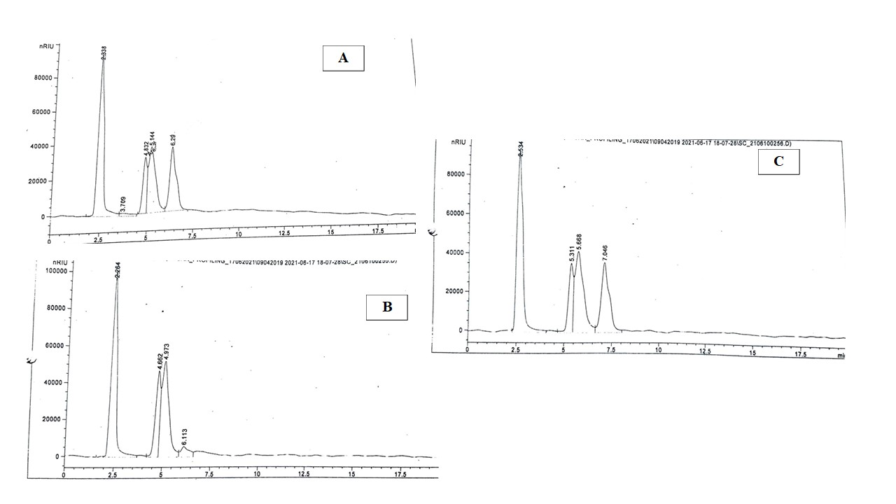

**Figure2. Turbidity measurements of different treatments of sugar, jaggery and honey based kinnow nectar**

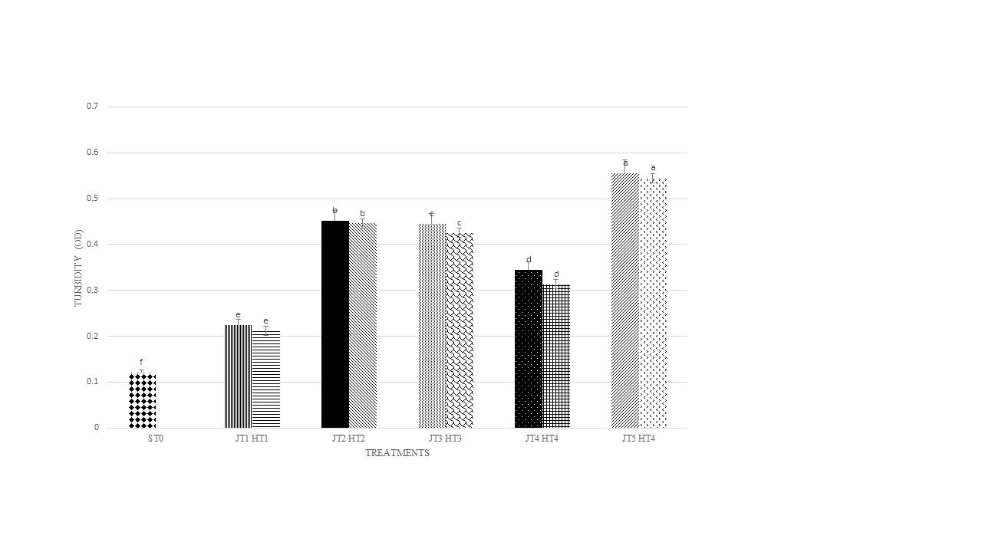

**Figure 3. Viscosity measurements of different kinnow nectar**

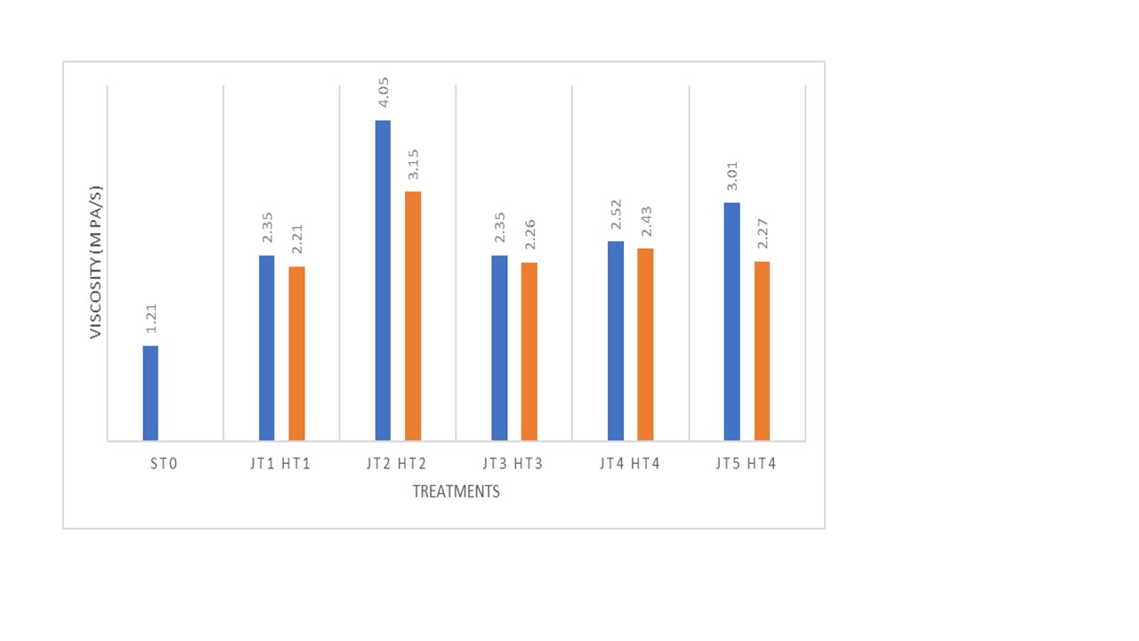

**Figure 4. Steady state rheology of kinnow nectar where JT1-JT5 presents treated jaggery nectars, HT1-HT5 represents treated honey nectars and ST0 represents sugar nectar.**

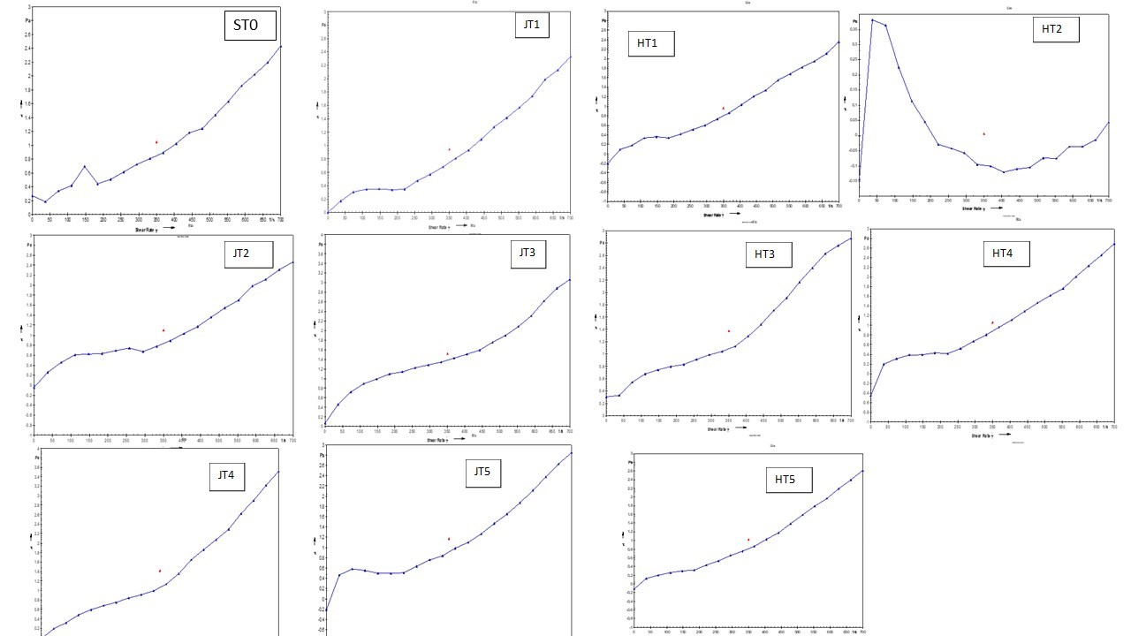

**Figure 5. Effect of sweetener and their respective treatments on sensory properties of kinnow nectar**

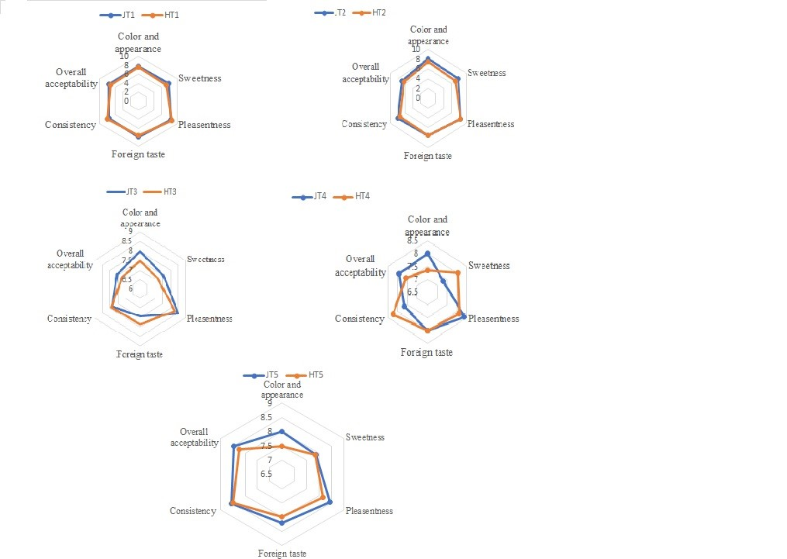

**Table 1. Physicochemical and bioactive composition of kinnow fruit nectar**

|  |  |  |  |  |  |  |  |  |
| --- | --- | --- | --- | --- | --- | --- | --- | --- |
| Treatments | TSS  (0 B) | pH | Reducing sugars (mg/100ml) | Total sugars  (mg/100ml) | Ascorbic acid (mg/100ml) | Total phenols  (mg GAE/10ml) | Antioxidant value  (IC 50- mg/100ml) | Carotenoids  (µg beta carotene /100ml) |
| ST0 | 15.0±0.01b | 2.56±0.14b | 7.73±1.21c | 8.88±0.17c | 2.28±0.15c | 121.50±1.14c | 148.25±0.78a | 3.58±0.08b |
| JT1 | 15.11±0.05a | 2.98±0.11a | 10.44±0.89a | 12.33±0.15a | 3.56±0.19a | 207.51±1.16a | 56.28±0.24c | 4.35±0.04a |
| JT2 | 15.11±0.01a | 2.98±0.14a | 9.40±0.77ab | 12.33±0.24a | 3.24±0.18a | 210.38±0.89a | 59.45±0.18c | 4.30±0.09a |
| JT3 | 14.90±0.03a | 2.91±0.15a | 10.54±1.02a | 15.17±0.14a | 3.89±0.12a | 211.40±0.88a | 58.21±0.16c | 4.52±0.04a |
| JT4 | 15.13±0.02a | 3.0±0.16a | 10.34±0.90a | 14.44±0.14a | 3.56±0.14a | 209.29±0.56a | 56.19±0.14c | 4.69±0.08a |
| JT5 | 15.14±0.02a | 2.89±0.21a | 10.48±0.81a | 14.78±0.15a | 3.71±0.11a | 212.76±0.45a | 54.81±0.24c | 4.31±0.07a |
| HT1 | 15.03±0.02a | 2.35±0.14c | 9.02±0.58b | 13.78±0.27b | 2.83±0.04b | 155.52±0.78b | 86.94±0.54b | 3.98±0.05b |
| HT2 | 15.15±0.01a | 2.21±0.19c | 9.23±0.65b | 13.02±0.34b | 2.56±0.02b | 161.87±0.62b | 85.64±0.14b | 3.75±0.08b |
| HT3 | 15.08±0.04a | 2.39±0.15c | 9.42±0.57b | 13.72±0.45b | 2.87±0.08b | 158.23±0.78b | 86.14±0.21b | 3.59±0.05b |
| HT4 | 15.13±0.01a | 2.42±0.13bc | 9.89±0.41b | 13.23±0.54b | 2.43±0.04b | 156.67±0.29b | 86.44±0.19b | 3.67±0.07b |
| HT5 | 15.14±0.02a | 2.50±0.12b | 9.77±0.32b | 13.78±0.31b | 2.51±0.02b | 156.34±0.21b | 85.99±0.17b | 3.46±0.03b |

STO represents control sugar based nectar, JT1-JT5 represents jaggery based nectars and HT1-HT5 represents honey based nectars. Values in the table represents the mean value of 3 replicates ± SD.

Superscripts a,b,c…represnts significant differences within treatments in a column.

**Table 2 . Color properties of kinnow nectar**

|  |  |  |  |  |
| --- | --- | --- | --- | --- |
| Treatments | Color properties | | | Δ E |
| L* | a* | b* |
| ST0 | 41.46±2.22b | 4.42±0.10a | 21.20±1.57c | - |
| JT1 | 49.47±1.44a | 3.68±0.15b | 29.98±0.95a | 10.87 |
| JT2 | 49.6±2.50a | 2.66±0.74c | 30.02±3.48a | 10.65 |
| JT3 | 49.56±0.76a | 3.43±0.52b | 29.62±3.59a | 11.74 |
| JT4 | 49.33±1.08a | 3.10±0.35b | 29.12±0.91a | 11.41 |
| JT5 | 49.34±2.66a | 2.77±0.47c | 29.45±2.76a | 11.87 |
| HT1 | 41.47±1.44b | 0.68±0.15d | 25.98±0.95b | 5.45 |
| HT2 | 39.44±4.92c | 0.79±0.18d | 24.86±2.59b | 5.98 |
| HT3 | 41.79±1.86b | 1.11±0.09d | 23.72±1.01b | 5.43 |
| HT4 | 41.44±1.37b | 0.74±0.17d | 24.09±1.00b | 5.39 |
| HT5 | 41.44±2.11b | 1.11±0.15d | 24.21±1.09b | 5.56 |

STO represents control sugar based nectar, JT1-JT5 represents jaggery based nectars and HT1-HT5 represents honey based nectars. Values in the table represents the mean value of 3 replicates ± SD.

Superscripts a,b,c…represnts significant differences within treatments in a column.

**Table 3. Mineral profiles of kinnow nectar**

|  |  |  |  |
| --- | --- | --- | --- |
| Mineral | Jaggery Nectar | Honey  Nectar | Sugar  Nectar |
| Aluminium (Al) | 15874.61a | 11359.27b | 10207.91c |
| Chromium (Cr) | 251.13a | 93.65b | 36.85c |
| Manganese (Mn) | 856.06a | 314.36b | 202.60c |
| Iron (Fe)* | 68.24b | 90.54a | 4.96c |
| Cobalt (Co) | 6.33a | 1.62b | 0.51c |
| Nickel (Ni) | 35.71a | 28.12b | 4.79c |
| Copper (Cu)* | 117.86a | 67.37c | 105.11b |
| Zinc (Zn)* | 332.07b | 740.01a | 155.71c |
| Arsenic (As) | 2.76a | 2.34b | 1.12c |
| Selenium (Se)* | 9.96b | 12.35a | 7.40c |
| Silver (Ag) | - | - | - |

Values in the table represents the mean value of 3 replicates ± SD.

Superscripts a,b,c…represnts significant differences within treatments in a row.

**Table 4. Visual sediment effect demonstrated by the different hydrocolloids**

|  |  |  |  |  |  |
| --- | --- | --- | --- | --- | --- |
| Treatments | Visual sedimentation during storage (days) at 250 C | | | | |
| 5 | 10 | 15 | 20 | 25 |
| ST0 | + | ++ | x | x | x |
| JT1 | 0 | 0 | + | ++ | ++ |
| JT2 | 0 | 0 | 0 | + | + |
| JT3 | 0 | 0 | 0 | + | + |
| JT4 | 0 | 0 | 0 | + | ++ |
| JT5 | 0 | 0 | 0 | + | + |
| HT1 | 0 | 0 | + | + | + |
| HT2 | 0 | 0 | 0 | + | + |
| HT3 | 0 | 0 | 0 | + | + |
| HT4 | 0 | 0 | 0 | + | ++ |
| HT5 | 0 | 0 | 0 | + | + |

0 indicates no sediment observed; + slight sediment; ++ moderate sediment; x defective level sediment. STO represents control sugar based nectar, JT1-JT5 represents jaggery based nectars and HT1-HT5 represents honey based nectar.