***Original Research Article***

**Investigating the Anti-Angiogenic and Cytotoxic Characteristics of *Capparis decidua* through Integrated *in Silico* and *in Vitro* Analysis**

**Abstract**

*Capparis decidua*, an arid-zone indigenous plant, has been traditionally used for various medicinal purposes. It is a medically valued plant that has been reported to possess therapeutic potential. Herein, it was assessed for its anti-angiogenic and cytotoxic potential with a combined application of in vitro, in vivo, and in silico models with reference to its clinical potential in treating breast cancer. Cytotoxicity was determined by the MTT assay in MCF-7 breast cancer cells. The chick chorioallantoic membrane (CAM) assay was used to investigate anti-angiogenesis. Molecular docking studies were also performed on prominent phytoconstituents—Capparin and 6-(1-hydroxy-non-3-enyl) tetrahydropyran-2-one—against breast cancer-related targets MDM2 and estrogen receptor (ER) by ArgusLab and Discovery Studio. MTT assay showed a dose-dependent cytotoxic effect, with *C. decidua* extract having an IC₅₀ value of around 1368 µg/ mL. The extract significantly blocked blood vessel development at 12.5, 25, and 50 µg/ egg in the CAM assay, with antiangiogenic indices similar to those of 5-fluorouracil. Docking studies revealed that 6-(1-hydroxy-non-3-enyl) tetrahydropyran-2-one strongly attaches to MDM2 (−10.1887 kcal/mol) and ER (−10.8640 kcal/mol), suggesting it could interfere with processes that promote cancer. The results indicate that *Capparis decidua* exhibits significant anti-cancer activity, such as cytotoxic and anti-angiogenic effects, evidenced by its molecular interactions with key breast cancer targets. These findings support further exploration of *C. decidua* as a potential candidate for complementary or alternative cancer therapy.

**Keywords:** *Capparis decidua*, MCF-7, anti-angiogenic, cytotoxicity, CAM assay, molecular docking, breast cancer.

1. **Introduction**

Abnormal proliferation of breast tissue cells defines breast cancer. Atypical cell proliferation and multiplication in breast tissues cause breast cancer [1]. Breast cancer is among the most prevalent cancers in women, making it a major worldwide health issue. Breast cancer accounts for 25% of all cancer cases in women, rendering it the most common malignancy among the female population [2]. In India, breast cancer accounts for 28.2 % of all female cancer cases, with around 216,108 new cases reported in 2022 [3]. The age-standardized incidence rate of breast cancer among Indian women increased by 39.1% from 1990 to 2016, highlighting the urgent necessity for effective therapies. Although the majority of breast cancers are non-aggressive and can be adequately treated with surgical procedures, around 25% have slow-growing but highly invasive traits. Contemporary therapeutic strategies can inhibit tumour proliferation but frequently do not avert recurrence, increasing fatality rates [1]. Several cancer cell lines are utilised globally to evaluate their pathobiology and the effectiveness of novel investigational agents [4, 5]. Due to its molecular heterogeneity, suitable models are essential for understanding disease prognosis, underlying mechanisms, and the action of drugs [6]. MCF-7 cells were established in 1973 at the Michigan Cancer Foundation. This cell line is considered one of the optimal models for breast cancer studies due to its sensitivity related to the expression of estrogen receptors (ER) [7].

Angiogenesis is the process of new blood vessel formation and plays a significant role in tumour proliferation [8]. Tumours exhibiting insufficient angiogenesis have an inability to attain logarithmic growth, resulting in a dormant state, as tumour proliferation is significantly reliant on vascular development for the provision of essential nutrients [9]. The discovery of anti-angiogenic agents has garnered significant attention as tumour suppressive agents in cancer chemotherapy [9]. Numerous potential anti-angiogenic agents are under investigation for novel drug discovery [11]. The chicken chorioallantoic membrane (CAM) serves as an *in vivo* model for evaluating the effects of potential anti-angiogenic agents on blood vessel formation [12]. Natural products have emerged as a possible source for the development of anti-cancer therapies. Certain medicinal plants, particularly those used in traditional Chinese medicine, have been reported to exhibit efficacy in ischemic diseases and cancer [13].

Medicinal herbs like *Capparis decidua*, which have been used for different health issues, have important natural substances like glucosides, glucocapparin, stachydrine, n-triacontane, β-carotene, 6-(1-hydroxy-non-3-enyl) tetrahydropyran-2-one, β-sitosterol, and capparin that show strong anticancer effects according to literature surveys [14, 15, 16]. This study investigates the anticancer potential of *Capparis decidua*. Plant extract evaluated for cytotoxicity against MCF-7 cell line, along with anti-angiogenic and *in silico* molecular docking to predict potential binding modes.

1. **Materials and Methods**
2. **Materials**

Trypsin EDTA (Himedia), MTT reagent (Merck), dimethyl sulfoxide (DMSO), (Merck) 70% alcohol (Emplura), distilled water (Panshul Industries), hemocytometer (ROHEM INDIA), microscope and camera (Lab tech), ELISA plate reader (Alere medical Pvt. Ltd.), pipettes (Perfect), CO₂ incubator (Remi), culture flasks (Tarsons), 96-well plate (Himedia), and centrifuge tubes (Himedia).

1. **Plant Sample Collection**

Fresh plant materials of *Capparis decidua* were collected at Dive Ghat, Tal. Purandar, Pune. The specimens received were submitted for botanical authentication to the Botanical Survey of India (BSI), and an authentication number (CDSRM-2) was provided.

1. **Preparation of Extracts**

The chosen plant parts were washed clean of debris and dried in the shade for 15 days to keep them intact phytochemically. The leaves, after drying, were crushed into a fine powder using a mechanical grinder. A 50-gram sample of the coarse powder was cold extracted using methanol. The resulting extract was dried in the shade for 10–12 hours [17, 18]. The crude extract was then concentrated by evaporation of the solvent, giving a dry residue. The yield of the extraction was about 15% of the original plant material [19, 20].

1. **Details of the MCF-7 Cell Line**

The MCF-7 cell line was initially isolated from the breast tissue of a 69-year-old Caucasian woman with adenocarcinoma and is used extensively in the study of breast cancer. The cells have adherent growth patterns and are indicative of estrogen receptor-positive breast cancer. For the current study, the MCF-7 cell line was obtained from the National Centre for Cell Science (NCCS), Pune, India. All the cell culture steps were performed according to the standard protocol suggested by NCCS for ensuring the viability and authenticity of the cell line.

1. **In Vitro Cytotoxicity Assay – MTT Assay**

Cytotoxic activity of the test extract was determined using MTT assay in MCF-7 cells for breast cancer. The cell line was twice passaged when received from National Centre for Cell Science (NCCS), Pune, and then used. The cells were detached enzymatically by trypsin-EDTA solution, then centrifuged at 1000 RPM for 3 minutes. The cell pellet resulting from it was resuspended in new culture medium, and the cell density was brought to 1 × 10⁵ cells/mL. Each well in a 96-well plate was seeded with 100 μL of the pre-adhered cell suspension (1 × 10⁴ cells/well). The plates were incubated at 37 ± 1°C in a humidified atmosphere with 5% CO₂ for 24 hours for cell adhesion, recovery, and entry into the exponential growth phase. Cell monolayer formation and cell viability were verified using a phase-contrast microscope [21].Treatment consisted of placing 100 μL of media containing different concentrations of the test extract, negative control, or positive control in individual wells, with each treatment condition run in triplicate. The assay consisted of five different concentrations of the positive control and eight varying concentrations of the test extract. The plates were incubated a second time under the same condition for 48 hours. After treatment, media were removed cautiously and 10 μL MTT reagent (3-[4,5-dimethylthiazol-2-yl]-2,5-diphenyltetrazolium bromide) was added to each well. Plates were incubated for another 3 hours. MTT reagent was removed following incubation, and 100 μL dimethyl sulfoxide (DMSO) was added to dissolve the formazan crystals generated by living cells. Absorbance was quantitated at 570 nm on an ELISA plate reader for the determination of cell viability [22].

1. **In Vitro Anti-Angiogenic Assay – CAM Assay**

The anti-angiogenic activity of the test extract was tested with the Chick Chorioallantoic Membrane (CAM) assay. Fertilized chicken eggs were preliminary cleaned using 70% ethanol and incubated in a humidified chamber at 37°C for one day. A 1 cm² window was delicately cut on the fourth day of incubation on the eggshell of each egg and temporarily sealed with sterile adhesive tape. The test extract solutions were made up of distilled water to the required concentrations. Sterile 6-mm filter paper discs were wetted with 10 μL of the test extract or control solution on day six and placed directly on the CAM surface via the pre-cut window. The window was sealed with adhesive tape, and the eggs were again incubated for an additional 48 hours. On day eight, the CAMs were examined visually and photographed. The blood vessels in each CAM were counted to determine the degree of angiogenesis. The test samples were compared with the control groups to determine anti-angiogenic activity [23].

1. **Molecular Docking Studies**

The molecular docking analysis was performed to assess the interaction of the major phytoconstituents of Capparis decidua with chosen cancer-associated target proteins. The 3D structures of active chemical constituents capparin and 6-(1-hydroxy-non-3-enyl) tetrahydropyran-2-one were downloaded from the PubChem which are present in *Capparis decidua* [24]*.* The 3D structures of the active chemical compounds—Capparin and 6-(1-hydroxy-non-3-enyl) tetrahydropyran-2-one—were obtained from the PubChem database. These substances are reported to occur naturally in *Capparis decidua*. Breast cancer-related target proteins, such as estrogen receptors and MDM2, were chosen for the docking experiments. Their crystal structures were downloaded from the RCSB Protein Data Bank (PDB). Co-crystallized ligands and crystallographic water molecules were eliminated before docking to get the proteins ready for analysis. Molecular docking was conducted with ArgusLab 4.0.1 at default parameters to estimate binding affinities and interaction patterns. Docking visualization and ligand–protein interaction analysis was done using Discovery Studio Visualizer for visualization of binding poses and molecular interactions in detail.

1. **Results**
2. **In Vitro Model – MTT Assay (Anti-Cancer Activity)**

The ability of Capparis decidua extract to kill MCF-7 human breast cancer cells was tested using the MTT assay. The data are shown in Tables 1 and 2 and graphically illustrated in Figure 1. Within the first concentration range (12.5–500 µg/mL), *C.* *decidua* extract was not strongly cytotoxic, with cell viability greater than 70%, implying a weaker effect at reduced concentrations. The percentage viability between 12.5, 25, 50, 100, 200, 300, 400, and 500 µg/ mL was 74.29% to 104.10%, as indicated in Table 1, meaning IC₅₀ could not be established within the range.

**Table 1:** Absorbance, % Viability for vehicle, positive control, and test item- *Capparis decidua* extract

|  |  |  |  |  |  |  |  |  |
| --- | --- | --- | --- | --- | --- | --- | --- | --- |
| Absorbance at 570 nm- 24 hours | | | | | | | | |
| **Formulations** | | **Conc.**  **(µg/mL)** | **Ab. 1** | **Ab. 2** | **Ab. 3** | **Mean** | **SD** | **% Viability** |
| **Vehicle Control** | | 100 µL | 0.620 | 0.767 | 0.663 | 0.68 | 0.08 | 100.00 |
| ***Capparis decidua*** | F8 | 12.5 | 0.686 | 0.661 | 0.717 | 0.69 | 0.03 | 100.68 |
| F7 | 25 | 0.716 | 0.740 | 0.678 | 0.71 | 0.03 | 104.10 |
| F6 | 50 | 0.609 | 0.642 | 0.680 | 0.64 | 0.04 | 94.20 |
| F5 | 100 | 0.651 | 0.586 | 0.692 | 0.64 | 0.05 | 94.10 |
| F4 | 200 | 0.659 | 0.543 | 0.710 | 0.64 | 0.09 | 93.27 |
| F3 | 300 | 0.548 | 0.640 | 0.702 | 0.63 | 0.08 | 92.20 |
| F2 | 400 | 0.643 | 0.615 | 0.582 | 0.61 | 0.03 | 89.76 |
| F1 | 500 | 0.442 | 0.534 | 0.547 | 0.51 | 0.06 | 74.29 |

The study was extended to higher concentrations since the IC 50 cannot be calculated from the above results.

To determine IC₅₀, more extended concentrations were tested (125–5000 µg/ mL). As indicated in Table 2, there was a clear dose-dependent decrease in cell viability. The extract exhibited a noteworthy drop in cell viability in a rising concentration 88.23% at 125 µg/ mL to 17.26% at 5000 µg/ mL. The IC₅₀ was found to be about 1368 µg/ mL, reflective of moderate cytotoxicity. The cytotoxic profile of the extract was similar to that of the reference chemotherapeutic agent, Capecitabine, with a 20.81% viability recorded at 5000 µg/mL.

**Table 2:** Absorbance, % Viability for vehicle, positive control, and test item of ***Capparis decidua***

|  |  |  |  |  |  |  |  |  |
| --- | --- | --- | --- | --- | --- | --- | --- | --- |
| Absorbance at 570 nm- 24 hours | | | | | | | | |
| **Formulations** | | **Conc.**  **(µg/mL)** | **Ab. 1** | **Ab. 2** | **Ab. 3** | **Mean** | **SD** | **% Viability** |
| **Vehicle Control** | | 100 µL | 0.205 | 0.204 | 0.211 | 0.207 | 0.004 | 100.00 |
| ***Capparis decidua*** | F8 | 125 | 0.165 | 0.195 | 0.187 | 0.182 | 0.016 | 88.23 |
| F7 | 250 | 0.175 | 0.172 | 0.185 | 0.177 | 0.007 | 85.81 |
| F6 | 500 | 0.151 | 0.152 | 0.134 | 0.146 | 0.010 | 70.48 |
| F5 | 1000 | 0.105 | 0.108 | 0.107 | 0.107 | 0.002 | 51.61 |
| F4 | 2000 | 0.098 | 0.088 | 0.083 | 0.090 | 0.008 | 43.39 |
| F3 | 3000 | 0.077 | 0.087 | 0.09 | 0.085 | 0.007 | 40.97 |
| F2 | 4000 | 0.055 | 0.045 | 0.054 | 0.051 | 0.006 | 24.84 |
| F1 | 5000 | 0.035 | 0.034 | 0.038 | 0.036 | 0.002 | 17.26 |
| **Positive Control Capecitabine** | F5 | 1000 | 0.111 | 0.104 | 0.104 | 0.106 | 0.004 | 51.45 |
| F4 | 2000 | 0.074 | 0.074 | 0.085 | 0.078 | 0.006 | 37.58 |
| F3 | 3000 | 0.065 | 0.069 | 0.074 | 0.069 | 0.005 | 33.55 |
| F2 | 4000 | 0.054 | 0.060 | 0.068 | 0.061 | 0.007 | 29.35 |
| F1 | 5000 | 0.044 | 0.044 | 0.041 | 0.043 | 0.002 | 20.81 |

**Graphical presentation of data**

Graphical presentation of Absorbance, % Viability for the vehicle, positive control, and test tem- *Capparis decidua* extract

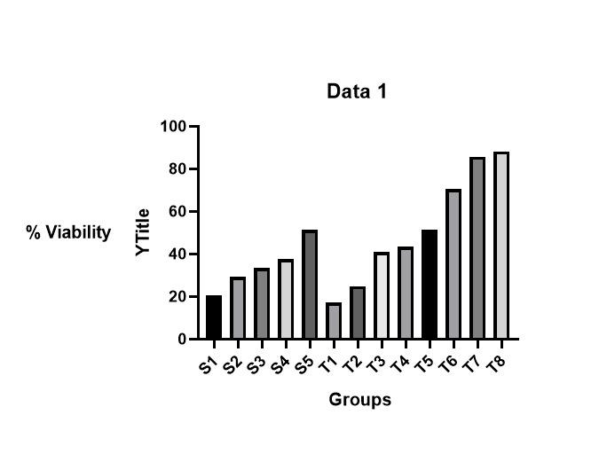

**Figure 1:** Graphical presentation of % viability of test item- *Capparis decidua*  and standard Capecitabine

The graph provides an easy graphical comparison of the impact of *Capparis decidua* extract on cancer cell viability with respect to the control drug Capecitabine. Consistent with expectation, Capecitabine demonstrated high cytotoxicity with decreasing cell survival. Surprisingly, even *C. decidua* significantly reduced cell viability, particularly at higher concentrations—nearly similar to that of comparable to that of Capecitabine control drug. This would indicate that the plant extract potentially has genuine potential as a natural anti-cancer drug, demonstrating both cytotoxic and potential anti-angiogenic activity that is worthy of further investigation.

Photographic support (Figures 2) recorded morphological alterations in cell structures and decreases in cell populations at high extract concentrations, indicative of the quantitative results.

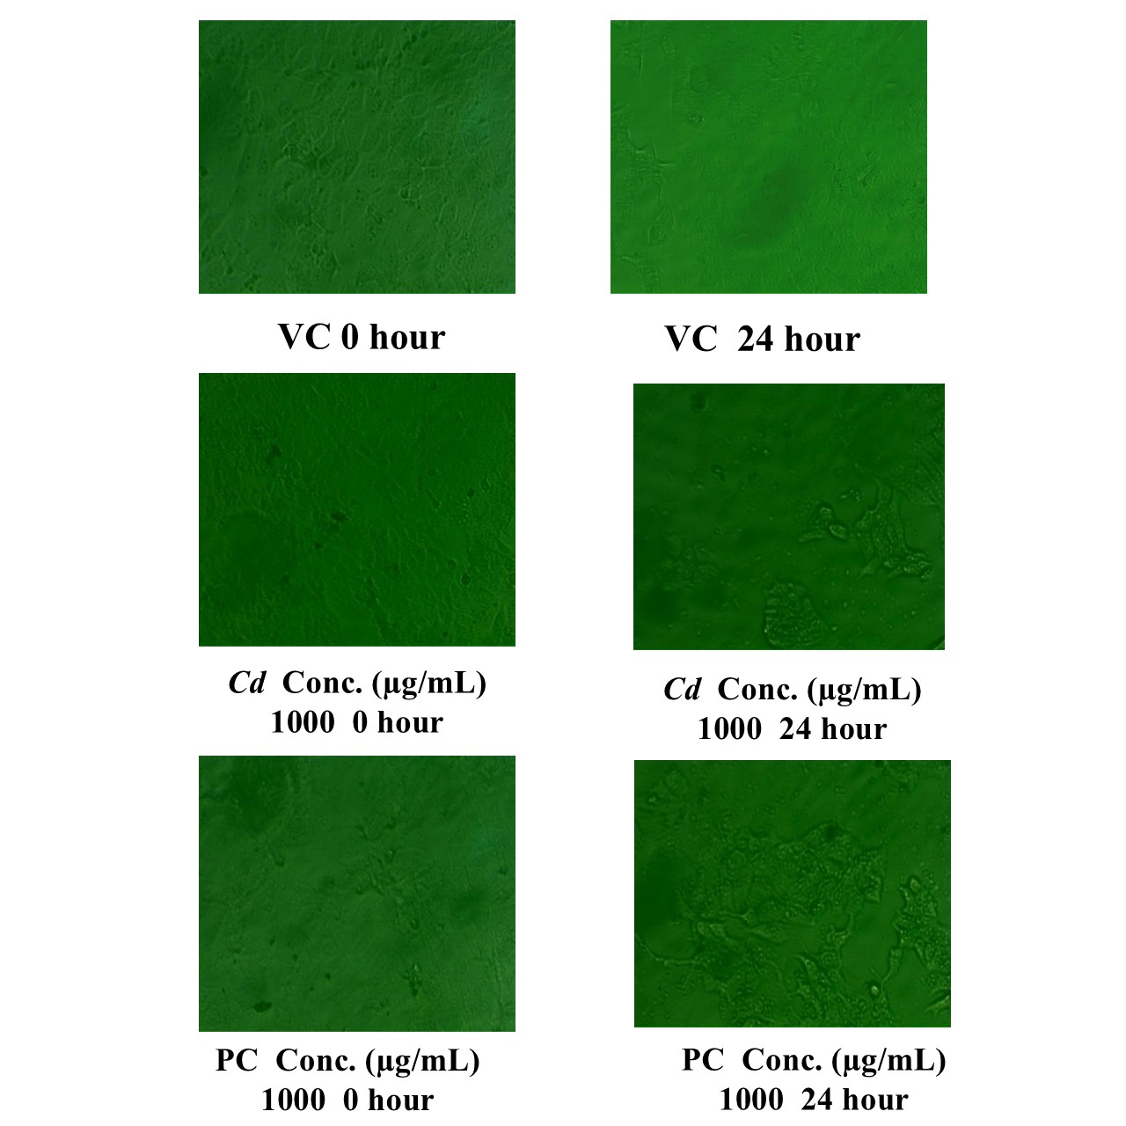

**Figure 2** Morphological alterations in cell structures at near it’s IC₅₀ . VC (Vehicle Control), Cd (*Capparis decidua*) and PC (Positive Control Capecitabine)

The present study demonstrated that *Capparis decidua* extract exhibits significant antiangiogenic activity in a dose-dependent manner, as observed through both quantitative data (antiangiogenic indices) and qualitative photographic documentation. The test extract, particularly at 50 µg/egg and 25 µg/egg, showed inhibition of blood vessel formation comparable to the standard drug 5-fluorouracil at 10 µg/egg and 5 µg/egg, respectively. These findings suggest that *Capparis decidua* contains bioactive constituents capable of suppressing angiogenesis, making it a promising candidate for further exploration as a natural antiangiogenic agent. This potential may be of therapeutic interest in the treatment of angiogenesis-dependent diseases such as cancer, diabetic retinopathy, and rheumatoid arthritis. However, further investigations, including phytochemical analysis, in vivo studies, and mechanistic evaluations, are warranted to establish its therapeutic potential and safety profile fully.

1. **In Vivo Model-Antiangiogenic Study**

The anti-angiogenic activity of *Capparis decidua* extract was determined by the chorioallantoic membrane (CAM) assay. Tertiary and quaternary blood vessel counts were performed after treatment, and the antiangiogenic index was computed (Table 3). At concentrations of 12.5, 25, and 50 µg/egg, the extract was highly anti-angiogenic, with indices of 45.24, 61.31, and 62.50, respectively. These are in line with that of the positive control, 5-fluorouracil, with antiangiogenic indices of 63.10 (10 µg/egg), 52.98 (5 µg/egg), 47.02 (2.5 µg/egg), and 44.05 (1.25 µg/egg). The nearly identical antiangiogenic indices point to the fact that *Capparis decidua* extract potently inhibits neovascularisation in a dose-dependent manner.

Representative photographs (Figures 3a-h) visually verify decreased blood vessel formation, supporting the extract's antiangiogenic effectiveness.

**Table No. 3** Number of tertiary and quaternary vessels, antiangiogenic index for positive control and test extract ***Capparis decidua***

|  |  |  |  |  |  |  |  |  |  |  |  |  |  |  |
| --- | --- | --- | --- | --- | --- | --- | --- | --- | --- | --- | --- | --- | --- | --- |
| Group | Conc.  µg/  egg | No. Tertiary vessels | | | | | No. Quaternary vessels | | | | | Sum | Avg. | Anti  Angiogenic Index |
| Rep. |  | 1. | 2. | 3. | 4. | 5. | 1. | 2. | 3. | 4. | 5. |
| NC | - | 8 | 6 | 6 | 8 | 7 | 25 | 34 | 14 | 29 | 31 | 168 | 33.6 | - |
| PC- F1 | 10 | 6 | 5 | 3 | 3 | 4 | 6 | 13 | 10 | 7 | 5 | 62 | 12.4 | 63.10 |
| PC- F2 | 5 | 6 | 3 | 4 | 3 | 5 | 20 | 8 | 10 | 9 | 11 | 79 | 15.8 | 52.98 |
| PC- F3 | 2.5 | 1 | 5 | 4 | 5 | 6 | 5 | 16 | 20 | 15 | 12 | 89 | 17.8 | 47.02 |
| PC- F4 | 1.25 | 4 | 4 | 5 | 6 | 5 | 6 | 22 | 13 | 15 | 14 | 94 | 18.8 | 44.05 |
| TI-F1 | 50 | 2 | 4 | 4 | 3 | 4 | 11 | 9 | 7 | 10 | 9 | 63 | 12.6 | 62.50 |
| TI-F2 | 25 | 5 | 5 | 6 | 4 | 6 | 6 | 5 | 9 | 9 | 10 | 65 | 13 | 61.31 |
| TI-F3 | 12.5 | 4 | 7 | 6 | 5 | 4 | 19 | 9 | 11 | 15 | 12 | 92 | 18.4 | 45.24 |

Rep.: Replicate; NC: Negative control; PC: Positive control; F: Formulation; TI: Test item. By comparison, the standard drug 5-fluorouracil showed antiangiogenic indices of 63.10, 52.98, 47.02, and 44.05 at respective doses of 10, 5, 2.5, and 1.25 µg per egg.

### Table 3, results show the antiangiogenic activity of *Capparis decidua* extract (Test Item, TI) in different concentrations (50 µg, 25 µg, and 12.5 µg per egg) in comparison to the reference chemotherapeutic drug 5-fluorouracil (Positive Control, PC) and a Negative Control (NC). In the negative control, there was normal vessel development with a mean number of vessels (tertiary plus quaternary) of 33.6. No antiangiogenic activity was expected as well as noted in this group, and the antiangiogenic index was not applicable. The positive control, 5-fluorouracil, showed evident dose-dependent inhibition of angiogenesis. The highest dose of 10 µg/egg (PC-F1) showed the highest antiangiogenic index of 63.10, reflecting maximum suppression of new vessel growth. With decreasing doses, the antiangiogenic index also decreased—52.98 at 5 µg/egg (PC-F2), 47.02 at 2.5 µg/egg (PC-F3), and 44.05 at the lowest level of 1.25 µg/egg (PC-F4), affirming the concentration-dependent nature of its antiangiogenic activity. Likewise, *Capparis decidua* extract was found to possess a dose-dependent antiangiogenic activity. At the highest tested dose (50 µg/egg, TI-F1), the extract had an antiangiogenic index of 62.50, which closely equaled that of the standard drug at 10 µg/egg. At 25 µg/egg (TI-F2), the index was high at 61.31, which indicated high inhibition of vascular growth. At the lowest tested dose (12.5 µg/egg, TI-F3), the index reduced to 45.24, reflecting lower but still significant antiangiogenic activity. Comparison between test item and the positive control indicates that *Capparis decidua* extract at 50 µg/egg is almost as potent as 5-fluorouracil at 10 µg/egg in inhibiting angiogenesis. At even 25 µg/egg, the extract showed antiangiogenic activity on par with intermediate doses of the reference drug, highlighting its prospect as a natural inhibitor of angiogenesis. These results as a whole indicate that *Capparis decidua* extract has impressive antiangiogenic activity in a dose-dependent pattern. Its similarity to 5-fluorouracil at higher concentrations indicates its potential as a drug candidate for targeting angiogenesis, a critical process in tumor progression and metastasis. Additional investigation into its mode of action and confirmation by in vivo models would be necessary to determine its potential in breast cancer treatment.

|  |  |
| --- | --- |
|  |  |
| **3 (a): NC** | **3 (b): PC- F1** |
|  |  |
| **3 (c): PC- F2** | **3 (d): PC- F3** |
|  |  |
| **3 (e): PC- F4** | **3 (f): TI- F1** |
|  |  |
| **3 (g): TI- F2** | **3 (h): TI-F3** |

**Figure 3:** Representative images for each experimental group are presented below to visually demonstrate the extent of blood vessel formation (angiogenesis) or inhibition (antiangiogenesis) observed.

Representative photographs of the CAM assay quantitatively illustrate the degree of angiogenesis or its inhibition within the experimental groups. In the negative control group (Figure 3a), the typical vascular growth was seen, where there existed a dense network and complexity of tertiary and quaternary vessels, reflecting unimpaired angiogenesis. Contrariwise, the positive control groups treated with 5-fluorouracil revealed a dose-related suppression of blood vessel formation. At the highest dose (10 µg/egg, Figure 3b), there was significant decrease in vascular density, indicating a strong antiangiogenic effect. With decreasing dose, the degree of inhibition decreased: the 5 µg/egg group (Figure 3c) had moderate inhibition, the 2.5 µg/egg group (Figure 3d) had mild suppression, and the lowest dose (1.25 µg/egg, Figure 3e) had the lowest antiangiogenic activity among the treated groups, with vessel formation being close to that of the control. The test groups treated with *Capparis decidua* extract also exhibited dose-dependent antiangiogenic activity. At 50 µg/egg (Figure 3f), there was significant inhibition of vessel formation, which was similar to that observed with 10 µg/egg of 5-fluorouracil, and it showed good inhibitory potential. At 25 µg/egg (Figure 3g), there was moderate antiangiogenic activity, with reduced branching and fewer blood vessels that were visible. The lowest concentration tested (12.5 µg/egg, Figure 3(h) showed only weak inhibition of vascular development against the control but still showed a significant measurable antiangiogenic effect. In summary, these snapshot images validate the quantitative data and demonstrate that *Capparis decidua* extract is a potent inhibitor of angiogenesis in a concentration-dependent response.

1. **In Silico Molecular Docking Studies:**

A molecular docking investigation was conducted under the assumption of a model in which the docking process treated the protein and ligand as flexible entities. The estimated docking score presented in Table 4 and 5. Molecular docking was performed using ArgusLab to investigate the interaction of two principal phytoconstituents of *Capparis decidua*—Capparin and 6-(1-hydroxy-non-3-enyl) tetrahydropyran-2-one—against cancer-related protein targets, MDM2 and Estrogen Receptor (ER).

**Against MDM2 (PDB ID: 4JRG, DOI: 10.2210/pdb4JRG/pdb):**

Capparin had a docking score of −7.7979 kca/mol with hydrophobic and van der Waals interactions with residues such as VAL A71, LEU A78, and PHE A87. 6-(1-hydroxy-non-3-enyl) tetrahydropyran-2-one showed a stronger attraction with a value of −10.1887 kcal/mol, connecting to important parts like MET B130, PHE B171, and ILE B183.

**Table 4:** Interaction between chemical constituents of ***Capparis decidua*** and MDM2PDB 4JRG PDB

|  |  |  |  |  |  |
| --- | --- | --- | --- | --- | --- |
| **DRUG** | **Docking score / binding energy (Kcal/mol )** | **Van Der waals** | **H bond** | **Pi sulphur** | **Alkyl** |
| Capparin | -7.7979 | VAL A 71  LEU A 78  PHE A 87  MET A 98 | LEU A 50 | PHE A 82 | LEU A 53  ILE A 57  VAL A 89  ILE A 95  ILE A 99 |
| 6-(1-hydroxy-non-3-enyl) tetrahydropyran-2-one | -10.1887 | MET B 130  LYS B 131  GLY B 138  ILE B 141  PHE B 171  VAL B 173  MET B 182  ILE B 183 | TRY B 135 |  | LEU B 137  LEU B 162  PHE B 166  ILE B 179 |

Source: DOI: https://doi.org/10.2210/pdb4JRG/pdb

**Against Estrogen Receptor (PDB ID: 1ERE, DOI: 10.2210/pdb1ERE/pdb):** Capparin displayed a docking score of −8.4043 kcal/mol, binding to residues like MET C861 and LEU C881. 6-(1-hydroxy-non-3-enyl) tetrahydropyran-2-one exhibited the highest docking score of −10.8640 kcal/mol, with binding at HIS D1229, LEU D1054, and PHE D1112.

**Table No. 5:** Interaction between chemical constituents of ***Capparis decidua*** *and* ESTROGEN RECEPTOR1ERE

|  |  |  |  |  |  |
| --- | --- | --- | --- | --- | --- |
| **DRUG** | **Docking score / binding energy (Kcal/mol)** | **Van Der waals** | **H bond** | **Pi sulphur** | **Alkyl** |
| Capparin | -8.4043 | LEU C 818  ALA C 823  GLU C 826  MET C 861  LEU C 881  GLY C 991  PHE C 898 | LEU C 826 | MET C 894 | LEU C 819  LEU C 822  LEU C 864  ILE C 897  LEU C 901 |
| 6-(1-hydroxy-non-3-enyl) tetrahydropyran-2-one | -10.8640 |  | HIS D 1229 |  | LEU D 1054  LEU D 1099  PHE D 1112  LEU D 1230 |

**Source: DOI: https://doi.org/10.2210/pdb1ERE/pdb**

These findings show promising potential for both compounds to disrupt MDM2-p53 interactions and ER-mediated mechanisms-two of the most important processes in breast cancer development. Docking images (Table 6) also depict these interactions.

**Table 6:** Docking images

|  |  |
| --- | --- |
| Capparin with MDM2 | 6-(1-hydroxy-non-3-enyl) tetrahydropyran-2-one with MDM2 |
|  |  |
| Capparin with Estrogen Receptor | 6-(1-hydroxy-non-3-enyl) tetrahydropyran-2-one with Estrogen Receptor |
|  |  |

The findings indicate that *Capparis decidua* may have an ability to inhibit critical cancer-related proteins could contribute to its anticancer effects. This mechanism is believed to play a role in the anticancer properties of *Capparis decidua.* Graphically it is presented in the Figure 4

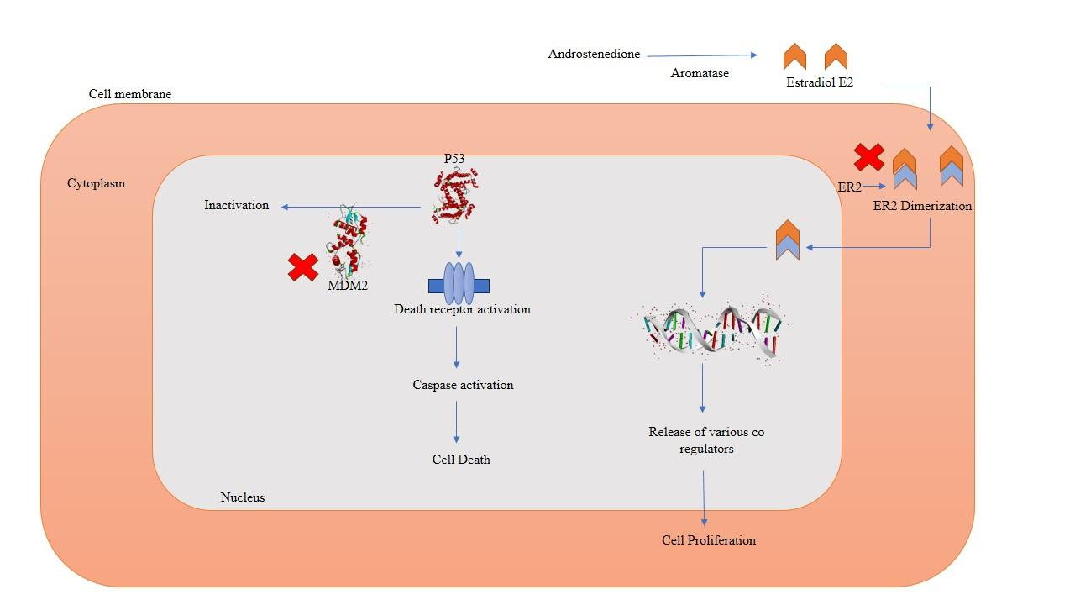

**Figure 4.** The image demonstrates the possible MOA of the active chemical constituents of *Capparis decidua*

1. **Discussion**

Breast cancer is the most prevalent cancer among women and ranks as the second leading cause of cancer-related fatalities in this population. Numerous patients seek complementary or alternative therapies alongside standard treatments like chemotherapy and radiation therapy. Herbal remedies represent a promising alternative treatment option due to their potential benefits and their capacity to alleviate side effects [25, 26, 27]. The significant adverse effects associated with conventional therapies can notably diminish a patient’s quality of life. Herbal medicines might aid in reducing these side effects or improving the efficacy of standard treatments. The effects of various herbs can vary among individuals based on factors such as lifestyle, genetic background, and more [28].The current research explores the anti-angiogenic and cytotoxic activities of *Capparis decidua* by using a mix of in vitro assays and in silico molecular docking studies. The results help to shed light on the probable mechanisms through which *C. decidua* acts to inhibit cancer, especially breast cancer.

An MTT assay (3-(4,5-dimethylthiazol-2-yl)-2,5-diphenyl tetrazolium bromide) was employed to investigate the cytotoxic effects of Capparis decidua. The cell viability of *Capparis decidua* was recorded at 17.26%, 24.84%, 40.97%, 43.39%, 51.61%, 70.48%, 85.81%, and 88.23% for concentrations of 5000, 4000, 3000, 2000, 1000, 500, 250, and 125 μg/mL, respectively against MCF-7 breast cancer cells. The IC50 value was noted at a concentration of 1368 µg/mL (Table 1), highlighting its potential therapeutic and nutritional benefits. The MTT assay results confirmed that the methanolic extract of *C. decidua* shows great cytotoxicity towards MCF-7 breast cancer cells, with an IC₅₀ value of ca. 2.58 µg/mL. The result is in accordance with existing research on the anticancer activity of Capparis species. For example, in a study conducted on *C. spinosa*, high cytotoxic activity against MCF-7 cells was reported, indicating the presence of anticancer bioactive compounds [29]. Likewise, other medicinal herbs have exhibited significant antiproliferative activity against MCF-7 cells, further reinforcing the therapeutic role of plant compounds in breast cancer [30].

A study in vivo was carried out to evaluate the antiangiogenic activity utilizing the chorioallantoic membrane assay technique. The antiangiogenic activity of the extract from *C. decidua* at doses of 50, 25, and 12.5 µg/egg showed antiangiogenic indices of 62.50, 61.31, and 62.50, respectively. In comparison, the positive control, 5-fluorouracil, exhibited antiangiogenic indices of 63.10, 52.98, 47.02, and 44.05 at dosages of 10, 5, 2.5, and 1.25 µg/egg, respectively. The extract revealed high inhibition of blood vessel development, which is equivalent to 5-fluorouracil, an anti-angiogenic standard compound. This result parallels findings involving other plant extracts, like the extract of *Tephrosia apollinea*, which demonstrated potent anti-angiogenic action through the suppression of microvessel sprouting [31]. The efficacy of CAM assay as a tool to test angiogenesis indicates its utility for screening would-be anti-angiogenic drugs [31, 32].

A molecular docking analysis was conducted using ArgusLab software. The key chemical constituents of *C. decidua* namely Capparin and 6-(1-hydroxy-non-3-enyl) tetrahydropyran-2-one, were docked against the estrogen receptor and MDM2. In silico molecular docking experiments were performed to understand the interaction of *C. decidua* phytoconstituents with major proteins responsible for cancer development, namely MDM2 and estrogen receptors (ER). The docking results indicated that molecules like Capparin and 6-(1-hydroxy-non-3-enyl) tetrahydropyran-2-one have high binding affinities to these targets. Interestingly, 6-(1-hydroxy-non-3-enyl) tetrahydropyran-2-one had a binding energy of −10.1887 kcal/mol to MDM2 and −10.8640 kcal/mol to ER, indicating a potential for modulating these cancer-associated pathways. Comparable molecular docking methods have been used to screen natural compounds as possible ERα antagonists and p53-MDM2 inhibitors and justify the utility of this technique in anticancer drug research [32].The docking scores for Capparin interacting with MDM2 and the estrogen receptor were -7.7979 and -10.1887, respectively. The docking scores for 6-(1-hydroxy-non-3-enyl) tetrahydropyran-2-one with MDM2 and the estrogen receptor were -8.4043 and -10.8640, respectively. From the docking analysis, it was inferred that Capparin and 6-(1-hydroxy-non-3-enyl) tetrahydropyran-2-one may bind to the MDM2 and estrogen receptors, potentially hindering their functions and probable mechanism given Figure 5,6.

1. **Conclusion**

Although these findings are quite promising, further research is necessary to clarify the specific mechanisms underlying the anticancer properties of *Capparis decidua*. In this context, thorough in vivo safety and efficacy assessments in mammalian breast cancer models would be essential. The development of a new anticancer drug derived from *Capparis decidua* would require additional steps, including the extraction and purification of active compounds along with subsequent molecular pharmacological modelling. The outcomes of this study imply that *Capparis decidua* could be a valuable addition to complementary or alternative therapies for breast cancer. In this context, thorough in vivo assessments of safety and effectiveness in mammalian breast cancer models are crucial. Creating a new anticancer drug from *Capparis decidua* would involve further steps, such as the extraction and purification of its active ingredients, along with sophisticated molecular pharmacological modelling. *Capparis decidua* may serve as a significant element in complementary or alternative treatments for breast cancer.

1. **References**
2. Hatsell, S., Rowlands, T., Hiremath, M., & Cowin, P. (2003). Beta-catenin and Tcfs in mammary development and cancer. *Journal of Mammary Gland Biology and Neoplasia*, *8*(2), 145–158. <https://doi.org/10.1023/a:1025944723047>
3. International Agency for Research on Cancer, World Health Organization. Global Cancer Observatory. Cancer Today. International Agency for Research on Cancer, World Health Organization; 2023. Accessed February 22, 2023. <https://gco.iarc.fr/>
4. Sathishkumar, K., Chaturvedi, M., Das, P., Stephen, S., & Mathur, P. (2022). Cancer incidence estimates for 2022 & projection for 2025: Result from National Cancer Registry Programme, India. *The Indian Journal of Medical Research*, *156*(4&5), 598–607. <https://doi.org/10.4103/ijmr.ijmr_1821_22>
5. Wilding, J. L., & Bodmer, W. F. (2014). Cancer cell lines for drug discovery and development. *Cancer Research*, *74*(9), 2377–2384. <https://doi.org/10.1158/0008-5472.CAN-13-2971>
6. Mahnashi, M., Elgazwi, S. M., Ahmed, M. S., & Halaweish, F. T. (2019). Cucurbitacins inspired organic synthesis: Potential dual inhibitors targeting EGFR - MAPK pathway. *European Journal of Medicinal Chemistry*, *173*, 294–304. <https://doi.org/10.1016/j.ejmech.2019.04.018>
7. Levenson, A. S., & Jordan, V. C. (1997). MCF-7: the first hormone-responsive breast cancer cell line. *Cancer research*, *57*(15), 3071–3078.
8. Welsh, J. (2013). Animal models for studying prevention and treatment of breast cancer. In *Elsevier eBooks* (pp. 997–1018). https://doi.org/10.1016/b978-0-12-415894-8.00040-3
9. Ayaz, M., Junaid, M., Ullah, F., Sadiq, A., Subhan, F., Khan, M. A., Ahmad, W., Ali, G., Imran, M., & Ahmad, S. (2016). Molecularly Characterized Solvent Extracts and Saponins from Polygonum hydropiper L. Show High Anti-Angiogenic, Anti-Tumor, Brine Shrimp, and Fibroblast NIH/3T3 Cell Line Cytotoxicity. *Frontiers in Pharmacology*, *7*, 74. <https://doi.org/10.3389/fphar.2016.00074>
10. Hanahan, D., & Folkman, J. (1996). Patterns and emerging mechanisms of the angiogenic switch during tumorigenesis. *Cell*, *86*(3), 353–364. <https://doi.org/10.1016/s0092-8674(00)80108-7>
11. Folkman, J., & Klagsbrun, M. (1987). Angiogenic factors. *Science (New York, N.Y.)*, *235*(4787), 442–447. <https://doi.org/10.1126/science.2432664>
12. Al-Abd, A. M., Alamoudi, A. J., Abdel-Naim, A. B., Neamatallah, T. A., & Ashour, O. M. (2017). Anti-angiogenic agents for the treatment of solid tumors: Potential pathways, therapy and current strategies - A review. Journal of Advanced Research, 8(6), 591-605. <https://doi.org/10.1016/j.jare.2017.06.006>

1. Ribatti, D., Nico, B., Vacca, A., Roncali, L., Burri, P. H., & Djonov, V. (2001). Chorioallantoic membrane capillary bed: a useful target for studying angiogenesis and anti-angiogenesis in vivo. *The Anatomical Record*, *264*(4), 317–324. <https://doi.org/10.1002/ar.10021>
2. Wang, S., Zheng, Z., Weng, Y., Yu, Y., Zhang, D., Fan, W., Dai, R., & Hu, Z. (2004). Angiogenesis and anti-angiogenesis activity of Chinese medicinal herbal extracts. *Life Sciences*, *74*(20), 2467–2478. <https://doi.org/10.1016/j.lfs.2003.03.005>
3. Nandi, S., Nag, A., Khatua, S., Sen, S., Chakraborty, N., Naskar, A., Acharya, K., Calina, D., & Sharifi-Rad, J. (2024). Anticancer activity and other biomedical properties of β-sitosterol: Bridging phytochemistry and current pharmacological evidence for future translational approaches. *Phytotherapy Research: PTR*, *38*(2), 592–619. <https://doi.org/10.1002/ptr.8061> PMID: 37929761.
4. Gupta, A. K. & Tandon, Neeraj & Sharma, Madhu & Saraswathy, A. & K. N., Sunil Kumar & Ramachandran, Shakila & Amala, Khoirun. (2008). Quality Standards of Indian Medicinal Plants Volume 7.
5. Nazar, S., Hussain, M. A., Khan, A., Muhammad, G., & Tahir, M. N. (2018). *Capparis decidua* Edgew (Forssk.): A comprehensive review of its traditional uses, phytochemistry, pharmacology and nutrapharmaceutical potential. *Arabian Journal of Chemistry*, *13*(1), 1901–1916. https://doi.org/10.1016/j.arabjc.2018.02.007
6. Sivanandham, V. (2015). Phytochemical Techniques - A Review. *World Journal of Science and Research*. 1. 80-91.
7. Dhakad, P. K., Sharma, P. K., & Kumar, S. (2018). Evaluation of Anti-arthritic Activity of Hydroalcoholic Extract of *Capparis decidua* (Forssk.) Edgew. on Freund’s Complete Adjuvant-induced Arthritis in Rats. *Immunology and Infectious Diseases*, *6*(1), 6–15. https://doi.org/10.13189/iid.2018.060102
8. Rathee, Sushila & Rathee, Permender & Rathee, Dharmender & Rathee, Deepti & Kumar, Dr. (2010). Phytochemical and pharmacological Potential of Kair (*Capparis Decidua*). *International Journal of Phytomedicine*. 2. 10.5138/ijpm.v2i1.80.
9. Sharma, Bindu & Kumar. (2008). Extraction and Pharmacological Evaluation of Some Extracts of *Tridax procumbens* and *Capparis decidua*. *International Journal of Applied Research in Natural Products*. 1.
10. Rathee, P., Rathee, D., Rathee, D., & Rathee, S. (2011). In vitro anticancer activity of stachydrine isolated from *Capparis decidua* on prostate cancer cell lines. *Natural Product Research*, *26*(18), 1737–1740. https://doi.org/10.1080/14786419.2011.608673
11. Kumar, P., Nagarajan, A., & Uchil, P. D. (2018). Analysis of cell viability by the MTT Assay. *Cold Spring Harbor Protocols*, *2018*(6), pdb.prot095505. https://doi.org/10.1101/pdb.prot095505
12. Kamili, C., Kakataparthy, R. S., Vattikutti, U. M., Chidrawar, V., & Ammineni, S. (2017). Anti-proliferative and anti-angiogenic activities of ion-channel modulators: In-ovo, in-vitro and in-vivo study. *Asian Pacific Journal of Tropical Biomedicine*, *7*(6), 555–562. https://doi.org/10.1016/j.apjtb.2017.05.005
13. Singh, Pradeep & Mishra, Garima & Sangeeta, & Srivastava, Shruti & Jha, K. & Khosa, R. (2010). Traditional uses, phytochemistry and pharmacological properties of *Capparis decidua*: An Overview. *Der Pharmacia Letter*, 3(2).
14. Dhillon, P. K., Mathur, P., Nandakumar, A., Fitzmaurice, C., Kumar, G. A., Mehrotra, R., et al. (2018). The burden of cancers and their variations across the states of India: the Global Burden of Disease Study 1990–2016. *The Lancet Oncology*, 19(10), 1289–1306. <https://doi.org/10.1016/s1470-2045(18)30447-9>
15. Khuwaja, G. A., & Abu-Rezq, A. N. (2004). Bimodal breast cancer classification system. *Pattern Analysis and Applications*, *7*(3), 235–242. <https://doi.org/10.1007/bf02683990>
16. Wanchai, A., Armer, J. M., & Stewart, B. R. (2010). Complementary and Alternative medicine use among Women with breast Cancer: a systematic review. *Clinical Journal of Oncology Nursing*, *14*(4), E45–E55. <https://doi.org/10.1188/10.cjon.e45-e55>
17. Li, S., So, T., Tang, G., Tan, H., Wang, N., Ng, B. F. L., Chan, C. K. W., Yu, E. C., & Feng, Y. (2020). Chinese Herbal Medicine for Reducing Chemotherapy-Associated Side-Effects in Breast Cancer Patients: A Systematic Review and Meta-Analysis. *Frontiers in Oncology*, *10*. <https://doi.org/10.3389/fonc.2020.599073>
18. Sherif, M.M. & El-Shiekh, H.H. & Elaasser, Mahmoud & Elbadry, Mostafa. (2013). In vitro evaluation of antimicrobial and cytotoxic effects of Caper (*Capparis spinosa*). *Journal of Applied Sciences Research*. 9. 2944-2950.
19. Hassan, L. E. A., Ahamed, M. B. K., Majid, A. S. A., Baharetha, H. M., Muslim, N. S., Nassar, Z. D., & Majid, A. M. A. (2014). Correlation of antiangiogenic, antioxidant and cytotoxic activities of some Sudanese medicinal plants with phenolic and flavonoid contents. *BMC Complementary and Alternative Medicine*, *14*(1). <https://doi.org/10.1186/1472-6882-14-406>
20. Kennedy DC, Coen B, Wheatley AM, McCullagh KJA. Microvascular Experimentation in the Chick Chorioallantoic Membrane as a Model for Screening Angiogenic Agents including from Gene-Modified Cells. Int J Mol Sci. 2021 Dec 31;23(1):452. <https://doi.org10.3390/ijms23010452>
21. Priatna, P. A., Pratama, R. R., Widyowati, R., & Sukardiman, S. (2023). Molecular Docking Estrogen Receptor Alpha Antagonist and P53- MDM2 Inhibitor, ADMET Prediction of Alkaloid Compound from *Mitragyna speciosa* for Breast Cancer Therapy. *Pharmacognosy Journal*, *14*(6s), 912–916. <https://doi.org/10.5530/pj.2022.14.188>