**Assessment of the Post-Closure Energy Potential of the Former Akouédo Landfill (Abidjan) Using a First-Order Decay Kinetic Model**

.

ABSTRACT

|  |
| --- |
| This study aims is to assesss, through a comparative modeling approach, the production and energy recovery potential of residual biomethane from a closed landfill, Akouédo, located in Abidjan (Côte d'Ivoire) using the LandGEM 3.02 and IPCC 2006 first-order decay models. The study adopts a comparative approach to estimate the methane volumes generated over a 40-year post-closure period following the official closure of the landfill in 2018. The methodology involves using the physical and mass characteristics of municipal solid waste (MSW) to input into the models and estimate the volumes of biogas produced. The results show that biogas production remains significant for several decades, with a peak of 288 GWh/year in 2019, allowing the installation of a cogeneration plant with a maximum capacity of 24.8 MW according to the IPCC model and 10.8 MW according to the LandGEM model. Even by 2038, the available biogas could generate approximately 6 MW, confirming the long-term viability of a valorization system. This study underscores the importance of modeling post-closure emissions and highlights the urgency of installing an on-site cogeneration unit to capture, valorize, and control residual methane emissions. In the context of sustainable urban development, this approach can reconcile the energy transition, greenhouse gas emission reduction, environmental security of the urban infrastructure, and the development of a sustainable urban environment. |

*Keywords: Biomethane production, energy recovery, sustainable urban development, first-order decay models.*

1. INTRODUCTION

Municipal solid waste (MSW) management is a major challenge in developing countries, at the crossroads of environmental, health and energy issues **(Zhang et al., 2024)**. Landfilling remains the most widely used treatment method in African urban areas, although it is associated with multiple negative impacts, including the uncontrolled generation of biogas and leachate **(Idowu et al., 2019)**. During their degradation under anaerobic conditions, organic waste produces biogas, mainly composed of methane (CH₄), a greenhouse gas whose global warming potential (GWP) is 28 times greater than that of carbon dioxide (CO₂) over a 100-year time horizon **(IPCC AR5, 2013)**.

Methane from landfills accounts for around 11% of global anthropogenic CH₄ emissions, or almost 70 million tonnes per year **(UNEP, 2022)**. Yet this gas can be valorized as a renewable energy source, thus contributing to the energy transition and the reduction of GHG emissions. Yet, in many parts of the South, post-closure management of landfills remains largely neglected, despite the fact that biogas production can continue for several decades after the end of operation **(Huber-Humer et al., 2008; Mønsted et al., 2019)**.

In this context, modeling post-closure biogas emissions has become an indispensable tool for anticipating long-term environmental risks, optimizing biogas recovery systems and assessing the energy potential of closed landfill sites. Among the models most widely used internationally are LandGEM (Landfill Gas Emissions Model) version 3.02, developed by the US Environmental Protection Agency (EPA), and the 2006 IPCC model, incorporated into the UNFCCC guidelines for national GHG inventories (**USEPA, 2005; IPCC, 2006**).

The general objective of this study is to assesss, through a comparative modeling approach, the production and energy recovery potential of residual biomethane from a closed landfill, in a West African urban context.

More specifically, the aim is to :

- estimate the volumes of methane generated over a post-closure period of 40 years;

- assess the energy potential exploitable by cogeneration from the captured biogas.

To this end, the study focuses on the former Akouédo landfill, located in Abidjan (Côte d'Ivoire), operated for over fifty years before its closure in 2018. This study provides unprecedented data for a major African site, and aims to support the development of public policies for post-closure management, while contributing to the achievement of the Sustainable Development Goals (SDGs 7, 11 and 13) through the promotion of clean energy, resilient urbanization and the fight against climate change.

2. methodology

**2.1 Mass and Physical Characteristics of Municipal Solid Waste**

The composition of Abidjan's municipal solid waste (MSW) is shown in **table 1 (Cyril *et al.*,2018):**

**Table 1:** Average annual composition of Abidjan's MSWs

|  |  |
| --- | --- |
| **Categories of MSW** | **Percentage (%)** |
| Putrescible | 45,42 |
| Papier-carton | 14 |
| Leaves | 2 |
| Wood | 4 |
| Bones and straw | 3,42 |
| Textiles | 2,75 |
| Glass | 2,5 |
| Metals | 1,75 |
| Plastics | 8,5 |
| Stone | 1 |
| Cells | 1,41 |
| Sand, dust | 13,25 |
| **Total** | **100** |

Waste masses from 2008 to 2015 were obtained from the Agence Nationale de la Salubrité Urbaine (ANASUR), which was responsible for managing garbage collection in the Abidjan district.

**2.2 Estimated Volume of Biogas Generated**

Two first-order mathematical models were used to estimate the volume of biogas generated by the waste buried at the former Akouédo landfill. These were the LandGEM 3.02 model and the IPCC waste model.

**2.2.1 Landfill gas emission model Version 3.02**

*2.2.1.1* ***Principle of the landgem model Version 3.02***

The annual biogas volume in this case was determined using LandGEM 3.02 software ( **USEPA, 2005**). In this study, the default values for k and L0 proposed by the LandGEM 3.02 model were used (**Table 2**).

Calculations were made using the Excel spreadsheet published by USEPA (**US EPA, 2016**) .

**Table 2 : Parameter values used in Landgem 3.02 (10: US EPA, 2016)**

k 0,05 /an

*L0* 170 m3/t

% 𝐶𝐻4 60 %

NMOC* 4000ppm

*NMOC (non-methane organic compound)

***2.2.1.2. Electrical energy generated according to the landfill gas emission model Version 3.02***

The potential electrical energy generated Eth (GWh/year) and the electrical power Pel (MW) were estimated from the annual quantity of methane generated according to equations 1 and respectively

$E_{th(GWh /year)}=\frac{R×Q_{{CH}_{4}}×{PCI}_{{CH}_{4}}}{3 600 000}$ (1)

Where𝑄𝐶𝐻4 *: annual volume of methane in the calculation year (m3/year);*

𝑃𝐶𝐼𝐶𝐻4 : *lower calorific value of CH4 (37.2 MJ/m3);*

𝑅 ∶ *biogas recovery rate (0,66);*

*8760: number of hours in a year.*

$P_{el(GW)}= \frac{E_{th(GWh/year)}}{8760}× n_{el}$ (2)

Where:

-ηel : electrical conversion efficiency (0.33) for a given internal combustion engine;

-8760: number of hours in a year.

2.2.2. **IPCC 2006 waste model**

Estimation of the volume of methane generated is based on the quantity of degradable organic carbon decomposed (CODDm). CODDm represents the quantity of degradable organic matter contained in the waste that is decomposed in the anaerobic phase. For the first year of burial, the quantity of methane generated is considered to be zero. The volume of methane generated (CH4 generated T) during year T is finally calculated with the quantity of decomposed material CODD𝑚𝑑𝑒𝑐𝑜𝑚𝑝𝑇 (**IPCC, 2006**) by equation 3**.**

CHgeneratedT = CODD mdecompT F (3)

With CHgeneratedT: volume of CH4 generated from CODDm that breaks down in year T;

F: volume fraction of CH4 in generated biogas (fraction);

CODD𝑚𝑑𝑒𝑐𝑜𝑚𝑝𝑇: CODDm (gigagram) decomposed during year T.

The CH4 generated by each waste category is added together to obtain the total volume of CH4 generated each year. Calculations were made using Excel software.

3. results and discussion

**3.1.** **Application of the Landfill Gas Emission model**

**3.1.1. Estimated biogas volume**

Figure 1 shows the volumes of CH4 and CO2 that could be generated from 2009 to 2059.

The estimated biogas volume is very high. It increases very rapidly from 2009, with a value of 3.3×107m3, to 2019, with a maximum of 7.0×107m3. After 2019, the volume of biogas decreases exponentially until 2059, with a value of 1.3× 107m3. As expected, methane and carbon dioxide volumes follow the same trend as biogas. In 2018, these maximum CH4 and CO2 volumes were 4.2× 107m3 and 2.8× 107m3 respectively.

The large volume of biogas estimated could be explained by the composition of the MSW, which contains a high organic waste fraction of 80.09% (Table 1). It is well known that organic matter has a high biogas production capacity (**Kim and Kim 2025**). The exponential growth in biogas volume observed is thought to be due to the accumulation of a large mass of biodegradable organic matter in the landfill (**Ntakiyiruta, et al., 2024; Abu-Qdais et al., 2010**). Furthermore, the anaerobic decomposition of waste in the methanogenic phase takes place progressively, depending on the type of organic waste (food waste, paper-cardboard, wood, etc.). Food waste degrades very rapidly, while paper and cardboard take four to ten years to decompose (Engineers**, S. C. S.,2009**).

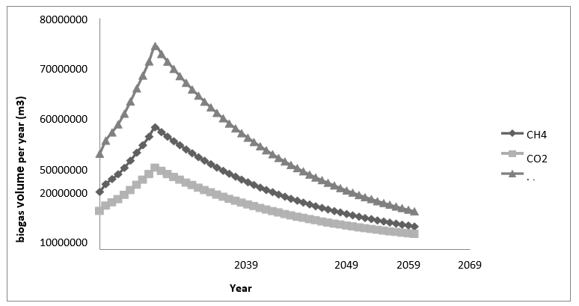

**Figure 1** : CH4 and CO2 generation per year according to LandGEM V3.02 model

The exponential decrease in biogas volume observed is linked to the reduction in the amount of decomposable organic matter in the landfill following its closure in 2018 **(Ntakiyiruta, et al., 2024; 14: Abu-Qdais et al., 2010**). After this date, the landfill entered its stabilization phase, where methanogenic bacteria produce fewer greenhouse gases due to their low water content and low biodegradability (**Zairi et al.,2014**). This decrease indicates that the degradation process is coming to an end. However, the volume of biogas remains high. This represents a potential risk for the ecosystem.

**3.1.2. Estimated energy potential**

The electrical energy potential generated by the Akouédo landfill from 2017 to 2059 is shown in **figure 2**.

The estimated energy potential is high. From 2018 to 2019, it rises from 266 GWh (10 MW) to 288 GWh (10.8 MW), with a peak in 2019. After 2019, the energy potential decreases exponentially until 2059, with a value of 56 GWh (2.1MW). Assuming that the biogas plant starts operating in 2019, by the twentieth year of operation (2038), the recovered biogas will be sufficient to generate 164 GWh (6MW), providing a significant energy opportunity for the cogeneration plant at the existing Akouédo urban park. Even in 2059, more than 40 years after its closure, the available biogas would be sufficient to generate 2 MW of power.

These high values of estimated energy potential could be explained by high values of biogas volume. The increase in energy potential from 2018 to 2019 can also be explained by the increase in methane volume over the same period. The exponential decrease in energy potential observed is explained by the exponential decrease in methane volume.

This production of energy from waste at the Akouédo landfill can enable Côte d'Ivoire to ensure its energy transition by substituting fossil fuels. Waste-to-energy conversion can become a green, renewable and sustainable energy source (**Rico de la Hera et al., 2014**). What's more, converting biogas into energy prevents the release of CH4, a greenhouse gas, into the atmosphere.

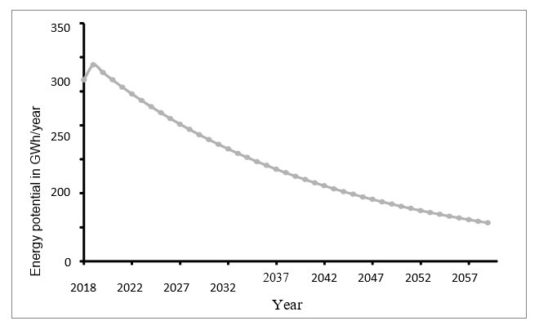

**Figure 2:** Energy potential of biogas from the Akouédo landfill according to LandGEM 3.02

3.2. **Application of the IPCC 2006 model to municipal solid waste from the Akouédo landfill site**

**3.2.1. Estimated biogas volume based on IPCC 2006 model**

**Figure 3** shows the CH4 and CO2 volumes generated from 2009 to 2059. The estimated volume of biogas is very significant. It also increases very rapidly from the year 2009 with a value of 7.7×107m3 to the year 2019 with a maximum of 15.7×107m3. After 2018, the volume of biogas decreases exponentially until 2059, with a value of 4.2× 105m3. Methane and carbon dioxide volumes follow the same trend as biogas. In 2019, the maximum CH4 and CO2 volumes are 9.4×107m3 and 6.3×107 m3 respectively.

Les Estimated variations in biogas volume as a function of time could be explained by the

above-mentioned factors, such as waste composition, waste mass and the age of the waste.

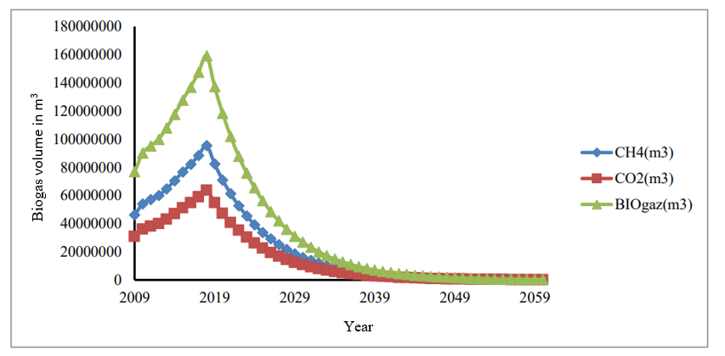

**Figure 3:** Biogas volume estimates based on the IPCC 2006 waste model

**3.2.2. Potential energy generated according to the IPCC 2006 model**

The electrical energy potential generated by the Akouédo discharge is shown **in Figure 4.**

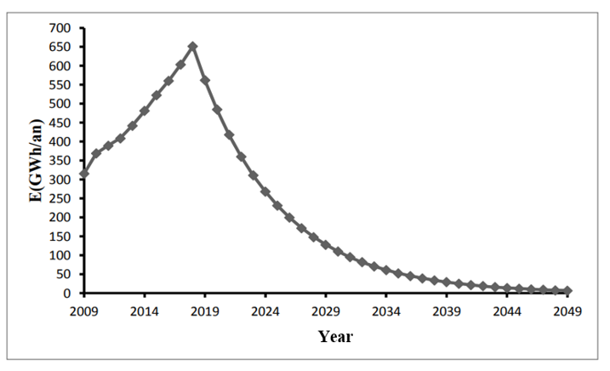

**Figure 4** : Energy potential of Akouedo landfill biogas according to IPCC 2006

The maximum electrical energy potentially available from the Akouédo landfill is 658 GWh in 2019. Converting this energy using a 33%-efficiency internal combustion engine will yield 217.1GWh, or 13% of CIE's total energy production in 2015 **(CIE, 2015)**. This corresponds to a maximum capacity of 24.8 MW, or a quarter of the installed capacity of the Vridi thermal power plant **(CIE, 2015)**. This capacity will decrease each year. By 2038, the recovered biogas will be sufficient to generate 39 GWh (1.5 MW), offering a significant energy generation opportunity.

**3.3. Comparison of the first-order models used**

The volumes estimated from the LandGEM 3.02, Mexican 2.0 and IPCC 2006 models were compared (**Figure 5**).

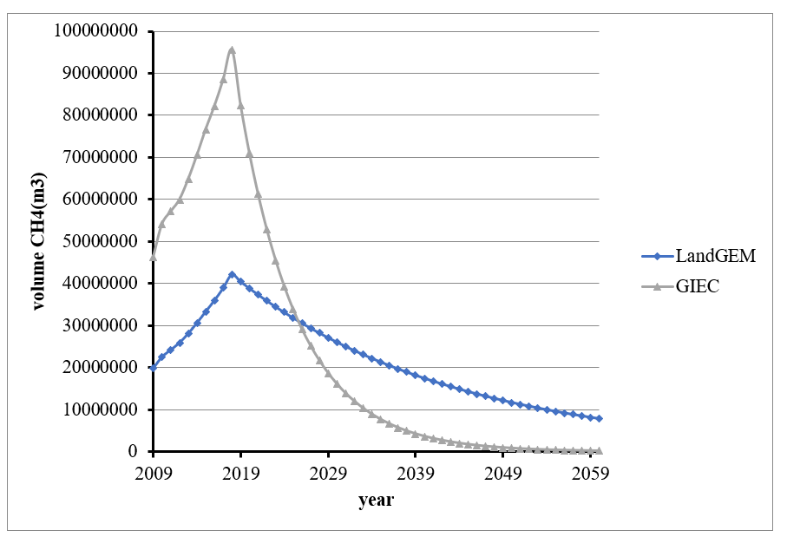

**Figure 5.** Comparison of methane volumes estimated by LandGEM and IPCC models

Maximum estimated methane volumes were obtained in 2019 for both models. They are 4.2×107m3and 9.4×107m3 respectively for the LandGEM and IPCC models. The IPCC model maximum is more than double that of the LandGEM model. For the period 2009 to 2026, methane volumes estimated by the IPCC model are higher than those estimated by the LandGEM model. However, they are lower than those estimated by the LandGEM model for the period 2026 to 2056. There is a significant difference between the methane volumes estimated by the two different models. The IPCC model tends to overestimate biogas volumes compared with the LandGEM model.

The methane volumes overestimated by the IPCC model compared with other models could be explained by the fact that the IPCC model takes into account higher quantities of organic carbon, unlike the LandGEM model (**Scharff & Jacobs, 2006**).

The LandGEM model estimates the volume of methane generated, assuming that all waste is considered municipal solid waste. The LandGEM model has a limited number of parameters. However, all organic carbon present in waste is assumed to be potentially converted, which is not realistic **(Scharff & Jacobs, 2006)**. The IPCC model (like the LandGEM model) implicitly considers waste quality (moisture content, age of waste) and landfill condition (temperature, precipitation).

The LandGEM model estimates the volume of methane generated, assuming that all waste is considered municipal solid waste. The LandGEM model has a limited number of parameters. However, all organic carbon present in waste is assumed to be potentially converted, which is not realistic **(Scharff & Jacobs, 2006)**. The IPCC model (like the LandGEM model) implicitly considers waste quality (moisture content, age of waste) and landfill condition (temperature, precipitation).

The various methane flow rates estimated in this study were compared with those obtained in other studies (**Table 3**).

**Table 3:** Comparison of methane flow rates

|  |  |  |  |  |
| --- | --- | --- | --- | --- |
| Authors | Year | Study area | Maximum CH4 flow  rate (m3/h) | MSW mass (t) |
| present study | 2025 | Abidjan | 4794-10731 | 1 209 135 |
|  |  |  |  |  |
| **(Zairi et al., 2014)** | 2010 | Tunis | 3995 | 680 000 |
| **(Mebarki et al., 2015)** | 2013 | Alger | 2192 | 91 400 |
| **(Aguilar-Virgen et al., 2014)** | 2018 | Ensenada | 2213 | 132055 |

The maximum methane flow rates obtained in the present study are higher than those obtained in other studies.

The very high maximum methane flows obtained in this study could be explained by the fact that the annual mass of DSM used in this study is much higher than in the other studies.

Each model has its own advantages and disadvantages, and no model is well-defined for estimating the volume of biogas generated by a landfill. Among these models, the LandGEM model has a relatively simple approach to estimating the methane generated by landfills. Moreover, the LandGEM model is widely used (**Zairi et al., 2014**). For this reason, this model has been retained for the remainder of this study.

Evaluation of the energy potential of biogas from the Akouédo landfill using first-order decay models (**Table 4**) shows that it is possible to install a 10 MW thermal power plant at the landfill. However, the plant's operating time can be reduced over time, depending on the volume of biomethane available.

**Table 4** : Summary of zero-order and first-order model energy potentials for 2018

|  |  |
| --- | --- |
| First-order model | |
| Model | Energy potential |
| landGEM 3.02 | 11.80 MW |
| GIEC 2006 | 24.8 MW |

**4.CONCLUSION**

This study assessed the potential for residual biomethane production after closure of the Akouédo landfill in Abidjan, through comparative modeling based on two first-order decay models: LandGEM 3.02 and the IPCC 2006 model. The results showed that, after the official closure of the site in 2018, methane production remains significant for several decades, with a peak observed in 2019 and a gradual decline until 2059. The volumes generated mean that the site can be considered a secondary energy source, still active in the long term.

The energy potential associated with this biogas is high. In 2019, it has been estimated at 288 GWh/year, representing an installable electrical capacity of 24.8 MW according to the IPCC 2006 model, and 11.8 MW according to the LandGEM model. Even up to 2038, the available volumes would generate around 6 MW, confirming the technical viability of a cogeneration project on a semi-industrial scale. These data demonstrate the relevance of investing in a cogeneration plant installed directly on the Akouédo site, to valorize residual biogas locally.

Beyond energy considerations, the installation of such an infrastructure is strategic to support the conversion of the site into an urban park, by ensuring the environmental safety of the subsoil, which is still active in terms of methane production. It would enable methane to be captured and burned in a controlled manner, thus reducing its impact on the climate, while injecting renewable electricity into the local grid.

In conclusion, this study fully justifies the immediate installation of a cogeneration system with an initial capacity of 10 MW, depending on the scenario selected. It paves the way for an integrated approach to post-closure landfill management, reconciling sustainable urban development, reduced greenhouse gas emissions and decentralized renewable energy production, in the service of an ambitious and realistic local energy transition for West Africa.

References

[1] Zhang, Z., Chen, Z., Zhang, J., Liu, Y., Chen, L., Yang, M. *et al*. (2024). Municipal solid waste management challenges in developing regions: A comprehensive review and future perspectives for Asia and Africa. Science of the Total Environment, 172794. <https://doi.org/10.1016/j.scitotenv.2024.172794>

[2] Idowu, I. A., Atherton, W., Hashim, K., Kot, P., Alkhaddar, R., Alo, B. I., et al. (2019). An analysis of the status of landfill classification systems in developing countries: Sub Saharan Africa landfill experiences. *Waste Management*, *87*, 761-771. <https://doi.org/10.1016/j.scitotenv.2024.172794>

[3] Intergovernmental Panel on Climate Change. (2013). Climate Change 2013: The Physical Science Basis. Contribution of Working Group I to the Fifth Assessment Report (T. F. Stocker et al., Éds.). Cambridge, UK: Cambridge University Press

[4] United Nations Environment Programme/Climate and Clean Air Coalition (2022). *Global Methane Assessment: 2030 Baseline Report. Nairobi*.

**[5] Huber-Humer, M., Gebert, J., & Hilger, H. (2008).** Biotic systems to mitigate landfill methane emissions. Waste Management & Research, 26(1), 33–46. <https://doi.org/10.1177/0734242X07087977>

**[6]** **Mønsted, J., Kjeldsen, P., & Scheutz, C. (2019).** Methodologies for measuring fugitive methane emissions from landfills – A review. Waste Management, 87, 835–859. <https://doi.org/10.1016/j.wasman.2018.12.047>

**[7] U.S. Environmental Protection Agency (EPA). (2005).** Landfill Gas Emissions Model (LandGEM) Version 3.02 User’s Guide (EPA-600/R-05/047). Cincinnati, OH: EPA Office of Research and Development. <https://www3.epa.gov/ttncatc1/dir1/landgem-v302-guide.pdf>

**[8] Eggleston, S., Buendia, L., Miwa, K., Ngara, T., & Tanabe, K. (Éds.). (2006).**2006 IPCC Guidelines for National Greenhouse Gas Inventories. Hayama, Japon: Institute for Global Environmental Strategies. <https://www.ipcc-nggip.iges.or.jp/public/2006gl/>

[9] Cyril, K. M., Essi, K., Agboue, A., & Albert, T. (2018). Characterization of the parameters and estimation of potential biogas of a Landfill in tropical area: case study of the principal landfill of Abidjan Akouedo landfill. *Research & Reviews: Journal of Ecology and Environmental Sciences*, *6*, 43-49.

[10] US EPA (2016) Inventory of US greenhouse gas emissions and sinks: 1990–2014, EPA EPA 430-R-16- 002, Washington

[11] IPCC (2006) Guidelines for national greenhouse gas inventories: intergovernmental panel on climate change. Waste, vol 5. IGES

[12] Kim, D., & Kim, J. (2025). Predicting biogas production from organic waste through anaerobic co-digestion. Journal of Cleaner Production, 496, 145122. <https://doi.org/10.1016/j.jclepro.2025.145122>

[13] Ntakiyiruta, P., Agossi, D. A. P., Briton, B. G. H., & Hien, S. A. (2024). Biogas Potential of Wastewater Sludge from a Palm Oil Refinery Plant. DOI:10.31695/IJASRE.2024.10.1

[14] Abu-Qdais H, Abdullah F, Qrenawi L. (2010). Solid waste landfills as a source of green energy: case study of Al Akeeder Landfill. Jordan Journal of Mechanical and Industrial Engineering, 4:69–74.

[15] Engineers, S. C. S. (2009). User's manual mexico landfill gas model version 2.0. USEPA 2009.

[16] Zairi, M., Aydi, A., & Dhia, H. B. (2014). Leachate generation and biogas energy recovery in the Jebel Chakir municipal solid waste landfill, Tunisia. *Journal of Material Cycles and Waste Management*, 16(1), 141-150. DOI 10.1007/s10163-013-0164-3

[17] Rico, C., Diego, R., Valcarce, A., & Rico, J. L. (2014). Biogas production from various typical organic wastes generated in the region of cantabria (Spain): methane yields and co-digestion tests. *Smart Grid and Renewable Energy*, *5*(6), 128-136. **DOI:**[10.4236/sgre.2014.56012](http://dx.doi.org/10.4236/sgre.2014.56012)

[18] CIE RAPPORT ANNUEL 2015

[www.cie.ci/ebook/rapportannuel_2015/docs/rapportannuel_2015.pdf](http://www.cie.ci/ebook/rapportannuel_2015/docs/rapportannuel_2015.pdf) , accessed on August 20, 2018.

[19] Scharff, H., & Jacobs, J. (2006). Applying guidance for methane emission estimation for landfills. *Waste Management*, 26 (4), 417-429. doi:10.1016/j.wasman.2005.11.015

[20] Mebarki, B., Adouane, B., Khaldi, F., Dehimi, S., & Haddad, D. (2015). Theoretical estimation of the production of biogas from the landfill of Batna city and its electrical conversion by a SOFC. *International Journal of Hydrogen Energy*, 40(39), 13799-13805. <https://doi.org/10.1016/j.ijhydene.2015.03.062>

[21] Aguilar-Virgen, Q., Taboada-González, P., Ojeda-Benítez, S., & Cruz-Sotelo, S. (2014). Power generation with biogas from municipal solid waste: Prediction of gas generation with in situ parameters. *Renewable and Sustainable Energy Reviews*, 30, 412-419. <http://dx.doi.org/10.1016/j.rser.2013.10.014>