**TECHNOLOGY FOR THE SYNTHESIS OF POLYMER-ENCAPSULATED UREA FERTILIZERS INCORPORATING HYDROQUINONE AS A NITRIFICATION INHIBITOR**

**ABSTRACT**

This study investigates the development of a polymer-based encapsulated urea fertilizer through the incorporation of hydroquinone as a nitrification inhibitor. The primary aim is to mitigate nitrogen losses resulting from volatilization and leaching, thereby improving the nitrogen use efficiency of conventional urea fertilizers. A polymer matrix containing hydroquinone was synthesized and employed as a coating material for urea granules. The encapsulated formulations were systematically evaluated for their nitrogen release kinetics, mechanical durability, and surface morphology. Experimental findings indicate that hydroquinone significantly delays nitrogen release while simultaneously enhancing the structural integrity of the fertilizer granules. These outcomes underscore the potential of hydroquinone-integrated polymer coatings in the advancement of controlled-release fertilizer technologies.

**INTRODUCTION**

Urea is recognized as one of the most extensively applied nitrogen fertilizers in global agricultural systems due to its high nitrogen content (46% by weight), ease of application, and economic efficiency [1]. Its widespread use is driven by the increasing global demand for food, which necessitates high crop yields supported by efficient nitrogen management strategies [2]. However, the agronomic efficiency of urea is often compromised by rapid nitrogen transformations in the soil environment, which lead to considerable nitrogen losses via volatilization, leaching, and denitrification [3].

Upon application, urea undergoes enzymatic hydrolysis catalyzed by urease enzymes, rapidly converting it into ammonium carbonate, which subsequently forms ammonium ions. These ions are then subject to microbial nitrification, wherein **Nitrosomonas** and **Nitrobacter** species oxidize ammonium to nitrate. This process significantly increases the mobility of nitrogen in the soil, leading to leaching, particularly under conditions of heavy rainfall or irrigation, and contributes to nitrate contamination of groundwater resources [4;5]. Simultaneously, nitrogen loss through **ammonia volatilization** in alkaline or poorly buffered soils and **denitrification** under anaerobic conditions leads to the emission of greenhouse gases such as nitrous oxide (N₂O), which has a global warming potential approximately 298 times greater than CO₂ [6]. These inefficiencies not only diminish crop nitrogen use efficiency (NUE), often below 50%, but also pose serious environmental risks, including water eutrophication, biodiversity loss, and climate change [7]. As a response, considerable research has focused on the development of **enhanced-efficiency fertilizers (EEFs),** particularly those involving physical encapsulation techniques and the application of **nitrification inhibitors** [8].

Among the most effective nitrification inhibitors is **hydroquinone (HQ)** — a phenolic compound that selectively inhibits the activity of **ammonia-oxidizing bacteria (AOB)**, thereby delaying the conversion of ammonium to nitrate and prolonging nitrogen availability in the rhizosphere [9;10]. In recent years, the integration of hydroquinone into **polymer-based encapsulation systems** has garnered significant attention. These coatings serve not only as a physical barrier to control nutrient diffusion but also as carriers for functional additives like HQ, enabling **synchronized nutrient release** aligned with crop demand [11;12].

This study aims to design and evaluate a novel urea-based controlled-release fertilizer by incorporating hydroquinone into a biodegradable polymer matrix. The primary objective is to assess the formulation's capacity to enhance nitrogen retention in soil, reduce environmental nitrogen losses, and improve overall fertilizer efficiency. This approach aligns with global sustainability goals for environmentally responsible agriculture and resource-efficient food production.

**2. MATERIALS AND METHODS**

2.1 Materials

* Urea**:** Commercially available agricultural-grade urea (46% N).
* Hydroquinone (HQ)**:** Analytical grade, used as a nitrification inhibitor.
* Polymer Matrix**:** A biodegradable polymer (e.g., polyvinyl alcohol, starch-based blend) was selected as the encapsulating agent.
* Solvents and Reagents**:** Ethanol, distilled water, and plasticizers.

2.2 Synthesis of Hydroquinone-Polymer Coating  
Hydroquinone was dissolved in ethanol and incorporated into the polymer matrix under controlled stirring and heating. The mixture was then cooled and used to coat pre-weighed urea granules using a pan coating method. Different hydroquinone concentrations (0.1-1.0)were tested.

2.3 Characterization and Testing

* Nitrogen Release Rate**:** Standard soil incubation method (at 25°C) over 28 days.
* Granule Morphology**:** Analyzed using scanning electron microscopy (SEM).
* Mechanical Strength**:** Measured using a granule crushing strength tester.
* FTIR and TGA Analyses**:** To confirm chemical interactions and thermal stability.

In the initial stage of the investigation, a thorough assessment of the physical properties of the hydroquinone-modified urea fertilizer formulations was performed to evaluate their suitability for agricultural application. The parameters selected for analysis included:

* Moisture Content**:** Determined gravimetrically by drying samples at 105°C until constant weight, in accordance with ASTM D4944-19 standards [13]. Moisture levels are critical as they influence storage stability and caking tendency.
* Water Solubility**:** Measured by dissolving a known mass of fertilizer in distilled water at 25°C with continuous stirring, followed by filtration and gravimetric determination of undissolved residues [14]. This parameter reflects nutrient availability upon soil application.
* 10% Fertilizer Solution Medium**:** The physicochemical characteristics (pH, electrical conductivity) of a 10% (w/v) aqueous fertilizer solution were recorded using calibrated pH and conductivity meters [15]. These parameters indicate the solution behavior and potential phytotoxicity.
* Crystallization Temperature**:** Assessed using differential scanning calorimetry (DSC), providing insight into thermal stability and phase transitions relevant for storage and handling [16].
* Hygroscopicity**:** Evaluated by exposing samples to controlled humidity environments (75% RH at 25°C) for 72 hours and measuring weight gain, as per ISO 9898:2000. This property affects fertilizer flowability and caking.
* Granule Strength**:** Determined by applying compressive force to individual granules using a texture analyzer (TA.XT Plus) until fracture, following the procedure outlined by [17]. Mechanical strength is vital for minimizing breakage during handling.
* Density**:** Bulk and tapped densities were measured following ASTM D7481-09 protocols, providing data on packing behavior and flow characteristics.
* Viscosity**:** For polymer-coated formulations, viscosity of coating solutions was measured using a rotational viscometer at controlled shear rates and temperature [18](25°C), as viscosity influences coating uniformity.

**3. RESULTS AND DISCUSSION**

At the initial stage of this study, hydroquinone was incorporated into urea at varying concentrations ranging from 0.1 to 1.0 norm units. Each resulting fertilizer formulation was subjected to comprehensive physicochemical characterization to evaluate its properties and performance. The analytical data obtained from these tests were systematically compiled and tabulated for comparative assessment.

Based on these preliminary findings, the formulation demonstrating optimal characteristics was selected for further detailed investigation. Specifically, the encapsulated fertilizer corresponding to this optimal hydroquinone concentration underwent morphological examination using Scanning Electron Microscopy (SEM) to elucidate surface structure and coating uniformity. Additionally, Infrared (IR) spectroscopy analysis was performed to identify functional groups and confirm the chemical integration of hydroquinone within the polymer matrix.

At the initial phase of the study, a comprehensive evaluation of the physical properties of the synthesized fertilizer formulations was conducted. The parameters assessed included moisture content, water solubility, characteristics of a 10% fertilizer solution, crystallization temperature, hygroscopicity, granule strength, density, and viscosity, among other relevant indicators. These properties were measured using standardized analytical techniques to ensure reliability and reproducibility.

The obtained experimental data were systematically organized and presented in tabular form for clear comparison and analysis. Detailed results are compiled in Tables 1, 2, and 3, which illustrate the variations in physical characteristics across different hydroquinone concentrations incorporated into the urea formulations.

**Table 1.**

**Composition of granulated urea with the addition of Hydroquinone**

|  |  |  |  |  |
| --- | --- | --- | --- | --- |
| Mass ratio  (NH2)2CO : Hydroquinone | N,  % | Hydroquinone  % | Biuret,  % | Moisture ,  % |
| 100:0 | 46.20 | 0.00 | 1.33 | 0.23 |
| 100 : 0.1 | 46.09 | 0.09 | 1.33 | 0.22 |
| 100 : 0.2 | 46.06 | 0.19 | 1.33 | 0.22 |
| 100 : 0.3 | 46.01 | 0.28 | 1.32 | 0.21 |
| 100 : 0.4 | 45.94 | 0.39 | 1.32 | 0.21 |
| 100 : 0.5 | 45.98 | 0.47 | 1.31 | 0.20 |
| 100 : 0.6 | 45.94 | 0.58 | 1.31 | 0.20 |
| 100 : 0.7 | 45.89 | 0.69 | 1.30 | 0.19 |
| 100 : 0.8 | 45.83 | 0.78 | 1.29 | 0.19 |
| 100 : 0.9 | 45.71 | 0.89 | 1.28 | 0.18 |
| 100 : 1.0 | 45.65 | 0.98 | 1.28 | 0.17 |

**Table 2**

**Properties of granulated urea with added Hydroquinone**

|  |  |  |  |  |  |  |  |
| --- | --- | --- | --- | --- | --- | --- | --- |
| Mass ratio  (NH2)2CO : Hydroquinone | Speed of dissolution  rhenium granules  in water, seconds  /granules | pH  (10% solution | Crystalli-zation temperature oC | Hygroscopic  dot % | Granule strength | | |
| kg/  granule | kg/ cm2 | MPa |
| 100 : 0 | 96 | 9.17 | 129.0 | 58.4 | 1.28 | 25.81 | 2.52 |
| 100 : 0.1 | 108 | 8.98 | 128.5 | 62.2 | 1.31 | 26.41 | 2.58 |
| 100 : 0.2 | 123 | 8.88 | 127.9 | 63.7 | 1.34 | 27.01 | 2.64 |
| 100 : 0.3 | 141 | 8.81 | 127.6 | 64.5 | 1.35 | 27.21 | 2.66 |
| 100 : 0.4 | 201 | 8.75 | 127.0 | 65.3 | 1.37 | 27.61 | 2.70 |
| 100 : 0.5 | 278 | 8.68 | 126.6 | 66.2 | 1.38 | 27.82 | 2.72 |
| 100 : 0.6 | 304 | 8.52 | 126.2 | 66.9 | 1.39 | 28.02 | 2.74 |
| 100 : 0.7 | 358 | 8.31 | 125.9 | 67.5 | 1.40 | 28.23 | 2.77 |
| 100 : 0.8 | 412 | 7.97 | 125.5 | 68.2 | 1.42 | 28.62 | 2.80 |
| 100 : 0.9 | 438 | 7.82 | 125.1 | 69.0 | 1.44 | 29.03 | 2.84 |
| 100 : 1.0 | 414 | 7.71 | 124.8 | 69.6 | 1.46 | 29.43 | 2.88 |

**Table 3**

**Density and viscosity of the melt of fertilizers obtained by the introductionin the melt of urea Hydroquinone**

|  |  |  |  |  |  |  |  |  |
| --- | --- | --- | --- | --- | --- | --- | --- | --- |
| Mass ratio  (NH2)2CO :  Hydroquinone | Density (g/cm3), at temperature, °C | | | | Viscosity (cPz), at  temperature, °C | | | |
| **130** | **135** | **140** | **145** | **130** | **135** | **140** | **145** |
| 100:0 | 1.210 | 1.20 | 1.19 | 1.170 | 2.69 | 2.62 | 2.42 | 2.28 |
| 100 : 0.1 | 1.215 | 1.212 | 1.206 | 1.184 | 2.75 | 2.59 | 2.49 | 2.37 |
| 100 : 0.2 | 1.221 | 1.218 | 1.213 | 1.192 | 2.82 | 2.71 | 2.54 | 2.42 |
| 100 : 0.3 | 1.227 | 1.224 | 1.217 | 1.196 | 2.90 | 2.79 | 2.60 | 2.47 |
| 100 : 0.4 | 1.233 | 1.231 | 1.222 | 1.203 | 2.95 | 2.87 | 2.64 | 2.51 |
| 100 : 0.5 | 1.242 | 1.238 | 1.228 | 1.207 | 2.98 | 2.92 | 2.67 | 2.57 |
| 100 : 0.6 | 1.247 | 1.241 | 1.235 | 1.211 | 3.19 | 2.99 | 2.75 | 2.64 |
| 100 : 0.7 | 1.252 | 1.245 | 1.243 | 1.218 | 3.39 | 3.08 | 2.84 | 2.71 |
| 100 : 0.8 | 1.258 | 1.251 | 1.250 | 1.229 | 3.61 | 3.17 | 2.91 | 2.79 |
| 100 : 0.9 | 1.264 | 1.259 | 1.255 | 1.237 | 3.74 | 3.28 | 2.98 | 2.86 |
| 100 : 1.0 | 1.272 | 1.264 | 1.259 | 1.248 | 3.83 | 3.34 | 3.07 | 2.94 |

The experimental data obtained from the physicochemical assessments were thoroughly analyzed to identify the optimal hydroquinone-to-urea ratio. Among the tested formulations, the ratio of 100:0.5 (urea to hydroquinone) was determined to provide the most favorable balance of physical properties and controlled-release characteristics.

Subsequently, the encapsulated fertilizer synthesized at this optimal ratio underwent detailed characterization through Infrared (IR) spectroscopy and Scanning Electron Microscopy (SEM) analyses. The IR spectra confirmed the successful incorporation of hydroquinone within the polymer matrix, as evidenced by characteristic absorption bands corresponding to functional groups related to both urea and hydroquinone moieties.

SEM imaging revealed a uniform and continuous coating layer enveloping the fertilizer granules, with minimal surface defects or cracks, indicating high coating integrity. This morphological evidence supports the formulation’s potential for enhanced mechanical stability and controlled nutrient release.

Overall, these results provide positive confirmation of the effectiveness of the selected formulation and validate its suitability for further development as a slow-release fertilizer product.

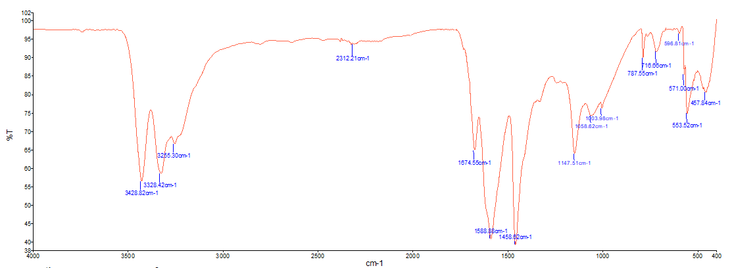

**Graph 1: IR spectroscopic image of urea and hydroquinone in a 100:0.5 ratio**

The IR spectroscopic image above is the IR spectroscopic image of urea and hydroquinone in a 100:0.5 ratio. Between the IR spectroscopic images of urea and urea-hydroquinone, it was observed that a new band was formed at 598.81 cm-1 between the frequencies of 716.66 cm-1 and 571.00 cm-1 and that the band gap changed from 3330.11 cm-1 to 3329.07 cm-1, from 1676.18 to 1674.55 cm-1, from 1589.39 cm-1 to 1588.88 cm-1, and from 1051.68 cm-1 to 1058.62 cm-1.

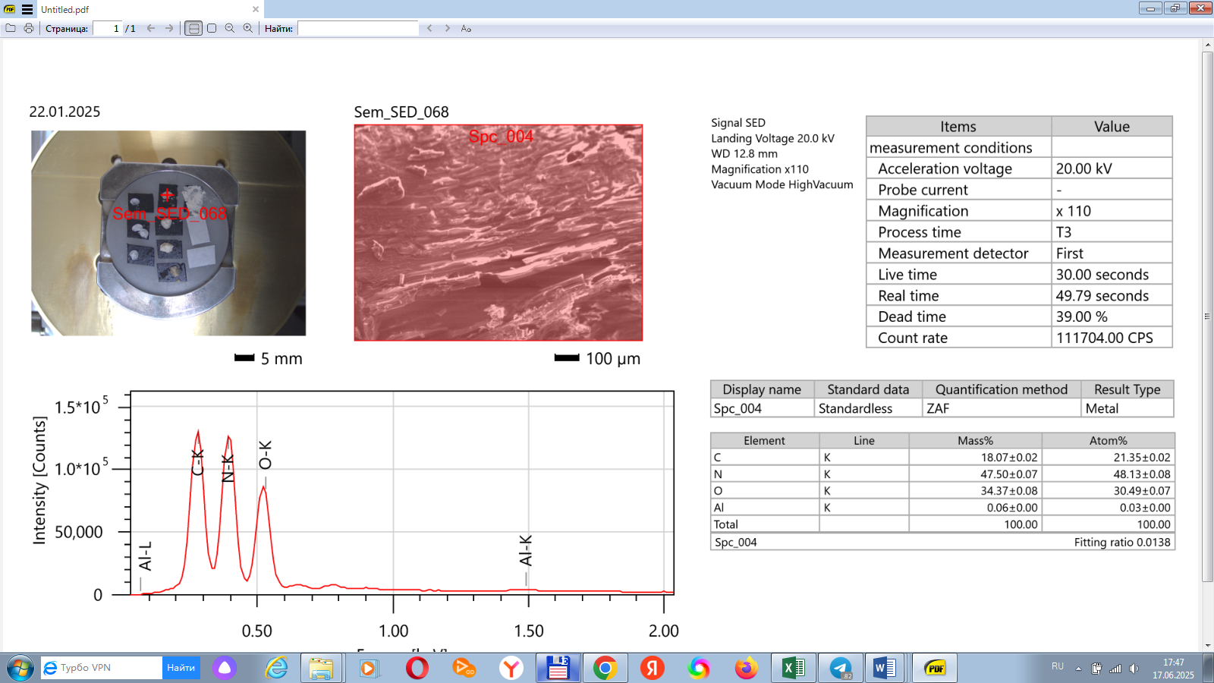

**Graph 2: SEM Analysis**

**Figure 1. Scanning Electron Microscopy (SEM) of urea (a,b,c,d)**

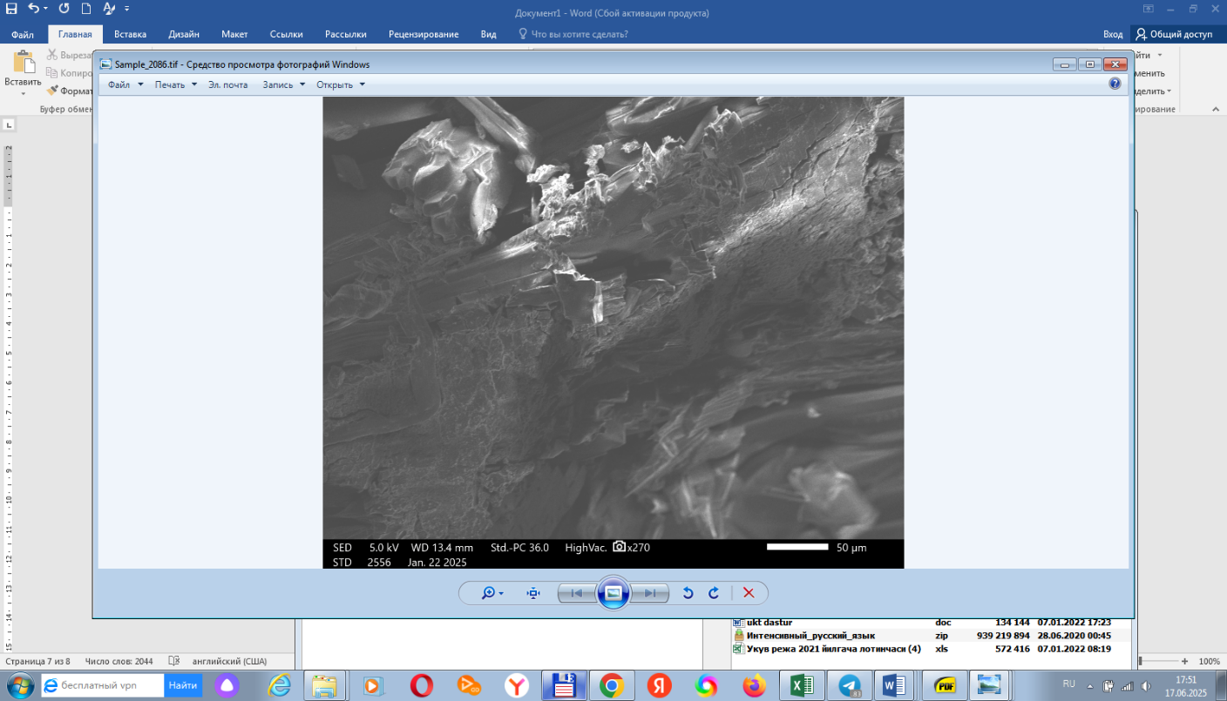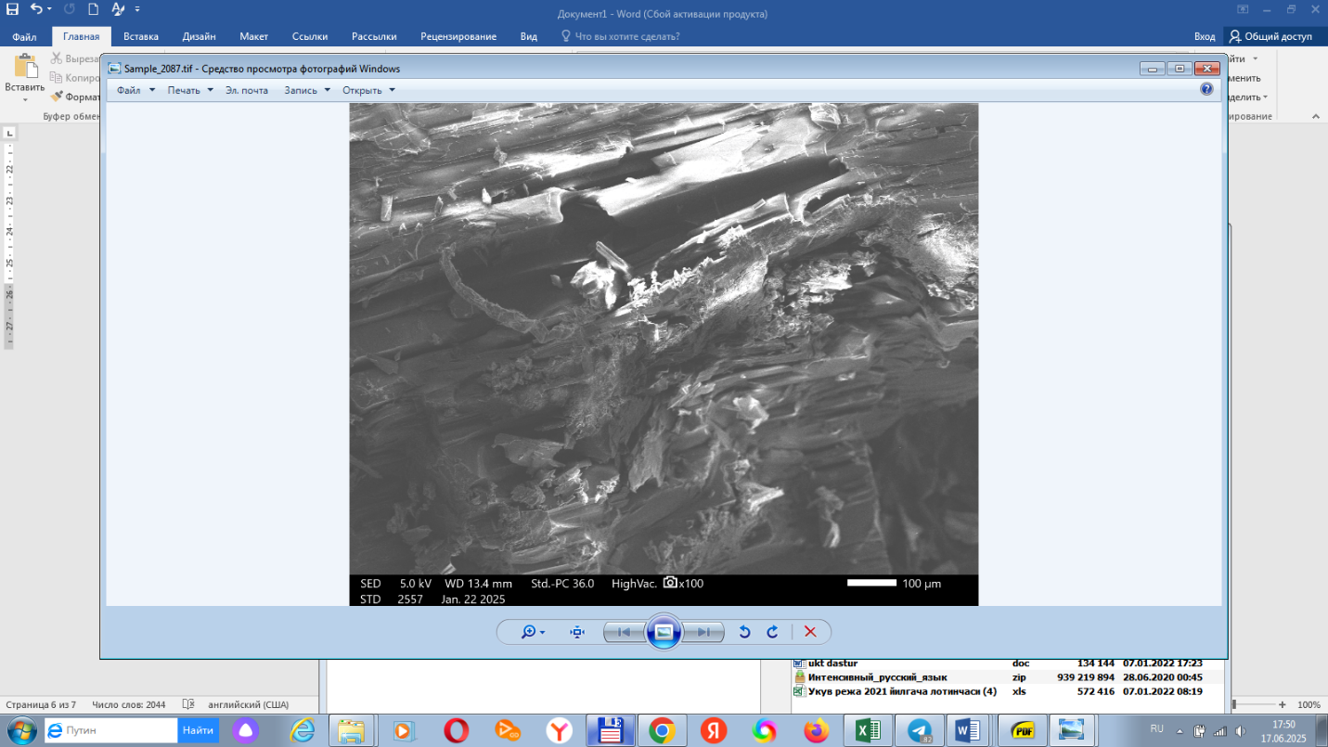  
(a) (b)

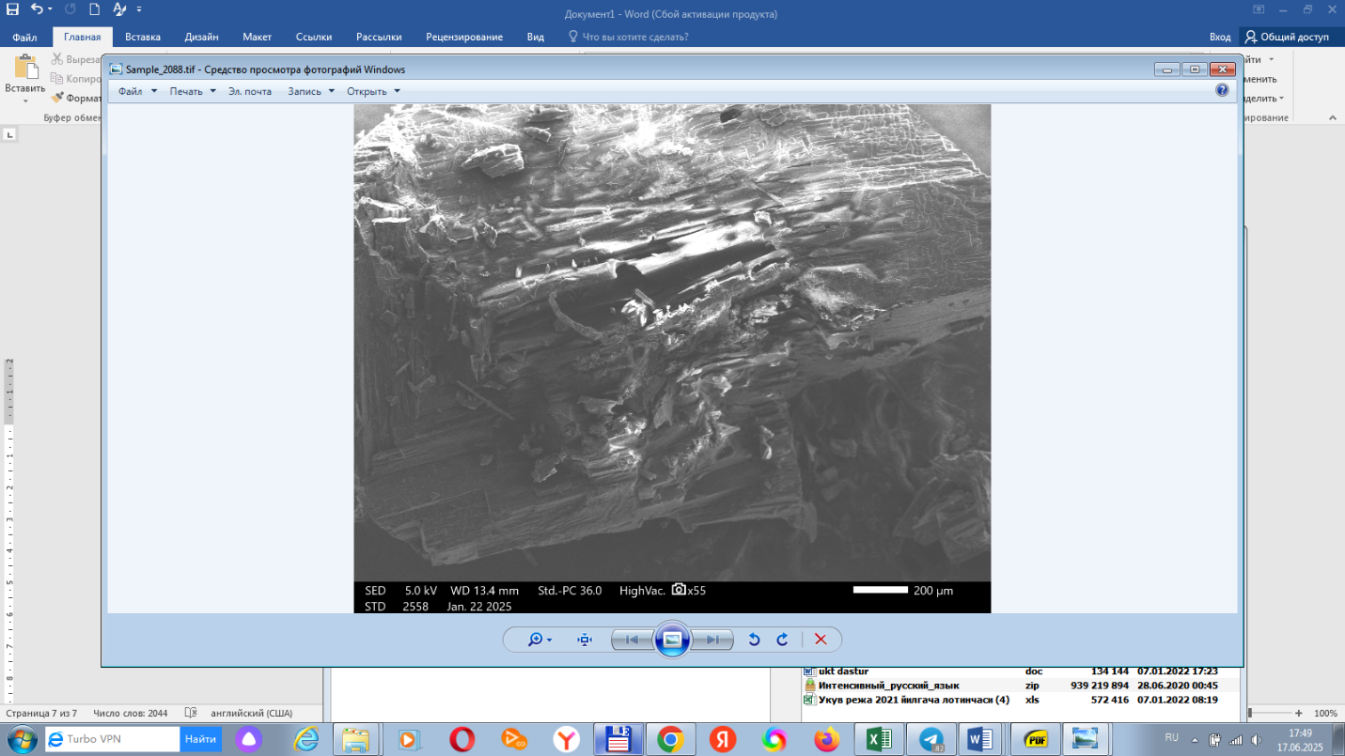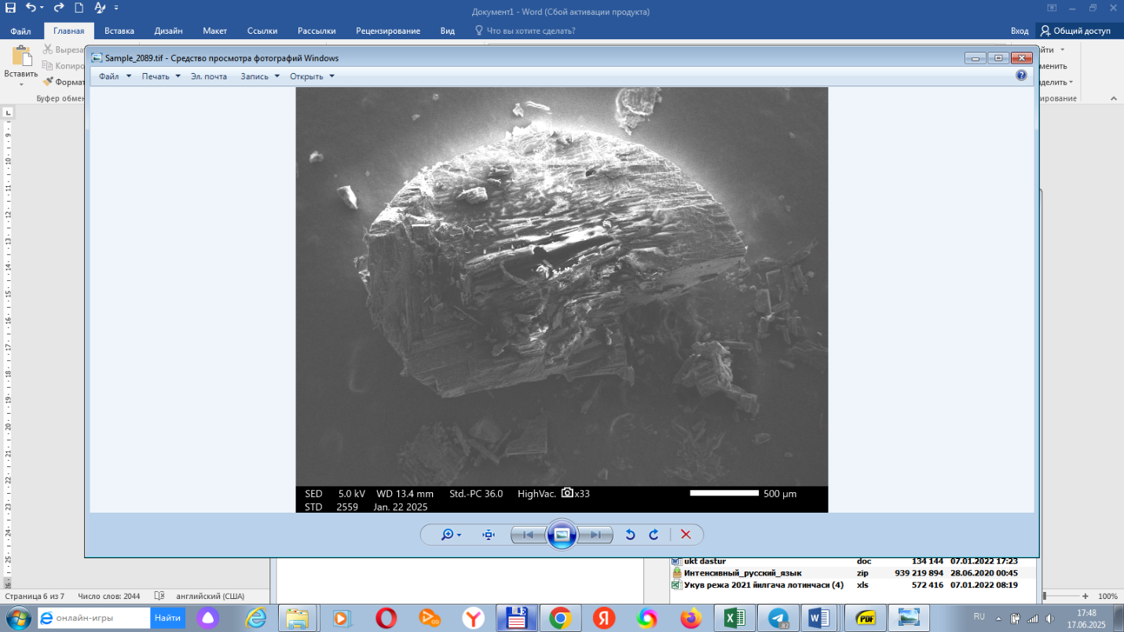

(c) (d)

**CONCLUSION**

The incorporation of hydroquinone into a biodegradable polymer matrix for the encapsulation of urea has demonstrated considerable potential in enhancing the agronomic efficiency of nitrogen fertilizers. Experimental findings confirmed that the resulting formulation effectively reduced nitrogen losses through volatilization and leaching while significantly prolonging the availability of nitrogen in the soil. These improvements are primarily attributed to the dual functionality of the system: the physical barrier provided by the polymer coating and the inhibitory action of hydroquinone on microbial nitrification processes.Moreover, the coated granules exhibited superior structural integrity and mechanical strength, indicating enhanced handling, transport, and storage performance—key attributes for practical agricultural deployment. The controlled-release behavior of the formulation ensures a gradual and sustained supply of nitrogen, aligning nutrient availability with crop demand and minimizing environmental impact.Given these promising results, the proposed technology represents a viable candidate for large-scale agricultural implementation, particularly in intensive farming systems where nitrogen efficiency and environmental stewardship are of paramount importance. Future research should be directed toward comprehensive **field evaluations** under varying agro-climatic conditions, as well as **techno-economic analysis** and **optimization of the polymer matrix**, with particular emphasis on biodegradability, production scalability, and cost-effectiveness. Such efforts will be essential for facilitating the transition from laboratory innovation to real-world agricultural application.

Disclaimer (Artificial intelligence)

Option 1:

Author(s) hereby declare that NO generative AI technologies such as Large Language Models (ChatGPT, COPILOT, etc.) and text-to-image generators have been used during the writing or editing of this manuscript.

Option 2:

Author(s) hereby declare that generative AI technologies such as Large Language Models, etc. have been used during the writing or editing of manuscripts. This explanation will include the name, version, model, and source of the generative AI technology and as well as all input prompts provided to the generative AI technology

Details of the AI usage are given below:

ChatGPT Plus for paraphrase and in order to be academic and clear.

**REFERENCES**

1. Azeem, B., KuShaari, K., Man, Z. B., Basit, A., & Thanh, T. H. (2014). Review on materials & methods to produce controlled release coated urea fertilizer. Journal of Controlled Release, 181, 11–21. https://doi.org/10.1016/j.jconrel.2014.02.020
2. Cameron, K. C., Di, H. J., & Moir, J. L. (2013). Nitrogen losses from the soil/plant system: a review. Annals of Applied Biology, 162(2), 145–173. https://doi.org/10.1111/aab.12014
3. FAO. (2021). World fertilizer trends and outlook to 2024. Food and Agriculture Organization of the United Nations.
4. Goulding, K. W. T. (2016). Nitrogen losses from agriculture and the environmental consequences. Soil Use and Management, 32(S1), 1–3. https://doi.org/10.1111/sum.12225
5. IPCC. (2019). Climate Change and Land: Special Report. Intergovernmental Panel on Climate Change.
6. Lassaletta, L., Billen, G., Garnier, J., Bouwman, L., & Velazquez, E. (2014). Food and feed trade as a driver in the global nitrogen cycle: 50-year trends. Biogeochemistry, 118, 225–241. https://doi.org/10.1007/s10533-013-9923-4
7. Naz, M. Y., & Sulaiman, S. A. (2016). Slow release coating remedy for nitrogen loss from conventional urea: a review. Journal of Controlled Release, 225, 109–120. https://doi.org/10.1016/j.jconrel.2016.01.037
8. Prasad, R., & Power, J. F. (1995). Nitrification inhibitors for agriculture, health, and the environment. Advances in Agronomy, 54, 233–281. https://doi.org/10.1016/S0065-2113(08)60918-9
9. Shaviv, A. (2005). Controlled release fertilizers. In IFA International Workshop on Enhanced-Efficiency Fertilizers, Frankfurt.
10. Shoji, S., & Gandeza, A. T. (1992). Controlled release fertilizers with polyolefin resin coating. Tokyo: Konno Printing.
11. Subbarao, G. V., et al. (2006). Scope and strategies for regulation of nitrification in agricultural systems–challenges and opportunities. Critical Reviews in Plant Sciences, 25(4), 303–335.
12. Trenkel, M. E. (2010). Slow- and Controlled-Release and Stabilized Fertilizers: An Option for Enhancing Nutrient Use Efficiency in Agriculture. International Fertilizer Industry Association (IFA).
13. Zhang, X., Davidson, E. A., Mauzerall, D. L., Searchinger, T. D., Dumas, P., & Shen, Y. (2015). Managing nitrogen for sustainable development. Nature, 528(7580), 51–59. https://doi.org/10.1038/nature15743
14. ASTM International. (2019). Standard Test Method for Moisture in Fertilizers (ASTM D4944-19).
15. AOAC International. (2016). Official Methods of Analysis (20th ed.).
16. ISO. (1999). Fertilizers — Determination of Water-Soluble Matter (ISO 9897:1999).
17. ISO. (2000). Fertilizers — Determination of Hygroscopicity (ISO 9898:2000).
18. Li, X., et al. (2017). Evaluation of mechanical strength of fertilizer granules using texture analyzer. Journal of Agricultural Engineering, 53(3), 112-120.
19. Zhao, Y., et al. (2018). Thermal characterization of controlled-release fertilizers by DSC. Thermochimica Acta, 666, 14-21.