**DEVELOPMENT OF A SUSTAINABLE TECHNOLOGY FOR PRODUCING GRANULAR CALCIUM NITRATE FROM INDUSTRIAL WASTE ORIGINATING FROM THE ANDIJAN LIMESTONE DEPOSIT**

**ABSTRACT**

This research investigates the potential application of limestone waste, sourced from the Andijan deposit, as a viable raw material for the synthesis of granular calcium nitrate fertilizers. The study employs a systematic process wherein calcium-rich limestone residues are treated with nitric acid to facilitate the conversion into a nitrogen-enriched compound. Subsequent granulation of the resultant material yields a high-quality granular fertilizer with enhanced agronomic value. This approach underscores a sustainable and innovative strategy for valorizing industrial mineral by-products, thereby contributing to waste minimization and promoting environmentally responsible agricultural inputs. The findings demonstrate the feasibility of transforming locally available mineral waste into a product with considerable significance for improving soil fertility and crop productivity, aligning with circular economy principles and sustainable agricultural development.

***KEYWORDS:*** *Andijan limestone deposit,* *nitric, ammonia, Scanning Electron Microscopy (SEM),*

**1.INTRODUCTION**.

In the contemporary framework of sustainable resource management, the valorization of industrial and mining waste has become a pivotal strategy to enhance circular economy practices and promote environmental stewardship. The Andijan limestone deposit, one of Uzbekistan's prominent carbonate rock sources, generates substantial quantities of waste during extraction and processing activities. These residues, predominantly composed of calcium carbonate (CaCO₃), present a promising and underutilized feedstock for the synthesis of calcium nitrate fertilizers.This study aims to evaluate the feasibility of transforming limestone waste from the Andijan deposit into granular calcium nitrate through a controlled chemical transformation process followed by granulation. The adoption of such waste valorization techniques not only contributes to environmental sustainability by reducing landfill disposal and mitigating associated ecological risks but also provides a cost-effective approach to manufacturing value-added nitrogenous fertilizers.Previous investigations have underscored the potential of industrial by-products and mining residues as alternative raw materials in fertilizer production. Zhao et al. [1] reported successful conversion of calcium-rich wastes, including slags, limestone residues, and fine limestone dust, into calcium-based fertilizers, demonstrating both economic and environmental benefits. Similarly, Kumar et al. [2] established that calcium carbonate-rich waste can be efficiently utilized to produce calcium nitrate through acid dissolution methods, highlighting the technical viability of such transformations.Within the realm of granulation, Singh and Thomas [3] emphasize that binder selection, particle size distribution, and moisture content critically influence the mechanical stability and uniformity of fertilizer granules. Their research further illustrates the effectiveness of rotary drum and fluidized bed granulation technologies in achieving scalable and efficient production processes [5]. These insights provide a technological foundation for optimizing granulation parameters tailored to limestone-derived calcium nitrate fertilizers.By integrating waste valorization with fertilizer technology, this study contributes to the dual objectives of waste management and agricultural sustainability. The conversion of locally abundant limestone waste into granular calcium nitrate fertilizer aligns with circular economy principles by closing material loops and reducing environmental footprint. Furthermore, the production of high-quality nitrogen fertilizers from secondary raw materials holds promise for enhancing soil fertility, crop productivity, and ultimately supporting food security within the region.

In Uzbekistan, numerous investigations have highlighted the considerable yet underexploited potential of limestone waste originating from the Andijan deposit. Notably, Rakhimov et al. [4] have demonstrated its promising application in the manufacture of construction materials and diverse chemical compounds, underscoring its versatility as an industrial by-product. Despite these advances, the utilization of this limestone waste specifically for the synthesis of nitrogen-based fertilizers remains comparatively underexplored. This gap in research underscores the necessity for comprehensive studies to evaluate and optimize the conversion processes, thereby unlocking new pathways for sustainable fertilizer production and contributing to the effective management of mineral waste resources within the region [6].

**2.MATERIALS AND METHODS.**

Initially, a thorough characterization of the chemical and mineralogical composition of limestone waste sourced from the Andijan deposit was conducted. This comprehensive analysis employed a combination of classical complexometric titration techniques alongside advanced instrumental methods, notably Scanning Electron Microscopy (SEM). The complexometric titration facilitated precise quantification of calcium content within the samples, ensuring accurate assessment of the material’s chemical suitability. Concurrently, SEM imaging provided detailed high-resolution visualization of the surface morphology and microstructural features of the limestone waste particles. These complementary analytical approaches collectively verified the material’s adequacy for subsequent chemical transformation processes aimed at producing calcium nitrate [7].

Figure 1 : SEM analysis of limestone waste sample from the Andijan deposit

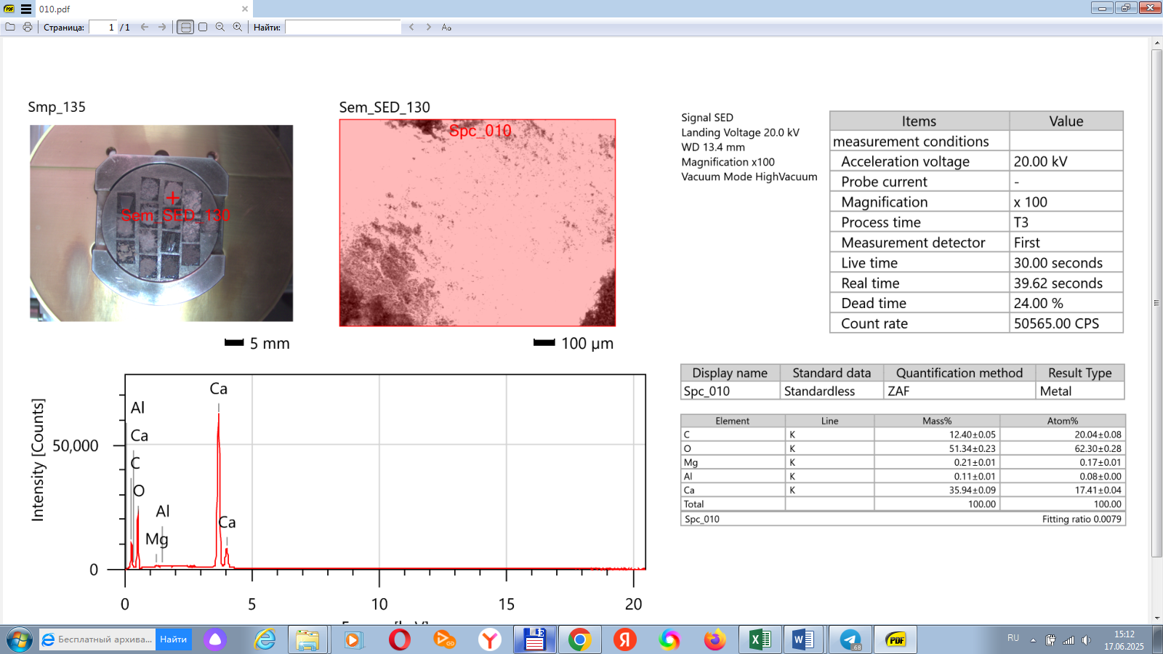

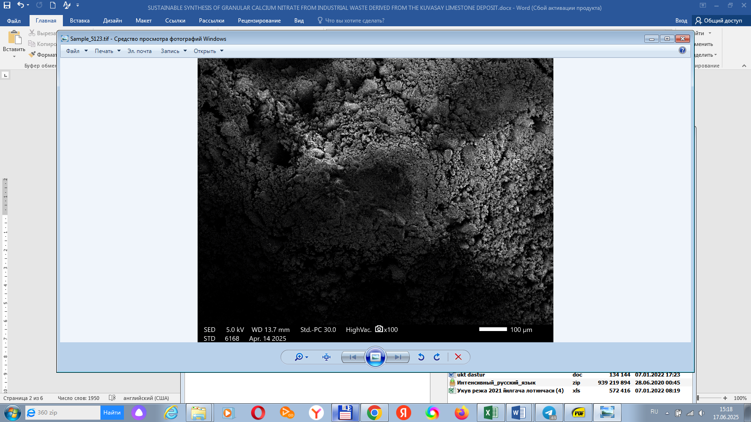

**(a)**

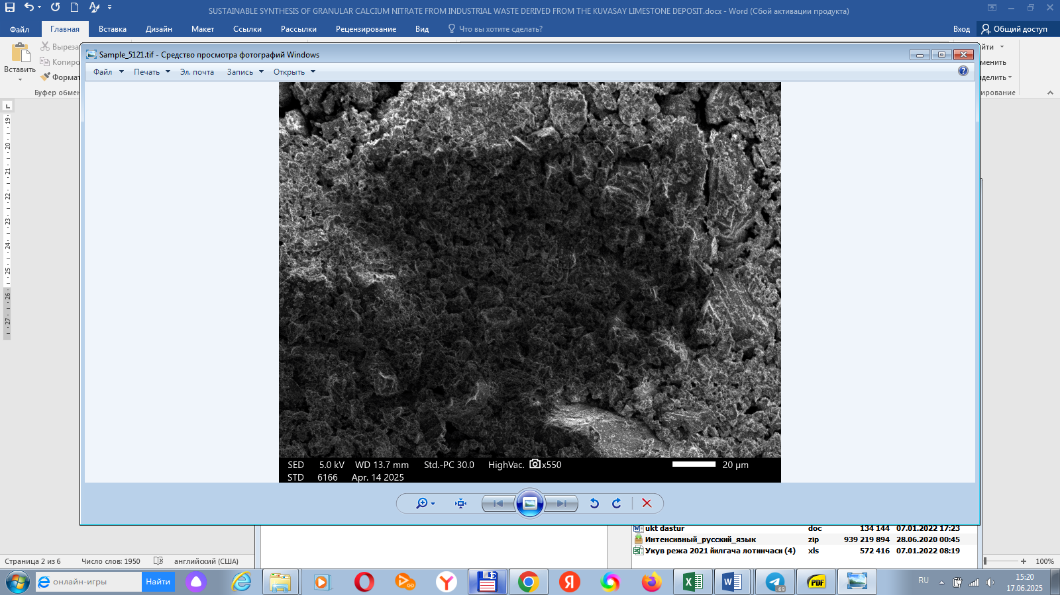

(b)

**Figure 2. Scanning Electron Microscopy (SEM) of Andijan limestone deposit (a,b)**

In the subsequent phase of the investigation, the pretreated limestone waste—primarily consisting of calcium carbonate (CaCO₃)—was subjected to chemical dissolution employing nitric acid solutions of varying molar concentrations. The acid was administered in different stoichiometric ratios relative to the calcium carbonate content to determine the optimal conditions for maximizing dissolution efficiency and reaction completeness [8]. The principal chemical reaction facilitating this conversion is represented by the equation:

**CaCO₃ + 2HNO₃ → Ca(NO₃)₂ + CO₂↑ + H₂O**

Upon completion of the acid dissolution stage, the resultant calcium nitrate-rich solution was carefully neutralized through the gradual addition of aqueous ammonia (NH₃·H₂O) until a near-neutral pH value was achieved. This neutralization step played a critical dual role: firstly, it effectively neutralized any residual unreacted nitric acid in the solution, thereby preventing potential corrosiveness or instability; secondly, it enhanced the physicochemical properties of the solution by stabilizing the ionic milieu, which in turn promoted improved homogeneity and stability. Such stabilization was crucial for optimizing the subsequent granulation process, ensuring the formation of mechanically robust and uniformly sized fertilizer granules [9].

Following neutralization, the calcium nitrate solutions were subjected to controlled evaporation to concentrate the solute to the target calcium nitrate content necessary for effective granulation [10]. The concentration process was carefully monitored to maintain optimal temperature and evaporation rates, ensuring the preservation of solution integrity and preventing premature crystallization. Subsequently, the concentrated calcium nitrate solution was fed into a rotary drum granulator, wherein it was uniformly sprayed onto pre-conditioned seed particles. This granulation step was conducted under rigorously controlled parameters of temperature and humidity, which were optimized to promote the agglomeration and growth of granules with consistent size and enhanced mechanical strength [11]. The precise regulation of these operational conditions was instrumental in producing granular calcium nitrate fertilizer with uniform morphology and sufficient structural stability, thereby meeting the agronomic requirements for effective field application [12].

**3.RESULTS AND DISCUSSION**

Two distinct methodological approaches were implemented for the production of granular calcium nitrate fertilizer. The first approach involved the removal of insoluble residues formed during the chemical decomposition stage through filtration prior to the granulation process. This step aimed to enhance the purity of the feed solution and potentially improve granule quality. Conversely, the second approach bypassed the filtration step, proceeding directly to granulation with the unfiltered solution containing suspended solids. The comparative evaluation of these two methodologies, including their effects on granule morphology, mechanical strength, and overall product quality, is systematically detailed in Tables 1 and 2, respectively

**Table 1**

**Product composition obtained through the filter**

|  |  |  |  |  |  |  |  |  |  |
| --- | --- | --- | --- | --- | --- | --- | --- | --- | --- |
| Norm  (HNO3) | Ca amount | | N2 amount | | | Mg amount | | | NH4NO3 |
| CaO | Ca(NO3)2 | (N)NH4 + | (N)NO3- | (N)um. | | MgO | Mg(NO3)2 |
| 40 % HNO3 acid | | | | | | | | | |
| 90 | 25,42 | 74,43 | 0,02 | 13,03 | 13,05 | | 0,19 | 0,70 | 0,11 |
| 95 | 25,17 | 73,72 | 0,01 | 13,54 | 13,56 | | 0,19 | 0,69 | 0,07 |
| 100 | 23,53 | 68,91 | 0,68 | 13,47 | 14,15 | | 0,17 | 0,64 | 3,21 |
| 105 | 23,05 | 67,51 | 0,89 | 13,84 | 14,73 | | 0,17 | 0,63 | 4,20 |
| 110 | 24,02 | 70,34 | 1,51 | 15,11 | 16,63 | | 0,18 | 0,66 | 7,13 |
| 45 % HNO3 acid | | | | | | | | | |
| 90 | 25,42 | 74,46 | 0,02 | 13,03 | 13,05 | | 0,20 | 0,74 | 0,11 |
| 95 | 25,18 | 73,74 | 0,01 | 13,54 | 13,55 | | 0,20 | 0,73 | 0,07 |
| 100 | 23,54 | 68,94 | 0,68 | 13,47 | 14,15 | | 0,18 | 0,68 | 3,21 |
| 105 | 23,06 | 67,53 | 0,89 | 13,84 | 14,73 | | 0,18 | 0,67 | 4,20 |
| 110 | 24,03 | 70,37 | 1,51 | 15,11 | 16,62 | | 0,19 | 0,70 | 7,13 |
| 50.4 % HNO3 acid | | | | | | | | | |
| 90 | 25,43 | 74,48 | 0,03 | 13,05 | 13,08 | | 0,21 | 0,78 | 0,12 |
| 95 | 25,19 | 73,77 | 0,02 | 13,56 | 13,58 | | 0,21 | 0,77 | 0,08 |
| 100 | 23,55 | 68,96 | 0,68 | 13,49 | 14,17 | | 0,20 | 0,72 | 3,22 |
| 105 | 23,07 | 67,56 | 0,89 | 13,86 | 14,75 | | 0,19 | 0,71 | 4,21 |
| 110 | 24,01 | 70,32 | 1,52 | 15,12 | 16,63 | | 0,20 | 0,74 | 7,13 |
| 55 % HNO3 acid | | | | | | | | | |
| 90 | 25,44 | 74,51 | 0,03 | 13,04 | 13,06 | | 0,22 | 0,82 | 0,14 |
| 95 | 25,20 | 73,79 | 0,02 | 13,55 | 13,57 | | 0,22 | 0,82 | 0,09 |
| 100 | 23,56 | 68,98 | 0,69 | 13,47 | 14,16 | | 0,21 | 0,76 | 3,23 |
| 105 | 23,08 | 67,58 | 0,90 | 13,84 | 14,74 | | 0,20 | 0,75 | 4,22 |
| 110 | 24,02 | 70,35 | 1,52 | 15,10 | 16,62 | | 0,21 | 0,78 | 7,14 |

**Table 2**

**Product composition obtained without the filter**

|  |  |  |  |  |  |  |  |  |  |  |  |
| --- | --- | --- | --- | --- | --- | --- | --- | --- | --- | --- | --- |
| Norm  HNO3 | Ca amount | | N2 amount | | | Mg amount | | Erimagan qoldiq | | | NH4NO3 |
| CaO | Ca(NO3)2 | (N)NH4 | (N)NO3- | (N)um. | MgO | Mg(NO3)2 | CaO | CO2 | CaCO3 |  |
| 40 % HNO3 acid | | | | | | | | | | | |
| 90 | 29,71 | 87,02 | 0,03 | 12,12 | 12,14 | 0,31 | 1,13 | 1,93 | 1,52 | 3,45 | 0,13 |
| 95 | 29,68 | 86,92 | 0,01 | 12,85 | 12,86 | 0,31 | 1,13 | 1,35 | 1,06 | 2,41 | 0,05 |
| 100 | 29,24 | 85,64 | 0,02 | 13,33 | 13,35 | 0,30 | 1,12 | 0,13 | 0,10 | 0,22 | 0,10 |
| 105 | 27,78 | 81,34 | 0,94 | 13,30 | 14,24 | 0,29 | 1,06 | 0,29 | 0,23 | 0,51 | 4,42 |
| 110 | 27,85 | 81,56 | 1,52 | 13,96 | 15,48 | 0,29 | 1,06 | 0,01 | 0,01 | 0,02 | 7,14 |
| 45 % HNO3 acid | | | | | | | | | | | |
| 90 | 29,72 | 87,04 | 0,03 | 12,12 | 12,15 | 0,31 | 1,13 | 1,93 | 1,51 | 3,44 | 0,13 |
| 95 | 29,68 | 86,93 | 0,01 | 12,86 | 12,87 | 0,31 | 1,13 | 1,34 | 1,06 | 2,40 | 0,05 |
| 100 | 29,25 | 85,65 | 0,02 | 13,34 | 13,36 | 0,30 | 1,12 | 0,12 | 0,09 | 0,21 | 0,10 |
| 105 | 27,78 | 81,35 | 0,94 | 13,30 | 14,24 | 0,29 | 1,06 | 0,28 | 0,22 | 0,50 | 4,42 |
| 110 | 27,85 | 81,56 | 1,52 | 13,97 | 15,48 | 0,29 | 1,06 | 0,01 | 0,00 | 0,01 | 7,14 |
| 50 % HNO3 acid | | | | | | | | | | | |
| 90 | 29,73 | 87,05 | 0,03 | 12,12 | 12,15 | 0,31 | 1,13 | 1,92 | 1,51 | 3,43 | 0,13 |
| 95 | 29,69 | 86,94 | 0,01 | 12,86 | 12,87 | 0,31 | 1,13 | 1,34 | 1,05 | 2,39 | 0,05 |
| 100 | 29,25 | 85,67 | 0,02 | 13,34 | 13,36 | 0,30 | 1,12 | 0,11 | 0,09 | 0,20 | 0,10 |
| 105 | 27,78 | 81,37 | 0,94 | 13,30 | 14,24 | 0,29 | 1,06 | 0,28 | 0,22 | 0,49 | 4,42 |
| 110 | 28,14 | 82,41 | 1,53 | 14,11 | 15,64 | 0,29 | 1,07 | 0,00 | 0,00 | 0,00 | 7,22 |
| 55 % HNO3 acid | | | | | | | | | | | |
| 90 | 29,76 | 87,15 | 0,03 | 12,13 | 12,16 | 0,31 | 1,14 | 1,92 | 1,51 | 3,43 | 0,13 |
| 95 | 29,69 | 86,95 | 0,01 | 12,86 | 12,87 | 0,31 | 1,13 | 1,33 | 1,05 | 2,38 | 0,05 |
| 100 | 28,36 | 83,04 | 0,02 | 12,93 | 12,95 | 0,29 | 1,08 | 0,10 | 0,08 | 0,19 | 0,09 |
| 105 | 27,79 | 81,38 | 0,94 | 13,30 | 14,24 | 0,29 | 1,06 | 0,27 | 0,21 | 0,48 | 4,42 |
| 110 | 28,15 | 82,43 | 1,53 | 14,11 | 15,65 | 0,29 | 1,07 | -0,01 | 0,00 | -0,01 | 7,22 |

Finally, the synthesized calcium nitrate granules were subjected to comprehensive physicochemical characterization to assess their suitability for agricultural application. Analytical evaluations encompassed measurements of moisture content, particle size distribution, and mechanical strength—specifically crush resistance—to determine the granules’ physical robustness. Additionally, surface morphology and microstructural features were examined using Scanning Electron Microscopy (SEM), providing detailed insights into granule texture and integrity. These systematic characterizations facilitated the optimization of granulation parameters and product formulation, thereby ensuring that the final granular calcium nitrate fertilizer met stringent agronomic quality standards. The key findings from these analyses are presented in Figure 3

**(a)**

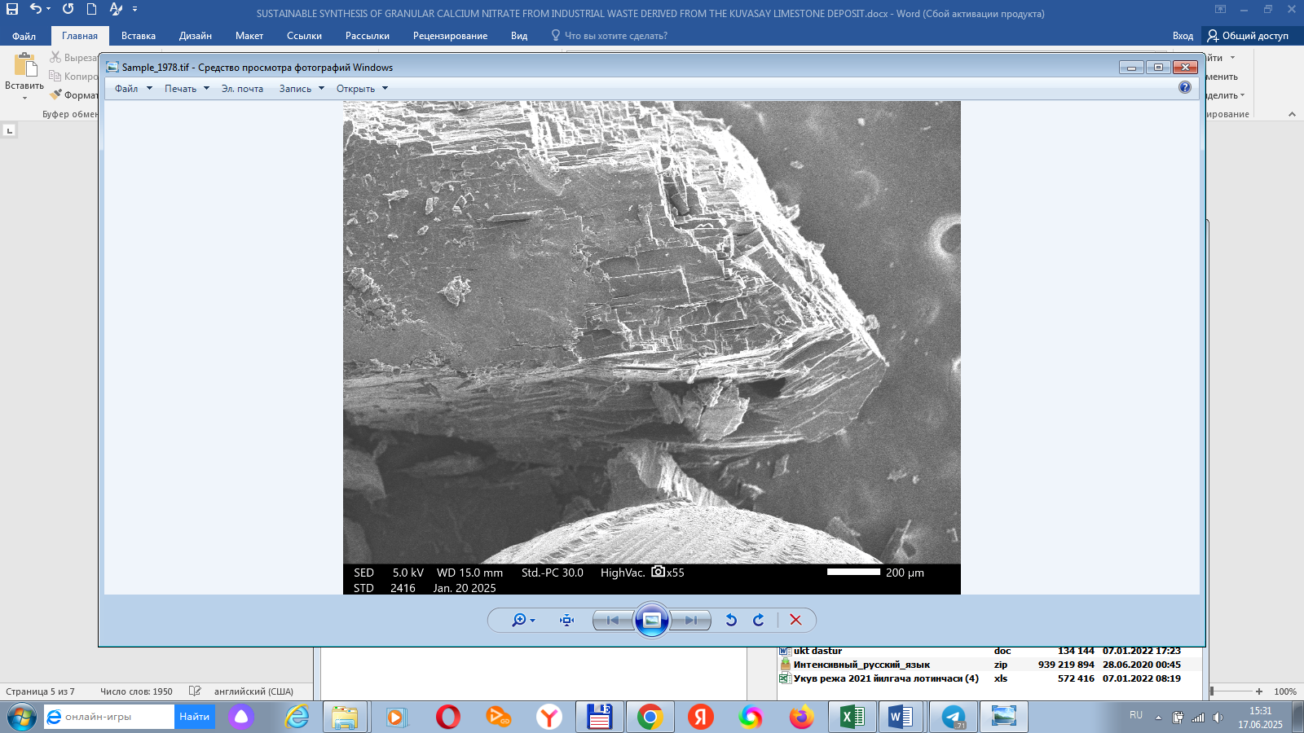

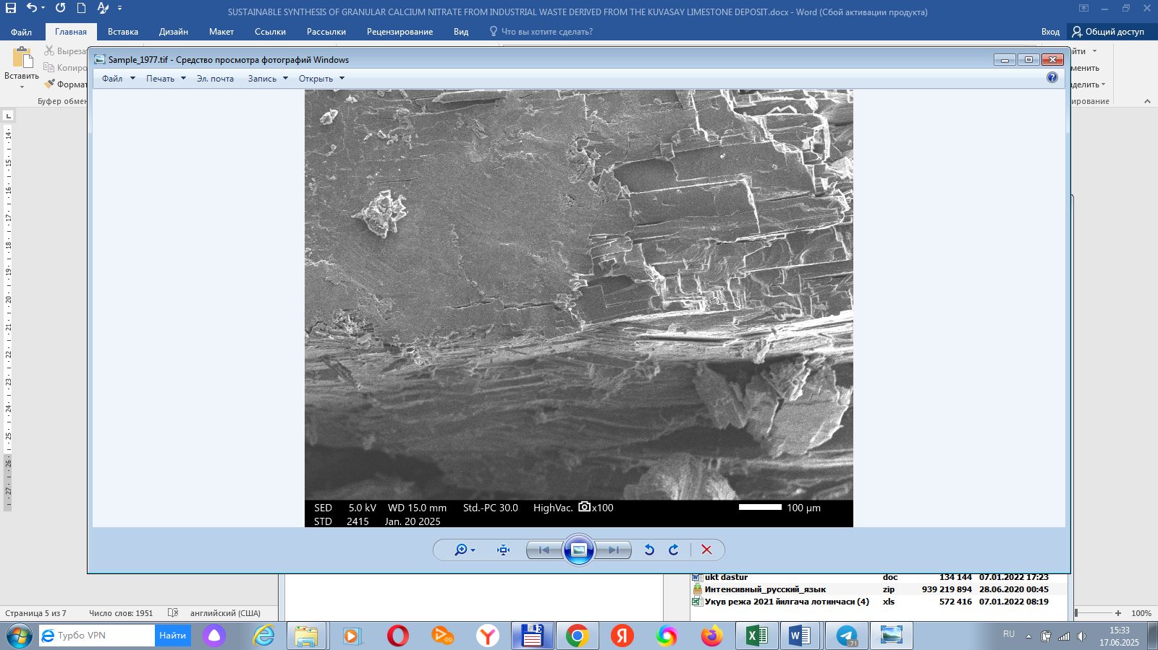

**(b)**

**Figure 3. SEM of Granul calcium nitrate**

**4.CONCLUSION**

This study successfully demonstrates a practical and sustainable methodology for the production of granular calcium nitrate fertilizer utilizing limestone waste derived from the Andijan deposit. The proposed process not only addresses the critical issue of industrial waste accumulation but also embodies circular economy principles by transforming mineral residues into a value-added product with significant agricultural utility. By valorizing this underutilized waste stream, the approach contributes to both environmental sustainability and resource efficiency. Future research efforts will be directed towards conducting comprehensive field trials to evaluate the agronomic performance of the produced fertilizer under real-world conditions. Additionally, further optimization of process parameters will be pursued to facilitate the transition from laboratory-scale experimentation to scalable industrial production, thereby enhancing the economic viability and broader adoption of this sustainable technology.

Disclaimer (Artificial intelligence)

Option 1:

Author(s) hereby declare that NO generative AI technologies such as Large Language Models (ChatGPT, COPILOT, etc.) and text-to-image generators have been used during the writing or editing of this manuscript.

Option 2:

Author(s) hereby declare that generative AI technologies such as Large Language Models, etc. have been used during the writing or editing of manuscripts. This explanation will include the name, version, model, and source of the generative AI technology and as well as all input prompts provided to the generative AI technology

Details of the AI usage are given below:

1. ChatGPT Plus for paraphrase and in order to be academic and clear.

**REFERENCES**

1. Zhao, Y., Li, H., & Wang, X. (2020). Utilization of Industrial Wastes in Fertilizer Production. *Journal of Cleaner Production*, 276, 124201.
2. Kumar, A., Patel, R., & Singh, M. (2018). Recovery of Calcium Nitrate from Limestone Waste. *Chemical Engineering Journal*, 336, 378–386.
3. Singh, D., & Thomas, M. (2017). Fertilizer Granulation: A Review. *Powder Technology*, 315, 123–131.
4. Rakhimov, A., Tursunov, B., & Ergashev, D. (2021). Prospects of Using Andijan Limestone Waste. *Uzbek Journal of Chemical Engineering*, 5(2), 33–40.
5. CHEMANALYST market analysis site
6. Characteristics of world production of mineral fertilizers // New chemical technologies. Analytical portal of the chemical industry. 10.11.2015. –С.4. URL: http:// [www.newchemistry.ru/letter. php?n_id=2247](http://www.newchemistry.ru/letter.%20php?n_id=2247)
7. Ergashev D.A., Isabaev D.Z. Study of systems that justify the process of obtaining liquid fertilizer of complex action //Eurasian Union of Scientists (ESU). No. 5(62). 2019. 1-Frequently. –P.25-30
8. Murzin A.M. Technological processes for the production of calcium nitrate.
   1. Journal of the Chemical Industry 1936-t.13 No. 10 – pp. 610-612.
9. Shapiro A.S. Processing carbonate sludge into calcium nitrate. Journal of the Chemical Industry 1936-t.13 No. 5 – pp. 273-275.
10. Yatsuta N.A. Semi-factory experiments on the production of calcium nitrate. Journal of the Chemical Industry 1936-t.13 No. 21 – pp. 1289-1292.

11. Zinchenko V.A. Chemical plant protection: means, technology and environmental safety. Moscow: Kolos, 2005. -P. 11.

12. Characteristics of the world production of mineral fertilizers // New chemical technologies. Analytical portal of the chemical industry. 10.11.2015. –P.2. URL: http://www.newchemistry.ru/letterphp?n_id=2247

13. Fedorova N.S. Trends in the development of the mineral raw materials and fertilizers market // Bulletin of the Russian State Pedagogical University named after A.I. Herzen. -2008. -No. 32 (70). -P. 350.

14. The world pesticide market is growing // RBC. Market research: Internet site. 13.05.2015. –P.3. URL: http://marketing.rbc.ru/news_ research/13/05/2015/56294999 5161960.shtml.