**EXTRACTION AND EVALUATION OF THE EXTRACT BLEND OF CARICA PAPAYA AND AMNONA MURICATA** **AS ANTIULCEROGENIC AND GASTROPROTECTIVE AGENT**

**ABSTRACT**

The study explores the extraction and evaluation of phytochemicals derived from *Annona muricata* and *Carica papaya* leaves as a potential candidate in the treatment of peptic ulcers. This study attempts to eliminate the limitations associated with modern medicines especially against ulcers with a complex pathology, indicating a need of substitute medication from an alternative system of medicine. Most of these drugs produce several adverse reactions including toxicities which may even alter biochemical mechanisms of the body upon chronic usage and cause severe potential gastrointestinal adverse effect and other non-gastrointestinal tract side effect. By extracting these chemicals from natural sources, the creation of a safer and reliable solution to modern medicine is greatly enhanced. Fresh leaves of Annona muricata and Carica papaya leaves were plucked. The extract was obtained using cold maceration and ethanolic extraction method and pure crude extract was gotten by evaporation and condensation of the macerated filtrate using Rota Vapor (BUCHI) apparatus. The extracts had sweet honey like scent for *Amnona muricata* and a characteristic herbaceous scent for Carica papaya extract. The evaluation of the blend’s potential and efficacy was determined by Histopathological study after administration and it was observed that the extract blend possessed significant antiulcer activity with increasing efficacy as the dosage was increased. Finally, the extracts were characterized using FTIR spectroscopy and the functional groups of each extract was observed.

The results showed that both extracts contained phytochemicals that makes them suitable as anti-ulcerogenic extracts. Treatment with aqueous extract caused significant decrease in gastric acidity and increase in mucus production, thereby exhibiting gastroprotective effects. Treatment with extracts did not show any sign of toxicity.

**Keywords:** Peptic ulcer, anti-ulcerogenic extract blend, gastroprotective activity, Hispathology.

1. INTRODUCTION

Peptic ulcer (PU) is a collective term used for a group of chronic diseases that affect mucosal stability of stomach and/or duodenal lining. It is characterized by pain, perforations, bloating, nausea, blood in stool or vomit, loss of appetite, weight loss [1], anaemia, chest pain, heartburn, gnawing or burning sensation occurring during meals [2]. PU manifest as a non-fatal disease majorly represented by periodic symptoms of epigastric pain, which are often relived by food or alkali, besides to trigger much discomfort to patients, disrupting their daily routines and causing mental agony [3]. Peptic ulcer disease (PUD) is a worldwide issue with a lifetime risk of development ranging from 5% to 10%. [4], [5].

Herbal medicines are used as treatment options by as many as 50% of the western population, where approximately 10% are for the treatment or prevention of digestive disorders [6]. Nowadays, herbal medicine is becoming a viable alternative treatment over the commercially synthetic drugs on PU management /treatment this is premised on low cost, perceived effectiveness, availability as well as little or no side effects. A number of these herbal remedies have demonstrated gastroprotective properties [7], [8] and have been used in the treatment of PU, digestive disorders and other related ailments.

Phytochemicals are bioactive secondary metabolites that are produced and found in plants that helps protect the plant from diseases and its environment. These compounds are produced either as intermediaries or end product in the system during metabolic processes. Some examples of these phytochemicals include flavonoids, tannins, saponins, and glycosides. These compounds when taking into the human body can be medicinal to the human. The antidiabetic, anti-hypertensive, anti-inflammatory, antiulcerogenic and the vast medical applications of herbal medicine is as a result of these phytochemicals and the human system. Not all phytochemicals are medicinal though as some have varying degree of toxicity.

*Carica papaya* is herbaceous succulent plant native to tropical and subtropical parts of world. It is a rich source of nutrients and vitamins (Vitamin A, C and E). Pharmacologically, papaya is used in the treatment of various conditions due to its antioxidant, anti-inflammatory, immunomodulatory, and antimicrobial properties [9], [10]. Bioactive constituents of papaya include β carotene, lycopene, kaempferol, myricetin, dehydrocarpain I and II, ferulic acid, caffeic acid, carpaine, β-sitosterol, xylitol, galactose and raffinose ([11]; [12]. Anti-ulcerogenic effect of methanolic extract of *C. papaya* was evaluated in various ulcer models (pyloric ligation, ethanol, acetic acid and indomethacin induced ulcer models). Treatment with aqueous and methanolic extract caused significant decrease in gastric acidity and increase in mucus production and GSH level, thereby exhibits gastroprotective effects [13]. Moreover, treatment with extracts did not show any sign of toxicity ([14]. In another study, anti-ulcer effect of aqueous extract of *C. papaya* seed was studied in ethanol induced ulcerative rats. Significant reduction in acidity, total gastric volume and ulcer index was observed in treatment groups as compared to control, hence can be a potential therapeutic agent for the treatment of ulcer [15].

*Annona muricata* L., a member of the Annonaceae family, is a widely distributed plant in Central and South America and tropical countries. [16]; [17]. Also known as soursop and graviola, this small tropical tree plant has long been cultivated by native peoples, due to its extensive applications in folk medicine and heart-shaped, edible fruits. [18]; [19]. The lanceolate dark green leaves of *A. muricata* are traditionally used as an antispasmodic nervine for heart conditions and as a sedative. In addition, the leaves are applied to treat asthma, cough, fever, headache, hypertension, and toothache [20], [21]. The leaves of *A. muricata* have been found to possess significant antioxidant effects, assessed by 2,2-diphenyl-1-picrylhydrazyl (DPPH) radical-scavenging activity, ferric reducing antioxidant power, and hydroxyl-scavenging activity techniques in animal models. [18], [20], [26]. In addition, the leaves demonstrated a notable protective effect against acute and chronic inflammations in rats, through suppression of proinflammatory cytokines. [23]. Previous studies have shown that the main chemical constituents in *A. muricata* are annonaceous acetogenins, alkaloids, and essential oils. Due to the significant antioxidant and anti-inflammatory features of *A. muricata* leaves, this plant may be a promising candidate for antiulcer agents.

Hence, the present study was carried out to investigate the antiulcerogenic and gastroprotective activity and toxicity of extract blend of *A. muricata and C. papaya* leaves against ulcer induced gastric injury in wistar rats.

**3. Materials and method**

All the chemicals used were purchased from different reputable vendors and were used without further purification. Ethanol, Methanol, Iron III Chloride (FeCl3), Hydrogen Chloride (HCl), Dragendorff’s reagent, Sulphuric Acid (H2SO4), Distilled water

Other materials include *A. muricata* and *Carica papaya* leaves, Sonicator, Rotary evaporator, filter paper, syringes, Fourier Transform Infra Red Spectroscopy (FTIR Spectroscopy), weighing scale mortar and pistil, blender, spatula, Wistar rats.

**3.1 Collection and preparation of Amnona muricata and Carica papaya leaves.**

The leaves of *A. muricata (sour sop leaves)* and *Carica papaya (paw paw leaves)* were plucked from State Lowcost and Tudun Wada respectively, located in Jos south LGA of Plateau State, Nigeria. Both plant samples (leaves) were then transported to the Chemistry laboratory of Bingham University Karu Nasarawa State.

Fresh papaya leaves were washed first under running tap water, followed by sterile distilled water. After drying at 40o C or 72 hours, the leaves were ground to a fine powder using a mechanical blender (Binatone ® Commercial blender). The dry weight was determined,

and the powder was stored in an air-tight container at 20 oC until further usage [24]

**3.1.1 Preparation and of extraction *of A. muricata*** extract.

The *A. muricata* leaves were collected, washed and cleaned with water, cut into small pieces, and dried for three days (72 hours) under room temperature. After drying they were blended and weighed.

150 grams of the dried soursop leaves was soaked in 96% ethanol for 30 minutes with continuous stirring using a magnetic stirrer. The mixture was covered and left undisturbed for 24 hours with occasional stirring. After filtration, the filtrate was then transferred to another container and left for one day to allow the alcohol to evaporate completely. [25].

**3.1.2 Solvent Extraction from Papaya Leaves**; This was done following the method of Abdullah et al., [26]. The compounds were extracted using a non -polar solvent (Ethanol). 150g of powdered leaves was immersed in conical flasks containing 1000 mL of ethanol. The flask was then placed in a Sonicator (Fisher brand TM 505) for 10 minutes at 25oC. The extract was pumped filtered through Whatman No. 1 filter paper. The filtrate was then evaporated and condensed using Rota Vapor (BUCHI) apparatus at 40oC, 150 rpm, to obtain the final volume of 1 mL of extract per 10 g of plant sample. The aliquots were then weighed and kept at 20 oC for further use. The extraction yield was determined using the following formula:

Yield (%) = $\frac{dry weight of extract}{dry weight of plant powder} x 100$

**3.3 Phytochemical Screening of extract blend**

1. Alkaloid test; A total of 0.5 g of extract plus 5 mL of 1% HCl was then heated and filtered. To 1mL of the filtrate was then added few drops of Dragendorff’s reagent. Formation of an orange to red precipitate indicated that the sample contains alkaloids.
2. Flavonoids test; A total of 1 mg of extract was added, and methanol 4 mL then heated. The filtrate was added H2SO4. The formation of red colour indicates the presence of flavonoids.
3. Phenolic test; To a total of 1 mg of extract was added two drops of 1% FeCl3. Positive extracts containing phenols was formed ,as they produce solid green and red colours.
4. Saponin test; A total of 1 mg sample was put into a test tube, then 5 mL of water and one drop of HCl were added and shaken for 20 seconds, and changes occurred. The foam formed and did not does not disappear for 20 minutes), this indicates the presence of saponins
5. Tannin test; to (1 mg) of the extract was added of 10 mL of water and boiled for 5-10 minutes. The mixture was filtered and 1% FeCl3 was added. The dark blue or greenish-black colour observed indicates the presence of tannins.

3.4 FTIR spectral analysis

The functional groups that made up the chemical components of the crude extracts were determined on a FTIR 670 Thermofisher Scientific Spectrophotometer. All absorption bands are expressed in cm-1..

**3.5 Administration of the extract blend of A. muricata and Carica papaya to ulcer induced Wistar rats**

Nine Wistar rats were divided into three (3) groups, each group consisting of three rats. Group 1 received distilled water (negative control), group 2 received 50 mg/kg of extract blend, group 3 rats were given 100 mg/kg of extract blend. The dose of extract blend used is as indicated in a study ***reported*** by Adeneye and Olagunju 2009, [27], [28]. The treatment in all the groups was single dose for fourteen consecutive days through gavages.

**Ethanol-induced gastric ulcer;** After two weeks of treatment, all the rats were fasted for 24 h with free access to water. Gastric ulcer was induced with 1 ml of 80% ethanol which was administered orally to each animal after 24 h fasting).

**4. RESULTS AND DISCUSSION**

**4.1 Physical Properties of the leaves and the extracted oil**

The physical properties of the extract is as shown in table 1 below. Soursop leaves are dark green, shiny, and large, with an oval-elliptical shape. The shape of the leaves was oblong to oval, measuring approximately 8 cm to 16 cm in length and 3 cm to 7 cm in width. The colour of the young and mature soursop leaves used for the extraction was light green and glossy dark green respectively.

The crude extract has a dark green colour. After the crude extract was obtained, the ethanol was evaporated and recovered using a rotary-evaporator and the aqueous extract was concentrated by removing moisture/water in a water bath. The concentrated extract has a sweet honey like scent. The concentrated extract was weighed and weight and percentage yield of the concentrated extract was recorded as 19.9g and 13.3% respectively.

Pawpaw leaves (Carica papaya), also known as papaya leaves, had several characteristics:

The Leaf Shape and Size of Pawpaw leaves were simple and alternate in arrangement. They had pinnate venation. The leaf appeared to be obovate or oblong in shape. Typically, they had 12 to 28 cm long and 5 to 8 cm wide. The aroma of pawpaw leaves when crushed produce a distinct green pepper odour.

The crude extract has a dark green colour. After the crude extract was obtained, the ethanol was evaporated and recovered using a rota-vapour and the aqueous extract was concentrated by removing moisture/water in a water bath. The concentrated extract has a characteristic herbaceous scent. The concentrated extract was weighed. The weight and percentage weight of concentrated extract is 17.4g and 11.6% respectively.

The poor yield could be attributed to low weight of starting material, poor solvent to feedstock ratio, low pressure and temperature of extraction process. This result aligns with previous work carried out by Kulczycki *et al.,* (2019) [29] on factors affecting yields in extraction as all these parameters affected the efficiency of extraction.

The individual extracts were mixed and blended using a ratio 1: 1 where equal quantity of individual extract was blended to obtain a homogenous extract before administration. It possessed a dark green colour of concentrated aliquot with a characteristic herbaceous scent

**Table 1: Physical properties of crude extract**

|  |  |  |  |  |
| --- | --- | --- | --- | --- |
| Leaves | Colour of aliquot | Smell of aliquot | Yield (g) | Percentage yield (%) |
| Annona muricata | dark green colour | Honey like scent | 19.9 | 13.3 |
| Carica papaya | brown green colour | A characteristic  herbaceous scent | 17.4 | 11.6 |
| Extract blend of both A. muricata and C. papaya | Dark green colour | Herbaceous scent | 37.3 | 24.9 |

4.2 Phytochemical screening

The phytochemical screening was done. and the results are as shown in table 2 below.

Table 2: Phytochemical Screening Result of Soursop Extract

|  |  |  |  |
| --- | --- | --- | --- |
| Parameter | Test | Observation | Inference |
| Saponins | 1mg of extract + 5ml distilled water + 1 drop HCl | Presence of frothing |  |
| Phenolics | 1mg of extract + 2 drops of 1% FeCl3 | Black colour observed |  |
| Tannins | 1mg of extract + 10ml distilled water + boil for 10 – 15min + filter.  Filtrate + 1% FeCl3 | Dark green coloured product formed |  |
| Alkaloids  (Dragendorff’s method) | 0.5g of extract + 5ml of 1% HCl + heat + filter.  Filtrate + few drops of Dragendorff’s Reagent | Orange precipitate formed |  |
| Flavonoids | 1mg of extract + 4ml methanol + heat + filter.  Filtrate + H2SO4 | Deep red precipitate formed |  |

**Table 3: Phytochemical screening result of pawpaw extract**

|  |  |  |  |
| --- | --- | --- | --- |
| Parameter | Test | Observation | Inference |
| Saponins | 1 mg of extract + 5ml distilled water + 1 drop HCl | Presence of frothing |  |
| Phenolics | 1 mg of extract + 2 drops of 1% FeCl3 | Black colour observed |  |
| Tannins | 1 mg of extract + 10ml distilled water + boil for 10 – 15min + filter.  Filtrate + 1% FeCl3 | Dark green coloured product formed |  |
| Alkaloids  (Dragendorff’s method) | 0.5 g of extract + 5ml of 1% HCl + heat + filter.  Filtrate + few drops of Dragendorff’s Reagent | Orange precipitate formed |  |
| Flavonoids | 1 mg of extract + 4ml methanol + heat + filter.  Filtrate + H2SO4 | Deep red precipitate formed |  |

* **Means Present.**

From the phytochemical screening conducted, results showed that the following bioactive substances namely saponins, phenolics, alkaloids, Galo tannins, flavonoids are present in both extracts. This agrees with the report of Aguilar-Hernandez et al. (2019) [30], which mentioned that Soursop leaves are rich in phenolic compounds that give the fruit numerous health benefit which makes them a potential source for the extraction of bioactive compounds that can be used in the pharmaceutical, cosmetic and food industrial sector. These compounds and biological activities attribute functionality and value to the soursop and pawpaw extracts making it to stand out as having anti -ulcerogenic property. The phytochemical investigation also suggests that papaya leaves contain alkaloids, saponins, tannins, flavonoid, hence have therapeutic properties like antibacterial, anti-inflammatory, anti-viral, hypoglycaemic antitumor, anti-ulcerogenic and many others.

The result from this study is similar to that of a work done by Vij et al. 2015 which reveals that the quantitative phytochemical analysis illustrated that aqueous papaya extract contained the presence of 0.001% tannins, 0.0022% saponins, 0.013% flavonoids,0.011%phenolics, 0.0019% alkaloids and 0.004% steroids [31].

4.3: FTIR spectral analysis:

The functional groups that made up the chemical components of the extracted oils were determined by infra-red spectrum on FTIR 670 Thermofisher Scientific Spectrophotometer in KBr disc. All absorption bands are expressed in cm-1.

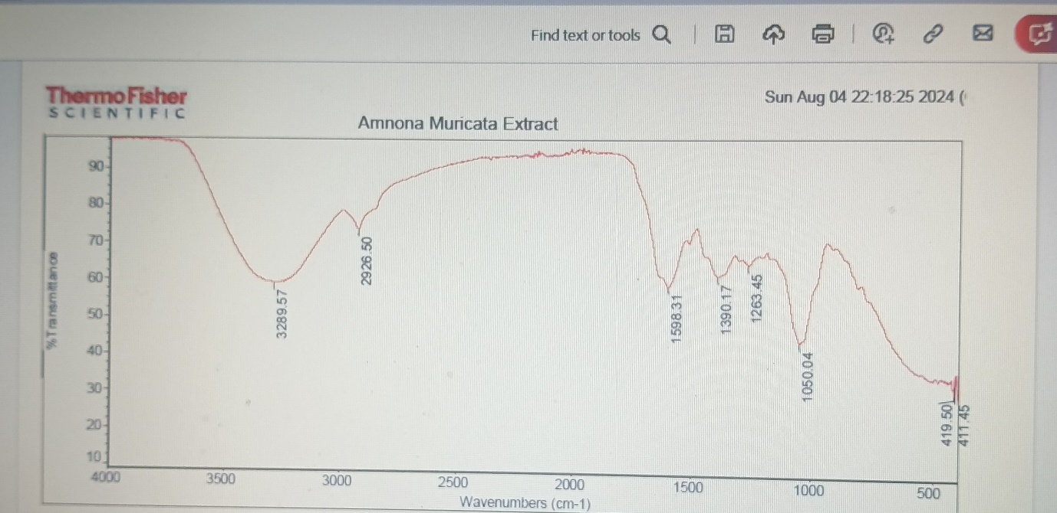

**Figure 1:** **FTIR spectrum of the crude extract from soursop.**

FTIR Annona muricata extract (cm-1): a medium peak was seen at 1598cm-1 and this is attributed to a stretching vibration of the conjugated carbon to carbon bond (C=C ring stretching) of an aromatic compound, this ring stretching is evidence of the -C=C functional group present in the benzene of all active compounds found. A sharp peak shown at 2926 cm-1 is attributed to the C-H stretch of CH2 and CH3 of the saturated compound which is found in the bioactive substances found in the extract. similarly, a broad peak/band was found at 3289 cm-1 to correspond to the functional group of (stretching vibration for O-H of the phenolic group) and another peak was seen at 1390 cm-1 attributed to C-H stretching deformation of the CH2 on the saturated compounds.

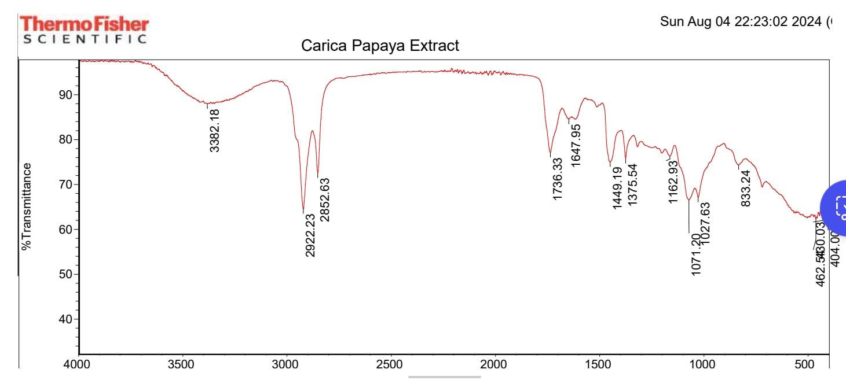

**Figure 2: FTIR spectrum of the crude extract from Carica papaya**

A strong and broad peak was seen at 3382 cm-1 and this is attributed to N-H stretching vibrations of alkaloid group present in the Carica *papaya* extract. A sharp peak was also seen at 2922 cm-1 and 2852 cm-1 corresponding to a – C-H stretch of CH2 and CH3 of the saturated compound. The carbon-to-carbon bond (C=C ring stretching) of a conjugated aromatic compound showed a sharp peak at 1647 cm-1 attributed to all aromatic structures of the bioactive substances present. A peak at 1736 cm-1 is attributed to -C=O stretching of a carbonyl of aldehyde/ketone. This is evidence of the -C=O functional group present in saponins and flavoloid (flavonone).

Similarly, A sharp peak shown at 1375 cm-1 is attributed to the C-H symmetrical deformation of CH2 of the saturated compound which is found in the bioactive substances found in the extract. similarly, a peak/band was found at 1162 cm-1 to correspond to the functional group of -C-O-C of the ester group and another peak was seen at 833 cm-1 attributed to C-H bending of the CH2 of the substituted benzene

4.4 Histopathological findings:

The rats were kept in the animal care unit in the university and were fed with animal feed and water once a day throughout the duration of the study. Ulcer was induced by fasting them for 24 hours with free access to water and then administering 1ml of 80% ethanol.

The extract was then administered orally for 14 days after which they were sacrificed and their stomachs harvested for analysis. The ulceration was analysed using macroscopic and microscopic (histochemistry) methods.

Different concentration of the extract showed gastroprotective effect in a dose dependent manner as compared to the negative control.

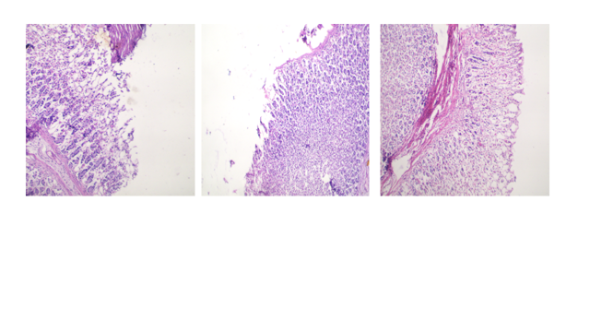

Figure 3: Histological sections of animals administered with 80% alcohol showed focal spots of ulcerations in the mucosa layers of the stomach (black arrows). (H&E. X400MG). (Group 1)

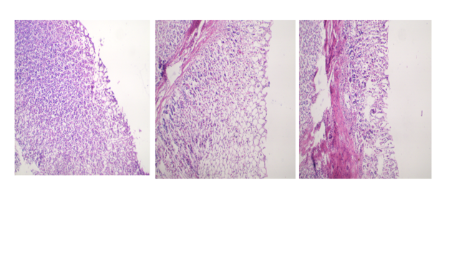

Figure 4: Histological sections of animals exposed to 80% alcohol and administered with different concentrations of extract blend showed some preserved areas from ulcerations in the mucosa layers of the stomach (red arrows). (H&E. X400 MG). (Group 2)

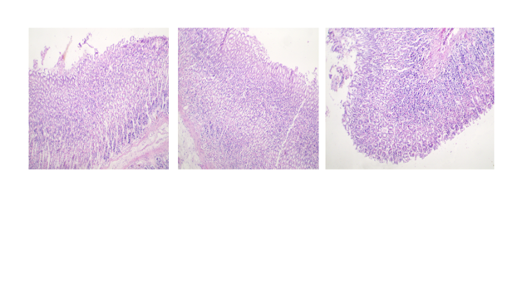

Figure 5: Histological sections of animals exposed to 80% alcohol and administered with different concentrations of extract blend showed some mucosa layers preserved from ulcerations in the stomach (Green arrows). (H&E. X400 MG). (Group 3)

From the figures above (figure 3 to figure 5) figure 3 shows the epithelial mucosal layer of the stomachs of Group 1 (control group), figure 4 shows the epithelial mucosal layer of the stomachs of Group 2 and figure 5 shows the epithelial mucosal layer of the stomachs of Group 3.

It is observed that there was a very high level of ulceration in the control group 1, and the level of ulceration decreases with increasing dosages of extract from 50mg/kg to 100mg/kg and to 150mg/kg respectively which shows that the mucosal layer of the stomachs was protected and confirms the Gastroprotective and Antiulcerogenic properties of the extract blend containing flavonoids and other bioactive compounds. This agree with what was stated in literature by Mehdi et al., 2018 describing the ascribed activity of flavonoid in the treatment of ulcer [32].

The phytochemical compounds present in the extract blend can function in the capacity of these various anti-ulcer therapy and their activity can be ascribed to specific classes of bioactive compounds such as alkaloids, tannins, phenolic, polyphenols (particularly flavonoids) Alkaloids can also act like antacids. it works with a mechanism to reduce gastric acid secretion, increase mucus and alkaline secretion and increase gastric mucosal blood flow to aid the healing and prevention of ulcers. Multitarget mechanism of action includes; Outer membrane/cytoplasmic membrane disruption, Z ring perturbation and Nuclei acid synthesis [33,34].

Mechanism of action of phenolic acids includes, antibacterial, cytoprotective, antisecretory, antioxidant modes of action. Phenolic acids act with a variety of free radicals either by the action of hydrogen atom transfer, transfer of single electron, sequential proton loss electron transfer and chelation of transition metals.

In conformity with a result by Mehdi et al., (2018), flavonoids present in the extract blend can inhibit the mucosal content of the platelet-activating factors in rats with gastric damage produced by ethanol. Due to the presence of hydroxyl groups (s) in their aromatic ring(s), they also possess antioxidant activity.[35]. Flavonoids have been reported to act in the gastrointestinal tract, having antispasmodic, anti-secretory, antidiarrheal, antiulcer, and antioxidant properties. According to Sumbul et al., (2011), Flavonoids are among the cytoprotective materials for which anti-ulcerogenic efficacy has been extensively confirmed. They protect the gastric mucosa against a variety of ulcerogenic agents via several mechanisms of action, mainly free-radical scavenging and antioxidant properties, increased mucus production, antisecretory action, and inhibition of the Helicobacter pylori growth.

In alignment with a work done by Vij et al., (2015), Tannins prevent ulcer development due to their protein precipitating and vasoconstricting effects. Their astringent action can help to precipitate microproteins on the ulcer site, thereby, forming an impervious layer over the lining, which hinders induced gastric ulcer in rats, as evidenced by the gut secretions, and protects the underlying mucosa from reduction in the ulcer scores.

Analysis of various literature data and previous researches conducted have indicated that phytochemicals are natural, safe and effective materials that can be administered and used in the prevention, control and treatment of various forms of ulcers

5.0 CONCLUSION:

This study investigated the physicochemical properties, chemical composition, and antiulcerogenic activity of an extract blend of Amona muricata and Carica papaya. The results indicated that certain bioactive compounds such as phenolics, saponins, tannins and flavonoids were present in both extract and these bioactive compounds are responsible for inhibitory property. Both extracts in isolation were found to have very similar physicochemical properties, hence a better property is enhanced when both extracts are combined for use. The findings of this study also demonstrated that the level of ulceration decreases with increasing dosages of extract from 50mg/kg to 100mg/kg and to 150mg/kg which shows that the mucosal layer of the stomachs were protected and confirms the gastroprotective and antiulcerogenic properties of the extract blend. Also, the use of plant extract and its administration for ulcer treatment has given rise to researches that are a safer and cheaper alternative. Chemical compounds in plants can be used to augment the treatment of ulcer with little adverse effects. The present research has shown a positive result to the treatment of peptic ulcers and will prove to be groundbreaking research in the medical field for the production of sustainable, cheaper and safer antiulcer drug.

The limited number of identified compounds in this study was likely due to the focus on constituents of interest and those identified in literature to possess anti ulcerogenic property.

This study offers valuable insight into the unique composition of blend of crude extract of A. muricata and C. papaya as as antiulcerogenic and gastroprotective agent when administered.

However, further research is necessary to chemically identify and isolate more of the still-unknown constituents or bioactive compounds present in this extract blend and also to quantify the Identified bioactive compounds particularly those that contribute significantly to its antiulcerogenic and gastroprotective activity, and to expand the understanding of their bioactive potential and mechanism of action.

**References**

[1] Mukta Gupta, Bhupinder Kapoor, Reena Gupta, & Naresh Singh (2021). Plants and phytochemicals for treatment of peptic ulcer: an overview. ScienceDirect.

[2] Najm W.I. Peptic ulcer disease. Primary Care: Clin. Office Pract. 2011;38:383–394.

doi: 10.1016/j.pop.2011.05.001. [[DOI](https://doi.org/10.1016/j.pop.2011.05.001)] [[PubMed](https://pubmed.ncbi.nlm.nih.gov/21872087/)] [[Google Scholar](https://scholar.google.com/scholar_lookup?journal=Primary%20Care:%20Clin.%20Office%20Pract.&title=Peptic%20ulcer%20disease&author=W.I.%20Najm&volume=38&publication_year=2011&pages=383-394&pmid=21872087&doi=10.1016/j.pop.2011.05.001&)

[3] Hamedi S., Arian A.A., Farzaei M.H. Gastroprotective effect of aqueous stem bark extract of ziziphus jujuba l. Against hcl/ethanol-induced gastric mucosal injury in rats. J. Tradit. Chin. Med. 2015;35: 666–670. doi: 10.1016/S0254-6272(15)30157-6. [DOI] [PubMed] [Google Scholar]

[4] Snowden, F. M. (2008). Emerging and re-emerging diseases: a historical perspective. Immunological Reviews, 225(1), 9-26.

[5] Lanas, A., & Chan, F. K. L. (2017). Peptic ulcer disease. Lancet, 390(10094), 613-624.

[6] Langmead, L., & Rampton, D. S. (2001). Herbal treatment in gastrointestinal and liver disease – benefits and dangers. Alimentary Pharmacology & Therapeutics, 15, 1239.

[7].De Andrade S.F., Lemos M., Comunello E., Noldin V.F., Cechinel Filho V., Niero R. Evaluation of the antiulcerogenic activity of Maytenus robusta (Celastraceae) in different experimental ulcer models. J. Ethnopharmacol. 2007; 113:252–257. doi: 10.1016/j.jep.2007.06.002. [[DOI](https://doi.org/10.1016/j.jep.2007.06.002)] [[PubMed](https://pubmed.ncbi.nlm.nih.gov/17629427/)] [[Google Scholar](https://scholar.google.com/scholar_lookup?journal=J.%20Ethnopharmacol.&title=Evaluation%20of%20the%20antiulcerogenic%20activity%20of%20Maytenus%20robusta%20(Celastraceae)%20in%20different%20experimental%20ulcer%20models&author=S.F.%20De%20Andrade&author=M.%20Lemos&author=E.%20Comunello&author=V.F.%20Noldin&author=V.%20Cechinel%20Filho&volume=113&publication_year=2007&pages=252-257&pmid=17629427&doi=10.1016/j.jep.2007.06.002&)

[8] Boligon A.A., de Freitas R.B., de Brum T.F., Waczuk E.P., Klimaczewski C.V., de Ávila D.S., Athayde M.L., de Freitas Bauermann L. Antiulcerogenic activity of Scutia buxifolia on gastric ulcers induced by ethanol in rats. Acta Pharm. Sinica B. 2014;4:358–367. doi: 10.1016/j.apsb.2014.05.001. [[DOI](https://doi.org/10.1016/j.apsb.2014.05.001)] [[PMC free article](https://pmc.ncbi.nlm.nih.gov/articles/PMC4629092/)] [[PubMed](https://pubmed.ncbi.nlm.nih.gov/26579405/)] [[Google Scholar](https://scholar.google.com/scholar_lookup?journal=Acta%20Pharm.%20Sinica%20B&title=Antiulcerogenic%20activity%20of%20Scutia%20buxifolia%20on%20gastric%20ulcers%20induced%20by%20ethanol%20in%20rats&author=A.A.%20Boligon&author=R.B.%20de%20Freitas&author=T.F.%20de%20Brum&author=E.P.%20Waczuk&author=C.V.%20Klimaczewski&volume=4&publication_year=2014&pages=358-367&pmid=26579405&doi=10.1016/j.apsb.2014.05.001&)

[9] Anjana, G. V., Priya, D., Srimathi, R., & Shantha, K. B. (2018). A review on medical advantages and chemical constituents of Carica papaya Linn. Asian Journal of Pharmaceutical and Clinical Research, 11, 53-571

[10] Vij, T., & Prashar, Y. (2015). A review on medicinal properties of Carica papaya Linn. Asian Pacific Journal of Tropical Disease, 5, 1-6.

[11] Marfo, E.K., Oke, O.L., & Afolabi, O.A. (1986). *Chemical composition of papaya (Carica papaya) seeds*. *Food Chemistry*, *22*, 259-266.

[12] Yogiraj, V., Goyal, P. K., Chauhan, C. S., Goyal, A., & Vyas, B. (2014). Carica papaya Linn: an overview. International Journal of Herbal Medicine, 2, 01-08.

[13] Pinto, L. A., Cordeiro, K. W., Carrasco, V., Carollo, C. A., Cardoso, C. A. L., Argadoña, E. J. S., & de Cássia Freitas, K. (2015). Antiulcerogenic activity of Carica papaya seed in rats. Naunyn-Schmiedeberg’s Archives of Pharmacology, 388, 305-317.

[14] Ezike, A.C., Akah, P.A., Okoli, C.O., Ezeuchenne, N.A., & Ezeugwu, S. (2009). *Carica papaya (Paw-Paw) unripe fruit may be beneficial in ulcer*. *Journal of Medicinal Food*, *12*[, 1268-1273](https://apastyle.apa.org/style-grammar-guidelines/references)

[15] Okewumi Tolunigba Abisola, Wahab Adekunle Oyeyemi (2012). *Gastroprotective activity of aqueous Carica Papaya seed extract on ethanol induced gastric ulcer in male rats.* DOI: [10.5897/AJB12.034](http://dx.doi.org/10.5897/AJB12.034)

[16] George, V. C., Kumar, D. R., Rajkumar, V., Suresh, P. A., & Kumar, R. A. (2012). Quantitative assessment of the relative antineoplastic potential of the n-butanolic leaf extract of Annona muricata Linn. In normal and immortalized human cell lines. Asian Pacific Journal of Cancer Prevention, 13(2), 699–7042

[17] George, V. C., Kumar, D. R., Suresh, P. K., & Kumar, R. A. (2014). Antioxidant, DNA protective efficacy and HPLC analysis of Annona muricata (soursop) extracts. Journal of Food Science and Technology, 1–83

[18] Zeng, L., Wu, F. E., Oberlies, N. H., McLaughlin, J. L., & Sastrodihadjo, S. (1996). Five new monotetrahydrofuran ring acetogenins from the leaves of Annona muricata. Retrieved from PubMed. Journal of Natural Products, 59(11), 1035–1042.

[19] Gleye, C., Laurens, A., Hocquemiller, R., Cavé, A., Laprévote, O., & Serani, L. (1997). Isolation of montecristin, a key metabolite in biogenesis of acetogenins from Annona muricata and its structure elucidation by using tandem mass spectrometry. Journal of Organic Chemistry, 62(3), 510–513.

[20] Adewole, S.O., & Caxton-Martins, E.A. (2006). *Morphological changes and hypoglycemic effects of Annona muricata Linn. (Annonaceae) leaf aqueous extract on pancreatic β-cells of streptozotocin-treated diabetic rats*. *African Journal of Biomedical Research*, *9*(3), 173–180.

[21] Adewole, S.O., & Ojewole, J.A. (2008). *Protective effects of Annona muricata Linn. (Annonaceae) leaf aqueous extract on serum lipid profiles and oxidative stress in hepatocytes of streptozotocin-treated diabetic rats*. *African Journal of Traditional, Complementary, and Alternative Medicine*, *6*(1), 30–31.

[22] Baskar, R., Rajeswari, V., & Kumar, T.S. (2007). *In vitro antioxidant studies in leaves of Annona species*. *Indian Journal of Experimental Biology*, *45*(5), 480.

[23] Foong, C.P., & Hamid, R.A. (2012). *Evaluation of anti-inflammatory activities of ethanolic extract of Annona muricata leaves*. *Revista Brasileira de Farmacognosia*, *22*(6), 1301–1307.

[24] Abdullah S, Gobilik J, Chong K P 2012 *Int J. Pharm and Pharmaceutical Sci*. **45** 227-230

[25] Indah Zahara, Effionora Anwar, Dian Ratih Laksmitawati, Deni Rahmat (2023). *Antioxidant Activity Cultivated of Soursop (Annona muricata L.) Leaves Extract in Jayasari Village, Pangandaran District, West Java. Pp (2)*

[26] Abdullah S, Gobilik J, Chong K P 2014 *Int. Conf. on Civil Biol. and Envi. Eng. CBEE*-2014 Istanbul Turkey

[27] Adeneye, A.A., & Olagunju, J.A. (2009). *Preliminary hypoglycemic and hypolipidemic activities of the aqueous seed extract of Carica papaya Linn. in Wistar rats*. *Biological and Medical Research*, *1*(1), 1-10.

[28] Verma, R. J., Nambiar, D., & Chinoy, N. J. (2006). Toxicological effects of Carica papaya seed extract on spermatozoa of mice. Journal of Applied Toxicology, 26(6), 533-535.

[29] Kulczycki K.and Aaron G. (2019). Cannabis science and technology 2(3),56-57

[30] Aguilar – Hernandez. G., Maria de los angeles V., Lourdes .G.Efgenia M., (2020). Molecules . Total Acetogenins from soursop fruits by response surface methodology. 25(5): 1139. DOI: 10.3390/molecules25051139

[31] Vij, T., & Prashar, Y. (2015). A review on medicinal properties of Carica papaya Linn. Asian Pacific Journal of Tropical Disease, 5, 1-6.

[32] [Mehdi S.](https://pubmed.ncbi.nlm.nih.gov/?term=%22Sharifi-Rad%20M%22%5BAuthor%5D), [Patrick V.](https://pubmed.ncbi.nlm.nih.gov/?term=%22Fokou%20PVT%22%5BAuthor%5D), [Farukh S.,](https://pubmed.ncbi.nlm.nih.gov/?term=%22Sharopov%20F%22%5BAuthor%5D), [Miquel M.](https://pubmed.ncbi.nlm.nih.gov/?term=%22Martorell%20M%22%5BAuthor%5D), [Adedayo O.,](https://pubmed.ncbi.nlm.nih.gov/?term=%22Ademiluyi%20AO%22%5BAuthor%5D), [Jovana R](https://pubmed.ncbi.nlm.nih.gov/?term=%22Rajkovic%20J%22%5BAuthor%5D) , [Bahare S., i](https://pubmed.ncbi.nlm.nih.gov/?term=%22Salehi%20B%22%5BAuthor%5D)[Natália Martins](https://pubmed.ncbi.nlm.nih.gov/?term=%22Martins%20N%22%5BAuthor%5D) , [I](https://pubmed.ncbi.nlm.nih.gov/?term=%22Iriti%20M%22%5BAuthor%5D) [Javad S.,](https://pubmed.ncbi.nlm.nih.gov/?term=%22Sharifi-Rad%20J%22%5BAuthor%5D) (2018) Antiulcer Agents: From Plant Extracts to Phytochemicals in Healing Promotion. Molecules, Jul 17;23(7):1751. doi: [10.3390/molecules23071751](https://doi.org/10.3390/molecules23071751)

[33] *Beserra F.P., Rozza A.L., Vieira A.J., Gushiken L.F., Pellizzon C.H. Studies in Natural Products Chemistry. Volume 47. Elsevier; Amsterdam, The Netherlands: 2016. Antiulcerogenic compounds isolated from medicinal plants; pp. 215–234. Atta-ur-Rahman.* [[*Google Scholar*](https://scholar.google.com/scholar_lookup?title=Studies%20in%20Natural%20Products%20Chemistry&author=F.P.%20Beserra&author=A.L.%20Rozza&author=A.J.%20Vieira&author=L.F.%20Gushiken&author=C.H.%20Pellizzon&publication_year=2016&)]

[34] Sumbul, S., Ahmad, M. A., & Mohd, A. (2011). Role of phenolic compounds in peptic ulcer: An overview. Retrieved from PubMed. DOI: 10.4103/0975-7406.84437.

[35] *Izzo A.A., Carlo G.D., Mascolo N., Capasso F., Autore G. Antiulcer effect of flavonoids. Role of endogenous paf. Phytother. Res. 1994;8:179–181. doi: 10.1002/ptr.2650080313.* [[*DOI*](https://doi.org/10.1002/ptr.2650080313)] [[*Google Scholar*](https://scholar.google.com/scholar_lookup?journal=Phytother.%20Res.&title=Antiulcer%20effect%20of%20flavonoids.%20Role%20of%20endogenous%20paf&author=A.A.%20Izzo&author=G.D.%20Carlo&author=N.%20Mascolo&author=F.%20Capasso&author=G.%20Autore&volume=8&publication_year=1994&pages=179-181&doi=10.1002/ptr.2650080313&)]