The Role of Artificial Intelligence in Enhancing the Occupational Safety and Health Management Systems

.

ABSTRACT

|  |
| --- |
| **Aim:** This study aimed to investigate the role of Artificial Intelligence (AI) in enhancing the occupational health and safety of workers within Oman context.  **Study design:** A quantitative approach was used to collect and analyse data on participants’ perceptions, on benefits, challenges, and preferences among professionals engaged in safety.  **Methodology:** A self-administered questionnaire was distributed to 125 health and safety professionals across selected workplace in Oman. The study sample included engineers, healthcare professionals, and health and safety practitioners who use artificial intelligence within their daily tasks. The study sample was chosen purposively. SPSS software version 26.0 was used to analyze quantitative data.  **Results**: The results indicate broad support for the use of Artificial Intelligence among participants in decision-making and real-time safety monitoring. Some concerns regarding privacy, data reliability, and job displacement were highlighted. However, no statistically significant differences in perception were found across different roles or experience levels, indicating consistent views on AI adoption in Occupational Health and Safety (OHS).  **Conclusion:** it was concluded that artificial intelligence is viewed as a beneficial technology to the OHS systems in Oman, and by extension globally. Nonetheless, for effective integration of AI into OHS systems in Oman, it is recommended to implement national training and readiness programs to develop workforce skills and digital proficiency across sectors. |

***Keywords:*** *Artificial Intelligence, Occupational Safety and Health, Safety Management System, Predictive Analytics, Technology Acceptance Model, Oman*

1. **INTRODUCTION**

Artificial Intelligence (AI) is rapidly transforming the occupational health and safety (OHS) domain and positively enhancing safety performance. This advance technology uses predictive analytics, and supports intelligent decision making to prevent accidents, predict equipment failure, and promote proactive safety practices across various industries (Abdelrahim et al., 2024; Ferrara et al., 2024; Maleki Varnosfaderani & Forouzanfar, 2024; Park & Kang, 2024). Globally, the integration of AI technologies within OHS is becoming progressively common and valuable, however, Oman has yet to adopt these technologies as widely.

The contribution of AI in predictive maintenance, diagnostics, and immersive safety training was underlined by several authors including (Ferrara et al., 2024; Maleki Varnosfaderani & Forouzanfar, 2024; Park & Kang, 2024). However, the success of these systems often depends on several factors that differ from place to place the. These factors include technological infrastructure of the country, organizations readiness, and the levels of digital literacy. In the context of Oman, although regulatory body such as (OSHAD), the Occupational Safety and Health Authority, which is responsible for setting national OHS standards (Al-Jabri et al., 2021), yet the integration of AI depends entirely on organization.

Nonetheless, vital economic sectors in Oman, including oil and gas, construction, and healthcare, stated to use AI in OHS that demonstrated positive and encouraging results (Al Kuwaiti et al., 2023; Kashoub et al., 2023; Komorowski et al., 2018). Although AI clearly has the possibility to enhance OHS performance in Oman, there is limited research on the subject, the use of AI in workplace safety is still at an early stage.

This is evident when analyzing data from Scopus database on AI publications that intersect with OHS, it was noted that Oman accounts for only 8% of publication from Gulf region countries excluding Kuwait that did not appear in the search results. The results indicates that Oman falls behind Saudi Arabia and the UAE. See Table 1

*Table 1: Emerging trends of AI research within gulf region*

|  |  |  |  |  |  |  |
| --- | --- | --- | --- | --- | --- | --- |
| Id | Country | Documents | Documents % | Citations | Average Citation Per Document | Total Link Strength |
| 1 | Saudi Arabia | 119 | 51% | 2401 | 20.2% | 43 |
| 2 | United Arab Emirates | 66 | 28% | 1236 | 18.7% | 26 |
| 3 | Qatar | 22 | 9% | 805 | 36.6% | 26 |
| 4 | Oman | 18 | 8% | 168 | 9.3% | 10 |
| 5 | Bahrain | 8 | 3% | 150 | 18.8% | 3 |

To address this gap, considering factors such as collectivism and organizational hierarchy that further restrict dual feedback, which is essential for adaptive and participatory AI safety, this study aims to adapt global AI and OHS frameworks to Oman’s environment and explore the views of Omani professionals on using AI for workplace safety.

1. Analyse stakeholder perceptions of AI in OHS.
2. Identify barriers to AI integration in workplace safety systems.
3. Assess how AI enhances safety management across industries.

* H₀₁: No significant difference in AI perception across occupational roles.
* H₀₂: No significant association between professional experience and AI trust.
* H₀₃: No significant variation in AI application preferences based on demographics.

This research uses Risk Management Theory as its main framework to analyze how AI is adopted in OHS. The key ideas are Perceived Risk (such as worries about privacy and job loss due to automation) and Trust, both especially relevant in safety-critical workplaces. Demographic variables—like age, gender, job role, and experience—are considered as factors that shape how individuals weigh the risks and benefits of using AI for workplace safety.

Figure 1: Conceptual Framework for AI Adoption in Occupational Health and Safety (OHS)

1. **METHODOLOGY**
   1. **Research Design**

A quantitative descriptive approach was used to collect and analyse data on AI perceptions, challenges, and preferences among professionals engaged in OHS.

* 1. **Participants and Sampling**

125 professionals were selected using purposive sampling across engineering, healthcare, IT, education, and administration. The sample included both early-career and experienced professionals, reflecting a broad perspective on OHS technology adoption.

* 1. **Research Instrument**

The questionnaire comprised five sections: demographics, AI familiarity, perceived usefulness and trust, concerns about AI integration, and application preferences. Items were scored on a 5-point Likert scale. Expert validation and a pilot study ensured reliability and clarity.

* 1. **Data Collection Procedure**

Data were collected online in April 2025. Informed consent was obtained, and participant anonymity was guaranteed. Data were cleaned and coded for statistical analysis.

* 1. **Data Analysis**

Statistical package for social science (SPSS) version 26.0 was used for descriptive and inferential analysis. The descriptive statistics summarized participant demographics and response trends. The inferential Chi-square tests explored associations between perception and variables such as occupation and experience. While this study did not conduct regression analysis, it lays the groundwork for future inferential studies.

* 1. **Ethical Considerations**

The study received ethical clearance from the institutional review board. Participants were informed of their rights, and participation was voluntary.

**3. RESULTS AND DISCUSSION**

**3.1 Demographic Summary**

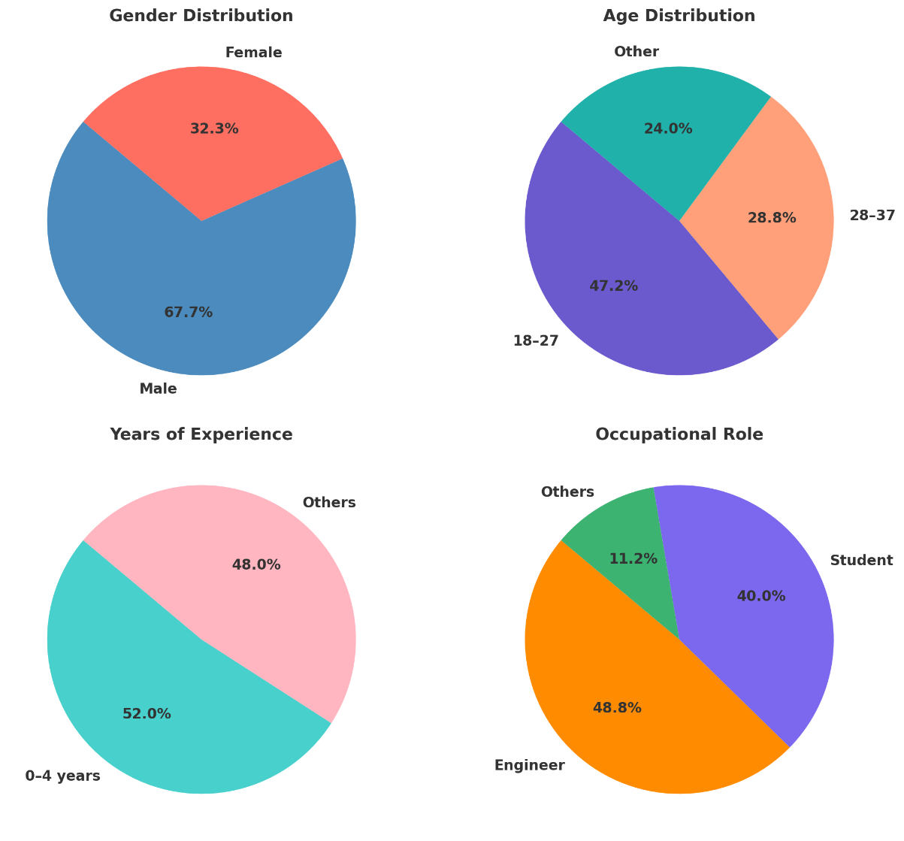

Figure 2: Demographic Profile of Respondents

The demographic profile of respondents reveals that 67.2% were male, a figure that aligns with the predominance of men in certain industries. Nearly half (47.2%) of participants were between the ages of 18 and 27, with 28.8% falling within the 28 to 37 age brackets. In terms of professional experience, 52% had 0 to 4 years of experience, while 48% reported 5 or more years. The sample was primarily composed of engineers (48.8%) and students (40%), reflecting the strong representation of these occupations within the participant pool. This distribution reflects a technologically literate, early-career workforce well-positioned to adopt digital tools.

**3.2 Inferential analysis**

Inferential analysis was conducted to test the proposed hypotheses and assess the significance and strength of the observed effects.

*Table 2: Perceived Usefulness of AI in Occupational Health and Safety*

| **Item** | **Mean Score** | **Standard Deviation** | **Verbal Interpretation** |
| --- | --- | --- | --- |
| Technology improves decision-making | 2.82 | 1.16 | Agree |
| Technology is trustworthy | 2.54 | 1.07 | Agree |
| Ease of completing tasks using technology | 1.18 | 0.83 | Disagree |
| Technology poses health risk | 1.95 | 1.10 | Neutral |
| Technology reduces workload | 2.45 | 1.16 | Neutral |

Table 2 shows the level of participants recognition of AI's decision-making benefits, but expressed doubt about usability and workload reduction, highlighting a gap in user experience design.

*Table 3: Primary Concerns about AI Integration in OHS*

| Concern | Frequency | Percentage (%) |
| --- | --- | --- |
| AI reliability | 67 | 53.6% |
| Data privacy | 66 | 52.8% |
| Job displacement | 65 | 52.0% |
| Lack of transparency | 46 | 36.8% |
| Other (please specify) | 12 | 9.6% |

These concerns echo with broader global discourse on AI ethics and trustworthiness, underscoring the need for governance framework. See table 3.

Table 4 illustrates the perception of participants regarding the applications of AI within their workplace. The real-time monitoring of worker safety is the most frequently reported AI application in occupational settings, followed by accidents prevention predictive analytics (48.8%) and training and education (47.2%).

*Table 4: AI Applications Perceived as Most Beneficial to OHS in Oman*

|  |  |  |
| --- | --- | --- |
| AI Application | Frequency | Percentage (%) |
| Real-time monitoring of worker safety | 76 | 60.8% |
| Predictive analytics for accident prevention | 61 | 48.8% |
| AI-powered training and education | 59 | 47.2% |
| Automated risk assessment and management | 53 | 42.4% |
| Other (please specify) | 4 | 3.2% |

These results affirm demand for AI tools that support proactive and adaptive safety management. The Chi-square tests revealed no significant association between perception and occupation (χ²=12.21, p=0.4286) or experience (χ²=13.04, p=0.3664). Thus, H₀₁ and H₀₂ were retained. Preferences were consistent across age and gender, supporting H₀₃.

1. **Discussion**

This study aimed to explore the potential of artificial intelligence (AI) to enhance Occupational Safety and Health (OSH) management systems in Oman. High agreement on decision-making enhancement aligns risk management theory.

Reliability and privacy emerged as major concerns, consistent with Risk Management Theory. Distrust in AI systems could hinder implementation unless mitigated through transparency and ethical safeguards (Ferrara et al., 2024; Mukhamediev et al., 2022). Job displacement anxiety also reflects a need for workforce reskilling initiatives.

The findings of this study highlight the strong preference for real-time monitoring, predictive analytics, and training validates AI's relevance in both reactive and proactive safety management (Shah & Mishra, 2024; Visschers & Siegrist, 2008). Moreover, the absence of significant demographic variation suggests broad alignment on AI’s value in OHS, streamlining national policy and training program design.

The findings of this study carry important implications for policy, practice, training, and technological development within Oman’s occupational health and safety landscape. At the policy level, there is a clear need to establish a national governance framework for AI integration in OHS, encompassing ethical guidelines, compliance mechanisms, and data protection standards (Ferrara et al., 2024; Shah & Mishra, 2024).

From (Ferrara et al., 2024; Shah & Mishra, 2024) a practical standpoint, organizations should prioritize the deployment of intuitive, user-friendly, and explainable AI systems to ensure accessibility and trust among diverse workforce groups (Komorowski et al., 2018) In terms of capacity building, targeted digital literacy and upskilling programs are essential to prepare employees, especially those in safety-critical roles, for AI-supported environments.

In line with previous literature this study confirms the role of Artificial intelligence in enhancing the workplace safety for example (Zhong et al., 2024). However, technologically, immediate attention should be directed toward implementing high-utility applications such as real-time monitoring systems and simulation-based training tools, which are both impactful and widely supported by end users. Together, these implications provide a roadmap for ethical, effective, and inclusive AI adoption in Oman’s evolving workplace safety ecosystem.

1. **CONCLUSION**

This study demonstrates that artificial intelligence (AI) is broadly recognized as a valuable enhancement to Occupational Health and Safety (OHS) systems in Oman. Professionals across diverse sectors, regardless of role or experience level, expressed strong support for AI’s potential to improve decision-making, real-time monitoring, and predictive analysis. These perceptions reflect high alignment with the constructs of the Technology Acceptance Model (Davis, 1989) particularly in terms of perceived usefulness. However, limitations related to perceived ease of use and concerns about reliability, data privacy, and job displacement persist. These issues reflect key themes from Risk Management Theory and underscore the need for ethical, transparent, and context-sensitive approaches to AI implementation in safety-critical environments.

To ensure the successful integration of artificial intelligence into OHS systems in Oman, several strategic actions are essential. First, national AI training and readiness programs should be launched to build workforce competence and foster digital fluency across sectors. In tandem, the development and deployment of explainable AI models must be prioritized to enhance transparency and build user trust in automated decision-making processes. Revising existing OHS policies to incorporate ethical frameworks and AI-specific compliance standards will further strengthen governance and accountability. Additionally, implementation efforts should focus on real-time monitoring, predictive analytics, and AI-based training tools technologies identified as both high-impact and well-received by the workforce. Finally, to support evidence-based decision-making and continuous improvement, longitudinal and sector-specific studies should be conducted to monitor the long-term effects and efficacy of AI applications in diverse industrial environments.

By adopting these measures, Oman can position itself at the forefront of AI-driven occupational safety in the Gulf region and serve as a model for responsible digital transformation in emerging economies.

**REFERENCES**

Abdelrahim, R., Katzis, K., Boustras, G., & Panayidou, K. (2024). The occupational safety, health, and well- being risks associated with industry 4.0 application: A systematic literature review. Multidisciplinary Reviews, 8(4), 2025106. https://doi.org/10.31893/multirev.2025106

Al Kuwaiti, A., Nazer, K., Al-Reedy, A., Al-Shehri, S., Al-Muhanna, A., Subbarayalu, A. V., Al Muhanna, D., & Al-Muhanna, F. A. (2023). A Review of the Role of Artificial Intelligence in Healthcare. Journal of Personalized Medicine, 13(6), 951. https://doi.org/10.3390/jpm13060951

Al-Jabri, F., Kvist, T., Sund, R., & Turunen, H. (2021). Quality of care and patient safety at healthcare institutions in Oman: quantitative study of the perspectives of patients and healthcare professionals. BMC Health Services Research, 21(1), 1109. https://doi.org/10.1186/s12913-021-07152-2

Davis, F. D. (1989). Perceived Usefulness, Perceived Ease of Use, and User Acceptance of Information Technology. MIS Quarterly, 13(3), 319. https://doi.org/10.2307/249008

Ferrara, M., Bertozzi, G., Di Fazio, N., Aquila, I., Di Fazio, A., Maiese, A., Volonnino, G., Frati, P., & La Russa, R. (2024). Risk Management and Patient Safety in the Artificial Intelligence Era: A Systematic Review. Healthcare, 12(5), 549. https://doi.org/10.3390/healthcare12050549

Kashoub, M., Al Abdali, M., Al Shibli, E., Al Hamrashdi, H., Al Busaidi, S., Al Rawahi, M., Al Rasbi, S., & Al Alawi, A. (2023). Artificial Intelligence in Medicine: A Double-edged Sword or a Pandora’s Box? Oman Medical Journal, 38(5), e542–e542. https://doi.org/10.5001/omj.2023.129

Komorowski, M., Celi, L. A., Badawi, O., Gordon, A. C., & Faisal, A. A. (2018). The Artificial Intelligence Clinician learns optimal treatment strategies for sepsis in intensive care. Nature Medicine, 24(11), 1716–1720. https://doi.org/10.1038/s41591-018-0213-5

Maleki Varnosfaderani, S., & Forouzanfar, M. (2024). The Role of AI in Hospitals and Clinics: Transforming Healthcare in the 21st Century. Bioengineering, 11(4), 337. https://doi.org/10.3390/bioengineering11040337

Mukhamediev, R. I., Popova, Y., Kuchin, Y., Zaitseva, E., Kalimoldayev, A., Symagulov, A., Levashenko, V., Abdoldina, F., Gopejenko, V., Yakunin, K., Muhamedijeva, E., & Yelis, M. (2022). Review of Artificial Intelligence and Machine Learning Technologies: Classification, Restrictions, Opportunities and Challenges. Mathematics, 10(15), 2552. https://doi.org/10.3390/math10152552

Park, J., & Kang, D. (2024). Artificial Intelligence and Smart Technologies in Safety Management: A Comprehensive Analysis Across Multiple Industries. Applied Sciences, 14(24), 11934. https://doi.org/10.3390/app142411934

Shah, I. A., & Mishra, S. (2024). Artificial intelligence in advancing occupational health and safety: an encapsulation of developments. Journal of Occupational Health, 66(1). https://doi.org/10.1093/joccuh/uiad017

Visschers, V. H., & Siegrist, M. (2008). Exploring the Triangular Relationship Between Trust, Affect, and Risk Perception: A Review of the Literature. Risk Management, 10(3), 156–167. https://doi.org/10.1057/rm.2008.1

Vivian, G. A., Bauder, R. A., & Khoshgoftaar, T. M. (2025). A comprehensive survey on machine learning for workplace injury analysis: risk prediction, return to work strategies, and demographic insights. Journal of Big Data, 12(1), 167. https://doi.org/10.1186/s40537-025-01229-z

Wang, B. (2021). Safety intelligence as an essential perspective for safety management in the era of Safety 4.0: From a theoretical to a practical framework. Process Safety and Environmental Protection, 148, 189–199. https://doi.org/10.1016/j.psep.2020.10.008

Yamin, T., & Murwaningsari, E. (2023). Exploring the Interplay Between Digital Technology, Transformational Leadership and Agility for Enhancing Organisational Performance. Business Ethics and Leadership, 7(4), 73–88. https://doi.org/10.61093/bel.7(4).73-88.2023

Zhong, X., She, J., & Wu, X. (2024). Tech for social good: Artificial intelligence and workplace safety. Technology in Society, 79, 102745. https://doi.org/10.1016/j.techsoc.2024.102745