*Review Article*

Global Trends and Burden of Diabetes: A Comprehensive Review of Global Insights and Emerging Challenges

.

ABSTRACT

|  |
| --- |
| **Background** Diabetes mellitus is a growing global health challenge, with its prevalence rising rapidly. This review is to provide a comprehensive analysis of the global trends, risk factors, and burden of diabetes while identifying emerging challenges in its prevention and management. **Materials and Methods:** This review is based on an extensive analysis of peer-reviewed literature, global health reports, and epidemiological data from authoritative sources such as the WHO, IDF, and CDC. A systematic search was conducted using databases like PubMed, Scopus, and Google Scholar. **Key facts:** Diabetes mellitus is a rapidly growing with prevalence expected to rise from 537 million adults today to 783 million by 2045. Type 2 diabetes accounts for over 90% of cases, with key risk factors including genetic predisposition, poor diet, physical inactivity, obesity, urbanization, and an aging population. The condition leads to severe health complications such as cardiovascular diseases, kidney failure, blindness, and amputations, imposing a significant economic burden that exceeds $1 trillion annually. Emerging challenges include increasing cases among children and adolescents, disparities in healthcare access, the impact of climate change and urbanization, and limited availability of advanced diabetes technologies. **Conclusion:** Addressing this crisis requires comprehensive public health interventions, including policy changes, educational programs, advancements in treatment, and strengthened healthcare systems to ensure early diagnosis and effective management. Coordinated global efforts are essential to reduce the burden of diabetes and improve health outcomes worldwide. |

*Keywords:* Burden of diabetes, Diagnosis, Emerging challenges, Global trends, Health outcomes.

1. INTRODUCTION

Overview of the global diabetes epidemic

Diabetes mellitus constitutes a chronic metabolic disease which currently spreads across the world as a fundamental public health concern. The main characteristic of diabetes is hyperglycemia which develops from defects in insulin action along with secretion and insulin action itself. Three major diabetes forms exist as Type I diabetes (T1D) alongside diabetes type 2 (T2D) and gestational diabetes mellitus (GDM). T2D represents the primary diabetes group which comprises more than 90% of all diagnosed diabetes cases. [1] The increase in diabetes population has been notably higher in lower and middle nations with resulting inequalities in the global disease burden. The affected region showcases South Asia, the Middle East, and Black Africa experiencing rising diabetes cases because of fast urbanization, industrialization along with advanced lifestyle choices and unhealthy eating patterns.[2]Direct medical expenses including insulin and prescription drugs and hospitalization costs together with indirect costs covering reduced wages and disability-related expenses form part of the total costs.[3]The insufficient pharmaceutical access in low-income countries worsens existing health disparities because these nations do not have enough insulin supplies.[4]Present-day scientific investigations demonstrate that diabetes stands among the most significant global health issues particularly those with type 2 diabetes which represents most diabetes cases.[5] Type 2 diabetes mellitus (t2DM) comprises about 90 percent of all diabetes incidences and is one of the leading non communicable diseases all over the world. Hormonal factors such as estrogen, as well as gender specific social economic and obesity trends, predispose premenopausal women to the condition. T2DM has great reproductive health risks, such as delayed puberty, menstrual problems, low fertility rate, pregnancy issues, and early menopause, The complications also put the health of the expectant women at greater risk, thus defying the international initiatives such as UN Sustainable Development Goal 3, which seeks to improve the situation by 2030 by ensuring that less than 70 per 100,000 lives are lost.

**IMPORTANCE OF EMPHASIZING GLOBAL TRENDS AND DEVELOPING ISSUES**

According to the Worldwide Diabetes Federation (IDF) the worldwide diabetes prevalence has escalated significantly across the globe. Sedentary living, urbanization, poor diet, genetic history, and increased age are a few causes for the increase in prevalence. Diabetes is a socioeconomic as well as a clinical issue and social determinants such as access to care, education, and income inequality have a significant role in diabetes outcomes [6]. Additional screening efforts and quick detection approaches alongside cost-effective treatment options need implementation because diabetes-related complications have grown heavier with an increased frequency of renal disease as well as cardiovascular disease diabetic retinopathy and lower extremity amputations [7]. In addition to this, the COVID-19 pandemic has highlighted how vulnerable individuals with diabetes are to severe infections, emphasizing the need for combined solutions [8]. It attempts to study new issues presented by diabetes, including rising rates among young individuals and adolescents, complications arising from diabetes (for example, renal illness, cardiovascular illness, and chronic retinopathy), and the cost of diabetes management [2]. The effectiveness of current diabetes preventive care and control strategies is also evaluated in this review, both at the international and regional levels. Imaginative approaches such as the utilize of cleverly methods within the treatment of diabetes, Health treatment, and the movement of accuracy pharmaceutical [9]. By considering these aspects, this review aims to provide feasible recommendations to researchers, policy-makers, and healthcare providers, helping to create more effective public health interventions and intervention strategies. Working together to develop long-term, evidence-based plans to reverse the tide of rising diabetes and improve world health outcomes is the long-term aim [10].

1. EPIDEMIOLOGY OF DIABETES

CURRENT STATISTICS ON DIABETES PREVALANCE WORLDWIDE

However, the largest numbers of diabetic cases are found in developing countries, most notably in Sub-Saharan Africa, the Middle East, and South Asia. Sedentary behavior, dietary changes, and rapid urbanization are all risk factors for the growing burden of diabetes in these nations [11]. The most affected areas are China, India, and the US; India alone is estimated to have more than 134 million diabetic patients by 2045 [12]. The Western Pacific region has the greatest number of diabetic patients, with more than 200 million reported cases, and rising rates in young adults and adolescents [13].

DIFFERENCES IN PREVALANCE ACROSS REGIONS

Diabetes prevalence is on the rise among both urban and rural communities due to differences in diets, lifestyle, and access to medical care. Because of inactivity, the intake of processed foods, and exposure to air pollution, diabetes is common in cities communities compared to rural communities, where historically it has been lower. Consequently, despite this, dietary changes, the lack of access to medical care, and higher levels of economic prosperity have resulted in more diabetes cases in rural communities [14]. Industrialization and socioeconomic growth in the majority of these countries are occurring at a fast pace. The urban-rural disparity in diabetes prevalence is narrowing due to industrialization, which is having a pervasive and adverse effect on lifestyles. Asians are less susceptible to environmental risk factors and are also genetically and ethnically predisposed to hyperglycemia. Therefore, compared to the Western population, they have lower waist circumferences, lower body mass indices, and are diagnosed with diabetes at an earlier age. The increasing trend of fat even in children and young people, has a direct correlation with the unwanted consequences of fat diets and physical inactivity. Healthcare outcomes are not favorable at all, and the economic costs of disease control are nil. Therefore, the disease complications are common and the burden is high, particularly for disadvantaged groups of the population [15].

**TRENDS OVER THE PAST FEW DECADES**

Roughly 37 million people globally are impacted by blindness. Of this number, diabetes related retinopathy constitutes 4.8%. It is estimated that 31.6% of Africans have diabetes- associated retinopathy. Seeking services from providers for the reduction and management of diabetes-related eye issues moreover that promotion of eye health is referred to as the use of eye care services. The proactive and proper use of these eye care services helps prevent and lessen vision loss for diabetic patients. Because diabetes related retinopathy, cataracts, and especially glaucoma are mostly asymptomatic in the beginning, they are often misdiagnosed or ignored. Patients with diabetes rom low and middle- income countries tend to seek eye care services only when the condition becomes advanced and vision-threatening. As per the American Academy of Ophthalmology, type 2 diabetes patients need to access eye care services on a regular and timely basis at the time of diagnosis, and also three to five years following a type 1 diabetes diagnosis [16]

OVERVIEW ON THE DISTRIBUTION IN T1DM AND T2DM

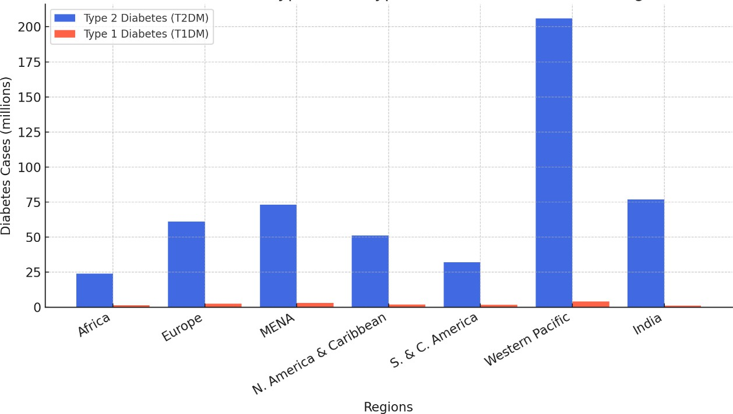

**Figure 1: The global distribution of Type 1 and Type 2 diabetes in 2021 by region**

Type 2 diabetes (T2DM) is far more prevalent across all regions (Figure 1), while Type 1 diabetes (T1DM) has a smaller but significant presence, especially in developed regions a significant burden of Type 2 diabetes (77 million cases) and a notable number of Type 1 diabetes cases (1.1 million). In any case, Scandinavian nations have the most elevated predominance of sort 1 diabetes (T1D) around the world, with their rates in Asia and Africa within the south of the Sahara remain lower than within the Western world. Alternately, populace development and nutritional changes are the strengths that lie within the start of sort 2 disaccharide (T2D) at incidence rates, basically in direct and low-income nations [17, 18]. A characterized imperfection within the generation or work of affront. Natural insuperable, including viral infections and hereditary helplessness, are imperative chance components for advancement. On the other hand, one insulin-resistant disease could be a reaction in which substantial cells are less delicate to affront than the most cause of sort 2 diabetes (T2D), most regularly went with by a dynamic diminishment in affront generation [19].

**AGE – SPECIFIC RECURRENCE AND PATTERN**

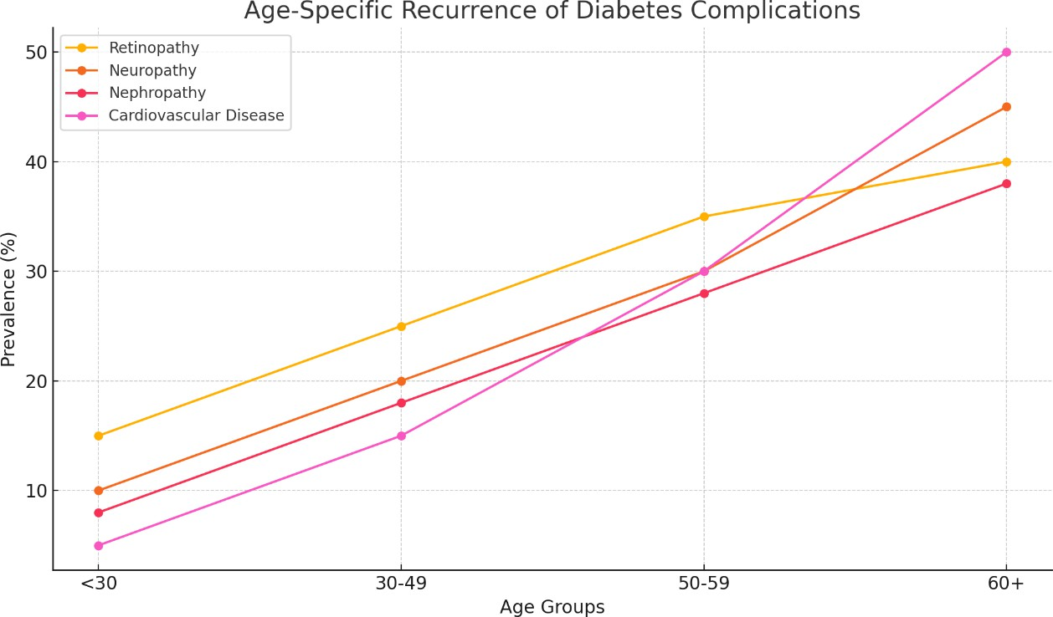

**Figure 2: Age – specific recurrence of diabetes complications**

Cardiovascular disease prevalence increases significantly in older age groups, while other complications also rise with age (Figure 2). The prevalence of T2D among children is a serious concern as it is linked with early-onset complexity such as cardiovascular disorder and renal failure. As can be observed from this reversal of the trend in prevalence, preventive care, early treatment, and lifestyle modification are most crucial in preventing the spread of diabetes among individuals of all ages [20].

1. **CHANGEABLE RISK ELEMENTS**

**OBESITY AND PHYSICAL INACTIVITY**

Physical dormancy and corpulence are two of the foremost critical modifiable chance variables for the rising frequency of sort 2 diabetes (T2D) around the world. In 2016, more than 650 million people were hefty, which contributed to the diabetes widespread to a noteworthy degree, as expressed by the World Wellbeing Organization (WHO), which shows that weight predominance has expanded by about three times since 1975. Overabundance body weight, and particularly stomach corpulence, disturbs glucose with dormancy and an expanding number of handled, high-calorie nourishment things, corpulence predominance has expanded at a quick pace in quickly urbanizing and financially creating countries. Physical inactivity has linked to a chance of getting diabetes because it decreases muscle cell glucose and insulin uptake and insulin sensitivity [21, 22]. Based on Global Burden of Disease Study, 1.4 billion physically inactive individuals are present in the world, with higher rates among high-income countries due to urbanization and advancements in technology [23].

**DIETARY PATTERNS, SMOKING AND ALCOHOL CONSUMPTION**

Various interconnected miracles, their special features, change impressively through the use of their regions, shapes, and nutritional design. These miracles include geographical domains, environment, agribusiness, culture and heirs, social standards and beliefs, civilization and globalization. Evidence suggests that nutritional safety, accessibility packaging, availability, use, and food contact can lead to changes in dietary trends. At this event, people consume more energy density and prepared nutrition, lower natural products, vegetables, and various nutritional qualities. In the case of expansion, this can lead to moderate use of nutritional supplements, particularly in the grapes, which are very important for wells, count proteins, vitamins and minerals. This can lead to metabolic components such as corpses, dyslipidemia, and hypertension. In the past, the social demographic characteristics of the metabolic opportunity component have been revealed through Ethiopia. This includes payments, work, home, previous status, gender, and previous status. Cochet, alcohol use, smoking tobacco, elaboration, exaggerated salt intake, and inadequate use of natural products and vegetables were all human chance components [24]. Smoking could be a consultation of important changes in diabetes and other non-transferable infectious diseases consistent with the World Welfare Organization (WHO). In the case of dilation, weight, liver damage, and impaired glucose control upgrade all chances of diabetes, but direct alcohol use can have a protective cardiovascular effect [25]. Ultra-highly processed nutrition is combined with humiliation, physicality and constant stimulation, all of which increase the chances of diabetes. They are too wealthy in trans fats, refined carbohydrates and artificial chemicals [26].

**NON – MODIFIABLE RISK FACTORS**

**GENETIC PREDISPOSITION**

The hazard of diabetes is intensely subordinate on the hereditary qualities of sort 2 diabetes, particularly when family history increments affectability. Considers have appeared that individuals with a first-time relationship with sort 2 diabetes regularly create twice as numerous infections. A few hereditary markers were related with the chance of diabetes [27]. Qualities from the complex of human leukocyte antigens (HLA) containing HLA-DR3 and HLA-DR4 are included within the immune system prepare driving to the annihilation of beta cells of T1D. The distinction between TCF7L2, PPARG, and KCNJ11 is known to decrease affront yield and make strides affront resistance in type 2 diabetes [28].

**ETHNIC AND RACIAL DISPARITIES**

The genetic predisposition however, varies with ethnicity. Hyperinsulinemia and beta- cell insufficiency, which can lead to development of diabetes and its progression, worsen prematurely in South Asians, African Americans, Hispanics and Indigenous people than in European populations [29]. These disparities are also worsened by disparities in diet habits, knowledge and utilization of healthcare [30].

**AGE AND GENDER DIFFERENCES**

At age 45, stability and beta cell work tend to require a diabetic sort, and age is the greatest danger for disease. T1D is the foremost critical common sort of diabetes among youthful individuals and young people, but it can influence individuals of all ages Hormonal changes that occur during menopause, gestational diabetes, and metabolic changes provide a more important probability of diabetes, while men offer lower BMI-2 diabetes [31].

**EMERGING RISK FACTORS**

**ENVIRONMENTAL FACTORS**

Studies have now showed that environmental conditions together with socioeconomic factors contribute to the worldwide increase in diabetes rates. Scientists found connections between water and air pollution which causes pollution and type 2 diabetes together with other metabolic problems. Worldwide diabetes rates increase because scientists now acknowledge socioeconomic factors together with environmental elements as major causes. The risk of developing diabetes increases when people hit a chemical that interferes with endocrine, such as bisphenol A (BPA). Phthalates and persistent organic pollutants (POPs) because chemical exposures interfere with insulin sensitivity and glucose regulation [32]. Long-term air pollution contacts expose individuals to increased risks of inflammation along with insulin resistance which are main drivers of diabetes development [33].

**SOCIOECONOMIC FACTORS AND URBANIZATION**

Medical experts now affirm that diabetes exists as a sophisticated health condition which results from natural hereditary elements alongside environmental and behavioural factors. The prevalence and consequences of this disease have been altered by modern socioeconomic situations combined with the increasing urbanization patterns. A person's socioeconomic status comprising their income together with their educational background and employment condition and healthcare access determines their diabetes management abilities and general health practices [34].

1. **COMPLICATIONS ASSOCIATED WITH DIABETES**

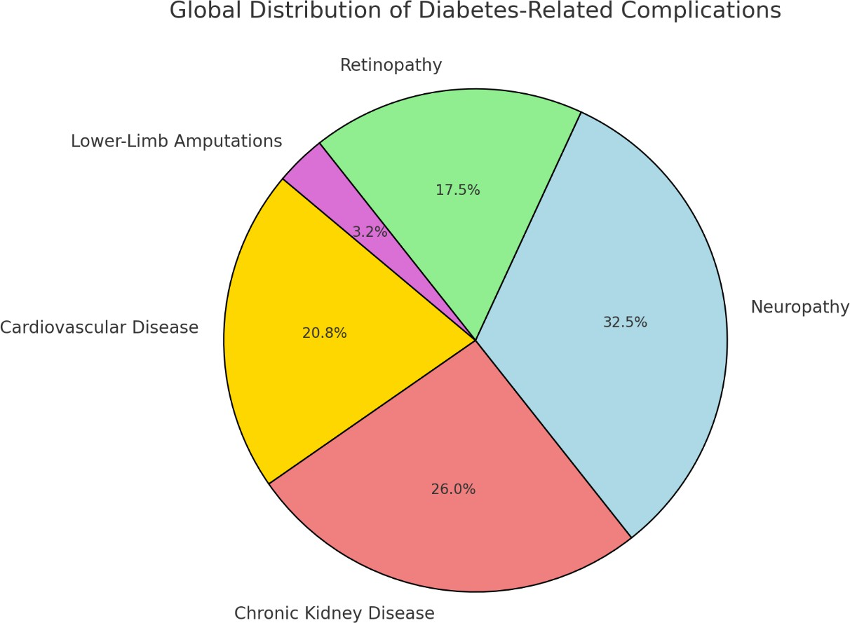

**Figure 3: Global distribution of diabetes related complications.**

Neuropathy and chronic kidney disease are among the most common complications, followed by cardiovascular disease and retinopathy. Lower-limb amputations, though less frequent, remain a serious concern (Figure 3 and 4).

**OVERVIEW OF THE LINK BETWEEN DIABETES AND CVD**

One of the foremost genuine and most common side impacts of diabetes is cardiovascular malady (CVD). This places a critical burden on dismalness and mortality rates around the world. Diabetes increments the chance of heart disappointment, stroke, and coronary illness by quickening the atherosclerosis prepare. Hyperglycaemia, affront resistance, and oxidative push lead to an expanded chance of cardiovascular infection (CVD) in diabetic patients by actuating endothelial brokenness, blood vessel firmness, and irritation. Compared to diabetic patients, diabetic patients have a 2-4-fold increment in circulatory disarranges [35]. Illness defilement is encourage progressed by synergistic impacts of diabetes and other CVD hazard variables such as weight, dyslipidaemia and hypertension. Based on this finding, it is important for diabetic patients to get early intercession within the shape of glycaemic control, way of life changes, and cardiovascular hazard administration to anticipate side impacts [36]. Apparently, the cardiovascular potential in diabetic patients using strategies such as statin treatment, blood weight treatment, sodium glucose cotler 2 (SGLT2) inhibitors and glucagon-like peptide-1 receptor agonist (GLP-1 RA) has been essentially reduced [37].

**CHRONIC KIDNEY DISEASE (CKD)**

**DIABETIC NEPHROPATHY EPIDEMIOLOGY**

Diabetic nephropathy is an undeniable outcome of diabetes and is an important constituency of unlimited kidney error (CKD). 30-40% of diabetics continue to agree to certain renal infections (CKD), and the proportion of cases around the world is increasing as two diabetes become more common [38]. Dynamic albuminuria, a reduction in glomerular filtration rate (GFR) (ESRD) in the final stage (ESRD) that may require dialysis or kidney transplantation, is a brand of diabetic nephropathy. Diabetes-related unlimited hyperglycemia, hypertension, and systemic expansion are the pathophysiology of constant renal infection (CKD), which is associated with seductive fibrosis of tubular routers, glomerular damage, and reduced renal function [39].

Controlling blood sugar levels is still crucial for anticipating, and medications like drugs that agonists of the (GLP-1 RAS) and hypoglycemia coveran -2 (SGLT2)-inhibitors provide advantages for chromosome security in addition to lowering blood sugar levels [40]. Controlling blood weight utilizing renin angiotensin aldosterone framework (RAAS), such as Pro inhibitors (angiotensin intertelling chemicals) and angiotensin II receptor blockers (ARBs), is imperative for diminishing albuminuria and abating down the infection handle. Diminishing the course of renal infection and cardiovascular chance, glucose cotranporter-2 (SGLT2) inhibitors such as empagliflozin and dapagliflozin have revolutionized the treatment of incessant renal illness (CKD) and are suggested by the worldwide CKD rules [41, 42]. Peritoneal and hemodialysis: dialysis administrations are well built up in high- income nations (HICs), but are an issue in low-income nations. In specific, nations such as China, Thailand and Mexico have advanced household peritoneal dialysis (PD) as a cheaper alternative [43].

**GLOBAL BURDEN OF DIABETIC RETINOPATHY AND NEUROPATHY**

Diabetic neuropathy (DN) and diabetic retinopathy (DR) are two of the most prevalent complications of diabetes, occurring in over one-third of diabetics globally [44]. The estimated 30% of adults over age 75 who have visual impairment due to diabetic retinopathy (DR) make it a leading cause of blindness, particularly in working- age individuals. Amputations, foot ulcers, and ongoing pain are all potential consequences of diabetic neuropathy, which affects nerves in as many as 50% of diabetics [45]. Because of limited access to initial screening and care, these complications disproportionately affect low- Because of limited access to initial screening and care, these complications disproportionately affect low- and middle- income countries (LMICs), resulting in delayed diagnosis and worse outcomes. DR and DN greatly compromise independence, locomotion, and activities of daily living. Despair, loneliness, and nervousness may occur due to visual loss, difficulty reading, driving, and facial identification in diabetic retinopathy patients [46]. Similarly, diabetic neuropathy produces ongoing pain, numbness, and weakness in the muscles, significantly hampering physical activity and increasing the likelihood of fractures, falls, and disability [47]. Due to their frequent need for medical attention, specialist therapies, and assistive technology, both conditions also increase healthcare costs. Recent research emphasizes the significance of early evaluation, lifestyle modifications, and medication therapies to delay the advancement of these complications and enhance the standards of life for people with diabetes globally [48].

**DIABETES AND ITS ASSOCIATION WITH INFECTIONS**

Diabetes suppresses immune function by inducing chronic hyperglycemia, which significantly enhances susceptibility to infections. During the COVID-19 pandemic, this susceptibility was particularly evident, as individuals with diabetes were more likely to be infected, to become critically ill, and to die [49]. In people with diabetes, the excessive expression of ACE2 receptors facilitated easy entry of the viruses into the body, increasing the danger of side effects such as acute breathing distress syndrome and multiple organ failure (ARDS) [50]. Disruption of diabetic-related medical services during the pandemic was a serious concern, as it resulted in delays in treating issues like diabetic foot ulcers [51].

**DIABETIC FOOR AND RISK OF AMPUTATIONS**

Diabetic foot problems are one of the primary reasons for of non-traumatic amputations of lower extremities globally, with over 20% of acute foot infections resulting in amputation [52]. Operations are more commonly needed to treat recurring ulcers, infections, and gangrene due to peripheral neuropathy, inadequate blood flow, and immunocompromise [53]. As a result of restricted access to wound care clinics and delayed treatment, the COVID-19 epidemic worsened the situation by substantially increasing the amputation rate globally [54]. According to a study, diabetic foot ulcers are increasingly gaining recognition as an international health crisis that demands urgent responses, such as early screening programs, to avert the loss of limbs, better infection control, and multidisciplinary foot care teams. To enhance early recognition and care of diabetic foot complications, telemedicine foot assessments and artificial intelligence-based diagnosis are being explored as promising alternatives [55]

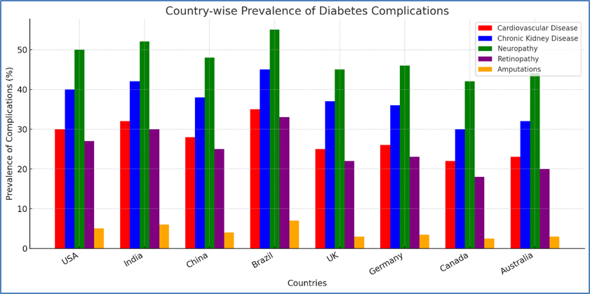

**Figure 4: Global studies highlight the significant burden of diabetes complications worldwide**

1. **ECONOMIC BURDEN OF DIABETES**

Direct and indirect costs of diabetes care globally Those health expenses that immediately and directly pertain to diabetes treatment and related complications are called "direct costs." The total projected direct worldwide health expenditure relating to diabetes for the year 2019 stood at $760 billion, Figure 5 was showing the estimated economic burden of diabetes by country in 2021. While projections placed that figure at$825 billion by the year 2030 and $845 billion by the year 2045. In which, for a staggering $294.6 billion, the United States accounted for the most expenditure, ahead of Brazil for $52.3 billion, as well as China for $109.0 billion. Hospital stays, medication, and the management of diabetes-related issues are the key reasons for these expenses [56].

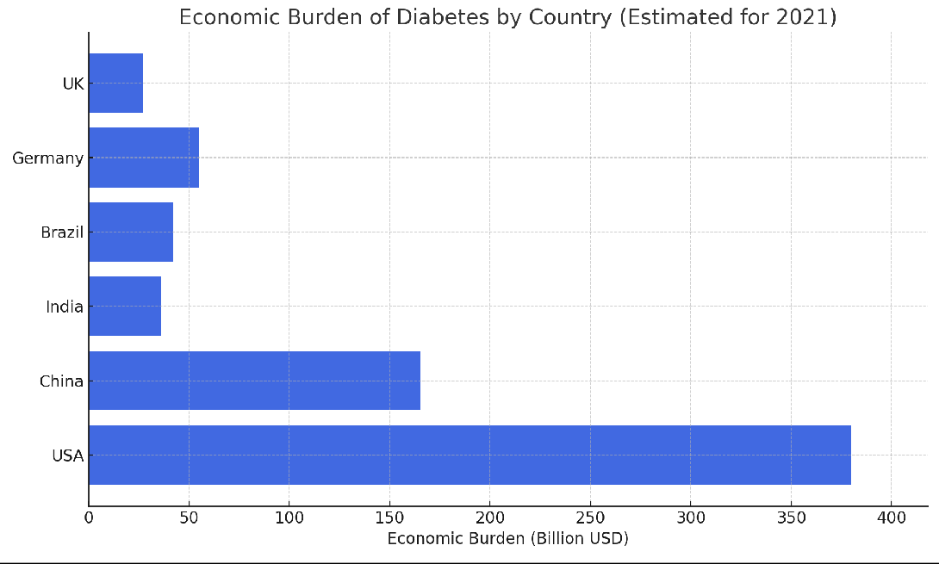

**Figure 5: Visualization of the economic burden of diabetes across different countries**

Differences in economic burden between high – income and low - income countries

Globally, 4.2 million people are afflicted with diabetes, mostly from lower-middle- income (LMIC) countries. According to the World Health Organization, 1.5 million individuals lose their lives to diabetes every year. The incidence of diabetes has risen rapidly across the world over the last few decades. Individuals aged 39 to 70 years and with low or moderate incomes have a higher tendency to develop diabetes, as observed in research. Diabetes occurs in 10.5% of the world's population, and by 2045, it is likely to increase to 12.2%. Based on a global survey done by the International Diabetes Federation (IDF), 537 million individuals were projected to have diabetes in 2021. In 2030 and 2045, it is likely to be 643 million and 783 million, respectively [57].

**PRODUCTIVITY LOSS**

Diabetes’s effects on worker productivity

Diabetes has a significant effect on the productivity of the worldwide workforce, resulting in early retirement, presenteeism (a decrease in productivity at work), absenteeism, and higher healthcare expenses. Workers with diabetes frequently suffer from problems including neuropathy, heart disease, and eye impairment, which impairs their capacity to work effectively. According to a research, diabetes-related productivity losses cost the world economy about $327 billion a year.

Diabetes-related disability-adjusted life years (DALYs)

Diabetes ranks among the greatest causes of disease burden globally, based on the impairment-Adjusted Life Years (DALYs) measure of burden of disease as a combined index of years lost due to early death and years lived in impaired health. The Global Burden of Disease Study of 2019 identified that over 60 million DALYs worldwide were attributed to diabetes and recorded notable elevations in populations of rapid urbanization and transition towards modern life styles [3, 58].

1. **MANAGEMENT AND PREVENTION STRATEGIES**

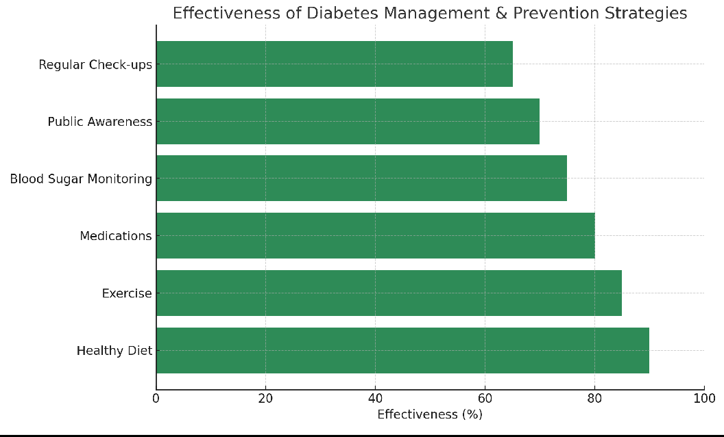

**Figure 6: Effectiveness of different diabetes management and prevention strategies.**

**LIFESTYLE INTERVENTIONS**

The effectiveness of food and exercise in managing and preventing diabetes. The cornerstones of diabetes management and prevention are dietary changes and increased physical activity. Healthy diet and exercise are among the most effective, followed by medications and blood sugar monitoring is still supported by recent research (Figure 6). The contribution of particular dietary elements, such omega-3 fatty acids and polyphenols, to improving metabolic health and averting complications from diabetes [59]. According to studies, an adequate diet supplemented with lean meat, whole grain, fibre, and healthy fat can decrease the incidence of type 2 diabetes by facilitating management of blood glucose. Regular exercise, consisting of resistance exercise and aerobic exercise, enhances glucose metabolism and sensitivity to insulin. Research shows that the combination of exercise with a dietary regimen lowers the level of HbA1c in diabetic patients and prevents disease progression in prediabetic patients [60].

**PHARMACOTHERAPY**

An overview of antidiabetic medications, including SGLT2 inhibitors, GLP-1 receptor agonists, and metformin. For many years, metformin has been the first-line treatment for type 2 diabetes (T2D). It works by improving insulin sensitivity, increasing peripheral tissue absorption of glucose, and inhibiting hepatic glucose production. Benefits: lowers blood sugar levels while keeping insulin levels stable. promotes modest weight loss or weight neutrality. has beneficial effects on the heart. Limitations: adverse effects on the digestive system (diarrhoea, nausea). Risk of lactic acidosis in patients with kidney disease [61].

GLP-1 RAs, or GLP-1 Receptor Agonists: Semaglutide and liraglutide are injectables that slow stomach emptying, reduce hunger, and boost insulin secretion. According to research, they help people lose weight and significantly lower their HbA1c levels, which makes them ideal for those with diabetes who are also obese. (Shen et. al., 2025) SGLT2 Inhibitors: These drugs, among which are dapagliflozin and empagliflozin, decrease blood glucose by inhibiting the kidneys from reabsorbing glucose. Also, they prevent kidney and heart damage, delaying the development of chronic renal illness and reducing the risk of heart failure [12].

**NEW TREATMENTS AND THEIR GLOBAL AVAILABILITY**

A significant shift in the management of diabetes has been achieved through the introduction of SGLT1/SGLT2 inhibitors and oral formulations of insulin, which provide effective alternatives for traditional injectable therapies. SGLT2 inhibitors, like empagliflozin and dapagliflozin, had already demonstrated their ability to decrease blood glucose concentration through the inhibition of renal reabsorption of glucose. However, the newer SGLT1/SGLT2 dual inhibitors offer additional benefits by enhancing glucose excretion via the kidneys (SGLT2 inhibition) and reducing intestinal glucose absorption (SGLT1 inhibition). Both type 1 and type 2 diabetes individuals are highly benefited by this dual action, which reduces postprandial glucose increases and favours more stable glycaemic control. (Mukta et. al., 2025) Diabetes Treatment with Stem Cell and Gene Therapy. To replace damaged pancreatic cells and resume insulin production, researchers are experimenting with gene therapy and beta-cell transplantation. Challenges: High cost and limited availability. Ethical concerns and immune rejection issues [61].

**GLOBAL PUBLIC HEALTH INITIATIVES**

**THE EFECTIVENESS OF NATIONAL DIABETES PREVENTION PROGRAMS**

Diabetes prevention programs are global initiatives to reduce the incidence of type 2 diabetes, particularly in high-risk individuals. Organized lifestyle interventions that promote physical activity, healthy eating, and weight loss are often the core of such programs. One of the most prominent models is the Centre for Disease Control and Prevention's (CDC) National Diabetes Prevention Program (NDPP) in the United States. Its basis is the Diabetes Prevention Program (DPP) clinical trial, which demonstrated that lifestyle modifications may reduce the risk of type 2 diabetes by 71% in individuals age 60 and older and 58% in at-risk individuals [62]. The NHS Diabetes Prevention Programme (NDPP) in the UK takes a similar approach by providing organized weight loss and exercise programs. According to a review of its performance, participants' blood sugar levels and weight loss were significantly improved [63]. In Australia, Life! Program has also shown promising results in Victoria after the Victorian Government funded it, as the volunteers have documented 29% decrease in the development of diabetes after four years [64]. Finland's Diabetes Prevention Study (DPS) was the first to demonstrate that lifestyle changes can prevent diabetes, with long-term follow-ups indicating persistent effects even 10 years after the intervention [65]. Through culturally appropriate dietary and exercise practices, a number of community-based initiatives, like the Diabetes Community Lifestyle Improvement Program (D-CLIP), have demonstrated efficacy in reducing the incidence of diabetes in India. The program was culturally modified to include local community involvement and Indian eating customs. SMS reminders and mobile devices were employed to improve participant adherence [66].

1. **CHALLENGES AND EMERGING ISSUES**

**BARRIERS TO EFFECTIVE DIABETES MANAGEMENT**

Access to medicine and medical treatment. Patients tend to experience logistics and cost issues due to the regular doctor visits for blood glucose checks, issues, and refills of medication. Solutions in digital health and telemedicine have been proposed as means to bridge these gaps. Nevertheless, access to technology remains a challenge for those residing in rural communities or individuals from low-income families. (ADA 2022)

Patient education and health literacy

Policies that promote healthcare affordability, expand insurance, and regulate the cost of prescription drugs are critical to eliminating such barriers. Public-private partnerships as well as funding from the government could also play a key role in ensuring everyone has access to diabetes. With its impact extending to a patient's ability to understand their condition, adhere to treatment protocols, and make prudent lifestyle choices, health literacy represents an important focus of diabetic treatment. Most diabetics find it difficult to comprehend medical information, determining insulin dosages, and recognizing signs of complications. Low self-management due to ignorance often leads to unnecessary hospitalizations and sequelae like cardiovascular diseases, neuropathy, and retinopathy [67].

## **Impact of Globalization and Urbanization**

The risk of diabetes is also increasing lifestyle. Overall, globalization and urbanization have revised lifestyles that contribute to the increased frequency of diabetes around the world. Type 2 One of the biggest random variables of diabetes, weight, increases along with some of the globalised nutritional industry, driving handles and energy intensity nutrition to overwhelm congenital diets. Sedentary living has been promoted by urbanization as well, as increasing numbers of individuals use motor transportation, have sedentary professions, and receive little exercise. In addition, economic constraints in urban places often lead to higher levels of stress, and this can contribute to unhealthy measures of coping, such as cigarette smoking or binge eating. The problem is compounded in certain metropolitan places through the unavailability of green areas and fresh fruits and vegetables. Research has indicated that nations undergoing swift urbanization experience a corresponding growth of diabetes cases, and there is a clear need for policies promoting healthier foods, active transportation, and enhanced access to healthcare [68].

**CLIMATE CHANGE AND DIABETES**

**HOW GLOBAL CLIMATE CHANGE COULD INFLUENCE DIABETES OCCURRENCE AND CONTROL**

Climate change alters environmental factors that affect diabetes onset and management, it presents an increasing challenge to diabetes prevalence and management. Extreme weather events and rising temperatures can raise stress levels, interfere with food supply chains, and decrease physical activity levels all of which raise the risk of diabetes. Because heat stress and dehydration can affect blood glucose homeostasis, heat exposure can potentially make diabetes problems worse for those with the disease. Hurricanes and wildfires are examples of climate-related disasters that might interfere with healthcare services, resulting in shortages of medications and access to vital diabetes control supplies like insulin and glucose monitors. According to research, air pollution exposure another effect of climate change may raise the risk of diabetes by causing insulin resistance. Such considerations underscore the importance of climate-resilient healthcare strategies, such as providing uninterrupted access to drugs, stimulating climate-resilient agriculture, and supporting public health measures addressing both metabolic disease and climate change [69].

**TECHNOLOGICAL ADVANCES**

**AI, TELEMEDICINE, AND DIGITAL HEALTH IN THE TREATMENT OF DIABETES**

Highlighting the sphere of diabetes care, the transition of mental health and treatment to digital tools (artificial intelligence (AI), telemedicine, and digital health tools) is beneficial in terms of access to care and more opportunities to monitor the state of mental health and effective treatment, even remotely, and patient loyalty in access to care and treatment. The combination of wearables and health apps facilitations enables people to monitor their blood glucose, physical activity, and diet, which enhances personal diabetes management by collecting the necessary data. Nevertheless, even promising results in the short-term effects of the new antidiabetic drugs in relation to weight and glucose control such as Tirzepatide, SGLT2 inhibitors and GLP-1 receptors agonists lack long-term safety and efficacy data. Additional clinical trials are needed to determine the effects on the kidney, cardiovascular status, and risks, including pancreatic disease or bone loss [70].

A plant-derived, naturally occurring compound, Plantamajoside, has emerged as a potential therapeutic agent for type 2 diabetes mellitus (T2DM). The research highlights the way it inhibits pancreatic β-cell death, an important process that hastens diabetes development. Plantamajoside shields diabetic β-cells by inhibiting endoplasmic reticulum (ER) stress, a key cellular dysfunction, according to the research [71]. Chronic hyperglycaemia, leading to stress in the ER of pancreatic β-cells and ultimately causing malfunction and cell death, is a characteristic feature of diabetes. If an accidentally folded protein accumulates in the emergency room, a developed protein response (UPR) is initiated. Prolonged UPR causes β-cell death. Plantamajoside was reported to induce the expression of DNAJC1, a molecular chaperone necessary for ER stress regulation and protein folding. By enhancing DNAJC1 expression, the drug maintains pancreatic β-cell function by suppressing ER stress-induced apoptosis.

1. **CONCLUSION**

The increasing global rate of diabetes is estimated to be as a result of lifestyle causes, including lack of diet, physical activity and urbanization that pose a public health challenge of major health and economic impacts. Inequality among vulnerable groups, such as children and those with poor access to healthcare, among others, highlights the necessity of concentrated global efforts, which should include early detection, treatment, and prevention strategies. To reverse the surging prevalence rate of diabetes and to boost the health conditions of the world community, it is crucial to mitigate these emerging challenges by means of policy change, education, technology, and fortifications of healthcare facilities. Combined efforts can be made at local, national and international level to ensure that disparities can be mitigated and a sustainable way of dealing with this form of epidemic can be addressed.

REFERENCES

1. Saeedi P, Petersohn I, Salpea P, Malanda B, Karuranga S, Unwin N, et al. Global and regional diabetes prevalence estimates for 2019 and projections for 2030 and 2045: results from the International Diabetes Federation Diabetes Atlas. Diabetes Res Clin Pract. 2019;157:107843.
2. Zhou B, Lu Y, Hajifathalian K, Bentham J, Di Cesare M, Danaei G, et al. Worldwide trends in diabetes since 1980: a pooled analysis of 751 population-based studies with 4.4 million participants. Lancet. 2016;387(10027):1513–30.
3. Bommer C, Sagalova V, Heesemann E, Manne-Goehler J, Atun R, Bärnighausen T, et al. Global economic burden of diabetes in adults: projections from 2015 to 2030. Diabetes Care. 2018;41(5):963–70.
4. Beran D, Ewen M, Laing R. Access to insulin: essential yet inequitable. Lancet Diabetes Endocrinol. 2021;9(7):439–52.
5. Guo Z, Wu D, Mao R, Yao Z, Wu Q, Lv W. Global burden of MAFLD, MAFLD-related cirrhosis, and MASH-related liver cancer from 1990 to 2021. Sci Rep. 2025;15:7083.
6. Tavasoli N, Larijani B. Editorial: Interdisciplinary research in diabetology. Front Endocrinol. 2024;15:1500000.
7. Forouhi NG, Wareham NJ. Diabetes: basic facts. Medicine (Abingdon). 2019;47(1):22–7.
8. Hussain A, Bhowmik B, do Vale Moreira NC. COVID-19 and diabetes: knowledge in progress. Diabetes Res Clin Pract. 2020;162:108142.
9. Sun H, Saeedi P, Karuranga S, Pinkepank M, Ogurtsova K, Duncan BB, et al. IDF Diabetes Atlas: global, regional, and country level diabetes prevalence estimates for 2021 and projections for 2045. Diabetes Res Clin Pract. 2022;183:109119.
10. Harding JL, Pavkov ME, Magliano DJ, Shaw JE, Gregg EW. Global trends in diabetes complications: a review of current evidence. Diabetologia. 2019;62:3–16.
11. Vakili R, Akhlaghi A, Yazdanparast A. The prevalence of type 2 diabetes (T2D) among Iranian children and adolescents: a literature review. Health Provider. 2025;5(1):1–10.
12. Li C, Li G. The role of sphingolipid metabolism in endocrine diseases. Front Endocrinol. 2024;15:1506971.
13. Liu X, Zhang J. Continuous glucose monitoring in prediabetes management: a comprehensive perspective. Front Endocrinol. 2024;15:1472898.
14. Ghosh S, Anand A, Ghosh D, Kumar P. Rural to urban transition of risk factors propensity for cardiovascular disease in Jharkhand, India. Int J Epidemiol Health Sci. 2025;6:1000000.
15. Ramachandran A, Snehalatha C, Shetty AS, Nanditha A. Trends in prevalence of diabetes in Asian countries. World J Diabetes. 2012;3(6):110–7.
16. Tassew WC, Zeleke AM, Ferede YA. Eye care service utilization and associated factors among diabetic patients in Africa: a systematic review and meta-analysis. Metab Open. 2024;22:100293.
17. Tassew WC, Zeleke AM, Ferede YA. Eye care service utilization and associated factors among diabetic patients in Africa: a systematic review and meta-analysis. Metab Open. 2024;22:100293.
18. Atkinson MA, Eisenbarth GS, Michels AW. Type 1 diabetes. Lancet. 2014;383(9911):69–82.
19. DeFronzo RA, Ferrannini E, Groop L, Henry RR, Herman WH, Holst JJ, et al. Type 2 diabetes mellitus. Nat Rev Dis Primers. 2015;1:15019.
20. Wagenknecht LE, Lawrence JM, Isom S, Jensen ET, Dabelea D, Liese AD, et al. Trends in incidence of youth-onset type 1 and type 2 diabetes in the USA, 2002–2018: results from the population-based SEARCH for Diabetes in Youth study. Lancet Diabetes Endocrinol. 2023;11(4):242–50.
21. Kahn SE, Hull RL, Utzschneider KM. Mechanisms linking obesity to insulin resistance and type 2 diabetes. Nature. 2006;444(7121):840–6.
22. Colberg SR, Sigal RJ, Yardley JE, Riddell MC, Dunstan DW, Dempsey PC, et al. Physical activity/exercise and diabetes: a position statement of the American Diabetes Association. Diabetes Care. 2016;39(11):2065–79.
23. Guthold R, Stevens GA, Riley LM, Bull FC. Worldwide trends in insufficient physical activity from 2001 to 2016: a pooled analysis of 358 population-based surveys with 1.9 million participants. Lancet Glob Health. 2018;6(10):e1077–e86.
24. Alamnia TT, Sargent GM, Kelly M. Dietary patterns and associations with metabolic risk factors for non-communicable disease. Sci Rep. 2023;13:21028.
25. Tinajero MG, Malik VS. An update on the epidemiology of type 2 diabetes: a global perspective. Endocrinol Metab Clin North Am. 2021;50(3):337–55.
26. Chen Z, Khandpur N, Desjardins C, Wang L, Monteiro CA, Rossato SL, et al. Ultra-processed food consumption and risk of type 2 diabetes: Three large prospective U.S. cohort studies. Diabetes Care. 2023;46(7):1335–44.
27. Mamun TI, Younus S, Rahman HM. [Title missing – please provide full title]. Cancer Treat Res Commun. 2024;41:100845.
28. Adebo DO, Olaniyan MF, Ugege CO, Odegbemi OB. Association between CAPN-10 gene variant and diabetes mellitus in Nigeria: A review. Egypt J Med Hum Genet. 2025;26(1):1–2.
29. Martínez-Nava Y, Ogaz-Escarpita MC, Reza-López SA, Leal-Berumen I. Diabetic kidney disease and polymorphisms of the ELMO1 and AGTR1 genes: A systematic review. Nefrología (Engl Ed). 2025.
30. Mamun TI, Younus S, Rahman HM. [Duplicate of ref 27]. Cancer Treat Res Commun. 2024;41:100845.
31. Davuluru SS, Jess AT, Kim JS, Yoo K, Nguyen V, Xu BY. Identifying, understanding, and addressing disparities in glaucoma care in the United States. Transl Vis Sci Technol. 2023;12(10):18.
32. Firdous P, Nissar K, Bashir H, Hussain QA, Masoodi SR, Ganai BA. Environmental factors as diabetic mediators: A mechanistic approach. Curr Diabetes Rev. 2022;18(9):1–5.
33. Beulens JW, Pinho MG, Abreu TC, den Braver NR, Lam TM, Huss A, et al. Environmental risk factors of type 2 diabetes—an exposome approach. Diabetologia. 2022;65(2):263–74.
34. Hill-Briggs F, Adler NE, Berkowitz SA, Chin MH, Gary-Webb TL, Navas-Acien A, et al. Social determinants of health and diabetes: A scientific review. Diabetes Care. 2020;44(1):258.
35. Huxley RR, Peters SA, Mishra GD, Woodward M. Risk of all-cause mortality and vascular events in women versus men with type 1 diabetes: A systematic review and meta-analysis. Lancet Diabetes Endocrinol. 2015;3(3):198–206.
36. Rawshani A, Rawshani A, Franzén S, Sattar N, Eliasson B, Svensson AM, et al. Risk factors, mortality, and cardiovascular outcomes in patients with type 2 diabetes. N Engl J Med. 2018;379(7):633–44.
37. Marso SP, Bain SC, Consoli A, Eliaschewitz FG, Jódar E, Leiter LA, et al. Semaglutide and cardiovascular outcomes in patients with type 2 diabetes. N Engl J Med. 2016;375(19):1834–44.
38. Tuttle KR, Bakris GL, Bilous RW, Chiang JL, De Boer IH, Goldstein-Fuchs J, et al. Diabetic kidney disease: A report from an ADA consensus conference. Diabetes Care. 2014;37(10):2864–83.
39. Beisswenger PJ. Glycation and biomarkers of vascular complications of diabetes. Amino Acids. 2012;42:1171–83.
40. Neuen BL, Young T, Heerspink HJ, Neal B, Perkovic V, Billot L, et al. SGLT2 inhibitors for the prevention of kidney failure in patients with type 2 diabetes: A systematic review and meta-analysis. Lancet Diabetes Endocrinol. 2019;7(11):845–54.
41. Brenner BM, Cooper ME, De Zeeuw D, Keane WF, Mitch WE, Parving HH, et al. Effects of losartan on renal and cardiovascular outcomes in patients with type 2 diabetes and nephropathy. N Engl J Med. 2001;345(12):861–9.
42. Perkovic V, Jardine MJ, Neal B, Bompoint S, Heerspink HJ, Charytan DM, et al. Canagliflozin and renal outcomes in type 2 diabetes and nephropathy. N Engl J Med. 2019;380(24):2295–306.
43. Goh KJ, Choong MC, Cheong EH, Kalimuddin S, Wen SD, Phua GC, et al. Rapid progression to acute respiratory distress syndrome: Review of current understanding of critical illness from coronavirus disease 2019 (COVID-19) infection. Ann Acad Med Singap. 2020;49(3):108–18.
44. Serban D, Dascalu AM. New diagnostic and therapeutic approaches in diabetic microvascular complications. Biomedicines. 2024;12(8):1858.
45. Musial DC, Ajita ME, Bomfim GH. Benefits of cilostazol’s effect on vascular and neuropathic complications caused by diabetes. Med Sci. 2024;13(1):1.
46. Armstrong CL, Gyato K, Awadalla AW. Bibliography current world literature Vol 18 No 6 December 2005. Mov Disord. 2005;11(1):1–8.
47. Burns RT, Arnold PJ, Song L, Moss KL, Powell CR. An analysis of urodynamic parameters in diabetic and nondiabetic women. Neurourol Urodyn. 2024;43(7):1600–8.
48. Janić M, Maggio V, Janež A, Rizzo M. Novel antidiabetic therapies in patients with peripheral artery disease: Current perspective. Front Clin Diabetes Healthc. 2024;5:1517265.
49. Jodheea-Jutton A, Hindocha S, Bhaw-Luximon A. Health economics of diabetic foot ulcer and recent trends to accelerate treatment. Foot. 2022;52:101909.
50. Miranda C, Zanette G, Da Ros R. Diabetic foot disease during the COVID-19 pandemic: Lessons learned for our future. Arch Med Sci Atheroscler Dis. 2022;7:e94.
51. Rastogi A, Dogra H, Jude EB. COVID-19 and peripheral arterial complications in people with diabetes and hypertension: A systematic review. Diabetes Metab Syndr. 2021;15(5):102204.
52. Casciato DJ, Yancovitz S, Thompson J, Anderson S, Bischoff A, Ayres S, et al. Diabetes-related major and minor amputation risk increased during the COVID-19 pandemic. J Am Podiatr Med Assoc. 2023;113(2).
53. Armstrong DG, Tan TW, Boulton AJ, Bus SA. Diabetic foot ulcers: A review. JAMA. 2023;330(1):62–75.
54. Chou YY, Hou CC, Wu CW, Huang DW, Tsai SL, Liu TH, et al. Risk factors that predict major amputations and amputation time intervals for hospitalized diabetic patients with foot complications. Int Wound J. 2022;19(6):1329–38.
55. Gamboa-Antiñolo FM. Diabetic foot ulcers: A growing global health emergency in the COVID-19 era. Intern Emerg Med. 2023;18(5):1259–61.
56. Williams R, Karuranga S, Malanda B, Saeedi P, Basit A, Besançon S, et al. Global and regional estimates and projections of diabetes-related health expenditure: Results from the International Diabetes Federation Diabetes Atlas, 9th edition. Diabetes Res Clin Pract. 2020;162:108072.
57. Butt MD, Ong SC, Rafiq A, Kalam MN, Sajjad A, Abdullah M, et al. A systematic review of the economic burden of diabetes mellitus: Contrasting perspectives from high and low middle-income countries. J Pharm Policy Pract. 2024;17(1). doi:10.1080/20523211.2024.2322107
58. Lin X, Xu Y, Pan X, Xu J, Ding Y, Sun X, et al. Global, regional, and national burden and trends of diabetes in 195 countries and territories: An analysis from 1990 to 2025. Lancet Diabetes Endocrinol. 2021;9(6):328–40.
59. Lordan R. Nutraceuticals for cardiometabolic diseases: Prophylactic and therapeutic research. Nutraceuticals. 2025;5(1):8.
60. Adinolfi LE, Marrone A, Rinaldi L, Nevola R, Izzi A, Sasso FC. Metabolic dysfunction-associated steatotic liver disease (MASLD): A systemic disease with a variable natural history and challenging management. Explor Med. 2025;6.
61. Mphasha MH, Vagiri R. A narrative review of the interplay between carbohydrate intake and diabetes medications: Unexplored connections and clinical implications. Int J Mol Sci. 2025;26(2):624. doi:10.3390/ijms26020624
62. Knowler WC, Barrett-Connor E, Fowler SE, Hamman RF, Lachin JM, Walker EA, et al. Reduction in the incidence of type 2 diabetes with lifestyle intervention or metformin. N Engl J Med. 2002;346(6):393–403.
63. Valabhji J, Barron E, Bradley D, Bakhai C, Fagg J, O’Neill S, et al. Early outcomes from the English National Health Service Diabetes Prevention Programme. Diabetologia. 2020;63(7):1420–30.
64. Laatikanen T, et al. Prevention of type 2 diabetes by lifestyle intervention in an Australian primary healthcare setting. BMJ Open. 2012;2(1):e001203.
65. Lindström J, Ilanne-Parikka P, Peltonen M, Aunola S, Eriksson JG, Hemio K, et al. Sustained reduction in the incidence of type 2 diabetes by lifestyle intervention. Lancet. 2006;368(9548):1673–9.
66. Ramachandran A, Snehalatha C, Ram J, Selvam S, Simon M, Nanditha A, et al. Effectiveness of mobile phone messaging in prevention of type 2 diabetes by lifestyle modification in men in India. Lancet Diabetes Endocrinol. 2013;1(3):191–8.
67. Sørensen K, Pelikan JM, Röthlin F, Ganahl K, Slonska Z, Doyle G, et al. Health literacy and its impact on chronic disease management. J Public Health Res. 2020;9(4):331–45.
68. Hu FB. Globalization of diabetes: The role of diet, lifestyle, and genes. Diabetes Care. 2011;34(6):1249–57.
69. Haines A, Ebi K. The imperative for climate action to protect health. N Engl J Med. 2019;380(3):263–73.
70. Jastreboff AM, Aronne LJ, Ahmad NN, Wharton S, Connery L, Alves B, et al. Tirzepatide once weekly for the treatment of obesity. N Engl J Med. 2022;387(3):205–16.
71. Zinman B, Wanner C, Lachin JM, Fitchett D, Bluhmki E, Hantel S, et al. Empagliflozin, cardiovascular outcomes, and mortality in type 2 diabetes. N Engl J Med. 2015;373(22):2117–28.