**Carbon-task Saving of Slag Cement Concrete with Rice Husk Ash**

**Abstract-**

The cement is popular for its cementous properties and considered traditional building materials, It is energy inefficient and environmental pollutant during its life-cycle. Present global demand is replacing by wastes or rebuilding new waste materials. Agricultural wastes Rice Husk Ash (RHA), can partially replace cement retaining the mechanical strength showing any adverse effect. Rice husk production in India is 31.40 million tonnes (record) in 2024-25, which disposed as landfills, or burnt in the field after threshing and that causes environmental problems. The high silica content RHA in cement concrete makes it pozzolanic and helps to solve environmental and economic issues.

Elevated structures and long-range spans need cement with high compressive strength. The RHA has proved to be substitute of slag cement. When made by advanced methods like improved combustion technique, evaluation of pozzolanic activity of RHA and strength growth of mortar occur. The Laboratory investigations have been done to evaluate the marketed cement already blended with slag and fly ash. The physical, mechanical tests are conducted by making 150mmx150mmx150mm cubes and testing the potential durability and environmental corrosivity by adding RHA at different proportions with local available cement manufacturing M-30 concrete. There is a lowering of compressive strength with higher content of blending with RHA but less water absorption and high durability. Replacement of cement by RHA can save carbon burden on the environment satisfying Sustainable development goal SDG-13.3

**Keywords**: Concrete, Rice Husk Ash, OPC, durability, Mechanical Strength, Energy efficient .

**1.0.0 INTRODUCTION**

The India has emerged as one among the 5 trillion-dollar economies with most populous country accommodating about 7.46 billion Indians under deteriorated economy, environment, societal values and slum dwellings. The apocalyptic player is the cement industry contribute for 5–8% of global CO2 emissions but cement is the material that invites the nation’s infrastructural, socio-political growth, and economic development. In comparison to other binding materials, cement is a formidable material in construction sector that contribute to world’s GDP as 13%. Construction’ sector in India has a 8.6%, growth rate such as economic, housing and skilled sector by ≈7.2%, and Transport, trade, electronic, hotels, communication sectors (6.4%) during 2024-25, which is fairly higher than other countries(Goswami et al 2023[1], South Indian bank1st mar 2025[2] 3Simbi et al, 2025[3])

The globes also confronted the wide range and use of materials like nano tubes, concrete without cement, clone technology, fortified food stuffs etc. Orthodox concrete constituents proved to deteriorate the natural environment during cement’s manufacturing/ extraction activities (Lopez et al, 2024[4], TERI 2025[5). Life Cycle Assessment (LCA) methodologies report the environmental problems during cement production, transportation and use. To alleviate these effects attempts are made by using substitute concrete ingredients like recycled industrial wastes, supplementary *cementitious materials* (SCMs), and the enactment of *carbon capture and storage* (CCS) technologies, bacteria for healing cracks. The Cementous wastes applied to achieve strengths either as innovative material or by part replacement. This pioneering concrete can bring environmental sustainability, societal health/wealth benefits, (Hosseini et al, 2022[6], Kioumarsi et al, 2024[7], Hayek et al, 2025[8], Krelani et al, 2025[9]), .

**1.1.0 THE INFRASTRUCTURE CRISIS:**

Present Portland cement (PC) is available as ordinary Portland cement (OPC), Portland slag cement (PSC), Pozzolana Portland cement (PPC), or Portland limestone cement (PLC), etc. OPC emit high CO2 emission. The construction industry (particularly cement concrete) and energy resources have surged with rising population and evolutionary industrialization/ endless urbanization. The world population have elevated from 190milli0n (mi.) in 200AD to 838 mi. in 2025, and shall project to rise 930 billion by 2050. (<https://www.worldometers.info/world-population/world-population-by-year/> ) There is shift of population from rural to urban areas and habitat growth from horizontal to vertical in urbans. Flourishing 20 mega cities accommodate of >10 mi. Requirement of more and more construction materials resources for housing, transportation, education, power, and WASH needs etc. to satisfy the basic amenities to support life in these cosmopolis, (Song et al, 2019[10], Paes et al, 2023[11], Azmat et al. 2025[12], Tran et al., 2025[13]). World’s top cement consumers and producers are in Fig 1.

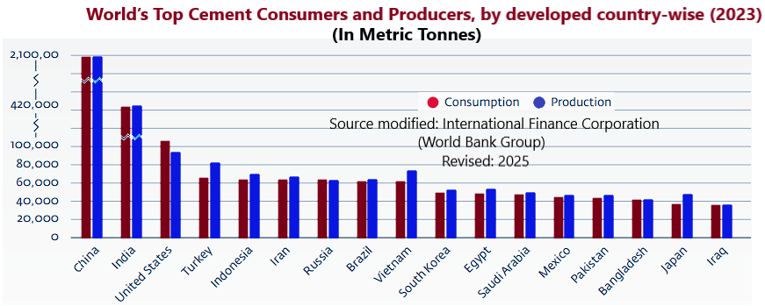

Fig 1: Cement consumption and production by top 17 countries in the globe 2023

*(Source International Cement Review forecasts. Source: CemNet.com n.d.)*

**1.1.1. Growing construction material pollution**

The urbanization and industrialization have warranted the demand for construction materials (steel & cement) to meet world energy demands. Main demanding construction materials are cement and steel. The data from 2020 -2024 are in fig 1. (Harichandan et al, 2022[14]). In India the air quality deterioration has become common in the name of construction and demolition wastes and the prime concern is air quality (AQ) that demands regular monitoring. It is essential to monitor AQ, (PM 2.5 and PM 10), how to use the AQ data, and compliance with existing standard to mitigate air pollution from cement industries and construction sites (Patra et al., 2025[15]).

Indias circular economy bases upon when buildings will turn out as material banks for future construction by avoiding wastes, dusts, and shall shift to green building materials by improving non-renewable building resources and processes (UNEP- 2023[16], Soars et al, 20253[17]).Being a testament to rapid economic growth, the flagship initiatives to make India global hub for Building materials and stressed through PM Awas Yojana India needs 20mi urban homes and 30mi rural houses to meet the India’s residential demand by 2025 (Vibrant Build Con 2025[18]). The rice husk can be a potential raw material for Feed stock for Ethanol Biofuel or Bran edible oil Production Fig 2.

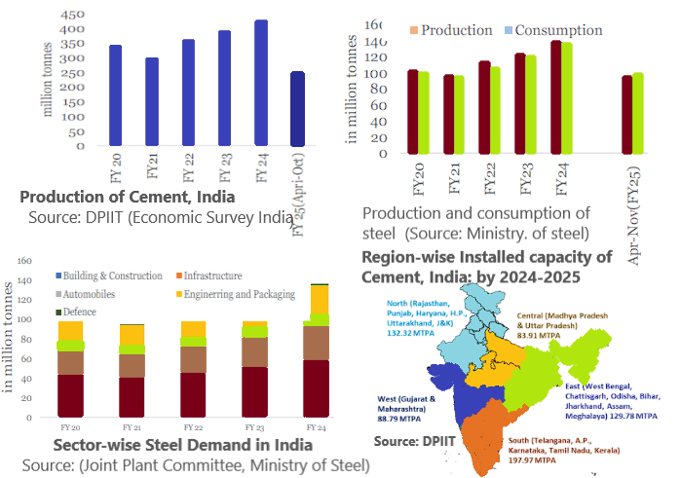

**Fig 2: The status of construction materials (Cement and Steel ) from 2020 to 2024 in India** **(Source: Economic survey of India 2024)**

The India has 500 MTPA installed capacity of cement as on date but produces 298 MMT/annum. About 35% of all the cement plants are housed in south India (Fig 1). In Perform, Achieve and Trade scheme (PAT) , it is targeted that India shall reduce installed capacity of Cement in India is 325 MTPA (65% less) from production potential 500MTPA. In India the embodied energy of building life cycles in construction sector of natural resources including engineering, transport and delivery of the final materials with low carbon building construction which is about 25 to 30% of the total primary energy demand and GHG emissions (Amit et al, 2025[19]), The days for the demand for Portland cement has been substituted by Concrete Ready mix (RM) concrete with OPC, RM concrete with Portland slag cement (25% GGBS), RM concrete with fly-ash (30% pozzolana), Lightweight Concrete (LWC) blocks, (Ojha et al, 2020[20]), medium density blocks, Precast concrete panels/flooring and self-healing concrete ( Majumdar et al, 2017[21], Das M. 2020[22],Dash et al, 2021[23], Sakhare et al, 2024[24]).

One Tonne cement roughly produces about 0.8 to 0.9MT of CO2. Clinker produced in Cement plants is energy-intensive and emit very high amount of CO2 and the suspended particulate matter (SPM) in air. (Rana et al., 2025[25) Those may cause surged rates of respiratory distractions like asthma, chronic obstructive pulmonary diseases (COPDs), and even lung cancer (Sisodiya et al, 2024[26]). India's cement industry produced 594.14 MT cement in (2022-23) which was 361MT in 2021-22 with 333 engineering units (including 150 Industrial units, and 260 kg/person which is less than the global average of 540 kg. (NITI Aayog-2025[27]).

**1.2.0 Objective of Present study:**

The objectives entertained in the present search are as below:

1. Studying ecological problems raised by OPC in comparison to other cement variety.

2. To have knowledge about the properties of Rice Husk Ash (RHA).

3. To estimate the % of optimal blending of RHA with local cement as per laboratory results.

**1.3.0 Problems With Ordinary Portland Cement:**

OPC exhibits high CO2 emission, undergoes high expansion, initially high heat of hydration, and vulnerable to Chloride and sulphate attack. The RCC made by using OPC shows deteriorated quality such as premature corrosion due to steel corrosion even under the specific building code requirements such as water cement ratio, curing, criteria for chloride and sulphate attack, durability, concrete cover etc. as per IS code. It may be due to low resistance properties of concrete cover for penetration of active ions like chloride , sulphate ions etc. in saline environment (Falacinki et al, 2021[28],Zhang et al, 2024[29], Hamed et al., 2025[30]). The main constituent of Portland cement are tri and di Calcium Silicates (C3S or C2S). When added with water id undergo chemical reaction. C3S provides to gain early strength, while C2S contribute towards long-term strength to concrete.

2 C3S (alite) + 6 H  🡺 C3S2H3 (gel)+ 3 CH ………….(i)

2 C2S (belite) + 4 H  🡺 C3S2H3 (gel) + CH ………….(ii)

===========================

2 C3S + 2 C2S +10H 🡺 2C3S2H3 (gel)+ 4CH +ΔH………(1)

The rice husk Ash comprises of more than 90% SiO2 which in combination with Ca(OH)2. The reaction between RHA with Ca(OH)2, the hydration process occur where cement form C-S-H gel. This gel highly influences and improves the compactness, strength and overall structure of the material. the material and improves the .

2SiO2 + 3 CH 🡺 C3S2H3 (Gel)……………….(2)

1. The tricalcium silicate provide initial strength whereas dicalcium silicate provides later strength. (C3S/C2S) ratio needs to be changed from about 1.2 to 3.0 to achieve early strength in CC after 28days curing. This achievement of design strength occur at low cement contents and high water to cement ratios (Wei et al, 2024[31]),
2. In case of OPC, initial heat of hydration is high and increases up to 17% than other cements. This optimum temperature is achieved within 50% of the time the high strength achievement but concrete is less durable. The literature reveals there is less direct affiliation between concrete strength and impermeability.

The above irregularities in OPC needs to be shorted out and it was tried to prepare cement concrete with OPC blended at various percentages with rice husk ash RHA to irradicate the above problems with OPC.

**1.3.1 Alternate Cement:**

Researches are done for a sustainable environment by reducing CO2 level by adding non-cement in concrete like GGBS, fly ash, wood ash, red mud, marble slurry, Pumecrete powder sugarcane ash, husk ash etc. and gaining mechanical strength equivalent to concrete. The other way search is for preparing artificial cement such as NaOH (Alkaline activator) and dissolving in aluminosilicate materials to generate a Cementous matrix. Some of the scholars from University of Colorado boulders, are working over self-healing concrete prepared from sand, moss and bacteria’s (Cyanobacteria) acting as reassigning original hardness to fractured or deteriorated concrete by receiving noxious gases from air and making the bacteria and leaving oxygen to air. Many investigators are trying with light and heavy density industrial wastes blended with cement concrete (CC) having variable specific gravity to prepare light weight, self-compacting or weather resistance concrete to improve concrete strength and properties, Hoby et al, 2017[32], Majumdar et al, 2017[33], Das Mohapatra et al, 2019[34],

Present study is to use the rice husk ash, the common waste from paddy, and prepare light weight concrete by adding different proportions and testing its mechanical properties.

**1.3.2 Cement as major driver to global warming-**

The carbon monoxide (CO) emission was about 10 billion MT during 1960 but due to rise in population and anthropogenic over exploitation of natural resources, by end of 20th century it surged to about 23 billion MT. The Kyoto agreement (1997), it was stressed to reduce the CO, emission globally by 5% by 2012. The cement industry contributes 5 to 7% of CO of the global emission. The India’s, cement industry, is burdened by 6% of nation’s total Green Hose gas (GHG) . The emission of Greenhouse gases (GHG) and raising atmospheric temperature is Global Warming (Plaza et al, 2020[35], Ahmed et al., 2024[36], Khalil et al, 2025[37]).

OPC comprises of 95% clinker and about 5% of CaSO4 (Gypsum as a retarder only) . The clinker used in cement manufacturing the hydraulic materials are tricalcium calcium silicates as (CaO)3·SiO2 and dicalcium Silicate (CaO)2·SiO2).These clinkers are burnt in Klins at higher temperature (900oC to 1400oC to produce C3S and C2S. The energy consumption in Indian industries was 270,000 KT. The cement consumes lion’s share of the energy globally, (≈ 49%) of the total. India is vertically growing with population surge parallel to its economic growth and raised the demand for the construction materials like steel, cement and aggregates etc. (TERI 2025[38])

**1.4.0 Cement Industry and Environment:**

Cement Industry mainly contribute to environmental pollution in the present Anthropocene epoch (1950 onwards). National policies need to be framed the planned waste management for sustainability than unplanned waste-disposal, landfill or incineration. The limestone clinker, when heated, breaks down into quick lime and CO2. These reductions are possible through use of waste materials (“alternative fuels”). The CO2 emission for different building materials (Yang et al, 2023[ 39]).

CaCO3(s) → CaO(s) + CO2(g) …………...(3)

As an alternative the fossil fuel, wind, water, geothermal or nuclear energy can reduce the energy mandate and substantial resources, that contribute to irredeemable environmental degradation, 3(a and b) (Tsakalakis 2020[40], Kanitkar et al, 2024[41])

a.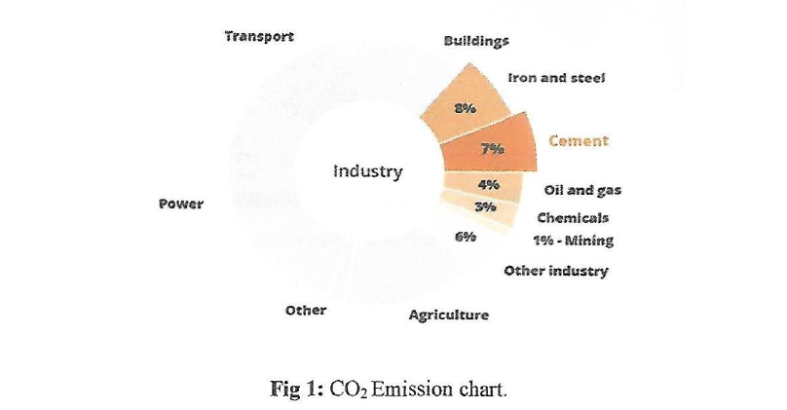b.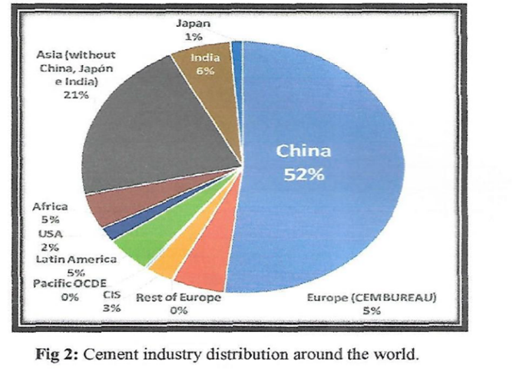

**Fig 3(a and b): (a)The CO2 emission (%) for different building materials; (b) Global distribution of Cement factories**

Cement is energy intensive industrial segment that emit 18 % of. India's industrial emissions. BIS has set up standard for Portland calcined clay limestone cement (LC3) where CO2 emissions from LC3 manufacture is about 30% lesser than OPC and 11% lower than PPC (as per IIT Delhi,). Expeditious innovative researches and technologies like Carbon Capture , Utilisation and Storage (CCUS), are use of innovative alternate cements and binders, etc. can be a major player to have a roadmap for zero carbon footprint (GCCA. TERI-2022-09 [42]).

**1.4.1 Cements in circular value chain and Energy Demands:**

The surged urbanization and industrialization have increased demand for construction materials; to gratify the energy demands. The housing sector contributes 63-65% of demand with an expected 6-7% growth for 2026. The infrastructure contributes ≈25% with a 7-8% growth rate, for commercial and industrial up to 15% with ≈6% growth as published MINT, ANI, 3 Jun 2025. Building materials have circular value chain that account for ≈50% of the annual solid waste produced. It is projected that the solid wastes may reach 2.2 billion tons/ year globally. It is in 2024-25 was 3.8 billion MT (4.2 billion tons) by 2050. The actions are to reduce the amount of waste either as construction and recycled (Redling 2018[43], Subedi et al. 2025[44] Soars et al., 2025[18]).

**1.4.2 Energy consumption under demographic surge:**

The industry segment accommodates about 25% global population but consumes ≈75% of the global energy. It is rose by 2.2% in 2024 – faster than the world’s average rate in the past decade as per the Ministry of Statistics and Programme Implementation (MOSPI). This disproportionate consumption of energy resources, the average energy availability is 2 kW years p.a. /person (defined as one unit). The per capita average consumption energy is 11units for North America whereas in SE-Asia is about 0.43units . The high energy consumption is through construction sector (IEA reports 2023[45]). With 7.5bi population, the energy demand compliance is difficult. <https://www.iea.org/reports/global-energy-review-2025/key-findings>

**1.5.0** **Major Paddy producing countries:**

China produces the highest followed by India. About 580 million tons (MMT) of paddy is produced/year in the globe and is rising. Rice husk(RH) is a part to paddy by about 20% by weight composition are about cellulose(≈50%), lignin(25% - 30%), silica (15% - 20%), and moisture(10% - 15%). The rice husk has a low bulk density of ranging 90 - 150kg/m3 .When husk is burnt, ≈18% of rice husk ash (RHA) remains as balance. Being a huge amount of ash can be used for part replacement of cement in concrete. Table 1.

Table 1 : Major Rice Producing Countries in the World (Milled production in million tonnes)

|  |  |  |  |  |
| --- | --- | --- | --- | --- |
| Country | 2023-24 | 2024-25 | 2024-25 | 2024-25 |
| By mass | Million MT | Million MT | Husk in MMT (20%) | (RHA) in MMT (18% |
| China | 144.62 | 145.28 | 29.056 | 26.1504 |
| India | 137.83 | 145 | 29 | 26.1 |
| Indonesia | 33.02 | 34 | 6.8 | 6.12 |
| Vietnam | 26.3 | 26.5 | 5.3 | 4.77 |
| Thailand | 20 | 20.1 | 4.02 | 3.618 |
| Philippines | 12.33 | 12 | 2.4 | 2.16 |
| Burma | 11.9 | 11.85 | 2.37 | 2.133 |
| Pakistan | 9.87 | 10 | 2 | 1.8 |
| Japan | 7.3 | 7.35 | 1.47 | 1.323 |
| Brazil | 7.2 | 8 | 1.6 | 1.44 |
| USA | 6.92 | 7.05 | 1.41 | 1.269 |
| Nigeria | 5.61 | 5.23 | 1.046 | 0.9414 |
| Egypt | 3.78 | 3.9 | 0.78 | 0.702 |
| South Korea | 3.7 | 3.59 | 0.718 | 0.6462 |
| European Union | 1.44 | 1.67 | 0.334 | 0.3006 |
| Source: www.usda.gov* Estimated | | | | |

Source: <https://www.pjtau.edu.in/files/AgriMkt/2025/March/Paddy-March-2025.pdf>

**1.5.1 Cracking and Quality of Concrete:**

RHA was produced after independence period in India by uncontrolled combustion, and the ash so produced was not used as RHA but wasted as manure, landfill in India. Presently the RHA can be used as accompanying cementing material, that upsurges its workability, corrosivity, durability and strength, . Similarly, the electrochemical instability aggravates corrosion in steel in concrete. It is due to active chloride and sulphate ions, the oxides of nitrogen and sulphur and atmospheric carbonation. To keep away these deteriorating players, the structural engineer must consider the depth of concrete cover in RCC, concrete quality, cracking and can be avoided. Researches reveal that different modified binder like Pulverized Fuel Ash (PFA), Ground Granulated Blast Furnace Slag (Slag), Silica Fume (SF), Rice Husk Ash, Natural Pozzolana, and Volcanic Ash, RHA, when blended with cement in CC can solve the challenge.

**1.5.2 Modified Binders:**

The problems durability of RCC depends upon the blend of siliceous materials (finely divided) in concrete. The supplementary cementing materials are RHA, SF, GGBS, VA etc. They are either pozzolanic or cementitious make them ideal companions to Portland Cement (PC). These foreign wastes are PFA/slag/SF/RHA mix can produce quality concrete (mechanical strength, chemical resistance and durability). The XRF analysis have compared the constituents of OPC and RHA in Oxide form given in Table-2.

Table 2: The chemical constituent of OPC cement and Rice Husk Ash (RHA)(% by mass)

|  |  |  |  |  |  |  |  |  |
| --- | --- | --- | --- | --- | --- | --- | --- | --- |
| Oxides | SiO2 | Fe2O3 | Na2O | SO3 | Al2O3 | CaO | MgO | K2O |
| by mass | % | % | % | % | % | % | % | % |
| OPC | 20.09 | 3.86 | 0.17 | 2.55 | 6.19 | 65.96 | 0.22 | 0.60 |
| RHA | 91.9 | 0.67 | 3.56 | 0.1 | 0.46 | 1.03 | 0.44 | 0.72 |

Source: CUTM Laboratory Jatni, Bhubaneswar, Odisha

Other stand-ins are self-healing concrete, alkali-activated concrete (AAC), bacterial concrete (BC) environment friendly and waste-based concrete are fiber-reinforced concrete (AAC), Foam lightweight concrete and construction/demolition waste (CDW), emerged for sustainability (Kara et al., 2025[46])).

**1.5.3 Cement production and Environment:**

Cement production need mainly Clinker (95%) for each MT of the product consuming energy of ≈4000-7500 MJ while slag requires(700 to 1000 MJ/tonne), and Pulverized Fuel Ash (PFA) (≈150 to 400 MJ/tonne). Replacing 65% of cement with slag having 15% moisture content, only requires 0.5 MT of raw material and consume 1500 MJ of energy. Each tonne of cement replaced will thus save at least 2500-6000 MJ of energy. Every tonne of cement of OPC releases ≈800 kg of CO2 less than one tonne OPC production. So, slag replacement reduce clinker factor and saves environmental degradation [https://www.worldcement.com/special-reports/04092015/reducing-the-clinker-factor-part-1-495/#](https://www.worldcement.com/special-reports/04092015/reducing-the-clinker-factor-part-1-495/): , Malhotra 1999[47] .

**2.0.0 Literature Review:**

Cement is the major material in construction domain due to its high binding property and high compressive strength but a potential threat ( by release of GHGs). RHA is a potential Cementous material that can reduce the risk of atmospheric pollution (Table 3).

Table 3: Researchers in India working on CC partly substituting RHA, to save environment

|  |  |  |  |
| --- | --- | --- | --- |
| Source of RHA | Procedure | Result (Optimal level) | Reference |
| Prepared from Boiler-fired rice husk residue | uncontrolled burning below 500 °C, | 30% by weight of RHA can be replaced | Ganeshan et al, 2007[48] |
| SiO2 (68.12%), Al2O3 (1.01%), CaO(1.01%) and Fe2O3 (0.78%) for strength | RHA consists up to 87% of silica, | 10 – 20% of RHA replace cement | Dabai et al. 2009[49] |
| SiO2 (87.20%); Al2O3 (0.15%);Fe2O3 (0.16%);CaO (0.55%); MgO 0.35% | For Target strengths of M30 and M60. | 15-20%; optimum compressive strength | Naveen et al., 2015[50] |
| Studied properties of RHA blended with Cement | the comp. strength of conc. > the target strength 10 to 20% | The sp. Gr. & water absorption of RHA is unlike from cement | Venkatesani et al., , 2016[51] |
| Chemical Composition and Physical Features of RHA Blended Cement | Strength and Durability Properties GGBFS+RHA of Geopolymer Conc. | Beyond 20% extra of RHA strength reduces | Raheem et al., (2017) [52] |
| Influence of incorporation of rice husk ash and coarse recycled concrete aggregates | RHA and coarse recycled conc. Aggt. (CRCA) into concrete | Use of 10–15% RHA and 100% RCA in concrete | Padhi et al., 2018[53] |
| RHA blended concrete may influence workability, water absorption/ comp. strength | At fixed water cement plus RHA compared with orthodox OPC in CC. | Increases imper-meability that may affect durability | Isberto et al, 2019[54] |
| Substitute OPC with RHA and (Lime stone powder) LSP | Paver sealer enhancer (PSE)and lime stone (LS) | high water claim of RHA; good workability | Saand et. al., 2019[55] |
| RHA based geopolymer concrete (GPC) specimens prepared with ultra-fine slag | High % of ultra-fine slag in rice husk ash geopolymer concrete | Ultra-fine slag improves strength & the durability | Jindal et al., 2020[[56] |
| RHA as a partial replacement for cement in concrete | To study strength characteristics | Advised for RHA + Robo Sand (50%) | Chetan et al., 2020[57] |
| Replacing 10% of cement with RHA gives 11.8% rise in comp. & 7.31% rise tensile strength | High Silica/specific surface area of RHA effect H2O absorption capacity of CC | Max 20% (weight mix of cement by RHA in concrete | Balraj et al, 2021[58] |
| Replacement of cement with rice husk ash in concrete | Cementous material added by RHA in concrete | Rise performance & quality by optimal 20% substitute. | Sarfaraj M 2022[59] |
| Study of RHA as eco-friendly substitute in CC | Impact on strength and durability of CC, Less carbon emissions. | Increase durability and load-bearing capacity of concrete. | Indumati et al, 2024[60] |
| partial blend of cement with rice husk ash & sugarcane bagasse ash | Test for the concrete's durability and efficacy | Workable & durable. Low cost of CC as wastes (RHA) and (ScBA) used | Singh et al., 2024[61] |
| Study on Part-substitute of Cement by RHA & Sand by Rice Husk | Replacement of  cement with RHA and sand with rice husk | Workable & strength is better than standard concrete | Maulya et al, 2025[62] |
| Replacement of cement with rice husk ash in concrete | Replacement of slag  cement with RHA and sand with rice husk | Workable and achieved strength at 10% blending to PSC + fly ash cement | **PRESENT STUDY** |
| Silicon dioxide (SiO2) ; Aluminium oxide (Al2O3) , Ferric oxide (Fe2O3) ; Calcium oxide (CaO) Magnesium oxide (MgO); CC: Cement concrete; ScBA: Sugarcane bagasse ash | | | | |

Many researchers worked for disposal of on-farm or industrial waste directly or in changed form to replace PSC + Fly ash cement to be partly replaced by RHA substitution of cement .

**3.0.0 Collection of RHAs:**

RH used in laboratory is collected from local area and uncontrolled burning gave RHA. Three colours of RHAs are obtained pink (at 600°C), grey ( at 800°C) and white (at 10000C or more). The RHA used in the Laboratory of a mixture of white and grey. The Specific gravity of RHA was found as 1.90 produced after uncontrolled burning. Chemical compositions of RHA are affected due to burning process and temperature. Silica content in the ash increases with high the burning temperature. Different physical properties of RHA are IN Table 4:

Table 4: Physical properties of local available slag Cement with fly ash

|  |  |  |
| --- | --- | --- |
| Particulars | Test Results | Requirements of Is: 1489 - 1991 |
| Specific Gravity | 2.89 |  |
| Fineness (M2/Kg) | 369 | 300 Min |
| Normal Consistency | 32% |  |
| Setting Time (Minutes)  . Initial  . Final | 85 Min  510 Min | 30 Min  600 Max |
| Soundness  . Le-Chatelier Expansion | 4mm | 10 Mm Max |
| % Of Fly Ash Addition | 29 |  |

The tests were conducted by using Vicat Apparatus. Specific gravity of cement was also measured by using the Le Chatelier's Flask method. Soundness test of cement was also conducted for the cement used for the experiment. Soundness test was conducted by using the Le Chatelier's apparatus. The physical properties of the cement obtained on conducting appropriate tests. The test results are specified on Table 4.

**3.1.0 Properties of Coarse Aggregate:**

The maximum nominal size of the coarse aggregate used for the work was 20 mm. Crushed Angular aggregate has been preferred for the experimental work. The specific gravity of the aggregate was found out to be 2.74. Though the surface of the coarse aggregate was free from moisture but the moisture absorption was found out to be 0.5% of the total volume of coarse aggregate.

**3.1.1 Properties of Fine Aggregate:**

The fine aggregate used for the work had specific gravity of 2.74 and was devoid of surface moisture. Whereas the moisture absorption of the aggregates used was 1.0% of the total volume of fine aggregate used for the experiment. The fine aggregate used conformed to Zone 1, conforming to Table 2 of IS 383, Fig 4 (a & d)

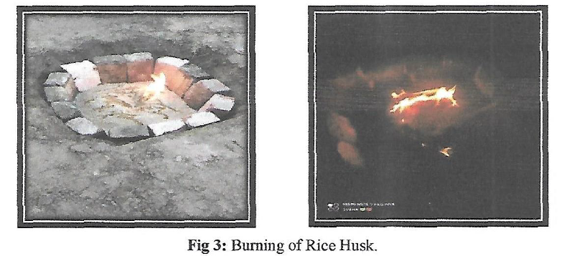

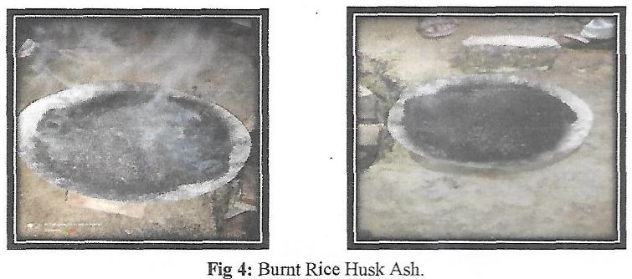

**Fig 4 (a to d): (a &b) Restricted burning of rice Husk ,(c&d) The burnt rice husk**

**3.1.2 Adopted Concrete Mix Proportioning (Design):**

Mix design is a process of selecting suitable ingredients for concrete and determining their proportions which would produce economical conc. The proportioning of the ingredients of concrete is an important for concrete technology as it ensures quality and economy. For obtaining the concrete of desired performance characteristics, the component materials should be selected are as per IS-456 – 2000[63], IS 10262-1982, 2009 and 2019[64]; :

**3.2.0 Concrete Mix Proportion:**

**3.2.1 Concrete Mix Proportion:**

The compressive strength is said to be the index of quality of concrete. Therefore the design mix should be prepared keeping in view compressive strength of concrete with adequateworkability so that the fresh concrete can be properly mixed, placed and compacted.

1. Selection of suitable ingredients-cement, supplementary cementing materials, aggregates, and water and chemical admixtures (if required).
2. Determination of the relative quantities of components to have economical concrete, that has desired rheological properties ie. strength and durability.
3. Careful quality control of every phase of the concrete making process. In the present study Mix Design (Design value at the age of 28 days) grade concrete is done according to BIS: 10262-2009.
4. **STIPULATION FOR PROPORTONING:**
5. Grade Designation:M20
6. Type of Cement: PSC conforming to IS 455 2015[65]
7. Maximum nominal size of aggregate: 20 mm
8. Minimum cement content: 320 kg/m (As per IS 456, Table-5)
9. Maximum water-cement ratio: 0.50 (As per IS 456, Table-5)
10. Workability: 100 mm (slump)
11. Exposure condition: Very Severe (for reinforced concrete)(As per IS 456, Table-
12. Method of concrete placing: Hand Placed
13. Type of aggregate: Crushed angular aggregate
14. Maximum cement content: 450 kg/rn3

**B. TEST DATA FOR MATERIALS:**

a. *Specific Gravity of Cement*: 2.89

b. *Specific Gravity of:* i. Coarse Aggregate: 2.75, ii, Fine Aggregate: 2.62;

c. *Water* Absorption*:* i. Coarse Aggregate: 0.5 %; ii, Fine Aggregate: 1.0%

d. *Free (Surface) Moisture*: i. Coarse Aggregate: Nil ; ii. Fine Aggregate: Nil

e*. Sieve Analysis:*

i*. Coarse Aggregate: The analysis of course aggregate fraction confirming to IS 383-2016 is in Table 5:*

*Table 5:* *The analysis of course aggregate fraction confirming to IS 383-2016 (Table 2)*

|  |  |  |  |  |  |  |
| --- | --- | --- | --- | --- | --- | --- |
| IS Sieve  Sizes (mm) | Analysis of Course  Aggregate Fraction | | Percentage of Different  Fractions | | | Remarks |
|  | I | II | I (60%) | II (40%) | Combined |  |
| 20 | 100 | 100 | 60 | 40 | 100 | Conforming  To Table 2  of IS 383 |
| 10 | 0 | 71.20 | 0 | 28.5 | 28.5 |
| 4.75 |  | 9.40 |  | 3.7 | 3.7 |
| 2.36 |  | 0 |  |  |  |

ii. **Fine Aggregate: Conforming to grading zone 1 of Table 4 of IS 383**

**C**. **Target Strength for Mix Proportioning:**

F’ck = fck + 1.65s

where, f' ck= target average compressive strength at 28 days,fck= characteristic compressive strength at 28 days, and s = standard deviation. **From Table 5 IS(IS 10262:2009),** standard deviation, s = 4 N/mm. Therefore, **Target Strength** = (20 + 1.65x4) N/mm? = 26.6 NAnm?

**D. SELECTION OF WATER CEMENT RATIO: (From Table 5 of IS 456)**

Maximum **Water-Cement Ratio** = 0.50 : Fine Aggregate: Conforming to grading zone 1 of Table 4 of IS 383 2016.

**. SELECTION OF WATER CONTENT:**

From Table 2, Maximum Water Content (for 20 mm aggregate) = 186 litre (for 20 mm to 50 mm slump range) (IS 10262 – 2019 clause 5.3)

**F. CALCULATION OF CEMENT CONTENT:**

Water Cement ratio = 0.50

Cement content = $\frac{192}{0.5}kg/m^{3}$ = 384 kg/m3

From Table 5, IS 456:2000, minimum cement content for very severe exposure condition=320 kg/m3 Since, 384 kg/m3> 300 kg/m3, **Hence OK.**

**G. PROPORTION OF VOLUME OF COARSE AGGREGATE AND**

**AGGREGATE CONTENT:**

From Table 3, volume of coarse aggregate corresponding to 20 mm size aggregate and fine aggregate (Zone I) from water-cement ratio of 0.50 = 0.62. (as per IS-10262 -2019 clause 5.5), So, corrected proportion of volume of coarse aggregate for the water-cement ratio of 0.50 = 0.62. Therefore, volume of fine aggregate content = 1 - 0.62 = 0.38 (Fig 5)

**H. MIX CALCULATION:**

1. Volume of Concrete: 1 m3
2. Volume of Cement: = = 0**.133m3**
3. Volume of cement: $\frac{MASS OF WATER }{SECIFIC GRAVITY OF CEMENT }×\frac{1}{1000}=$ $\frac{192}{1}×\frac{1}{1000}$ = **0.192 m3**
4. Volume of chemical Admixture : Nil
5. Volume of all in aggregate : [a-(b+c+d)] = [1-(0.133+0.192)] = **0.665m3**

Mass of coarse Aggregate: e x Volume of coarse aggregate x Specific gravity of

coarse aggregate x 1000 = (0.665 x 0,62 x 2.75 x 1000) Kg. = 1134kg = **662 kg**

I. MIX PROPORTIONS FOR TRIAL NUMBER 1:

1. Cement = 384 kg/m*
2. Water = 192 kg/m?
3. Fine aggregate = 662 kg/n*
4. Coarse aggregate = 1134 kg/m*
5. Chemical admixture = Nil
6. Water-cement ratio = 0.50

J. **Calculation of Concrete Content for Three Cubes:**

Volume of 1 Concrete Cube = (0.150 x 0.150 x 0.150) m?= 0.003375 m°

Volume of 3 Concrete Cube = (3 x 0.003375) = 0.010125 m°

Weight of cement required for 3 cubes is: (384 x 0.010125) = 3.88 Kg.

Weight of water required for 3 cubes is: (3.88 x 0.50) = 1.94 Kg.

Weight of Fine Aggregate required for 3 cubes is: (662 x 0.010125) = 6.703 Kg.

Weight of Coarse Aggregate required for 3 cubes is: (1134 x 0.010125) = 11.48 Kg. Water Cement Ratio: = 0.50

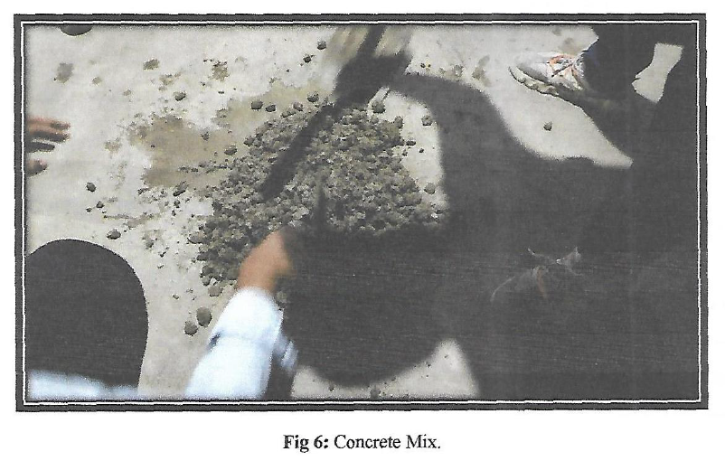

Fig 5 : The RHA and Cement concrete mix at the laboratory

**4.0.0 Results**

The average compressive strength is determined by testing concrete cubes of 150mm x 150mm x 150mm. The test is conducted first by zero percent replacement of cement with rice husk ash. The percentage of rice husk is then gradually varied up to 15 percent. The amount of rice husk ash is increased by 5% for each test.

To determine the average compressive strength of the concrete cubes, a minimum of three concrete cubes for 0%, 5%, 10% and 15% replacement were cast and then cured for 28 days. Before the tests were made, the cubes were made to attain surface dry condition. A comparison of strength of the concrete as determined from the test is shown in Table 7. From the comparison of compressive strength of concrete, it is clearly visible that with an increase in the percentage of rice husk ash, the strength of the concrete reduces (*Table 6*).

Table 6: Compressive Strength of concrete at RHA substitutes in place of cement in cpncrete

|  |  |  |  |  |  |
| --- | --- | --- | --- | --- | --- |
| % of RHA substitute | Weight of cube(kg) | Surface Area  (mm2) | Ultimate  Load(kn) | Compressive  Strength(MPa) | Av. Compressive  (MPa) |
| 0 | 8.04 | 22499 | 620 | 27.56 | 26.77 |
| 8.05 | 22650 | 600 | 26.49 |
| 8.035 | 22800 | 605 | 26.53 |
| 5 | 8.190 | 22499 | 531 | 23.44 | 23.64 |
| 8.8085 | 22650 | 490 | 21.63 |
| 8.235 | 22800 | 595 | 25.87 |
| 10 | 8.190 | 22499 | 495.5 | 22.02 | 21.26 |
| 8.085 | 22650 | 454 | 20.25 |
| 8.235 | 22800 | 490.4 | 21.51 |
| 15 | 8.190 | 22499 | 427.5 | 19 | 18.5 |
| 8.085 | 22650 | 407.7 | 18 |
| 8.235 | 22800 | 419 | 18.5 |

The compressive strength test was carried out by replacing a certain percentage of cement with rice husk ash. Most of the researchers focused on replacing the ordinary Portland cement with RHA but here research has been conducted by replacing Composite cement with rice husk ash. The cement used for the test consists of 31% fly ash and 26% slag. The presence of these materials in cement indicates that only a small amount of cement with RHA. But as discussed earlier, even a small amount of decrease in the consumption of cement can reduce the global warming by a significant amount .

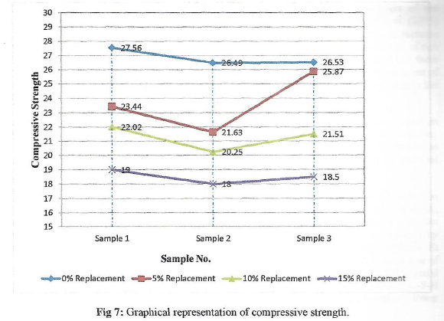

**Fig 6 : Compressive strength of concrete at various blending (RHA+ cement) in Concrete**

The above Table 8 provides an idea about the variation of strength of concrete relating to the change in percentage of rice husk ash. It is clearly noticeable that the average compressive strength of concrete is as high as 26.77 MPa when zero percent cement is replacement. As the percentage of RHA increases to 5 percent, the average strength gets slightly reduced to approximately 24 MPa. With further decrease in the quantity of cement and increase in the quantity of RHA by 10 percent of the total amount of cement, the average compressive strength gets decreased further to 21.26MPa . The average compressive strength thus obtain is slightly above the compressive strength for which the concrete has been designed

Despite the fact that the strength is much less than the target strength, it can be used for small/ less load bearing structure that may not experience surplus load to that for which the structure is designed . Increasing the percentage of rice husk by 5 more percent so that the total amount of rice husk ash used in the concrete is 15% . The result is the strength of concrete falls below the test design strength of concrete used for the structure (Fig 7).

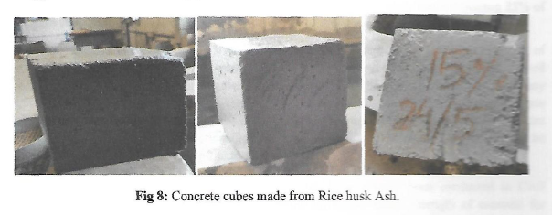

**Fig 7: Various concrete cubes made of cement and Rice Husk ash at various mixes**

Thus, it may be concluded that the optimum amount of slag cement that can be successfully replaced with rice husk ash is up to 10 percent. Higher amount of replacement may result in declining the performance of concrete. The result is for PSC with 31% fly ash and 26% slag. The strength may get increased or decreased for the same amount of replacement depending on the type of cement .

**5.0.0 Discussion:**

The consumption of cement in India is 257 kg/person, far away from the world average of 540 kg/person as per DPIIT, 2023. The concrete segment produces ≈ 20,000 downstream jobs for a MT of cement manufactured (CMA, 2022). So the government has initiated a road map of decarbonization for the Indian cement domain for Net-Zero CO2 by 2070, [https://teriin. org/files/Decarbonisation-Roadmap-for-the-Indian-Cement-Sector.pdf](https://teriin.org/files/Decarbonisation-Roadmap-for-the-Indian-Cement-Sector.pdf) **5.1.0**  **Cement sector use is the hard to decline to emit CO2 :** In cement production Process CO2 emissions is about 50 – 55 %. The technology like Carbon Capture Use or Carbon Capture storage can be employed to reduce carbonation in cement/ concrete manufacture or usages or storages (i.e. CCU or CCS). About 30 – 35% emission can be saved from combustion of fossil fuel and 2 – 5% from vehicular/equipment emission.

**5.1.1 Electrical Carbon Foot Print;** To reduce carbon dioxide release to environment it is essential to adopt Renewable sources or energy generated from waste which are energy efficient machineries/equipment.

**5.1.2 Thermal Carbon Foot print:** Among OPC, PPC, PSC and CC, the ordinary Portland cement has the highest foot print of value 740 tonnes of carbon dioxide equivalent (CO2e). So,Pyro processing technology which was considered popular during 20th century can be switched up by using green fuels, Hydrogen as fuel, sustainable biomass, renewable thermal power, geothermal energy, and innovative clinker system to reduce CO2 emission.

**5.1.2 Part blending with Cementous Material:** Materials and industrial wastes having cementous properties can be substituted in place of Portland cement (PC) i.e. OPC (ordinary Portland cement), PPC (Portland Pozzolana cement) or Portland slag Cement (PSC). The part additives are fly ash, Ground Granulated Blast Furnace slag (GGBFS), natural calcined clay or red mud etc, IS 10262 -2009[64], Mishra et al., 2020[66].

**5.1.3 Multi Blend Cement:** Innovative researches are in race to develop binders and use more clinker-efficient cements. They are like geopolymers, carbo-silicates and calcium hydro silicate binders. Due to limited availability of required raw materials and economic viability intensive researches are needed.

**5.1.4 So, it is desired to reducing Process Emissions by**  Carbon Capture and Utilisation (CCU), and innovative Novel Cements with Low Carbon/No Carbon raw material. Also, CO2 emission can be reduced by electric, and fuel cells. The use of renewable energy sources, geothermal, energy generation by solar and windvanes can reduce GHG/Carbon footprint using electric vehicle or green procurements etc.

**5.2.0 Compliance to SDG -13:** CO2 levels of the globe have exceeded by 150% above global industrial period by limiting global warming by 1.50C. As per Target 13.3, of sustainable development goals, global CO2 emissions should reach by 45% by 2030 based on 2010 levels, and range net-zero emissions by the year 2050. It is predicted by world bank that the achievement is 12 tCO₂e GHG emissions/person/year for the high-income countries emit 8 tCO₂e for upper-middle income countries, 3 tCO₂e in lower-middle . So, by prioritizing action plans to combat climate change (CC) and its impression by reducing global GHG missions, enhance climate resilience to oblige goals stipulated by SDG 13-3 (Mishra et al, 2023[67]).

So, it is of option to reduce CO2 emission in Cement production as cement/ and concrete are answerable for 8–9% of Green House gases, energy demand (2–3%) , and industrial water withdrawals (9%) (NITI Aayog report 2022[68]). It is high time to think of blended cement i.e. for replacing partly cement in concrete by substituting RHA in place of cement by 15%. The RHA based sand cement blocks have cooling effect on the room temperature so that it can significantly save energy, add to impermeability, durability and compressive strength. .

**6.0.0 Conclusion**:

To impart durability and free from corrosion it is essential to  focus on quality of clinker, energy efficient, green concrete cement-based materials and admixtures with self-healing mechanisms, in construction practices, and applications in both new constructions and structures under retrofitting. Many a researcher have worked on partial replacement of RHA by OPC and tested the improvements in the properties of cement concrete. Such type of RHA blended OPC have the properties like Pozzolanic, physical properties, durability, densified, impermeable have better internal curing capability, and prevent early corrosion of reinforced bars in RCC but the major drawback is loss of early workability in case of such concrete. However the RHA as part substituted cement command less carbon footprint, saves carbon credit/ ecosystem and environmentally friendly. However, the GHG emission must be minimally optimised from the time of manufacture of cement to its use and allowing part replacement of cement by blending with the pozzolanic property bearing RHA confirming SDG 13.3.

**Reference:**

1. Goswami, A., Kapoor, H. S., Jangir, R. K., Ngigi, C. N., Nowrouzi-Kia, B., & Chattu, V. K. (2023). Impact of Economic Growth, Trade Openness, Urbanization and Energy Consumption on Carbon Emissions: A Study of India. Sustainability, 15(11), 9025. https://doi.org/10.3390/su15119025
2. South Indian Bank, 2025. world’s GDP as 13%. Construction’ sector in India has a 8.6%, growth rate such as financial, real estate & professional services’ sector by 7.2%. Date of publication, 1st Mar 2025, date of reading: 24.06.2025
3. Simbi H., C., Yao, F., & Zhang, J. (2025). Sustainable Development in Africa: A Comprehensive Analysis of GDP, CO2 Emissions, and Socio-Economic Factors. Sustainability, 17(2), 679. https://doi.org/10.3390/su17020679
4. Lopez, R., & El-Fata, C. (2024). Environmental Implications of Using Waste Glass as Aggregate in Concrete. Journal of Composites Science, 8(12), 507. https://doi.org/10.3390/jcs8120507
5. The energy and resource Institute(TERI), (2025). Driving Industry Transition, Focus on cement Sector, WSDS 2025 Thematic Track- Driving Industry transition: Focus on Cement Sector, Maple Hall, India Habitat Centre, New Delhi
6. Hosseini, P., & Han, B. (2022). Editorial for Special Issue Cement and Construction Materials. Crystals, 12(10), 1490. https://doi.org/10.3390/cryst12101490
7. Kioumarsi, M., & Plevris, V. (2024). Advanced Concrete and Construction Materials for Sustainable Structures. Sustainability, 16(4), 1427. Doi.org/10.3390/su16041427
8. Hayek, M., El Bitouri, Y., Bouarab, K., & Yahia, A. (2025). Structural Build-Up of Cement Pastes: A Comprehensive Overview and Key Research Directions. Construction Materials, 5(2), 31. https://doi.org/10.3390/constrmater5020031
9. Krelani, V., Ahmeti, M., & Kryeziu, D. (2025). Increased Durability of Concrete Structures Under Severe Conditions Using Crystalline Admixtures. Buildings, 15(3), 352. https://doi.org/10.3390/buildings15030352
10. Song, G., Zheng, Y., & Wu, B. (2019). Emerging Construction Materials and Sustainable Infrastructure. Applied Sciences, 9(19), 4127. https://doi.org/10.3390/app9194127
11. Paes, V.d.C.; Pessoa,C.H.M.; Pagliusi, R.P.; Barbosa, C.E.;Argôlo, M.; de Lima, Y.O.; Salazar, H.;Lyra, A.; de Souza, J.M. Analyzing the Challenges for Future Smart and Sustainable Cities. Sustainability 2023,15, 7996.
12. Azmat, M., Ghalayini, M., Hadeed, R. (2025). Navigating Mobility in Crises: Public Transport Reliability and Sustainable Commuting Transitions in Lebanon. Sustainability, 17(12), 5482. <https://doi.org/10.3390/su17125482>
13. Tran, C. N. N., Illankoon, I. M. C. S., & Tam, V. W. Y. (2025). Decoding Concrete’s Environmental Impact: A Path Toward Sustainable Const. Buildings, 15(3), 442. https://doi.org/10.3390/buildings15030442
14. Harichandan, B., Mishra, SP., Deepak Kumar, Sahu DK., Mishra S., (2022), The Non-Carbon Kaolinite; Part Substituent of Cement in Concrete. Current Journal of Applied Science and Technology; 41(1): 1-13, DOI: 10.9734/CJAST/2022 /v41i131643
15. Patra, A., Ganguly, T., Tiwari, A., Kumar, A., handapani, S., Narang, S. 2025. How can India Reduce Pollution from Construction Activities? Strengthening the Pollution Monitoring Regime. New Delhi: Council on Energy, Environment and Water.
16. United Nations Environment Programme (2023). Building Mat. and the Climate: Constructing a New Future. Nairobi, P 1-138
17. Soares, N., Tavares, V. (2025). Bibliometric Analysis of the Intersection of Circular Economy, Prefabrication, and Modularity in the Building Industry. Buildings, 15(11), 1923. https://doi.org/10.3390/buildings15111923
18. Vibrant Build Con, 2025. International Exhibition for Building Materials. From April 13th -16th, 2025, Ahmadabad.
19. Amit Ku., Ralhan R., Nath, B., Joshi, R., Nautiyal A., (2025). Supported by: EU-India Clean Energy & Climate Partnership. www.cecp-eu.in/uploads/ documents /events / 63/EU_India_CECP_RI_report_on_low_embodied_energy_building_materials.
20. Ojha B, Mishra S. P., Nayak S., Panda S., and Siddique Md., 2020, Bauxite Waste as cement Substitute after Normalisation: Sustaining environment, Journal of Xidian University, Volume 14(4), 1449 – 1463; ISSN No:1001-2400, https://doi.org/10. 37896/jxu14.4/168;2020
21. Majumdar P., Mishra SP., 2017. Management of Pumicecrete as LWC/LWA construction material with Fly Ash as part cement substitute. Int. J. of Dev. Res., 7 (07), 13978-13984
22. Das M., Mishra SP., (2020). Parametric Strategy for Composite Cement Concrete Blended with Fly Ash & Glass Fiber; CJAST. 39(35):162-176; DOI: 10.9734/ CJAST/2020/v39i3531065
23. Dash, SS., Mishra, SP., Panda,S. (2021), Physiognomies and Strength Investigation of Concrete Part Blended by Wood Ash, Int. J. of Env. and ClC, 11(5): 143-155,
24. Sakhare, V., Taware, T., Ingole, R. et al. Investigating the factors affecting sustainability of ready-mix concrete plants: case study of Pune region. Discov Civ Eng 1, 106 (2024). https://doi.org/10.1007/s44290-024-00110-x
25. Rana, A., & Andino, J. M. (2025). A Review of Materials for Carbon Dioxide Capture. Catalysts, 15(3), 273. https://doi.org/10.3390/catal15030273
26. Sisodiya, S., Jaiswal, A. (2024). Health hazards and environmental impact of cement industries, Anthropo-Indialogs,4: 1, 47-55. DOI:10.47509/AI.2024.v04i01.05
27. NITI Aayog , India. (2025). A workshop was held on the “Carbon Capture, Utilization, & Storage (CCUS) in the Indian Cement Sec. on 16th Jan. 2025,Vigyan Bhawan, ND.
28. Falaciński, P., Machowska, A., & Szarek, Ł. (2021). The Impact of Chloride and Sulphate Aggressiveness on the Microstructure and Phase Composition of Fly Ash-Slag Mortar. Materials, 14(16), 4430. https://doi.org/10.3390/ma14164430
29. Zhang, Y., Tang, Z., Liu, X., Zhou, X., He, W., & Zhou, X. (2024). Study on the Resistance of Concrete to High-Concentration Sulfate Attack: A Case Study in Jinyan Bridge. Materials, 17(14), 3388. https://doi.org/10.3390/ma17143388
30. Hamed, Y. R., Keshta, M. M., Elshikh, M. M. Y., Elshami, A. A., Matthana, M. H. S., & Youssf, O. (2025). Performance of Sustainable Geopolymer Concrete Made of Different Alkaline Activators. Infrastructures, 10(2), 41. https://doi.org/10.3390/infrastructures10020041
31. Wei, T., Xiao, J., Cheng, X., Gong, P., Mei, K., Hou, Z., Wu, X., (2024). Improving the Mechanical Properties of Cement-Based Materials Under High Temperature: Reducing the C3S/C2S Ratio. Construction and Building Materials, 421, 13574, http://dx.doi.org/10.2139/ssrn.4697934
32. Hoby, PM, Santhi AS, GM. Ganesh,(2017). The Performance of Multi Blended Cement Concrete in Marine Env., Int. J. of Civil Eng. and Tech., 8(7),219–231.
33. Majumdar P., Mishra SP., 2017. “Management of Pumice Crete as LWC/LWA construction material with Fly Ash as part cement substitute”, International Journal of Development Research, 7, (07), 13978-13984.
34. Das MP., Mishra SP., Nayak S., Siddique M., 2019, Optimized structural performance of paver blocks of bajri concrete: NRM partly substituting cement, IJITEE, 9(1), ,1938-49.
35. Plaza, M. G., Martínez, S., & Rubiera, F. (2020). CO2 Capture, Use, and Storage in the Cement Industry: State of the Art and Expectations. Energies, 13(21), 5692. https://doi.org/10.3390/en13215692
36. Ahmed, M. S., Tasnim, A., & Kabir, G. (2024). From Grinding to Green Energy: Pursuit of Net-Zero Emissions in Cement Production. Engineering Proceedings, 76(1), 8. <https://doi.org/10.3390/engproc2024076008>
37. Khalil, E., & AbouZeid, M. (2025). Framework for Cement Plants Assessment Through Cement Production Improvement Measures for Reduction of CO2 Emissions Towards Net Zero Emissions. Const. Mate., 5(2), 20. [doi.org/10.3390/constrmater5020020](https://doi.org/10.3390/constrmater5020020)
38. GCCA India-TERI. (2025). Decarbonization Roadmap for the Indian Cement Sector: Net-zero CO2 by 2070.
39. Yang, W., Feng, L., Wang, Z., Fan, X. (2023). Carbon Emissions and National Sustainable Development Goals Coupling Coordination Degree Study from a Global Perspective: Characteristics, Heterogeneity, and Spatial Effects. Sustainability, 15(11), 9070. <https://doi.org/10.3390/su15119070>
40. Tsakalakis G., (2020). Conventional Clinker Grinding - A New Approach to the prediction of Power Consumption. Conference: Presented at the Ultrafine Grinding 06 (UFG 06), June 12-13, Minerals Eng Int. (MEI), Falmouth-Cornwall, U.K,: <http://www.min-eng.com/ultrafinegrinding06/paps.html>
41. Kanitkar, T., Mythri A., Jayaraman, T.. (2024) Equity assessment of global mitigation pathways in the IPCC Sixth Assessment Report. Climate Policy 24:8, pages 1129-1148
42. GCCA India-TERI. (2025). Decarbonization Roadmap for the Indian Cement Sector: Net-zero CO2 by 2070.
43. Redling, Adam. 2018. “Construction Debris Volume to Surge in Coming Years.” Construction & Demolition Recycling, March 5, 2018. <https://www.cdrecycler.com/news/global-volume-construction-demolition-waste>
44. Subedi, A., Kim, H., Lee, M.-S., & Lee, S.-J. (2025). Thermal Behavior of Concrete: Understanding the Influence of Coefficient of Thermal Expansion of Concrete on Rigid Pavements. Applied Sciences, 15(6), 3213. <https://doi.org/10.3390/app15063213>
45. IEA Report 2023, <https://www.iea.org/reports/renewables-2023>
46. Kara De Maeijer, P. (2025). Innovative Solutions for Concrete applications, Infrastructures, 10(3), 59. <https://doi.org/10.3390/infrastructures10030059>
47. Malhotra, V. M., 1999. Role of supplementary cementing materials in reducing greenhouse gas emissions, Proc. Int. Conf. on Infrastructure Regeneration and Rehabilitation -Improving the Quality of Life Through Better Construction - A Vision for the next Millennium, Ed. R. N. Swamy, Sheffield Acad. Press, 1999,
48. Ganeshan K., Rajgopal k., Thangav K., (2007). Rice husk ash blended cement: Assessment of optimal level of replacement for strength and permeability properties of concrete. Construction and Building Materials, 22 (8), 675-1683, https://doi.org/10.1016/j.conbuildmat.2007.06.011
49. Dabai M U, Muhammad C, Bagudo B U., Musa A., (2009) Durian pectin and rice husk ash (RHA) as partial replacement of cement in concreteNiger. J. Basic Appl. Sci. 17 (2), 252–256
50. Naveen S.B., Antil Y., (2015):effect of rice husk on compressive strength of concrete. Int. jour. emerging tech. 6(1) :144-150, 0975-8364
51. Venkatesan PR., Pazhani KC. (2016) Strength and Durability Properties of Geopolymer Concrete made with Ground Granulated Blast furnace Slag and Black Rice Husk Ash. KSCE J. of Civil Eng. 20(6):2384-2391DOI 10.1007/s12205-015-0564-0− 2384 –
52. Raheem, A.A. and Kareem, M.A. (2017) Chemical Composition and Physical Characteristics of Rice Husk Ash Blended Cement. Int. J. of Eng. Res. in Africa, 32, 25-35.https://doi.org/10.4028/www.scientific.net/JERA.32.25
53. Padhi, R.S., et al., Influence of incorporation of rice husk ash and coarse recycled concrete aggregates on properties of concrete. Construction and Building Materials, 2018. 173(2018): p. 289-297
54. Isberto CD., Labra KL., Jan MBL, Jesus RD. (2019). Optimized preparation of rice husk ash (RHA) as a supplementary cementitious material. GEOMATE Jour., 16(57), 56–61. Retrieved from <https://geomatejournal.com/geomate/article/view/2810>
55. Saand, A.; Ali, T.; Keerio, M.A.; Bangwar, D.K. Experimental Study on the Use of Rice Husk Ash as Partial Cement Replacement in Aerated Concrete. Eng. Technol. Appl. Sci. Res. 2019, 9, 4534–4537
56. Jindal B.B. , Jangra, P., Garg A., (2020). Effects of ultra fine slag as mineral admixture on the compressive strength, water absorption and permeability of rice husk ash based geopolymer concrete, Mater. Today. Proc., 32 (2020), pp. 871-877
57. Chetan D., Aravindan A., (2020). An experimental investigation on strength characteristics by partial replacement of RHA and Robo sand in concrete, 33(1), Mat. Today, Proceedings, 502-507, https://doi.org/10.1016/j.matpr.2020.05.075
58. Balraj A, Jayaraman D, Krishnan J, Alex J. Experimental investigation on water absorption capacity of RHA-added cement concrete. Environ Sci Pollut Res Int. 2021 . doi: 10.1007/s11356-020-11339-1.
59. Sarfaraj Md., (2022). Positive impact on the strength and durability of concrete, while also contributing to a reduction in carbon emissions. IJRAR, 9(4), 126-131.
60. Indumathi M., Nakkeeran G., Roy, D. et al. (2024). Innovative approaches to sustainable construction: a detailed study of rice husk ash as an eco-friendly substitute in cement production. Discov Appl Sci 6, 597, Doi.org/10.1007/s42452-024-06314-1
61. Singh J., Sharma H., Kumar S., Madhubala, (2024). Partial replacement of cement with RHA & sugarcane bagasse ash: review paper. Industrial Eng. Jou. 53(6), 664.
62. Maulya KT, Hemantha KM, Sinchana MD, Neha P, Manjunath HS., (2025). An Experimental Study on Partial Replacement of Cement by RHA and Sand by Rice Husk. Int. Research J. of Eng. and Tech. (IRJET) 12(2), 622-625,
63. IS 456 2000 :IS456-2000 (2000) Indian Standard Plain and Reinforced Concrete Code of Practice. Bureau of Indian Standards, New Delhi.
64. IS-10262-2009- and IS-10262 2019; New Concrete Mix-design.pdf
65. IS 455 : 2015: Portland Slag Cement - Specification (Fifth Revision) ; Name of Standards Organization: Bureau of Indian Standards (BIS)
66. Mishra S. P., (2020) Tax and Pandemic; Curbing Carbon Burden of India's Blue Sky; Current Journal of Applied Science and Technology 39(35):35-56; DOI: 10.9734/ CJAST/2020/v39i3531053
67. Mishra SP, Mohapatra SK and Sethi KC (2023) The Values and Blue Carbon Ecosystem of the Chilika Lagoon through Ages, India. Environ Sci Arch 2(2):164-184
68. NITI Aayog 2022, Report of the Inter-Ministerial Committee on Low Carbon Technologies formed under the India-US Sustainable Growth Pillar of the Strategic Clean Energy Partnership, 1-44