**TISSUE CULTURE AND ITS APPLICATIONS IN MULBERRY PROPAGATION**

**ABSTRACT**

Mulberry is an economically important perennial tree serving as the sole food source for the silkworm, *Bombyx mori* L., and plays a vital role in the sericulture industry. However, conventional methods of propagation such as stem cuttings and grafting are often limited by low multiplication rates, seasonal constraints and susceptibility to diseases. Tissue culture techniques offer a promising alternative for rapid, large-scale propagation, genetic improvement and conservation of mulberry germplasm. Through *in-vitro* approaches such as micropropagation, somatic embryogenesis and organogenesis, elite and disease-free planting material can be produced efficiently. Furthermore, tissue culture facilitates the conservation of valuable and rare germplasm under controlled conditions, ensuring the preservation of genetic diversity for future breeding and research. This review highlights the role of tissue culture in the improvement and conservation of mulberry, discussing recent advancements, applications, and future prospects of these biotechnological tools in supporting sustainable sericulture and mulberry genetic resource management.

**Key words**: Mulberry; Tissue culture; Micropropagation;Somatic embryogenesis; *In-vitro* conservation;Germplasm preservation;Genetic improvement;Organogenesis

1. **INTRODUCTION**

Mulberry (*Morus* spp.) is a fast-growing, woody perennial plant of significant economic importance, especially in countries where sericulture is a major rural industry. Its leaves are the sole food source for the silkworm (*Bombyx mori*), making mulberry cultivation critical to the success of silk production. The perennial nature of mulberry, along with its extended juvenile phase hampers the pace of its genetic improvement (Kavyashree *et al*., 2001). Although mulberry can reproduce both sexually and asexually, its high heterozygosity makes seed propagation unsuitable for commercial purposes due to the resulting genetic variability. Furthermore, the dioecious habit, long juvenile period and pronounced inbreeding depression make the development of stable inbred lines particularly challenging (Vijayan *et al*., 2011).

Vegetative propagation methods such as stem cuttings, grafting and budding are commonly used for mulberry. However, the success of these techniques is influenced by factors like the plants genetic constitution, age and physiological state of the parent material, climatic conditions and cultivation practices. Moreover, newly developed mulberry varieties cannot be propagated immediately through stem cuttings, as the parent plants require a maturity period of at least 6-7 months before suitable cuttings can be harvested (Kapur *et al*., 2001).

The propagation of mulberry through stem cuttings is commonly followed method of planting mulberry crop. The success of stem cuttings is dependent on many factors *viz*., origin of genotype, age of stem, rooting ability of plant, physiological condition of plant and environmental conditions (Taha *et al*., 2020). The other methods of propagation include grafting, budding, layering also implicit some complexity at commercial scale. Vegetative propagation of mulberry through grafting is not economically viable (Attia *et al*., 2014). Mulberry tree improvement through conventional breeding is slow and also difficult due to its heterozygous nature.

To overcome these challenges, plant tissue culture has emerged as a powerful and reliable tool (Guha *et al*., 2010; Taha *et al*., 2020). Tissue culture exploits the totipotency of plant cells their inherent ability to regenerate into whole plants under aseptic and controlled environmental conditions (Hussain et al., 2012). It enables the rapid production of a large number of true-to-type, disease-free plants throughout the year. Over the decades, various tissue culture techniques have been refined for mulberry, including micropropagation through axillary bud proliferation, organogenesis from callus, somatic embryogenesis and production of synthetic seeds.

These biotechnological approaches not only ensure mass multiplication but also play a vital role in conserving elite germplasm, introducing desirable traits, and developing improved cultivars with enhanced productivity and stress resistance (Kavyashree *et al*., 2001; Thirugnanakumar *et al*., 2001; Islam *et al*., 2012). The application of tissue culture techniques has therefore become indispensable in modern mulberry improvement programs and in ensuring a sustainable and productive sericulture industry (Vijayan *et al*., 2011; Taha *et al.,* 2020).

**Challenges in Conventional Propagation of Mulberry**

**1. Low multiplication rate and seasonal dependence**

Mulberry is commonly propagated through stem cuttings, grafting and budding. However, these methods are slow and limited by the natural growth cycle they cannot supply large quantities of plants year-round (Chowdary and Bindroo, 2013).

**2. Genetic heterozygosity and variability**

Mulberry is a highly heterozygous, dioecious species and seed propagation leads to significant genetic variability. This makes it unsuitable for maintaining uniform, true-to-type plants in commercial cultivation (Hussey, 1978).

**3. Prolonged juvenile phase**

Newly bred or selected plants require a long period to reach reproductive maturity, which delays the production of viable propagules and slows down breeding programs (Bharath Kumar *et al*., 2024).

**4. Poor rooting of cuttings in some varieties**

Rooting success depends heavily on genotype, physiological status and environmental conditions and some desirable cultivars are particularly difficult to root through cuttings (Taha *et al*., 2020).

**5. Susceptibility to pests and diseases in nurseries**

Cuttings and young plants grown in conventional nurseries are vulnerable to soil-borne pathogens, pests and abiotic stress, reducing survival and quality of planting material (Attia *et al.*, 2014).

**6. Delayed propagation of new varieties**

Newly developed cultivars cannot immediately supply large numbers of cuttings, because the parent plants need to grow and mature for at least 6-7 months before sufficient material can be harvested (Kapur *et al*., 2001).

The limitations of conventional propagation techniques such as low multiplication rate, genetic variability, long juvenile phases, poor rooting in some genotypes, susceptibility to diseases and delayed availability of planting material so, there is a critical need for more efficient and reliable methods to produce large quantities of uniform, healthy mulberry plants throughout the year.

One such promising approach is plant tissue culture which enables the rapid, large-scale and disease-free propagation of true-to-type plants irrespective of season or genotype limitations. Tissue culture has successfully addressed many of the limitations of traditional propagation methods and is now widely applied for both mulberry improvement and large-scale multiplication.

**Tissue culture**

Tissue culture is the technique of maintaining and growing plant or animal cells, tissues or organs in an artificial, nutrient-rich medium under controlled aseptic conditions (Thorpe, 2007)

**Importance of tissue culture in mulberry**

1. In a relatively short time and space a large number of plantlets can be produced starting from the single explant.

2. Taking an explant does not usually destroy the mother plant, so rare and endangered plants can be cloned safely.

3. It is easy to select desirable traits directly from the culture setup (*in*-*vitro*) thereby decreasing the amount of space required for field trials.

4. Once established, a plant tissue culture line can give a continuous supply of young plants throughout the year.

5. The time required is much shortened, no need to wait for the whole life cycle of seed development.

6. *In*-*vitro* growing plants usually free from the bacterial and fungal diseases. Virus eradication and maintenance of plants in virus free state. This facilitates movement of plant across international boundaries.

7. Plant tissue banks can be frozen and then regenerated through tissue culture. It preserves the pollen and cell collections from which plants may be propagated.

(Qadir *et al*., 2024)

The mulberry (*Morus spp*.) is a significant plant in the sericulture sector since the silkworm (*Bombyx mori* L.) only consumes its leaves as nourishment. Industrial advancements are greatly aided by qualitative and quantitative improvements in mulberry. This process is slowed down by the perennial nature of the tree and the extended juvenile phase of the species. Stock improvement methods have frequently used plant tissue culture and the important techniques used in tissue culture are discussed as under:

Picture 1 : **Tissue culture technique in mulberry**

**Tissue culture technique in mulberry has developed and ramified into different areas such:**

* Micropropagation
* Callus culture
* Organogenesis
* Screening of genotypes for stress tolerance
* Induction of polyploids
* Cryopreservation
* Transgenesis

**There are three methods widely used in tissue culture which includes:**

* Micro propagation
* Organogenesis
* Somatic embryogenesis

**MICROPROPAGATION**

Numerous explant sources including shoot tips and axillary, solitary or winter buds, have been used to micropropagate mulberry (*Morus spp*.). The first reports come from Japan and one of them is from Ohyama, who grew the first full-grown plantlets from axillary bud tissue on MS (Murashige and Skoog, 1962) substrate that had growth regulators added to it. Sub terminal buds showed the highest responsiveness to multiple-shoot induction (Hossain, 1999).

Mulberry can be vegetatively propagated through stem cuttings, grafting or budding.  However, success of these methods depends on a number of factors such as genetic makeup of the plant, age and physiological conditions of the parental cutting, climatic conditions and others. Newly developed mulberry varieties cannot immediately propagated through stem cuttings as at least 6-7 month maturity is required to make the cuttings from the parental plant. Micropropagation, on the other hand allows multiplication of the plant in a short period under the controlled conditions (Suraksha Chanotra, 2019). Further, in conventional method of propagation through stem cuttings, each stem cutting produces only one plant, whereas in micropropagation thousands of plants can be produced from a single plant piece. Moreover, micropropagation can provide plantlets throughout the year irrespective of seasonal variations. It is thus an efficient and cost effective tool for rapid multiplication of mulberry in a relatively shorter time and space.Micropropagation also facilitates production of virus-free plants from the apical meristematic tissues. However, success of micropropagation is dependent on a number of factors among them genetic makeup, age and origin, physiological and pathological conditions of the explants, media composition and culture conditions are considered key factors.

**ORGANOGENESIS**

Regeneration of plants from somatic cells plays a crucial role in improving woody tree species, as it enables the production of transgenic plants, the identification of somaclonal variants and the development of stress-tolerant lines through cell line selection and propagation of superior genotypes (Bajaj,1986; Gupta, 1988). Consequently, several efforts have been made in mulberry to establish protocols for direct regeneration from explants such as leaves, cotyledons and embryos, as well as indirect regeneration via callus culture. Direct organogenesis from explants offers the benefit of minimal genetic variation among the regenerated plants, ensuring true-to-type clonal propagation, whereas organogenesis through callus culture tends to enhance plant productivity (Desai *et al*., 2022) . Moreover, plants derived from callus are an important source of genetic variability, enabling the selection of somaclonal variants with desirable characteristics.

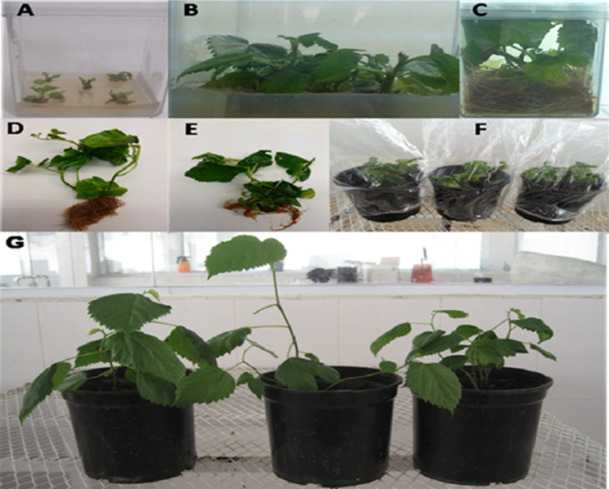

**Explants**

Winterbuds, Nodal segments, Shoot tips

**Surface Sterilization**

Treat with mild detergents for 10 min; wash thoroughly with sterile water 3 times; treat with 7% NaOCl2 for 10 min; wash thoroughly with sterile water 3 times; treat with 0.1% HgCl2 for 10 min; wash thoroughly with sterile distilled water 3-4 times

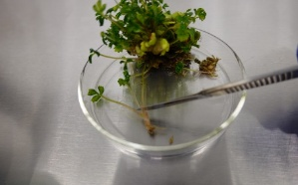

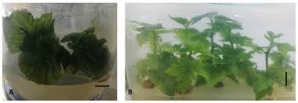

**Shoot initiation**

MS+BA(2.0mg/L)+fructose (3%)+0.8% agarose, pH ≥5.8



**Shoot Multiplication**

MS+BA(2.0mg/L)+fructose (3%)+0.8% agarose, pH ≥5.8

**Rooting**

MS+NAA(0.1-0.2 mg/L)+ Fructose (3%)+0.8% agarose, pH ≥5.8

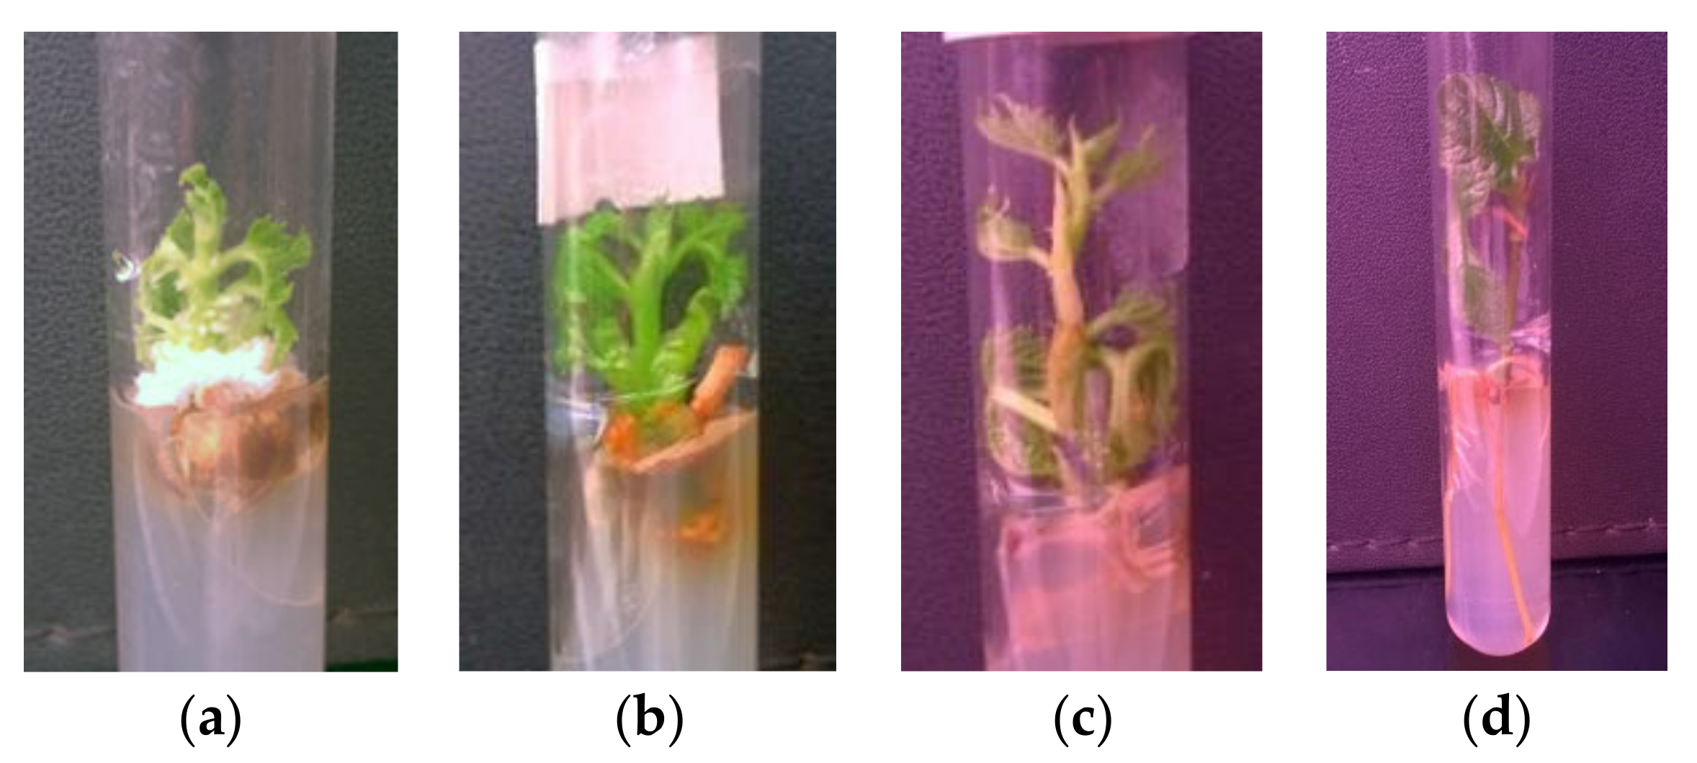

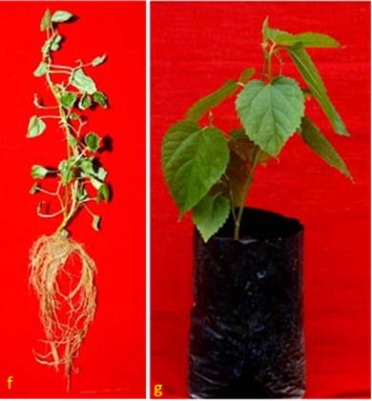

**Hardening**

80-85 % humidity, 25-27 ◦C for 15 days, Normal condition under shade for 60 days, transfer to earthen pot containing fine soil

**Fig. 1: Schematic representation of the procedure of micro propagation in mulberry**

Organogenesis is a complex phenomenon involving de novo formation of organs. Successful organogenesis depends on a number of factors which include appropriate selection of explants, age of the explants, media compositions, specific growth regulators, genotype, sources of carbohydrate, gelling agent and other physical factors including light, temperature, humidity and other factors. Depending on these factors plant regeneration may occur either directly or indirectly. In direct organogenesis, plants develop directly from the explants without formation of intermediate callus while in indirect organogenesis plant develops via callus formation.  Again, callus induction depends on a number of factors such as nature of explants, genotype, medium and its composition. A variety of explants has been tested to initiate callus formation in mulberry.

**SOMATIC EMBRYOGENESIS**

Somatic embryogenesis refers to the process where a single cell or a group of cells initiates a developmental pathway, resulting in the consistent regeneration of non-zygotic embryos that can germinate into complete plants. This technique is an important tool for accelerating the genetic improvement of commercial crop species. Although several research groups have attempted to induce somatic embryos in mulberry, the success rate has been relatively low. Shajahan *et al*. (1995) reported the formation of heart-shaped embryos from *Morus alba* hypocotyl segments cultured on MS medium supplemented with 2,4-D (0.45–4.52 μM) and BAP (2.2 μM). Agarwal (2002) obtained primary and secondary somatic embryos by culturing zygotic embryos on MS medium containing 0.05 mg/L 2,4-D, 0.1 mg/ L BAP, and 6% sucrose. However, due to the challenges in hormonally regulating the formation of adventitious shoots and roots in mulberry, somatic embryogenesis has not been as successful as in many other crop plants (Tiku *et al.,* 2021). Therefore, coordinated efforts are required to establish an effective somatic embryogenesis protocol in mulberry.

**HAPLOID PRODUCTION**

Haploid plants being gametophytic in origin, possess only half the normal number of chromosomes as present in the parent. They can be used to produce homozygous lines, which are invaluable for breeding programmes, especially in tree crops with long generation cycles and high heterozygosity (Guha & Maheshwari, 1964; Kasha & Maluszynski, 2003). Since the first successful report on regeneration of haploid plants from pollen grains of cultured anthers of *Datura* (Guha & Maheshwari, 1964), this technique has been extensively applied in many agriculturally important plant species. However, only limited success has been achieved in tree species (Bonga, 1987). In mulberry (*Morus* spp.), although anther culture was attempted as early as the 1980s (Sastri *et* *al*., 1983; Kavyashree *et* *al*., 2001), no regenerated plants were obtained. However, gynogenic haploids were successfully regenerated by culturing immature female catkins on MS medium (Chauhan *et al.,* 1984).No further reports on haploidy in mulberry are available, despite the potential value of doubled haploidy in mulberry breeding (Kavyashree *et al*., 2001; Tiku *et al*., 2021).

**Explants**

(Cotyledons, Hypocotyl, Epicotyl, Stem segment, Roots, Leaves)

**Surface Sterilization**

Treat with mild detergents for 10 min; Wash thoroughly with sterile water 3 times; treat with 7% NaOCl2 for 10min; wash thoroughly with sterile water 3 times; treat with 0.1% HgCl2 for 10 min;wash thoroughly with sterile distilled water 3-4 times

**Pre-soaking**

MS+BA (1-2 mg/l) for 48-72 h

**Direct shoot induction**

MS+BA (1-2 mg/l) +Sucrose (3%) +0.8% agarose pH ≥ 5.8

MS+NAA (0.1-0.2 mg/l) + Sucrose (3 %) 0.8% agarose pH ≥ 5.8

**Callus induction**

MS+2, 4-d (2 mg/l) + BA (0.1-0.5 mg/l) + Casein hydrolysate (100 mg/l) + Coconut water (150 ml/l +Sucrose (3 %) +0.8% agarose pH ≥ 5.8

**Hardening**

80-85 % humidity, 25-27 ◦C for 15 days, Normal condition under shade for 60 days, transfer to earthen pot containing fine soil

**Shoot initiation**

MS+ BA (2 mg/l) + TBA (0.1 mg/l) Sucrose (3 %) +0.8% agarose pH ≥ 5.8

**Fig. 2: Schematic representation of organogenesis procedure in mulberry**

**Other Applications of Tissue Culture in Mulberry**

**Induction of Tetraploidy**

In general, the mulberry is propagated through vegetative means. Hence, sterile high yielding varieties/cultivars do not pose any problems for their true to type multiplication. Triploid in mulberry is considered as the optimum level of ploidy because triploids show several advantages over plants of other ploidy. Triploids are superior in leaf yield, stress resistance and chemical components of the leaf (Yang and Yang, 1989).  Considering these advantages, tetraploids are developed from diploids by colchicine treatment of the growing shoots. In this method, small cotton pads soaked with 1.0-2.0% colchicine solution is applied over the growing buds for 2-3 consecutive days. Though this method is easier to apply, it suffers from quick drying of the cotton pad, excessive loss of colchicine and difficulty in maintaining the uniform concentration of the colchicine solution.

Another method of getting triploidy in mulberry is to culture the endosperm because in angiosperm, endosperm is a triploid tissue formed via double fertilization. In mulberry, the first time, successfully developed triploids from endosperm of the variety S36 were developed.

**SCREENING FOR STRESS TOLERANCE**

In mulberry, salt tolerance is a complex trait that involves morphological, physiological and biochemical mechanisms. Therefore, screening genotypes for salt tolerance should be carried out under conditions where the impact of external factors is minimized (Vijayan *et al*., 2011). Using *in vitro* systems is considered an ideal approach, as they allow for the maintenance of uniform salinity levels and better control over environmental conditions. India isolated salt tolerant genotypes by surface sterilizing the nodal explants and culturing on MS medium supplemented with 2 mg/ L BAP, 30 mg L-1 sucrose and 0.0% to 1.0% NaCl.

**SYNTHETIC SEEDS**

Synthetic seeds are encapsulated somatic embryos that mimic the function of zygotic seeds and are capable of developing into seedlings under sterile conditions. More broadly, the term also includes encapsulated buds or other meristematic tissues that can regenerate into whole plants (Redenbaugh *et al*., 1986). In mulberry (*Morus* spp.), synthetic seeds have primarily been produced by encapsulating apical or axillary buds or somatic embryos in a 3-5% sodium alginate matrix with 100 mM calcium chloride serving as the complexing agent (Sharma *et al*., 2010). The sodium alginate solution is prepared by mixing it with a culture medium containing the necessary nutrients and hormones for optimal growth. This technology for artificial seed production in mulberry has been successfully developed (Sharma *et al.,* 2010; Ara *et al*., 2013). However, its application for large-scale propagation has been limited to a few *M. indica* genotypes. Since it is challenging to induce somatic embryogenesis in mulberry, researchers have explored the use of *in vitro*-derived vegetative propagules such as shoot tips and buds for synthetic seed production.

Plate 1 : **Synthetic seeds produced by encapsulating apical or axillary buds or somatic embryos**

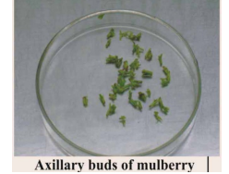 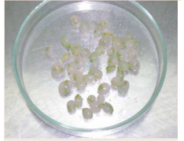 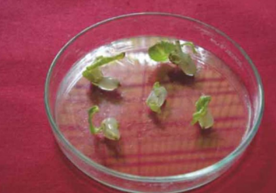

Axillary buds of mulberry Synthetic seeds of mulberry Germination of

synthetic seeds

**CRYOPRESERVATION OF GERMPLASM**

The high heterozygosity of mulberry makes conservation of its germplasm through seeds challenging, as the resulting progenies are highly heterogeneous and rarely true-to-type (Kumar *et al.,* 2015). Therefore, *ex-situ* conservation is commonly done in field gene banks which is labor-intensive, costly and susceptible to damage from natural disasters, pests and diseases (Soneji & Rao, 2014). To address these challenges, safer and more economically viable alternatives are being explored. Cryopreservation offers a promising option where plant materials are stored at ultra-low temperatures (−196 °C) in liquid nitrogen. At this temperature, all metabolic processes including cell division are halted, allowing the material to remain viable and genetically stable over long periods (Reed, 2008; Soneji & Rao, 2014).

Cotyledonary, leaf, hypocotyl and shoot-tip explants of mulberry (*Morus alba* L.), derived from embryos cultured with benzyladenine (BA), were induced to form adventitious shoots when cultured in media containing high BA with or without a low concentration of naphthaleneacetic acid (NAA). The adventitious shoots formed at the basal cut ends of the cotyledons and leaves. Histological analysis of the explants showed a wound cambium at the base of the bud primordia. In addition to adventitious buds, shoot-tip explants also produced axillary buds. Higher levels of NAA in the medium completely nullified the effectiveness of BA. Elongation of the buds was achieved by gradual reduction of BA in the medium. Plantlets were regenerated by inducing root formation on the shoots with indole-3-butyric acid (Kim *et al*., 1985).

**Studies on Tissue Culture Techniques in Mulberry:**

Bhau and Wakhlu (2001) reported that multiple shoots were initiated within two weeks from nodal and shoot tip explants of *Morus alba* cultivars (Chinese White, Kokuso-27, Ichinose) and *M. multicaulis* cultivars (Goshoerami, Rokokuyaso). Nodal explants were more responsive than shoot tips. Murashige and Skoog (MS) medium supplemented with 6-benzylaminopurine (BAP) was found most suitable for shoot induction. Explants collected between April and September showed better responses. Shoot multiplication was achieved by culturing nodal segments from in vitro-grown shoots on cytokinin-enriched medium, with sucrose identified as the most effective carbon source. Multiplication efficiency increased up to the 4th or 5th subculture. Rooting was induced on auxin-supplemented medium, and acclimatized plants were successfully established in the field.

A protocol for plant regeneration from leaf explants was developed for tropical mulberry varieties. Effect of sugars, 6-benzyladenine and genotype on shoot regeneration was studied. Highest percentage of shoot regeneration (80±6) was obtained with genotype $799 on medium containing glucose and 8.9 µM 6-benzyladenine. Genotypes Mandalaya and MIHP, having thicker leaves with waxy cuticle, showed poorer regeneration ability than S799 and Sujanpur-5, which have thinner leaves and cuticle. Histological studies revealed that shoots regenerated from sub-epidermal cells (Vijayan *et al*., 2000).

Vijayan *et* *al*. (2000) developed a regeneration protocol from leaf explants of tropical mulberry, examining the effects of sugar type, genotype, and 6-benzyladenine (BA). The highest regeneration rate (80 ± 6%) was observed in genotype S799 on glucose-containing medium with 8.9 µM BA. Genotypes with thinner leaves (S799, Sujanpur-5) responded better than those with thicker, waxy leaves (Mandalaya).

Sajeevan *et al*. (2011) developed an efficient protocol for mass propagation of mulberry using nodal segments. Multiple shoots were induced after 45 days on MS medium containing BAP (1.0 mg/l), TDZ (0.1 mg/l) and NAA (0.25 mg/l). Shoot elongation and bud proliferation were enhanced on MS medium supplemented with BAP, NAA, and GA₃ (0.5 mg/l). Rooting was successfully achieved on MS with IBA (0.5 mg/l), with or without activated charcoal. Hardened plantlets showed a 98% survival rate under greenhouse conditions, indicating the protocol's suitability for large-scale propagation and transgenic applications.

Chattopadhyay *et al*. (2011) evaluated the micropropagation potential of diploid and triploid cytotypes of mulberry variety S1 using axillary buds through organogenesis. Optimal shoot lengths of 4.8 cm (diploid) and 5.6 cm (triploid) were achieved with 8.8 μM and 4.4 μM 6-BAP, respectively. Regenerated shoots were rooted on auxin-supplemented media. Diploids exhibited more vigorous rooting than triploids. Maximum rooting in diploids (15 roots/shoot; 4.2 cm root length) occurred on MS medium with 4.0 μM NAA, while triploids showed 8.3 roots/shoot at 4.4 μM NAA after 21 days of culture.

Lalitha *et al*. (2014) evaluated the efficiency of three plant-derived gelling agents—corn flour, cassava powder, and arrowroot powder—as cost-effective alternatives to agar in the micropropagation of *Morus indica* L., S-1635. Among the tested treatments, corn flour (2.2% w/v) combined with low-dose agar (0.35% w/v) yielded the best in vitro shoot growth, showing shoot lengths comparable to those on agar alone. This combination also produced vigorous, healthy plantlets with a high survival rate (83.3%). The findings suggest that corn flour–based media can effectively replace agar, reducing micropropagation costs by up to 42.95%, thereby supporting low-cost tissue culture technology in developing countries.

Taha *et al*. (2020) developed an efficient and reproducible in vitro propagation protocol for various *Morus alba* cultivars. Optimal sterilization was achieved using 0.2% mercuric chloride for 10 minutes. Maximum shoot multiplication, shoot number, and shoot length were observed when explants were cultured on Murashige and Skoog (MS) medium supplemented with 1.5 mg/l BA. Rooting was most effective with 1 mg/l NAA, producing the highest number and length of roots. Successful acclimatization and hardening were achieved using a peatmoss:sand:perlite mixture (1:1:1:1 v/v), with survival rates reaching up to 90%. This protocol supports rapid, year-round propagation of true-to-type mulberry plants for large-scale cultivation.

Anis *et al*. (2023) reported successful in vitro regeneration and multiplication of *Morus alba* L. A high frequency of sprouting 80% from nodal and 70% from shoot tip explants along with shoot differentiation was observed in primary cultures on MS medium supplemented with BAP and Kn. Rapid shoot multiplication was achieved by culturing shoot tips and nodal explants on MS medium containing BAP (2 mg/l) and NAA (0.2 mg/l), which proved to be the most effective combination for multiple shoot formation. Further enhancement in shoot elongation and axillary bud sprouting was obtained by adding asparagine (25 mg/l) and glutamine (1 mg/l) to the same medium. Rooting was induced in about 80% of the shoots on MS medium supplemented with NAA (1.0 mg/l), and approximately 70% of the rooted plantlets successfully acclimatized to soil conditions.

**Future Perspectives:**

While significant progress has been made in applying tissue culture to mulberry, there remains vast potential for further research and development. Future efforts could focus on:

* Optimizing protocols for somatic embryogenesis and haploid production to improve efficiency and reproducibility
* Developing robust cryopreservation methods for long-term conservation of diverse mulberry germplasm
* Integrating tissue culture with molecular breeding tools, such as marker-assisted selection and genetic engineering, to accelerate the development of stress-resistant and high-yielding cultivars
* Exploring genome editing technologies such as CRISPR/Cas9, in combination with tissue culture to introduce precise genetic improvements
* Scaling up synthetic seed technology and automation of *in vitro* propagation systems to make them more cost-effective for commercial application

Continued research in these areas will further enhance the role of tissue culture in mulberry improvement, ensuring sustainable sericulture and contributing to rural livelihoods.

1. **CONCLUSION**

Tissue culture techniques have revolutionized mulberry propagation and improvement by enabling rapid, large-scale and disease-free production of true-to-type plants irrespective of season or genotype. Methods such as micropropagation, organogenesis, somatic embryogenesis, synthetic seed production and cryopreservation have successfully addressed many limitations of conventional propagation methods, such as low multiplication rates, genetic heterogeneity and susceptibility to pests and diseases. These biotechnological approaches not only support the sericulture industry by ensuring a reliable supply of high-quality planting material but also contribute to conserving valuable germplasm and developing improved cultivars with desirable traits.

1. **REFERENCES**
2. Ara, H., Jaiswal, U. & Jaiswal, V. S. (2013). Synthetic seed: prospects and limitations. *Current Science*, 104(8),1126–1134.
3. Asmeena Qadir, Shalini Aryan, Somagaini Pavankumar, Sumiya Afreen & Neha Sudan. (2024). An overview of tissue culture techniques for crop improvement in mulberry. *International journal of Research in Agronomy*, 7(8), 763-768.
4. Bajaj, Y. P. S. (1986). Biotechnology of tree improvement for rapid propagation and biomass energy production in tress: *Biotechnlogy in Agriculture and Forestry*, 1- 23.
5. Bharath Kumar, B. M., Chandana, H. S., Mili Gajendra Pusdekar, K., Mani Bharathi, B., Garai, I. & Shruthi, G. H. (2024). A study to analyse pros and cons of different propagation methods in mulberry (*Morus sp*.). *International Journal of Advanced Biochemistry Research*, 8(9), 28-32
6. Bhau, B. S. & Wakhlu, A. K. (2003). Rapid micropropagation of five cultivars of mulberry. *Biologia Plantarum*, 46(3), 349-355.
7. Bonga, J. M. (1987). Clonal propagation of mature trees: problems and possible solutions. *Cellular and Molecular Life Sciences*, 43, 1031–1038.
8. Chattopadhyay, S., Doss, S. G., Halder, S., Ali, A. K. & Bajpai, A. K. (2011). Comparative micropropagation efficiency of diploid and triploid mulberry (*Morus alba cv. S1*) from axillary bud explants. *African Journal of Biotechnology*, 10(79), 18153-18159.
9. Chauhan, S. S., Thomas, E. & Devarumath, R. M. (1984). In vitro production of gynogenic haploids in mulberry (*Morus* spp.). *Indian Journal of Sericulture*, 23(2), 31–35.
10. Chowdary, N. B. & Bindaroo, B. (2013). Causes for poor rooting of mulberry cuttings.The Hindu, p. 4.
11. Desai, P., Desai, S., Rafaliya, R. & Patil, G. (2022). Plant tissue culture: Somatic embryogenesis and organogenesis. Advances in Plant Tissue Culture. *Academic Press*, 109-130.
12. Guha, S., & Maheshwari, S. C. (1964). In vitro production of embryos from anthers of *Datura*. *Nature*, 6(5), 204-497.
13. Gupta, P, K. (1988). Advances in biotechnology of conifers. *Current Science*. P. 629-637.
14. Hossain, M., Rahman, S. M., Zaman, A., Joarden, O. I. & Islam, R.(1991). Effect of Nature of Explant and pH on *In-vitro* Propagation of Some Mulberry Genotypes. Bulletin of Sericulture Research, 2,13-22.
15. Hussey, G. (1978). The application of tissue culture to the vegetative propagation of plants. *Science Progress,* 65 (258),185–208.
16. Islam, R., Saha, S. & Rahman, M. S. (2012). In vitro clonal propagation of mulberry (*Morus alba* L.) through nodal explants. *Plant Tissue Culture and Biotechnology*, 22(1), 65–71.
17. Kasha, K. J., & Maluszynski, M. (2003). Production of doubled haploids in crop plants. *An introduction*. Kluwer Academic Publishers. 8, 1-10
18. Kavyashree, R., Bhagwat, K. A., & Thippeswamy, T. (2001). Somatic embryogenesis and plant regeneration in mulberry (*Morus indica* L.). *Sericologia*, 41(1), 99–106.
19. Kim, H. R., Patel, K. R. & Thorpe, T. A.(1985). Regeneration of mulberry plantlets through tissue culture. *Botanical Gazette*, 146(3), 335-340.
20. Lalitha, N., Devi, L. M., Banerjee, R., Chattopadhyay, S., Saha, A. K. & Bindroo, B. B. (2014). Effect of plant derived gelling agents as agar substitute in micropropagation of mulberry (Morus indica L. cv. S-1635). *International Journal of Advanced Research*, 2(2), 683-690.
21. Murashige, T. & Skoog, F. (1962). A Revised Medium for Rapid Growth and Bioassays with Tobacco Tissue Cultures. *Physiologia Plantarum*, 15, 473- 497.
22. Ohyama, K. (1970). Tissue Culture in Mulberry Tree. *Japan Agriculture Research Quarterly*, 5, 30-34.
23. Redenbaugh, K., Paasch, B., Nichol, J., Kossler, M., Viss, P., & Walker, K. (1986). Somatic seeds: encapsulation of asexual plant embryos. *Nature Biotechnology*, 4(9), 797–801.
24. Sajeevan, R.S., Singh, S.J., Nataraja, K.N. & Shivanna, M.B., (2011). An efficient in vitro protocol for multiple shoot induction in mulberry, *Morus alba* L variety V1. *International Research Journal of Plant Science*, 2(8), 254-261.
25. Sastri, B. N., Singh, P., & Sastry, K.S. (1983). In vitro anther culture in mulberry. *Current Science*, 52, 1123–1124.
26. Shajahan, A., Kathiravan, K. & Ganapathi, A.( 1995). Induction of embryo-like structures by liquid culture in mulberry (*Morus alba* L.). *Japanese Journal of Breeding*, 45(4),413-417.
27. Sharma, T. R., Sharma, R. K. & Sharma, A. K. (2010). Synthetic seed technology in mulberry. In: *Biotechnology and Sericulture*, Central Silk Board, Bangalore, pp. 67–75.
28. Suraksha Chanotra, S. (2019). Role of biotechnology in mulberry improvement. *Journal of Pharmacognosy and Phytochemistry*, 1,1126-1129.
29. Taha, H., Ghazy, U. M., Gabr, A. M. M., El-Kazzaz, A. A. A., Ahmed, E. A. M. M. & Haggag, K. M. (2020). Optimization of in vitro culture conditions affecting propagation of mulberry plant. *Bulletin of the National Research Centre*, 44(1), 60.
30. Taha, R. M., Wafa, M. I., & Mohd, W. W. (2020). Vegetative propagation techniques in mulberry: A review. *Agricultural Reviews*, 41(3), 221–228.
31. Thirugnanakumar, S., Ramalingam, S. & Ramesh, M. (2001). Soma clonal variation in micro propagated mulberry (*Morus* spp.) plants. *Plant Cell, Tissue and Organ Culture*, 66(3), 287-293.
32. Thorpe, T. A. (2007). History of plant tissue culture. *Molecular biotechnology*, 37(2), 169-180.
33. Tiku, A. R., Khurana, P. & Sharma, T. R. (2021). Advances in mulberry improvement: genomics and biotechnological interventions. *Biotechnology in Tree Crops*, 4, 441-449.
34. Tiku, A. R., Thomas, T. D. & Razdan, M. K.( 2021). Plant tissue culture in mulberry improvement. In: Mulberry. *CRC Press*, p. 108-121.
35. Vijayan, K., Chakraborti, S. P. & Ghosh, P. D. (2004). Screening of mulberry (Morus spp.) for salinity tolerance through in vitro seed germination. *Indian Journal of Biotechnology*, 3, 47-51.
36. Vijayan, K., Chakraborti, S. P. & Sarkar, A. (2011). Biotechnological advances in mulberry (*Morus* spp.) improvement: Progress and prospects. *Tree and Forestry Science and Biotechnology*, 5(1), 1–12.
37. Vijayan, K., Chakraborti, S. P. and Roy, B. N. (2000). Plant regeneration from leaf explants of mulberry: influence of sugar, genotype and 6-benzyladenine. *Indian Journal of Experimental Biology*, 38(5), 504-508.
38. Vijayan, K., Srivastava, P. P., Raghunath, M. K. & Saratchandra, B. (2011). Enhancement of stress tolerance in mulberry. *Scientia Horticulturae*, 129(4), 511-519
39. Yang, J. H. & X. H. Yang. (1989). Breeding of artificial triploids in mulberry. *Sericulture* *Science Japan,* 15, 65-70.