***Review Article***

**Human-wildlife interaction in India: a decade-long systematic review of trends, hotspots**

**Abstract**

Human-wildlife conflict (HWC) is a term often misunderstood, with most people restricting its use to the damage caused to humans and property by wildlife, rather than vice versa, thereby leading to a biased approach to its resolution. HWC is rising, primarily due to a growing human population and associated habitat destruction. The lack of critical analyses in the HWC challenge has resulted in inadequate and subpar responses. A systematic review of HWC across India is necessary to understand the trends, hotspots, and significant species involved, develop appropriate mitigation measures, and propose a policy-level framework to minimise its impact on humans and wildlife. For this review, approximately 246 papers from the past decade (2012–2022) were collected that mentioned HWC in their keywords. After screening the papers, 172 relevant papers published in 166 different journals were identified. Among those 172 papers, the majority of HWC-related documents have been published in Karnataka, followed by Kerala and West Bengal. The highest conflict species seems to be the elephant, followed by wild pigs and leopards. Other species involved in conflicts include the tiger, nilgai, and macaque. More focused research is needed on HWC to analyse every factor influencing the rise of HWC in India. More research is crucial as it emphasizes the importance of continuous learning and improvement in managing human-wildlife conflicts. Introducing an interdisciplinary approach involving multiple stakeholders is vital for effectively managing HWC in India.

Keywords: Human-Wildlife Conflict, Conservation, livestock depredation, crop damage, India

1. **Introduction**

The spread of civilisation and the rapid increase in the human population globally have exploited natural resources beyond tolerable levels. This has further escalated extinction and threatened several species and their ecosystems (Gomez *et al.,* 2021). It is known that humans have evolved and emerged by fighting with different species for survival. However, we have arrived at a time when we cannot escape coexisting with wildlife anymore, which demands us to explore various angles of human-wildlife coexistence (Jolly *et al*., 2022; Pooley *et al.,* 2020). HWC requires an interdisciplinary approach that encompasses understanding human thoughts and behaviours, as well as social psychology, among other areas of focus (Teel *et al*., 2022). An interdisciplinary approach is crucial, emphasising the importance of collaboration and understanding the various aspects of human-wildlife conflicts. Humans and animals have interacted negatively with increased dependence on natural resources, especially near protected areas (Prasad *et al.,* 2020). Wild animals dispersing from secure regions cause conflicts with the local community (Turner *et al.,* 2022). They wander into human habitats and raid or damage crops, attack or kill livestock, and damage properties, among other actions. On the other hand, humans also engage in retaliatory killing of wildlife, which endangers both wildlife and humans (Sharma *et al.,* 2021). Furthermore, the rapid change in land cover, driven by human influence and response, especially in developing countries, causes habitat fragmentation within natural habitats. This fragmentation restricts the movement of free-ranging large-bodied mammals, E.g., elephants, leopards and tigers, resulting in all sorts of human-animal conflicts which further wreak havoc on the livelihoods of local communities (Karanth, 2017: Mandal *et al*., 2021). The encroachment of natural areas for agricultural purposes, settlements on the fringes of forest areas threaten ecological sustainability of wild animals’ habitat, resulting in extreme pressure and competition for resources (Billah, 2021).

India has a total forest cover of 7,13,789 km², accounting for 21.71% of the country’s geographical area (FSI 2021). Forest types, ranging from tropical evergreen to dry deciduous forests, support a diverse array of endemic fauna and flora. However, forest resources are also being utilised to improve the economic status of the local population. Many buildings and high infrastructure, such as roads and flyovers, are being constructed for better connectivity, which eventually reduces forest cover. This invariably leads to forest fragmentation and the loss of the priceless gene pool, and also causes disturbance to free-ranging wild animals in their natural habitat. This, in turn, escalates into negative human-animal interactions (Desai *et al.,* 2021).

Human-wildlife conflict is one of the major issues that policymakers and conservationists find challenging to address to arrive at lasting solutions. These issues have led to the extinction and decline of numerous abundant species worldwide (Sime *et al.,* 2022). HWC has become an essential aspect of conservation these days. To achieve conservation goals in a comprehensive manner, we must address human-wildlife conflicts from a socio-ecological perspective, encompassing cultural, political, geographical, and wildlife considerations. Conservation and human welfare are like two sides of a coin; focusing on one thing without complementing the other is not productive. Hence, it is essential to understand the root cause of such conservation issues and develop scientific management solutions to minimise their impact. Before understanding and applying new techniques that can help reduce the HWC to some extent, it is necessary to understand the driving force behind the rising HWC cases in India. The major driving force towards HWC would be an increase in human population, and to accommodate them, forest cover and other habitats are being reduced, leaving wildlife with the only option to interact with humans for survival. People living near wildlife habitats are more vulnerable due to their livestock, which attracts predators, and the nutritious crops they grow, which attract crop raiders (Sharma *et al*., 2021).

This review focuses on a varied range of data analysis that showcases the HWC studies conducted across Indian states, the species involved, types of conflicts, the yearly number of studies, and the connectivity of keywords in India over the past decade. Overall, this review is a small effort to understand the trends and identify research gaps for reducing HWC and management issues across India.

1. **Materials and Methods**

We conducted a comprehensive review of published articles related to HWC in India. We used search engines such as ScienceDirect (www.sciencedirect.com), Web of Science (www.webofscience.com), and Google Scholar (www.scholar.google.com). We focused on studies conducted across India over the past decade, from 2012 to 2022. These included keywords such as human-wildlife conflict, wildlife, animal, crop depredation, crop loss, crop raiding, crop damage, livestock depredation, and livestock mortality. Other keywords and phrases, such as a human attack, retaliatory killing, human-leopard conflict, human-elephant conflict, and human-wild pig conflict, were also used. The screening of abstracts was the first step in selecting research papers for inclusion in this review. Further, the articles were collected for India and categorised accordingly to achieve each objective. The publications were limited to journal articles. Additionally, we used a spreadsheet to enter data chronologically and organise it into authors, year of publication, species, type of conflict, states, etc. The articles with multiple species records were assigned to each species category separately.

**2.1. Analysis**

We mapped conflict zones based on literature articles and categorised the number of studies state-wise. We converted that data into spatial data and plotted it in the India state shape files. We classified the conflicts into high and low categories based on the conflict studies reported across the country. The highly categorised states across the country are considered high-conflict zones. Based on the years of publications, we created a graph of year-wise studies, which illustrates the temporal pattern of HWC studies conducted in India. We prepared a bar graph showing the relationship between the number of studies and the distribution of conflict species. We categorised types of conflicts into animal death/injury, crop damage, human death/injury, and livestock/property damage, and quantified the number of species involved in each conflict. To visualise and construct a bibliometric network, we used VOSviewer (<https://www.vosviewer.com>). In this figure, we imagined the frequency of keywords to understand the most focused area of research related to HWC in India. The lines in the graph indicate the connectivity of the keywords, and the intensity of the link provides the number of articles that used similar keywords. We used RStudio (version 2022.07.1) to perform all the other mentioned analyses, utilising the ggplot2 package.

1. **RESULTS**

***3.1. Spatial and temporal pattern***

In this systematic review, the highest number of studies were found to be published in states such as Karnataka (9.02%), Kerala (8.27%), West Bengal (7.89%), Tamil Nadu (7.51%) and Uttarakhand (7.51%). Moderate studies were published from states such as Assam (6.39%), Madhya Pradesh (6.01%), Odisha (5.61%), Jammu and Kashmir (5.63%), Rajasthan (5.26%), Himachal Pradesh (4.13%) and Maharashtra (3.75%). Few studies were published in states such as New Delhi (0.37%), Meghalaya (0.37%), and Mizoram (0.37%), among others (Fig. 1).

The temporal graph indicated that more studies were published in 2018. Due to the COVID situation, there was a sharp decline during 2019-20, and after 2020, there was a sharp increase (Fig 2).

* 1. ***Biological components***

From the generated data, we found that 100 species were recorded as being involved in HWC. These include mammals, reptiles, rodents, birds, and other animals. Elephants (n=94), wild pigs (n=65), leopards (n=63), and tigers (n=42) are found to be the most conflict species, whereas Indian grey mongoose (n=1), hog deer (n=1), spotted deer (n=1), etc., are the most minor conflict species (fig 3).

Of those 100 species, 45 were involved in crop damage, 34 caused livestock depredation and property damage, 24 involved human killing/ injury or attacks, and eight involved animal death/ injury (fig 4). Elephants were found to be involved in almost all types of conflicts.

* 1. ***Bibliometric network analysis***

The bibliometric network analysis revealed that 161 keywords were frequently used. Out of these, the keyword "India" was repeated 93 times, "HWC" 78 times, "conservation" 53 times, "Western Ghats" 37 times, and "compensation" was repeated 37 times. Among those keywords, carnivores such as leopard and tiger were repeated 57 and 50 times, respectively. In the type of conflict terms, such crop damage was mentioned 29 times, livestock depredation 20 times, crop raiding 13 times, elephants 28 times and human casualties were repeated six times, etc. [fig 5]

Compared to keywords with low occurrence, frequently occurring keywords, such as India, have high link strength. HWC, compensation, conservation, wildlife, and mitigation were among the top keywords with high link strength.

* 1. ***Conflict type***

Crop damage is the most prevalent conflict type, followed by livestock attacks and property damage. The studies report moderate human deaths/ injuries. Very few studies reported animal deaths/injuries. Elephants, bears, leopards, and wild pigs are found to be involved in all types of conflicts. Other species, such as tigers, gaurs, macaques, jackals, and wolves, reportedly involve at least three types of disputes (supplementary table 1).

1. **Discussion**

The review identifies felids as a significant family involved in HWC in India. Conflict with humans affects 75% of the world’s Felidae species, and the severity increases with their body masses (Ranade *et al.,* 2015). Due to their more extensive habitat range and dietary preferences, felids are mainly involved in conflict with humans (Inskip and Zimmermann, 2009). They mostly conflict with humans while attacking livestock (Garrote *et al.,* 2012). To prevent felid attacks on livestock, retaliation of the affected people causes death or injuries to these species. This has posed several threats to numerous endangered felid species (e.g., tigers and leopards). Among the felids, leopards have been studied most extensively for conflicts in India. They have adapted to live in the forest fringes of India due to their behavioural plasticity and wide range of dietary choices, which often leads them to enter human habitats in search of food and become involved in conflicts (Athreya *et al.,* 2013). Leopard conflicts have a long history in India, and during the 20th century, reports emerged of leopard attacks on humans, with some leopards being killed as man-eaters (Naha *et al.,* 2020). The second most studied species is the tiger. There is a negative attitude towards tiger conservation across the states due to their involvement in livestock depredation and human attacks. This has reduced local people’s support and help towards tiger conservation (Goodrich, 2010). The well-managed protected areas provide sufficient food and shelter; however, young tigers disperse to human-dominant landscapes in search of territories, and older or wounded tigers become involved in conflicts. Worldwide, field human conflict is the most urgent conservation problem, yet the effort to synthesise its knowledge is less (Inskip and Zimmermann, 2009).

Elephantidae is the second-highest family studied in India for HWC. Studies have found that elephant conflicts occur due to the expansion of human settlements and agricultural fields across Asia and Africa, as well as the loss of natural forests and habitat fragmentation (Shaffer *et al.,* 2019). Globally, Sri Lanka had the highest elephant fatality and the second highest number of human deaths (Prakash *et al.,* 2020). According to the Project Elephant Census 2017, India is home to 29,964 elephants, the largest in Asia. With increasing human population densities, elephants and people are forced to share land and resources, leading to frequent and often fatal conflicts. In India, only 22 per cent of elephant habitat is found within our protected area network – the remaining elephant range lies outside, in places now overrun by people (Chartier *et al.,* 2011). Elephants are involved in crop raiding, property damage, house damage, injuries, and human deaths (Gubbi, 2012). Apart from that, poaching is also a significant conflict for elephant conservation in India.

Wild pigs are the most studied conflict species, second only to elephants. They are distributed across all the states of India. The population of feral pigs is increasing as they are prolific breeders and breed throughout the year (Senthilkumar, 2016). Crop damage is the most severe issue reported in human-wild pig conflict studies, and it primarily occurs in areas adjacent to the forest boundary (Milda *et al.,* 2022). Other species, such as deer, are also studied in conflict and observed to be more involved in crop damage. Crops and fruit orchards are often raided by wild ungulates, primates, granivores and frugivorous birds, which cause damage to both food crops and young shoots of other crops and plantations (Manral *et al*., 2016). These types of conflicts often lead to substantial economic losses, and as a result, there is an increase in a negative attitude towards protecting these wild animals.

1. **Conclusion**

This article comprehensively analyses HWC in India, highlighting the significant impact on felids, elephants, and wild pigs. It emphasizes that felids, particularly leopards and tigers, frequently conflict with humans due to livestock depredation and habitat encroachment. The study also notes the severe consequences of these conflicts, including retaliatory killings that threaten endangered species. Elephants are similarly involved in conflicts, often due to habitat fragmentation and human encroachment, leading to crop raiding and human fatalities. Wild pigs are another major source of conflict, causing extensive crop damage across India.

The research underscores the need for more studies in less-researched states despite the higher HWC studies in Karnataka, Kerala, and West Bengal. It identifies critical areas for further investigation, including animal deaths due to retaliatory actions and poaching, which require more attention. The temporal analysis of published research articles over the past decade shows an increasing focus on HWC, reflecting growing awareness and concern among conservationists and researchers in India.

Effective HWC management requires a multifaceted approach that involves policy-making, conservation education, legal enforcement, and the management of economic and natural resources. The article advocates for prioritising conservation education and awareness among local and tribal communities, emphasising the importance of understanding ecosystem services and promoting sustainable forest use. The ultimate goal is to balance human needs with wildlife conservation, ensuring coexistence and mitigating conflicts for the benefit of both humans and wildlife.

**References**

Mandal M. and Chatterjee N.D. (2021). Spatial alteration of fragmented forest landscape for improving structural quality of habitat: a case study from Radhanagar Forest Range, Bankura District, West Bengal, India. *Geology, Ecology, and Landscapes*, *5*(4), 252–259.

Gomez L., Wright B., Shepherd C.R. and Joseph T. (2021). An analysis of the illegal bear trade in India. *Global Ecology and Conservation*, *27*, e01552.

Pooley S., Bhatia S. and Vasava A. (2020) Rethinking the study of human-wildlife coexistence.

Jolly H., Satterfield T., Kandlikar M., Tr S. Indigenous insights on human-wildlife coexistence in southern India. Conserv Biol. 2022 Aug 24: e13981.

Prasad S., Singh D.K. and Choudhary S.K. (2020). Residential Population Structure and Abundance of Nilgai, Boselaphus tragocamelus, (Pallas) in Bihar, India. *Current Journal of Applied Science and Technology*, *39*(13), 110-117.

Karanth K.K. and Kudalkar S. (2017). History, Location, and Species Matter: Insights for Human-Wildlife Conflict Mitigation from India. *Human Dimensions of Wildlife*, *22*(4), 331–346.

Teel T.L., Adams M., Don Carlos A.W., Bonnell M.A. and Breck S.W. (2022). A Mixed-Methods Social Psychology Application Evaluating the Role of Citizen Science in Mitigating Human-Wildlife Conflict. *Society and Animals*, *205*(6178).

Turner W.C., Périquet S., Goelst C.E., Vera K.B., Cameron E.Z., Alexander K.A., Belant J.L., Cloete C.C., du Preez P., Getz W.M., Hetem R.S., Kamath P.L., Kasaona M.K., Mackenzie M., Mendelsohn J., Mfune J.K.E., Muntifering J.R., Portas R., Scott H.A., Strauss W.M., Versfeld W., Wachter B., Wittemyer G., Kilian J.W. (2022). Africa’s drylands in a changing world: Challenges for wildlife conservation under climate and land-use changes in the Greater Etosha Landscape. *Global Ecology and Conservation*, *38*, e02221.

Sharma P., Chettri N. and Wangchuk K. (2021). Human-wildlife conflict in the roof of the world: Understanding multidimensional perspectives through a systematic review. *Ecology and Evolution*, *11*(17), 11569-11586.

Billah M. M., Rahman Md.M., Abedin J. and Akter H. (2021). Land cover change and its impact on human-elephant conflict: a case from Fashiakhali forest reserve in Bangladesh. *SN Applied Sciences*, *3*(6), 649.

Desai S., Talluri H. and Dharaiya N. (2021). An assessment of farmers’ attitudes towards crop damage by wildlife and its prevention methods in the arid landscape of Gujarat. 42, 52–60.

Ahmed R.A., Prusty K., Jena J., Dave C., Das S.K.R., Sahu H.K., Rout S.D. (2012). Prevailing Human Carnivore Conflict in Kanha-Achanakmar Corridor, Central India.

Suryawanshi K.R., Bhatnagar Y.V., Redpath S. and Mishra C. (2013), People, predators and perceptions: patterns of livestock depredation by snow leopards and wolves. J Appl Ecol, 50: 550-560.

Beisner B.A., Heagerty A., Seil S.K., Balasubramaniam K.N., Atwill E.R., Gupta B.K., Tyagi P.C., Chauhan N.P., Bonal B., Sinha P. and McCowan B. (2015). Human-wildlife conflict: Proximate predictors of aggression between humans and rhesus macaques in India. Am. J. Phys. Anthropol., 156: 286-294.

Govind S. and Jayson E. (2016). *Crop damage by wild animals in Thrissur District, Kerala, India*.

Rao V.V., Naresh B., Reddy V.R., Sudhakar C., Venkateswarlu P. and Rao D.R. (2015). Traditional management methods used to minimize wild boar (Sus scrofa) damage in different crops at Telangana state, India. *International Journal of Multidisciplinary Research and Development*, *2*(2), 32–36.

Mishra S., Sethy J. and Bisht H. (2015). *Study on Human-Elephant Conflict in Baripada Division of Mayurbhanja, Odisha, India*.

Senthilkumar K., Mathialagan P., Manivannan C., Jayathangaraj M.G., Gomathinayagam S. (2016). A study on the tolerance level of farmers toward human-wildlife conflict in the forest buffer zones of Tamil Nadu. Vet World. 2016 Jul;9(7):747-52.

Mukherjee N. (2016). A Brief Appraisal of HWC in Jalpaiguri and Alipurduar districts of West Bengal. *Int J Sci Res Pub*, *6*, 131–136.

Dharmaraj J. and Ramakrishnan B. (2017). People’s perception on human-elephant conflicts in Gudalur Forest Division, Tamilnadu. *International Journal of Advanced Research in Biological Sciences*, *4*(11), 55–65.

Kumara V. and Diandra L. (2018). Study on human‐macaque conflict in the Hosanagara taluk of Shivamogga district, Karnataka. *International Journal of Life Sciences*, *6*, 605–614.

Balodi K.N. and Anwar M. (2018). Community Attitude and Religious Bonding in Human-Wildlife Conflict Mitigation: A Study of Kilpura-Khatima-Surai Corridor, Terai Arc Landscape, India. *Asian Journal of Environment & Ecology*, *7*, 1–13.

Nair R.P. and Jayson E.A. (2019). Occurrence of the Indian Crested Porcupine (Hystrix indica Kerr. 1792) and the Damage on Plantation Crops in the Nilambur Forest Divisions of Southern Western Ghats, Kerala, India. *Agricultural Science Digest-A Research Journal*, *39*(4), 301–305.

Srivathsa A., Puri M., Karanth K.K., Patel I., Kumar N.S. (2019) Examining human – carnivore interactions using a socio-ecological framework: sympatric wild canids in India as a case study. R. Soc. open sci. 6: 182008.

Bharali K., Bordoloi K., Singha K., Sahariah D., Sharma D. and Singh Y. (2020). Identification of Human-Leopard Conflicts, Conservation Threats and Habitat Suitability in the Urban Landscapes of Guwahati City, Assam, India using Field-based and Geospatial Techniques. *International Journal of Advanced Science and Technology*, *29*, 4064–4073.

Naik M.I., Basavadarshan A.V., Boraiah B., Harsha H.K. (2020). Impact of human-animal conflict on farming in and around the protected areas of Savanadurga (Magadi), Karnataka. J Entomol Zool Stud 2020;8(5):266-274.

Maheshwari A., Kumar A.A. and Sathyakumar S. (2021). Assessment of changes over a decade in the paterns of livestock depredaton by the Himalayan Brown Bear in Ladakh, India. Journal of Threatened Taxa 13(7): 18695–18702.

Islary M., Biswas S. and Nautiyal S. (2021). India in Twenty First Century: Human Wildlife Conflicts Still Unsolved. *Journal of Human Ecology (Delhi, India)*, *76*, 23–31.

Das G., Selvan K., Lahkar B. and Gopi G.V. (2022). Effectiveness of physical barriers in mitigating human– elephant negative interactions in North-East India. Front. Conserv. Sci. 3:956568.

Majumder R. (2022). Human-elephant conflict in West Bengal, India: present status and mitigation measures. *Eur J Wildl Res* **68**, 33.

Sime D., Siraj Z., Teklemariam A. and Tilahun B. (2022). Human-Wild Animals Conflict in and around Amba Forest, Ezha District, Gurage Zone, Southern Ethiopia. *International Journal of Zoology*, *2022*, 7002645.

Ranade P., Londhe S., Mishra A. and Bhatnagar P. (2015). Geo-informatics approach to human-leopard conflict in urban forest areas case review of Sanjay Gandhi National Park (SGNP), Borivali, Mumbai. *International Journal of IT, Engineering and Applied Sciences Research*, *4*(3), 12–15.

Inskip C. and Zimmermann A. (2009). Human-felid conflict: A review of patterns and priorities worldwide. *Oryx,* *43*(1), 18-34.

Garrote G., López G., Gil-Sánchez J.M. *et al.* (2013). Human–felid conflict as a further handicap to the conservation of the critically endangered Iberian lynx. *Eur J Wildl Res* **59**, 287–290.

Bhatia S., Athreya V., Grenyer R. and Macdonald D.W. (2013). Understanding the Role of Representations of Human–Leopard Conflict in Mumbai through Media-Content Analysis. *Conservation Biology*, *27*(3), 588–594.

Naha D., Dash S.K., Chettri A. *et al.* (2020). Landscape predictors of human–leopard conflicts within multi-use areas of the Himalayan region. *Sci Rep* **10**, 11129.

Chapron G., Miquelle D.G., Lambert A., Goodrich J.M., Legendre S. and Clobert J. (2008). The impact on tigers of poaching versus prey depletion. *Journal of Applied Ecology*, *45*(6), 1667–1674.

Zimmermann A., Baker N., Inskip C., Linnell J., Marchini S., Odden J., Rasmussen G. and Treves A. (2009). Contemporary Views of Human–Carnivore Conflicts on Wild Rangelands. In *Wild Rangelands: Conserving Wildlife while Maintaining Livestock in Semi-arid Ecosystems* (pp. 129–151).

Shaffer L.J., Khadka K.K., van den Hoek J. and Naithani K.J. (2019). Human-Elephant Conflict: A Review of Current Management Strategies and Future Directions. *Frontiers in Ecology and Evolution*, *6*.

Chartier L., Zimmermann A. and Ladle R.J. (2011). Habitat loss and human–elephant conflict in Assam, India: does a critical threshold exist? *Oryx*, *45*(4), 528–533.

Gubbi S. (2012). Patterns and correlates of human–elephant conflict around a south Indian reserve. *Biological Conservation*, *148*(1), 88–95.

Kumar K.S., Mathialagan P., Chinnaiyan M., Sankaralingam G. and Thangaraj M. (2016). HUMAN-ELEPHANT CONFLICT: CASE STUDY FROM TAMIL NADU. *International Journal of Science, Environment and Technology*, *5*, 445–448.

Milda D., Ramesh T., Kalle R., Gayathri V., Thanikodi M. and Ashish K. (2022). Factors driving human–wild pig interactions: implications for wildlife conflict management in southern parts of India. *Biological Invasions*.

Prakash T.G.S., Wijeratne A. and Fernando P. (2020). *Human-Elephant Conflict in Sri Lanka: Patterns and Extent*. *51*, 16–25.

Manral U., Sengupta S., Hussain S.A., Rana S. and Badola R. (2016). HWC in India:A Review of Economic Implication of Loss and Preventive Measures. **Indian Forester**, [S.l.], p. 928-940, oct. 2016.

Moher D., Stewart L. and Shekelle P. (2016). Implementing PRISMA-P: recommendations for prospective authors. *Systematic Reviews*, *5*(1), 1–2.

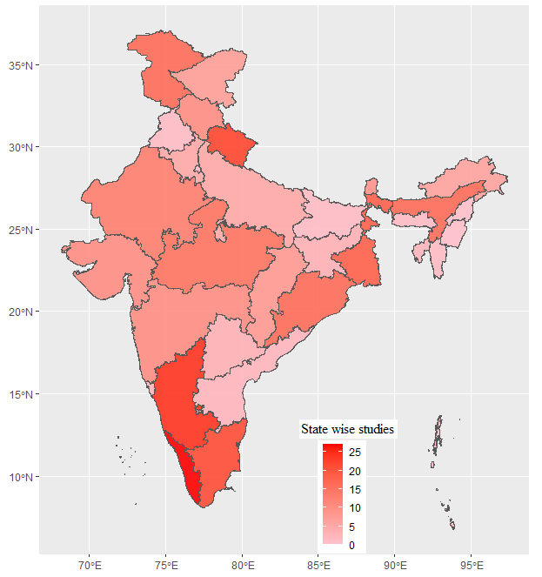

**Fig 1. Map showing the number of studies across Indian states**

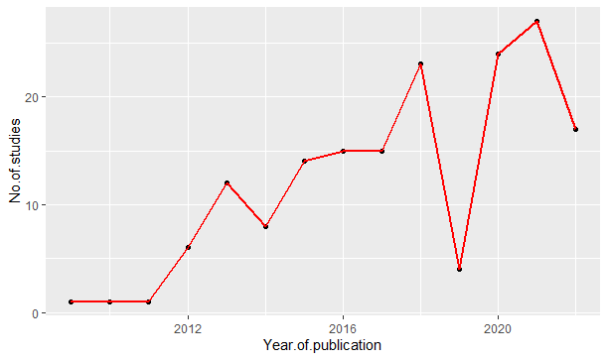

**Fig 2. Temporal pattern of studies on HWC in India**

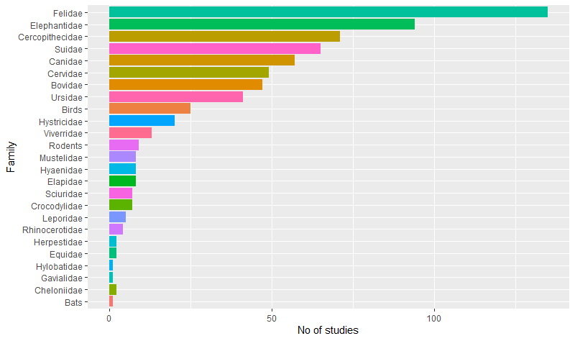

**Fig 3. Distribution of family-wise conflict species**

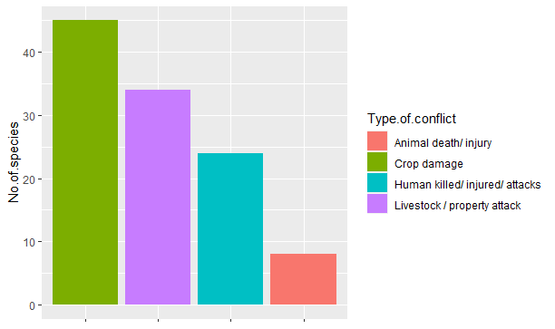

**Fig 4. Graph showing the type of conflicts of HWC**

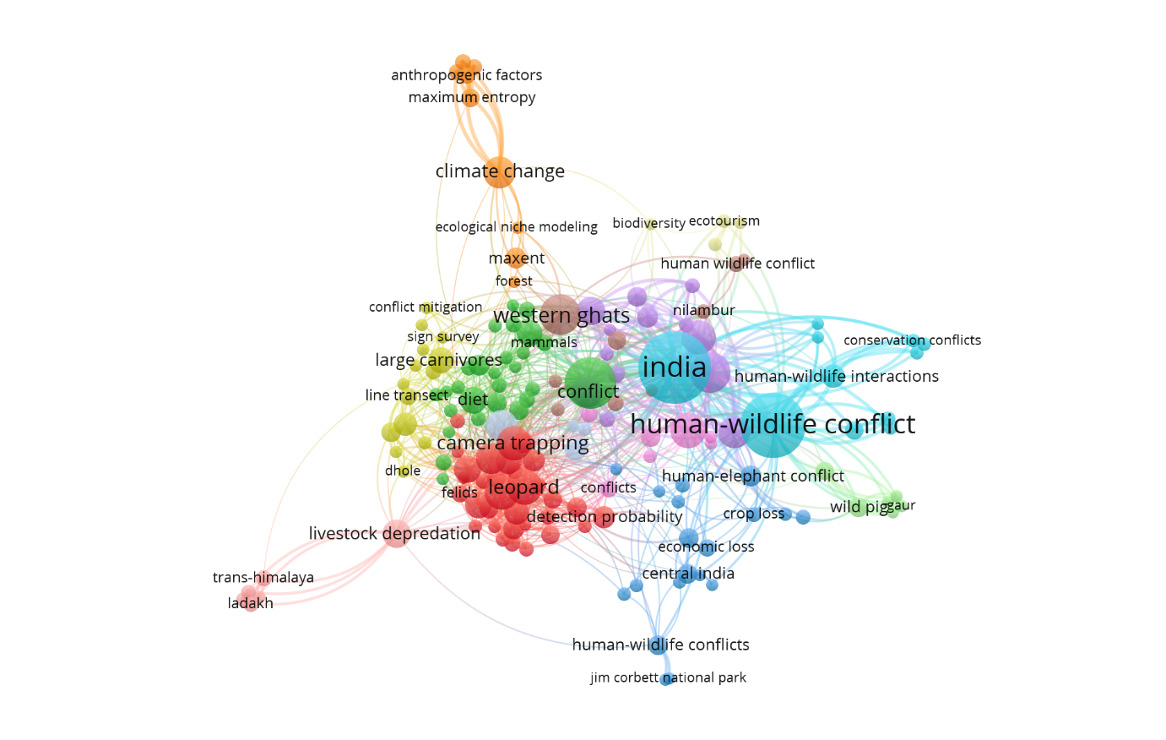

**Fig 5. VOSViwer network of keywords co-occurrence for HWC articles published in India.**

**Supplementary Table 1 shows the species involved, their IUCN status, the type of conflict, and the number of 415 articles published.**

|  |  |  |  |  |  |  |  |
| --- | --- | --- | --- | --- | --- | --- | --- |
| **Species** | | **IUCN status** | **Type of Conflict** | | | | **Number of articles that recorded the species** |
| **Common name** | **scientific name** | **animal death/ injury** | **Crop damage** | **livestock/property attack** | **Human killed/ injured/ attacks** |  |
| Elephant | Elephas maximus | Endangered | 12 | 52 | 13 | 28 | 58 |
| Gaurs | Bos gaurus | Vulnerable |  | 5 | 1 | 2 | 7 |
| Monkeys | NA | Na |  | 3 |  | 1 | 4 |
| Chital/ spotted deer | Axis axis | Least concern |  | 9 |  | 1 | 10 |
| Nilgai | Boselaphus tragocamelus | Least concern |  | 14 | 1 | 3 | 14 |
| Chinkara | Gazella bennettii | Least concern |  | 1 |  |  | 1 |
| Wild pigs | Sus scrofa | Least concern | 1 | 42 | 4 | 7 | 43 |
| Primates | NA | Na |  | 4 |  |  | 4 |
| Canids | NA | Na |  | 1 | 1 |  | 1 |
| Common leopards | Panthera pardus | Vulnerable | 2 | 2 | 38 | 22 | 46 |
| Snow leopard | Panthera uncia | Vulnerable |  |  | 5 | 1 | 5 |
| Lions | NA | Na |  |  | 1 |  | 1 |
| Tigers | Panthera tigris | Endangered | 1 |  | 24 | 9 | 26 |
| Ungulates | NA | Na |  |  |  |  | 1 |
| Cobra or snakes | NA | Na | 2 |  | 3 | 4 | 6 |
| Wild ass | Equus hemionus khur | Near threatened |  | 1 |  |  | 1 |
| Jackals | NA | Na |  | 6 | 8 | 2 | 10 |
| Wolves | Canis lupus Linnaeus | Least concern |  | 1 | 7 | 2 | 7 |
| Hyenas | Hyaena hyaena | Near threatened |  |  | 1 | 2 | 2 |
| Striped hyenas |  |  | 1 |  | 1 |
| Sloth bears | Melursus ursinus | Vulnerable | 1 | 4 | 2 | 10 | 11 |
| Black bears | Ursus thibetanus | Vulnerable |  | 3 | 2 | 4 | 5 |
| Barking deers | Muntiacus muntjak | Least concern |  | 4 |  |  | 5 |
| Porcupines | Hystrix indica | Least concern |  | 6 |  |  | 6 |
| Indian crested porcupine |  | 5 |  |  | 5 |
| Dhole or carnivore dogs | Cuon alpinus | Endangered |  |  | 7 |  | 7 |
| Macaques | NA | Na |  | 1 | 1 | 1 | 3 |
| Rhesus macaque | Macaca mulatta | Least concern |  | 9 |  | 1 | 9 |
| Bonnet macaque | Macaca radiata | Vulnerable |  | 7 | 1 | 2 | 8 |
| Northern plains langur | *Semnopithecus entellus* | Least concern |  |  |  |  | 1 |
| Sambar | Rusa unicolor | Vulnerable |  | 6 |  |  | 7 |
| Indian hare | *Lepus nigricollis* | Least concern |  |  |  |  |  |
| Civet cat (small indian civet) | Viverricula indica | Least concern |  | 1 | 3 |  | 4 |
| Common palm civet | Paradoxurus hermaphroditus | Least concern |  |  |  |  | 1 |
| Large indian civet | Viverra zibetha | Least concern |  |  |  |  | 1 |
| Goral | Naemorhedus goral | Near threatened |  |  |  |  | 1 |
| Birds | NA | Na |  | 3 |  |  | 3 |
| Brown bear | Ursus arctos | Least concern |  | 1 | 3 |  | 3 |
| Felids | NA | Na |  |  |  |  | 1 |
| Raptors | NA | Na |  |  |  |  | 1 |
| Himalayan black bear | Ursus thibetanus laniger | Vulnerable |  |  | 1 |  | 1 |
| Himalayan brown bear | Ursus arctos isabellinus | Critically endangered | 1 | 1 | 3 |  | 3 |
| Grey wolves | Canis lupus | Threatened |  |  | 1 |  | 1 |
| Crocodiles | NA | Na |  |  |  |  | 1 |
| Himalayan palm civet | NA | Na |  |  |  |  | 1 |
| Golden jackalas | Canis aureus | Least concern |  |  | 2 |  | 2 |
| Deers | NA | Na |  | 4 |  |  | 4 |
| Eagle | NA | Na |  |  |  |  | 1 |
| Eurasian jay | Garrulus glandarius | Least concern |  |  |  |  | 1 |
| White throated laughing thrush | Garrulax albogularis | Least concern |  |  |  |  | 1 |
| Clouded leopard | Neofelis nebulosa | Vulnerable |  |  | 1 |  | 1 |
| Jungle cat | Felis chaus Schreber | Least concern |  | 1 | 2 |  | 3 |
| Asiatic black bear | Ursus thibetanus | Vulnerable |  | 2 | 3 | 3 | 5 |
| Tibetan wolves | Canis lupus chanco Gray | Critically endangered |  |  |  |  | 1 |
| Indian fox/ bengal fox | Vulpes bengalensis | Least concern |  | 1 | 2 |  | 3 |
| Red fox | Vulpes vulpes | Least concern |  |  |  | 1 | 1 |
| Desert fox | Vulpes vulpes pusilla | Least concern |  |  |  |  | 1 |
| Rodents | NA | Na |  | 4 |  |  | 4 |
| Peacock | Pavo cristatus | Least concern |  | 2 |  |  | 2 |
| Vulture | NA | Na |  |  |  |  | 1 |
| Gharial | NA | Na |  |  |  |  | 1 |
| Rhinocerous | Rhinoceros unicornis | Vulnerable |  | 3 |  |  | 3 |
| Asian golden cat | Catopuma temminckii | Near threatened |  |  | 1 |  | 1 |
| Leopard cat | Prionailurus bengalensis | Least concern |  |  | 2 |  | 2 |
| Himalayan yellow throated marten | Martes flavigula | Least concern |  |  | 2 |  | 2 |
| Peafowl | Pavo cristatus Linnaeus | Least concern |  | 5 |  |  | 5 |
| Langur | NA | Na |  | 1 |  |  | 1 |
| Hanuman langur | Semnopitheaus entellus | Lower risk |  | 2 |  |  | 2 |
| Indian grey mongoose ( mongoose) | Urva edwardsii | Least concern |  |  | 2 |  | 2 |
| Indian/ malabar giant squirrel | Ratufa indica | Least concern |  | 2 |  |  | 2 |
| Indian giant flying squirrel | Petaurista philippensis | Least concern |  | 2 |  |  | 2 |
| Parakeet | NA | Na |  | 2 |  |  | 2 |
| Indian hare | Lepus nigricollis | Least concern |  | 3 |  |  | 3 |
| Barasingha or swamp deer | Rucervus duvaucelii | Vulnerable |  | 2 |  |  | 2 |
| Bats | NA | Na |  | 1 |  |  | 1 |
| Sarus crane | Grus antigone | Vulnerable |  |  |  |  | 1 |
| Myna | NA | Na |  |  |  |  | 1 |
| Assamese macaques | Macaca assamensis | Near threatened |  | 1 |  |  | 1 |
| Arunachal macaques | Macaca munzala | Endangered |  |  |  |  | 1 |
| Pig tailed macaques | Macaca leonina | Vulnerable |  |  |  |  | 1 |
| Golden langurs | Trachypithecus geei | Endangered |  |  |  |  | 1 |
| Long tailed macaques | Macaca fascicularis | Endangered |  |  |  |  | 1 |
| Eastern hillock gibbon | Hoolock leuconedys | Vulnerable |  |  |  |  | 1 |
| Black-footed grey langur | Semnopithecus hypoleucos | Least concern |  |  |  |  | 1 |
| Capped langur | Trachypithecus pileatus | Vulnerable |  |  |  |  | 1 |
| Tibetan macaques | Macaca thibetana | Near threatened |  |  |  |  | 1 |
| Green sea turtle | *Chelonia mydas* | Endangered |  |  |  |  | 1 |
| Saltwater crocodile | Crocodylus porosus | Least concern |  |  | 1 | 1 | 1 |
| Mugger crocodile | *Crocodylus palustris* | Vulnerable |  |  |  |  | 1 |
| Blackbuck | Antilope cervicapra | Least concern |  | 2 |  | 1 | 3 |
| 4 horned antelope/ chowsinga | Tetracerus quadricornis | Vulnerable |  |  |  | 1 | 1 |
| Himalayan goral | *Naemorhedus goral* | Near threatened |  |  |  |  | 1 |
| Jungle fowl | NA | Na |  |  |  |  | 1 |
| Assamese hare | NA | Na |  |  |  |  | 1 |
| Spotted dove | *Spilopelia chinensis* | Least concern |  |  |  |  | 1 |
| Smooth-coated otter | Lutrogale perspicillata | Vulnerable |  |  |  | 1 | 1 |
| Marbled cat | Pardofelis marmorata | Near threatened | 1 |  |  |  | 1 |
| Hog deer | Axis porcinus | Endangered |  | 2 |  |  | 2 |