***Original Research Article***

**Investigation of the Presence of Norovirus (GI, GII) and Hepatitis A virus with Real-Time RT-PCR test in Milk Cans of Small Family Enterprises that Selling Raw Milk†**

**ABSTRACT**

In this study, the presence of Norovirus GI, NoV GII and Hepatitis A Virus was investigated in milk cans where the milk of dairy cows aged 24 months and older were collected from small family enterprises selling raw milk in Burdur-Merkez. In the Real-Time RT-PCR analysis performed to determine the presence of NoV and HAV in milk samples taken from 100 small family enterprises selling raw milk in Burdur-Centre; 16% NoV GI, 12% NoV GII, 8% HAV positivity was detected. In the results obtained as co-infection; 4% NoV GI + NoV GII and 8% NoV GI + NoV GII + HAV were determined. The mean SCC in the milk obtained in the study was determined as 339.020+249.230.9. In this study, the mean SCCs of NoV GI, NoV GII and HAV positive samples were statistically lower than the mean SCCs of negative samples (*p<0,05*). The mean SCC of NoV GI positive samples was 225.375+60.018,9 (*p=0,005*), the mean SCC of NoV GII positive samples was 251.166,7+42.994,9 (*p=0,01*) and the mean SCC of HAV positive samples was 248.750+49.969,1 (*p=0,04*). It was concluded that the presence of NoV GI, NoV GII and HAV in milk did not affect SCC and could not be used as an indicator of viral presence in milk.

*Keywords:* Hepatitis A virus; Norovirus; Milk can; Raw milk; Real-Time RT-PCR.

**1. INTRODUCTION**

Dairy cattle farms are the most important reservoirs of foodborne pathogens. Food pathogens in milk are generally transmitted directly from the environment or as a result of contamination from extracts from the udder of the infected animal. The most important source of food pathogens in businesses is ruminant intestines. In addition, consumption of water and food infected with feces, excretions of other infected animals, direct contamination of milk jugs/tanks with feces during the collection of raw milk, presence of mastitis milk directly in milk, milking machines and milking practices, milk processing stages and post-pasteurization stages, presence of infected animals, contamination of pastures and living spaces by infected animals with their feces, contamination of milk jugs and tanks, consumption of unpasteurized milk and milk (cheese, etc.) by people, birds, rodents, pests, pet animals (cats and dogs) fed on the farm and other agents also play an important role in the transmission of bacteria, fungi, viruses and parasites. Raw milk tanks and jugs in dairy farms provide information about udder health, environmental pathogens, milk chemical residues and antibiotics [3,18,13]. Therefore, the biggest responsibilities of the dairy industry, large and small dairy farms globally, are to prevent the spread of foodborne diseases among human populations and to produce high quality and safe dairy products [12]. In this study, the presence of Norovirus (NoV) GI, NoV GII and Hepatitis A Virus (HAV) was investigated molecularly in the milk jugs where milk from dairy cows aged 24 months and above were collected in small family farms selling raw milk in Burdur-Center. Somatic Cell Count (SCC) was performed on the milk samples taken.

**2.MATERIALS AND METHODS**

**2.1. Experimental Units**

Milk production by small familial enterprises selling raw milk in Burdur-Central Milk samples were obtained from 40 kg milk jugs and placed in two 15 mL and 50 mL centrifuge tubes. To achieve this, 100 enterprises were sampled. Milk from cows aged 24 months or older was chosen. Number of cows in the enterprises was shown in the Figure 1. The milking and hygienic conditions in the enterprises where the sample was collected were also investigated. For this aim, a survey was undertaken in the establishments where sampling was done. It is located between 29º-24' and 30º-53' Eastern longitudes and 36º-53' and 37º-50' Northern latitude.

**Figure 1.** Number of cows in the enterprises

**2.2. Preparation of Milk Serum Samples**

Approximately 15 ml of milk samples were taken from milk jugs into sterile tubes, and 0.2 ml of rennin and 0.1 ml of saturated CaCl2 were added and incubated at 37oC for 1 hour. Then, it was centrifuged at 3000 rpm for 20 minutes and the cream layer was removed with the help of a spatula. Milk serum was collected using a Pasteur pipette. Milk serum samples were transferred to a sterile tube using a sterile pipette (approximately 1 ml), 5 ml of RNAfterTM (GeneMark, GMbiolab Co., Ltd., Taichung, Taiwan) solution was added and vortexed for 5 minutes. After these processes, the mixture was stored in the -300C deep freezer until test application. The other 50 ml milk samples taken into sterile tubes were used directly in somatic cell analysis on the same day.

**2.3. Preparation of Milk Serum Samples for RNA Extraction**

Milk serum samples collected under appropriate conditions (cold chain) and stored at -200C in RNAafterTM solution were thawed at room temperature. About 1 ml of milk sample was taken from the dissolved mixture using a sterile pipette. The milk sample taken was transferred to previously prepared sterile eppendorf tubes. Approximately 1 ml of Phosphate Buffer Solution (PBS) was added to these tubes. This new mixture in the eppendorf tubes were vortexed for 10 minutes. Then, the eppendorf tubes were centrifuged at 2500 rpm for 25 minutes at + 4 ºC. After centrifugation, 0.25 ml of the supernatants in the eppendorf tubes were taken and transferred to another sterile eppendorf tubes. After this stage, the RNA extraction protocol was started.

**2.4. RNA Extraction Protocol of Milk Serum Samples**

RNA extraction protocol was applied to detect the virus genome in milk serum samples. For this purpose, Foodproof Sample Preparation Kit IV (BIOTECON Diagnostic®, Potsdam, Germany) was used. The application was carried out according to the procedure reported by the company (BIOTECON Diagnostic®, Potsdam, Germany). According to this; 500 µl of milk serum and 2 ml of lysis buffer containing carrier-tRNA were added to the 13-15 ml reaction tube and vortexed for 15 seconds and then it was incubated at room temperature for 10 minutes. Brief centrifugation was performed at 7,000 x g for 10 seconds. 2 ml absolute ethanol was added into the same tube and vortexed for 15 seconds. Brief centrifugation was performed again at 7,000 x g for 10 seconds. 700 µl of treated milk serum was transferred to the upper chamber of the filtered collection tube using a pipette. Centrifugation was performed at 7,000 x g for 1 minute. The filtered collection tube was changed for the desired volume of sample and centrifugation was performed at 7,000 x g for 1 minute. The desired volume of milk serum was placed in a new filtered collection tube, 500 µl Washing Solution-I was added and centrifugation was performed at 7,000 x g for 1 minute. The milk serum obtained again was placed in a new filtered collection tube, 500 µl Washing Solution-II was added and centrifugation was performed at 20,000 x g for 3 minutes. The milk serum obtained here was placed in a new filtered collection tube and centrifuged at 20,000 x g for 1 minute. A filtered tube was placed in a clean 1.5 ml reaction tube, 60 µl Elution Buffer was added and incubated for 1 minute at room temperature. At the end of this period, centrifugation was performed at 7,000 x g for 1 minute. Finally, eluted RNA was obtained in a 1.5 ml reaction tube.

**2.5. Detection of NoV and HAV Genomes by Real-Time PCR**

Foodproof® Norovirus GI, GII plus Hepatitis A virus Detection Kit-5'Nuclease-(BIOTECON Diagnostic®, Potsdam, Germany) kits were used to detect NoV GI, GII and HAV in milk samples by Real-Time PCR method. For this purpose, firstly, a total of 15 µl of PCR mixture was prepared for each sample, including 14 µl of foodproof® Norovirus GI, GII plus Hepatitis A virus kit master mix and 1 µl of enzyme solution in a reaction tube. 10 µl of each RNA extraction sample was taken into a different reaction tube and 15 µl of the previously prepared PCR mixture was added. A total of 25 µl of mixture was prepared in the reaction tube of one sample. Additionally, 10 µl of Negative control was added to one of two different reaction tubes and 10 µl of Positive control was added to the other tube. The samples in all reaction tubes were transferred to PCR plates in the amount they contained, tightly covered with transparent foil, and centrifuged for a short time (10-15 seconds) in a suitable centrifuge device. The amplification phase was started in the Real-Time PCR device (BioRad, Cfx96™ Real-Time System C1000 Touch Thermal Cycler, USA) in accordance with the temperature-time program specified by the kit manufacturer. The prepared plate was placed into the device and the program was run. The temperature-time program specified by the kit manufacturer was applied: For reverse transcription, 1 cycle of 450C for 30 minutes, 1 cycle of 950C 5 minutes for pre-incubation and For amplification, 50 cycles were performed for PCR: 950C for 15 seconds as the first step, 600C for 60 seconds as the second step, and 720C for 10 seconds as the third step. The data obtained after the fluorescent reading of the amplification results on the device (BioRad, Cfx96™ Real-Time System) were evaluated according to the result evaluation table specified by the kit manufacturer.

**2.6. SCC Analysis**

Milk samples taken from the milk jugs (40 kg) of small family businesses selling raw milk in Burdur-Center into 50 ml centrifuge tubes were brought to Burdur Mehmet Ersoy University Scientific and Technology Application and Research Center (BİLTEKMER) under cold chain. Somatic cell count was performed on the Milk Analyzer device (Bentley 150, Infrared Milk Analyser, USA) on the same day. In this analysis, the Turkish Standards Institute's (TSE) Counting of Milk Somatic Cells, Electronic Particle Counter Method [23,24] procedures were taken into account.

**2.7. Statistical Analysis**

IBM SPSS version 15 software was used in the statistical analysis in the study. Descriptive analyzes were given using mean and standard deviation. The SCC averages of NoV GI, NoV GII and HAV positive milk samples were compared with Student-T test. Comparison of binary groups in the survey study was made with the Chi-square test. Cases with a P value below 0.05 were considered statistically significant.

**3. RESULTS**

In the Real-Time PCR analysis performed to detect the presence of NoV and HAV in milk samples taken from 100 small family businesses selling raw milk in Burdur-Center; 16% NoV GI, 12% NoV GII and 8% HAV positivity were detected (Table 1; Figure 2). Additionally, the results obtained as co-infection were determined as 4% NoV GI + NoV GII and 8% NoV GI + NoV GII + HAV (Figure 3; Figure 4). The results were evaluated according to the evaluation table provided by the test kit (Table 2). No statistically significant result was found between NoV GI, NoV GII, HAV positivity and number of animals (*p>0.05*).

**Table 1. NoV (GI, GII) and HAV positivity level in milk samples**

|  |  |  |  |
| --- | --- | --- | --- |
| **Type** | **Positive (%)** | **Negative (%)** | **Total** |
| HAV | 8 (8%) | 92 (92%) | 100 (100%) |
| NoV GI | 16 (16%) | 84 (84%) | 100 (100%) |
| NoV GII | 12 (12%) | 88 (88%) | 100 (100%) |

**Table 2. Result evaluation table according to the status of fluorescence wavelengths of FAM, HEX and ROX channels**

|  |  |  |  |  |
| --- | --- | --- | --- | --- |
| **FAM** | **HEX** | **ROX** | **Positive control (Cy5)** | **Interpretation of results** |
| + | + | + | + / - | HAV, NoV GI, NoV GII positive |
| - | + | + | + / - | NoV GI, NoV GII positive |
| + | - | + | + / - | HAV,NoV GII positive |
| + | + | - | + / - | HAV, NoV GI positive |
| - | + | - | + / - | NoV GI positive |
| + | - | - | + / - | HAV positive |
| - | - | + | + / - | NoV GII positive |
| - | - | - | + | HAV, NoV GI, NoV GII negative |
| - | - | - | - | Invalid |

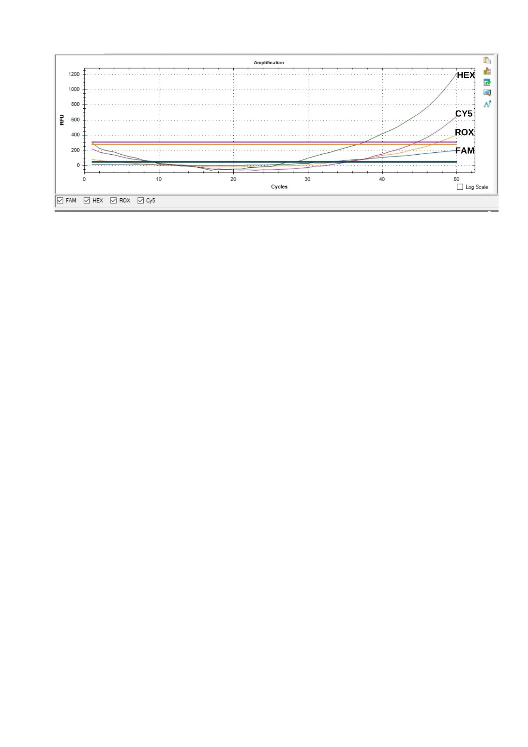

**Figure 2.Real-Time PCR results (NoV GI positive)**

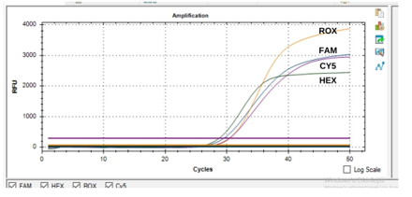

**Figure 3.Real-Time PCR results (HAV + NoV GI+ NoV GII positive)**

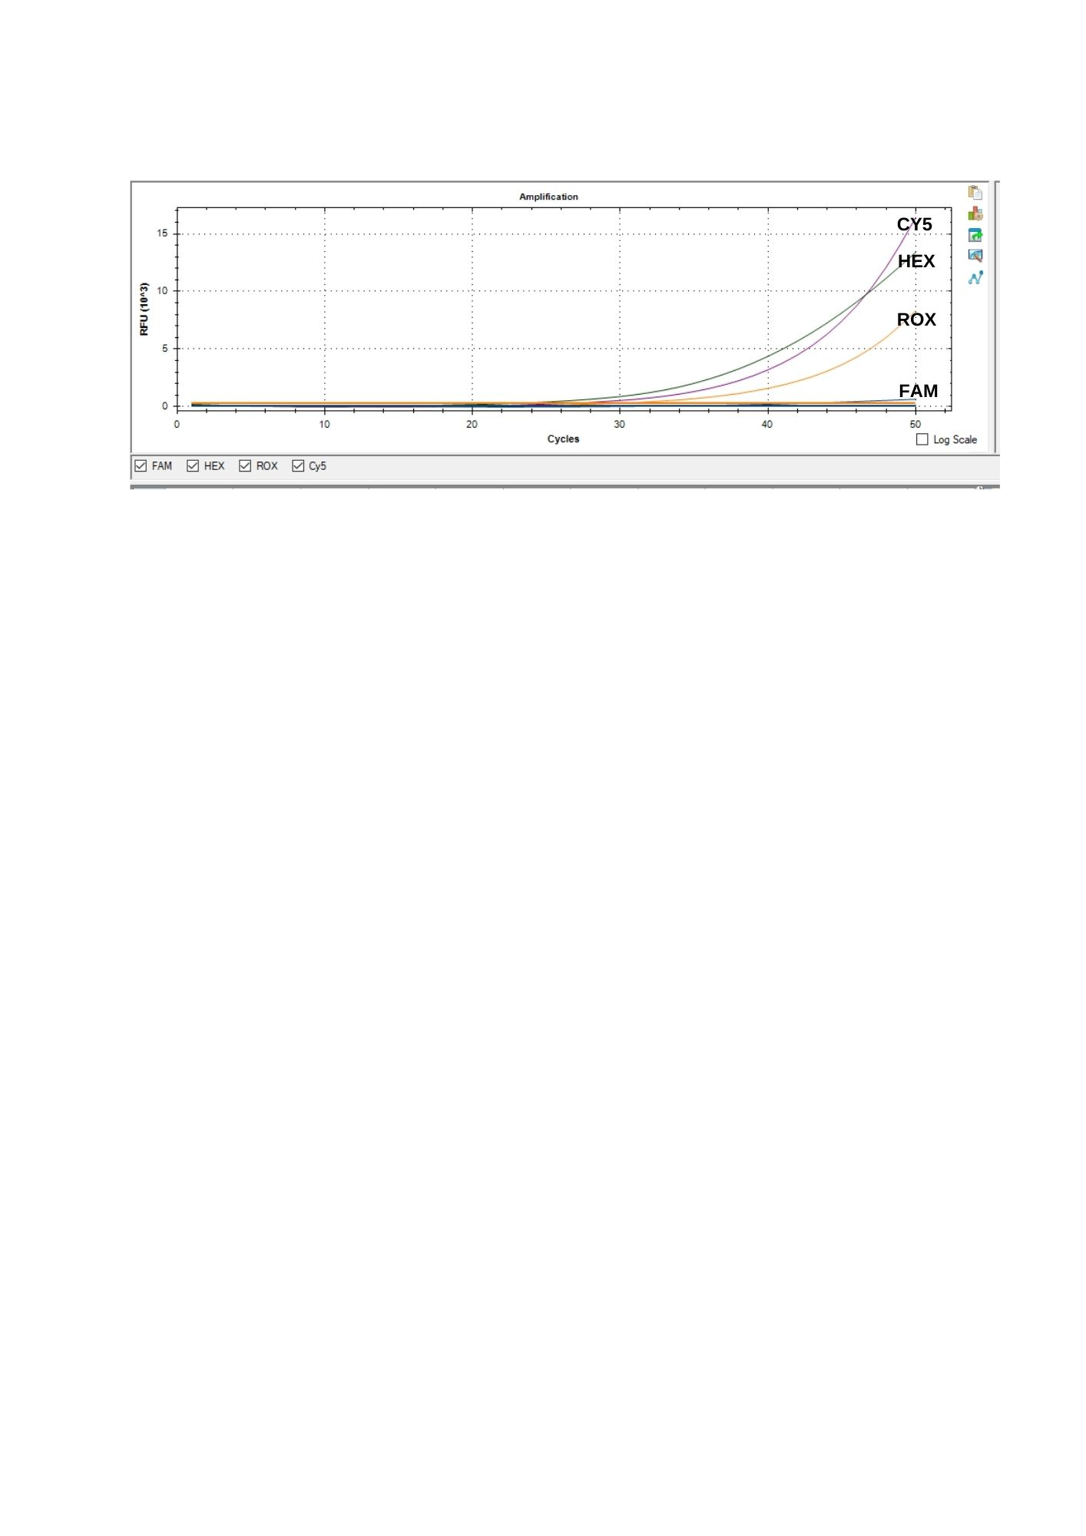

**Figure 4.Real-Time PCR results (NoV GI + NoV GII positive)**

SCCs in milk jugs in enterprises where viral agents detected are given in detail in Table 3 for NoV GI, NoV GI+NoV GII and NoV GI+NoV GII+HAV. In determining the SCC, for Raw Cow Milk, the number of colonies at 30 ˚C has been reported as ≤ 100,000 (per milliliter) and SCC (per milliliter) ≤ 400,000 as the Communiqué on the Supply of Raw Milk in the Official Gazette dated 27 April 2017, Issue: 30050 (Communiqué No: 2017/20) Annex: 6 Criteria to be complied with by Livestock and Food Business Operators Producing Milk. The statistical analyzes were made taking this criterion into consideration. The average SCC in the milk obtained in the study was 339.020+249.230,9. NoV GI (225.375+60.018,9; p=0.005), NoV GII (251.166.7+42.994,9; p=0.01) and HAV (248.750+49.969,1; p=0.04) obtained in this study. SCC averages were found to be statistically lower than negative sample averages (*p<0.05*).

**Table 3. SCC averages of milk samples found positive**

|  |  |  |  |  |
| --- | --- | --- | --- | --- |
| Sample No | NoV GI | NoV GII | HAV | SCC Average ± Standart deviation |
| 10 | + | - | - | 146.000 |
| 14 | + | + | + | 194.000 |
| 22 | + | + | + | 281.000 |
| 30 | + | + | - | 227.000 |
| 43 | + | - | - | 150.000 |
| 44 | + | + | + | 220.000 |
| 46 | + | + | + | 300.000 |
| 47 | + | + | - | 285.000 |
| 56 | + | - | - | 161.000 |
| 61 | + | + | + | 173.000 |
| 68 | + | + | + | 202.000 |
| 75 | + | + | - | 225.000 |
| 86 | + | - | - | 172.000 |
| 87 | + | + | + | 218.000 |
| 91 | + | + | + | 289.000 |
| 94 | + | + | - | 297.000 |

**4. DISCUSSION**

In our study, Real-Time PCR analysis was performed to detect the presence of NoV in milk samples taken from 100 small family businesses selling raw milk in Burdur-Central; 16% NoV GI and 12% NoV GII positivity was detected. Additionally, 4% was determined as NoV GI + NoV GII co-infection. Human NoV strains are classified as GI, GII and GIV. The GI.1 Norwalk virus strain is classified as the prototype, and the most commonly detected type of NoV GII, known as NoV GII 4, can cause large epidemics in humans [9]. Studies have reported that the primary agents in uncooked foods are AstV and NoV [11], while the highest prevalence in milk and dairy products is NoV [6] . Pakbin et al. [14] investigated NoV GI, NoV GII, HAV, RoV, AstV, Bovine Leukemia Virus (BLV) and Tick Born Encephalitis Virus (TBEV) in 492 raw cow's milks in dairy markets in Iran by conventional and nested RT-PCR method. As a result of the research; They determined that there was contamination at the level of NoV GI 34.95% and NoV GII 7.72%. Interestingly, they found that AstV and NoV GI were the most common virus profiles together in samples collected in the southern region of the country, and the highest correlations were seen between RoV and HAV, TBEV and NoV GII. It has been pointed out that the presence of different foodborne and zoonotic virus profiles and prevalence rates in raw milk may be due to the cow's milk production chain and pasteurization processes. Silva et al. [17] examined NoV GI, GII, and Human Adenovirus (HAdv) with Real-Time PCR in cheeses prepared from raw milk in Brazil. Out of 100 samples, they identified NoV GI in 2 (26%), HAdV in 14 (14%), and both NoV GI and HAdV in 3 (3%). However, NoV GII could not be detected. According to these results, in cheeses prepared from raw milk, they reported that applying minimal processes, preparing from raw milk, not applying heat treatment, collecting samples from markets and using fresh ready-to-eat products increase the risk of infection. Therefore, they stated that GMP and HACCP practices are needed in the dairy industry and markets. Yavarmanesh et al. [27] conducted a study on the distribution and correlation of HNoV GI, GII in the presence of *E.coli* and F+ coliphage in raw milk. In another study supporting this situation [2], they investigated the presence of NoV, RoV, AstV antigens on the hands of personnel working in the production departments of milk and dairy products enterprises in Burdur city center and Bucak district with ELISA tests. In the study, they determined the presence of NoV antigen in the stool of 1 personnel. They concluded that the person who was found to be NoV antigen positive among the personnel participating in the study did not receive hygiene training, a personnel who did not receive hygiene training did not use gloves, and the personnel with whom NoV antigen was detected had the potential for viral transmission to both other personnel and the foodstuffs they came into contact with during packaging. It has been reported that RoV, HAV, NoV GI and GII factors detected in raw milk can be easily transmitted from infected human hands and surfaces in milk tanks, production facilities, packaging, etc. [5].

In this study, 8% HAV positivity was detected in the Real-Time PCR analysis performed to detect the presence of HAV in milk samples taken from 100 small family businesses selling raw milk in Burdur-Center. Additionally, 8% was determined as NoV GI + NoV GII + HAV co-infection. Pakbin et al. [14] investigated NoV GI, NoV GII, HAV, RoV, AstV, BLV and TBEV using conventional and nested RT-PCR method in 492 raw cow's milk in markets selling dairy products in Iran. As a result of the research, they determined that HAV contamination was at a level of 25.81%. Hennechart-Collette et al. [7] investigated the presence of HAV, HEV, NoV GI, GII, and MNV-1 in milk and dairy products. They determined the presence of HAV, HEV, and NoV in 16 different milk and dairy products (milk, cheese, yoghurt and cream) simultaneously in milk, cheese, yoghurt and cream and found HAV between 5.76% and 76.40%. Terzi et al. [21] investigated the presence of Enterovirus and HAV in raw milk and whey sold in markets in Samsun, Turkey, using RT-PCR. While 4 (8%) Enteroviruses were detected in 50 milks, the presence of HAV was not found in any milk. Additionally, both enterovirus and HAV positivity could not be detected in whey. As a result of the research, it is emphasized that milk should be pasteurized to preserve milk nutrition, kept under control under cooling, complete pasteurization services to protect contaminations after pasteurization, and more successful maintenance to eliminate HAV and Enteroviruses from contaminated milk. Hirneisen et al. [8] reported that HAV was detected between 33.8% and 49% in milk with virus at a level of 106 - 107 TCID50/ml in the milk inoculum. Wu et al. [26] detected HAV in green onions, strawberries, mussels and milk with the double-step reverse transcription loop-mediated isothermal amplification bioluminescence-based determination of amplification in real-time method. Accordingly, they determined a detection limit of 8.3x100 PFU/40 ml in milk. It was concluded that the developed technique was effective, simple, sensitive and reliable in detecting HAV.

It has been reported that a comprehensive control set should be used due to the low level of viral contamination in foods and the presence of fat, casein, whey proteins and lactose in dairy products [19]. The ISO 15216 method involves the use of a process control virus and external amplification controls such as external control RNA to evaluate any inhibition of amplification. The ISO 16140 procedure establishes the general principle as well as the technical protocol for the validation of alternative methods in the field of microbiological analysis of foods. The latest international standard ISO 16140-4:2018 defines experimental designs to test the effect of matrices, virus inoculum levels and the interaction between various factors. It also reflects variation within a single laboratory under routine conditions [7]. With the kit we used in this research, simultaneous, qualitative detection and discrimination of HAV, NoV GI and GII, and bacteriophage MS2, which is a process control, is possible according to ISO 15216 criteria. The kit also includes a bacteriophage MS2 solution that can be added to the sample and treated as a sample. A specific sequence of process control is then detected in each sample. Enrichment of food samples is not possible in standard ISO protocols. Instead, matrix-specific virus concentration protocols are provided. Prepared for manual extraction of samples in the Foodproof® Sample Preparation kit IV. After virus concentration and RNA extraction, the RNA is tested with the foodproof® NoV (GI, GII) and HAV Detection Kit. The analysis shows whether HAV or NoV-specific sequences are amplified and whether recovery rates higher than 1% are obtained for process control. In this way, the detection results are verified [15,25]. Increases in SCC in milk are seen as the first reaction of the cow's immune system.

Increases in SCC in milk are seen as the first reaction of the cow's immune system. The presence of a high number of SCC in milk indicates that the udder is exposed to infection by microorganisms [16]. In terms of milk technology, the raw material to be used in the production of drinking milk and dairy products is important in the quality of raw milk. SCC is among the quality criteria of raw milk in our country, as in most countries, and also ensures a premium to the producer in the pricing of milk. Research has shown that when SCC is high, milk yield decreases, the processability of milk into products decreases, it causes loss of efficiency in cheese production due to the decrease in casein rate, and as a result of faster lipolysis and proteolysis in pasteurized milk obtained from such milk, sensory quality losses (rancidity and bitterness) and shelf life are shortened [20]. It has been reported that more than 200,000 SCCs are required in one ml of milk [4]. It has been explained that if SCC is above 250,000-300,000 cells in one ml of milk, the milk is not healthy, the udder is likely to be infected with mastitis, and may have negative effects on milk yield and quality [10]. In the European Union Commission Communiqué No. 1662/2006, "Specific Hygiene Rules for Foods of Animal Origin", it is stated that SCC in raw cow's milk should be determined for 3-month periods by taking at least 1 sample per month and the geometric mean of the number found is 400,000 per ml. and below [1]. In our country, according to the Turkish Food Codex (TGK) Communiqué No. 2000/6 on "Raw Milk and Heat-Treated Drinking Milks", it is reported that the number of somatic cells per ml of raw cow's milk should be 500,000 or less [22].

The average SCC in the milk collected in the study was determined as 339.020+249.230,9. In this study The average SCC in milk obtained with NoV GI positive was 225.375+60.018,9 (*p=0,005)*, SCC average in NoV GII positive milk was 251.166,7+42.994,9 (*p=0,01)* and the average SCC in HAV positive milk was determined as 248.750+49.969,1 (*p=0,04)* The averages of these positive samples were found to be statistically lower than the negative sample averages *(p<0.05).* According to the results obtained, it was concluded that the presence of NoV GI, NoV GII and HAV in milk did not affect SCC and could not be used as an indicator of viral presence in milk. In our literature review, we did not find any study based on the relationship between the presence of NoV GI, NoV GII and HAV in individual cow milk, tank or jug milk and SCC. The results we obtained are the first in this regard.

**5. CONCLUSIONS**

In this study, the presence of NoV GI, NoV GII and HAV was detected in milk samples from small family businesses selling raw milk. It was concluded that the presence of NoV GI, NoV GII and HAV in milk collected in the same enterprises did not affect SCC and could not be used as an indicator of viral presence in milk.

**ETHICAL APPROVAL**

According to the Regulation on Working Procedures and Principles of Animal Experiments Ethics Committees, clinical practices for diagnosis and treatment, procedures with dead animals or their tissues, slaughterhouse materials, waste fetuses, cow milking, collecting feces or waste samples, and swabbing interventions do not require permission from MAKÜ HADYEK (Burdur, Turkey).

**REFERENCES**

1.Anonymous. (2006). Commission Regulation (EC) No: 1662/2006. Amending Regulation (EC) No 853/2004 of the Europen Parliament and of the Council Laying Down Specific Hygiene Rules for Food of Animal Origin.

2.Aydoğan H, Gürsoy O, Kale M. Detection of norovirus, rotavirus and astrovirus antigens in hand swabs and stool specimens of employees in dairy processing plants. Akademik Gıda. 2021; 19(4): 393-397.

3.Bean NH, Goulding Joy S, Lao C, Angulo FJ. Surveillance for foodbornedisease outbreaks in the United States, 1988-1992. Morbidity and Mortality Weekly Report. 1996; 45(5): 1-66.

4.Caraviello DZ. 2004. Selection for clinical mastitis and somatic cell count. The Babcock Institute University of Winconsin. Dairy Updates. Reproduction and Genetics No: 613. Accessed: 13 November 2021. Available: http://babcock.wisc.edu/sites/default/files/documents/productdownload/du_613.en_.p df.

5.El-Senousy WM, Abu Senna ASM, Mohsen NA, Hasan SF, Sidkey NM. Clinical and environmental surveillance of rotavirus common genotypes showed high prevalence of common P genotypes in Egypt. Food and Environmental Virology. 2020; 12(2): 99–117.

6.Hardstaff JL, Clough HE, Lutje V, McIntyre KM, Harris JP, Garner P, O'Brien SJ. Foodborne and food-handler norovirus outbreaks: a systematic review. Foodborne Pathogens and Disease. 2018; 15(10): 589-597.

7.Hennechart-Collette C, Fourniol L, Fraisse A, Martin-Latil S, Perelle S. Evaluation of a proteinase k-based extraction method to detect hepatitis a virus, hepatitis e virus and norovirus in artificially contaminated dairy products. Foods. 2023; 12(7): 1489.

8.Hirneisen KA, Hoover DG, Kniel KE. Isolation and infectivity of potential foodborne viral pathogens by immunomagnetic capture. Food Protection Trends. 2009; 29(9): 564-570.

9.Karst SM, Wobus CE, Goodfellow IG, Green KY, Virgin HW. Advances in norovirus biology. Cell Host & Microbe, 2014; 15(6): 668–680.

10.Kirk JH. 2005. The effect of poor quality raw milk on finished products. Extension Veterinarian School of Veterinary Medicine University of California Davis Tulare, CA.

11.Miranda RC, Schaffner DW. Virus risk in the food supply chain. Current Opinion in Food Science. 2019; 30: 43-48.

12.Msalya G. 2017. Contamination levels and identification of bacteria in milk sampled from three regions of Tanzania: Evidence from literature and laboratory analyses. Hindawi Veterinary Medicine International.

13.Murinda SE, Nguyen LT, Ivey SJ, Gillespie BE, Almeida RA, Draughon FA, Oliver SP. Molecular characterization of salmonella spp. isolated from bulk tank milk and cull dairy cow fecal samples. Journal of Food Protection. 2002; 65: 1100-1105.

14.Pakbin B, Rossen JW, Brück WM, Montazeri N, Allahyari S, Dibazar SP, Abdolvahabi R, Mahmoudi R, Peymani A, Samimi R. Prevalence of foodborne and zoonotic viral pathogens in raw cow milk samples. FEMS Microbiology Letters. 2022; 369(1): e108.

15.Rapid Microbiology 2023. Foodproof Sample Preparation Kit IV (BIOTECON Diagnostic®, Potsdam, Germany). Accessed: 10 November 2023. Available:https://www.rapidmicrobiology.com/news/foodproof-norovirus-gi-gii-plus-hepatitisa-virus-detection-kit.

16.Rice DN, Bodman GR. The somatic cell count and milk quality, cooperative extension. Institute of Agriculture and Natural Resources, University of Nebraska Lincoln. 1997; G 93-1151-A: 2-4.

17.Silva MR, Ferreira FC, Maranhão AG, Lanzarini NM, de Carvalho Castro KN, Miagostovich MP. Assessment of viral contamination of five brazilian artisanal cheese produced from raw milk: a randomized survey. Food Environmental Virology. 2021; 13: 528-534.

18.Simsek O, Gültekin R, Oksüz O, Kurultay S. The effect of environmental pollution on the heavy metal content of raw milk. Die Nahrung. 2000; 44(5): 360-363.

19.Suffredini E, Lanni L, Arcangeli G, Pepe TJ, Mazzette R, Ciccaglioni G, Croci L. Qualitative and quantitative assessment of viral contamination in bivalve molluscs harvested in Italy. International Journal of Food Microbiology. 2014; 184: 21–26.

20.Temelli S, Şerbetcioğlu T. Bir süt işletmesinde işlenen inek sütlerinde somatik hücre sayısının dört yıllık periyottaki değişiminin incelenmesi. Uludağ Üniversitesi Veteriner Fakültesi Dergisi. 2011; 30(1): 1-7.

21.Terzi G, Albayrak H, Siriken B, Cadirci O, Okur-Gumusova S, Yazici Z. Detection of enteroviruses and hepatitis a virus RNA in cow milk by RT-PCR. Acta Veterinaria. 2010; 60(2-3): 197-204.

22.Türk Gıda Kodeksi 2000. Çiğ süt ve ısıl işlem görmüş içme sütleri tebliği. 14: 2000-23964.

23.Türk Standartları Enstitüsü 2007. Süt-Somatik Hücrelerin Sayımı-Bölüm 2: Elektronik Tanecik Sayıcı Metot. ISO 13366-2/AC. 2006.1-13.

24.Türk Standartları Enstitüsü 2008. Süt-Somatik Hücrelerin Sayımı-Bölüm 2: FloroOpto-Elektronik Sayıcı İşlemleri İçin Rehber. ISO 13366-2/AC. 2008. 1-4.

25.Türk Standartları Enstitüsü 2013. ISO/TS 15216-2:2013. Gıda ve hayvan yemlerinin mikrobiyolojisi-Gerçek zamanlı RT-PCR kullanılan gıdalarda hepatitis A ve norovirusun tayini için yatay yöntem-Bölüm 2: Kalitatif tespiti için yöntem. 1- 54.

26.Wu R, Meng B, Corredig M, Griffiths MW. Rapid detection of hepatitis a virus in foods using a bioluminescent assay in real-time (bart) and reverse transcription loop-mediated isothermal amplification (rt-lamp) technology.Food and Environmental Virology. 2023; 15(2): 144-157.

27.Yavarmanesh M, Alum A, Abbaszadegan M. Occurrence of Noroviruses and their correlation with microbial indicators in raw milk. *Food and Environmental Virology*. 2015; 7: 232–238.