Evaluating the Synergistic Effects of Arbuscular Mycorrhizal Fungi and Phosphate-Solubilizing Bacteria on Growth and Yield Enhancement in Eggplant (*Solanum melongena* L.)

# ABSTRACT:

A pot culture experiment investigated the combined effects of *Glomus fasciculatum* (AM fungi) and *Bacillus megaterium* (phosphate-solubilizing bacteria, PSB) on brinjal (*Solanum melongena* L.) under varying phosphorus levels (50% and 75% of the recommended P dose) alongside standard nitrogen and potassium fertilization. Among the ten treatments evaluated, **T7 (75% P + *G. fasciculatum* + *B.***

***megaterium*)** emerged as the most effective, demonstrating significant enhancements

in plant growth, nutrient uptake, and yield. The study highlighted a synergistic interaction between AM fungi and PSB: AM fungi improved phosphorus acquisition efficiency through hyphal networks, while PSB solubilized soil-bound phosphorus, thereby increasing its bioavailability. This dual inoculation strategy not only optimized phosphorus utilization but also amplified biomass accumulation and fruit productivity in brinjal, underscoring its potential for sustainable nutrient management in solanaceous crops.

**Keywords:** Brinjal, *Glomus fasiculatum*, *Bascillus megaterium*, growth and yield

# INTRODUCTION:

Eggplant, a commonly grown vegetable in India and various other regions worldwide, has become a staple in many cuisines. However, it is important to note that eggplant cultivation is not suitable for higher altitudes. In India, a wide variety of eggplant cultivars are grown, with the selection based on factors like yield and consumer preference. Scientifically known as *Solanum melongena* L., eggplant is an

herbaceous, tropical perennial plant that belongs to the Solanaceae family. Its edible fruit is highly prized for its culinary applications. Interestingly, eggplant is known by different names in different countries, such as Bazinga in Egypt, aubergine in France and England, eggplant in the United States, and brinjal in India (Zayed *et al*., 2017). For optimal growth, fruit development, and seed yield, solanaceous vegetables heavily rely on abundant supplies of vital nutrients such as nitrogen, phosphorus, and potassium. (Sathe *et al*., 2016). Additionally, secondary nutrients like calcium and sulfur are also crucial. However, the exorbitant cost of inorganic fertilizers has rendered them inaccessible to small and marginalized farmers, causing ongoing ecological damage.

Enhancing the sustainability of agricultural soil management requires the implementation of various techniques, including the utilization of biofertilizers like arbuscular mycorrhizal (AM) fungi and plant-beneficial bacteria. These biofertilizers have the potential to significantly improve both crop yield and the overall quality of fruits. (Singh, S. and Kapoor, K.K. 1999).

Vesicular arbuscular mycorrhiza (VAM) establishes a symbiotic relationship with the majority of dicots and monocots, with only a small number of key crops unable to engage in mycorrhizal symbiosis (Gianinazzi, S. 1991). Mycorrhizal fungi play a crucial role in enhancing soil structure, water retention, controlling root pathogens, boosting resistance to various stresses, promoting plant growth, and increasing fruit production. (Bowles *et al*., 2016).Additionally, they enhance the uptake of trace elements, synthesize plant hormones, and enhance the activity of nitrogen-

fixing organisms in the root zone. Crop plants greatly benefit from the symbiotic

relationships formed with fungal associations. These associations play a crucial role in improving nutrient availability, particularly phosphorus, as well as enhancing water uptake. (Birhane *et al.*, 2012). Additionally, they contribute to disease resistance and ultimately increase crop yield (Lekberg and Koids, 2005). Arbuscular mycorrhizal fungi, also known as bio-fertilizers, are particularly noteworthy in this regard. They provide plants with increased tolerance to various stressful conditions such as heat, salinity, drought, metals, and extreme temperatures (Rani *et al*., 2018).

Phosphate-solubilizing bacteria (PSB) are a type of beneficial bacteria with the ability to convert organic and inorganic phosphorus from insoluble compounds. The prevailing view is that the solubilization of mineral phosphate by PSB strains is connected to the liberation of low molecular weight organic acids. (Zehra, 2010).

Phosphorus is a key nutrient for plants, ranking just behind nitrogen in terms of importance for crop growth. It accounts for 0.2 percent of a plant's dry weight. While many Indian soils have abundant phosphorus content, it is often in an inaccessible form for plants. To address this challenge, scientists advocate the use of phosphobacteria to enhance phosphorus availability across different crop varieties. Furthermore, the application of phosphorus-solubilizing and mobilizing microorganisms is recommended to tackle phosphorus deficiency.

Inoculation with AM fungi and phosphobacteria boosts growth and development through the production of growth-promoting hormones, as well as the solubilization and mobilization of essential nutrients such as phosphorus, nitrogen, potash, zinc, and micronutrients. Additionally, it helps protect plants from various stresses and pathogens.

# MATERIALS AND METHODS

The experiment's layout is outlined below, providing comprehensive information on the materials utilized and the methods employed.

# Experimental site

The growth and yield of Brinjal (Solanum melongena.L) were investigated in a pot experiment titled "Co-inoculation effect of AM fungi and Phosphate solubilizing bacteria." This experiment took place at the Pot Culture Yard, situated in the Cauvery Delta zone of Chidambaram. The Pot Culture Yard is positioned at an altitude of 7 meters above the mean sea level, with a geographical bearing at 11.39°N latitude and

79.71°E longitude.

Chidambaram region falls within the semiarid tropical zone of Northern Tamilnadu. Typically, this area experiences rainfall during the North-East monsoon. The summer season is characterized by scorching heat, with temperatures frequently

exceeding 37°C, while the winter season remains relatively warm. The weather information includes data on average maximum and minimum temperatures, relative humidity, and rainfall.

The average weekly maximum temperature throughout the crop season varied between 27.60°C and 39.58°C, with an average of 33.55°C. The mean minimum temperature ranged from 14.30°C to 28.80°C, averaging at 21.55°C. The average weekly relative humidity during the crop period fluctuated between 45.10% and 73.30%, with an average of 59.20%. A total rainfall of 272.4 mm was recorded during the crop season.

# Cultivar

The seeds of the Brinjal (*Solanum melongena.*L) cultivar PLR-1 were acquired from the Vegetable Research Station located in Palur.

# Treatment Details

The details of the treatments included in the trail are as follows: T1 : Control (No biofertilizers and chemical fertilizers) T2 : RDF T3 : *Glomus fasciculatum* T4 : *Bacillus megaterium* T5 : 75% of P + *Glomus fasciculatum* T6 : 75% of P + *Bacillus megaterium* T7 : 75% of P + *Glomus fasciculatum* + *Bacillus megaterium* T8 : 50% of P + *Glomus fasciculatum* T9 : 50% of P + *Bacillus megaterium* T10 : 50% of P + Glomus fasciculatum + *Bacillus megaterium*

Jancy Sathiyavathi (2002) discovered that dual inoculation with *G. fasciculatum* and *B. megaterium* increased leaf length and tiller number more than single inoculation at each of three phosphorus levels.

# Collection of samples

Samples were procured from multiple locations, including brinjal roots and rhizosphere soil. Each collection included 20-30 cores measuring 2.5 cm in diameter and 15-20 cm in length. Following the excavation of roots and surrounding soils to a depth of 15-20 cm, the samples were carefully placed in polythene bags for subsequent analysis.The standard methods were used to determine the physico-chemical

properties such as soil texture, pH, EC, organic carbon content, available nitrogen, phosphorus, and potash.

# Isolation and characterization of AM fungi

To assess the presence of AM fungal spores, all soil samples collected underwent examination using the wet sieving and decanting method, with a particle size range of 1000 – 45 μm. The spores were subsequently separated from soil particles using the sucrose density gradient centrifugation method and washed with distilled water, following the protocol established by Mertz *et al*. in 1979. The abundance of spores in each soil sample was determined using a Stereo zoom microscope (45 X). During the counting process, identical spores were sorted into distinct groups, mounted, and identified.

# Assessment of AM fungi for their efficacy in brinjal root zone soils

Raised nursery beds measuring 3.0 × 1.0 m were set up using a combination of FYM, red soil, and sand in equal parts. Subsequently, seeds were sown and the nursery beds were meticulously maintained for a period of 30 days. The effectiveness of selected AM fungal cultures including, *Glomus fasciculatum Glomus mosseae, Gigaspora margarita,* and *Acaulospora laevis* in colonizing 30-day-old eggplants was assessed. Cement pots were filled with a sand and soil mixture (1:1 ratio) treated with 2% formaldehyde. These pots were then inoculated with various AM fungal cultures (50 g per pot) and planted with 6 eggplant seeds each. Observations were recorded on the 30th, 60th, and 90th days post-transplanting for the eggplants.

# Mass production and purification of specific AM fungal isolates

The multiplication of *G. fasciculatum* soil inoculum was carried out, followed by filling pots with a diameter of 40 cm with a mixture of sterilized sand and soil (1:1) that had been fumigated using a 2% formaldehyde solution. Each pot was then supplemented with 50 g of *G. fasciculatum* inoculum, and sorghum seeds were planted at a rate of 10 seeds per pot. After 30 days of growth, the plants were removed, and the roots were analyzed for AM fungal colonization. The number of AM fungal spores

in the soil was quantified using the wet sieving and decanting method (Gerdemann and Nicolson, 1963).

# Phosphobacteria Enumeration

Phosphobacteria were counted in the rhizosphere soils of various brinjal cultivation sites through serial dilution plate method as described by Sperber in 1958. Soil samples were diluted serially up to a 10-4 dilution. One milliliter aliquots of the final dilution were plated using Sperber's hydroxyapatite medium. The plates were then incubated for up to two weeks at 28±2°C. Bacterial colonies with clear zones were counted and reported as cfu g-1 of dry soil. The process of purifying Phosphobacteria involved streaking a single colony in Pikovskaya's medium, followed by microscopic examination of the colonies. These purified cultures were then maintained in Pikovskaya's slants for further research.

# Biometric observations

For the purpose of recording the biometric observations, a total of five samples were randomly chosen from each treatment and permanently labeled. These observations focused on the growth characters and yield attributes of brinjal.

# Result and Discussion

The results of present investigation includes the isolation of AM fungi, phosphobacteria and screening them for their efficiency to mobilize and solubilize phosphorus under laboratory conditions and pot culture experiments were conducted to investigate the co- inoculation effect of *Glomus fasciculatum* and *Bacillus megaterium* at graded levels of P2O5 (50 and 75 per cent) in brinjal (*Solanum melongena*.L)

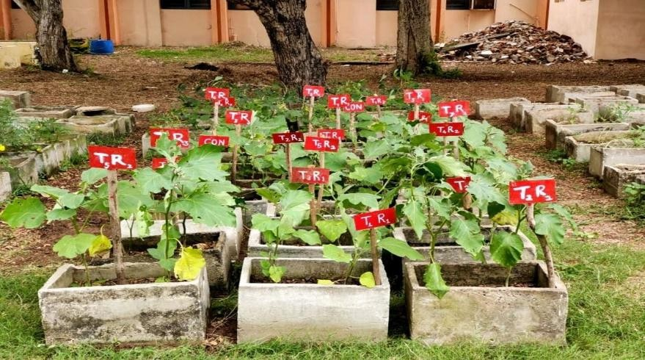

**Fig 1 : Productivity of brinjal**

**Table 1: Co-inoculation effect of *G. fasciculatum* and *B.megaterium* on the number of branches of brinjal at different levels of phosphorus**

|  |  |  |  |  |  |  |
| --- | --- | --- | --- | --- | --- | --- |
| **S.No.** | **Treatments** | | | **Number of branches plant-1** | | |
| **30 DAT** | **60 DAT** | **90 DAT** |
| 1. | T1 | : | Control | 6.59 | 8.89 | 11.98 |
| 2. | T2 | : | RDF | 10.23 | 12.98 | 16.43 |
| 3. | T3 | : | *Glomus fasciculatum* | 7.99 | 10.13 | 13.14 |
| 4 | T4 | : | *Bacillus megaterium* | 7.59 | 9.43 | 13.01 |
| 5. | T5 | : | 75% of P+ *G. fasciculatum* | 10.01 | 12.23 | 15.61 |
| 6. | T6 | : | 75% of P + *B. megaterium* | 9.56 | 11.57 | 15.31 |
| 7. | T7 | : | 75% of P + *G. fasciculatum + B. megaterium* | 12.51 | 16.01 | 19.81 |
| 8. | T8 | : | 50% of P + *G. fasciculatum* | 8.98 | 11.01 | 14.13 |
| 9 | T9 | : | 50% of P + *B. megaterium* | 8.43 | 10.56 | 13.91 |
| 10. | T10 | : | 50% of P + *G. fasciculatum + B. megaterium* | 11.51 | 14.51 | 17.99 |
| S.Ed | | | | 0.32 | 0.37 | 0.56 |
| CD(p=0.05) | | | | 0.64 | 0.75 | 1.12 |

The number of branches of brinjal as influenced by various treatments was recorded on 30, 60 and 90 DAT (Table 1).

The number of branches gradually increased upto 90 DAT both under inoculated and uninoculated condition. In general, all the treatments of inoculation *G.*

*fasciculatum* and *B. megaterium* both single and co-inoculation at different phosphorus levels increased the plant growth compared to uninoculated control. The maximum number of branches per plant (19.81 branches plant-1) was observed with co- inoculation of *Glomus fasciculatum* and *Bacillus megaterium* at 75 per cent phosphorus levels followed by 50 per cent phosphorus levels (17.99 branches plant-1).

**Table 2:Co-inoculation effect of *G. fasciculatum* and *B.megaterium* on the fruit weight of brinjal at different levels of phosphorus**

|  |  |  |  |  |
| --- | --- | --- | --- | --- |
| **S.No.** | **Treatments** | | | **Fruit weight (g)** |
| 1. | T1 | : | Control | 70.02 |
| 2. | T2 | : | RDF | 77.61 |
| 3. | T3 | : | *Glomus fasciculatum* | 73.31 |
| 4 | T4 | : | *Bacillus megaterium* | 72.65 |
| 5. | T5 | : | 75% of P+ *G. fasciculatum* | 76.98 |
| 6. | T6 | : | 75% of P + *B. megaterium* | 76.53 |
| 7. | T7 | : | 75% of P + *G. fasciculatum + B. megaterium* | 80.61 |
| 8. | T8 | : | 50% of P + *G. fasciculatum* | 75.01 |
| 9 | T9 | : | 50% of P + *B. megaterium* | 74.34 |
| 10. | T10 | : | 50% of P + *G. fasciculatum + B. megaterium* | 79.01 |
| S.Ed | | | | 0.74 |
| CD(p=0.05) | | | | 1.48 |

Fruit weight of brinjal in response to *G. fasciculatum* and *B. megaterium* inoculation was observed at harvest and the results are presented in Table 2. In all the periods of assessment, the co-inoculation treatment at all the phosphorus levels recorded higher values than single inoculation of *G. fasciculatum* and *B. megaterium*. Among the co- inoculation treatment, the maximum fruit weight was observed in the 75 per cent phosphorus level (80.61 g fruit-1). Interestingly, it was also observed that the inoculation effect in terms of weight of fruits between 50 and 75 per cent were found to be on par with each other. Brinjal plants showed significant response to the combined inoculation of *G. fasciculatum* and *B. megaterium*. The result clearly

established that co- inoculation of *G. fasciculatum* and *B. megaterium* significantly increased the yield of brinjal by increasing the fruit weight.

# Table 3: Co-inoculation effect of *G. fasciculatum* and *B.megaterium* on the fruit volume and fruit girth of brinjal at different levels of phosphorus

|  |  |  |  |  |  |
| --- | --- | --- | --- | --- | --- |
| **S.**  **No.** | **Treatments** | | | **Fruit volume (cc)** | **Fruit Girth (cm)** |
| 1. | T1 | : | Control | 41.69 | 3.23 |
| 2. | T2 | : | RDF | 58.23 | 5.69 |
| 3. | T3 | : | *Glomus fasciculatum* | 48.61 | 4.01 |
| 4 | T4 | : | *Bacillus megaterium* | 45.43 | 3.76 |
| 5. | T5 | : | 75% of P+ *G. fasciculatum* | 56.98 | 5.35 |
| 6. | T6 | : | 75% of P + *B. megaterium* | 55.48 | 5.01 |
| 7. | T7 | : | 75% of P + *G. fasciculatum + B. megaterium* | 65.91 | 6.43 |
| 8. | T8 | : | 50% of P + *G. fasciculatum* | 54.03 | 4.76 |
| 9 | T9 | : | 50% of P + *B. megaterium* | 51.01 | 4.53 |
| 10. | T10 | : | 50% of P + *G. fasciculatum + B. megaterium* | 60.59 | 6.03 |
| S.Ed | | | | 1.41 | 0.20 |
| CD(p=0.05) | | | | 2.83 | 0.40 |

Among the treatments T7 (75 per cent P + *G. fasciculatum* + *B. megaterium*) was found to be better in brinjal with respect to growth parameters (plant height, dry matter production, number of branches), yield parameters (fruit weight, fruit volume, fruit grith and seed yield) in the rhizosphere soil.

Fruit length and fruit girth of brinjal in response to *G. fasciculatum* and *B. megaterium* inoculation was observed at harvest and the results are presented in Table

3. Increase in fruit volume and girth were observed both in inoculated and uninoculated control. The co-inoculated brinjal at all the phosphorus levels recorded higher values than the single inoculation. The maximum fruit volume of 65.91 cc and girth of 6.43 cm was recorded in the co-inoculation of *G. fasciculatum* and *B. megaterium* at 75 per cent phosphorus levels.

In this study, percentage colonisation and spore number by *G. fasciculatum* in brinjal were higher at 75%, followed by 50% phosphorus. Lower phosphorus levels

resulted in the maximum percentage of root colonisation and spore number in several plant species by AM fungus, according to Konda and Patil (1993) and Lingarju *et al* (1995).

Fig 2 : Fruit length and fruit girth of brinjal

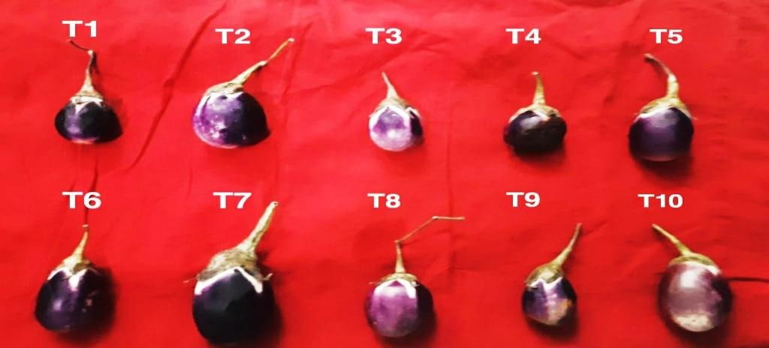

# Conclusion

The findings of the study revealed that the combined application of *Glomus fasciculatum* (AM fungi) and *Bacillus megaterium* (phosphate-solubilizing bacteria) had a synergistic effect, significantly enhancing various growth and yield parameters in brinjal. Co-inoculation led to notable improvements in plant growth, biomass production, and yield components. Additionally, it increased nutrient uptake in the plants, particularly nitrogen and phosphorus, which are critical for optimal growth and development.

The treatment also positively influenced soil health and microbial activity in the brinjal rhizosphere. Specifically, there was a marked increase in available nitrogen and phosphorus levels in the soil, along with higher root colonization percentages by AM fungi. The spore count of AM fungi, the population of phosphate-solubilizing bacteria, and the overall microbial count in the rhizosphere soil were also significantly elevated.

These results highlight the potential of co-inoculating *G. fasciculatum* and *B. megaterium* as a sustainable agricultural practice to improve brinjal productivity, enhance soil fertility, and promote beneficial microbial activity in semiarid tropical regions.

# Reference:

1. Birhane E, Sterck F, Fetene M, Bongers F, Kuyper T (2012) Arbuscular mycorrhizal fungi enhance photosynthesis, water use efficiency, and growth of frankincense seedlings under pulsed water availability conditions
2. Bowles, T. M., Barrios-Masias, F. H., Carlisle, E. A., Cavagnaro, T. R., & Jackson,

L.E. (2016). Effects of arbuscular mycorrhizae on tomato yield, nutrient uptake, water relations, and soil carbon dynamics under deficit irrigation in field conditions. *Science of the Total Environment*, *566*, 1223-123

1. Gerdemann, J.W. and T.H. Nicolson. 1963. Spores of mycorrhizal *Endogone* species, extracted from soil by wet sieving and decanting. Trans Br. Mycol. Soc., 46: 235-244.
2. Gianinazzi, S. (1991). Vesicular-Arbuscular EndoMycorrhizas Technology in Agriculture: from Genes to Byproducts.
3. Jancy Sathiyavathi, R. 2002. Studies on the phosphate mobilization by *Glomus fasciculatum* and solubilizing by *Bacillus* sp. in the rhizosphere of sugarcane. Ph.D. (Ag.) Thesis, Annamalai University, Tamil Nadu, India.
4. Konda, B.K. and B.S. Patil. 1993. Yield and N, P uptake by chilli as influenced by *Glomus* and *Azospirillum* inoculations with phosphate levels. Proc. International Symposium on Bioinoculants.A.V.V.M. Sri Pushpam College, Poondi, India, pp. 1-22.
5. Lekberg, Y. and R.T. Koids. (2005). Arbuscular mycorrhizal fungi, rhizobia available P and nodulation of groundnut (*Archis hypogea* L.) in zimbawe. *Agric. Ecosys. Environ*., 110: 143-148.
6. Lingaraju, S., & Goswami, B. K. (1995). Effect of two organic amendments in the interaction of Glomus fasciculatum and Rotylenchulus reniformis. *Indian Journal of Nematology*, *25*(1), 33-37.
7. Mertz, Jr. S.M., Heithas III, J.J., and Bush, R.L. 1979. Massproduction of axenic spores of the endomycorrhizal fungus Gigaspora margarita Transactions of British Mycological Society 72: 167-169
8. Rani N, Sharma HR, Kaushik A, Sagar A. (2018). Bioremediation of Mined Waste Land. Chapter. Handbook of Environment materials management, 2018.
9. Sathe, T. V., Patil, S. S., Bhosale, A. M., Devkar, S. S., Govali, C. S., & Hankare,

S. S(2016). Ecology and Control of Brinjal insect pests from Kolhapur region, India. *Bio life*, *4*(1), 147-154.

1. Singh, S., & Kapoor, K. K. (1999). Inoculation with phosphate-solubilizing microorganisms and a vesicular-arbuscular mycorrhizal fungus improves dry matter yield and nutrient uptake by wheat grown in a sandy soil. *Biology and fertility of soils*, *28*(2), 139-144.
2. Sperber, J. I. 1958. Solubilization of apatite by soil microorganisms producing organic acids. Australian Agricultural Research, 9: 782-787.
3. Zayed, G. A., Abdo, A. A., Hammam, H. B., & Khafagi, E. Y. (2017). Cultivation and production of pepper and eggplant in Egypt. *Technical issue*, (15).
4. Zehra Ekin (2010). Performance of phosphate solubilizing bacteria for improving growth and yield of sunflower (*Helianthus annuus* L.) in the presence of phosphorus fertilizer. Af. J. Biotech. 9: 3794-00.