**HUGE DEGENERATED FIBROID MIMICKING HYDATID CYST OF THE UTERUS: A RARE DIAGNOSTIC DILEMMA**

**Abstract**

**Background:**  
Uterine leiomyomas are among the most frequently encountered benign tumors in women of reproductive age. Although typically well-characterized on imaging, degenerative changes can alter their appearance and occasionally mimic more sinister or rare pathologies. One such rare mimic is a hydatid cyst, especially in endemic rural areas where humans have close contact with definitive hosts such as dogs. Hydatid disease involving the uterus is an exceptional rarity, and its clinical and imaging presentation can closely resemble that of a degenerating fibroid, leading to diagnostic ambiguity.

**Case Presentation:**

We report the case of a 34-year-old multiparous woman (Para 2, Living 2) who presented with complaints of lower abdominal pain and a palpable mass. She belonged to a rural agrarian background with frequent exposure to domestic dogs and cattle. Ultrasonography revealed a large heterogeneous solid-cystic mass arising from the uterine fundus, measuring approximately 10.7 × 6.8 × 10.5 cm, with internal septations and fluid components, raising a differential diagnosis of a cavitated fibroid or a hydatid cyst. Surgical management in the form of total abdominal hysterectomy with bilateral salpingectomy was undertaken. Gross pathological examination revealed multiple well-defined intramural masses ranging from 0.8 to 2.9 cm, without evidence of necrosis or hemorrhage. Microscopic examination confirmed leiomyomas with degenerative changes and revealed eosinophilic granular material suggestive of parasitic etiology. Empirical anti-helminthic therapy with albendazole was initiated. A full-body radiological screening showed no secondary lesions, and postoperative recovery was uneventful. The patient remains stable on regular follow-up.

**Conclusion:**

This case highlights a rare and intriguing diagnostic challenge where a huge degenerative fibroid closely mimicked a hydatid cyst both radiologically and histopathologically. In regions endemic to echinococcosis, especially among individuals with close animal contact, such mimics must be considered in the differential diagnosis. Accurate intraoperative assessment and histopathological correlation are essential to avoid misdiagnosis and to guide appropriate therapeutic intervention.

**Keywords:**

Degenerated fibroid, Hydatid cyst, Leiomyoma, Cystic degeneration, Uterine mass, Albendazole, Rural exposure, Diagnostic dilemma

**Background**

Uterine fibroids, also known as leiomyomas, are benign smooth muscle tumors of the uterus and are among the most prevalent gynecological conditions affecting women of reproductive age. The incidence of fibroids increases with age, peaking in the fourth and fifth decades of life, and they are often associated with symptoms such as abnormal uterine bleeding, pelvic pain, pressure symptoms, and reproductive dysfunction. Most fibroids are easily diagnosed based on characteristic imaging features and clinical history **[1,2]**. However, when they undergo degenerative changes, their radiological appearance may become atypical and lead to considerable diagnostic confusion.

Degenerative changes in leiomyomas occur when the tumor outgrows its vascular supply, leading to alterations such as hyaline, cystic, myxoid, or red degeneration. Among these, cystic degeneration is seen in approximately four percent of fibroids and may create a multilocular, anechoic pattern on ultrasound, mimicking other cystic pelvic masses **[3]**. This creates a diagnostic dilemma, especially in endemic regions where hydatid disease is prevalent. Echinococcosis, caused by the larval stage of Echinococcus granulosus, is a parasitic zoonosis typically affecting the liver and lungs but may occasionally involve rare sites such as the uterus. Uterine hydatid cysts are extremely uncommon, with very few documented cases in literature **[4]**.

In areas with widespread livestock farming and close human-animal contact, particularly involving dogs and sheep, the possibility of echinococcal infection must be considered in the differential diagnosis of cystic uterine lesions. Misinterpretation can lead to unnecessary alarm or inappropriate therapy if not correlated with clinical, epidemiological, and pathological findings **[5]**. This case is presented to highlight an unusual scenario where a large degenerative uterine fibroid mimicked a hydatid cyst, both clinically and histologically, in a young woman with significant rural exposure. The case underlines the importance of maintaining a broad differential in atypical presentations of uterine masses and reinforces the need for a comprehensive clinical and pathological approach for accurate diagnosis **[6]**.

**Materials and Methods**

A 34-year-old woman, para 2 with two living children, presented to the outpatient department with complaints of lower abdominal pain and a gradually increasing abdominal lump over the past several months. The pain was dull in nature, non-radiating, and intermittently associated with a feeling of pelvic pressure. There was no history of abnormal uterine bleeding, weight loss, or systemic symptoms such as fever. Menstrual cycles were regular, and her obstetric history was uneventful. She did not report any prior surgeries or significant gynecological illness.

The patient belonged to a rural farming community and was a housewife by occupation. She reported regular exposure to domestic animals, including cattle and three household dogs, which were not dewormed. This history raised a clinical suspicion of parasitic infections, particularly echinococcosis.

On general physical examination, the patient was afebrile and hemodynamically stable. Abdominal examination revealed a firm, non-tender mass palpable in the hypogastrium, extending up to the umbilicus. Per vaginal examination confirmed the presence of a well-defined uterine mass. Transabdominal and transvaginal ultrasonography revealed a large, well-encapsulated, heterogeneous mass measuring 10.7 × 6.8 × 10.5 cm arising from the uterine fundus. The lesion demonstrated both solid and cystic areas, with multiple septations and areas of internal echogenic fluid. The right ovary was visualized separately; however, the left ovary was not clearly delineated. The imaging findings raised a differential diagnosis of a cavitated uterine fibroid or a hydatid cyst.

In view of the size of the mass and diagnostic uncertainty, surgical intervention was planned. The patient underwent total abdominal hysterectomy with bilateral salpingectomy. Intraoperatively, a markedly enlarged uterus was noted with a lobulated, cystic mass arising from the fundal region. The external surface appeared encapsulated and smooth. On sectioning, the lesion revealed multiple cystic spaces with clear fluid and yellowish eosinophilic material, which grossly mimicked hydatid cyst contents. No other abdominal or pelvic lesions were visualized intraoperatively.

The excised specimen was sent for detailed histopathological evaluation. Based on intraoperative findings and epidemiological risk, empirical anti-helminthic therapy with albendazole was initiated postoperatively. The patient underwent a full-body radiological screening, including chest X-ray and abdominal ultrasound, which revealed no secondary lesions suggestive of disseminated hydatid disease. Her postoperative recovery was uneventful, and she was discharged in stable condition with advice for regular follow-up.

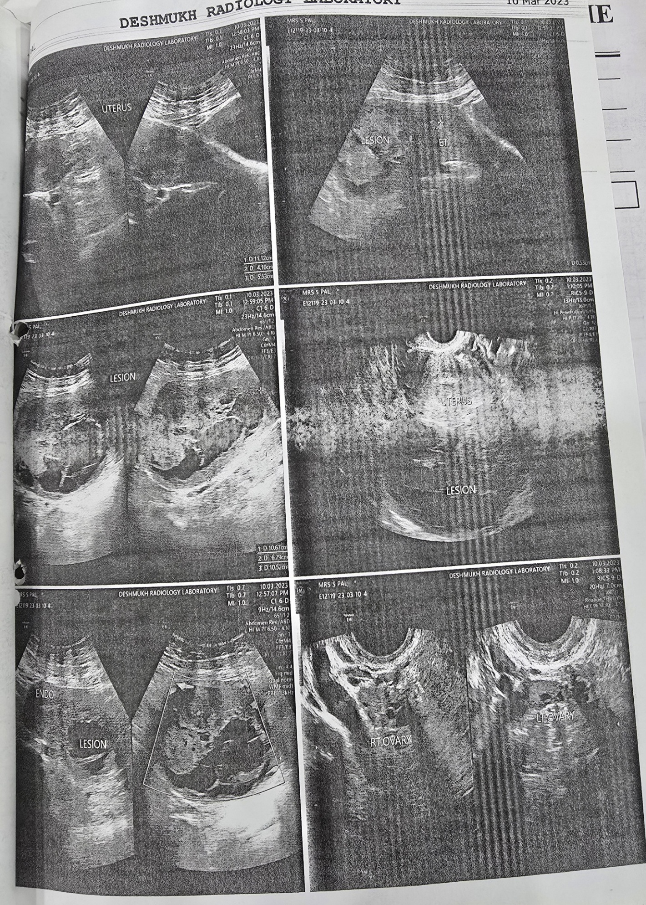

Figure 1: Transabdominal and transvaginal ultrasound images showing a well-defined multiloculated cystic lesion arising from the uterine fundus, with clearly visualized endometrial thickness and both ovaries.

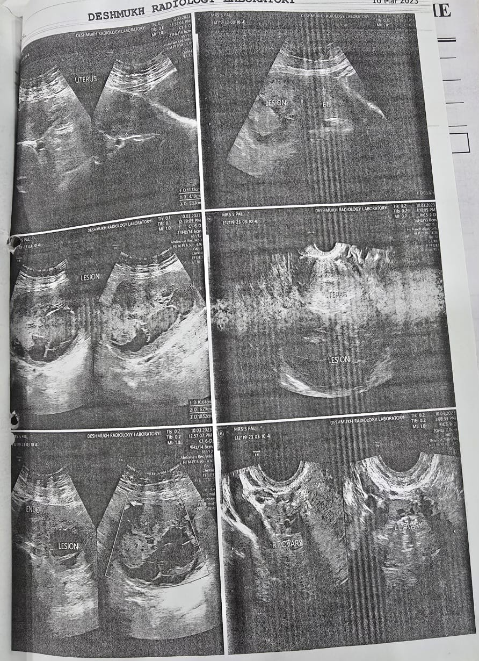

Figure 2: Transabdominal and transvaginal ultrasonographic images demonstrating multiple heterogeneous lesions within the uterus, some mimicking daughter cysts, suggestive of fibroid degeneration versus cystic pathology.

**Results**

The excised uterus with bilateral fallopian tubes was submitted for detailed gross and microscopic evaluation following total abdominal hysterectomy with bilateral salpingectomy. On external examination, the uterus appeared globular and significantly enlarged, measuring approximately 10.5 × 6.5 × 4.0 cm. The serosal surface was smooth with mild bosselation, and no adhesions or extrauterine lesions were noted. The fallopian tubes and ovaries appeared unremarkable on gross inspection.

On serial sectioning, the myometrium revealed multiple well-circumscribed nodular masses ranging in size from 0.8 cm to 2.9 cm. These lesions were firm in consistency and grey-white to yellow in color, consistent with leiomyomatous nodules. Several of the nodules showed central areas of softening and cystic change, with straw-colored to cloudy eosinophilic fluid emerging from the cavities. The cystic components were well-demarcated, with thin fibrous walls and internal septations in some areas. The endometrial cavity was displaced and thinned due to the mass effect of the intramural lesions, though no overt breach of the endometrial lining was observed.

The gross cystic morphology of the uterine lesions, particularly the presence of multiple fluid-filled cavities with translucent membranes and yellowish gelatinous contents, closely resembled the appearance of daughter cysts typical of hydatid disease. The intraoperative findings of yellowish fluid and hydropic translucent sacs raised a strong suspicion for a hydatid cyst, especially in the clinical context of the patient’s epidemiological background.

Histopathological evaluation of representative sections from the masses demonstrated intersecting fascicles of benign smooth muscle cells with areas of hyaline and cystic degeneration. Within some of the cystic spaces, granular eosinophilic acellular material was noted, along with occasional bacterial colonies. However, there were no definitive parasitic elements such as scolices, hooklets, or laminated membranes typically seen in echinococcal infections. The surrounding myometrium showed focal areas of adenomyosis. The endometrial lining was inactive, displaying no signs of hyperplasia, malignancy, or gestational changes.

The cervical tissue displayed features of chronic cervicitis along with the presence of a Nabothian cyst. Both fallopian tubes were histologically unremarkable. No evidence of tubercular granulomas, neoplastic changes, or endometriosis was observed in any of the examined sections.

The constellation of imaging findings, intraoperative gross morphology, and histopathological ambiguity posed a unique diagnostic dilemma. Although definitive evidence of hydatid disease was not identified on microscopy, the suspicion could not be entirely excluded due to the presence of eosinophilic material and the striking gross similarity to parasitic cysts. Given the patient’s rural residence and her history of frequent contact with domestic dogs and cattle known reservoirs of echinococcal infection empirical antihelminthic therapy with albendazole was initiated in the postoperative period as a precautionary measure.

Further systemic evaluation was undertaken to rule out secondary or disseminated echinococcosis. Abdominal ultrasonography, chest radiograph, and clinical evaluation of other visceral organs revealed no additional lesions or suspicious findings. The patient recovered uneventfully following surgery and was discharged in stable condition. She has remained asymptomatic at successive follow-up visits, with no signs of recurrence or systemic involvement after completion of anti-parasitic therapy.

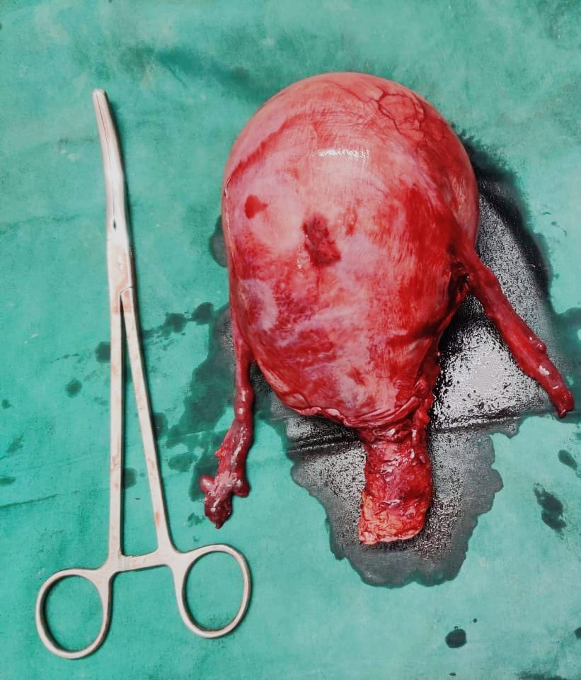

Figure 3: Gross photograph of the intact hysterectomy specimen showing a markedly enlarged uterus with bilateral fallopian tubes and cervix prior to dissection.

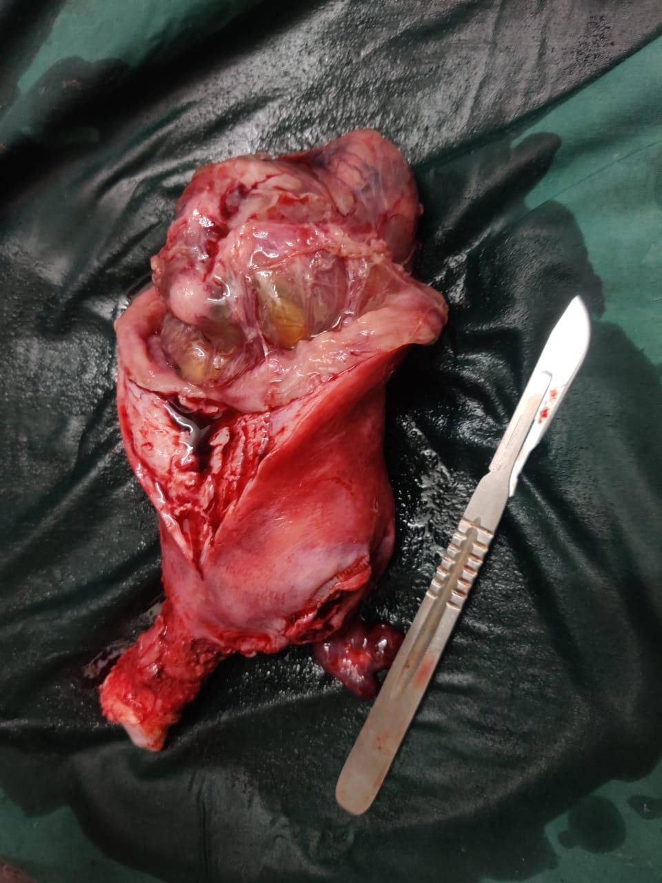

Figure 4: Sectioned uterine specimen showing multiloculated cystic areas with yellowish fluid-filled compartments, closely mimicking hydatidiform cystic degeneration.

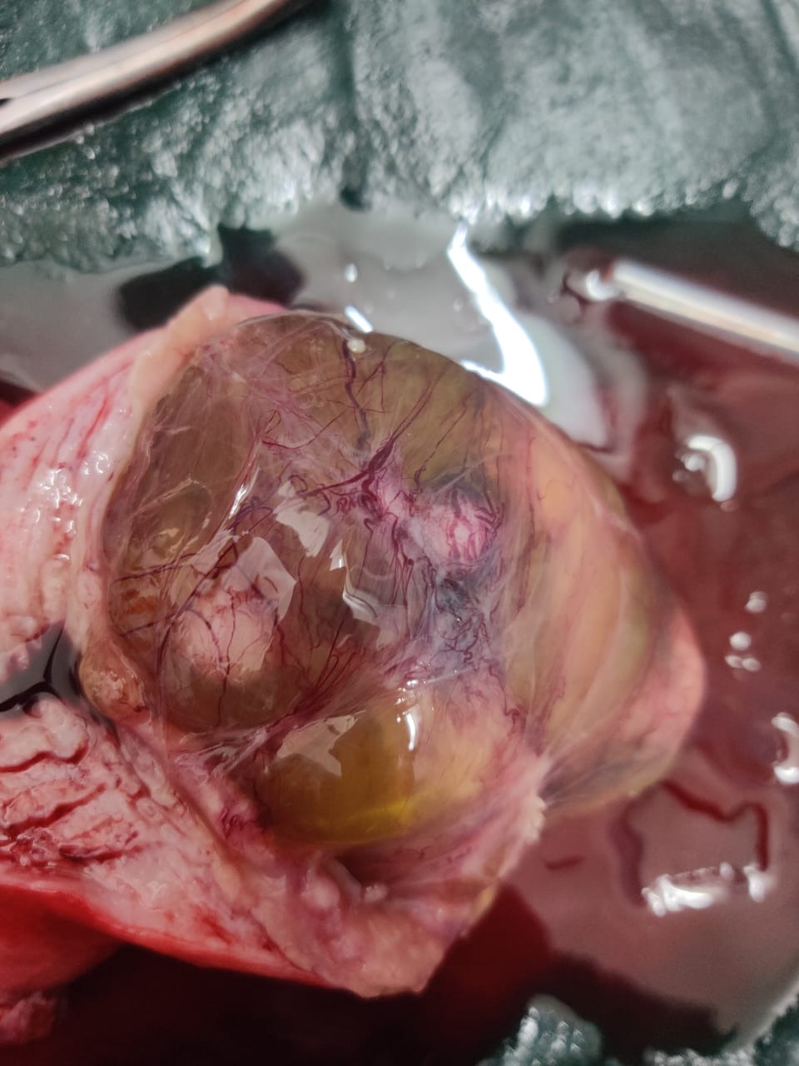

Figure 5: Close-up intraoperative image showing multiloculated fluid-filled cysts within the uterine mass, with prominent vascular markings on the cyst wall suggestive of hydropic degeneration mimicking hydatid cyst morphology.

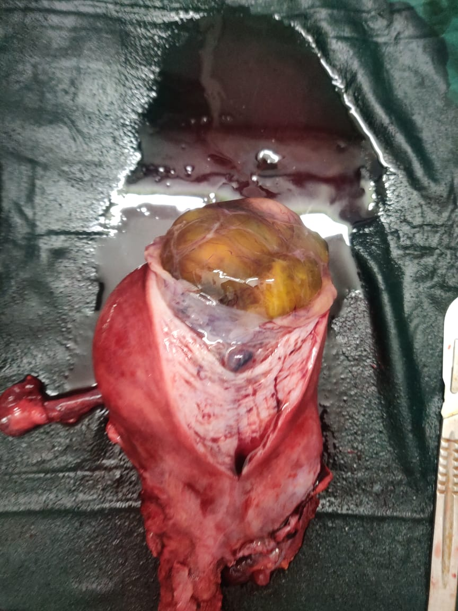

Figure 6: Gross surgical specimen showing uterus with a large cystic mass exhibiting clear, yellowish fluid and thin-walled membranes resembling hydatidiform cystic degeneration.

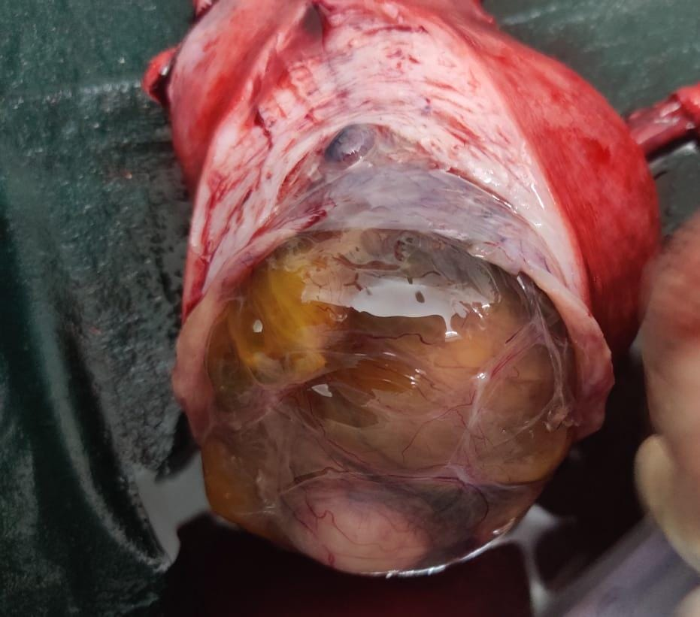

Figure 7: Close-up view of the cystic mass revealing thin vascular membranes and yellowish clear fluid within the uterine specimen, supporting gross suspicion of hydropic or hydatidiform morphology.

**Discussion**

Uterine leiomyomas are the most commonly encountered benign smooth muscle tumors in women of reproductive age, with an estimated prevalence ranging from twenty to forty percent in this demographic **[7]**. Most fibroids are asymptomatic and are incidentally detected during imaging or routine gynecologic examination **[8]**. However, when symptomatic, they may present with menstrual irregularities, pelvic pressure, infertility, or acute pain due to degeneration **[9]**. Among the various types of degenerative changes that fibroids may undergo, cystic degeneration is one of the rarer forms, seen in less than four percent of cases. Cystic degeneration results from inadequate blood supply to the tumor, leading to liquefactive changes in the fibroid stroma **[10]**.

While the imaging characteristics of typical fibroids are well recognized, cystic degeneration can significantly alter their ultrasonographic appearance. These changes may mimic ovarian cysts, adnexal masses, or in rare cases, parasitic infections such as hydatid cysts **[11]**. In the present case, the ultrasound findings of a large, multiseptated, mixed solid-cystic lesion arising from the uterine fundus raised suspicion for either a degenerating fibroid or an echinococcal cyst, especially given the presence of multiple internal fluid-filled compartments resembling daughter cysts **[12]**.

Hydatid disease, caused by the larval stage of Echinococcus granulosus, is a zoonotic parasitic infection endemic in sheep- and cattle-rearing areas. The liver and lungs are the most frequently involved organs, with uterine involvement being extremely rare **[13]**. Only a few cases of isolated uterine hydatid cysts have been reported in the literature, and most of these have been diagnosed intraoperatively or on histopathological examination. The present case is noteworthy in that the patient had significant epidemiological risk factors including regular exposure to domestic dogs and cattle in a rural setting. Furthermore, the gross appearance of the uterine mass with multiple cystic areas containing eosinophilic fluid closely mimicked that of a hydatid cyst **[14,15]**.

Histopathological examination revealed typical features of leiomyoma with cystic degeneration, and although eosinophilic material and bacterial colonies were noted, definitive features such as scolices, hooklets, or laminated membranes were absent. This lack of confirmatory histological evidence precluded a definitive diagnosis of echinococcosis **[16]**. Nonetheless, given the potential for false negatives due to degeneration or secondary infection of parasitic material, and considering the patient's exposure risk, empirical antihelminthic therapy with albendazole was administered. The patient’s clinical condition remained stable postoperatively, and follow-up imaging did not reveal any recurrence or other hydatid lesions in the body **[17]**.

This case underscores the diagnostic challenge posed by atypical presentations of common pathologies in endemic regions. In areas where hydatid disease is prevalent, physicians must maintain a high index of suspicion when encountering unusual cystic pelvic masses. At the same time, careful correlation of imaging findings with histopathology and clinical history is essential to avoid overtreatment or misdiagnosis **[18]**. The role of a multidisciplinary approach involving radiologists, pathologists, and clinicians is particularly crucial in resolving such diagnostic dilemmas. Additionally, this case illustrates the utility of initiating empirical therapy in situations where clinical and histological findings suggest, but do not confirm, a parasitic etiology **[19]**.

The rarity of uterine hydatid disease and the overlapping features with degenerative fibroids highlight the need for thorough evaluation, especially in patients with relevant exposure histories. Although surgical excision remains the mainstay of treatment for both conditions, the adjunct use of anti-parasitic medication may be justified in select cases where ambiguity exists **[20]**.

**Conclusion**

This case illustrates a rare and diagnostically challenging presentation of a large cystically degenerated uterine fibroid that closely mimicked a hydatid cyst, both radiologically and grossly. The diagnostic dilemma was compounded by the patient's epidemiological background, which included regular exposure to dogs and livestock in a rural setting, raising legitimate concerns for echinococcosis. Despite the absence of definitive histopathological features of a hydatid cyst, the presence of eosinophilic granular material and complex cystic morphology necessitated empirical anti-parasitic treatment and thorough systemic evaluation. This case emphasizes the importance of considering atypical presentations and maintaining a broad differential diagnosis in endemic regions. A multidisciplinary approach, careful correlation of imaging, histopathology, and clinical history, along with prompt surgical and medical intervention, is essential in effectively managing such rare mimics and ensuring favorable outcomes.

COMPETING INTERESTS DISCLAIMER:

Authors have declared that they have no known competing financial interests OR non-financial interests OR personal relationships that could have appeared to influence the work reported in this paper.

**References**

1. Kakaei F, Asvadi Kermani T, Tarvirdizade K. A case report: Primary hydatid cyst of uterus. Int J Surg Case Rep. 2018;42:67-69. doi: 10.1016/j.ijscr.2017.10.068. Epub 2017 Dec 1. PMID: 29248836; PMCID: PMC5985249.
2. Bouknani N, Kassimi M, Saibari RC, Fareh M, Mahi M, Rami A. Hydatid cyst of the uterus: Very rare location. Radiol Case Rep. 2022 Dec 22;18(3):882-885. doi: 10.1016/j.radcr.2022.10.068. PMID: 36589497; PMCID: PMC9798129.
3. Ennaceur F, Toumi D, Jaouad F, Mabrouk A, Hajji A, Gara M, Chamakh A, Zouari I, Maatouk M, Daldoul S, Sayari S, Haouet K, Safta YB, Faleh R, Moussa MB. Primary Echinococcus Hydatid Cyst of the Uterus: An Unusual Location. Case Rep Surg. 2021 May 21;2021:9977326. doi: 10.1155/2021/9977326. PMID: 34094614; PMCID: PMC8163547.
4. Loukil I, Zouari A. Kyste hydatique utérin: localisation rare [Hydatid cyst of the uterus: a rare localization]. Pan Afr Med J. 2021 Aug 26;39:272. French. doi: 10.11604/pamj.2021.39.272.29631. PMID: 34754349; PMCID: PMC8556726.
5. Hammouda SB, Njima M, Hadhri R, Zakhama A. Incidentally diagnosed hydatid cyst of uterus. Eur J Obstet Gynecol Reprod Biol. 2020 Dec;255:267-268. doi: 10.1016/j.ejogrb.2020.10.029. Epub 2020 Oct 16. PMID: 33097310.
6. Başgül A, Kavak ZN, Gökaslan H, Küllü S. Hydatid cyst of the uterus. Infect Dis Obstet Gynecol. 2002;10(2):67-70. doi: 10.1155/S1064744902000042. PMID: 12530482; PMCID: PMC1784608.
7. Beyhan YE, Yılmaz H, Taş Cengiz Z, Yıldızhan R, Kotan Ç, Batur A, Bayram İ, Erten R, Halidi AG. A Rare Case of Secondary Hydatid Cyst: Uterus and Colon Locations in the Same Patient. Turkiye Parazitol Derg. 2019 Sep 10;43(3):149-151. doi: 10.4274/tpd.galenos.2019.6303. PMID: 31502806.
8. Alloun M, Alomar K, Shaker K, Maidaa AN, Alabed Z, Dalati H. A rare case of an isolated primary hydatid cyst in the uterus in a 7-year-old child: Case report and review of the literature. Int J Surg Case Rep. 2023 Dec;113:109077. doi: 10.1016/j.ijscr.2023.109077. Epub 2023 Nov 23. PMID: 38006741; PMCID: PMC10709489.
9. Komongui DG, Diouf A, Dao B, Gentile B, Bah MD, Diadhiou F. Kyste hydatique de l'utérus (a propos d'un cas observé à la clinique gynécologique et obstétricale du C.H.U. de Dakar [Hydatid cyst of the uterus (apropos of a case seen at the gynecologic and obstetrical clinic of the C.H.U. of Dakar)]. Dakar Med. 1990;35(2):162-7. French. PMID: 2135788.
10. Arslan B, Sonmez O. Diagnosis of a Ruptured Pulmonary Hydatid Cyst in a 26-Week Pregnant Female With Bedside Lung Ultrasound in Emergency (BLUE) Protocol: A Case Report. Cureus. 2022 May 28;14(5):e25431. doi: 10.7759/cureus.25431. PMID: 35774713; PMCID: PMC9236701.
11. Dugar D, Mahobi HS, Saha A, Mohanty D. Primary hydatid disease of fallopian tubes: the risk of infertility looms large. Ann Parasitol. 2021;67(4):813-815. doi: 10.17420/ap6704.400. PMID: 35339121.
12. Brezeanu AM, Brezeanu D, Tica VI. An unexpected case of an adnexal hydatid cyst in a pregnant woman: a case report. J Med Case Rep. 2024 Jul 7;18(1):312. doi: 10.1186/s13256-024-04640-x. PMID: 38971794; PMCID: PMC11227696.
13. Abd-el-Maeboud KH. Hydatid cyst of Morgagni: any impact on fertility? J Obstet Gynaecol Res. 1997 Oct;23(5):427-31. doi: 10.1111/j.1447-0756.1997.tb00868.x. PMID: 9392907.
14. Tekin AF, Yilmaz H, Kara T, Seçkin E, Aybay MN, Alkan E. A very rare case: Hydatid cyst surrounding uterus and magnetic resonance imaging findings in the pregnant patient. Radiol Case Rep. 2018 Nov 2;14(2):168-170. doi: 10.1016/j.radcr.2018.09.020. PMID: 30416638; PMCID: PMC6223230.
15. HAGBERG CJ, MAIZELS G. Solitary hydatid cyst of the uterus. S Afr Med J. 1954 Jun 12;28(24):499-500. PMID: 13178812.
16. Terek MC, Ayan C, Ulukuş M, Zekioğlu O, Ozkinay E, Erhan Y. Primary pelvic hydatid cyst. Arch Gynecol Obstet. 2000 Sep;264(2):93-6. doi: 10.1007/s004040000068. PMID: 11045332.
17. Rajbhandary S, Bista KD, Bajracharya S, Shrestha P, Mallik P. Primary Solitary Uterine Hydatid Cyst Mimicking an Intramyometrial Cyst: A Case Report. JNMA J Nepal Med Assoc. 2024 Mar 31;62(272):272-274. doi: 10.31729/jnma.8536. PMID: 39356847; PMCID: PMC11025491.
18. BOLOT F. Kyste hydatique de l'utérus [Hydatid cyst of the uterus]. Mars Chir. 1951 Nov-Dec;3(5):643-4. Undetermined Language. PMID: 14928795.
19. VASCONCELOS FP. Um caso de quisto hidático primitivo do útero [A case of primary hydatid cyst of the uterus]. J Med (Oporto). 1954 Feb 20;23(578):479. Undetermined Language. PMID: 13142808.
20. Görgen H, Api M, Cetin A. Primary adnexial hydatid cyst mimicking ovarian tumor. J Turk Ger Gynecol Assoc. 2009 Dec 1;10(4):232-4. PMID: 24591878; PMCID: PMC3939171.