**Original Research Article**

**Machine Translation Errors Identification and Pre-editing Strategies in Chinese-to-English Translation of Pharmaceutical Instructions**

**Abstract**

With the increasing share of Chinese drugs in the international market, the translation quality of instructions has become an important factor affecting the internationalization of Chinese drugs. In recent years, machine translation has been widely used in the field of pharmaceutical instructions translation. However, its translation quality is sometimes unreliable and errors occur frequently, which brings potential risks to the accurate use and safety supervision of drugs. In this study, a total of 50 Chinese pharmaceutical instructions and their corresponding English translations were selected by convenient sampling method. Based on the Multidimensional Quality Metrics (MQM) model, this study classifies and analyzes the common errors in the machine translation of Chinese pharmaceutical instructions. The findings show that the errors of Chinese pharmaceutical instructions are mainly concentrated in three aspects: terminology, accuracy and fluency. In response to the above issues, this thesis proposes six pre-editing strategies: explanation, terminology standardization, annotation, word order adjustment, omission, and addition. It is hoped to improve the quality of machine translation of Chinese pharmaceutical instructions to better meet the international market demand.

**Key Words**:*Machine translation, pre-editing strategies, pharmaceutical instructions, Chinese-English translation*

**1.Introduction**

As has been the case with the process of globalization, global cooperation in the drug business between countries and global trade in medicine have been common, and translation requirements of pharmaceutical instructions into multiple languages have been increasingly needed. Meanwhile, as artificial intelligence has been developing rapidly, the application of machine translation in medicine has been widespread as well. Notably, machine translation was used on a large scale in Chinese-English and English-Chinese pharmaceutical instruction translation. Because drug texts are highly technical in nature with characteristics of technical terms, standard format, and specific content, the reliability of translation is of prime concern.

While machine translation can improve translation efficiency, it is still prone to comparatively high error rates when applied to pharmaceutical instructions, which affects drug safety and therapeutic action. Hence, learning how to optimize the quality of source texts and reduce machine translation errors is of immense practical value and importance. At the same time, as China’s pharmaceutical industry continues to go global, improving the accuracy and standardization of translations of pharmaceutical instructions not only meets international standards in the field of medicine but also plays an important role in advancing the internationalization of Chinese drug products. Therefore, this research attempts to improve Chinese-English pharmaceutical instruction machine translation through an in-depth analysis of the types of errors and pre-editing methods. It mainly addresses the following two questions:

RQ1.What are the common errors in the machine translation of pharmaceutical instructions from Chinese to English?

RQ2.How to reduce the errors in the machine translation of pharmaceutical instructions via pre-editing strategies?

**2. Previous Studies on the Pre-editing Strategies in Machine Translation**

Artificial intelligence drives the rapid development of translation technology and promotes disruptive changes in the language service industry (Wang & Liu, 2021). Computer-aided translation software has significant advantages in improving the translation speed and quality of translators, and its application research has attracted the attention of the industry (Liu, 2021). In such an environment, computer-aided translation has become a widely accepted working mode in the language service industry, and human-computer interaction has also become the mainstream mode of current and future professional translation (Wang, 2020). The translator’s rational use of machine translation can appropriately reduce the translation burden and improve the translation efficiency. However, the translation quality of machine translation still cannot reach the level of manual translation of professional translators (Cui, 2014). There are a large number of texts lacking coherence and ambiguity in machine translation. In order to further improve the quality of the translation, it is particularly necessary to manually participate in the translation editing (Zhao, 2023).

The low quality of machine translation is due to the frequent occurrence of error types. Although machine translation can maximize the equivalence with the original information, there are prominent issues in the types of errors such as ‘inappropriate terminology’, ‘inaccurate information’, ‘unsmooth translation’ and ‘ irregular grammar’ (Yang & Leng, 2024). In his research, Wang (2023) points out that when machine translation is used in Chinese-English translation of literary texts, translation errors are manifested in various aspects of vocabulary, syntax and discourse. Machine translation is not satisfactory and cannot completely replace manual translation.

Machine translation is used in some relatively limited professional fields, such as medical literature, legal texts, etc. However, the quality of machine translation has been criticized (Zeng & Wang, 2020). In view of the shortcomings in the above research, this study proposes innovation, aiming to make up for the shortcomings of existing research by improving the quality of machine translation and reducing errors. Under the guidance of MQM error theory, this study examines the errors existing in the quality of DeepL machine translation, so as to further improve the quality of machine translation and reduce the occurrence of translation errors.

The study found that after machine translation of the pre-editing original text, fewer errors need to be corrected in the output of the original translation (Wang, 2024). Alarcón and Matínez (2016) evaluated the effectiveness of pre-editing rules by analyzing the errors in the translation of English news texts into Spanish. LADD (2009) also supported this view in its experimental evaluation, believing that pre-editing is an effective means to improve the quality of machine translation.For the strategy of pre-editing, Hu (2012) discussed and put forward pre-editing strategies including reordering, adding elements, omitting elements, compiling in advance, segmentation, rewriting, paraphrasing, abbreviation and re-marking sentences. Taking Patient Zero: A Curious History of the World ’s Worst Diseases as an example, Liang (2023) discussed the role of pre-editing in machine translation of medical popular science texts, and proposed pre-editing strategies such as term base production, synonym substitution, addition of modifiers, pre-editing, reordering, pronoun restoration, splitting and rewriting. Cao and Ma (2018) analyzed the role of pre-editing in dealing with machine translation of news releases, and proposed that the methods of pre-editing include supplement, omission and adjustment of word order.

However, the research on pre-editing is mostly biased towards English-Chinese translation (Gui & Yang, 2022), and there are few studies on the pre-editing methods of the style of pharmaceutical instructions at home and abroad, especially the pre-editing strategies of Chinese-English translation of pharmaceutical instructions. Among them, the research on the translation of pharmaceutical instructions focuses on the English translation of Chinese patent medicine instructions. Lin, Zhou and Li (2010) took the Chinese-English translation of domestic pharmaceutical instructions as an example to discuss and analyze the types of errors. Taking the translation of Chinese patent medicine instructions as an example, Liu (2021) discussed the application of the ‘PE + MT + CAT + PE’ translation model to the English translation of Chinese patent medicine instructions, and proposed pre-editing strategies such as fixed format, supplementing sentence missing components, and adjusting word order.

By summarizing effective pre-editing strategies, the accuracy and efficiency of machine translation can be improved, so as to ensure that patients can accurately understand the information of drug use and ensure the safety of drug use. It is of great significance to promote the accurate dissemination of global drug information and improve the quality of cross-cultural communication.

**3. Previous Studies on the Translation of Pharmaceutical Instructions**

The translation study of pharmaceutical instructions involves a variety of theoretical frameworks and translation strategies, aiming to solve the issues of accuracy and readability of professional texts. Zhang (2024) used Nord’s text analysis model to explore the translation of passive voice, medical terms and amphibious vocabulary of pharmaceutical instructions from the perspective of intratextual and extratextual factors, and proposed to improve the quality of translation through standardization and free translation strategies. Based on the theory of eco-translatology, Shi (2023) analyzed three Chinese translation methods of passive voice, emphasizing the adaptive selection of language dimension, cultural dimension and communicative dimension. Under the guidance of Translation Variation Theory, Wang (2023) proposed to meet the needs of specific readers through adaptation strategies such as amplification and omission, which highlights the flexibility of pharmaceutical instructions translation. These studies together show that the choice of theoretical framework has important guiding significance for solving syntactic and terminological issues in the translation of pharmaceutical instructions.

The translation of pharmaceutical instructions not only needs language transformation, but also needs to take into account cultural differences and audience needs. Li and Tan (2023), taking the Olaparib film instructions as an example, pointed out the performance of the translator’s subjectivity in three aspects: ‘self-reliance, passivity and initiative’, and emphasized that the translator’s dynamic adjustment is very important for the transmission of medical information. Cheng and Wang (2021) focused on the instructions of Chinese patent medicines and found that the four-character expressions and culture-loaded words unique to TCM need to be processed through strategies such as annotation and domestication under the guidance of teleology to ensure the understanding of international readers. Wang (2020) further proposed that the English translation of TCM instructions should be combined with context theory to balance the standardization of the original text and the habits of the target language. These studies reveal the core role of acculturation and translator’s subjectivity in cross-cultural medical communication.

The translation of pharmaceutical instructions should strictly follow professional norms and pay attention to functional objectives. Under the guidance of teleology, Hu (2023) proposed strategies such as loan translation, transliteration and formal subject conversion for difficulties such as terms and non-subject sentences, emphasizing that the translation should conform to the cognitive habits of target readers. Wang (2016), taking Gongxuening Capsule as an example, also based on Skopostheorie, proposes that functionalist translation strategies should give priority to the communicative purpose of the text. In addition, Mitka (2007) pointed out that the negligence in the translation of drug instructions may threaten the safety of patients, so lexical and syntactic transformations need to be treated rigorously. These studies jointly call for the establishment of a standardized translation process to ensure the accurate transmission of medical information and the smooth development of international drug trade.

**4. Methods**

Qualitative methods are employed in this study to explore Chinese-English machine translation of pharmaceutical instructions error types and pre-editing methods. By closely reading the text, qualitative methods can facilitate a deeper understanding of internal structure and linguistic features rather than quantitative data presentation. As pharmaceutical instructions contain highly specific terminologies and complex sentence structures, machine translation errors in such kinds of texts should be complex and diversified. By using qualitative analysis, it is possible to identify specific error types and provide pragmatic solutions on how to pre-editing, which can enhance translation quality.

As for data collection, this study used convenience sampling method. It was a non-probabilistic sampling method in which researchers select samples based on availability and convenience, rather than random or stratified sampling (Sudman, 1976). A total of 10 Chinese pharmaceutical instructions and their English translations were selected from the official medical websites. DeepL was selected as the machine translation due to its high accuracy and professionalism in the field of medical text translation, and the neural network model can better deal with medical terms and fixed expressions.

In the data analysis phase, this study utilized the Multidimensional Quality Metrics (MQM) framework which is a flexible system for evaluating the quality of translated texts. According to this framework, errors were mainly categorized into accuracy, fluency, terminology, style, locale, convention, and other source error (Lori Thicke & Arle Lommel, 2012). Under each of such broad categories, there existed more specific subcategories and descriptions, as listed in Table 1. In order to facilitate such analysis, the present research constructed a Chinese-English Parallel dataset of ten pharmaceutical instructions. By comparing the Chinese original text and two English translations, a reference translation and one DeepL translation, the present research identified a variety of error types that emerged in translation. Based on these identified errors, the study proposed a set of pre-editing strategies aiming at reducing such errors in machine translation of pharmaceutical instructions.

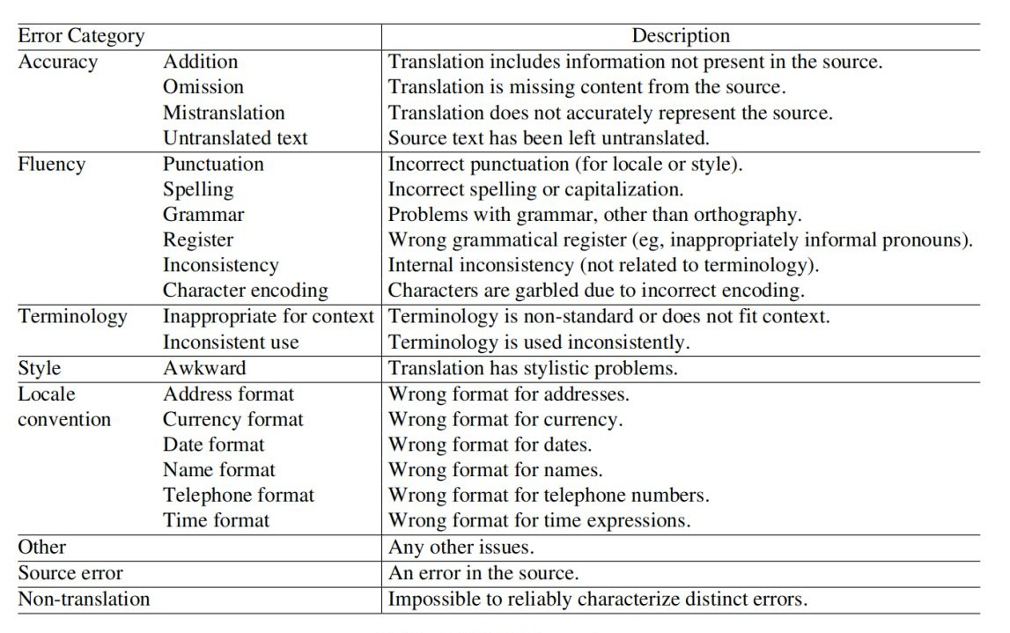

**Table 1 MQM Framework**

1. **Error Types Identification in the Translation Process**

In the process of Chinese-English machine translation of pharmaceutical instructions, the identification of error types and the formulation of pre-editing strategies are the key links to improve the quality of translation. Error types not only affect the professionalism and readability of the translation, but also may pose potential risks to the safety of drug use and the effectiveness of information transmission. The proposed pre-editing strategies would help to reduce the error rate of machine translation and improve the overall translation quality.

Based on MQM, this study identified a total of 376 errors in DeepL translation, which were categorized into teminology, accuracy and fluency errors, as illustrated in Figure 1. Specifically, terminology errors accounted for 43%, accuracy errors for 32%, Fluency errors for 25% of the total errors. These three error types collectively formed the focal of the data analysis.

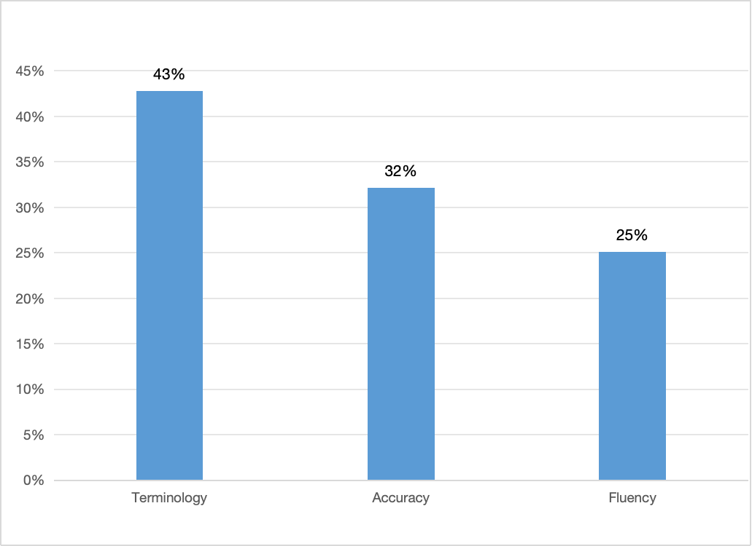

**Figure 1 MQM Error Counts in DeepL**

According to the MQM framework, terminology errors are mainly categorized into two subtypes: inappropriate for context and inconsistent use. In this study, it was found that there were 107 inappropriate terminology errors and 55 inconsistent ones. An example of inappropriate context can be found in the word‘益气活血’, which is translated into ‘Replenishes Qi, activates blood circulation’ by DeepL. This translation lacks semantic depth, as it does not convey the original meaning in the context of TCM. Within the conceptual framework of TCM,‘益气’refers to the function of tonifying qi and enhancing qi, and a more accurate translation should be ‘tonifies Qi’. ‘Tonify’ is a medical term commonly used in TCM, referring to the enhancement or supplementation of body functions, such as qi, blood, yin and yang, through drugs or therapies.

As for accuracy errors, they are mainly categorized into four subtypes: addition, omission, mistranslation, and untranslated text. In this study, it was found that there were 20 addition, 16 omission, 80 mistranslation and 4 untranslated text. Through analysis, it was found that the concept of syndrome differentiation and treatment unique to traditional Chinese medicine is often simply corresponding to the description of western medicine symptoms. An example of mistranslation can be found in the phrase‘消暑利湿’,which is translated into ‘relieve summer heat and promote dampness’ by DeepL. This translation is misleading, as it fails to convey the intended meaning within the context of TCM. In TCM, ‘利湿’ refers to the process of eliminating excess moisture from the body to achieve effects such as clearing internal heat, resolving phlegm, and promoting diuresis.

Fluency errors are mainly divided into six subtypes: punctuation, spelling, grammar, register, inconsistency, and character encoding. In this study, it was found that there were 15 punctuation, 10 spelling, 12 grammar, 11 register, 46 inconsistency,. An case of grammatical errors is in the sentence ‘服药后请勿驾驶车辆’, which is translated by DeepL as ‘after taking medicine please do not drive vehicles’. This kind of translation contains a word order error, as it does not follow the conventional English syntax for negative constructions, hence weakening the intended warning. According to standard English warning norms, negative words are usually placed in a fronted position to convey urgency and emphasis.

**6. Pre-editing Strategies in Translating Pharmaceutical Instructions from Chinese to English**

According to the aforementioned common errors in the DeepL translation, this study proposed a set of pre-editing strategies from the aspects of terminology, accuracy and fluency errors.

**6.1 Pre-editing Strategies in Terminology Errors**

The pre-editing strategies for terminology errors include explanation, terminology standardization, and annotations. Explanation is to make implicit, vague, or culturally embedded information in the source text explicit in the pre-translation process. Terminology standardization refers to replacing synonymous or inconsistent expressions with domain-approved terminology. Additionally, use of domain-specific glossaries or annotations is to enhance translation fidelity. Here are some examples.

**Example 1**

**Source text:** 辛凉解表

**DeepL translation:** Releases exterior with pungent-cool herbs

**Pre-edited source text:** 性味辛凉的药物解除风热表证

**DeepL translation after pre-editing:** pungent and cooling medicine to resolve wind-heat symptoms

**Reference translation:**resolving exterior with coolness and acridity

In example 1, ‘辛凉解表’ is the core treatment of Wind-Heat Exterior Syndrome in TCM. It refers to the use of pungent-cool drugs to relieve wind-heat pathogens on the surface by sweating and dispelling wind-heat. DeepL translates‘辛凉解表’as ‘releases exterior with pungent-cool herbs’ without conveying the logic of TCM treatment. In English, ‘release’ refers to physical release, which has nothing to do with the treatment of traditional Chinese medicine and is inconsistent with the context of TCM. Pungent drugs have the effects of dispersing, promoting *qi*, and penetrating the surface. Cool drugs can clear heat and reduce fire.

In the context of pathogenic heat, the pathological basis of‘解表’(relieving the exterior) lies in the invasion of wind-heat pathogens into the body’s surface defense system, leading to an imbalance between *Ying* (nutritive *qi*) and *Wei* (defensive *qi*). *Wei qi*, or defensive energy, is responsible for protecting the body’s exterior. When disrupted, it can result in symptoms such as fever, chills, and spontaneous sweating.The treatment goal is to restore the normal function of *Wei qi* by sweating and expelling the invading pathogens. Through explanation, the original text is interpreted as a machine-translatable and contextually appropriate sentence, ensuring that the use of terms aligns with the intended meaning.

**Example 2**

**Source text:** 川贝母

**DeepL translation:** Sichuan fritillary bulb

**Pre-edited source text:** Bulbus Fritillaria cirrhosa

**DeepL translation after pre-editing:** Bulbus Fritillariae Cirrhosae

**Reference translation:** Bulbus Fritillaria cirrhosa

In Example 2, ‘川贝母’ is translated by DeepL as ‘Sichuan fritillary bulb’. In this translation, ‘川’ is mistranslated as a geographical indicator referring to Sichuan Province, while ‘贝母’ is rendered as a plant with bell-shaped flowers. However, in TCM, ‘川贝母’ refers to a specific medicinal herb used to clear heat and moisten the lungs. The correct and standardized term in the medical domain is Bulbus Fritillariae Cirrhosae. To ensure terminological consistency and avoid ambiguity, terminology standardization is essential, as it helps machine translation systems maintain lexical stability and produce accurate outputs in specialized contexts.

**Example 3**

**Source text:** 夏枯草

**DeepL translation:** Prunella vulgaris

**Pre-edited source text:** 夏枯草（中药材：Spica Prunellae）

**DeepL translation after pre-editing:** Xia Ku Cao (Chinese herb: Spica Prunellae)

**Reference translation:** Spica Prunellae

In example 3, ‘夏枯草’ (pinyin: *Xia Ku Cao)* is translated by DeepL as ‘prunella vulgaris’. This botanical term is technically correct from a taxonomical perspective, but it fails to present the specific meaning and usage of *Xia Ku Cao* in the context of TCM. In TCM, *Xia Ku Cao* refers to the dried spike of the herb Prunella vulgaris, rather than the whole plant. It endows with medicinal properties and is traditionally used to clear heat and toxin, alleviate liver-related discomfort and soothe coughing. The correct English term for it is Spica Prunellae. To address this type of terminological error, domain-specific annotation “夏枯草（中药材：Spica Prunellae)” is used during the pre-editing process. Such annotation provides disambiguating context that guides the machine translation system toward contextually appropriate and accurate renderings.

**6.2 Pre-editing Strategies in Accuracy Errors**

The pre-editing strategies for accuracy errors mainly rely on explanation, which is a useful way to make culturally or contextually implied meanings explicit. This strategy is particularly important in enabling machine translation system to produce more accurate translation. The following examples illustrate this.

**Example 4**

**Source text:** 活血祛瘀、通脉活络

**DeepL translation:** Promotes blood circulation, removes blood stasis, unblocks collaterals

**Pre-edited source text:**促进血液循环和消除血瘀，疏通经脉和畅通络脉

**DeepL translation after pre-editing:** Activates blood circulation and resolves blood stasis, dredges meridians and unblocks collaterals

**Reference translation:** Activate blood and remove stasis, unblock meridians and activate collaterals

In Example 4,‘活血祛瘀’is the treatment of blood state, which is embodied in improving circulating blood and eliminating stasis. ‘通脉活络’ belongs to the treatment of vascular system, which is reflected in dredging the trunk, activating the branches, and reflecting the treatment concept of‘气血同治’in traditional Chinese medicine. DeepL mistranslated‘通脉活络’into‘unblocks collaterals’, which confused the hierarchical relationship between‘经脉’and‘络脉’. Through explanation, the study clarifies the implicit information in the original text as “促进血液循环和消除血瘀，疏通经脉和畅通络脉”. Such strategy not only conveys the treatment principles of TCM, but also clearly expresses the relationship between meridians (*jing*) and collaterals (*luo*).

**Example 5**

**Source text:** 风湿在表之痹证

**DeepL translation:** wind-damp obstruction syndrome

**Pre-edited source text:** 外感风湿导致的关节肌肉疼痛综合征

**DeepL translation after pre-editing:** Joint muscle pain syndrome caused by exogenous rheumatism

**Reference translation:** exogenous wind-dampness syndrome

In Example 5,‘风湿在表’clearly points out that the cause of the disease is rheumatism and the location of the disease is on the body surface;‘痹证’is a unique pathological concept of traditional Chinese medicine, which refers to the pain symptoms caused by qi and blood obstruction of meridians. DeepL translates‘痹证’into ‘obstruction’, which fails to accurately express the pain characteristics of ‘痹证’, and then omits the disease location information of‘在表’. Through explanation, the‘外感’corresponding to the‘在表’of the source text is retained, the disease location is clarified, and the‘关节肌肉疼痛综合征’accurately summarizes the symptom characteristics. The overall expression is not only in line with the theory of traditional Chinese medicine but also easy to understand.

**Example 6**

**Source text:** 脉微涩而紧

**DeepL translation:** slightly choppy-tight pulse

**Pre-edited source text:** 脉细弱不畅而紧

**DeepL translation after pre-editing:** weak, not smooth and tight pulse

**Reference translation:** tight and a bit rough pulse.

In Example 6, ‘脉微涩而紧’contains three kinds of pulse information: ‘微’refers to weak pulse, deficiency of qi and blood;‘涩’refers to the pulse blood flow is not smooth, there is blood stasis;‘紧’means that the pulse is particularly tight, and the patient has a cold syndrome or pain syndrome. DeepL mistranslated ‘涩’ into ‘choppy’, and ‘choppy’ was a navigation term, losing the specificity of traditional Chinese medicine pulse. Through explanation,‘微’and‘涩’are interpreted as ‘细弱’and‘不畅’, and difficult terms about TCM pulse are edited into easy-to-understand words, which makes it easier for DeepL to better translate accurate and complete translations.

**6.3 Pre-editing Strategies in Fluency Errors**

The pre-editing strategies of fluency errors contain word order adjustment, omission, and addition. Word order adjustment is to adjust the sentence order according to the target language syntax and grammar. Omission refers to the deletion of synonymous repetition modifiers to meet the simplicity requirements of drug instructions. Addition includes supplementing implicit subject or object and adjusting voice to ensure the integrity and accuracy of sentence structure and effectively improve the fluency of translation. Here are some examples.

**Example7**

**Source text:** 每日三次，每次两片

**DeepL translation:** Daily three times, each two tablets

**Pre-edited source text:** 一次2片，一日3次

**DeepL translation after pre-editing:** 2 capsules each time, 3 times daily

**Reference translation:** 2 capsules each time, 3 times daily

In Example 7, the time adverbial ‘ daily ’ is wrongly limited to ‘ three times ’ rather than the whole administration behavior, which violates the standard expression of ‘verb + dose + frequency’ in English pharmaceutical instructions. Through adjusting the word order, the route of administration is supplemented to construct a complete sentence structure. Then, the word order is reconstructed according to the principle of ‘dose centered, frequency postposition’, and the standard sentence pattern of ‘X units, X times daily’ is formed.

**Example 8**

**Source text:** 服药后可能出现轻微的少许头晕

**DeepL translation:** After taking the medicine, slight minor dizziness may occur

**Pre-edited source text:** 服药后或现轻微头晕

**DeepL translation after pre-editing:** Slight dizziness may occur after taking the medicine

**Reference translation:** Mild dizziness may occur after taking this medication.

In Example 8 , the overlapping use of ‘slight’ and ‘minor’ as synonymous degree adverbs not only violates the EMA’s regulatory requirements for a single degree of modification of the description of adverse drug reactions, but also does not meet the basic principles of conciseness and accuracy in the WHO guidelines for the preparation of pharmaceutical instructions. Through omission, the redundant word ‘minor’ is deleted, and the most accurate ‘slight’ is retained as the only degree modifier. The word order is adjusted to highlight the core symptoms and make the expression more concise and accurate.

**Example 9**

**Source text :** 儿童必须在成人监护下使用

**DeepL translation :** Children must be used under adult supervision

**Pre-edited source text:**儿童必须在成人的监护下使用本品

**DeepL translation after pre-editing:**Adult supervision is required throughout pediatric medication

**Reference translation:** Pediatric use requires adult supervision.

In Example 9, the object ‘本品’ implied in the original Chinese sentence is not explicit, which leads to the machine mistaking ‘儿童’ as the action object, resulting in the ambiguity of children being used; the use of passive voice violates the international norms that pharmaceutical warnings should use active voice. Through addition, a ‘subject-predicate-object’ structure is established to reveal the implicit components in the Chinese pre-editing stage. Specifically, the adding of ‘本品’ helps to clarify the action object, hence reconstructing key grammatical elements that may be omitted in the original sentence.

After applying various pre-editing strategies to DeepL translations, the data indicates a significant improvement in translation quality. Terminology errors decreased from 43% to 8%, accuracy-related errors were reduced from 32% to 6%, and fluency errors dropped from 25% to 4%. These results demonstrate that pre-editing substantially enhances the overall performance of machine translation in specialized domains.

**7. Conclusion**

The objective of this research is to explore and analyze the pre-editing method and the kinds of errors in machine translation in Chinese-English pharmaceutical instruction translation. As part of research on the difficulties faced during translation with machine translation, this research summarizes common errors such as terminology errors, accuracy errors, and fluency errors and recommends related pre-editing methods.

This paper’s research verifies that the pre-editing method significantly determines the level of improvement in the machine translation error types, which actually increases translation quality, reduces misinterpretation and ambiguity, and increases the accuracy and readability of the pharmaceutical instructions during the internationalization process. It is able to continue researching other machine translation error types and enhance the translation outcome using additional specific pre-editing methods in the future in order to contribute more guidelines and instructions in the implementation of machine translation in the professional setting.

Funding Project: 2024 Guangxi Philosophy and Social Science Research (Project number (24WYL008)

**COMPETING INTERESTS DISCLAIMER:**

Authors have declared that they have no known competing financial interests OR non-financial interests OR personal relationships that could have appeared to influence the work reported in this paper.

References

1. Akbari Alireza & Segers Winibert.(2021).Evaluation of Translation through the Proposal of Error Typology: An Explanatory Attempt.Lebende Sprachen,66(1),198-198.
2. Arning, A& Seifert, R.(2024). Insufficient correctness of package inserts for psychotropic drugs in Germany. Naunyn-Schmiedeberg’s Archives of Pharmacology, 1-17.
3. Cao, Y., & Ma, Y. (2018). Pre-editing in Google’s Chinese–English machine translation: A case study of press releases on the Beijing Traditional Chinese Medicine Information Network. Overseas English, (15), 153–155.
4. Cheng, A. (2021). Translation strategies of traditional Chinese medicine instructions based on the English translation of Qingfei Paidu Decoction [On the translation strategies of TCM drug instructions from the English translation of the instructions for Qingfei Paidu Decoction]. Shizhen Traditional Chinese Medicine and Pharmacology, 32(6), 1534–1536.
5. Chung ling Shih.(2021).How to Empower Machine-Translation-to-Web Pre-Editing From the Perspective of Grice’s Cooperative Maxims.Theory and Practice in Language Studies,11(12),1554-1561.
6. Cui, Q. (2014). On post-editing in machine translation. Chinese Translators Journal, (6), 68–73.
7. Daems Joke,Vandepitte Sonia,Hartsuiker Robert J & Macken Lieve.(2017).Identifying the Machine Translation Error Types with the Greatest Impact on Post-editing Effort.Frontiers in psychology,1282.
8. Gui, T., & Yang, Z. (2023). Common errors in medical literature machine translation and pre-editing approaches: A case study of Google Translate. English Plaza, (13), 37–40.
9. Han, X., & Wang, F. (2023). A study on pre-editing in Chinese–English machine translation. China New Telecommunications, (2), 32–35+131.
10. Hu, X. (2023). A translation practice report on Chinese–English translation of drug instructions (Master’s thesis). Chengdu University of Technology.
11. Li, X., & Tan, Y. (2023). On translator subjectivity in the translation of imported drug instructions: A case study of Olaparib tablets. Overseas English, (10), 27–30.
12. Lin Ying & Zhou Yumei.(2011).Lexis in Chinese-English Translation of Drug Package Inserts: Corpus-based Error Analysis and Its Translation Strategies.International Journal of Biomedical Science,6(4),344.
13. Lin, Y., Zhou, Y., & Li, C. (2010). Analysis of typical errors and translation strategies in Chinese–English drug instruction translation. Forum of Science and Technology Associations, (3), 164–166.
14. Liu, T. (2021). A study on the translation of traditional Chinese medicine instructions under the PE+MT+CAT+PE assisted translation model (Master’s thesis). Jiangxi University of Traditional Chinese Medicine.
15. Mitka,M.(2007).For Non-English Speakers, Drug Label Instructions Can Be Lost in Translation.JAMA: The Journal of the American Medical Association,(23),2575-257.
16. PHILIP LADD.(2009). Pre-editing of machine translation input:An experimental evaluation. Multilingua-Journal of Cross-Cultural and Interlanguage Communication,(4), 217-224.
17. Sahar A,Tarek A&Raafat A.(2018).A Knowledge-Based Machine Translation Using AI Technique.International Journal of Software Innovation (3),79-92.
18. Shao, N. (2020). Error analysis and corresponding pre-editing and post-editing strategies in machine translation [Machine translation error example analysis and corresponding pre-translation and post-translation editing strategies] (Master’s thesis). Beijing International Studies University.
19. Shi, Y. (2023). A translation practice report on English–Chinese translation of passive voice in imported drug instructions [Imported English drug instructions in passive voice English-Chinese translation practice report] (Master’s thesis). Hebei University of Science and Technology.
20. Wang, H. (2020). Research on translation technology in the era of artificial intelligence. Foreign Languages ​​and Cultures, (1), 85.
21. Wang, H., & Wang, Y. (2023). A review of domestic research on computer-aided translation (1980–2021). Foreign Languages ​​and Literature, (2), 130–138.
22. Wang, J. (2023). Analysis of error types in Chinese–English machine translation. Overseas English, (15), 12–15.
23. Wang, X. (2016). Translation strategies for drug instructions: A case study of the English translation of “Gongxuening Capsule”. English Plaza, (5), 42–43.
24. Wang, X. (2023). A translation practice report on English–Chinese translation of drug instructions under the theory of transformative translation [English–Chinese translation of drug instructions under the guidance of transformative translation] (Master’s thesis). Xidian University.
25. Wang, X. (2024). A study of pre-editing strategies based on error types: A case study of Border Town under neural network translation. New Chu Culture, (21), 56–59.
26. Wang, Y. (2021). A study on English translation of external-use Chinese patent medicine instructions guided by relevance translation theory (Master’s thesis). Beijing University of Chinese Medicine.
27. Wang, Y., Liu, A., & Wu, Q. (2020). Research on the writing and English translation of external-use traditional Chinese medicine instructions. World Journal of Integrated Traditional and Western Medicine, 15(9), 1756–1760.
28. Wei, C. (2008). Preprocessing in machine translation. Forum of Science and Technology Associations, (9), 93–94.
29. Yang, B., & Leng, B. (2024). An empirical analysis of machine translation error types in professional texts based on the MQM quality assessment model. Journal of University of Shanghai for Science and Technology (Social Science Edition), 1–7.
30. Zeng, J., & Wang, Y. (2020). Error type analysis in English–Chinese machine translation: Based on medical corpus. Overseas English, (2), 39–41+47.
31. Zhang, Z. (2024). A translation practice report on Chinese–English drug instruction translation guided by Nord’s text analysis model (Master’s thesis). Xi’an International Studies University.
32. Zhao, Y. (2018). Exploring interactive translation strategies in Chinese–English machine translation [A Study on Interactive Translation Strategies in Chinese-English Machine Translation]. Overseas English, (17), 149–151.
33. Zheng Ying, Peng Chang & Mu Yuanyuan. (2022). Designing Controlled Chinese Rules for MT Pre-Editing of Product Description Text. International Journal of Translation, Interpretation, and Applied Linguistics (IJTIAL), 4(2), 1-13.