**SPECIES OF MACROFUNGI IN ALLEN, NORTHERN SAMAR**

**ABSTRACT**

This descriptive research was done to collect and identify the different macrofungi species present in the area; document the environmental parameters, such as air and soil temperature, soil pH, type of substrate, relative humidity, rainfall intensity, and vegetation; evaluate the economic uses of macrofungi; and, determine the anthropogenic activities affecting macrofungi in six barangays of Allen, Northern Samar, namely: Barangays Alejandro, Bonifacio, Cabacungan, Jubasan, Lipata, and Victoria.

A total of thirty-eight (38) macrofungi species were collected and identified. The air temperature was generally warm with an average of 24.7oC, soil temperature that ranged from 24oC to 25oC, and soil pH that was slightly alkaline. The substrates of the macrofungi species were on twigs, fences, decaying logs, coconut trunk, soil, and banana trunk and in clay loam soil. The humidity ranged from 89.6% to 95.8%, and all sampling sites have the same vegetation which were coconut plantation, grassland, and shrubs. Rainfall intensity based on secondary data, was an average of 56.5 mm in January and 19.51 mm in February, 2023.

There were only eight macrofungi species that were used for economic purposes, particularly for food. "Kaingin", deforestation, and urban area expansion are the anthropogenic activities in the sampling sites.

The results indicated that there is a diversity macrofungal species in the sampling areas and the environmental conditions were crucial for the growth and development of macrofungal species. The anthropogenic activities did impact macrofungal diversity.

The researcher recommends studying these macrofungi species further to learn more about their economic relevance and research for alternatives to mitigate the anthropogenic activities in the sampling sites.

______________________

***KEYWORDS****: macrofungi, inventory, economic utilization of macrofungi species, anthropogenic activities,*

**INTRODUCTION**

Macrofungi are huge fructifications visible to the unaided eye, and by the untrained sight, in contrast to microfungi which are made conspicuous by the sickness, rotting, and deformation they cause (Redhead, 1997). Although by definition they are visible to the naked eye, macrofungi are, like other fungi, microorganisms. They interact and compete with all manner of other microorganisms, and predators or browsers. Genetically, they generate masses of pharmaceutically active chemicals, such as antibiotics, anti- carcinogens, hormones, pheromones, toxin, carcinogens, enzymes, and pigments. Each species presents a unique combination of these features and therefore represents potential benefits (Redhead, 1997).

One of the most varied ecologies in the world may be found in the Philippines because of the country’s geographic isolation and perfect climate, thus, many of the country’s plants and animals, including macrofungi species, are endemic (Bhatt, 2018).

Macrofungi are still understudied in most parts of world (Mueller, 2006). Aesthetically, some macrofungi are among the most picturesque, colourful, and delicate formations in nature. Hence, the researchers were interested in documenting the species of macrofungi in the study area and hopefully establish baseline information on the different species of macrofungi, the environmental conditions and anthropogenic influences presentm and the economic utilization of these organisms in the Municipality of Aleen, Northern Samar, Philippines.

**Objectives of the Study**

Generally, the study sought to determine the macrofungi species present in Allen, Northern Samar. Specifically, it attempted to; (1) identify the different species of macrofungi in the study area; (2) document the economic uses of macrofungi species; (3) describe the environmental parameters during the time of sampling, such as: air temperature, soil temperature, soil pH, substrate, relative humidity, rainfall intensity, and vegetation; and, (4) enumerate the anthropogenic factors that influence macrofungi abundance and diversity.

**LITERATURE REVIEW**

Fungi touch our lives in many ways; they, together with bacteria, are the decomposers of the world, breaking down vast quantities of dead organic matter that would otherwise accumulate and make the earth uninhabitable. Their role as decomposers has its dark side, however, because they also cause spoilage of bread, fruits, vegetables, and other foodstuffs, and the deterioration of other goods, fabrics, paper, lumber, and other valuable products. Some fungi are parasitic on or in animals, including humans; many skin diseases, including ringworm and athlete’s foot, are caused by fungi and there are several serious diseases of the lungs caused by fungi (McFadden, 1998).

Mushrooms are fleshy fungi with high prospects for the production of secondary metabolites including extracellular enzymes with high agricultural and biotechnological significance. Worldwide, they are well recognized as supplementary foods due to their high nutritional value and their medicinal importance, which includes their uses in exhibiting antioxidant and antimicrobial activities, as immune enhancers, and to be effective for the treatment of several diseases including diabetes and few types of cancers as well. According to recent studies, extracellular enzymes produced by several white-rot fungal strains and several mushrooms have shown a high capacity to decolorize dyes that are very harmful for the environment. Moreover, wild macrofungi have the capability to synthesize nanoparticles which are more useful for the treatment of cancer, gene therapy, DNA analysis, and as biosensors. Wild macrofungi are extremely important models for basic biology and commercial manufacture (Singh, 2019).

Fungi, defined as eukaryotic heterotrophs devoid of chlorophyll, obtaining its nutrients by absorption, and reproducing by means of spores, are the most diverse organisms on earth (Kinge, 2017). Large fungi form visible fructifications, like Basidiomycota and Ascomycota, with large observable spore bearing structures. Ecologically, macrofungi are of three groups: the *saprophytes*, the *parasites*, and the *symbiotic* (*mycorrhizal*) species. Macrofungal diversity is an important component of the global diversity, particularly community diversity. Mushrooms are widespread in nature and they still remain the earliest form of fungi known to mankind (Kinge, 2017).

Only about 6.7% of the 1.5 million species of fungi estimated in the world have been described and these are mostly in temperate regions. The tropical region which has the highest fungal diversity has not been fully exploited (Kinge, 2017). Wild edible mushrooms play a key role in nutrition, and are one of the most important natural resources on which people of many nationalities rely on. The use of fungi for food and medicine goes back a long way in human history, but research and documentation of such knowledge are relatively new It is therefore crucial to document the diversity and ethnomycology of macrofungi communities. Hence, investigation of the mushroom species richness with the aim of producing a checklist of macrofungi and also to document the traditional knowledge of mushrooms in the communities, must be done (Kinge, 2017).

Mushrooms have been valuable sources of food and medicines, containing polysaccharides, proteins, crude fat, crude fiber, minerals, vitamins, triterpenoids, phenols, nucleotides and their derivatives, glycoproteins, and sterols. As natural medicine, mushrooms are utilized as alternative remedy for bronchitis, inflammation, flu, asthma arthritis, hypertension, diabetes, gastric ulcer, hepatitis, kidney failure, tumor, and cancer. Because of these advantages, wild edible mushrooms are being collected to rescue their cell lines in order to harness their potential in mushroom production (Liwanag, 2017).

The Philippines is a haven of diverse biological resources and remains one of the biodiversity hotspots in the planet. Many studies have been conducted on the inventory and survey of different species of plants, animals, insects, and marine organisms, but very limited investigations on mushrooms have been done (Liwanag, 2017).

The rapid expansion of human activities in recent years has resulted in a rise in air pollution and ecosystem degradation, both of which have significant negative effects on fungal communities. Environmental or pollution-related issues that have a more local or specific effect on fungi include deposition of various pollutants (including acid rain depositions) leading to soil modifications or contamination of water resources, accumulation of metals on substrates, presence of residues resulting from the widespread use of pesticides and fungicides primarily in agricultural lands, eutrophication, desertification, fragmentation of habitats resulting from forest cutting, urban extension, alterations in land uses and change of agricultural practices (Zervakis, 2007).

De Leon (2021), carried out a study to document macrofungi species in Paracelis, Mountain Province and the study's findings may shed light on their significance to the community. A total of 37 macrofungi belonging to 16 families, 26 genera, and 29 species were collected and identified. Twenty nine of the collected macrofungi were identified up to its species level and eight were only identified at its genus level. The collected samples were subjected to morphological identification based on its macroscopic and microscopic characteristics.

Local studies, particularly in the municipality of Palapag, Northern Samar, show that macrofungi thrive temperatures ranging from 24oC to 26oC, with neutral soil pH, in vegetation which are mostly grassland, coconut plantations, or in forested mountainous areas. Further, it is reported that there were 21 species collected, belonging to one class, 3 orders, 7 families, and 21 genera (Arnesto, 2009).

In the study of Esquillo, (2006) in four selected barangays of Lavezares, Northern Samar, he found 34 species of macrofungi, but only 31 were identified, and they belonged to three classes, six orders, eleven families, and twenty eight genera.

Rabina, (2010) reported a total of ten macrofungi species identified from the municipality of San Roque, Northern Samar. These macrofungi were mostly found on trunks, exposed portions of the tree, the bark of the tree, decaying banana trunk, and tree stumps. In terms of utilization, only three species were considered edible by the local residents.

Another study has revealed a total of 15 species of mushrooms present in ten study areas in Catarman, Northern Samar. However, only 14 were identified as belonging to four orders, six families, and thirteen genera. The edible mushroom species were *Tremella foliaceae* (ligat), *Schizophyllum commune* (kurakdot), *Pleurotus porrigens* (banay), and *Termitomyces clypeatus* (ligbos). The rest of the identified mushrooms were all poisonous (Miano, 2010). Likewise, a total of twenty-six macrofungi species were present in ten sampling sites in San Antonio, Northern Samar, as reported by Jusayan (2013)..

In selected barangays of Catarman, Northern Samar, a total of fifteen species were identified, and they were mostly found on tree trunks, decaying logs and banana trunks, with temperatures ranging between 31oC to 33oC. The 15 species belong to six families, six orders, under the classes Basidiomycetes and Hymenomycetes. *Boletus edulis* (“duka”), *Cantharellus cibarius* (“banay”), *Schizophyllum commune* (“korakdot”), *Volvariella gloiocephala* (“ulaping”), and *Volvareilla volvaceae* (“ligbos”) were considered edible by residents (Marcelino, 2012).

In the municipality of Mapanas, Northern Samar, a total of twenty one macrofungi species were reported present in five sampling sites. They were mostly found in fences, decaying logs, dead trunks, soil, coconut husks, and tree branches (Tarrega, 2012).

Results from the “Inventory and Utilization of Macrofungi Species for Food and Medicine” show at least 18 macrofungi species identified, but only 4 species were traditionally used for food. The four species that were locally considered or known as edible by the local residents, were *Schizophyllum* *commune* (locally known as “kurakdot”), *Cantharellus cibarius* (locally known as “banay”), *Auricularia polytricha* (locally known as “taingang daga”), and *Inocybe rimosa (*locally known as “ligbos”) [Flores, *et al*., 2014].

From selected barangays of Silvino Lubos, Northern Samar, Cabides (2019) collected a total of 25 species, but only 20 species were identified. Species were mostly found on decaying logs, coconut roots, coconut husk, decaying banana trunks, fences, and dead anahaw palm. The air temperature in the areas ranged from 30oC to 33.26oC, with soil pH ranging from neutral to very alkaline. Elevation of the sites ranged from plain to moderately highly elevated. Only four were considered edible, namely: *Auricularia polytricha* (“ligat”), *Cantharellus cibarius* (“banay”), *Coprinopsis atramentaria* (“ulaping”), and *Schizophyllum commune* (“kurakdot”).

Chia (2022) who did an inventory of macrofungi in five selected barangays of Lavezares, Northern Samar, reported a total of forty-five macrofungi species collected and identified. The air temperature in the area ranged from 28.3֯C to 30.3֯C, with humidity between 72.5% to 82%, and soil pH ranging from 7.1 to 7.3 (slightly alkaline). Elevation varied from plain to moderately elevated, and the species mostly found on coconut trunks, decaying logs, and trunks. There were only three macrofungi species that were used for economic purposes, particularly for food. “Kaingin” (slash-and-burn or swidden agriculture), deforestation, and urban area expansion were the anthropogenic factors seen to impact the presence of macrofungi in the study area.

**METHODOLOGY**

Locale of the Study

Northern Samar occupies the northernmost part of the Island of Samar on the eastern edge of the Philippines Archipelago. The province consists of 24 municipalities with Catarman as its capital.

Allen is a coastal municipality of the province with a land area of 47.60 square kilometers, or 18.38 square miles, which constitutes 1.29% of Northern Samar's total area. In the 2020 Census of Population, there were 25,228 individuals residing in the municipality, representing 3.95% of the total population of Northern Samar, or 0.55% of the overall population of the Eastern Visayas region. Based on these figures, the population density is computed at 530 inhabitants per square kilometer or 1,373 inhabitants per square mile (http://[www.PhilAtlas.com)](http://www.philatlas.com/).

The municipality is strategically located at the northwest tip of Samar Island, and its proximity to the island of Luzon (barely 12.5 miles stretch or one hour ferry trip to Matnog, Sorsogon) poses a huge geographical advantage. Its accessibility to “Balicuatro” towns make the municipality the center of trade, commerce, and industry, as well as the center of political, cultural, medical, judicial, tourism, and education in this part of Northern Samar. Allen has a tropical rainforest climate (Classification: Af), with yearly average temperature at 27.54ºC (81.57ºF), which is 0.32% higher than Philippines’ average, typically receiving about 133.12 millimeters (5.24 inches) of precipitation and has 200.2 rainy days (54.85% of the time) annually (MPDO, 2022).

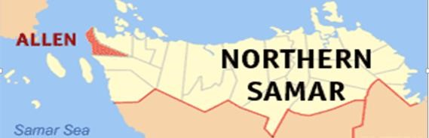

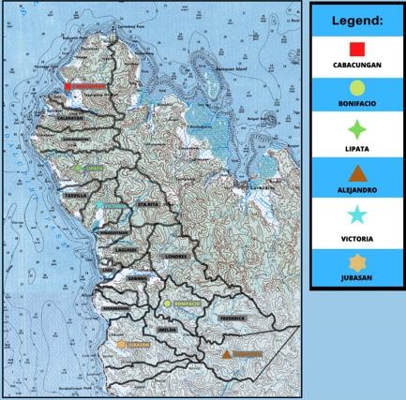

Figure 1. Map of Allen, Northern Samar, showing the sample barangays.

**Barangay Alejandro**, situated at approximately 12.4818N, 124.3323E, has an elevation estimated at 128.0 meters or 419.9 feet above mean sea level at these coordinates. Its population as determined by the 2020 Census was 251, representing 0.99% of the total population of Allen. It can be reached within 5 minutes (approximately 2.7 km) from the town proper and is accessible by motorcycle and tricycle. Major sources of livelihood are “habal-habal” (motorcycle) transportation, and root crop and rice farming [(](http://www.philatlas.com/)http://[www.PhilAtlas.com)](http://www.philatlas.com/).

**Barangay Bonifacio** is situated at approximately 12.4908N, 124.3134E, in the island of [Samar.](https://www.philatlas.com/physical/islands/samar.html) Elevation at these coordinates is estimated at 40.7 meters or 133.5 feet above mean sea level. Its population as determined by the 2020 Census was 795, which represents 3.15% of the total population of the municipality. The residents’ sources of income include “habal-habal” transportation, and farming of root crops. It is approximately 4.6 kilometers from the town proper and accessible by motorcycle and tricycle [(](http://www.philatlas.com/)http://[www.PhilAtlas.com)](http://www.philatlas.com/).

**Barangay Cabacungan,** situated at approximately 12.5640N, 124.2735E, has an elevation estimated at 3.1 meters or 10.2 feet above mean sea level at these coordinates. In the 2020 Census, its population of 2,086, represented 8.27% of the municipality’s total population. It is approximately 10 kilometers from the town proper and travel time is more or less 21 minutes, and is accessible through motorcycle and tricycle. Major source of livelihood are “habal-habal” transportation, fishing, farming, and recently, its beaches have become famous as tourist spots [(](http://www.philatlas.com/)http://[www.PhilAtlas.com)](http://www.philatlas.com/).

**Barangay Jubasan** is situated at approximately 12.4866N, 124.2874E, with elevation at these coordinates estimated at 4.0 meters or 13.1 feet above sea mean level. Its population of 3,023 represents 11.98% of the total population of Allen. It can be reached within 6 minutes (approximately 2.5km) from the town proper, accessible by motorcycle and tricycle. Sources of income include “habalhabal” transportation, fishing, and root crops production [(](http://www.philatlas.com/)http://[www.PhilAtlas.com)](http://www.philatlas.com/).

**Barangay Lipata** is situated at approximately 12.5363N, 124.2702E, with elevation at these coordinates estimated at 3.4 meters or 11.2 feet above sea mean level. Its population in 2020 was 1,723, which represented 6.83% of the total population of the municipality. It is more or less 5.6 kilometers from the town proper, and can be reached within 12 minutes by motorcycle or tricycle. The residents’ sources of income are “habal-habal” transportation, fishing, and root crop farming [(](http://www.philatlas.com/)http://[www.PhilAtlas.com)](http://www.philatlas.com/).

**Barangay Victoria,** approximately 12.5217N, 124.2783E, has an elevation estimated at 11.1 meters or 36.4 feet above sea mean level. Its population (2020 Census) was 471, represent 1.87% of the total municipal population. It is approximately 2.5 kilometers from the town proper, and can be reached within 8 minutes through motorcycle or tricycle. The source of income are “habal-habal” transportation, fishing, root crop farming [(](http://www.philatlas.com/)http://[www.PhilAtlas.com)](http://www.philatlas.com/).

**Research Design**

The descriptive research design was used in the study, with focus on identifying, classifying, and gathering data about the kind of substrate, the economic uses, the environmental parameters, and the anthropogenic factors that influence macrofungi abundance and diversity in selected barangays of Allen, Northern Samar.

**Sampling Technique**

The purposive sampling technique was done in each of the study site. Representative species of macrofungi present in a particular study area were photographed and documented in their natural habitat to identify and classify the species present in the areas.

**Data Gathering Procedure**

Initially, the researchers asked for permission from the Department of Environment and Natural Resources (DENR) and the executives of concerned local government units. During the actual sampling, each specimen was photographed in its habitat for future identification, then was collected using knife, and placed in a container or bag to avoid desiccation, and collected specimens were properly tagged.

Measurements of air and soil temperatures and soil pH, was done at each site, including the other environmental parameters (substrate, vegetation, and humidity), which were noted in a field notebook.

To reduce cross-contamination of a specimen’s spores, the researchers and the hired assistant always washed their hands after handling macrofungi specimens. Using an interview guide, the researchers asked informants regarding their knowledge of the different macrofungi species in the study area, their economic uses, and the anthropogenic factors that affect the species.

**Determination of Environmental Parameters**

1. *Air Temperature*

To determine the air temperature, the researchers used a common laboratory (mercury) thermometer, which was placed in a spot not too shady or sunny, measured at about one meter above the macrofungi species.

1. *Soil Temperature*

Determination of soil temperature was done using a digital soil temperature tester with its probe inserted about an inch below the soil surface.

1. *Soil pH*

Soil pH determination for the macrofungi species also utilized a digital soil pH tester with probes placed a few inches below the soil surface.

1. *Substrate*

The substrate where macrofungi species grow in each sampling site was observed and examined, and then categorized either as soil or decaying organic matter. Photo documentation was done where the different macrofungi grow and lived.

1. *Relative Humidity*

To determine humidity, the researchers used a thermo-hygrometer, which was placed in a spot not too shady or sunny, and measured at about one meter above the macrofungi species.

1. *Rainfall Intensity*

For this data, the researchers requested for secondary data from the Philippine Atmospheric, Geophysical, and Astronomical, and Space Administration (PAGASA) Synoptic Station in Barangay Dalakit, Catarman, Northern Samar for the months of January and February, 2023.

1. *Vegetation*

In this regard, vegetation in sites where macrofungi species were found and collected was visually observed, photographed, and categorized into types such as shrubs, trees, grasses, ferns, or vines.

**Preservation of Specimens**

Woody macrofungi underwent air drying process, while fragile and soft specimens were soaked in 10% formalin solution to make them rigid and firm. After one or two days, they were removed and washed with water and then transferred into jars containing 70% ethyl alcohol where they can be kept and preserved indefinitely.

**Identification of Specimens**

Preliminary identification of macrofungi specimens was done in the field using identification guides and other references from web pages about macrofungi, especially their spore prints, on the internet. The verification and authentication of the preliminary identification was done by a mycologist, an expert on macrofungi species, in the College of Science.

**Labeling of the Specimen**

Specimen labels contain important data about the species, and printed on paper following the format for mycological collections, with data taken from the field notebook and tags attached to the specimens during collection.

**RESULTS AND DISCUSSION**

*Species Composition of Macrofungi Species in Allen, Northern Samar*

Table 1 presents the species of macrofungi present in every sampling site arranged by Family. These species belong to four classes ([*Agaricomycetes,*](https://www.itis.gov/servlet/SingleRpt/SingleRpt?search_topic=TSN&search_value=936303)[*Basidiomycetes,*](https://fieldguide.mt.gov/displayOrders.aspx?class=Basidiomycetes)[*Dacryomycetes*,](https://www.mindat.org/taxon-273.html) and [*Homobasidiomycetes*](https://www.bionity.com/en/encyclopedia/Homobasidiomycetes.html)), seven orders ([*Agaricales,*](https://www.itis.gov/servlet/SingleRpt/SingleRpt?search_topic=TSN&search_value=194402) [*Auriculariales*](https://www.itis.gov/servlet/SingleRpt/SingleRpt?search_topic=TSN&search_value=14108)*,* [*Cantharellales,*](https://www.mindat.org/taxon-1300.html)[*Dacryomycetales*](https://www.mindat.org/taxon-1138.html)*,* [*Polyporales,*](https://www.mindat.org/taxon-1145.html)[*Stereales,*](https://fieldguide.mt.gov/displayFamily.aspx?order=Stereales)and[*Thelephorales*](https://en.wikipedia.org/wiki/Thelephorales)), 17 families (*Agaricaceae, Auriculariaceae, Clavulinaceae, Cyphellaceae ,Dacryomycetaceae, Ganodermataceae, Hydnaceae, Marasmiaceae, Mycenaceae, Psathyrellaceae, Polyporaceae, Repetobasidiaceae, Schizophyllaceae ,Stereaceae, Strophariaceae, Thelephoraceae,* and *Tricholomataceae*), and 32 genera (*[Agaricus](https://en.wikipedia.org/wiki/Agaricus)*[*,*](https://en.wikipedia.org/wiki/Agaricus)[*Barcheria,*](https://en.wikipedia.org/wiki/Barcheria)[*Bovista,*](https://en.wikipedia.org/wiki/Bovista)[*Calvatia,*](https://en.wikipedia.org/wiki/Calvatia) [*Adustochaete,*](https://en.wikipedia.org/wiki/Adustochaete) [*Aporpium,*](https://en.wikipedia.org/wiki/Aporpium) [*Auricularia,*](https://en.wikipedia.org/wiki/Auricularia) [*Elmerina,*](https://en.wikipedia.org/wiki/Elmerina) [*Exidia,*](https://en.wikipedia.org/wiki/Exidia)[*Amyloflagellula,*](https://en.wikipedia.org/wiki/Amyloflagellula)[*Anastrophella,*](https://en.wikipedia.org/wiki/Anastrophella)[*Anthracophyllum,*](https://en.wikipedia.org/wiki/Anthracophyllum)[*Aphyllotus,*](https://en.wikipedia.org/wiki/Aphyllotus)[*Baeospora,*](https://en.wikipedia.org/wiki/Baeospora) [*Calathella,*](https://en.wikipedia.org/wiki/Calathella)[*Decapitatus,*](https://en.wikipedia.org/wiki/Decapitatus) [*Favolaschia,*](https://en.wikipedia.org/wiki/Favolaschia)and[*Flabellimycena*](https://en.wikipedia.org/wiki/Flabellimycena)).

The results also show differences in the number of macrofungi collected and identified in each sampling site. Barangay Alejandro appears to have eight macrofungi species (*Macrolepiota procera* (Scop.) Singer, *Chondrotereum purpureum* (Pers.) Pouzar, *Dacryopinax spathularia* (Schwein) G. W. Martin, *Pleurocybella porrigens* (Pers.) Singer, *Ganoderma tropicum* (Jungh.) Bres., *Favolus acervatus* (Lloyd.) Sotome & Hatt, *Clitocybe dealbata* (Sowerby) Gillet, and *Trogian infundibuliformis* Berk & Broome. Barangay Bonifacio is represented by four species (*Auricularia auricula-judae* (Bull.) J. Schrot, *Sistotrema confluens* Pers., *Muscinupta laevis* (Fr.) Redhead, Lucking & Lawrey and *Laccaria tortilis* [Bolton] Cooke). Barangay Cabacungan is represented by eight species (*Mycena adscendens* (Lasch) Maas Geest., *Marasmius calhouniae* Singer, *Cantharellus cinnabarinus* (Schwein.), *Coprinellus disseminatus* (Pers.) J.E. Lange, *Leratiomyces ceres* (Cooke & Massee) Spooner & Bridge , *Schizophyllum commune* Fr., *Marasmius delectans* Morgan, and *Pycnoporus sanguines* (L.) Murrill), while in Barangay Lipata, seven species were collected (*Auricularia mesenterica* (Dicks.) Pers., *Clavulina corralloides* (L) J. Schrot.,

*Dacrymyces chrysospermus* Berk. & M. A. Curtis, *Marasmius rotula* (Scop.) Fr., *Omphalotus nidiformis* (Berk.) O. K. Mill, *Clitocybe robusta* and *Stereum ostrea* (Blume & T. Need ex Fr.). Likewise, Barangay Jubasan was represented by five species (*Mycena* *galopus* (Pers.) P. Kumm, *Agrocybe pediades* (Fr.) Fayod, *Thelephora vialis* (Schwein), *Delicatula integrella* (Pers.) Fayod, and *Clitocybe rivulosa* (Pers.) P. Kumm). Similarly, Barangay Victoria was represented by six species (*Auricularia mesenterica* (Dicks.) Pers., *Clitocybula abundans* (Peck) Singer, *Mycena leptocephala* (Pers.) Gillet, *Parasola plicatilis* (Curtis), *Hemimycena mauretani,* and *Fomes fomentarius* L. Fr.)

Such results imply that there is diversity of macrofungi species in different sites in Allen, Northern Samar, with Barangays Alejandro and Cabacungan having the most number of species collected, while Barangay Bonifacio had the least number of macrofungi species present.

Table 1. Species Composition of Macrofungi Species in Allen, Northern Samar

|  |  |  |  |  |  |  |  |
| --- | --- | --- | --- | --- | --- | --- | --- |
| FAMILY | SCIENTIFIC NAME | SAMPLING SITES | | | | | |
| 1 | 2 | 3 | 4 | 5 | 6 |
| Agaricaceae | *Macrolepiota procera* (Scop.) Singer | ✓ | x | x | x | x | x |
| Auriculariaceae | *Auricularia mesenterica* (Dicks.) Pers. | x | x | x | x | x | ✓ |
| *Auricularia auricula-juda*e (Bull.) J. Schrot | x | ✓ | x | x | x | x |
| Clavulinaceae | *Clavulina corralloides* (L) J. Schrot. | x | x | x | ✓ | x | x |
| Cyphellaceae | *Chondrostereum purpureum* (Pers.) Pouzar | ✓ | x | x | x | x | x |
| Cantharellaceae | *Cantharellus cinnabarinus* (Schwein.) | x | x | ✓ | x | x | x |
| Dacryomycetaceae | *Dacrymyces chrysospermus* Berk. & M. A. Curtis | x | x | x | ✓ | x | x |
| *Dacryopinax spathularia* (Schwein) G. W. Martin | ✓ | x | x | x | x | x |
| Ganodermataceae | *Ganoderma tropicum* (Jungh.) Bres. | ✓ | x | x | x | x | x |
| Hydnaceae | *Sistotrema confluens* Pers. | x | ✓ | x | x | x | x |
| Marasmiaceae | *Marasmius rotula* (Scop.) Fr.  *Pleurocybella porrigens* (Pers.) Singer  *Clitocybula abundans* (Peck) Singer  *Omphalotus nidiformis* (Berk.) O. K. Mill  *Trogian infundibuliformis* Berk & Broome  *Marasmius calhouniae* Singer  *Marasmius delectans* Morgan | X  ✓ x  x  ✓ X  x | x  X  x  X  x  X  x | X  x  x  x  x  ✓  ✓ | ✓  x  X  ✓  x  X  x | X  X  X  x  X  x  x | X  x ✓ x  x x  x |
| Mycenaceae | *Mycena leptocephala* (Pers.) Gillet  *Mycena galopus* (Pers.) P. Kumm  *Mycena adscendens* (Lasch) Maas Geest. | X  X  x | X  X  x | X  x  ✓ | X  X  x | x  ✓  x | ✓ X  x |
| Psathyrellaceae | *Parasola plicatilis* (Curtis)  *Coprinellus micaceus* (Bull.:Fr.) Vilgalys, Hopple & Jacq.  Johnson  *Coprinellus disseminatus* (Pers.) J.E. Lange | X  x  x | X  x  x | x  x  ✓ | X  ✓  x | X  x  x | ✓  X  x |
| Polyporaceae | *Fomes fomentarius* L. Fr.  *Pycnoporus sanguine*s (L.) Murrill  *Favolus acervatus* (Lloyd.) Sotome & Hatt | X  X  ✓ | X  X  x | x  ✓  x | X  X  x | X  X  x | ✓ X  x |
| Repetobasidiaceae | *Muscinupta laevis* (Fr.) Redhead, Lucking & Lawrey | x | ✓ | x | x | x | x |
| Schizophyllaceae | *Schizophyllum commune* Fr. | x | x | ✓ | x | x | x |
| Stereaceae | *Stereum ostr*ea (Blume & T. Need ex Fr.) | x | x | x | ✓ | x | x |
| Strophariaceae | *Agrocybe pediades* (Fr.) Fayod  *Leratiomyces ceres* (Cooke&Massee) Spooner & Bridge | X  x | X  x | x  ✓ | X  x | ✓  x | X  x |
| Thelephoraceae | *Thelephora vialis* (Schwein) | x | x | x | x | ✓ | x |
| Tricholomataceae | *Clitocybe rivulosa (*Pers.) P. Kumm  *Laccaria tortilis* (Bolton) Cooke  *Hemimycena mauretani*  *Delicatula integrella* (Pers.) Fayod Clitocybe robusta  *Clitocybe dealbata* (Sowerby) Gillet | X  x  x  X  ✓ | ✓  x  x  x  x | X  x  X  x  x | X  x  x  ✓  x | ✓  x  x  ✓  x | X  X ✓ x  x |

Legend: ✓= Present 1 = Barangay Alejandro 2 = Barangay Bonifacio 3 = Barangay Cabacungan

X = Absent 4 = Barangay Lipata 5 = Barangay Jubasan 6 = Barangay Victoria

**Environmental Parameters in Study Area**

Data for the environmental parameters is shown in the Table 2. It appears that macrofungi species prefer an air temperature range of about 27.15oC (± 3oC), a soil temperature of about 24.5oC, and a neutral or a very weakly alkaline soil pH. Most of the species sampled were found on coconut trunks, coconut husks, logs fences, twigs, or decaying banana trunks, aside from those that were found on the soil surface. In many of the areas sampled, relative humidity ranged from 80.1% to 95.8%, indicating that most species thrive in warm and moist conditions. The vegetation oftentimes associated with macrofungi were coconut plantations, grasslands, shrubs, and forested areas.

Rainfall intensity data for the months of January and February, 2023, when specimen collection was done, was supplied by the Philippine Atmospheric, Geophysical, Astronomical, and Space Administration (PAGASA) Synoptic Station in Barangay Dalakit, Catarman, Northern Samar. Data show that the average rainfall intensity for January 2023 was 56.5mm, while for February 2023, it was 19.51mm.

Table 2. Environmental Parameters in the Study Area

|  |  |  |  |  |  |  |
| --- | --- | --- | --- | --- | --- | --- |
| Sampling Site | Average Temperature (oC) | | Soil pH | Substrate Type | Relative Humidity (%) | Vegetation |
| Air | Soil |
| Alejandro | 27.7 | 24.0 | 7.0 | Clay loam soil decaying coconut | 89.6 | Coconut plantation, shrubs, grasses |
| Bonifacio | 24.3 | - | - | Fences, decaying coconut trunk | 95.8 | Coconut plantation, shrubs, grasses |
| Cabacungan | 27.7 | - | - | Decaying logs, coconut trunk | 80.1 | Coconut plantation, shrubs, grasses |
| Jubasan | 26.4 | - | - | Clay loam soil decaying banana trunk, coconut trunk and roots | 95.0 | Coconut plantation, shrubs, grasses |
| Lipata | 28.6 | 25.0 | 7.1 | Decaying coconut trunk, logs, fences | 82.8 | Coconut plantation, shrubs, grasses |
| Victoria | 30.0 | - | - | Decaying banana trunk, coconut trunk, fences | 81.5 | Coconut plantation, shrubs, grasses |

**Economic Uses of Macrofungi Species**

In interviews done among selected respondents in each sample barangay, utilizing a researcher-made interview guide, it was found that only *Clitocybula abundans* (Peck) Singer, commonly known as “Coincaps”, and locally called *“nagtutubo sa lubi”*, is considered edible. However, based on the identification of the species collected, there were eight species considered edible, namely: *Macrolepiota procera* (Scop.) Singer (Parasol mushroom), *Auricularia auricula-judae* (Bull.) J. Schrot (Jelly ear), *Dacrymyces chrysospermus* Berk. & M. A. Curtis (Orange jelly spot), *Dacryopinax spathularia* (Schwein) G. W. Martin (fan-shaped jelly fungus), *Marasmius calhouniae* Singer (Calhoun’s pinwheel), *Coprinellus micaceus* (Bull.:Fr.) Vilgalys, Hopple & Jacq. Johnson (glistening inky cap), *Pycnoporus sanguines* (L.) Murrill (tropical cinnabar bracket fungus), and *Thelephora vialis* (Schwein) (common fiber vase). Other respondents do not have any idea of the economic uses of other macrofungi species but they are familiar with these macrofungi species.

Table 3. Economic Uses of Macrofungi Species

|  |  |  |  |
| --- | --- | --- | --- |
| **Family** | **Scientific Name** | **Use** | |
| **Edible** | **Inedible** |
| Agaricaceae | Macrolepiota procera (Scop.) Singer | ✓ |  |
| Auriculariaceae | Auricularia mesenterica (Dicks.) Pers. |  | x |
| Auricularia auricula-judae (Bull.) J. Schrot | ✓ |  |
| Clavulinaceae | Clavulina corralloides (L) J. Schrot |  | x |
| Cyphellaceae | Chondrostereum purpureum (Pers.) Pouzar |  | x |
| Cantharellaceae | Cantharellus cinnabarinus (Schwein.) |  | x |
| Dacrymycetaceae | Dacrymyces chrysospermus Berk. & M. A. Curtis | ✓ |  |
| Dacryopinax spathularia (Schwein) G. W. Martin | ✓ |  |
| Ganodermataceae | Ganoderma tropicum (Jungh.) Bres. |  | x |
| Hydnaceae | Sistotrema confluens Pers. |  | x |
|  | Marasmius rotula (Scop.) Fr. |  | x |
| Pleurocybella porrigens (Pers.) Singer |  | x |
| Clitocybula abundans (Peck) Singer |  | x |
| Omphalotus nidiformis (Berk.) O. K. Mill |  | x |
| Trogian infundibuliformis Berk & Broome |  | x |
| Marasmius calhouniae Singer |  | x |
| Marasmius delectans Morgan |  | x |
| Mycenaceae | Mycena leptocephala (Pers.) Gillet |  | x |
| Mycena galopus (Pers.) P. Kumm |  | x |
| Mycena adscendens (Lasch) Maas Geest. |  | x |
| Psathyrellaceae | Parasola plicatilis (Curtis) | ✓ |  |
| Coprinellus micaceus (Bull.:Fr.) Vilgalys, Hopple & Jacq. Johnson |  | x |
| Coprinellus disseminatus (Pers.) J.E. Lange |  | x |
| Polyporaceae | Fomes fomentarius L. Fr. | ✓ | x |
| Pycnoporus sanguines (L.) Murrill |  | x |
| Favolus acervatus (Lloyd.) Sotome & Hatt |  | x |
| Repetobasidiaceae | Muscinupta laevis (Fr.) Redhead, Lucking & Lawrey |  | x |
| Schizophyllaceae | Schizophyllum commune Fr. |  | x |
| Stereaceae | Stereum ostrea (Blume & T. Need ex Fr.) |  | x |
| Strophariaceae | Agrocybe pediades (Fr.) Fayod | ✓ |  |
| Leratiomyces ceres (Cooke & Massee) Spooner & Bridge |  | x |
| Thelephoraceae | Thelephora vialis (Schwein) | ✓ |  |
| Tricholomatacea | Clitocybe rivulosa (Pers.) P. Kumm. |  | x |
| Laccaria tortilis (Bolton) Cooke | ✓ |  |
| Hemimycena mauretani |  | x |
| Delicatula integrella (Pers.) Fayod |  | x |
| Clitocybe robusta |  | x |
| Clitocybe dealbata (Sowerby) Gillet | ✓ |  |

**Anthropogenic Activities in Study the Areas**

In the interviews among some residents in the area, the most commonly mentioned anthropogenic activity was “kaingin” (also called slash-and-burn or swidden agriculture), a technique of clearing the land that involves cutting and burning underbrush and trees, then plowing the ashes under to serve as fertilizer, after which they plant root crops or other plants that can provide an economic benefit necessary for their survival of the residents. Secondly, deforestation was also common among respondents’ answers, referring to the clearing of wooded land for a specific purpose. Trees are felled for wood, which are then transported and sold. Lastly, urban area expansion was also mentioned, and it consumes immeasurable tracts of forests, farmlands, or woodlands. The identified anthropogenic activities can affect macrofungal diversity, in a way that these can cause climate change and depletion of forests, air pollution, ecosystem degradation, and urban extension, all of which have negative effects on fungal communities (Zervakis & Venturella 2007).

Table 4. Anthropogenic Activities in the Study Area

|  |  |  |  |
| --- | --- | --- | --- |
| Sampling Site/Barangays | Kaingin | Deforestation | Urban Expansion |
| Alejandro | ✓ | ✓ | x |
| Bonifacio | ✓ | ✓ | x |
| Cabacungan | ✓ | ✓ | ✓ |
| Jubasan | ✓ | ✓ | x |
| Lipata | ✓ | ✓ | ✓ |
| Victoria | ✓ | ✓ | ✓ |

Legend: ✓ = Present x = Absent

**CONCLUSIONS AND RECOMMENDATIONS**

*Conclusions*

1. Allen, Northern Samar has a diversity of macrofungi species, as shown by the 38 different species collected and identified by the researchers. This diversity implies the potential for macrofungi as sources of raw materials for drug discovery or development.
2. Of the species collected and identified, only 8 are considered edible and economically useful to the residents, while the rest are inedible. This implies that a larger number of macrofungi species may harbor constituents that may be toxic in their pure form, but may be raw materials for beneficial drugs if properly processed and utilized.
3. The environmental conditions in the study area was generally optimal for macrofungi species to thrive, given that substrates necessary for their growth and survival were commonly available in the area.
4. Anthropogenic activities however, influence the presence or absence of macrofungi species in the study area. Such activities may have negative impacts on macrofungi diversity through loss of habitat.

*Recommendations*

1. A similar investigation be done in other locations and at different times of the year to establish the spatial and temporal distribution of macrofungi species in the study area.
2. Phytochemical analysis of the constituents of macrofungi species, especially those that are inedible, is recommended to evaluate if they can be raw materials for drug discovery or development.
3. Being essential components of biodiversity and in the normal functioning of ecosystems, the maintenance of optimal environmental conditions to preserve these vital organisms are of primary importance.
4. Anthropogenic activities that negatively impact macrofungi diversity should be strictly prohibited, and all laws, rules, policies and regulations pertinent to environmental protection should be religiously implemented.

REFERENCES

Angeles-De Leon, M. A. 2021. Vol. 5 No. 2 (2021): CLSU International Journal of Science & Technology.

Arenas, E. R. 2018. Taxonomic Inventory Based on Physical Distribution of Macrofungi in Mt. Maculo, Cuenca Batangas, Philippines. International Journal of Biology, Pharmacy and Allied Science, 7(5): 672-687.

Arnesto, L. L. 2009. The Fungi of Palapag Northern Samar. BS Biology Thesis, College of Science. University of Eastern Philippines, University Town, Northern Samar.

Cabides, J. D. 2019. Macrofungi in Selected Barangays of Silvino Lubos, Northern Samar. BS Biology Thesis, College of Science. University of Eastern Philippines, University Town, Northern Samar.

Chia, V. M. 2022. Inventory of Macrofungi in Selected Barangays of Lavezares, Northern Samar. BS Biology Thesis, College of Science. University of Eastern Philippines, University

Town, Northern Samar.

Esquillo, J. J. 2006. Taxonomic Classification of Macrofungi in Seleced Barangays of Lavezares, Northern Samar. BS Biology Thesis, College of Science. University of Eastern Philippines, University Town, Northern Samar.

Flores, A. A. U. Jr., M. L. C. Alvarez., F. E. Cortez, B. O Perez.,F. L. Sanico., M.J.M Somoray., M.C.G. Vicencio,. and K.M.R Cui,.(2014). Inventory and Utilization of Macrofungi Species for Food and Medicine. International Conference on Biological, Chemical and Environmental Sciences . Penang (Malaysia) http://dx.doi.org./10.15242/IICBE.C614006

[https://www.toppr.com](https://www.toppr.com/)

[https://www.sciencedirect.com](https://www.sciencedirect.com/)  <https://www.biologyonline.com/>

[https://www.fao.org/3/u3160e/u3160e05.htm#:~:text=Rainfall%...(mm%2Fh)](https://www.fao.org/3/u3160e/u3160e05.htm#:~:text=Rainfall%20intensity%20is%20defined%20as,hour%20(mm%2Fh))

[https://www.esf.edu.com](https://www.esf.edu.com/) [https://www.nrcs.usda.gov.com](https://www.nrcs.usda.gov.com/)

[https://foursquare.com/v/allenport/4e1a49c87d8b8af9139f93f0/photos](https://foursquare.com/v/allen-port/4e1a49c87d8b8af9139f93f0/photos)

<https://en.wikipedia.org/wiki/Allen,_Northern_Samar><https://commons.wikimedia.org/wiki/File:Ph_locator_northern_samar_allen.png>

[https://www.canr.msu.edu/news/macrolepiotaprocera#:~. . . .mushroom.](https://www.canr.msu.edu/news/macrolepiota-procera#:~:text=Location%3A%20Charlevoix%2C%20MI-,Macrolepiota%20procera%20is%20found%20throughout%20the%20United%20States%20and%20Europe,It%20is%20a%20white%20mushroom)

[https://swallowtail.ca/witches-butter-mushroom/#:~:text=Dacrymyces.....](https://swallowtail.ca/witches-butter-mushroom/#:~:text=Dacrymyces%20(chrysospermus)%20both%20are%20edible,wood%20(hardwood%20vs%20conifer))

Jusayan, R.R. and M.C.G. Vicencio. 2013. The Macrofungi in the Island of San Antonio, Northern Samar, Philippines. International Journal of Trend in Scientific Research and Development (IJTSRD) Volume: 3. Available online: www.ijtsrd.com E-ISSN: 2456-6470

Kinge, N. A. 2017. "Species Richness and Traditional Knowledge of Macrofungi (Mushrooms) in the Awing Forest Reserve and Communities, Northwest Region, Cameroon. Journal of Mycology,

9 pages.

Liwanag, E. E. 2017. Species Listing of Macrofungi In Angat Watershed Reservation,Bulacan Provinc, Luzon Island, Philippines. IJBPAS, 6(5): 1060-1068.

Mejica, M. M. March 2012. Inventory of Macrofungi Species in Selected Barangays of Gamay, Northern Samar. BS Biology Thesis, College of Science. University of Eastern Philippines, University

Town, Northern Samar.

Miano, M. J. 2010. Taxonomic Classification of Mushroom in Selected Barangay of Catarman N. Samar. BS Biology Thesis, College of Science. University of Eastern Philippines, University

Town, Northern Samar.

Municipal Planning and Development Coordinator's Office 2022

Rabina, H. S. 2010. Taxonomic Classification of Macrofungi in Selected Barangays of San Roque, N. Samar. BS Biology Thesis, College of Science. University of Eastern Philippines, University

Town, Northern Samar.

Singh, L. A. 2019. Biology of Macrofungi. Springer.

Tarrega, R. S. T. 2012.The Macrofungi in Selected Barangays of Mapanas, Northern Samar. BSBiology Thesis, College of Science. University of Eastern Philippines, University Town, Northern Samar.

The Great Soviet Encyclopaedia, 3rd Edition (1970-1979). 2010 The Gale Group, Inc.)

Zervakis, G. I. & Venturella, G. 2007. Adverse effects of human activities on the diversity of macrofungi in forest ecosystems. Bocconea 21: 000-000.ISSN 1120-4060.

**MACROFUNGI SPECIES COLLECTED AND IDENTIFIED**

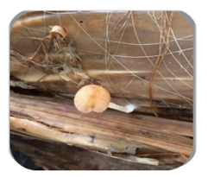

**Plate 1. Agrocybe pediades (Fr.) Fayod**

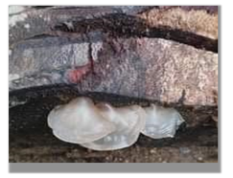

**Plate 2. Auricularia auricula-judae (Bull.) J. Schrot**

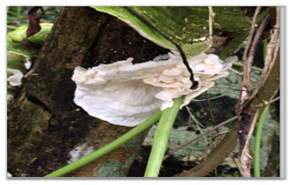

**Plate 3. Auricularia mesenterica (Dicks.) Pers.**

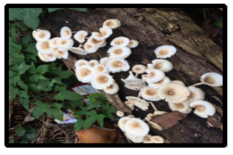

**Plate 4. Clitocybula abundans (Peck) Singer**

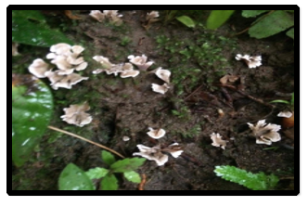

**Plate 5.Chondrostereum purpureum (Pers.) Pouzar**

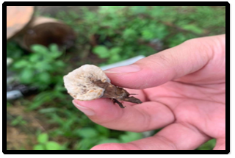

**Plate 6.Clavulina corralloides (L) J. Schrot.**

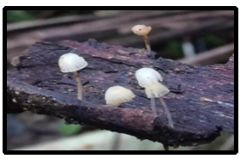

**Plate 7. Coprinellus disseminatus (Pers.) J.E. Lange**

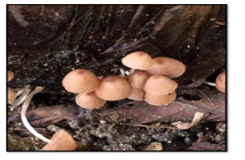

**Plate 8. Coprinellus micaceus (Bull.:Fr.) Vilgalys, Hopple & Jacq. Johnson**

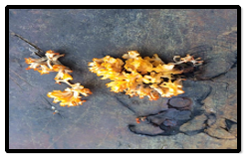

**Plate 9. Dacrymyces chrysospermus Berk. & M. A. Curtis**

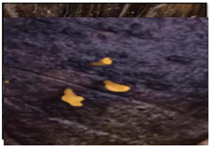

**Plate 10. Dacryopinax spathularia (Schwein) G. W. Martin**

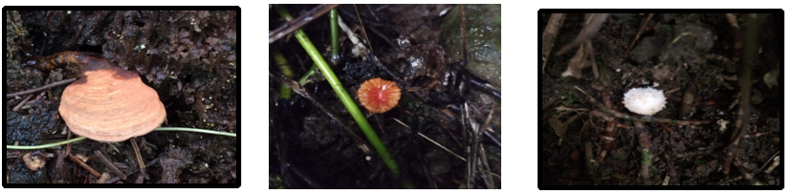

|  |  |  |
| --- | --- | --- |
| **Plate 11.** *Fomes fomentarius* L. Fr. | **Plate 12**. Laccaria tortilis (Bolton) Cooke | Plate 13.Macrolepiota procera (Scop.) Singer |

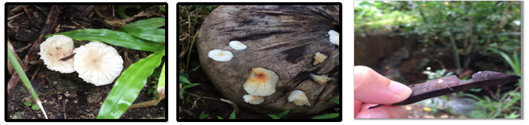

|  |  |  |
| --- | --- | --- |
| Plate 14. Marasmius calhouniae Singer | Plate 15. Marasmius rotula (Scop.) Fr | Plate 16. Mycena adscendens (Lasch) Maas Geest. |

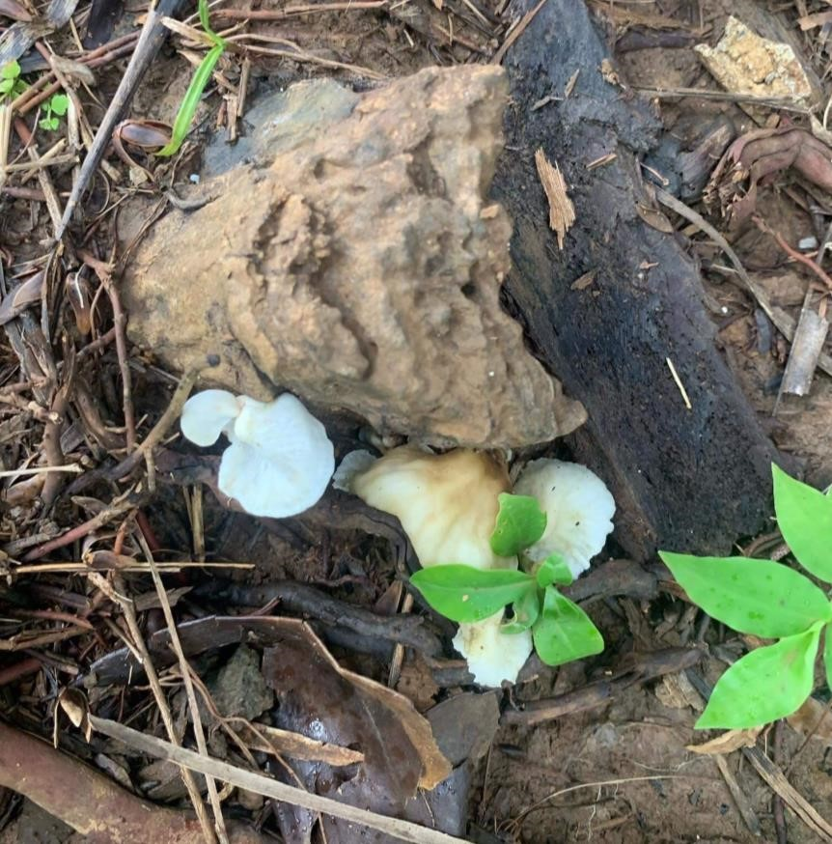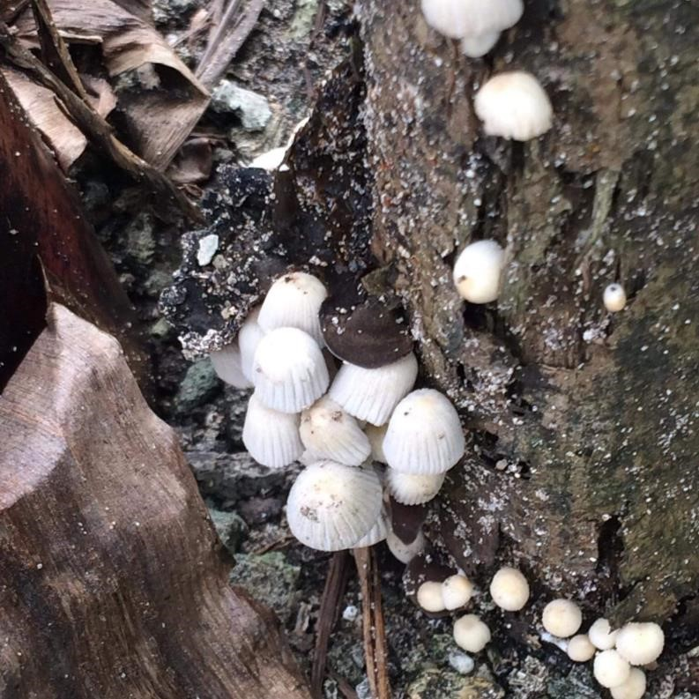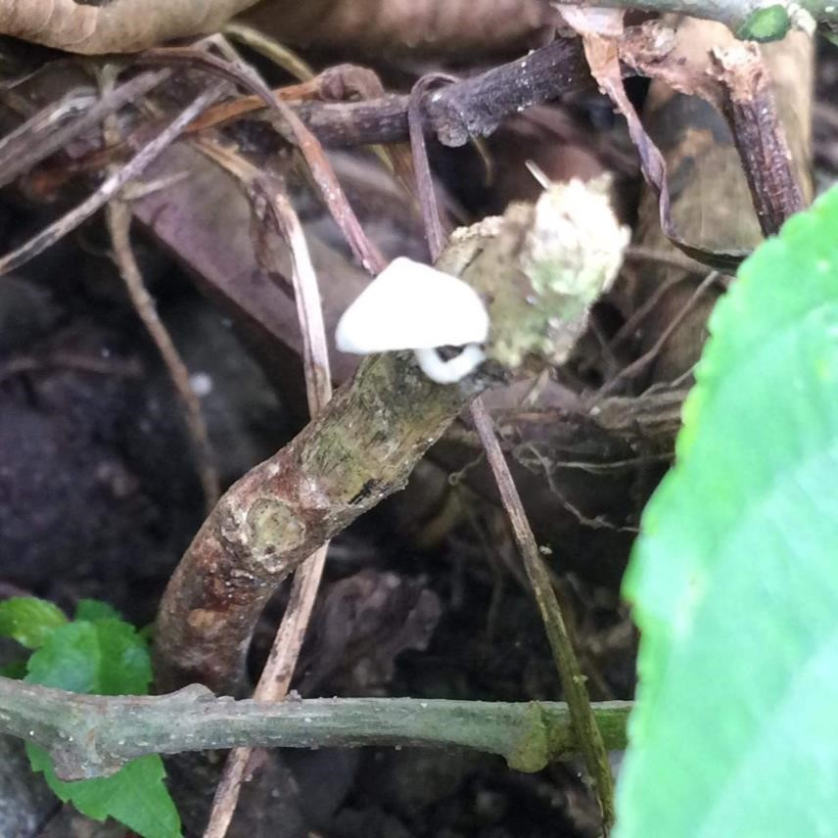

**Plate 17**. *Mycena galopus* (Pers.) P. Kumm **Plate 18**. *Mycena leptocephala* (Pers.) Gillet**Plate 19**. *Omphalotus nidiformis* (Berk.)

O. K. Mill

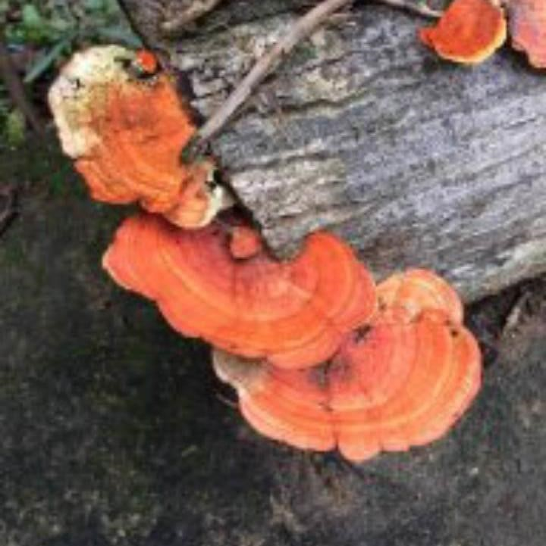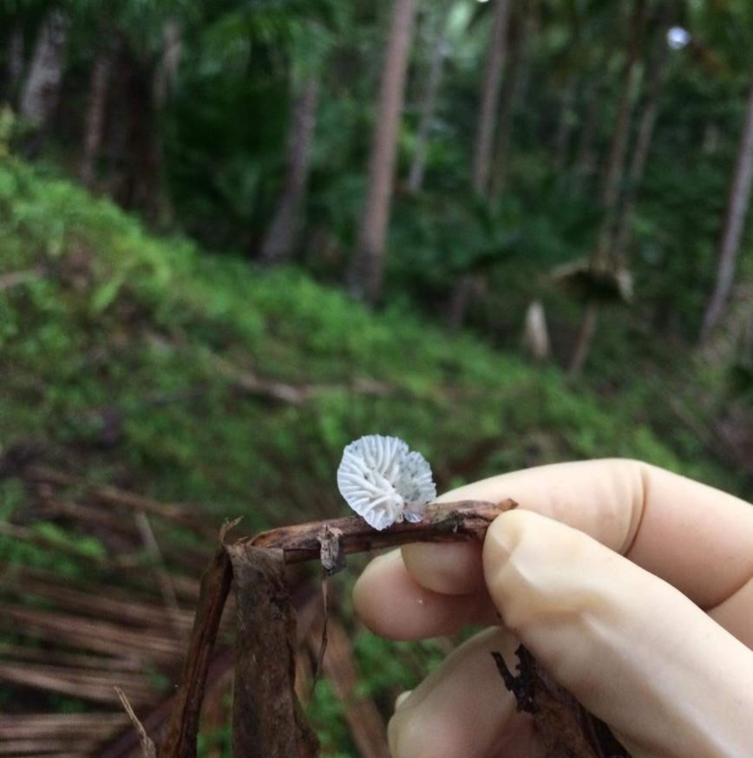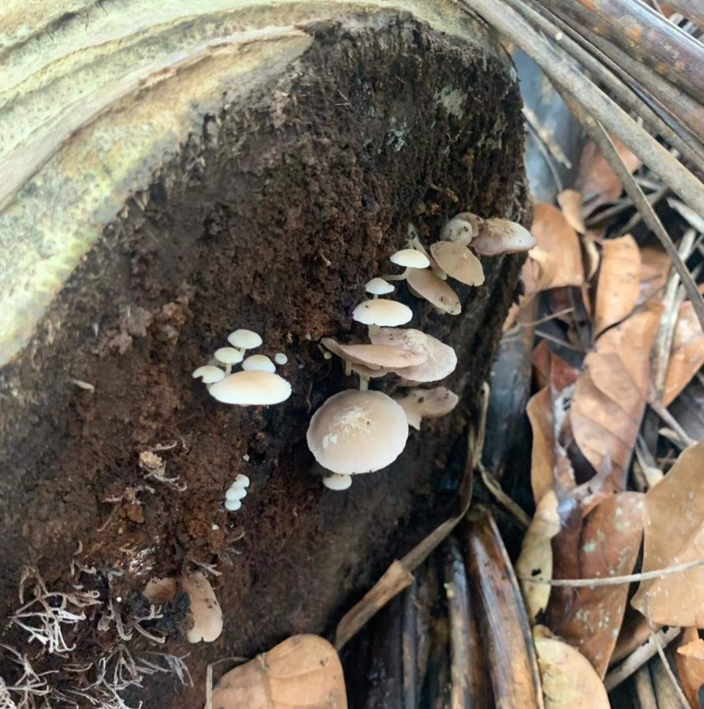

**Plate 20***. Parasola plicatilis* (Curtis) **Plate 21**. *Pleurocybella porrigens* (Pers.) **Plate 22**. *Pycnoporus sanguines* (L.) Singer Murrill

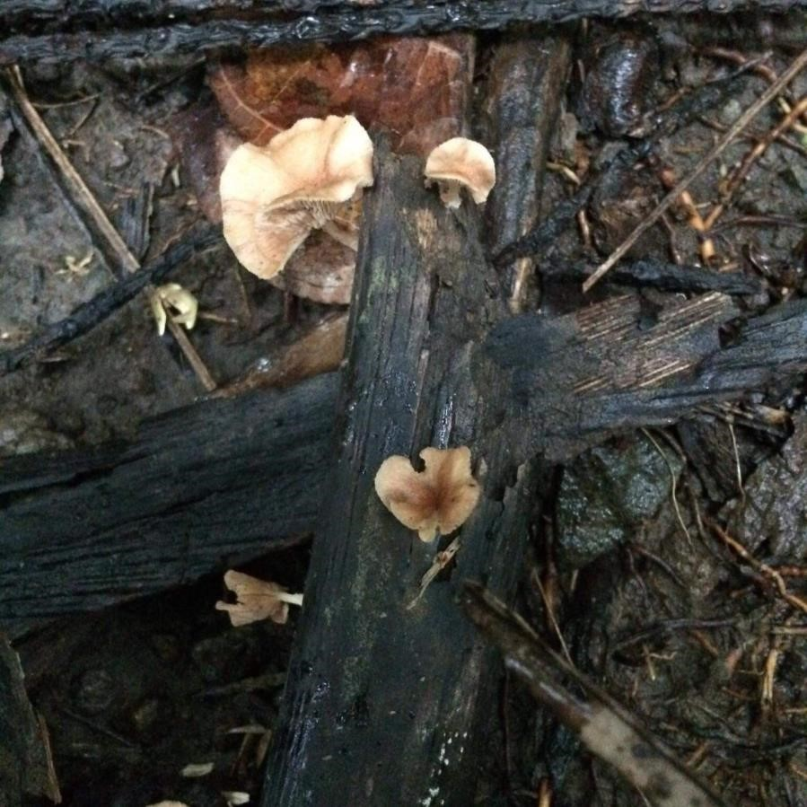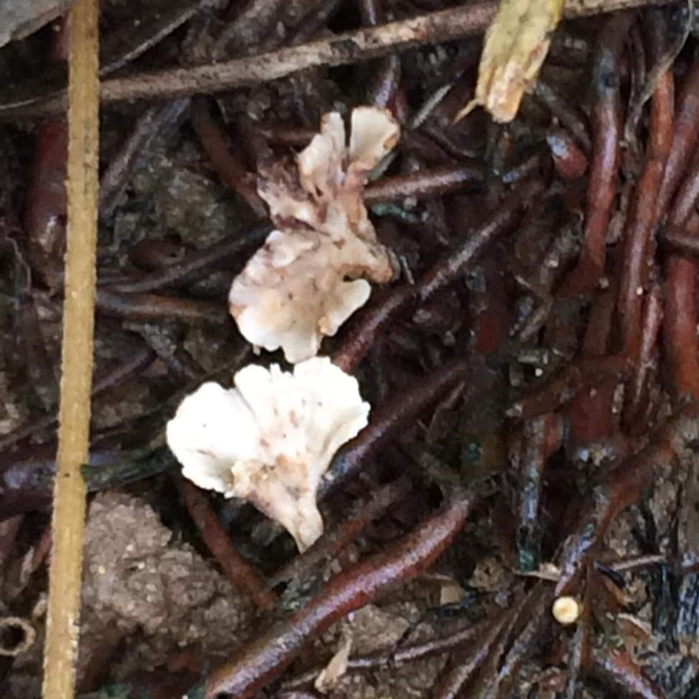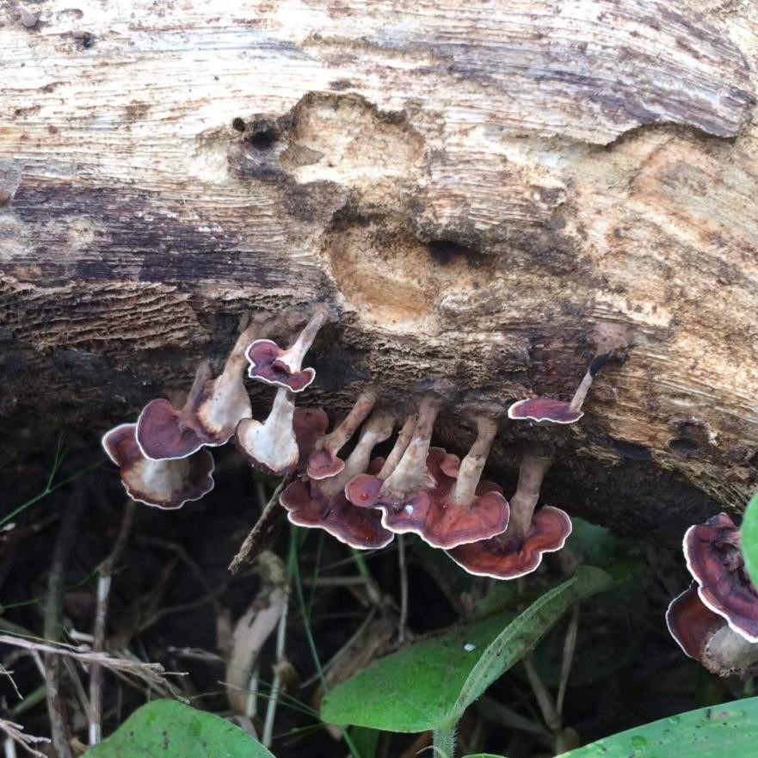

**Plate 23.** *Stereum ostrea* (Blume &  **Plate 24.** *Thelephora vialis*  **Plate 25**. *Trogian infundibuliformis*

T. Need ex Fr.) (Schwein) Berk & Broome

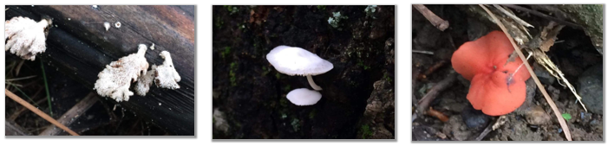

**Plate 26**. *Schizophyllum commune* Fr. **Plate 27**. *Marasmius delectans* Morgan **Plate 28**. *Cantharellus cinnabarinus* (Schwein.) Schwein

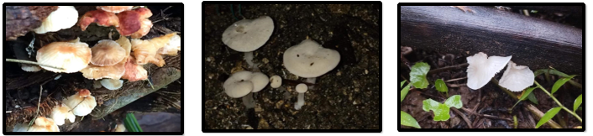

**Plate 29.** *Leratiomyces ceres* (Cooke & **Plate 30.** *Clitocybe rivulosa* (Pers.)  **Plate 31**.*Sistotrema confluens* Pers.

Massee) Spooner & Bridge P. Kumm.

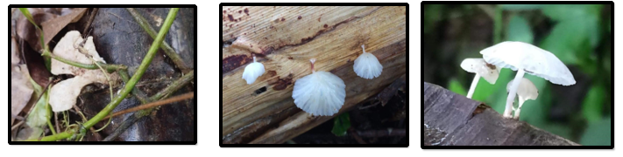

**Plate 32**. *Muscinupta laevis* (Fr.) Redhead,  **Plate 33.** *Hemimycena mauretani*  **Plate 34.** *Delicatula integrella*

Lucking & Lawrey (Pers.) Fayod

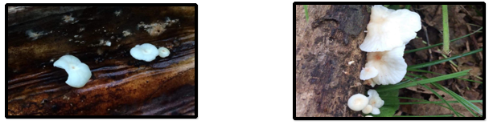

**Plate 35**. *Favolus acervatus* (Lloyd.) Sotome & Hatt **Plate 36**. *Clitocybe robusta*

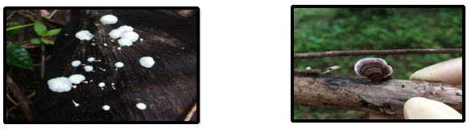

**Plate 37**. *Clitocybe dealbata (*Sowerby) Gillet **Plate 38**. *Ganoderma tropicum* (Jungh.) Bres.

**SAMPLING SITES**

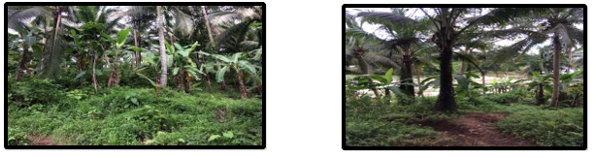

### Plate 39- Barangay Victoria, Allen, Northern Samar Plate 40- Barangay Jubasan, Allen, Northern Samar

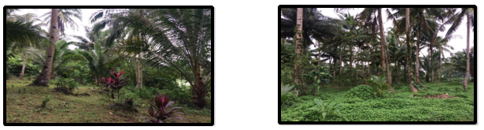

|  |  |
| --- | --- |
| Plate 41- Barangay Lipata, Allen, Northern Samar | Plate 42- Barangay Cabacungan, Allen, Northern Samar |

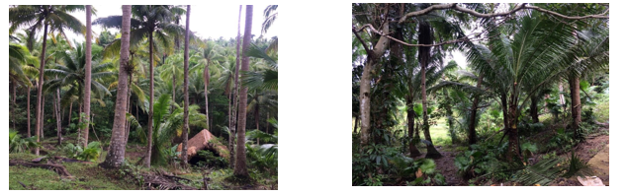

|  |  |
| --- | --- |
| Plate 43-Barangay Alejandro, Allen, Northern Samar | Plate 44- Barangay Bonifacio, Allen, Northern Samar |