*Original Research Article*

Determination of the Lethal Dose of Ethyl Methane Sulfonate (EMS) for Optimal Mutagenesis in Banana (*Musa* spp. cv. Phee-gyan)

.

ABSTRACT

|  |
| --- |
| To enhance genetic variation in *Musa* (ABB group, Bluggoe subgroup) cv. ‘Phee-gyan’, a popular cultivar in Myanmar, ethyl methane sulphonate (EMS) mutagenesis was applied to *in vitro* proliferated shoot tips. Shoot tips were treated with EMS at concentrations of 0%, 0.3%, 0.6%, 0.9%, 1.2%, and 1.5% across three incubation periods (30 min, 60 min, and 90 min) and cultured in five replicates using a randomized block design. The experiment was conducted at the laboratory of New Genetics (YAU) and Biotechnology Research Section (DAR) during 2023-2024. The results showed a dose-dependent decrease in survival percentage, shoot length, and fresh weight in the M1V1 generation compared to the control. The highest survival rate (91.48%) was recorded at 0.3% EMS (30 min), while the lowest survival (31.29%) occurred at 1.5% EMS (90 min). A 50% survival rate was recorded at 1.2% EMS (90 min), indicating a balance between mutation induction and plant viability. Shoot length was reduced to ~ 50% of the control at 1.2% EMS across all incubation times, while fresh weight decreased to ~ 50% of the control at 1.5% EMS (60 min and 90 min). Probit analysis determined LD₅₀ values based on survival percentage as 1.9% EMS for 30 min and 60 min, and 1.2% EMS for 90 min. For shoot length, LD₅₀ values were 1.3% EMS (30 min), and 1.1% EMS (60 min and 90 min), while for fresh weight, they were 1.9% EMS (30 min), 1.7% EMS (60 min) and 1.5% EMS (90 min). Based on these findings, the optimal mutagenesis condition for inducing genetic variability in banana cv. ‘Phee-gyan’ was determined to be 1.2% EMS for 90 min, which provided 50% survival rate while maintaining favorable growth parameters. |

*Keywords: Banana, Chemical mutagenesis, Ethyl methane sulphonate (EMS), LD50, Survival percentage.*

1. INTRODUCTION

Bananas (*Musa* spp.) are among the world’s most important food crops, widely cultivated across tropical and subtropical regions. In developing countries, they rank as the fourth most vital crop after rice, wheat, and maize, playing a significant role in national economies. For many people living in the tropical countries, bananas are a staple food and an essential part of their daily nutrition. They are a rich source of fiber, carbohydrates, protein, potassium, phosphorus, calcium, manganese, magnesium, copper, vitamin B complex, vitamin A and vitamin C, as well as various antioxidants and phytochemicals (Li et al. 2013, Ranjha et al. 2020, Wan et al. 2005). Cultivated bananas are generally believed to have originated in the warm, moist regions of Southeast Asia, including India, Myanmar, Thailand, and Indonesia, as well as in west Oceania (Li et al. 2013, Wang et al. 2019).

In Myanmar, banana is one of the most important and commonly consumed fruits, valued not only as a food source but also for their role in religious and traditional ceremonies. They can be cultivated throughout the country and are available year-round. The total area under banana cultivation was approximately 111,000 hectares (Department of Planning, 2023). Myanmar is also recognized as a rich source of both cultivated bananas and their wild relatives. A total of thirteen *Musa* species, including wild types, are widely grown, with *Musa acuminata*, *M. cavendishii*, and four varieties under *M. sapientum* being the most prevalent varieties (Aye Tun, 2004).

A local banana cultivar *Musa* (ABB group, Bluggoe subgroup), ‘Phee-gyan’ is widely cultivated in Myanmar due to its adaptability and popularity. It plays a significant role in supporting the livelihoods of many smallholder farmers. Valued for its high yield, good taste, rich nutrient content, and strong market demand, Phee-gyan provides a reliable source of income and contributes to the local economy. However, banana production in Myanmar faces several challenges, including leaf spot diseases, leaf streak, bunchy top, fusarium wilt, other viral infections, and stem borer infestations (International Plant Protection Convention, 2015). These problems negatively affect both yield and postharvest quality, posing constraints for farmers throughout the country.

Mutation breeding has become a highly productive tool, offering the possibility of inducing desired traits that are not found in nature. Mutations can be induced using physical and chemical mutagens, with chemical mutagens generally having a larger ratio of mutational to undesired alterations compared to physical mutagens (Oladosu et al. 2016). As a result, chemical mutagens have become an essential component of mutation breeding. One of the commonly used chemical mutagens is ethyl methane sulfonate (EMS), an alkylating agent that induces chemical modification in nucleotides by introducing an active alkyl group. This leads to base changes and nucleotide mutations (Arisha et al. 2014, Gillmor and Lukowitz, 2020, Sabetta et al. 2011). EMS has been used to create new germplasm in several crops, such as barley (Caldwell et al. 2004), rice (Serrat et al. 2014), potato (Moon et al. 2018), wheat (Wang et al. 2018), and maize (Zhang et al. 2020a).

The genetic characteristics of banana, such as parthenocarpic, polyploidy, irregular meiotic behavior, low fertility, and seed viability, among others make conventional breeding through crossing difficult in dessert banana varieties (Wang et al. 2021). EMS-induced mutagenesis is a valuable tool in banana research and breeding programs for producing somaclonal diversity (Omar et al. 1989). It enables the development of new banana varieties with improved traits, addressing major challenges faced by banana growers, such as disease susceptibility and yield limitations. As a result, EMS has been applied in banana breeding to improve agronomic traits, enhance cold tolerance, and disease resistance (Liu et al. 2024, Wang et al. 2021).

There is limited R&D for banana in the country, which has reduced the genetic diversity available for banana improvement programs. The present study aims to enhance genetic variation in Myanmar's local banana cv. Phee-gyan, through *in vitro*-induced mutations using chemical mutagen EMS. The objectives of this study are to determine the optimum dosage of EMS and to evaluate its effects on the growth and survival of mutants.

2. material and methods

**2.1 Experimental Site**

The experiment was conducted at the laboratory of the Biotechnology Research Section, Department of Agricultural Research, and Department of New Genetics, Advanced Center for Agricultural Research and Education, Yezin Agricultural University, Yezin, Nay Pyi Taw, during 2023-2024.

**2.2 Plant Materials and Surface Sterilization**

The banana cultivar Phee-gyan was used in the present study. The suckers with an estimated size (30-45 cm) were collected from pest and disease free, healthy mother plants grown at germplasm maintenance block of the Biotechnology Research Section, Department of Agricultural Research (DAR), Yezin.

The suckers were thoroughly washed with tap water to remove adherent soil particles. The leaf sheaths and outer tissues of suckers were then trimmed and prepared to initiate explants. The explants were first sterilized in a fungicide solution (Homai) at a concentration of 1 gram per liter for 30 min under the laminar flow cabinet, then washed three to five times with sterilized distilled water. They were subsequently treated with 20% sodium hypochlorite (NaOCl) for 5 min, followed by three to five washes with sterilized distilled water. The explants were then sterilized with 70% ethanol for 2 min, washed again three to five times with sterilized distilled water, and air-dried for 5-10 minutes. The explants (approximately 2-3 cm in length) were vertically cut and cultured on MS medium (Murashige and Skoog, 1962) supplemented with 6-benzylaminopurine (BAP) to initiate shoot formation. The shoot tips were then sub-cultured (three times) at a 30-day interval in the same medium to produce multiple shoots.

**2.3 Mutagen Treatment and Data Collection**

A total of 30 excised shoot tips (about 1 cm in length) were prepared for each treatment, with three shoot tips per vessel across 10 culture vessels. Five different concentrations of EMS were prepared: Control (0.0 %, soaking in sterile water), 0.3 %, 0.6 %, 0.9 %, 1.2 %, and 1.5 %. The required concentrations of EMS solution (300 μl, 600 μl, 900 μl, 1200 μl, and 1500 μl) were added separately to 100 ml of sterile water in different vessels. The shoot tips were treated with freshly prepared EMS solutions and incubated for three different durations: 30 min, 60 min, and 90 min. The treatments were conducted at room temperature with an orbital shaker set at 80 rpm.

The EMS-treated shoot tips were rinsed three times with sterile distilled water to remove any chemical residues and then blotted dry on sterile filter paper. The shoot tips (M1V0) were subsequently cultured on solid MS medium supplemented with BAP at pH (5.8). The cultures were maintained at 25 ± 1°C with a 16-hour light and 8-hour dark photoperiod for 30 days. Finally, survival (%), the fresh weight (g) and shoot length (cm) of the explants were measured after 30 days.

**2.4 Experimental Design and Data Analysis**

The experiment was set up as a factorial Randomized Complete Block Design using a series of EMS concentrations and incubation times, resulting in 18 treatment combinations with five replications. The data were analyzed using Analysis of Variance (ANOVA) with Statistix (version 8) software. To compare treatment means, the least significant difference (LSD) was applied at the 0.05 % significant level. Linear regression analysis was performed using Microsoft Excel.

The lethal dose (LD50) was determined using Probit analysis (Finney. 1978) based on survival percentage, shoot length, and fresh weight. The Probit analysis was performed in Microsoft Excel using the method described below. The percentage of explants that survived after EMS treatment was calculated using the following formula.

$$Survival rate \left(\%\right)=\frac{Number of survival plantlets}{Number of regenerated plantlet produced} X 100$$

Consequently, the percentage of shoots tips that died was calculated and rounded to the nearest whole number. The corrected mortality percentage is then calculated using Abbott’s formula, as shown below: Corrected mortality (%) = [(M observed – M control / (100 – M control)] x 100.

3. results and discussion

**3.1 Effect of EMS Treatment on Survival Rate**

The two-way ANOVA results revealed significant effects of EMS concentrations and treatment duration on mutagen-induced plant responses (Table 1). A significant reduction in the survival rate was observed with increasing EMS concentrations and longer treatment duration (P < 0.01). The survival percentage was highest in the control (0 % EMS) and gradually decreased with EMS treatment, ranging from 91.48 % (0.3 % EMS) to 64.04 % (1.5 % EMS) for 30 min; 87.07 % (0.3 % EMS) to 60.95 % (1.5 % EMS) for 60 min; and 85.11 % (0.3 % EMS) to 31.29 % (1.5 % EMS) for 90 min.

A significant interaction effect was observed between the treatments and incubation time (P < 0.05). The highest survival percentage (91.48 %) was recorded with 0.3 % EMS treatment for 30 min, followed by 0.3 % EMS treatment for 60 min (87.07 %) and the lowest survival percentage (31.29 %) was observed with 1.5 % EMS treatment for 90 min. Approximately 50 % survival rate was observed at 1.2 % EMS treatment for 90 min and survival of shoot tips declined as EMS concentrations increased (Table 1 and Fig. 1). These results are consistent with previous findings in soybean, banana, and papaya (Anusha et al. 2024, Hofmann et al. 2004, Liu et al. 2024, Ravi et al. 2023, Shirani et al. 2016), which confirmed that survival percentage decreased with increasing EMS levels.

Biological damage induced by mutagens in the M1 generation such as reduced seed germination and plant survival can serve as an indicator of mutagenic effects (Gual. 1970). Alkylating agents such as EMS introduce mutations by adding methyl or ethyl groups to DNA bases, resulting in base mis-paring. The incorporation of toxic alkylated bases (e.g., 3-alkyl adenine) into the DNA template disrupts replication, leading to replication fork stalling. This inhibition of DNA synthesis suppresses cell division and differentiation, ultimately reducing survival rate.

**Table 1. Survival percentage of banana cv. ‘Phee-gyan’ induced by EMS mutagenesis**

|  |  |  |  |  |  |  |
| --- | --- | --- | --- | --- | --- | --- |
| **EMS**  **dosages**  **(%)** | **30 min** | | **60 min** | | **90 min** | |
| **Survival**  **(%)** | **Percent over control** | **Survival**  **(%)** | **Percent over control** | **Survival**  **(%)** | **Percent over control** |
| 0 | 78.89 a | 100.00 | 76.67 a | 100.00 | 74.44 a | 100.00 |
| 0.3 | 72.22 b | 91.48 | 66.67 b | 87.07 | 63.33 b | 85.11 |
| 0.6 | 70.00 b | 88.31 | 60.00 c | 78.36 | 52.22 c | 70.09 |
| 0.9 | 58.89 c | 74.04 | 56.67 c | 74.13 | 47.78 c | 64.16 |
| 1.2 | 56.67 c | 72.56 | 52.22 d | 68.14 | 40.00 d | 53.69 |
| 1.5 | 51.11 d | 64.04 | 46.67 e | 60.95 | 23.33 e | 31.29 |
| LSD (0.05) | 2.18 |  | 1.89 |  | 3.03 |  |
| CV (%) | 4.13 |  | 3.88 |  | 7.39 |  |
| F test | EMS Dosage (D) | | | ** | | |
| Incubation Time (T) | | | ** | | |
| D x T | | | * | | |

*Note: ** P<0.01; * P<0.05*

*Numbers with different letters are significantly different at P < 0.05 based on an LSD test.*

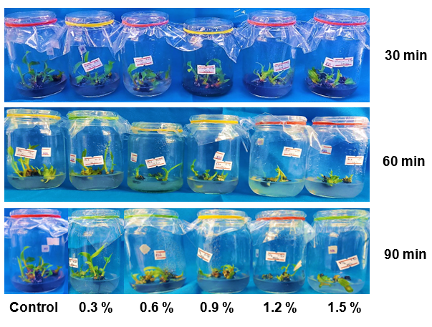

**Fig. 1. Effect of EMS treatment on survival of mutants in banana cv. ‘Phee-gyan’**

**3.2 Effect of EMS Treatment on Shoot Length and Fresh Weight**

Shoot length significantly decreased with increasing EMS concentrations across all treatments (P < 0.01) compared to their respective controls (0 % EMS: 3.76 cm, 3.53 cm, and 3.16 cm for 30 min, 60 min, and 90 min incubations, respectively). For the 30 min treatment, shoot length decreased from 2.97 cm (0.3 % EMS) to 1.46 cm (1.5 % EMS). Similarly, in the 60 min treatment, it declined from 2.69 cm (0.3 % EMS) to 1.27 cm (1.5 % EMS); while the 90 min treatment showed a reduction from 2.39 cm (0.3 % EMS) to 1.11 cm (1.5 % EMS) (Table 2). At 1.2 % EMS, shoot length was reduced by approximately 50 % across all three incubation periods. No significant interaction effect was observed between EMS concentration and incubation time on shoot length.

Similar results were reported in banana (Anusha et al. 2024, Shirani et al. 2016), acid lime (Davi et al. 2021), and papaya (Ravi et al. 2023), where shoot length progressively declined with increasing EMS concentrations. Mutants also exhibited delayed and weak growth compared to control, along with morphological abnormalities such as white leaf stripes, xantha, chlorosis, and dwarfism (Fig. 2).

The fresh weight of shoot tips significantly decreased across all EMS treatments (P < 0.01) compared to the control (0 % EMS: 1.69 g, 1.63 g, and 1.57 g for 30 min, 60 min, and 90 min incubations, respectively). After 30 min of EMS exposure, fresh weight declined from 1.57 g (0.3 % EMS) to 1.11 g (1.5 % EMS). Similarly, the 60 min treatment showed a reduction from 1.44 g (0.3 % EMS) to 0.89 g (1.5 % EMS), while the 90 min treatment decreased from 1.30 g (0.3 % EMS) to 0.73 g (1.5 % EMS) (Table 3). The highest fresh weight (1.57 g) was recorded at 0.3 % EMS (30 min), whereas the lowest (0.73 g) occurred at 1.5 % EMS (90 min). A nearly 50 % reduction in fresh weight was observed at 1.5 % EMS (60 min) and 1.2 % EMS (90 min). No significant interaction effect was observed between EMS concentration and incubation time on shoot length.

These findings align with previous studies on banana cultivars (Arachchige et al. 2016, Bidabadi et al. 2012, Jankowicz-Cieslak et al. 2012), where increasing EMS doses similarly reduced fresh weight. The reduction in both shoot length and fresh weight of explants is a commonly used indicator of the biological effects of chemical mutagens in M1 generation, likely due to disruptions in metabolic processes at the embryonic level.

**Table 2. Shoot length of banana cv. ‘Phee-gyan’ induced by EMS mutagenesis**

|  |  |  |  |  |  |  |
| --- | --- | --- | --- | --- | --- | --- |
| **EMS dosages (%)** | **30 min** | | **60 min** | | **90 min** | |
| **Shoot**  **length(cm)** | **Percent Over control** | **Shoot**  **length(cm)** | **Percent Over control** | **Shoot**  **length (cm)** | **Percent Over control** |
| 0 | 3.76a | 100.00 | 3.53a | 100.00 | 3.16a | 100.00 |
| 0.3 | 2.97b | 78.99 | 2.69b | 76.20 | 2.39b | 75.63 |
| 0.6 | 2.73b | 72.61 | 2.29bc | 64.87 | 1.89c | 59.81 |
| 0.9 | 2.59b | 68.88 | 2.20c | 62.32 | 1.86c | 58.86 |
| 1.2 | 1.89c | 50.27 | 1.63d | 46.18 | 1.43d | 45.25 |
| 1.5 | 1.46d | 38.83 | 1.27d | 35.98 | 1.11d | 35.13 |
| LSD (0.05) | 0.18 |  | 0.21 |  | 0.19 |  |
| C.V% | 11.13 |  | 14.69 |  | 14.73 |  |
| F test | EMS Dosage (D) | | | ** | | |
| Incubation Time (T) | | | ** | | |
| D x T | | | n.s | | |

*Note: ** P<0.01; * P<0.05; n.s., non-significant*

*Numbers with different letters are significantly different at P < 0.05 based on an LSD test.*

**Table 3. Fresh weight of banana cv. ‘Phee-gyan’ induced by EMS mutagenesis**

|  |  |  |  |  |  |  |
| --- | --- | --- | --- | --- | --- | --- |
| **EMS dosages (%)** | **30 min** | | **60 min** | | **90 min** | |
| **Fresh weight (g)** | **Percent Over control** | **Fresh weight (g)** | **Percent Over control** | **Fresh weight (g)** | **Percent Over control** |
| 0 | 1.69a | 100.00 | 1.63a | 100.00 | 1.57a | 100.00 |
| 0.3 | 1.57ab | 92.90 | 1.44b | 88.34 | 1.30a | 82.80 |
| 0.6 | 1.56ab | 92.31 | 1.42b | 87.12 | 1.22b | 77.71 |
| 0.9 | 1.45b | 85.80 | 1.31c | 80.37 | 1.18b | 75.16 |
| 1.2 | 1.26c | 74.56 | 1.14d | 69.94 | 0.90c | 57.32 |
| 1.5 | 1.11c | 65.68 | 0.89d | 54.60 | 0.73c | 46.50 |
| LSD (0.05) | 0.07 |  | 0.05 |  | 0.09 |  |
| C.V% | 8.12 |  | 6.19 |  | 12.47 |  |
| F test | EMS Dosage (D) | | | ** | | |
| Incubation Time (T) | | | ** | | |
| D x T | | | n.s | | |

*Note: ** P<0.01; * P<0.05; n.s., non-significant*

*Numbers with different letters are significantly different at P < 0.05 based on an LSD test.*

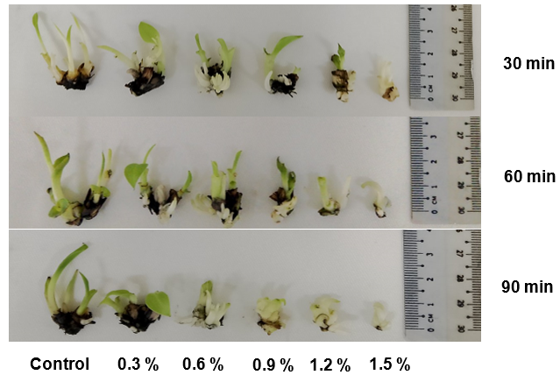

**Fig. 2. Morphological variations in proliferated shoot tips of banana cv. ‘Phee-gyan’ induced by EMS mutagenesis**

**3.3 Determination of LD50 Value**

Determination of the lethal dose is essential for any mutation breeding program in crops. The lethal dose 50 (LD50) is defined as the EMS concentrations and treatment duration that results in 50 % mortality or 50 % survival of mutants (Arisha et al. 2015). LD50 generally indicates the concentration that induces a high mutation rate with minimal plant damage (Hohmann et al. 2005). This value is also influenced by factors such as explant type, crop species, variety, season, chemical properties, maturity level, moisture content and other (Parthasarathi et al. 2020).

In the present study, the banana variety ‘Phee-gyan’ was treated with the chemical mutagen EMS, and the LD50 value for EMS was calculated using Probit analysis based on survival percentage, shoot length and fresh weight (Table 4 and Appendix Table 1 and 2). The dose response curves based on probit values were drawn and presented in Fig. 3, 4 and 5 for 30 min, 60 min and 90 min respectively.

The results demonstrated LD50 values of 1.9 %, 1.9 %, and 1.2 % for survival rate; 1.3 %, 1.1 % and 1.1 % for shoot length; and 1.9 %, 1.7 % and 1.5 % for fresh weight across the three incubation periods. These finding align with previous reports of optimum EMS mutagenesis conditions: 1.4 % for 60 min and 0.8 % for 120 min in banana cv. ‘Tella Chakkerakeli’ (Anusha et al. 2024), 0.8 % for 4 h in banana cv. ‘FenJiao’ (Wang et al. 2021), 0.33 % for 6 h in acid line cv. ‘PKM1’ (Devi et al. 2021), 0.55 % for 3 h in papaya cv. ‘CO7’ (Ravi et al. 2023), and 1 % for 24 h in cucumber (Wang et al. 2014).

**Table 4. Effect of EMS mutagenesis on LD50 for survival percentage in banana cv. ‘Phee-gyan’**

|  |  |  |  |  |  |  |  |  |
| --- | --- | --- | --- | --- | --- | --- | --- | --- |
| **EMS dosages (%)** | **Survival (%)** | | **Survival**  **(%) over control** | **Mortality (%) over control** | **Observed mortality (%)** | **Corrected mortality (%)** | **Probit value** | **LD50** |
| 30 min incubation time | | | | | | | | |
| 0 | | 78.89 | 100.00 | - | 21.11 | - | - | 1.9 % |
| 0.3 | | 72.22 | 91.48 | 8.52 | 27.78 | 8.45 | 3.66 |  |
| 0.6 | | 70.00 | 88.31 | 11.69 | 30.00 | 11.27 | 3.77 |  |
| 0.9 | | 58.89 | 74.04 | 25.96 | 41.11 | 25.35 | 4.33 |  |
| 1.2 | | 56.67 | 72.56 | 28.72 | 43.33 | 28.18 | 4.42 |  |
| 1.5 | | 51.11 | 64.04 | 35.96 | 48.89 | 35.21 | 4.61 |  |
| 60 min incubation time | | | | | | | | |
| 0 | | 76.67 | 100.00 | - | 23.33 | - | - | 1.9 % |
| 0.3 | | 66.67 | 87.07 | 12.93 | 33.33 | 13.05 | 3.87 |  |
| 0.6 | | 60.00 | 78.36 | 21.64 | 40.00 | 21.74 | 4.23 |  |
| 0.9 | | 56.67 | 74.13 | 25.87 | 43.33 | 26.09 | 4.36 |  |
| 1.2 | | 52.22 | 68.14 | 31.86 | 47.78 | 31.89 | 4.53 |  |
| 1.5 | | 46.67 | 60.95 | 39.05 | 53.33 | 39.13 | 4.72 |  |
| 90 min incubation time | | | | | | | | |
| 0 | | 74.44 | 100.00 | - | 25.56 | - | - | 1.2 % |
| 0.3 | | 63.33 | 85.11 | 14.89 | 36.67 | 14.92 | 3.96 |  |
| 0.6 | | 52.22 | 70.09 | 29.91 | 47.78 | 29.85 | 4.48 |  |
| 0.9 | | 47.78 | 64.16 | 35.84 | 52.22 | 35.82 | 4.64 |  |
| 1.2 | | 40.00 | 53.69 | 46.31 | 60.00 | 46.27 | 4.90 |  |
| 1.5 | | 23.33 | 31.29 | 68.71 | 76.67 | 68.65 | 5.50 |  |

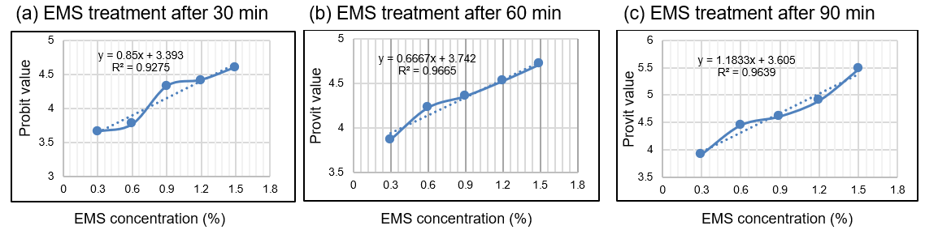

**Fig. 3. LD50 for survival percentage in banana cv. ‘Phee-gyan’ across three different incubation times**

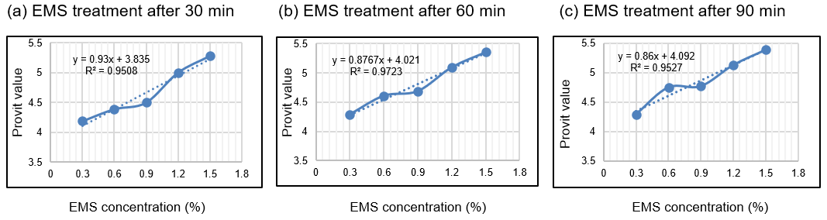

**Fig. 4. LD50 for shoot length in banana cv. ‘Phee-gyan’ across three different incubation times**

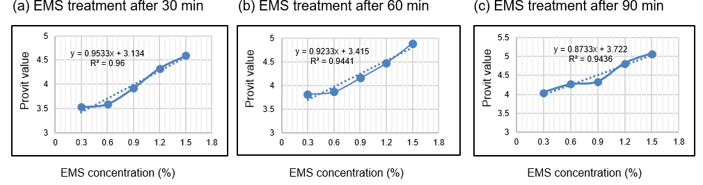

**Fig. 5. LD50 for fresh weight in banana cv. ‘Phee-gyan’ across three different incubation times**

**4. CONCLUSION**

The successful induction of desirable mutations depends critically on optimizing both EMS concentration and mutagenesis duration. This study demonstrated that varying EMS concentrations and incubation times significantly influenced explant fresh weight, shoot length, and survival rates (p < 0.05). A clear dose-dependent response was observed, where increasing EMS concentrations progressively reduced fresh weight, shoot length and survival percentage. For the banana cv. ‘Phee-gyan’, the optimal mutagenesis condition was identified as 1.2 % EMS treatment for 90 min, yielding a 53.69 % survival rate with favorable growth retention (45 % shoot length and 57 % fresh weight). The developed EMS-induced mutants of ‘Phee-gyan’ will facilitate efficient screening for enhanced tolerance to various climate change associated stresses, thereby supporting the development of more resilient banana varieties.

**REFERENCES**

Arisha, M., Liang, B., Shah, S. M., Gong, Z., & Li, D. (2014). Kill curve analysis and response of first-generation *Capsicum annuum* L. B12 cultivar to ethyl methane sulfonate. *Genetics and Molecular Research*, *13*(4), 10049–10061. <https://doi.org/10.4238/2014.november.28.9>.

Arisha, M. H., Shah, S. N. M., Gong, Z., Jing, H., Li, C., & Zhang, H. (2015). Ethyl methane sulfonate induced mutations in M2 generation and physiological variations in M1 generation of peppers (*Capsicum annuum* L.). *Frontiers in Plant Science*, *6*. <https://doi.org/10.3389/fpls.2015.00399>.

Anusha, D., Kumar, K. R., Reddy, P. V. K., & Rani, A. S. (2024). Effect of EMS on *in vitro* chemical mutagenesis in banana cultivar Tella Chakkerakeli (AAA). *International Journal of Advanced Biochemistry Research*, *8*(10), 275–279. <https://doi.org/10.33545/26174693.2024.v8.i10d.2447>.

Aye Tun. (2005). Current situation of banana R&D in Myanmar. In E. A. Vargas (Ed.), *Advancing banana and plantain R&D in Asia and the Pacific* (Vol. 13, pp. 97–100). INIBAP.

Bidabadi, S. S., Meon, S., Wahab, Z., Sreeramanan, S., & Mahmood, M. (2012). Induced mutations for enhancing variability of banana (*Musa* spp.) shoot tip cultures using ethyl methane sulphonate (EMS). *Australian Journal of Crop Science*, *6*(3), 391–401.

Caldwell, D. G., McCallum, N., Shaw, P., Muehlbauer, G. J., Marshall, D. F., & Waugh, R. (2004). A structured mutant population for forward and reverse genetics in Barley (*Hordeum vulgare* L.). *The Plant Journal, 40*(1), 143–150. <https://doi.org/10.1111/j.1365-313x.2004.02190.x>.

Department of Planning. (2023).  *Myanmar agriculture sector in brief*, p.60. Ministry of Agriculture, Livestock and Irrigation.

Devi, D. M., Kumar, S. R. C., Rajangam, J., Santha, S., & Sankar, C. (2021). Determination of lethal dose (LD50) and effect of physical and chemical mutagenesis in acid lime var. PKM 1. *Journal of Pharmaceutical Innovation, 10*(11), 583–588.

Gillmor, C. S., & Lukowitz, W. (2020). EMS Mutagenesis of *Arabidopsis* seeds. *Methods in Molecular Biology*, 15–23. <https://doi.org/10.1007/978-1-0716-0342-0_2>.

Gaul, H. (1970). Mutagen effects observable in the first generation. *In Manual on mutation breeding* (Technical Report Series No. 119, pp. 85–89). Vienna, Austria: International Atomic Energy Agency.

Finney, D. J. (1978). *Statistical method in biological assay* (3rd ed., pp. 362–368). London and High Wycombe: Charles Griffin.

Hofmann, N. E., Raja, R., Nelson, R. L., & Korban, S. S. (2004). Mutagenesis of embryogenic culture of soybean and detecting polymorphism using RAPD markers. *Biologia Plantarum*, *48*(2), 173–177.

Hohmann, U., Jacobs, G., & Jung, C. (2005). An EMS mutagenesis protocol for sugar beet and isolation of non‐bolting mutants. *Plant Breeding, 124*(4), 317–321.

Jankowicz-Cieslak, J., Huynh, O. A., Brozynska, M., Nakitandwe, J., & Till, B. J. (2012). Induction, rapid fixation and retention of mutations in vegetatively propagated banana. *Plant Biotechnology Journal, 10*, 1056–1066.

Li, L., Wang, H., Zhang, C., Wang, X., Shi, F., Chen, W., & Ge, X. (2013). Origins and Domestication of Cultivated Banana Inferred from Chloroplast and Nuclear Genes. *PLOS One, 8*(11), e80502. <https://doi.org/10.1371/journal.pone.0080502>.

Liu, Y., Li, Y., Wang, A., Xu, Z., Li, C., Wang, Z., ... Li, J. (2024). Enhancing cold resistance in banana (*Musa* spp.) through EMS-induced mutagenesis, L-Hyp pressure selection: Phenotypic alterations, biomass composition, and transcriptomic insights. *BMC Plant Biology, 24*(1), 101. <https://doi.org/10.1186/s12870-024-04775-5>.

International Plant Protection Convention. (2015).  Disease of Banana-fruit in Myanmar.<https://assets.ippc.int/static/media/files/pestreport/2015/10/03/BANANA_FRUIT_PESTS_in_MM.pdf>.

Moon, K. B., Ahn, D. J., Park, J. S., Jung, W. Y., Cho, H. S., Kim, H. R., ... Kim, H. S. (2018). Transcriptome profiling and characterization of drought-tolerant potato plant (*Solanum tuberosum* L.). *Molecules and Cells, 41*(11), 979-992. <https://doi.org/10.14348/molcells.2018.0312>.

Murashige, T., & Skoog, F. (1962). A revised medium for rapid growth and bio assays with tobacco tissue cultures. *Physiology Plantarum, 15*(3), 473–497.

Oladosu, Y., Rafii, M. Y., Abdullah, N., Hussin, G., Ramli, A., Rahim, H. A., & Usman, M. (2016). Principle and application of plant mutagenesis in crop improvement: A review. *Biotechnology & Biotechnological Equipment, 30*(1), 1–16.

Omar, M. S., Novak, F. J., & Brunner, H. (1989). *In vitro* action of ethyl methane sulphonates on banana shoot tips. *Scientia Horticulturae, 40*, 283–295.

Parthasarathi, G., Pillai, M. A., Kannan, R., Kumari, S. M. P., & Binodh, A. K. (2020). Optimal lethal dose determination for gamma rays and EMS induced mutagenesis in TMV7 and SVPR1 sesame (*Sesamum indicum* L.) varieties. *Current Journal of Applied Science and Technology, 39*(28), 136–144.

Ranjha, M. M. A. N., Irfan, S., Nadeem, M., & Mahmood, S. (2020). A comprehensive review on nutritional value, medicinal uses, and processing of banana. *Food Reviews International, 38*(2), 199–225. <https://doi.org/10.1080/87559129.2020.1725890>.

Ravi, A., Rani, M. A., Auxcilia, J., Thiruvengadam, V., & Karthikeyan, G. (2023). Assessment of mutagenic sensitivity and lethal dose of EMS in papaya (*Carica papaya* L.) variety CO 7. *Agricultural Science Digest, 10*(33), 1165–1169.

Sabetta, W., Alba, V., Blanco, A., & Montemurro, C. (2011). A TILLING resource for gene function analysis in sunflower. *Plant Methods, 7*(1), 1–13. <https://doi.org/10.1186/1746-4811-7-20>.

Serrat, X., Esteban, R., Guibourt, N., Moysset, L., Nogues, S., & Lalanne, E. (2014). EMS mutagenesis in mature seed-derived rice calli as a new method for rapidly obtaining TILLING mutant populations. *Plant Methods, 10*(1), 5. <https://doi.org/10.1186/1746-4811-10-5>.

Shirani, D. A., Niroshani, K. A. C., Gaminie, A. W., & Abeysinghe, P. D. (2016). Determination of optimum dosage of the mutagen ethyl methane sulphonate (EMS) for mass treatment of shoot tips of banana variety ‘Agra’. *Sri Lanka Journal of Food and Agriculture, 2*(2).

Wan, Y., Watanabe, J. A., San, S. Y., Htaik, T., Win, K., Yamanaka, S., ... Watanabe, K. N. (2005). Assessment of genetic diversity among the major Myanmar banana landraces. *Breeding Science, 55*(3), 365-369.

Wang, H., Sui, X., Guo, J., Wang, Z., Cheng, J., Ma, S. I., ... Zhang, Z. (2014). Antisense suppression of cucumber (*Cucumis sativus* L.) sucrose synthase 3 (CsSUS3) reduces hypoxic stress tolerance. *Plant, Cell & Environment, 37*(3), 795–810.

Wang, W., Simmonds, J., Pan, Q., Davidson, D., He, F., Battal, A., … Akhunov, E. (2018). Gene editing and mutagenesis reveal inter-cultivar differences and additivity in the contribution of TaGW2 homoeologues to grain size and weight in wheat. *Theoretical and Applied Genetics, 131*(11), 2463–2475. <https://doi.org/10.1007/s00122-018-3166-7>.

Wang, Z., Miao, H., Liu, J., Xu, B., Yao, X., Xu, C., … Jin, Z. (2019). *Musa balbisiana* genome reveals subgenome evolution and functional divergence. *Nature Plants, 5*(8), 810–821. <https://doi.org/10.1038/s41477-019-0452-6>.

Wang, X., Wang, A., Li, Y., Xu, Y., Wei, Q., Wang, J., … Li, J. (2021). A Novel Banana Mutant “RF 1” (*Musa* spp. ABB, Pisang Awak Subgroup) for Improved Agronomic Traits and Enhanced Cold Tolerance and Disease Resistance. *Frontiers in Plant Science, 12*. <https://doi.org/10.3389/fpls.2021.730718>.

Zhang, K., Guo, L., Cheng, W., Liu, B., Li, W., Wang, F., … Li, K. (2020). SH1-dependent maize seed development and starch synthesis via modulating carbohydrate flow and osmotic potential balance. *BMC Plant Biology, 20*(1). <https://doi.org/10.1186/s12870-020-02478-1>.

APPENDIX

**Table 1. Effect of EMS mutagenesis on LD50 for shoot length in banana cv. ‘Phee-gyan’**

|  |  |  |  |  |  |
| --- | --- | --- | --- | --- | --- |
| **EMS**  **Dosages (%)** | **Shoot length (cm)** | **(%) Over control** | **(%) Reduction over control** | **Probit unit** | **LD50** |
| 30 min incubation time | | | | | |
| 0 | 3.76 | 100.00 | - | - | 1.3 % |
| 0.3 | 2.97 | 78.99 | 21.01 | 4.19 |  |
| 0.6 | 2.73 | 72.61 | 27.39 | 4.39 |  |
| 0.9 | 2.59 | 68.88 | 31.12 | 4.48 |  |
| 1.2 | 1.89 | 50.27 | 49.73 | 5.00 |  |
| 1.5 | 1.46 | 38.83 | 61.17 | 5.25 |  |
| 60 min incubation time | | | | | |
| 0 | 3.53 | 100.00 | - | - | 1.1 % |
| 0.3 | 2.69 | 76.20 | 23.80 | 4.29 |  |
| 0.6 | 2.29 | 64.87 | 35.13 | 4.61 |  |
| 0.9 | 2.20 | 62.32 | 37.68 | 4.69 |  |
| 1.2 | 1.63 | 46.18 | 53.82 | 5.10 |  |
| 1.5 | 1.27 | 35.98 | 64.02 | 5.36 |  |
| 90 min incubation time | | | | | |
| 0 | 3.16 | 100.00 | - | - | 1.1 % |
| 0.3 | 2.39 | 75.63 | 24.37 | 4.29 |  |
| 0.6 | 1.89 | 59.81 | 40.19 | 4.75 |  |
| 0.9 | 1.86 | 58.86 | 41.14 | 4.77 |  |
| 1.2 | 1.43 | 45.25 | 54.75 | 5.13 |  |
| 1.5 | 1.11 | 35.13 | 64.87 | 5.39 |  |

**Table 2. Effect of EMS mutagenesis on LD50 for fresh weight in banana cv. ‘Phee-gyan’**

|  |  |  |  |  |  |
| --- | --- | --- | --- | --- | --- |
| **EMS**  **dosages (%)** | **Fresh weight (g)** | **(%) Over control** | **(%) Reduction over control** | **Probit unit** | **LD50** |
| 30 min incubation time | | | | | |
| 0 | 1.69 | 100.00 | - | - | 1.9 % |
| 0.3 | 1.57 | 92.90 | 7.10 | 3.52 |  |
| 0.6 | 1.56 | 92.31 | 7.69 | 3.59 |  |
| 0.9 | 1.45 | 85.80 | 14.20 | 3.92 |  |
| 1.2 | 1.26 | 74.56 | 25.44 | 4.33 |  |
| 1.5 | 1.11 | 65.68 | 34.32 | 4.59 |  |
| 60 min incubation time | | | | | |
| 0 | 1.63 | 100.00 | - | - | 1.7 % |
| 0.3 | 1.44 | 88.34 | 11.66 | 3.82 |  |
| 0.6 | 1.42 | 87.12 | 12.88 | 3.87 |  |
| 0.9 | 1.31 | 80.37 | 19.63 | 4.16 |  |
| 1.2 | 1.14 | 69.94 | 30.06 | 4.48 |  |
| 1.5 | 0.89 | 54.60 | 45.40 | 4.9 |  |
| 90 min incubation time | | | | | |
| 0 | 1.57 | 100.00 | - | - | 1.5 % |
| 0.3 | 1.30 | 82.80 | 17.20 | 4.05 |  |
| 0.6 | 1.22 | 77.71 | 22.29 | 4.23 |  |
| 0.9 | 1.18 | 75.16 | 24.84 | 4.33 |  |
| 1.2 | 0.90 | 57.32 | 42.68 | 4.82 |  |
| 1.5 | 0.73 | 46.50 | 53.50 | 5.10 |  |