Effects of Plant Growth Regulators, Media and Genotype on Callus Induction in Maize (Zea mays L.) Anther Culture

.
ABSTRACT

Maize (Zea mays L.) anther culture is a promising technique for the rapid production of doubled haploids, but its efficiency is limited by genotype dependency and low callus induction rates. This study aimed to evaluate the effects of plant growth regulators (PGRs), media composition, and genotype on callus induction in six maize genotypes commonly used in Myanmar's breeding programs. The research employed an experimental approach utilizing Murashige and Skoog (MS) media supplemented with varying concentrations and combinations of 2,4-dichlorophenoxyacetic acid (2,4-D) plus kinetin or naphthaleneacetic acid (NAA), and 2,3,5-triiodobenzoic acid (TIBA) alone. Callus formation was monitored over eight weeks, and data were analyzed to assess the influence of PGRs and genotype on induction rates. Significant differences were observed among genotypes and PGR treatments, with Yezin 14, C7, and D6 exhibiting the highest frequency of late uninucleate microspores and superior callus induction. The combination of 2,4-D (2.0 mg L⁻¹) plus kinetin (1.5 mg L⁻¹) produced the highest callus induction rate of 19.44% in Yezin 14. TIBA, when used alone, also stimulated callus formation, although it often resulted in increased watery callus. Chi-square analysis confirmed that both genotype and PGR treatment significantly influenced callus induction efficiency (p < 0.05). These findings highlight the importance of optimizing genotype-specific protocols and the balance of hormones to enhance androgenesis in maize. The results provide valuable insights for improving doubled haploid production in Myanmar’s maize breeding programs, contributing to more efficient and cost-effective cultivar development.

Keywords: Anther culture, Maize (Zea mays L.), Plant growth regulators (PGRs), Callus induction

1. INTRODUCTION

Maize (Zea mays L.), domesticated from wild teosinte (Zea mays ssp. mexicana ) in the Mexican highlands (Yan et al., 2011), has become the third most important cereal crop globally after rice and wheat, with extensive use in food, feed, biofuel, and industrial applications (Tripathy et al., 2020). It holds particular significance in Myanmar, where it ranks second in agricultural value, contributing approximately 9% of annual crop production, yet exhibits substantial regional yield variability.
Anther culture-based haploid induction offers a promising alternative to conventional inbreeding methods in maize breeding programs, significantly reducing time and labor requirements (Lanto et al., 2023; Matova et al., 2023). However, its application remains limited by low and inconsistent callus induction rates, particularly in elite genotypes (Srichuay et al., 2004; Goralski et al., 2005). Key factors influencing androgenesis include microspore developmental stage, environmental conditions, culture media composition, and genotype (Kahrizi et al., 2000).
Plant growth regulators (PGRs) play a important role in determining microspore developmental fate during anther culture. The auxin 2,4-dichlorophenoxyacetic acid (2,4-D) is essential for initiating sporophytic development and callus formation (Rosaura et al., 1998). Combinations of 2,4-D with cytokinins such as kinetin or auxins like naphthaleneacetic acid (NAA) have shown synergistic effects on embryoid quality, though optimal concentrations vary widely across genotypes. Additionally, 2,3,5-triiodobenzoic acid (TIBA), an auxin transport inhibitor, has been reported to enhance callus induction frequency by modulating auxin distribution, increasing efficiency by 15–40% in responsive genotypes (Spitkó et al., 2006).
Genotype-specific responses further complicate protocol standardization. While dent corn shows moderate androgenic response under optimized auxin–cytokinin ratios, flint maize generally performs better on N6 medium. In contrast, waxy and flour maize are recalcitrant, often requiring higher auxin concentrations (Hosseini et al., 2014). Sweet corn and popcorn exhibit particularly low embryogenesis rates (<5%) on standard Murashige and Skoog (MS) medium, necessitating tailored adjustments in growth regulator combinations and sugar content (Hosseini et al., 2014). These findings underscore the lack of a universal protocol and highlight the need for genotype-specific optimization.
Despite global advances, there remains a critical gap in adapting anther culture protocols to regionally adapted germplasm, particularly in resource-constrained settings such as Myanmar. Current protocols predominantly target commercial hybrids and do not account for local genetic diversity or cost-effective media components. This limits the potential for developing locally adapted hybrids through efficient doubled haploid technology.
To address this gap, the present study was designed with the following objectives:
(1) To assess the effects of varying concentrations and combinations of 2,4-D with kinetin or NAA, and TIBA alone on callus induction in selected maize genotypes using MS medium.
(2) To evaluate genotypic variation in androgenic response among inbred maize lines.
2. material and methods
The experiments were carried out in the Department of Agricultural Biotechnology, Yezin Agricultural University (19°50′08″N, 96°16′42″E), Myanmar, from February to December 2024. The experimental design included two factors: Factor A consisted of six levels of plant growth regulators, and Factor B comprised six maize genotypes (Table 1). The selected maize hybrids and inbred lines represent commonly cultivated or locally significant varieties in Myanmar and are considered suitable for breeding and genetic studies.
2.1 Tassel Collection and Anther Incubation
Tassels containing anthers at the uninucleate microspore stage were collected from donor plants before emergence from the leaf whorl. The developmental stage of the microspores was confirmed using acetocarmine squash staining. Immediately after collection, tassels were wrapped in aluminum foil and stored in a low-temperature incubator at 5–7 °C for one week, following the protocol of Barnabas et al. (2003).
For surface sterilization, tassel fragments were immersed in 2% (w/v) sodium hypochlorite solution for 10 minutes and subsequently rinsed three times with sterile distilled water. Under aseptic conditions, anthers were carefully dissected and transferred into 100 mL glass tubes containing various induction media. These cultures were incubated in the dark at a constant temperature of 28 °C until callus formation was observed.
The basal induction medium was based on Murashige and Skoog (1962), supplemented with 500 mg/L casein hydrolysate, 30 g/L sucrose, and 8.0 g/L agar. The pH was adjusted to 5.8 prior to autoclaving, and activated charcoal was omitted from the formulation (Genovesi and Collins, 1982).
2.2 Experimental Design and Data Analysis
A completely randomized design (CRD) was employed, with three biological replicates per treatment. The following parameters were recorded: microspore developmental stage, number of calli formed, type of callus and callus induction percentage (%). Data analysis was conducted using Python (Version 3.12.0). The pandas library was utilized for data manipulation, numpy for numerical computations, and matplotlib.pyplot and seaborn for data visualization. Descriptive statistics, including means and percentages of callus formation, were calculated for each treatment combination and genotype across the four-week observation period. Standard error of the mean (SEM) was also computed to assess variability among replicates.
Table 1. Six selected maize genotypes used in the experiment
No. | Genotypes | Types | Lifespan
1 | Yezin 10 | Hybrid | 100 -110
2 | Yezin 14 | Hybrid | 115-120
3 | C2 | Inbred | 100-120
4 | C7 | Inbred | 100-120
5 | D6 | Inbred | 100-120
6 | D15 | Inbred | 100-120

Table 2. PGRs used in experiment
No. | Plant growth regulators | Concentration (mg⁻¹)
A. | 2,4-D + Kinetin | 2.0 + 1.5
B. | 2,4-D + NAA | 2.0 + 2.0
C. | 2,4-D + Kinetin | 2.5 + 1.5
D. | TIBA | 0.05
E. | TIBA | 0.1
F. | TIBA | 0.15

3. results and discussion
3.1 Determination of Microspore Developmental Stages
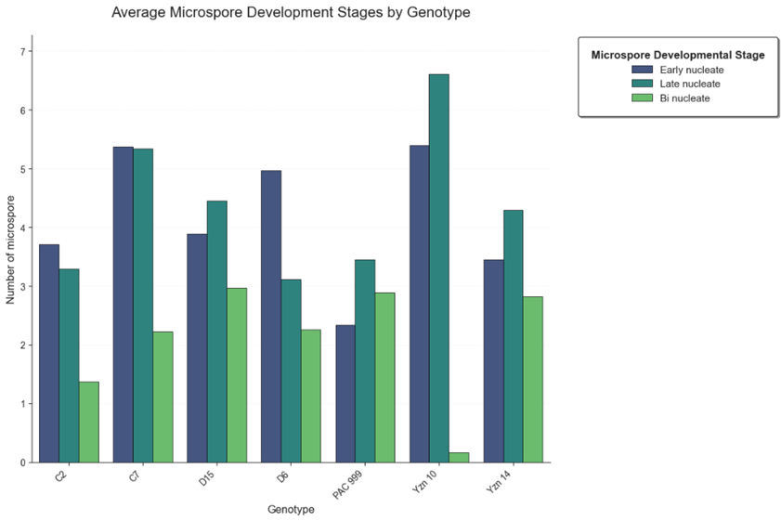
Figure 1. Genotypic Differences in Microspore Development Stages
3.1.1 Microspore Developmental Stage Distribution Among Genotypes
Microscopic examination revealed significant variation in microspore developmental stages among the evaluated maize genotypes (Figure 1). For example, genotypes C7, D6, and Yezin 10 exhibited a predominance of 'late uninucleate' microspores, with mean values of 5.33, 4.96, and 6.61, respectively. This stage is generally considered optimal or highly responsive for inducing embryogenesis in maize and other cereals (Jähne & Lörz, 1995; Testillano et al., 2002), as microspores at this stage possess the necessary cellular machinery and plasticity to alter their developmental pathway.
Among these, genotype Yezin 10 showed the highest retention of microspores at the late uninucleate stage (6.61), followed by C7 (5.33) and D6 (4.96). In contrast, genotype C2 had the lowest proportion of late uninucleate microspores (3.30), suggesting potentially reduced responsiveness to androgenic induction. On the other hand, genotypes D15, PAC999, and Yezin 14 displayed a more balanced distribution across early uninucleate, late uninucleate, and binucleate stages, indicating a less synchronized and more asynchronous pattern of microspore development.
Genotype C7 exhibited an exceptionally uniform distribution between the early (5.37) and late (5.33) uninucleate stages, with a relatively low proportion of binucleate microspores (2.22), making it a promising candidate for in vitro androgenesis (Żur et al., 2015).

3.1.2 Callus Formation Rates in Response to Plant Growth Regulators
Callus induction was evaluated across six maize genotypes (Yezin 14, Yezin 10, C7, C2, D6, and D15) cultured on media supplemented with varying plant growth regulator (PGR) combinations. The effects of genotype and PGRs on callus formation were monitored over four weeks, with observations recorded weekly. Initial callus formation began during Week 1 across all genotypes and treatments (Figure 2). The highest callus induction rate (0.12%) was observed in Yezin 14 treated with 0.1 mg L⁻¹ 2,3,5-triiodobenzoic acid (TIBA), followed by a 0.06% rate under 2.0 mg L⁻¹ 2,4-dichlorophenoxyacetic acid (2,4-D) and 1.5 mg L⁻¹ kinetin. Genotype D6 also exhibited a stable 0.06% callus formation rate under the same auxin–cytokinin combination, indicating consistent responsiveness. Notably, visible callus initiation occurred as early as the first week, suggesting rapid cellular reprogramming.
By Week 2, Yezin 14 achieved the highest callus formation rate (0.14%), followed by D6 (0.11%) and C7 (0.09%) under TIBA (0.1 mg L⁻¹) or 2,4-D plus kinetin treatments. These findings corroborate previous reports that optimal auxin–cytokinin balance, particularly with potent auxins like 2,4-D, is essential for dedifferentiation and proliferation in cereal anther cultures (Indrianto et al., 2001; Soriano et al., 2007). Comparable responses to TIBA alone and 2,4-D plus kinetin suggest Yezin 14 exhibits robust callogenic potential under both auxin-dominant and balanced hormonal conditions (Figure 2). By Week 4, Yezin 14’s callus formation stabilized at 0.18% under previously identified optimal PGR regimes.
In contrast, genotype C2 showed near-zero callus induction, potentially due to lower cell totipotency or altered endogenous hormone sensitivity (Liu et al., 2017). This genotype-dependent variability aligns with literature emphasizing the strong influence of genetic background on maize haploid tissue culture success (Henry et al., 2023). Rapid callus initiation within the first week reflects the combined impact of genotype, medium composition, PGRs, and pretreatment stressors—factors known to modulate embryogenesis speed and efficiency (Murashige & Skoog, 1962; Fehér, 2015). Early callus development in Yezin 14 under 2,4-D and kinetin (0.06% by Week 1) indicates efficient microspore reprogramming and totipotent activation, consistent with evidence linking hormonal signaling and stress-induced pathways to androgenic competence (Fehér, 2015; Pulido et al., 2009; Sharma et al., 2021; Gu et al., 2020). The sustained response of Yezin 14 to auxin-based treatments supports its inherent embryogenic capacity, as reported in prior studies (Smith et al., 2018).
From Weeks 2 to 4, Yezin 14 consistently demonstrated high responsiveness to auxin–cytokinin combinations, particularly those containing 2,4-D or TIBA. Similarly, D6 maintained low but reproducible callus formation rates, underscoring its reliable androgenic potential and regenerative competence (Bhowmik, 2011; Soriano et al., 2007). Conversely, genotypes C2 and Yezin 10 exhibited consistently low callus induction, regardless of treatment, reinforcing the genotype-specific nature of androgenesis (Hu & Kasha, 1997; Prigge & Melchinger, 2012). Reduced responsiveness may stem from poor microspore viability, delayed signal transduction, or impaired metabolic reprogramming (Testillano et al., 2000). These results of earlier findings highlighting the critical role of auxin–cytokinin balance in cereal anther culture systems (Indrianto et al., 2001; Soriano et al., 2007).
The early onset of callus formation in responsive genotypes suggests a swift physiological shift post-culture, likely triggered by stress pre-treatments, nutrient availability, and optimal PGR exposure. Such early responses are advantageous for shortening culture duration and minimizing somaclonal variation—key considerations for improving doubled haploid production efficiency (Touraev et al., 1996; Forster et al., 2007).

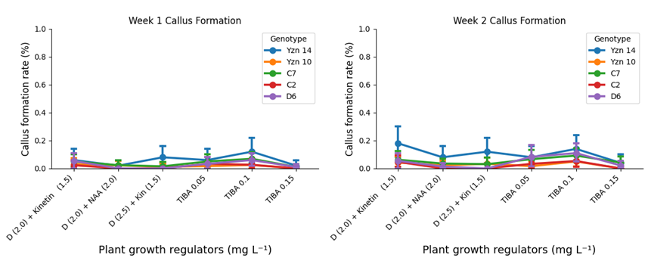
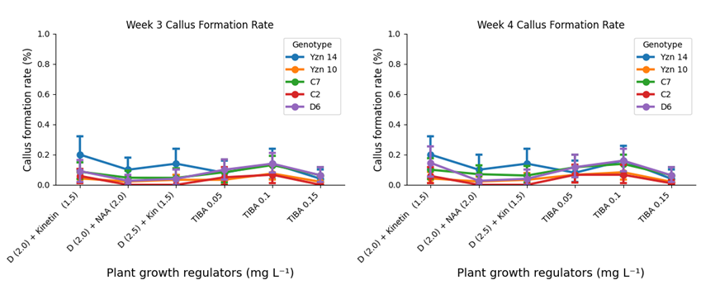
Figure 2. Influence of plant growth regulator combinations on callus formation rates in six maize genotypes during four weeks of anther culture in experiment
3.1.3 Callus Formation Rates: Effects of Genotype and Culture Medium
Chi-square (χ²) analysis revealed statistically significant associations (p < 0.05) between callus formation and both genotype and culture medium across all four weeks of observation (Table 3). In Week 1, genotype (χ² = 16.087, p = 0.0029) and plant growth regulator (PGR) composition (χ² = 22.805, p = 0.0004) significantly influenced callus induction, with PGRs showing a stronger effect. These effects intensified over time: genotype χ² values increased to 30.583 (Week 2), 29.088 (Week 3), and 28.988 (Week 4) (all p < 0.0001), indicating a progressively pronounced genotypic influence. Similarly, PGR effects remained highly significant throughout, with χ² values rising from 26.168 (Week 2) to 30.989 (Week 4) (all p < 0.0001).
These findings underline the critical and sustained roles of genotype selection and culture medium optimization in determining callus induction efficiency. The results are consistent with previous studies emphasizing the genetic and environmental determinants of tissue culture success in cereals (Ali et al., 2021) and highlight the importance of synergistically tailoring both factors to enhance anther culture outcomes.
Table 3. Effects of genotype and culture medium on callus formation rates in maize anther culture: chi-square test results (weeks 1- 4) in experiment
Week | Factor | χ² Value | p-value*
1 | Genotype | 16.087 | 0.0029
 | PGRs | 22.805 | 0.0004
2 | Genotype | 30.583 | <0.0001
 | PGRs | 26.168 | 0.0001
3 | Genotype | 29.088 | <0.0001
 | PGRs | 27.5 | <0.0001
4 | Genotype | 28.988 | <0.0001
 | PGRs | 30.989 | <0.0001
*Note: All tests used α = 0.05.
3.2 Effect of Plant Growth Regulators and Genotype on Callus Induction in Maize Anther Culture
3.2.1 Callus Formation in Response to PGR Treatments
Significant variation in callus induction rates was observed across genotypes and plant growth regulator (PGR) treatments. The highest callus induction rate (19.44%) was recorded in Yezin 14 when cultured on medium supplemented with 2,4-D (2.5 mg L⁻¹) and kinetin (1.5 mg L⁻¹), followed by 2,4-D (2.0 mg L⁻¹) + kinetin (1.5 mg L⁻¹) (13.44%) and TIBA (0.1 mg L⁻¹) (15.83%), indicating broad hormonal responsiveness in this genotype. C7 exhibited a maximum response (12.71%) under the same 2,4-D (2.5 mg L⁻¹) + kinetin combination, with moderate responses under 2,4-D (2.0 mg L⁻¹) + kinetin (9.63%) and 2,4-D (2.0 mg L⁻¹) + NAA (1.5 mg L⁻¹) (9.38%). D6, generally less responsive, unexpectedly showed a high induction rate (15.44%) under 2,4-D (2.5 mg L⁻¹) + kinetin, while other PGR combinations yielded minimal responses (<2%).
In contrast, Yezin 10 and C2 exhibited lower overall callus formation, peaking at 7.16% and 6.72%, respectively, under 2,4-D (2.5 mg L⁻¹) + kinetin and TIBA (0.15 mg L⁻¹). Low concentrations of TIBA (e.g., 0.05 mg L⁻¹) and imbalanced auxin-cytokinin ratios consistently resulted in poor callus induction (<2%) across multiple genotypes.
The combination of 2,4-D (2.5 mg L⁻¹) and kinetin (1.5 mg L⁻¹) emerged as the most effective treatment, inducing high callus frequencies in Yezin 14, C7, and D6. This finding underscores the critical role of genotype in determining optimal culture conditions. Among the tested lines, Yezin 14 demonstrated superior responsiveness, making it a promising candidate for future studies aimed at identifying quantitative trait loci (QTLs) associated with anther culturability—an essential component in doubled haploid breeding programs (Chaudhary et al., 2019).
The efficacy of 2,4-D in combination with kinetin aligns with established principles in plant tissue culture, where a balanced auxin–cytokinin ratio is crucial for initiating cell division and callus formation (Gaspar et al., 1996; Wang et al., 2011). As a synthetic auxin, 2,4-D is widely recognized for its stability and potent stimulatory effect on cell proliferation (Hassan et al., 2001). In contrast, TIBA—used alone—showed limited effectiveness, suggesting that auxin transport inhibition alone cannot substitute for exogenous auxin and cytokinin supply. While TIBA may modulate endogenous auxin distribution (Thomas, 1978, citing Genovesi, 1990), its inconsistent performance across genotypes highlights the need for precise optimization in specific genetic backgrounds.
In summary, these results highlight the pivotal influence of both PGR composition and genotype on callus induction in maize anther culture. The consistent superiority of 2,4-D and kinetin combinations supports their use as standard regulators for optimizing androgenesis protocols, particularly in highly responsive genotypes such as Yezin 14.
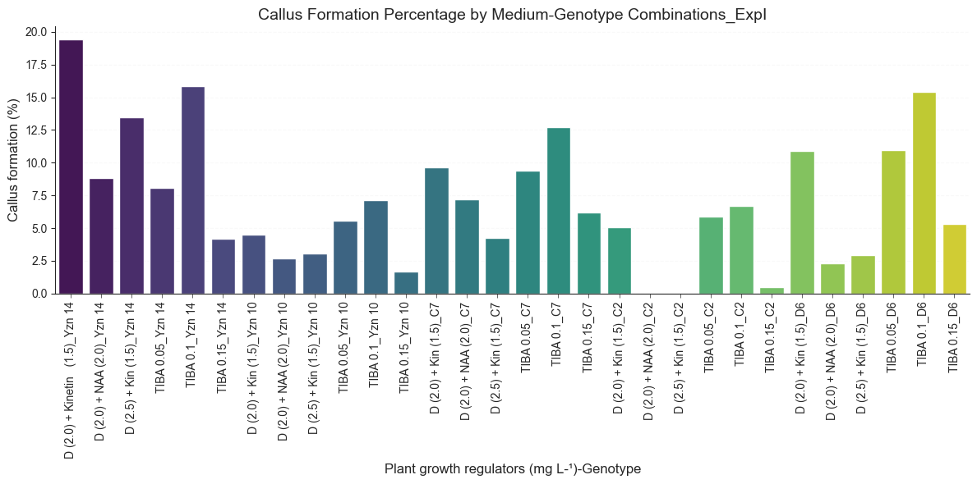

Figure 3. Influence of genotype and plant growth regulator combinations on callus formation percentage in experiment
3.3 Genotypic Variation and Plant Growth Regulator Effects on Non-responsiveness in Maize Anther in vitro Culture
Across all treatments and genotypes, the majority of anthers exhibited a "No Response" phenotype, underscoring the inherent recalcitrance of maize to in vitro androgenesis. Among plant growth regulator (PGR) treatments, TIBA at 0.1 mg L⁻¹ elicited the highest frequency of non-responsive anthers (n = 393), followed by the combination of 2,4-D (2.0 mg L⁻¹) and NAA (2.0 mg L⁻¹) (n = 344), and TIBA at 0.15 mg L⁻¹ (n = 350). Genotypes C2, C7, and Yezin 10 displayed the highest proportions of non-responsiveness, indicating limited androgenic potential. Conversely, Yezin 14 consistently showed the lowest incidence of non-response, suggesting superior responsiveness and a favorable genetic background for callus induction.
3.3.1 Effect of Plant Growth Regulators and Genotypic Variation on Normal Callus Formation
TIBA at 0.1 mg L⁻¹ was the most effective PGR for inducing normal callus formation, yielding 57 responsive anthers. Other treatments including 2,4-D (2.0 mg L⁻¹) plus kinetin (1.5 mg L⁻¹) and TIBA at 0.05 mg L⁻¹ produced 35 and 27 normal calli, respectively. Among genotypes, C7 generated the highest number of normal calli (~49 out of 500 anthers), followed by D6 (41) and Yezin 14 (37 out of 350), highlighting their relatively strong regeneration capacity. In contrast, C2 and Yezin 10 produced minimal normal callus, confirming their poor androgenic response.
3.3.2 Influence of PGRs and Genotypic Variation on Watery Callus Formation
Watery callus formation was predominantly observed in TIBA-supplemented media, with TIBA at 0.1 mg L⁻¹ producing the highest incidence (n = 25), followed by TIBA at 0.15 mg L⁻¹ (n = 19) and 0.05 mg L⁻¹ (n = 17). Treatments combining 2,4-D with either kinetin or NAA resulted in fewer watery calli, suggesting greater morphological stability. Yezin 10 and Yezin 14 exhibited the highest frequencies of watery callus, indicating a propensity for aberrant development despite their overall responsiveness. In contrast, C2, C7, and D6 produced minimal watery callus, reflecting a lower tendency toward cellular dysfunction. Given that watery callus is often associated with poor regenerative capacity, its prevalence even among high-performing genotypes highlights the need for optimization to enhance callus quality.
Synthesis and Implications
These findings underline the critical interplay between genotype and culture medium in determining both the success and morphological integrity of callus induction in maize anther culture. Pronounced genotypic differences, particularly in the proportion of non-responsive anthers, align with previous reports emphasizing the genetic basis of in vitro responsiveness in maize.
Among tested genotypes, Yezin 14 demonstrated the highest responsiveness, with significantly fewer non-responsive anthers, suggesting efficient microspore reprogramming and callus initiation. This makes it a promising candidate for DH breeding programs. Notably, genotypes such as C7 and D6, though less frequently responsive, produced a disproportionately high proportion of morphologically normal calli with minimal watery formations. These results imply that, although callus induction rates are low in these genotypes, successful induction tends to yield higher-quality callus with improved regenerative potential. Thus, C7 and D6 may remain viable candidates if induction protocols are optimized through tailored media formulations or pretreatment strategies.
The variability in callus morphology across genotypes underlines the complex interaction between genetic makeup and culture conditions. While callus induction frequency is crucial, callus quality—particularly the absence of watery phenotypes—is equally vital for successful regeneration. Future studies should focus on fine-tuning hormonal concentrations and refining culture techniques to minimize watery callus formation, especially in highly responsive genotypes like Yezin 14, thereby enhancing their utility in androgenesis-based breeding pipelines.
Statistical analyses revealed a highly significant dependence of callus development on both genotype and PGR treatment (P < 0.0001), reinforcing the importance of genotype-specific optimization in anther culture systems.
Table 4. Distribution of Callus Types in Maize Anther Culture Across Different Media, Plant Growth Regulators, and Genotypes; Chi-squared Statistic = 65.84, P < 0.0001
Factor Type | Factor Level | No Response | Normal Callus | Watery Callus
PGRs | 2,4-D (2.0 mg L⁻¹) + Kinetin (1.5 mg L⁻¹) | 326 | 35 | 4
 | 2,4-D (2.0 mg L⁻¹) + NAA (2.0 mg L⁻¹) | 344 | 15 | 1
 | 2,4-D (2.5 mg L⁻¹) + Kinetin (1.5 mg L⁻¹) | 288 | 16 | 1
 | TIBA (0.05 mg L⁻¹) | 246 | 27 | 17
 | TIBA (0.1 mg L⁻¹) | 393 | 57 | 25
 | TIBA (0.15 mg L⁻¹) | 350 | 16 | 19
Chi square statistic: 74.77, P-value: < 0.0001
Genotype | Yezin 14 | 241 | 37 | 22
 | Yezin 10 | 457 | 24 | 24
 | C7 | 461 | 15 | 19
 | C2 | 402 | 15 | 8
 | D6 | 386 | 41 | 8
Chi-square statistic: 65.84, P-value: < 0.0001

4. CONCLUSION
This study underlines that the success of maize anther culture is critically dependent on both genotype and the precise composition of plant growth regulators (PGRs) in the induction medium. Genotypes Yezin 14, C7, and D6 consistently exhibited higher frequencies of microspores at the late uninucleate stage the optimal phase for androgenesis resulting in more rapid and robust callus induction compared to less responsive genotypes such as C2 and Yezin 10. Notably, Yezin 14 and D6 displayed the highest callus induction rates when cultured on media supplemented with balanced auxin–cytokinin combinations, particularly 2,4-D and kinetin, highlighting the crucial interplay between genetic background and hormonal regulation in in vitro androgenesis.
The most effective PGR combination was identified as 2.0 mg L⁻¹ 2,4-dichlorophenoxyacetic acid (2,4-D) paired with 1.5 mg L⁻¹ kinetin, with Yezin 14 showing the greatest responsiveness. Although 0.1–0.15 mg L⁻¹ 2,3,5-triiodobenzoic acid (TIBA) also induced callus formation, its effects were inconsistent and often associated with undesirable watery callus morphology.
Overall, genotype emerged as the predominant factor influencing callus induction, although PGR type and concentration, as well as basal medium composition, exerted significant modulatory effects. These findings support the integration of genotype selection with optimized medium formulations and PGR regimes to enhance haploid induction efficiency in maize breeding programs.

References
Barnabás, B. (2003). Anther culture of maize (Zea mays L.). In Doubled haploid production in crop plants: a manual (pp. 103-108). Dordrecht: Springer Netherlands.
Bhowmik, S. K. (2011). Plant regeneration and production of doubled haploids in maize through anther culture. Plant Tissue Culture & Biotechnology, 21(1), 71–79.
Fehér, A. (2015). Somatic embryogenesis — Stress-induced remodeling of plant cell fate. Biochimica et Biophysica Acta (BBA) - Gene Regulatory Mechanisms, 1849(4), 385–402. https://doi.org/10.1016/j.bbagrm.2014.07.005
Gaspar, T., Kevers, C., Penel, C., Greppin, H., Reid, D. M., & Thorpe, T. A. (1996). Thiamine and plant growth. Plant Cell, Tissue and Organ Culture, 45(1), 1-13.
Genovesi, A. D., & Collins, G. B. (1982). In vitro production of haploid plants of corn via anther culture. Crop Science, 22(5), 1133-1140.
Goralski, G., Rozier, F., Matthys-Rochon, E., & Przywara, L. (2005). Cytological features of various microspore derivatives appearing during culture of isolated maize microspores.
Gu, W., Zhang, Y., & Chen, H. (2020). Haploid maize tissue culture: Advances in callus induction. Plant Cell Reports, 39(4), 563–575.
Hassan, L., Ahmad, S. D., & Okumus, A. (2001). The direct regeneration of maize haploids through anther culture. Journal of Biological Sciences, 1(10), 900-901.
Henry, J. K., Smith, L. M., Chen, Y., & Patel, R. (2023). Genotypic variation in maize anther culture: Influence of auxins and cytokinins. Journal of Plant Biology, 78(3), 255–268.
Hosseini, S. Z., Ismaili, A., & Pour Mohammadi, P. (2014). Improvement of maize (Zea mays L.) anther culture embryogenesis and direct regeneration by different plant growth regulators and gelling agents. Journal of Applied Biotechnology Reports, 1(1), 17-21.
Hu, H., & Kasha, K. J. (1997). Improvement of isolated microspore culture of wheat (Triticum aestivum L.) through ovary co-culture. Plant Cell Reports, 16, 520–525. https://doi.org/10.1007/s002990050289
Indrianto, A., Barinova, I., Touraev, A., & Heberle-Bors, E. (2001). Tracking individual wheat microspores in vitro: Identification of embryogenic microspores and body axis formation. Planta, 212, 163–174.
Jähne, A., Lörz, H., & Lüscher, M. (1994). Plant regeneration from embryogenic callus, microspores, and protoplasts of maize. Plant Cell, Tissue and Organ Culture, 39(1), 1–9.
Kahrizi, D., Moieni, A., & Bozorgipour, R. (2000). Effects of genotype and carbohydrate source on androgenesis of hexaploid wheat (Triticum aestivum L.).
Lantos, C., Jancsó, M., Székely, Á., Szalóki, T., Venkatanagappa, S., & Pauk, J. (2023). Development of in vitro anther culture for doubled haploid plant production in indica rice (Oryza sativa L.) genotypes. Plants, 12(9), 1774.
Liu, C., Wang, H., Zhao, L., & Chen, Y. (2017). Embryogenic response in maize haploid cultures: A comparative study. Biotechnology Advances, 35(1), 47–59.
Manivannan, A., Kaul, J., Singode, A., & Dass, S. (2010). Callus induction and regeneration of elite Indian maize inbreds. African Journal of Biotechnology, 9(46), 7929-7936.
Matova, P. M., Kamutando, C. N., Warburton, M. L., Williams, W. P., Magorokosho, C., Shimelis, H., ... & Gowda, M. (2023). New techniques for breeding maize (Zea mays) varieties with fall armyworm resistance and market‐preferred traits for sub‐Saharan Africa. Plant Breeding, 142(1), 1-11.
Petolino, J. F., & Thompson, S. A. (1987). Genetic analysis of anther culture response in maize. Theoretical and Applied Genetics, 74(2), 284–286.
Prigge, V., & Melchinger, A. E. (2012c). Production of haploids and doubled haploids in maize. In V. M. Loyola-Vargas & N. Ochoa-Alejo (Eds.), Plant cell culture protocols (3rd ed., pp. 161–172). Humana Press. https://doi.org/10.1007/978-1-61779-818-4_13
Rapela, M. A. (1985). Organogenesis and somatic embryogenesis in tissue cultures of Argentine maize (Zea mays L.). Journal of Plant Physiology, 121(2), 119–122. https://doi.org/10.1016/S0176-1617(85)80036-5
Rosaura, G. R., Peña-Valdivia, C. B., Joaquin, O. C., Molina G, J. D., & Remigio, M. L. (1998). The improvement of maize (Zea mays L.) anthers tissue culture by the addition of free amino acids in the culture medium. Cereal Research Communications, 26, 357-365.
Sharma, S., Kumar, R., Li, Y., & Ahmed, T. (2021). Callus formation dynamics in maize: Effects of plant growth regulators. Journal of Agricultural Biotechnology, 29(5), 573–588.
Smith, P., & Gomez, R. (2018). Maize genotypic variability in anther culture responses. Plant Tissue Culture, 34(4), 89–102.
Soriano, M., Cistué, L., Vallés, M. P., & Castillo, A. M. (2007). Effects of the auxin/cytokinin ratio on the induction of barley microspore embryogenesis. Plant Cell Reports, 26, 745–751.
Spitkó, T., Sagi, L., Pintér, J., Marton, L. C., & Barnabás, B. (2006). Haploid regeneration aptitude of maize (Zea mays L.) lines of various origin and of their hybrids. Maydica, 51(3), 537.
Srichuay, W., Kalawong, S., Sirisom, Y., & Te-chato, S. (2014). Callus Induction and Somatic Embryogenesis from Anther Cultures of Hevea brasiliensis Muell Arg. Agriculture and Natural Resources, 48(3), 364-375.
Testillano, P. S., Ramírez, C., Domenech, J., Coronado, M. J., Vergne, P., Matthys-Rochon, E., & Risueño, M. C. (2002). Young microspore-derived maize embryos show two domains with defined features also present in zygotic embryogenesis. International Journal of Developmental Biology, 46(8), 1035–1047.
Thompson, S. A., & Petolino, J. F. (1988). Selection for increased anther culture response in maize. Theoretical and Applied Genetics, 77(5), 609–613.
Touraev, A., Indrianto, A., Wratschko, I., Vicente, O., & Heberle-Bors, E. (1996). Efficient microspore embryogenesis in wheat induced by starvation at high temperature. Sexual Plant Reproduction, 9, 209–215
Tripathy, S. K., Patra, S., & Kar, J. (2020). Scope of double haploid production for inbred development in tropical maize. Emergent Life Sciences Research, 6, 21-27.
Yan, J., Warburton, M., & Crouch, J. (2011). Association mapping for enhancing maize (Zea mays L.) genetic improvement. Crop Science, 51(2), 433-449.
Yan, S., Weng, B., Jing, L., & Bi, W. (2023). Effects of drought stress on water content and biomass distribution in summer maize (Zea mays L.). Frontiers in Plant Science, 14, 1118131.
Żur, I., Dubas, E., Krzewska, M., Waligórski, P., Dziurka, M., & Janowiak, F. (2015). Hormonal requirements for effective induction of microspore embryogenesis in triticale (× Triticosecale Wittm.) anther cultures. Plant Cell Reports, 34, 47-62.

