***Original Research Article***

**Agronomic and Economic Performance of Finger Millet (*Eleusine coracana*) Under Varying nutrient management regimes in North-Western Himalayas**

**Abstract**

**Aim:** A field experiment was piloted to evaluate the agronomic efficiency and economic viability of finger millet (*Eleusine coracana*) under varying nutrient management systems, to identify sustainable practices for improving productivity and profitability in the region’s farming systems.

**Study Design:** The experiment was performed using randomized block design.

**Place and Duration of Study:** Current study was conducted at the experimental farm of the Krishi Vigyan Kendra, Hamirpur, Himachal Pradesh (India) during *kharif* season of 2024.

**Methodology:** Different/combined nutrient sources were alienated into nine treatments (T1: FYM @ 5 t/ha, T2: N40P20K0 + FYM @ 5 t/ha, T3: N40P20K20 + FYM @ 5 t/ha, T4: N60P30K20 + FYM @ 5 t/ha, T5: N40P20K0 + FYM @ 5 t/ha + *Azospirillum*, T6: N40P20K20 + FYM @ 5 t/ha + *Azospirillum*, T7: N60P30K20 + FYM @ 5 t/ha + *Azospirillum*, T8 and T9 natural and organic farming practices) which were replicated thrice.

**Results:** The application of N60P30K20 + FYM @ 5 t/ha + *Azospirillum* resulted in the highest growth and yield attributes like plant height and effective tillers/m2which remained statistically at par with T6, having highest ear weight and thousand grain weight. The maximum total yield (grain + straw) was achieved under T7 and it was also statistically at par with T6. Similar treatment performed best in terms of gross and net return, in contrast the highest B:C ratio (2.12) was originated in T6. Regression analysis revealed effective tillers/m² and plant height had a significant positive impact on grain and straw yield. Net returns showed negligible sensitivity to cultivation costs (R²=0.06) but responded strongly to grain (R²=0.86) and straw yield (R²=0.98).

**Conclusion:** Among the tested treatments, T7 and T6 offered the best balance between agronomic performance and economic returns, making both sustainable option for finger millet cultivation in the North-Western Himalayas.

**Keywords:** Finger Millet, Nutrient management, Yield, Economics

**Introduction**

Finger millet (*Eleusine coracana*) is considered as one of the most nutritious cereal globally. It has been a traditional food crop in many regions of the world especially in the South-Asian region, due to its high abundance in proteins, minerals, amino acids, vitamins and dietary fibre. Once integral to traditional Indian diets and farming systems, finger millet production and consumption declined gradually during the Green Revolution era. However, this transition contributed to the neglect of nutrient-dense, hardy grains suited for marginal environments which require low synthetic inputs. Currently finger millet is grown over an area of 11.63 lakh hectares with production of 16.91 lakh tonnes in India (Anonymous, 2023). In 2022-23, Himachal Pradesh produced 1.07 metric tonnes of finger millet over an area 1.15 thousand hectares with productivity 932.9 kg/ha (Department of agriculture, H.P., 2023), which is below the optimal productivity of 1300-1600 kg ha-1 under hill conditions. Despite its potential in enhancing food and nutritional security among the community, finger millet remains underutilized and is often cultivated with minimal integrated nutrient inputs, resulting in suboptimal yields. In most cases, poor soil fertility management, deprived agronomic practices and lack of economic optimization restrict its productivity. In recent years, millets have gained renewed attention around the world (UN International Year of Millets - 2023) and in India’s agricultural discourse, Therefore, it is necessary to optimize nutrient management practices and economic strategies to uplift the cultivation and productivity of finger millet, particularly under these relatively challenging conditions.

Researchers have documented that integrated nutrient management (INM) is a strategic factor influencing growth, yield and economic returns of finger millet, considering its natural adaptability to low-fertility conditions, it is highly responsive to appropriate nutrient supplementation ((Wu and Ma, 2015, Y et al., 2022). INM include combined and opportune application of organic material (farmyard manure, compost etc.), chemical fertilizers and natural practices (*Beejamrit*, *Ghanjeevamrit)* from seed treatment to harvesting. It has emerged as a promising strategy for supplementing nutrient availability, improving soil physical health, microbial activity and sustainable yield production over time (Boruah et al., 2024). Organic and natural inputs not only improve overall soil health but also filter soil system from toxic substances, while chemical fertilizers ensure quick nutrient availability during critical growth stages (Biswas et al., 2025). Judicious use of all these inputs promote porosity, root development, nutrient uptake and resilience to climate stress, all while cutting the doses of chemical fertilizers and lowering cultivation costs. In contrast, while the sole application of chemical inputs at higher rates can boost finger millet productivity in the short term, but in parallel it leads to the degradation of long-term soil fertility and incurs high costs (Aravind et al., 2022), making it an impractical option for many marginal farmers. Improving yield attributes, production and associated profitability through sustainable management tactics, is crucial to enhance its appeal among every farmer. Hence, evaluating the benefit-cost (BC) ratio of different nutrient management approaches becomes essential to recommend practical practices that are both agronomically effective and economically feasible.

The main aim of this research is to observe the most effective nutrient management system that can match soil nutrient supply with crop demand (spatially and temporally) and have potential to maintain nutritional security and sustainable farming amid changing climate. Despite finger millet’s resilience and nutritional value, limited research exists on performance of finger millet under varying nutrient management practices in the region of Lower West Central Himalayas. Considering this a study was conducted with the objective to fill that gap by evaluating the influence of integrated nutrient management on finger millet yield characteristics, productivity and economic returns.

**Material and method**

An experiment was conducted on finger millet during *kharif* season of 2024 under irrigated conditions at experimental farm of Krishi Vigyan Kendra (CSK HPKV) Hamirpur, Himachal Pradesh (India). The experimental farm is situated at 31°46’ 20.28” N latitude and 76° 24’ 30.636’’ E longitude falling in low hills, sub-humid agro-climatic zone of Himachal Pradesh. This region receives average rainfall of about 1257 mm/annum however a major portion (82%) of this is received during the monsoon (July – September) and rest of the precipitation occurs due to western disturbances. Study site often observes prolonged dry spells in winter and summer season. A detailed meteorological data during the crop growing period was provided in the **Fig. 1**. Before the trial experimental site soil was slightly acidic in reaction (6.32) and clay loamy in texture, medium in organic carbon content (6.45 g/kg), available nitrogen, phosphorous and potassium (279, 21.46 and 138 kg/ha), respectively. The soil having EC of 0.26 ds/m. Initial physical and chemical characteristics of the surface soil (0-15 cm) are given in **table 1**.

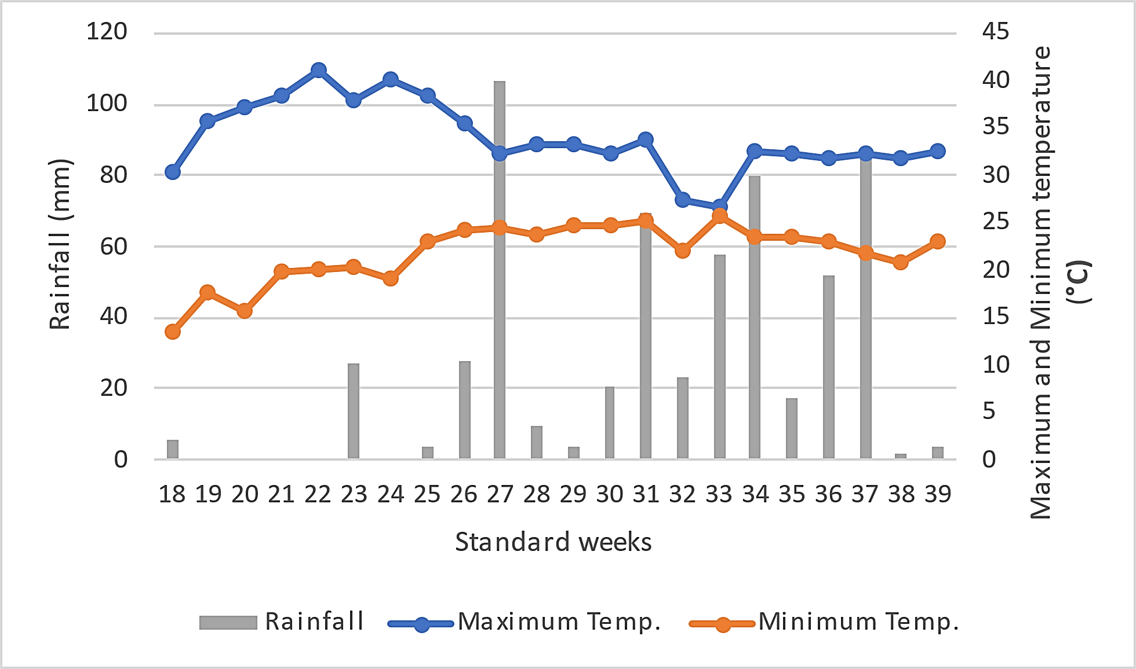

**Fig. 1 Mean meteorological data of the crop season**

**Table 1. Initial physical and chemical characteristics of the soil**

|  |  |
| --- | --- |
| **Soil property** | **Value** |
| Mechanical separates (%) | |
| Sand | 42.42 |
| Silt | 27.12 |
| Clay | 30.46 |
| Textural class | Clay loam |
| Bulk density (g /cm3) | 1.36 |
| pH | 6.32 |
| Electrical conductivity (dS/ m) | 0.26 |
| Organic carbon (g /kg) | 6.45 |
| Available nutrients (kg /ha) | |
| N | 278 |
| P | 21.46 |
| K | 138 |

The experiment was laid out in randomized block design having nine treatments replicated thrice. The field was prepared by ploughing twice, followed by harrowing to create a fine tilth suitable for finger millet cultivation. The field was divided into twenty-seven equal plots (5m2) at the time of inception of experiment. Organic manures were incorporated into the soil during the final harrowing to ensure even distribution. One pre-sowing irrigation through flood irrigation method was given for the field preparation. The finger millet variety VL 352 was sown on 1st May, 2024 having seed rate of 20kg/ha in rows spaced at 22.5 cm and thinning was done 2 weeks later to maintain plant spacing of 10 cm. Different nutrient management practices were applied during sowing a combination of inorganic, natural and organic practices whose details are shown in the **table 2**.

**Table 2. Details of treatment**

|  |  |
| --- | --- |
|  | **Treatment** |
| **T1** | 5t FYM/ha |
| **T2** | 5t FYM/ha + N:P2O5:K2O @ 40:20:0 kg/ha |
| **T3** | 5t FYM/ha + N:P2O5:K2O @ 40:20:20 kg/ha |
| **T4** | 5t FYM/ha + N:P2O5:K2O @ 60:30:20 kg/ha |
| **T5** | 5t FYM/ha + N:P2O5:K2O @ 40:20:0 kg/ha *+ Azospirillum* |
| **T6** | 5t FYM/ha + N:P2O5:K2O @ 40:20:20 kg/ha *+ Azospirillum* |
| **T7** | 5t FYM/ha + N:P2O5:K2O @ 60:30:20 kg/ha + *Azospirillum* |
| **T8** | Seed treatment with *Beejamrit*, *Ghanjeevamrit* @ 250 kg/ha at sowing, foliar spray of *jeevamrit* once in a month @ 500 l/ha starting 30 DAS. |
| **T9** | FYM @ 10 t/ha, seed treatment with *Azospirillum* |

* General recommended dose : 40:20:00 kg/ha (N: P2O5: K2O)

Seeds were treated with *Azospirillum* @ 17.5 g/kg before sowing in treatment T5, T6, T7 and T9

**Harvesting and threshing**

The crop was harvested at physiological maturity, indicated by the hardening of grains and the drying of the panicles. Harvesting was done manually by first harvesting matured panicle followed by cutting the plants at ground level. The harvested plants were sun-dried, and the panicles were threshed to separate the grains. Field observations with respect to yield characteristics were recorded in each plot and their means were worked out for statistical analysis and the data were compared across different nutrient management practices.

**Plant height:** The plant height was recorded at 45 days after sowing (DAS), 70 DAS and 140 DAS. Five plants were randomly selected in plot and were tagged. The height of plant was recorded from ground level to the tip of top youngest leaf. The average was worked out to get the mean plant height

**Number of effective tillers**: Total number of grains bearing tillers from two observational units of one square meter were counted and mean number of effective tillers per m2 were calculated.

**Finger weight**: Fully matured 5 panicles were harvested, and the weight of individual fingers was measured using a digital weighing balance. The average finger weight was recorded.

**1000-grain weight**: A sample of 1000 grains was taken from the harvested produce of the five-ear head from each plot and their weight was recorded at 14 per cent moisture.

**Grain and straw yield**: Ear head obtained from each plot were threshed manually and grain yield after threshing was recorded. To compute the straw and grain yield from the biological yield was deducted from each plot.

**Economics analysis**

**Cost of cultivation**

All costs involved in each input/operation were added to calculate the cost of cultivation Annexure. The treatment wise cost of cultivation was worked out. The requirements of labour and machines for different operations were calculated as per the rates approved by the university and expressed as thousand rupees per hectare.

**Gross returns**

The gross returns were worked out by converting the grain and straw yields in monetary terms in rupees based on the prevalent market/university prices and expressed as ₹ thousand/ ha.

**Net returns**

Net returns were worked out by subtracting the cost of cultivation from the gross returns of respective treatment and expressed in ₹thousand/ ha.

Net returns (₹thousand /ha) = Gross returns (₹thousand /ha) – Cost of cultivation (₹thousand /ha)

**Benefit cost ratio**

B: C = Gross returns (₹thousand /ha) / Cost of cultivation (₹thousand /ha)

**Statistical analysis**

The data collected from field studies were statistically analysed using the analysis of variance (ANOVA) approach for the randomised block design as suggested by Gomez and Gomez (1984). Regression analysis to find relationship between different factors toward yield and economics was done using “ggplot2” and “ggpmisc” packages in Rstudio 4.4.2.

**Result and discussion**

**Effect on growth parameters and yield attributes**

**Plant height**

Results of the study revealed significant variation in plant height **(Table 3)**, owing to different nutrient management practices, with notable taller plants of height 40.0, 82.3 and 115.7 cm at 45, 70 and 140 DAS respectively, in the treatment T7 (NPK+ FYM @ 5 t/ha + *Azospirillum*). However, the lowest plant height (32.1, 66.2, 87.2 cm) was recorded in the treatment where FYM @ 5t/ha (T1) was applied and the use of fertilizers was omitted. Among the unfertilized treatments significantly higher plant height at all the growth stages was observed in treatment T9 i.e. organic farming (33.9, 72.5 and 98.0 cm) which was at par with T8 i.e. natural farming (33.1, 70.6 and 94.8 cm). The increased plant height in treatment T7 may be attributed to integrated application of manure, fertilizers and biofertilizer, which ensured regular supply of nutrients to the crop at different growth stages, led to accelerated cell multiplication and elongation and improved plant growth and development. Treatment T7 exhibited 24.6, 24.16 and 32.68 per cent increase in the plant height at 45, 70 and 140 DAS over control, respectively. Similarly, Elasi et al. (2021) reported significant increase in plant height (93.63 cm), when the crop was fertilized with RDF (60:30:30 kg of NPK/ ha) + Vermicompost @ 3 t/ha + Seed treatment with *Azospirillum* @ 600 g/ha + Inoculation of VAM @ 12 kg /ha + Sulphur @ 40 kg/ha through gypsum + Foliar spray of Borax 0.5 per cent. Additionally, integrated supply of inputs improves microbial activities in soil that stimulated root growth, development and uptake of nutrients from the soil resulting in superior plant height over control (Nigade et al., (2014; Chauhan et al., 2023).

**Number of effective tillers**

Findings of the study revealed that (**Table 4)**, different nutrient management practices significantly improved the number of effective tillers in finger millet, ranged from 140 to 169 tillers/m2. The treatment T7 (169 tillers/m2) was recorded superior, which was statistically at par with the T6 (165 tillers/m2), T3 (165 tillers/m2) and T4 (165 tillers/m2). Whereas, the lowest number of tillers (140 tillers/m2) were noted in the plots where only FYM was applied and devoid of NPK fertilization. Improved tillering in T7 might be attributed to the combined use of higher NPK dose and organic sources, which ensured continuous nutrients availability throughout the crop developmental stages. These findings are consistent with Aparna et al. (2019) who recorded significantly higher number of panicles (158 panicles/m2), number of fingers (8.5 fingers/ear head) when crop was fertilized with 75% RDN + 25% N through cotton stubbles vermicompost + 2% rock phosphate.

**Table 3. Effect of nutrient management practices on the plant height (cm) of finger millet**

|  |  |  |  |
| --- | --- | --- | --- |
| **Treatment** | **45 DAS** | **70 DAS** | **140 DAS** |
| T1 - FYM @ 5 t/ha | 32.1 | 66.2 | 87.2 |
| T2 - N40P20K0 + FYM @ 5 t/ha | 35.8 | 74.6 | 104.1 |
| T3 - N40P20K20 + FYM @ 5 t/ha | 37.0 | 77.8 | 107.4 |
| T4 - N60P30K20 + FYM @ 5 t/ha | 38.6 | 79.2 | 111.8 |
| T5 - N40P20K0 + FYM @ 5 t/ha + *Azospirillum* | 36.1 | 75.9 | 107.0 |
| T6 - N40P20K20 + FYM @ 5 t/ha + *Azospirillum* | 37.9 | 78.7 | 110.3 |
| T7 - N60P30K20 + FYM @ 5 t/ha + *Azospirillum* | 40.0 | 82.2 | 115.7 |
| T8 – Natural farming practices | 33.1 | 70.6 | 94.8 |
| T9 - Organic farming practices | 33.9 | 72.5 | 98.0 |
| **CD (p=0.05)** | **4.57** | **7.00** | **8.84** |

**Ear weight**

Test crop ear weight was ranged from 13.86 (T1) to 18.53 g (T6) under various nutrient management strategies, representing a significant increase of 33.7 per cent over control **(Table 4)**. The higher ear head weight of finger millet was obtained with T6, whichexhibited statistical parity with T2, T3, T4, T5 and T7. Whereas, among the unfertilized treatments (T1, T8 and T9), organic farming practice (16.27 g) resulted in significantly higher ear weight, had statistical parity with all the fertilized treatments except for T6 (18.53 g) and T7 (18.00 g). The higher ear head weight of finger millet was observed with integrated nutrient management practices. This could be attributed to the effectiveness of *Azospirillum* in atmospheric nitrogen fixation that support plant growth (Raja et al., 2025), FYM improves the soil health and nutrient intake and NPK encourages vegetative growth and ear head development.

**Thousand grain weight**

Thousand grain weight, an important parameter depicts the seed quality, ranged from 2.59 g in control to 3.29 g in T6 **(Table 4)**. Plot receiving N40P20K20 + FYM @ 5 t/ha + *Azospirillum* had 27 per cent higher grain weight over control and significantly outperformed the other treatments. However, among the unfertilized treatments T9 achieved significantly higher seed weight. The results were corroborating with the findings of Harika et al. (2019) and Prabhakar et al. (2023) who also reported significant increase in 1000 seed weight with different nutrient mangment practices. The combined effect of manure, fertilizer and Azospirillum probably improved the nutrient availability to the crop as compared to sole application of fertilizer or manure. This led to increased nutrient uptake by plant and improved the grain filling and ultimately increased thousand seed weight.

**Table 4. Effect of nutrient management practices on growth and yield attributes**

|  |  |  |  |  |  |
| --- | --- | --- | --- | --- | --- |
| **Treatment** | **No. of effective tillers/m2** | **Ear weight (g)** | **1000 grain**  **weight**  **(g)** | **Grain yield** **(q/ha)** | **Straw yield**  **(q/ha)** |
| T1 - FYM @ 5 t/ha | 140 | 13.86 | 2.59 | 10.72 | 23.57 |
| T2 - N40P20K0 + FYM @ 5 t/ha | 157 | 17.09 | 3.08 | 16.66 | 29.25 |
| T3 - N40P20K20 + FYM @ 5 t/ha | 160 | 17.52 | 3.17 | 19.27 | 30.43 |
| T4 - N60P30K20 + FYM @ 5 t/ha | 165 | 17.76 | 3.22 | 20.23 | 32.98 |
| T5 - N40P20K0 + FYM @ 5 t/ha + *Azospirillum* | 158 | 17.56 | 3.13 | 17.71 | 29.95 |
| T6 - N40P20K20 + FYM @ 5 t/ha + *Azospirillum* | 165 | 18.53 | 3.29 | 21.15 | 32.84 |
| T7 - N60P30K20 + FYM @ 5 t/ha + *Azospirillum* | 169 | 18.00 | 3.24 | 21.32 | 33.93 |
| T8 – Natural farming practices | 151 | 15.37 | 2.89 | 14.85 | 28.94 |
| T9 - Organic farming practices | 155 | 16.27 | 2.94 | 15.50 | 24.95 |
| **CD (p=0.05)** | **9.89** | **1.51** | **0.19** | **2.79** | **4.25** |

**Effect of different nutrient management practice on grain yield and straw yield**

**Grain yield**

Our study elucidates that following nutrient management practices resulted in substantial variation in the finger millet grain yield **(Table 4)**, which varied from 10.72 q/ha in T1 (FYM @ 5 t/ha) to 21.32 q/ha in plots receiving combined application N60P30K20 + FYM @ 5 t/ha +*Azospirillum*, being at with T4 and T6. The treatment T7 exhibited a significant increment of 98.9 per cent over control, showcased the potential with peak grain yield among the treatments. Additionally, among the unfertilized treatments treatment T9 (15.50 q/ha) resulted in highest gain yield, highlighted the importance of organic inputs on grain yield compared to T1 where only FYM was applied. The study revealed that grain yield improved markedly when FYM, conventional fertilizers and *Azospirillum* seed treatment were applied together, owing to more effective sink formation and greater translocation of carbohydrates from vegetative to reproductive plant parts which increased the number of effective tillers which ultimately resulted in significant increase in grain yield. Similarly, Ahiwale et al. (2011) reported highest grain yield of 22.40 q/ha with the combined application of FYM @ 5 t/ha + 75% RDF (60:30:00 kg NPK/ha) + biofertilizers (*Azospirillum* + PSB). Behera et al. (2025) also confirmed the benefits of combining FYM with balanced NPK doses in improving yield.

**Straw yield**

Different nutrient management practices differ the output of straw yield with maximum value (23.57 q/ha) in plots receiving N60P30K20 + FYM @ 5 t/ha + *Azospirillum* seed treatment together with lower value noted with the sole application of FYM @ 5 t/ha **(Table 4)**. Among unfertilized treatments natural farming yielded highest straw yield (28.94 q/ha) which was statistically at par to all NPK fertilized treatments except treatments T7*.* The integrated nutrient management practice through FYM, fertilizers and *Azospirillum* yielded higher straw yield owing to synergistic interaction between FYM and optimized doses of fertilizers, FYM provides uninterrupted supply of nutrients to the crop throughout life cycle which increased the plant height and dry matter accumulation in the crop thus resulting in higher straw yield of the crop. Menon et al. (2023) with FYM Treatment (5 t/ha) + 90:45:45 kg N: P₂O₅:K₂O ha⁻¹ achieved top yields in Kerala’s lateritic soils.

**Total Yield**

Total yield of finger millet varied significantly across treatments. The highest yield was recorded in T7 (55.25 q/ha), followed by T6 and T4 **(Fig. 2)**. Moderate yields were observed in T3, T5 and T2 (49.71, 47.65 and 45.91 q/ha), respectively. While, lower yields were obtained under T8 and T9 (43.79 and 40.45 q/ha) (natural and organic farming) and the minimum yield was in T1 (34.29 q/ha), which received only FYM. Yield progression in T7 over T1 was 61.1% and 36.6 % over organic farming, indicating superior performance of combining higher doses of NPK, organic manure and biofertilizers. The inclusion of *Azospirillum* and balanced NPK likely enhanced nitrogen fixation, nutrient availability and root development resulting in better nutrient uptake and leading to better biomass and productivity (Choudhary et al., 2023).

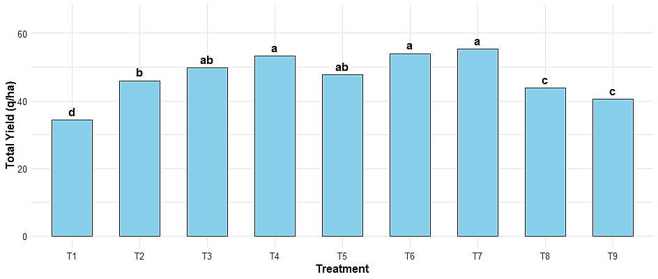

**Fig. 2 Effect of various nutrient management practices on total yield of finger millet**

According to DMRT, treatment means with different alphabetical letters differ substantially.

**Relationship between yield and yield attributes**

A significant positive linear relationship was observed between the number of effective tillers per square meter and grain yield of finger millet. Regression analysis revealed that effective tillers were a strong predictor of yield **(Fig. 3)**, with the coefficient of determination (R²) was 0.97, indicating that 97% of the variability in grain yield could be explained by the number of effective tillers alone. This suggests that even a marginal increase in tiller number significantly enhances grain yield. The regression was statistically significant (p < 0.001), and the trend line closely followed the distribution of observed data points, confirming the strength of the association. These results highlight the critical role of effective tillering in determining grain productivity and reinforce its importance as a key trait in optimizing finger millet performance under field conditions (Boruah et al., 2024).

A strong and positive linear relationship was observed between plant height and straw yield, with a R2 values of 0.85. This indicates that 85% of the variation in straw yield can be explained by differences in plant height **(Fig. 4)**. The regression slope suggests that for every 1 cm increase in plant height, straw yield increased by approximately 0.36 q/ha. These results highlight the strong dependence of straw biomass accumulation on vegetative growth (Menon et al., 2023), suggesting that taller plants contributed significantly to higher straw yield under the studied nutrient management treatments.

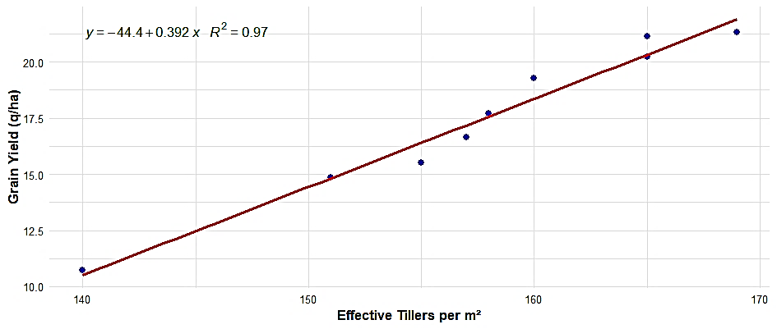

**Fig.3 Relationships between grain yield and effective tillers per m2**

D:\finger millet paper\regression 2.tiff

**Fig.4 Relationships between straw yield and plant height**

**Cost of cultivation**

Results of the study revealed that organic farming practice (T9) had the highest cultivation cost of ₹86.14 thousand/ha followed by T7 treatment (N60P30K20 + FYM @ 5 t/ha + *Azospirillum*)with a cost of ₹68.61 thousand/ha **(Table 5)**. On the other side, the natural farming practice had the lowest cultivation cost of 55.44 ₹thousand/ha, as no conventional fertilizer, FYM or *Azospirillum* was used in this treatment. Among the treatments in which fertilizers was added (T2 to T7) the cost of cultivation increased just 2.2 ₹thousand/ha. However, when the source nutrient application was switched fully by using FYM there was a dramatic increase in cost of cultivation, as FYM has to be used in a very large amount to fully replace the chemical fertilizers.

**Gross returns**

The application of conventional fertilizer for treatment N60P30K20 + FYM @ 5 t/ha + *Azospirillum* (T7) resulted in highest gross returns followed by N40P20K20 + FYM @ 5 t/ha + *Azospirillum* treatment (T6) with gross returns amounting 144.87 ₹thousand/ha and 143.30₹ thousand/ha, respectively. The lowest gross returns of 76.12 ₹thousand/ha were recorded under control.

1. **Net returns**

The treatment with N60P30K20 + FYM @ 5 t/ha + *Azospirillum* (T7) yielded the highest net returns of 76.26 ₹thousand/ ha followed by treatment comprising N40P20K20 + FYM @ 5 t/ha + *Azospirillum* (T6) with net returns value of 75.64 ₹thousand/ ha. Lowest net returns were recorded for T1 in which only FYM @ 5 t/ha was applied (13.11 ₹thousand/ha).

1. **Benefit Cost ratio (B:C)**

It has been observed that various integrated and sole inputs have unalike returns (Table 5). Highest B:C ratio perceived in the treatment T6 (2.12) followed by T7 (2.11) whereas, control (1.21) proved to be the least profitable **(Table 5)**. The findings are in agreement with Amala et al. (2019) and Gupta et al. (2022**)** who reported maximum benefit cost ratio (4.76) with integrated nutrient management. Similarly, Behera et al. (2025) demonstrated recommended practice: lime + 30:20:20 kg NPK, delivered highest net return and B:C ratio by efficiently improving grain and straw yield.

**Table 5 Effect of nutrient management practices on cost of cultivation, gross return, net return and B:C ratio**

|  |  |  |  |  |
| --- | --- | --- | --- | --- |
| **Treatment** | **Cost of cultivation**  **(thousand/ha)** | **Gross return**  **(thousand/ha)** | **Net return**  **(thousand/ha)** | **B:C ratio** |
| T1 - FYM @ 5 t/ha | 63.01 | 76.12 | 13.11 | 1.21 |
| T2 - N40P20K0 + FYM @ 5 t/ha | 66.41 | 114.59 | 48.18 | 1.73 |
| T3 - N40P20K20 + FYM @ 5 t/ha | 66.96 | 130.86 | 63.90 | 1.95 |
| T4 - N60P30K20 + FYM @ 5 t/ha | 67.91 | 137.86 | 69.96 | 2.03 |
| T5 - N40P20K0 + FYM @ 5 t/ha + *Azospirillum* | 67.11 | 121.21 | 54.11 | 1.81 |
| T6 - N40P20K20 + FYM @ 5 t/ha + *Azospirillum* | 67.66 | 143.30 | 75.64 | 2.12 |
| T7 - N60P30K20 + FYM @ 5 t/ha + *Azospirillum* | 68.61 | 144.87 | 76.26 | 2.11 |
| T8 – Natural farming practices | 55.44 | 103.59 | 48.15 | 1.87 |
| T9 - Organic farming practices | 86.14 | 105.47 | 19.33 | 1.22 |

**Regression Insights into Farm Economics**

The regression analysis revealed distinct associations between net return and key agronomic variables. A weak negative relationship was observed between net return and cost of cultivation (R² = 0.06), indicating that cultivation cost accounts for minimal variation in profitability. In contrast, net return exhibited a strong positive correlation with grain yield (R² = 0.86), directly linked to food security and market demand making it primary economic product (Menon et al., 2023). Statistically strongest association was observed between net return and straw yield (R² = 0.98), underscoring its potential contribution to overall economic returns. However, despite its statistical strength, the perceived economic value of straw remains lower than that of grain, primarily because straw is often regarded as a secondary product with limited market integration (Biswas et al., 2025). Thus by establishing proper farm to market channel for straw utilization in fodder, bedding/compost and material packaging, underlining its critical role in enhancing farm income. Therefore, the adoption of integrated nutrient management practices, combining organic, inorganic and natural inputs can play a pivotal role in improving both grain and straw yields, thereby maximizing total farm profitability.

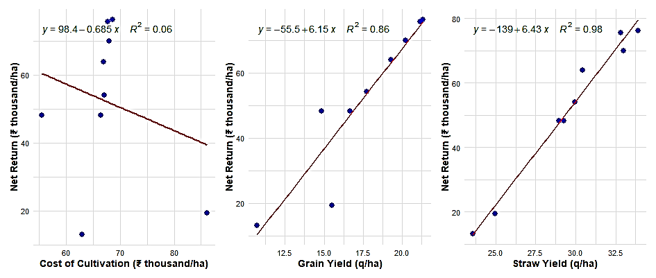

**Fig. 5** **Relationships between net return (a) cost of cultivation, (b) grain yield and (c) straw yield**

**Conclusion**

Results of the study revealed that plots receiving N60P30K20 + FYM @ 5t/ha + *Azospirillum* (T7)resulted in maximum finger millet growth parameters i.e. plant height, number of effective tillers/m2, whereas, average ear weight and thousand grain weight were found to be highest in the treatment T6 i.e.N40P20K20 + FYM @ 5t/ha + *Azospirillum*. Total yield (grain and straw) was also achieved in the T7 making it the most effective treatment for both gross and net returns. However, the highest B:C ratio (2.12) was observed in T6, suggesting that a reduced NPK dose of 40:20:20 kg/ha can be more economically efficient than 60:30:20 kg/ha but also environmentally sustainable by minimizing nutrient losses. Relationship studies revealed that Grain yield and straw yield were strongly correlated with net return, indicating their critical role in farm profitability. Although cost of cultivation showed a weak negative association with net return, the findings conclude that integrated nutrient management is a key strategy for sustainably enhancing productivity, profitability and preserving long-term soil and environmental health addressing the core concerns of farmers.

**Declaration section**

**Disclaimers**

The views and conclusions expressed in this article are solely those of the authors and do not necessarily represent the views of their affiliated institutions. The authors are responsible for the accuracy and completeness of the information provided, but do not accept any liability for any direct or indirect losses resulting from the use of this content.

**References**

Ahiwale, P. H., Chavan, L. S., and Jagtap, D. N. (2011). Effect of establishment methods and nutrient management on yield attributes and yield of finger millet (*Eleusine coracana* G.). *Advance research Journal of Crop Improvement,* 2, 247-250.

Amala, D., Prabhakar, B. N., Padma, M., and Triveni, S. (2019). Effect of integrated nutrient management on yield, quality and economics of turmeric (*Curcuma longa L*) var. IISR Pragathi. *Journal of Pharmacognosy and Phytochemistry*, 8(4), pp.3112-3114.

Annual Report. (2022-2023). Department of agriculture, HP, India, pp. 1-44.

Anonymous. (2023). Statewise millet production 2023-24 apeda.gov.in.

Aparna, K., Rekha, K. B., Vani, K. P., and Prakash, T. R. (2019). Growth and yield of finger millet as influenced by crop residue composting*. Journal of Pharmacognosy and* *Phytochemistry,* 8, 1108-1111.

Aravind, J., Ramesh, R., & Devi, D. D. (2022). Effect of organic nutrient sources on growth, yield and soil health in transplanted finger millet (*Eleusine coracana*). *Journal of Crop and Weed*, 18(2), 124–129.

Behera, S. S., Nayak, B. R., & Mishra, S. S. (2025). Response of finger millet to integrated nutrient management in lateritic soils of Odisha. *International Journal of Bio-resource and Stress Management*, 16(1), 52–57.

Biswas, S., Das, R., an& Dutta, D. (2025). Irrigation and primary nutrients’ performance on winter maize productivity, profitability, energetics, and carbon footprint in Gangetic plains of India. *Scientific Reports*, 15, 19714.

Boruah, D., Das, K., & Deka, S. (2024). Soil nutrient dynamics under integrated nutrient management in finger millet (*Eleusine coracana*) in Assam. *Agricultural Reviews*, 45(1), 71–76.

Chauhan, A., Singh, V. K., Sharma, A., and Jeena, K. (2023). Effect of organic and bio fertilizer on growth and yield of soyabean (*Glycine max*) in doon valley of Uttarakhand. *Pharma Innov J*, 12(6), pp.1601-5.

Choudhary, M., Sharma, R., an& Rana, A. (2023). Effect of integrated nutrient management on growth and yield of finger millet (*Eleusine coracana* L.) under mid-hill conditions of Himachal Pradesh. *Indian Journal of Agronomy*, 68(1), 42-47.

Elasi, S., Kalaiyarasan, C., Muruganandam, C., and Jawahar, S. (2021). Effect of VAM, sulphur and boron on growth and yield of ragi (*Eleusine coracana* L.). *Research Journal of Agricultural Sciences,* 12, 1133-1135.

Gomez, K. A., and Gomez, A. A. (1984). Statistical Procedure for Agricultural Research. 2nd edition. Wiley Inter Science, New York, USA. p 680.

Govindappa, M., Vishwanath, A. P., Harsha, K. N., Thimmegowda, P., and Jnanesh, A. C. (2009). Response of finger millet (*Eluesine coracana* L.) to organic and inorganic sources of nutrients under rainfed condition. *Journal of Crop and Weed,* 5, 291-293.

Gupta, S., Rawat, P. B., Kumar, S., and Singh, V. (2022). Influence of integrated nutrient management on growth and yield of finger millet (*Eleusine coracana* L. Gaertn*). Indian Journal of Natural Sciences,* 13, 976-997.

Harika, J. V., Maitra, S., Shankar, T., Bera, M., Mansa, P. (2019). Effect of integrated nutrient management on productivity, nutrient uptake, and economics of finger millet (*Eleusine coracana* L. Gaertn). *International Journal of Agriculture, Environment and Biotechnology,* 12, 273-279.

Jackson, M. L. (1973). Soil Chemical Analysis. Prentice Hall of India. (Pvt.) Ltd.

Menon, P. S., Mathew, J., & Kumar, P. R. (2023). Effect of FYM and NPK on yield, economics and soil nutrient status of finger millet under lateritic soil of Kerala. *Journal of Agronomy*, 22(3), 231–238.

Nigade, R. D., Gajbhiye, P. N., and More, S. M. (2014). Integrated nutrient management studies in finger millet (*Eleusine coracana* L.). *Crop Research,* 48, 27-31.

NRC (National Research Council). (1996). Alternative agriculture. Washington, DC.

Prabhakar, M., Gopinath, K. A., Sai, S. U., Srasvan, K. G., Thirupathi, M., Samba, S. G., Meghalakshmi, G., Ravi, K. N., and Singh, V. K. (2023). Potential for yield and soil fertility improvement with integration of organics in nutrient management for finger millet under rainfed Alfisols of Southern India*. Frontiers in Nutrition,* 10, 56-68.

Raja, D., Ravi, M. V., and Latha, H. S. (2025). Conjugation Effect of Zinc and Iron on Quality of Crops and Soil Fertility in Foxtail Millet-Chickpea Sequential Cropping System. *Asian Journal of Soil Science and Plant Nutrition*, 11(2),63-72. https://doi.org/10.9734/ajsspn/2025/v11i2510

Rao, R., Kavitha, K., Srinivasrao, C., Wani, S. P., Sahrawat, K. L., and Pardhasaradhi, G. (2012). Alleviation of multinutrient deficiency for productivity enhancement of rain-fed Soybean and Finger Millet in the Semi-arid Region of India. *Communications in Soil Science and Plant Analysis,* 43, 1427-1435.

Sandhya, Y. R., Jamuma, P., Triveni, U., Patro, T. S. S. K. (2022). Agronomic fortification in finger millet (*Eleusine coracana*) for yield and quality improvement in red sandy loam soils. *The Indian Journal of Agricultural Sciences*, *92*(2), 217-221. <https://doi.org/10.56093/ijas.v92i2.122224>

Walkley, A., and Black, I. A. (1934). An examination of the Degtjareff (wet acid) method for determining soil organic matter and a proposed modification of the chromic acid titration method. *Soil Science,* 37, 29-38.

Wu, W., & Ma, B. (2015). Integrated nutrient management (INM) for sustaining crop productivity and reducing environmental impact: A review. *Science of The Total Environment,* 6*,* 415-427.