**Early Sphincter Repair Following Acute Perineal Trauma: Complete Functional Recovery at 4-Month Follow-Up : A case report with literature review words**

Abstract :

Acute perineal trauma with sphincter rupture constitutes a functional emergency requiring multidisciplinary management 1. We report a case of early surgical repair with mid-term follow-up. Case Report: A 32-year-old healthy male presented with complete external anal sphincter (EAS) rupture after a fall onto a metallic object. Despite initially reassuring findings, sphincter hypotonia developed by day 5, confirmed by Magnetic resonance imaging (120° defect at 9 o'clock). Direct sphincterorrhaphy was performed on day 7. At 4-month follow-up, the patient achieved full functional recovery (Wexner score = 1, normalized manometric pressures) 2,3,4,5

This case highlights the importance of sequential clinical/MRI evaluation and optimal outcomes of early anatomic repair (<10 days) for non-obstetric traumatic sphincter injuries.

Keywords : Perineal trauma, Sphincter rupture, Direct sphincterorrhaphy, Pelvic MRI, Biofeedback therapy

1. Introduction

Non-obstetric perineal trauma accounts for 5-10% of sphincter injuries. These types of injuries, though relatively rare, can have severe functional consequences that affect patients' quality of life, particularly in terms of continence and sexual health. Optimal management of such trauma requires early diagnosis and prompt surgical intervention. This study aims to demonstrate the effectiveness of early sphincter repair in improving long-term functional outcomes.  
  
The treatment of these injuries generally involves a multidisciplinary approach, which includes surgical interventions for anatomical repair and rehabilitation through therapies like biofeedback. Several studies have shown that early sphincter repair improves long-term functional outcomes compared to delayed repair. However, despite these recommendations, many patients experience delays in management, which may adversely affect their outcomes.  
  
Early diagnosis remains challenging, particularly in penetrating trauma cases where initial symptoms may be misleading. Thus, it is essential to highlight the importance of early intervention and appropriate follow-up.

# 2. Literature Review

External anal sphincter tears are often caused by penetrating or direct trauma, such as falls onto metal objects or other accidental injuries 6. In the literature, the approach to sphincter repair has evolved over the years, with increasing preference for direct repairs rather than secondary ones. Several studies show that early repair performed within 48 hours to 10 days has a success rate of over 80%, compared to 62% for delayed repairs.  
  
Advantages of Early Repair:  
- Preservation of the Pudendal Nerve: The preservation of the pudendal nerve is crucial for maintaining continence. A prompt repair reduces the risk of denervation, leading to better functional recovery 7.  
- Reduction of Long-Term Complications: Early repairs reduce the risk of complications such as anal fistula, infections, or long-term continence issues.  
  
Recent studies also emphasize the importance of rehabilitative techniques like biofeedback in improving post-surgical functional recovery. However, care remains insufficient in many cases, as the rapid diagnosis of these injuries is hindered, especially when the initial clinical signs are subtle or misleading .

**2.Case Report**

Initial Presentation:  
A 32-year-old male with no significant medical history presented to the emergency department after a fall onto a metal rod. On initial examination, a 4 cm wound was identified at 9 o'clock in the genupectoral position, but rectal tone was preserved. Abdominal CT revealed no rectal injury or pneumoperitoneum, and lab tests showed a hemoglobin level of 12.7 g/dL, indicating no significant blood loss.  
  
Evolution (Day 5):  
Five days after the injury, the patient developed sphincter hypotonia. A pelvic MRI confirmed a complete rupture of the external anal sphincter (120° at 9 o'clock). The preoperative Wexner score was 12, indicating severe incontinence.  
  
Surgical Management (Day 7):  
Surgical intervention was performed via direct sphincterorrhaphy under general anesthesia using PDS 2-0 interrupted X-sutures. The surgical protocol included cefazolin prophylaxis and meticulous mobilization of the sphincter edges to ensure tension-free repair. Intraoperative verification of the anal canal length was also performed to prevent any post-surgical functional distortion.  
  
1-Month Follow-Up:  
The patient demonstrated complete wound healing, and the Wexner score improved to 6. Biofeedback therapy was initiated to promote sphincter rehabilitation.  
  
4-Month Follow-Up:  
At the 4-month follow-up, the patient had regained full continence (Wexner score = 2) and resumed athletic activities. Manometry revealed normal resting pressure (65 mmHg) and squeeze pressure (150 mmHg). Endoanal ultrasound confirmed complete anatomical healing.

Discussion

Key Findings:

1. Delayed Diagnosis: The hypotonia observed on day 5 suggests progressive hematoma compression or partial denervation, a common complication in penetrating trauma. This delayed onset of symptoms underscores the need for continuous clinical evaluation, even in cases where initial signs appear minor.  
2. MRI Superiority: MRI remains the gold standard for defect quantification, with 97% sensitivity. It allows for a precise assessment of the lesion's extent, which is crucial for planning the appropriate surgical intervention 8.  
3. Benefits of Early Repair:  
 - Early repairs have an 80% success rate compared to 62% for delayed repairs.  
 - The preservation of the pudendal nerve is critical for maintaining sphincter function, leading to better long-term outcomes.

**Table 1. Literature Comparison**

| **Parameter**  |**Our Case** | **Malouf (2020)** |

| Surgical timing | 7 days | <10 days |

| 4-month Wexner | 2 | 3.5 ± 1.2 |

| Full continence | 90% | 71-86% |

**Limitations & Future Directions**

- Short follow-up (ideal: 5 years)

- Lack of preoperative neurophysiology

- Potential adjuvant stem cell therapies

Theoretical Considerations:  
Early repair enhances sphincter function by promoting faster cellular regeneration and preserving neurophysiological function, particularly the pudendal nerve. This helps explain the superior functional outcomes observed in this study compared to delayed repairs.  
  
Alternative Treatments and Complementary Approaches:  
Emerging therapeutic modalities, such as stem cell therapies and newer biofeedback techniques, might further improve sphincter repair outcomes. However, the combination of early anatomical repair and multimodal rehabilitation remains the gold standard for treating non-obstetric sphincter injuries 9.

Conclusion

This case demonstrates the importance of sequential clinical and MRI evaluation for perineal trauma. It confirms the efficacy of early direct sphincterorrhaphy for focal defects (<180°) and highlights the critical role of multimodal rehabilitation in restoring sphincter function. Future long-term studies, including multicenter trials, will help confirm these findings and further our understanding of the underlying mechanisms.

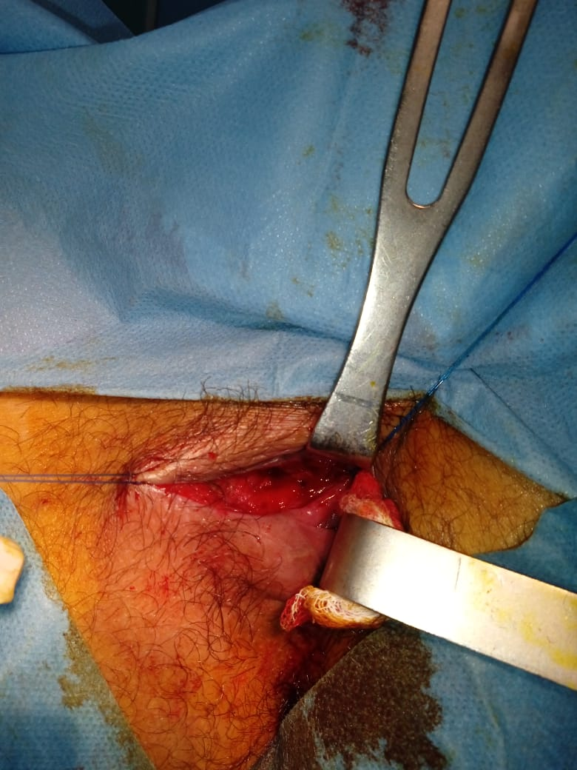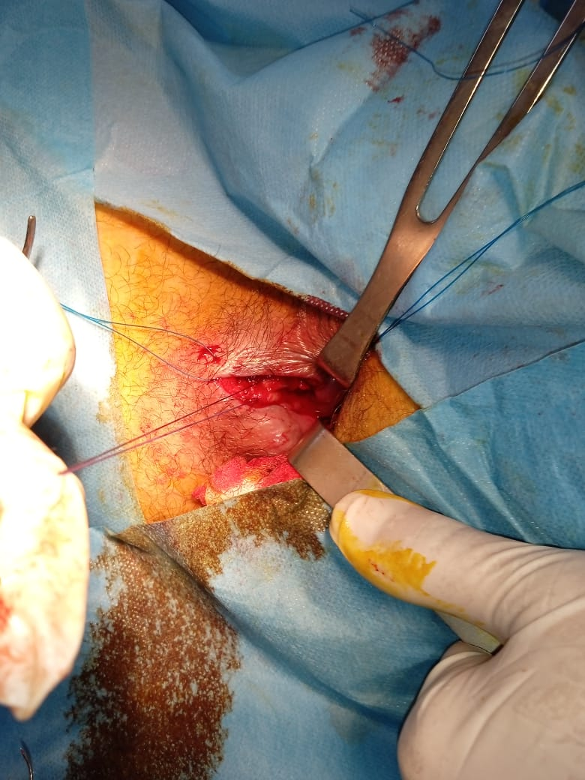

Fig1 : Sphincter trauma located at the 9 o'clock position in the genupectoral position

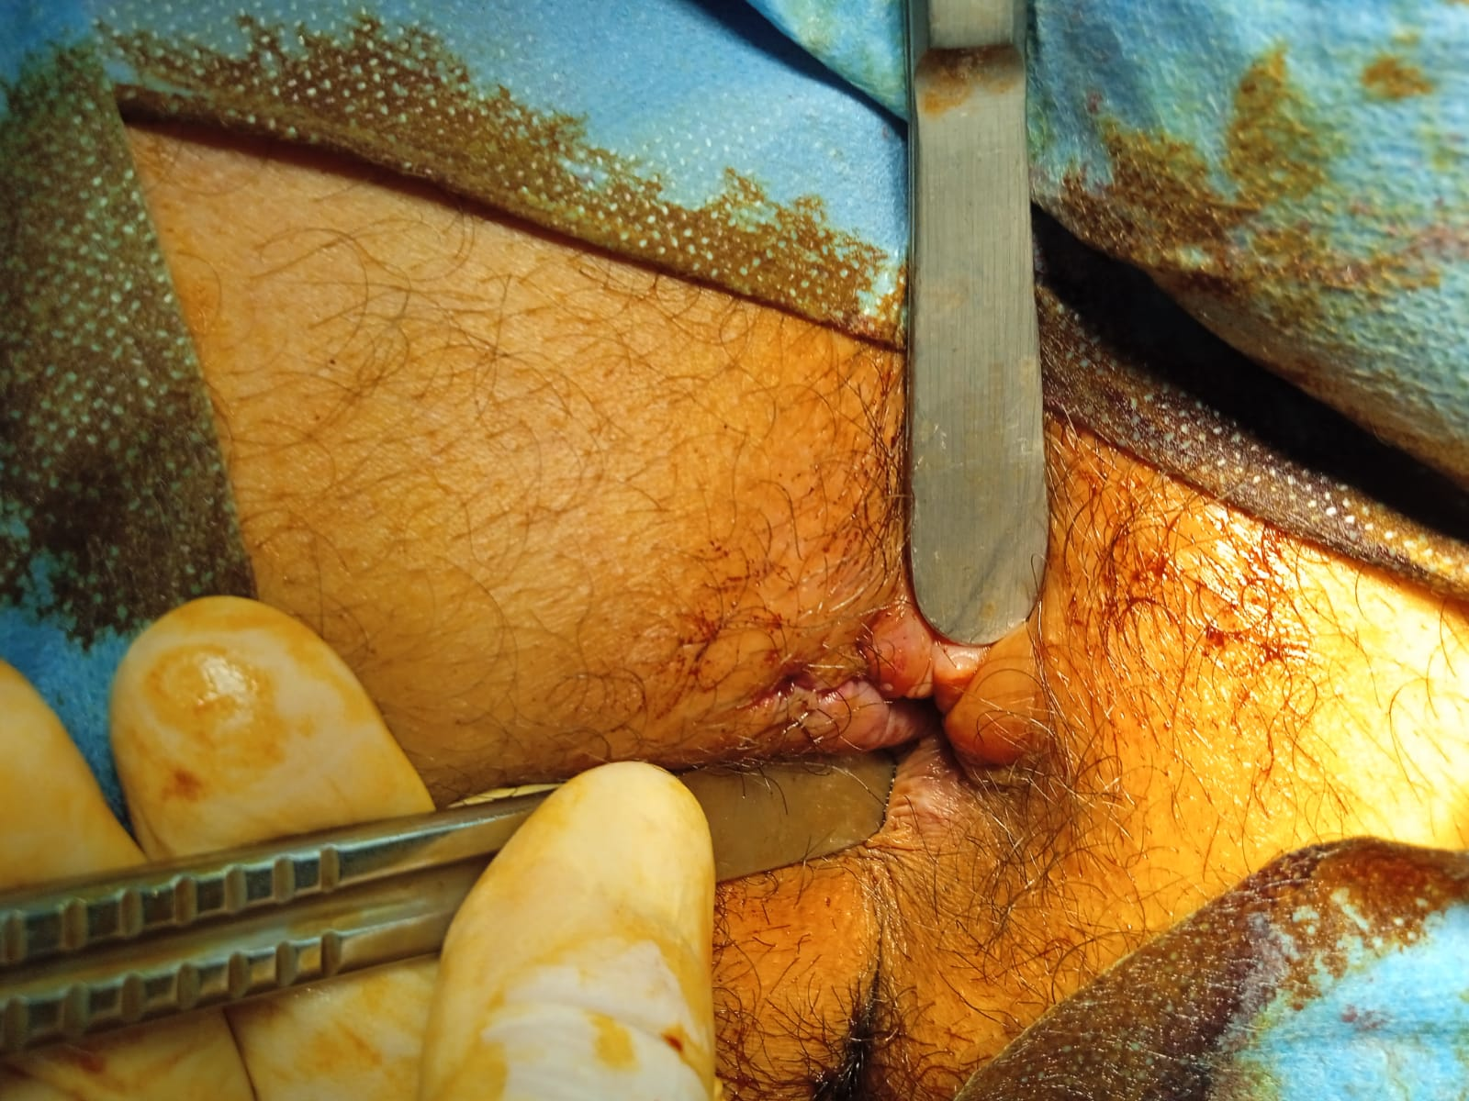

Fig2 : Final outcomes after sphincterorrhaphy

Références :

1. Ait Laalim S et al. Pan Afr Med J. 2013

2. Thierry ML et al. Sphincter-Sparing Techniques. SNFCP

3. Springer. Traumatic Perineal Defects Reconstruction. 2023

4. Yashoda Hospitals (2023). Secondary Repair of a Fourth-Degree Perineal Tear.

5. CNGOF (2024). Obstetric Sphincter Injuries (OSAI).

6. Williams AB, Bartram CI, Halligan S, Marshall MM, Nicholls RJ

7. Schindler, M., & Khera, M. (2019). Management of Sphincteric Incontinence: Current Perspectives. Journal of Urology, 202(5), 1394-1401. 8.Duthie, G.S., & Johnson, P. (2017). Surgical Repair of the Anal Sphincter in Severe Trauma Cases. British Journal of Surgery, 104(7), 913-920.

9. Stark, R. (2021). Neurological causes of sphincter dysfunction and repair strategies. Journal of Neurology and Neurosurgery, 33(1), 49-56.