Case report

Textilomas migrating through the colonic wall: a case report, pathophysiology, and literature review.

ABSTRACT

|  |
| --- |
| *This is a case of a 40 years old female patient, with a history of 2 C-sections (Caesarion-sections) 10 years ago and 6 months ago, consulting for bowl obstruction for 20 days, CT scan showing two masses, located on the caecal and sigmoid region, presuming a malignant origin and a pre-perforated colon in CT-scan with signs of peritoneal carcinosis, per operative findings showed a perforated colon with two surgical mesh. This article shows the importance of counting mesh in all surgeries, especially those performed in closed cavities, and considering clinical and complementary examinations when treating a patient.* |

*Keywords: Textiloma, mesh, colic occlusion, mesh migration, C-section, postoperative bowl obstruction, pathophysiology*

1. INTRODUCTION

*Postoperative bowel obstruction is a common case in abdominopelvic surgeries; the usual common cause is postoperative ileus and adhesive bowel obstruction, rarely secondary to retained foreign bodies. In our case, the bowel obstruction was caused by two textilomas that were left in the abdomen in a C-section surgery performed 6 months ago; they migrated slowly into the caecum and the sigmoid colon, making it the first known case of two separate colonic intraluminal mesh findings from a C-section.*

2. Case presentation

Our patient is a 40 years old female, with a history of 2 C-sections, the first was performed 10 years ago, for a twin pregnancy, and the second was performed 6 months ago, emergency C-section for cephalopelvic disproportion, post-operative care was marked with abdominal pain and a reflex ileus that were treated symptomatically, actually the three babies are in healthy condition.

The patient was admitted to the hospital for mild abdominal pain and bowel obstruction occurring 20 days ago, with the presence of gas emission. The patient had consulted another hospital, where they tried medical treatment before referring the patient to our healthcare institute.

Clinical examination showed a relatively stable patient with a GCS of 15/15, no neurological deficit, blood pressure 100/50mmHg, tachycardic at 123 beats per minute, cold extremities, peripheral oxygenation 96%, respiratory rate of 17, and no abnormalities in cardiopulmonary auscultation; the temperature was 39 C degree.

Abdominal examination showed an abdominal distention with meteorism, digital rectal examination found no faecal matter, and no hernial defect.

Laboratory examination showed a white blood cell count of 7300, a haemoglobin level of 10 hypochromic microcytic, hypokalaemia at 2,75mmol/L, hyponatremia at 128mmol/L, urea level at 0.15g/L, and creatinine level at 5.7mg/L with a C-reactive protein level at 173mg/L.

A cytobacteriological urine analysis and a chest X-ray were performed to look for an origin that could explain the fever; the results came back negative.

Abdominal X-ray showed diffuse abdominal gas.

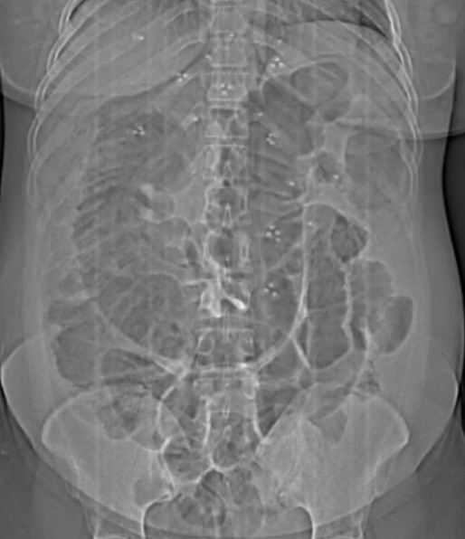

Figure 1: X-Ray of the abdomen showing an important aerocolic distribution

The patient was seen with a CT scan performed three days before being referred to us showing a dilation of the colonic frame measuring 103mm at the level of the caecum, upstream of a parietal thickening of the sigmoid colon reaching 8mm in thickness and extending over approximately 6cm, associated with infiltrated appearance of the adjacent fat. This is associated with a poorly defined tissue pseudo mass in the right iliac fossa, measuring 47x39mm, infiltrating the iliac vessels and invading the ovary. Mass in the rectus abdominis muscle measuring 48x30mm: endometriotic nodule? to be correlated with patient history. Small volume pelvic effusion.

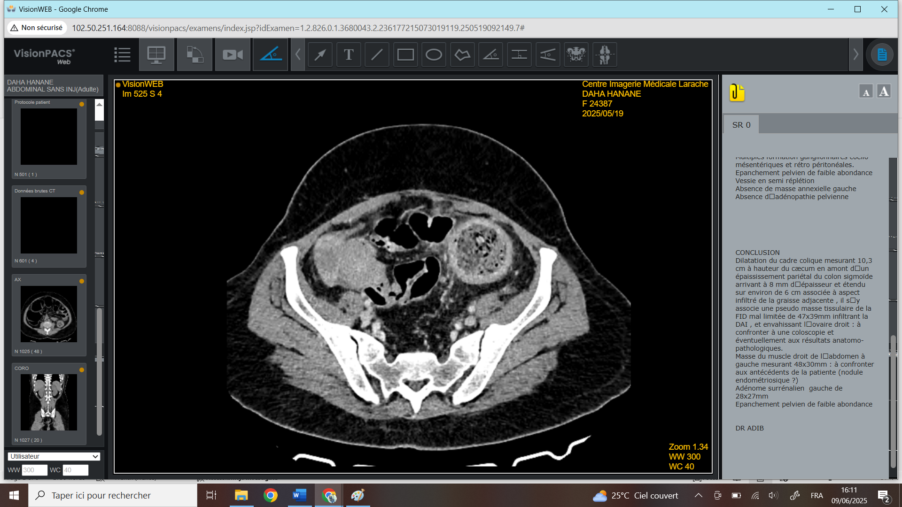

Figure 2: CT scan showing a mass of the caecum (White arrow) and sigmoid colon( Pink arrow)

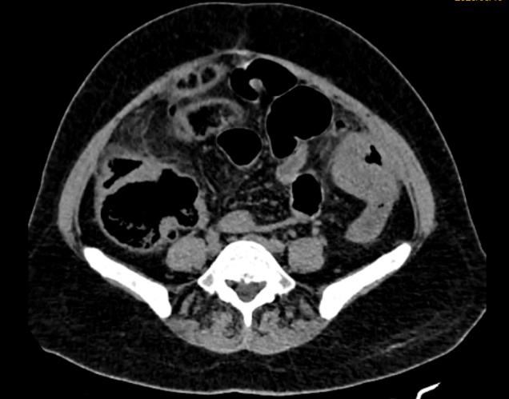

Figure 3: CT scan showing a thickening of the sigmoid colon

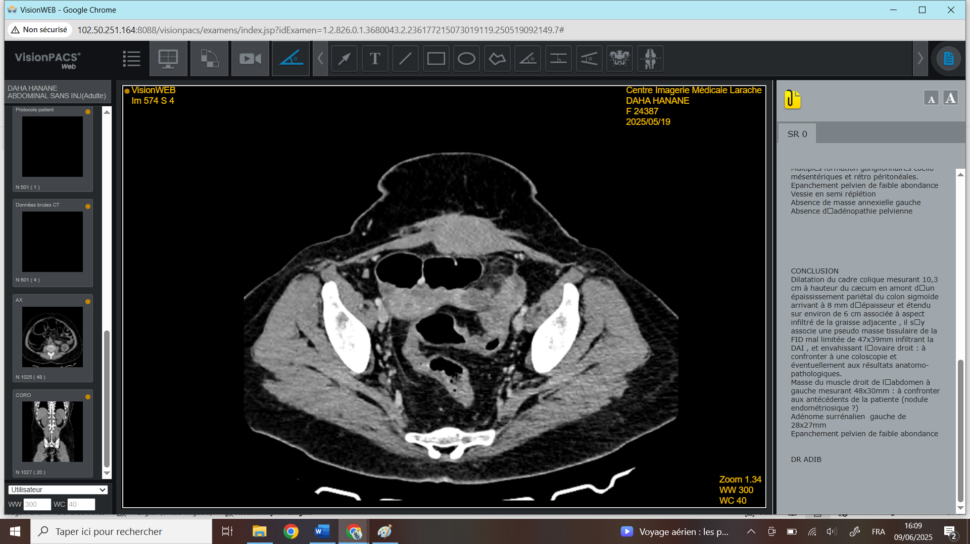

Figure 4: CT scan showing the caecal mass(white arrow), thickening of the sigmoid wall(pink arrow), and the aponeurosis’s thickening (White arrow).

The decision to make the surgery or not was difficult, considering the sub-occlusion state, carcinosis suspicion on one hand, and the pre-performative colic state and the unexplained fever on the other.

The patient was admitted to the operating room, a midline incision was performed, no parietal mass was found, and the manipulation of the unwinding of the small intestines led to diastatic perforation of the caecum, which was temporarily sutured to limit stercoral contamination.

Subsequent unwinding of the small intestine, from the first loop to the last ileal loop, revealed a perforation 65 cm from the first loop.

Exploration of the left colic revealed two masses, approximately 7 to 8 cm proximal and distal to a sigmoid perforation. These masses were mobile and hard. They were mobilized digitally and evacuated through the sigmoid perforation, with an aspect of fibrosis and thickening of the colic walls next to these masses.

The masses were 2 textilomas (2 green fields). The perforation was temporarily sutured to limit stercoral contamination of the peritoneal cavity.

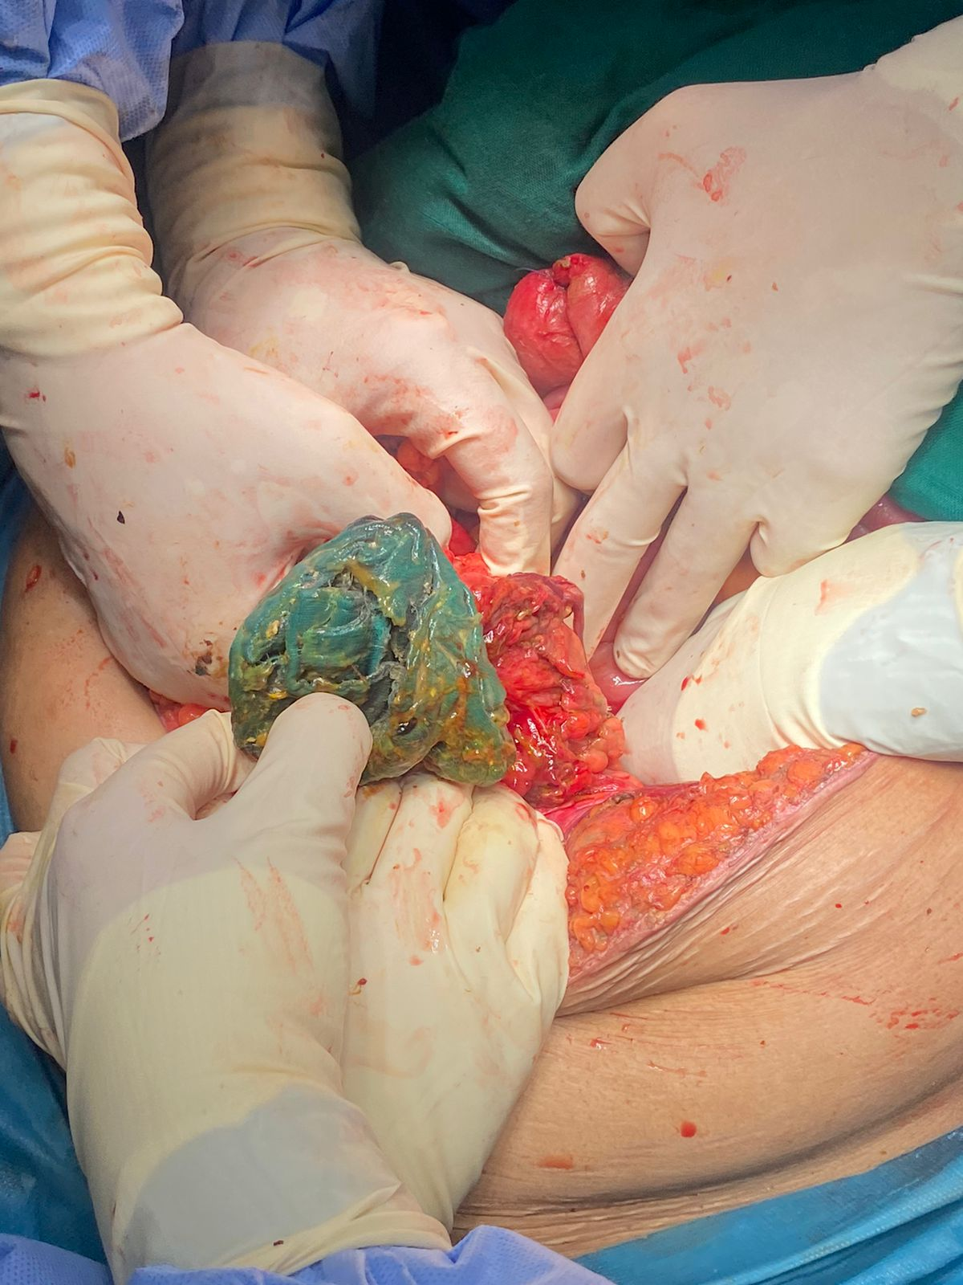

Figure 5: An operative picture showing the extraction of the textiloma, with a biofilm formation around the mesh.

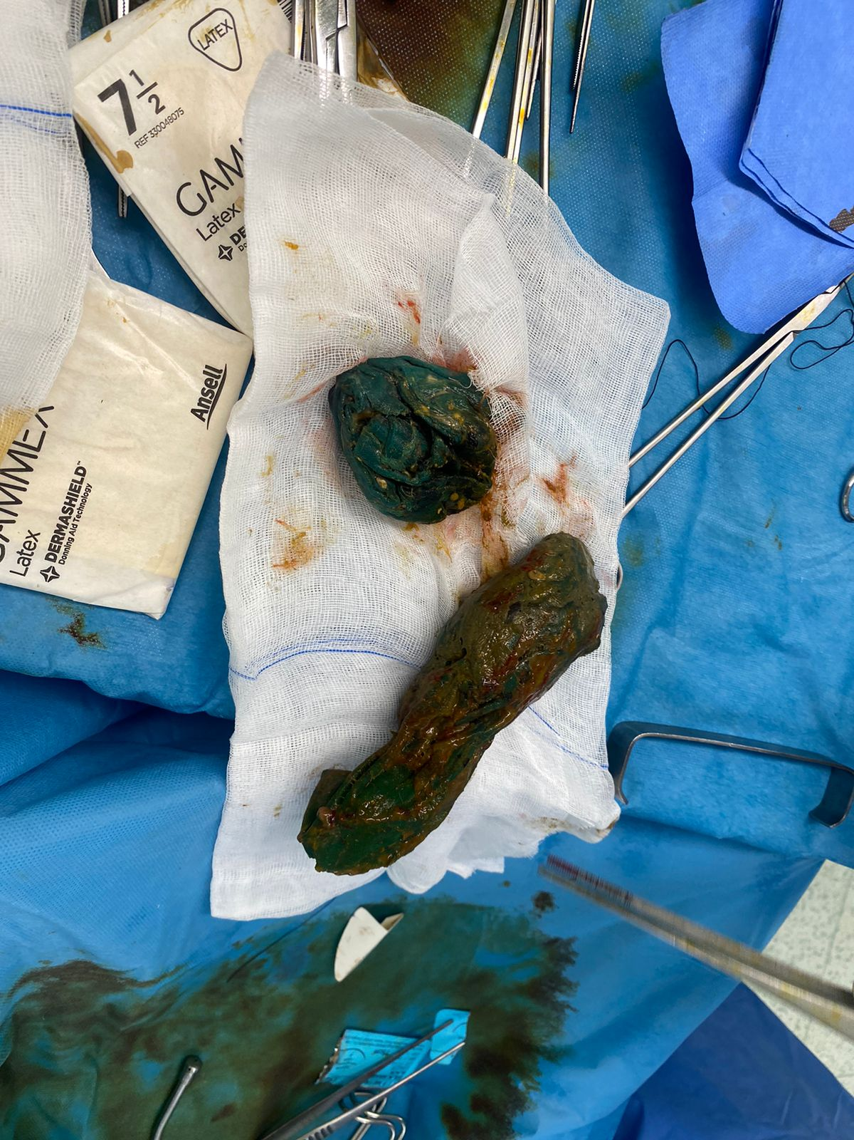

Figure 6: showing the two textilomas after extraction.

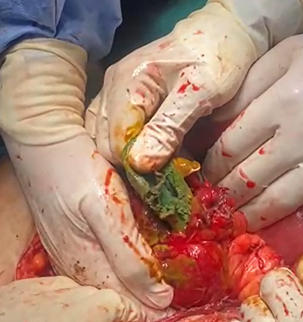

Figure 7: The extraction of the textiloma in the sigmoid colon.

After extracting the two textilomas, the - ileocecal resection with a double stoma: right colo-parietal detachment, ligation, and section of the mesocolon, and a double ileo-colic stoma fixed with 3-0 Vicryl.

-Creation of a left colostomy on a rod after recutting the sigmoid perforation, fixed with 3-0 Vicryl.

-Simple 3-0 Vicryl suture of the small bowel perforation mentioned above.

Abundant peritoneal cleansing with warm SS (20 liters).

A large drainage was performed on the right abdominal cavity by a Delbet drain at the right iliac fossa, and a Redon drain, while on the left, a Delbet drain was put next to the small bowel suture. The patient was transferred to the intensive care unit after the surgery, which lasted almost 6 hours. Blood loss was estimated at 200cc.

The patient left the OR room with a 30-noradrenaline speed.

Post-operative care was marked by a functional stoma, a retraction of the left stoma, and an excess secretion of sero-hematic liquid, leading to the installation of a Redon drain in the incision.

The patient was discharged 12 days postoperatively, after a progressive noradrenaline withdrawal and improvement of her clinical and biological condition.

Anatomopathological outcomes of the ileocecal and sigmoid resection showed no signs of malignancy.

3. DISCUSSION

Retained surgical items kept in the peritoneal cavity, such as meshes or sponges, are rare but can cause serious postoperative complications. The abdominal cavity is the primary concerned site (56%), followed by the pelvis. [1].

The reported incidence varies between 1 in 100 and 1 in 3000 for all surgical interventions and 1 in 1000 and 1 in 1500 for intra-abdominal operations.[2] This case is particularly notable due to two forgotten surgical meshes left after a caesarean section that subsequently migrated into the colonic lumen, presenting months later as large bowel obstruction mimicking two colic cancers, which is a rare clinical scenario, and represents the first case in the literature with two textilomas.

The most asked question is how this non-resorbable tissue migrates through the colonic layers to get into the lumen?

The answer to this question isn’t quite clear and not at all fully proven, therefore many hypothesis can helps better understanding of this phenomena, especially a fibrous reaction of the colic wall due toa long-term friction between the outer layer of the colon and the correspondent retained object, this fibrous reaction is often associated with an exudative inflammatory-reaction which is presented with vascular changes ( blood vessels become more permeable), immune cells migration and an exudate formation due to accumulation of fluid secondary to vessel leakage, often forming pus, serous fluid, or fibrin-rich exudate, this leads to the formation of foreign body granuloma, usually after a clinically silent phase. This chronic inflammation and local bowel wall tissue necrosis likely facilitated a progressive and gradual transmural erosion of the foreign body into the colon. Over time, the foreign bodies caused partial or complete mechanical obstruction, resulting in classical symptoms such as abdominal pain, distention, constipation, and vomiting.[3] -

The next question is why the mesh erosion doesn’t always cause a frank perforation?

The hypothesis answering this question is quite simple, and will be classified into 4 reasons:

**The 1st one: Gradual erosion with localized inflammatory sealing:** The mesh migration is typically a very slow process that takes months or years. The slow process allows the body to generate a local inflammatory response, creating adhesions and granulation tissue that close the area off. This arrangement avoids a leakage of bowel contents into the peritoneal cavity and the occurrence of peritonitis.[4]

**The 2nd One:** **Encapsulation by surrounding tissues:** The body's defense mechanisms may encapsulate the migrating mesh with the omentum or adjacent bowel loops. This encapsulation isolates the mesh, preventing direct exposure of the peritoneal cavity to intestinal contents and thus reducing the risk of peritonitis.[5]

**The 3rd one:** **Formation of a fistulous tract:** the mesh can create a controlled fistulous tract into the bowel lumen. This tract allows the mesh to enter the bowel without causing widespread contamination of the peritoneal cavity, thereby avoiding peritonitis.[6]

**The 4th one: Biofilm formation on the mesh surface:** Over time, bacterial biofilms can develop on the surface of the mesh, modulating the local immune response, and leading to a subdued inflammatory reaction that doesn't escalate to peritonitis.[7], [8]

Clinical presentation and diagnosis are usually pain, abdominal distention, nausea, vomiting, inability to pass stool, and flatulence, and systemic signs of sepsis, and obviously, without forgetting the surgical background of the patient.

Diagnostic imaging, especially CT scan, may be the key to identifying the cause, is may show a bowel wall thickening and inflammatory changes, adhesions, and mass effect, polypoid lesions on endoscopy. Sometimes the mesh itself limits the diagnosis, because Standard surgical meshes are often radiolucent, making direct visualization on CT difficult. As a result, the mesh may not be apparent, which was the case in our patient; therefore, the diagnosis relies on indirect signs and clinical correlation. [9], [10]

This subject was frequently discussed in the literature with several published reports of textilomas migration in obstetric surgery, and some cases discuss the migration of textilomas into the digestive tract. [11], [12]

Surgical management of the postoperative mesh depends on many factors, including the patient’s overall condition, the location of the mesh, the presence of complications (e.g., obstruction, perforation, fistula), and the type of mesh.

Treatment includes three pillars:

**The first pillar**: removing the foreign body[13] :

Since the mesh can cause organ erosion or fistulation, bowel obstruction, chronic infection or abscess, or intraluminal migration. The surgical removal may require segmental bowel resection if the mesh has deeply eroded into or through the wall (e.g., colon or bladder), which was our case.

**The second pillar:** Management of Associated Complications[14] :

Fistulae: Enterocutaneous or enterocolic fistulae often require a resection of the involved bowel with mesh.

Perforation/Sepsis: Requires urgent laparotomy, mesh removal, source control, and often temporary diversion.

Obstruction: May need bowel resection or adhesiolysis, with mesh removal depending on involvement.

**The third pillar**, specific to parietal surgery, is whether the abdominal wall is left with a defect after mesh excision.[15] :

Biological mesh is a considerable therapeutic option, although it’s more expensive than synthetic mesh, its primary benefit is its ability to lower the risk of infection and rejection. Delayed reconstruction is to be considered if the field is infected.

Postoperative complications following abdominal mesh removal and reconstruction can be significant, particularly when associated with mesh migration, infection, or erosion. These complications may manifest immediately after surgery or emerge months to years later.

They can be classified into [16], [17], [18] :

**Infectious Complications are the most frequent complications. 4 subtypes can be identified:** Surgical Site Infection, especially in contaminated fields, mesh infection, which is a Persistent or recurrent infection, that may necessitate further surgical intervention, abscess formation, which may require drainage, and fistula formation, defined as abnormal connections between organs or tissues, may occur due to infection or inflammation

***Wound and Healing Complications such*** as seroma: Accumulation of serous fluid at the surgical site, Hematoma that leads to infection, and Delayed Wound Healing: secondary to infections or poor vascular supply.

***Neurological and Pain-Related Complications mainly presented*** by chronic Postoperative Pain secondary to nerve damage or mesh-related tissues, and nerve damage during surgery may lead to sensory disturbances

***Recurrence and Structural Complications:*** represented by hernia recurrence and mesh migration or erosion.

***Other Potential Complications*** likeAdhesion Formation, where scar tissue may form, leading to bowel obstruction or chronic pain, and Bowel Obstruction or Perforation

4. Prevention:

The role of prevention is primordial, and it doesn’t only signify preventing medical and surgical complications, but also the medicolegal and ethical considerations. This can be made by :

- Meticulous surgical count protocols for all sponges and mesh materials

- Utilization of radio-opaque or trackable textile materials

- Thorough exploration before closure in obstetric procedures, especially during emergencies

- Consideration of intraoperative radiography when counts are uncertain

5. Medicolegal and Ethical Considerations:

Retained surgical items are considered "never events"; these preventable medical errors should never occur. The long delay in diagnosis may also point to missed opportunities during prior evaluations or imaging. Such cases carry significant legal and ethical consequences.

6. Conclusion:

This unusual case of dual retained meshes after a CS, which eroded into the colic lumen gradually and silently, provides a reminder about serious late clinical presentations, difficult diagnosis, and the paramount significance of prevention. Although symptoms can be alleviated by surgical removal, the psychological, physical, and social effects can be devastating. Continued focus on strict surgical safety measures will be required to avoid a repetition of such events.

Consent (where ever applicable)

As per international standards or university standards, patient’s written consent has been collected and preserved by the

authors.

Ethical approval

It is not applicable.

COMPETING INTERESTS DISCLAIMER:

Authors have declared that they have no known competing financial interests OR non-financial interests OR personal relationships that could have appeared to influence the work reported in this paper.

References

[1] V. Bilali, S. Bilali, A. Mitrushi, R. Pirushi, H. Nina, et E. Ktona, « Gossypiboma in abdomen: retained surgical gauze after a cesarean section », *Il G. Chir.*, vol. 40, no 4, p. 338‑342, 2019.

[2] [Indu Lata](https://pubmed.ncbi.nlm.nih.gov/?term=%22Lata%20I%22%5BAuthor%5D), [Deepa Kapoor](https://pubmed.ncbi.nlm.nih.gov/?term=%22Kapoor%20D%22%5BAuthor%5D), [Sandeep Sahu](https://pubmed.ncbi.nlm.nih.gov/?term=%22Sahu%20S%22%5BAuthor%5D) «Gossypiboma, a rare cause of acute abdomen: A case report and review of literature».

[3] T. Kato *et al.*, « Intestinal Obstruction due to Complete Transmural Migration of a Retained Surgical Sponge into the Intestine », *Case Rep. Gastroenterol.*, vol. 6, no 3, p. 754‑759, sept. 2012, doi: 10.1159/000346285.

[4] Nair, Ishwarya; Slater, Kellee, « When hernia mesh erodes into the bowel: A “bezoar” case », *International Journal of Abdominal Wall and Hernia Surgery*, p. 5(3):p 150-153, September 2022.

[5] « Complete migration of a composite mesh into small bowel incidentally found during laparotomy for colectomy in an asymptomatic patient: a case report | Journal of Medical Case Reports

[6] « Chronic Infection and Enterocutaneous Fistula Secondary to Mesh Migration and Erosion into the Small Bowel | Surgical Infections Case Reports ». Consulté le: 14 juin 2025. [En ligne]. Disponible sur: https://www.liebertpub.com/doi/10.1089/crsi.2017.0003

[7] Ahmad, H., H. J. Majid, and A. Shahid, « Mesh Migration into Sigmoid Colon after Inguinal Hernioplasty Presenting as Lower Abdominal Mass: A Case Report », *J Med Res Surg 2.4 (2021)*, p. 1-3.

[8] Ogino, T., Sekimoto, M., Nishimura, J. et al., « Intraluminal migration of a spacer with small bowel obstruction: a case report of rare complication », *World J Surg Onc 10, 30 (2012).*

[9] Dar, Hanief & Dogra, Varun & Lone, Sikender & Farooq, Sheikh, « Transmural Migration of a Retained Sponge Through bowel wall causing intestinal obstruction », *International Journal of Surgery and Medicine*, 2015.

[10] Liu S, Zhou XX, Li L, Yu MS, Zhang H, Zhong WX, Ji F, « Mesh migration into the sigmoid colon after inguinal hernia repair presenting as a colonic polyp: A case report and review of literature », *World J Clin Cases*, 26 October 2018.

[11] Shin WY, Im CH, Choi SK, Choe YM, Kim KR, « Transmural penetration of sigmoid colon and rectum by retained surgical sponge after hysterectomy », *World J Gastroenterol*, 14 mars 2016.

[12] Ogundiran T, Ayandipo O, Adeniji-Sofoluwe A, Ogun G, Oyewole O, Ademola, « A. Gossypiboma: complete transmural migration of retained surgical sponge causing small bowel obstruction », *BMJ Case Rep*, 29 juin 2011.

[13] Sharma D. et al., « Intraluminal migration of mesh after inguinal hernioplasty: A case report and review of literature. », *Int J Surg Case Rep*, 2013.

[14] LeBlanc KA, « Management of complications of prosthetic mesh used for hernia repair », *Surg Clin North Am*, 2013.

[15] Atema JJ, et al, « Major complications of abdominal wall surgery: role of mesh », *Br J Surg*, 2015.

[16] Elneil, S., Delanerolle, G., Zeng, Y. et al, « Mesh-associated pain syndrome: predictors for continence and prolapse mesh removal surgery in a single centre. », *BMC Women’s Health 24*, p. 585, 2024.

[17] Bueno Garcia Reyes P, Hashim H., « Mesh complications: best practice in diagnosis and treatment. », *Ther Adv Urol*, juillet 2020.

[18] Arnold, Michael R.; Kao, Angela M.; Gbozah, Korene K.1; Heniford, B. Todd; Augenstein, Vedra, « Optimal management of mesh infection: Evidence and treatment options », *International Journal of Abdominal Wall and Hernia Surgery*, p. 1(2):p 42-49