Case Report

Ureteropelvic Junction Obstruction in a Sigmoid Kidney in children: A Case Report

.

ABSTRACT

|  |
| --- |
| **Introduction :**The sigmoid kidney is a rare form of crossed renal ectopia, in which the ectopic kidney is fused to the orthotopic kidney at its upper pole. This congenital anomaly is extremely uncommon. The purpose of this case report is to highlight the role of imaging in the management of crossed renal ectopia and to discuss the surgical indications for this anomaly.  **Case presentation :**We present the case of a 6-year-old female patient who underwent surgery for ureteropelvic junction obstruction in the setting of a sigmoid kidney. A comprehensive workup was performed, including uro-MRI, MAG3 scintigraphy, and 99mTc-DMSA renal scintigraphy, to evaluate the renal parenchyma and precisely assess the relative renal function.  **Results :**A 6-year-old girl presented with acute abdominal pain. Abdominopelvic ultrasound followed by uro-MRI revealed an ectopic left kidney located anterolaterally and paraspinally on the right side, with malrotation. Its upper pole was fused with the lower pole of the right kidney, forming a sigmoid-shaped mass measuring 135 mm in bipolar length. There was significant left-sided pelvicalyceal dilatation. A left ureteropelvic junction obstruction was diagnosed, with a relative renal function estimated at 30%. A pyeloplasty was performed with placement of a double-J stent, and the postoperative course was uneventful.  **Conclusion :**The sigmoid kidney is a rare congenital anomaly, often discovered incidentally, and frequently associated with ureteropelvic junction obstruction. Surgical management should be considered on a case-by-case basis, guided by periodic imaging and functional monitoring. |

*Keywords: Ureteropelvic Junction Obstruction , Sigmoid Kidney , children. of crossed renal ectopia, Ectopic kidney,* *Kuss-Anderson-Hynes, pyeloplasty*

1. INTRODUCTION

Ureteropelvic junction obstruction (UPJO) is one of the most common congenital anomalies of the urinary tract in children. It is characterized by a partial or complete blockage of urine flow from the renal pelvis into the proximal ureter, leading to progressive dilation of the pelvicalyceal system (hydronephrosis) and, if untreated, potential deterioration of renal function.

The sigmoid kidney, on the other hand, is an extremely rare form of crossed fused renal ectopia, in which the ectopic kidney is fused to the contralateral kidney at one of its poles, typically forming an "S"-shaped anatomical configuration. The association of a sigmoid kidney with UPJO constitutes an exceptional clinical entity, involving two coexisting anomalies of urinary tract development. This combination presents diagnostic and therapeutic challenges due to the atypical anatomical features.

In pediatric patients, this rare condition requires careful assessment using appropriate imaging modalities to evaluate the anatomical relationships and functional status of the renal units, and to plan for possible surgical correction. The aim of this case report is to present a rare case of UPJO in a sigmoid kidney in a 6-year-old girl, and to discuss the diagnostic, therapeutic, and prognostic features of this unusual malformative association.

2. Case presentation

We report the case of a 6-years-old girl referred to our department for acute abdominal pain, evolving intermittently over several weeks. Initial clinical examination revealed a soft abdomen, without any palpable mass, but with localized tenderness in the right lumbar fossa.

An abdominopelvic ultrasound(,fig 1) completed by a uro-MRI,(Fig 2) revealed a right kidney of normal size and structure, measuring 92 mm in length, and a left ectopic kidney located in a right-sided pre- and paraspinal position, in the right flank region, measuring 84 mm, with abnormal rotation and an anteriorly facing hilum. The upper pole of the ectopic kidney was fused to the lower pole of the right kidney, forming a typical sigmoid kidney configuration. The total fused renal mass measured 175 mm in bipolar length, with significant dilatation of the left pyelocaliceal cavities, contrasting with a fine ureter below the pelvis. The renal pelvis measured 27 mm in anteroposterior diameter, and the upper calyces reached 19 mm.

The left renal artery appeared to arise from the left common iliac artery.

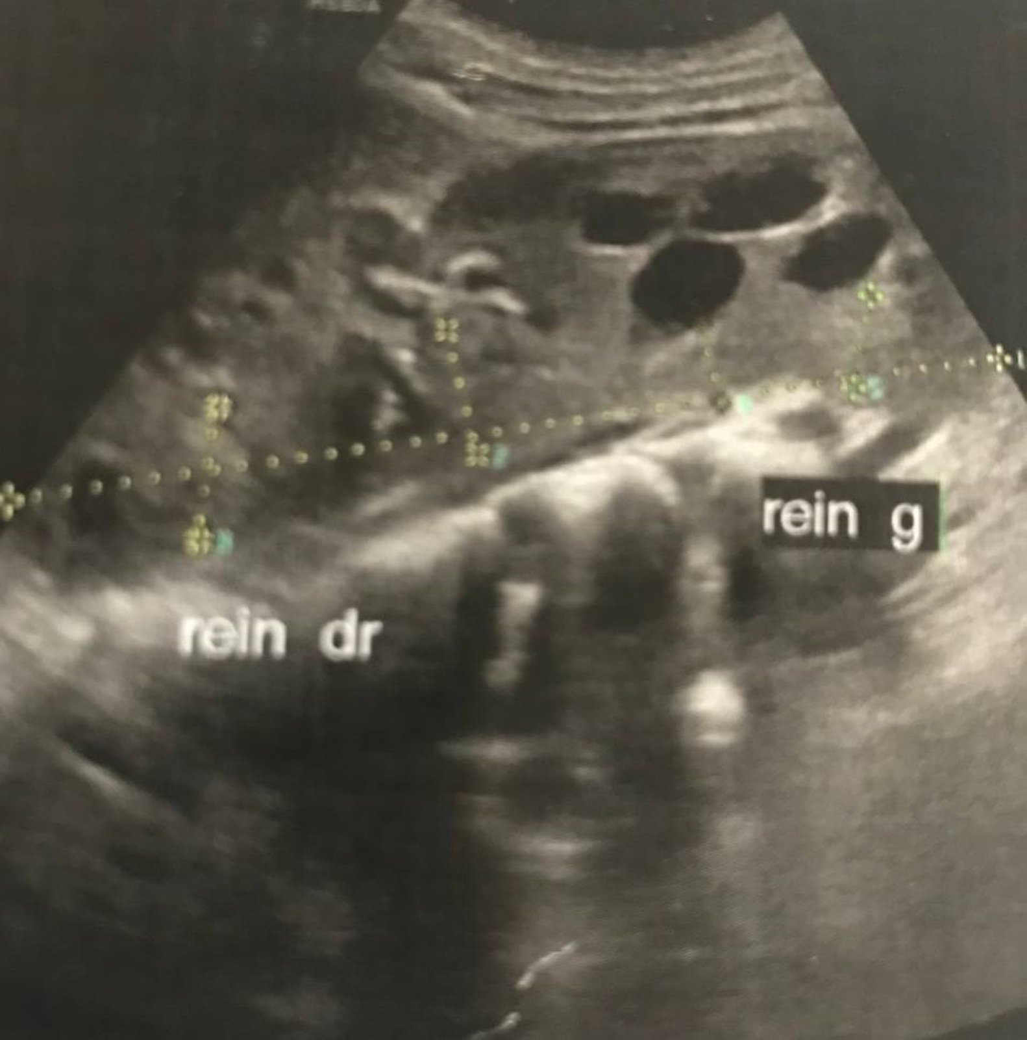

Fig 1:Abdominopelvic ultrasound:

significant dilatation of the left pyelocaliceal cavities.

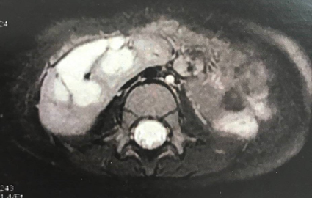 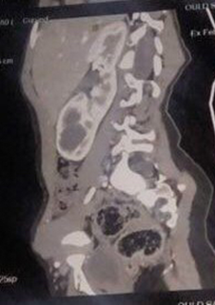 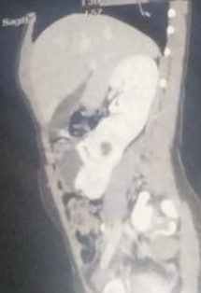

Fig 2: Uro MRI:Sigmoîd kidney measured 175 mm in bipolar length .Face/ right and left Profile .

Renal scintigraphy (Fig3) using MAG3 and DMSA showed poor drainage of the ectopic kidney, consistent with an obstructive syndrome, without evidence of pyelonephritis, and a relative renal function estimated at 30%.

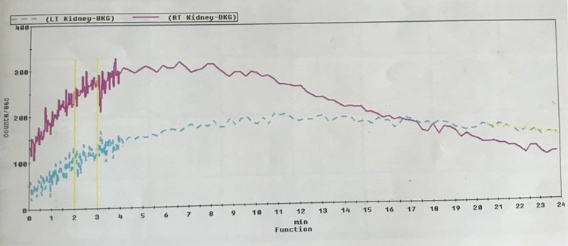

Fig 3 :Renal scintigraphy: Obstructive syndrome

3. discussion

The diagnosis of ureteropelvic junction obstruction in a sigmoid kidney was established, a Kuss-Anderson-Hynes pyeloplasty was performed on the ectopic kidney with placement of a double-J stent.The postoperative course was simple, without any notable complications.

Follow-up with periodic renal ultrasound was initiated.

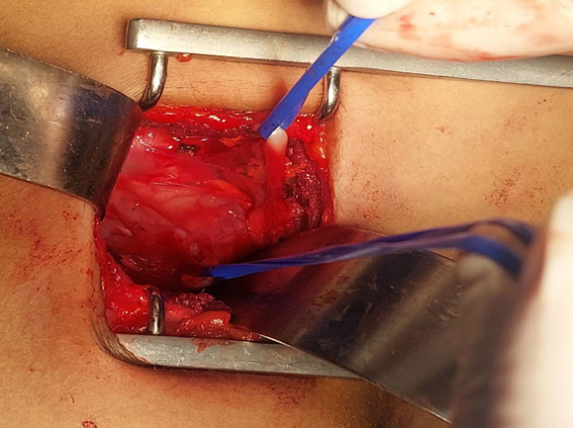 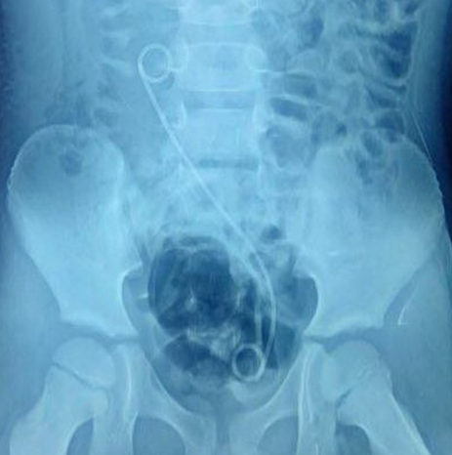

Fig 4 : Both ureters have been isolated. Fig 5 : a double-J stent in place

Crossed ectopia is a rare congenital anomaly. S-shaped (sigmoid) kidney is one of the varieties of crossed ectopia that is associated with absence of any renal tissue in the contralateral renal fossa. [1]

The sigmoid kidney represents a rare congenital anomaly where a crossed ectopic kidney is fused to the orthotopic kidney at the upper pole. Its prevalence is approximately 1/16,000 **in adult autopsies and 0.05% in the general population.[2]** Ureteropelvic junction obstruction associated with crossed ectopic kidneys is a rare uropathic anomaly resulting from defective renal development.

Crossed renal ectopia is a situation in which the fused mass of total kidney substance is located on one side of the midline. One moiety may be the seat of hydronephrosis, infection or calculus formation. The adrenal glands are normally situated [3]

The acronym **CAKUT** (congenital anomalies of the kidney and urinary tract) should now replace other terms for all congenital anomalies of the kidney and urinary tract. The diagnosis is often made prenatally, and management is generally pediatric, but this condition can also be recognized in adulthood. Overall, boys are more frequently affected than girls, especially when an obstruction is present, and urinary tract infection is common and sometimes the first sign. The risk of renal failure exists whenever the lesions are bilateral, and CAKUT represent the leading cause of end-stage renal disease in children. Advances in genetics have improved our understanding of urinary tract embryology and the anomalies involved. Management is often medico-surgical. [4].[5]

In clinical practice, surgical intervention is only warranted when the condition is symptomatic. Regular monitoring of blood pressure and renal function is essential due to the risk of developing renal insufficiency.

4. Conclusion

Sigmoid kidney is a rare and often incidental congenital malformation, commonly associated with upjo. Surgical management should be considered on a case-by-case basis, supported by periodic ultrasound and functional monitoring.

Consent

All authors declare that ‘written informed consent was obtained from the patient (or other approved parties) for publication of this case report and accompanying images. A copy of the written consent is available for review by the Editorial office/Chief Editor/Editorial Board members of this journal.

Ethical approval

All authors hereby declare that all experiments have been examined and approved by the appropriate ethics committee and have therefore been performed in accordance with the ethical standards laid down in the 1964 Declaration of Helsinki.

References

[1] Amrith raj rao, David maudgil, and Marc laniado. Images in clinical urology.urology 81: e7ee8, 2013. 2013 elsevier inc. An unusual case of s-shaped malformation of the ipsilateral kidney with normal contralateral kidney. 0090-4295/12/$36.00 HTTP://DX.DOI.ORG/10.1016/J.UROLOGY.2012.08.051

[2].t. dardouri, m. well cold, z. world, a. ezzine, h. boudrigua, s. mensi, k. chatti.Pyeloureteral junction obstruction on a sigmoid kidney: about a case, nuclear medicine, volume 45, issue 4, 2021, page 207, issn 0928-1258,

https://doi.org/10.1016/j.mednuc.2021.06.065.(https://www.sciencedirect.com/science/article/pii/s0928125821001157)

[3]. Bauer sb (2007) Anomalies of the upper urinary tract. Campbellwalsh urology, 9th edn. vol 4. saunders elsevier, pp 3269–3303.

[4]. P. Cochat a, b, ⁎ , B. Fretes a, c, D. Demède a, d, A. Bertholet-Thomas a, L. Michel-Calemard a, e, S. Cabet a, f, J. Bacchetta a, b. CONGENITAL ANOMALIES OF THE KIDNEY AND URINARY TRACT - 05/02/22. [4-085-B-30] - DOI : 10.1016/S1637-5017(21)76982-1

|5]. Blessings, Ruhston gil Congenital anomalies of the kidney and urinary tract. springer. 2016 (isbn 9783319292175