*Short Research Article*

Field Evidence of Erythrism and Partial Leucism in House Sparrow (*Passer domesticus*) Populations of Ajmer City, Rajasthan

.

ABSTRACT

|  |
| --- |
| **Aims:** To document and analyse the occurrence of plumage aberrations in House Sparrows (*Passer domesticus*) in Ajmer City, Rajasthan, and to assess the possibility of a localized, genetically distinct population maintaining these rare traits.  **Study design:** Observational, field-based study focusing on phenotypic variation within a free-living urban bird population.  **Place and Duration of Study:** Urban and suburban areas of Ajmer City, Rajasthan, India from January 2024 to April 2025.  **Methodology:** Systematic field surveys were conducted across multiple sites within the Ajmer district using direct visual observation, supported by photography for documentation. Individual sparrows displaying atypical plumage were identified and compared against the standard plumage characteristics of *Passer domesticus*. Morphological parameters such as plumage coloration, body size, and apparent health status were recorded.  **Results:** A total of three erythristic House Sparrows (three males and two females) were documented from three distinct locations within Ajmer City. These individuals consistently displayed reddish-brown pigmentation on the crown, nape, back, and ventral regions, distinctly different from standard plumage. In addition, a single case of partial leucism was recorded, characterized by localized patches of depigmented (whitish) feathers.  **Conclusion:** The repeated sightings of erythristic and leucistic House Sparrows in Ajmer suggest the potential existence of a localized, genetically influenced anomaly within the population. Further genetic and ecological studies are necessary to confirm inheritance patterns and to explore the adaptive significance of these rare plumage traits in an urban environment. |

*Keywords: House Sparrow; Erythrism; Partial Leucism; Phenotypic Anomaly; Urban Ecology*

1. INTRODUCTION

Plumage coloration in birds plays a crucial role in various biological functions, including camouflage, mate selection, social signaling, and thermoregulation (Baker & Parker, 1979). Variation from typical coloration is termed *colour aberrations* a rare but significant phenomena that can be induced from genetic mutations, environmental stressors, and evolutionary processes within avian populations (Hill & McGraw, 2006).

The House Sparrow (*Passer domesticus*) is a widely distributed and well-studied urban passerine, adapted to a range of environments from rural farmlands to densely populated cities across the globe (Chamberlian et al., 2007; De Laet & Summers-Smith, 2007; Shaw et al., 2008). Colour anomalies can affect an individual’s survival and reproductive success by altering camouflage effectiveness, thermoregulatory capacity, and social interactions within flocks (Duarte et al., 2017).

In India, and particularly in the arid regions of Rajasthan, reports of such aberrant plumage patterns in House Sparrows are extremely rare or altogether lacking in published literature (Jangir et al., 2023). This gap underscores the importance of systematic field-based documentation to better understand the frequency, distribution, and potential causes of these aberrations in wild bird populations.

While colour aberrations have been documented sporadically in various passerine species worldwide, there remains a paucity of focused studies investigating these anomalies in the context of Indian urban avifauna. The present study aims to bridge this gap by providing the systematic field-based report of colour anomaly in House Sparrows from Ajmer City.

2. material and methods

This observational, field-based study was conducted across various urban and suburban habitats of Ajmer City, situated in the central part of Rajasthan, India (26.4499° N, 74.6399° E), over a period from January 2024 to April 2025. Ajmer is geographically positioned on the eastern fringe of the Aravalli range and is characterized by a semi-arid climate with hot summers, mild winters, and low to moderate rainfall predominantly received during the monsoon season (Jangir et al., 2023; Choudhary et al., 2025). In addition, the presence of peri-urban farmlands and water bodies (Khiyani et al., 2022) enhances habitat heterogeneity as this region lies in ecotone of arid and semi-arid biogeographic zones (Choudhary et al., 2023), offers feeding and roosting opportunities that are critical for sustaining avian populations in semi-urban ecosystems.

Systematic field surveys were carried out across pre-selected sites within the city to capture the variability of the local sparrow population. Each location was surveyed at least twice a month during peak sparrow activity periods i.e. early morning (06:30–09:30 hours) and late afternoon (16:30–18:30 hours). Observations were made using Nikon 10x50 binoculars, and photographic documentation was obtained with a Canon EOS 90D DSLR camera fitted with a 70–300 mm telephoto lens. This approach enabled detailed post-field analysis of plumage features and individual identification.

Individual House Sparrows exhibiting atypical plumage characteristics were identified during these surveys. The criteria for classification as colour abnormality was adopted from Van Grouw (2012).

For each sighting of an aberrant individual, detailed field notes were recorded, including date, time, exact GPS coordinates of the location, habitat description, estimated age class (adult or juvenile), and sex (when determinable based on plumage and morphological features). Additional observations on body size (relative to nearby conspecifics), apparent health status (activity level, feeding behavior, flock participation), and the presence or absence of any visible injuries or deformities were also documented. Photographs were reviewed after each field visit to confirm and catalogue individuals, ensuring reliable differentiation between unique and resighted birds.

No physical capture, handling, or genetic sampling of birds was undertaken, in order to maintain ethical standards and avoid disturbance to the wild population. Data were analyzed descriptively to summarize the frequency, distribution, sex ratio, and plumage characteristics of aberrant individuals observed across the study period.

3. results and discussion

A total of three individual House Sparrows (*Passer domesticus*) displaying plumage aberrations were recorded during the course of systematic field surveys conducted between January 2024 and April 2025 across various locations in Ajmer City, Rajasthan. Of these, two individuals (one males and one females) exhibited a distinct form of erythrism, while one individual displayed partial leucism.

The erythristic individuals were characterized by uniform reddish-brown pigmentation covering the crown, nape, mantle, back, and ventral regions, a clear deviation from the typical grey and brown plumage of wild-type House Sparrows (Van Grouw, 2012). Notably, the degree of erythristic coloration was consistent among both individuals, indicating a possible common genetic basis rather than independent spontaneous mutations. This consistency, along with repeated sightings of some individuals at the same locations over multiple months, points towards the likelihood of a localized, genetically distinct subpopulation carrying the mutation responsible for erythristic plumage expression.

In contrast, a single partially leucistic individual was documented, exhibiting localized white feather patches on the wings and flanks, while maintaining normal pigmentation on the head, beak, eyes, and legs (Van Grouw, 2012). This pattern of partial leucism suggests a defect in melanin deposition limited to certain feather tracts, consistent with previously reported cases of leucism in passerines (Davis, 2007; Konter, 2015). The occurrence of both erythristic and leucistic phenotypes within the same geographical population is intriguing and may imply an increased frequency of pigment-related genetic mutations in this area, potentially due to factors such as inbreeding, genetic drift, or urban environmental stressors.

The repeated documentation of erythristic sparrows from multiple locations over a span exceeding a year supports the hypothesis of heritable transmission of this colour aberration within a local breeding population (Jangir et al., 2023; Kumar & Khan, 2024). Although the exact genetic mechanism remains undetermined in the absence of molecular analysis, erythristic coloration in birds is often associated with mutations affecting melanin synthesis or distribution pathways, particularly those regulating phaeomelanin expression. Similarly, leucism arises from disruptions in the differentiation or migration of melanocytes during feather development.

The ecological implications of such plumage aberrations warrant careful consideration. Aberrant coloration can impact fitness by altering camouflage efficiency, predation risk, mate selection, and social dominance within flocks (Choudhary et al., 2025). However, the fact that these anomalous individuals appeared healthy, engaged in normal activities such as feeding and flocking, and were repeatedly resighted suggests that their survival and integration within the local population are not immediately compromised. Whether these traits confer any adaptive advantage or disadvantage in the urban environment of Ajmer remains speculative and requires further behavioral and ecological studies. The presence of aberrant *Passer domesticus* individuals in habitats dominated by invasive plant species such as Lantana camara and Prosopis juliflora suggests that these altered environments may provide suitable resources or refuge, potentially influencing the expression or survival of plumage anomalies; however, the ecological role of such invasive flora in shaping urban bird populations requires further investigation (Hussain et al., 2021; Choudhary et al., 2024; Jangir et al., 2024).

The persistence and recurrence of erythristic individuals over multiple breeding seasons strengthen the case for a genetically based anomaly rather than isolated, non-heritable mutations. However, without genetic analysis, the underlying mode of inheritance remains undetermined. Future studies incorporating molecular genetic techniques such as DNA sequencing or microsatellite analysis are recommended to elucidate the inheritance patterns and assess potential founder effects or inbreeding within this urban sparrow population.

**Table 1. Observation data.**

|  |  |  |  |  |  |  |  |  |  |  |  |
| --- | --- | --- | --- | --- | --- | --- | --- | --- | --- | --- | --- |
| **S. No.** | **Date** | **Time** | **GPS Coordinates** | **Habitat Description** | **Age Class** | **Sex** | **Body Size** | **Apparent Health Status** | **Visible Injuries / Deformities** | **Colour Anomaly** | **Flock Participation (Yes/No)** |
| 1 | 2-Feb-24 | 14:00 pm | 26°30'31.3"N 74°41'02.2"E | Roadside | Adult | M | Same size of adult | Healthy | No | Erythrism | No |
| 2 | 2-Feb-24 | 17:30 pm | 26°30'37.1"N 74°40'42.4"E | *Lantana camara* Patch | Adult | F | Same size of adult | Healthy | No | Erythrism | No |
| 3 | 24-Nov-24 | 10:00 AM | 26°29'23.3"N 74°40'20.0"E | *Prosopis juliflora* patch | Adult | F | Same size of adult | Healthy | No | Partial Leucism | Yes |

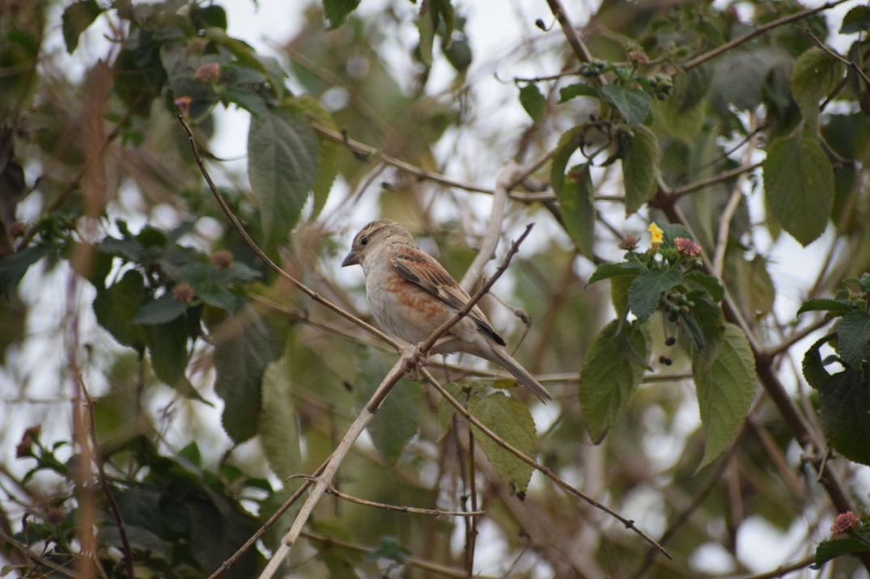

**Fig.1. House Sparrow (female) with erythrism, roosting in *Lantana camara.***

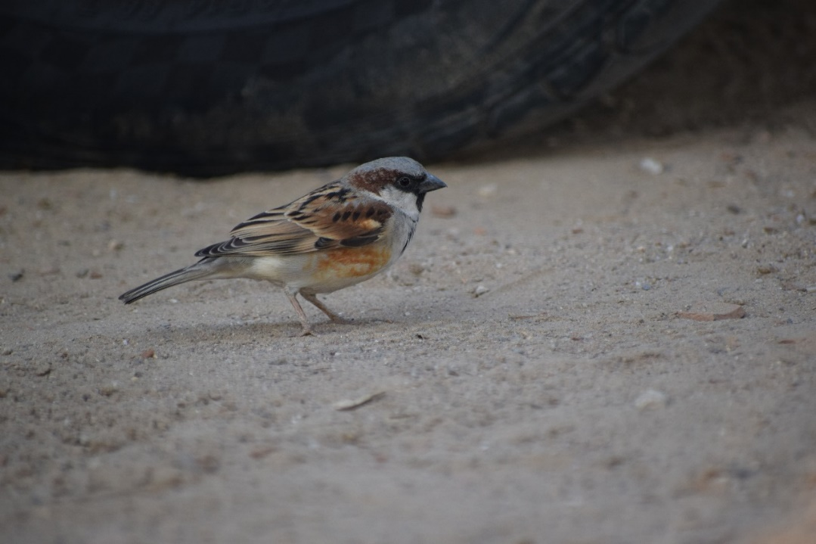

**Fig. 2. House Sparrow (Male) with erythrism foraging.**

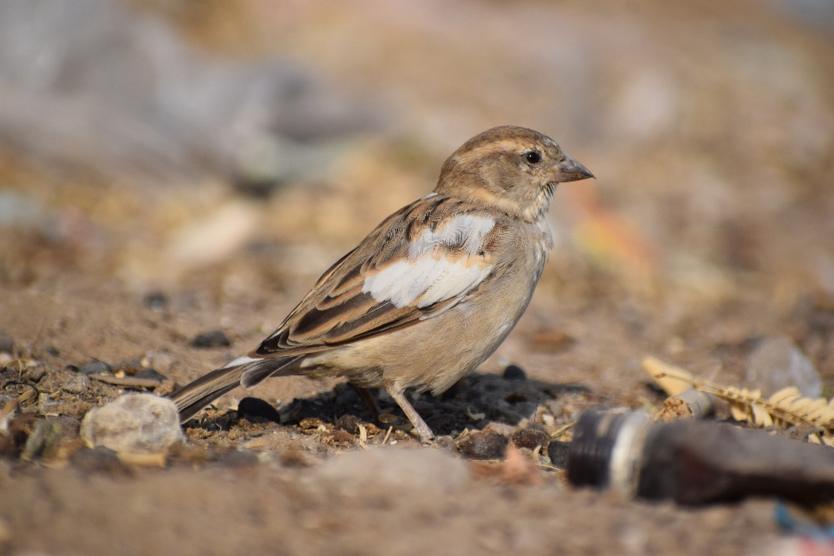

**Fig. 3. House Sparrow (Female) with partial leucism.**

4. Conclusion

The present study provides the first systematic documentation of erythristic and partially leucistic individuals in House Sparrow (*Passer domesticus*) populations within Ajmer City, Rajasthan. The consistent observation of erythristic sparrows across distinct locations, along with one instance of partial leucism, suggests the possible existence of a localized, genetically influenced anomaly in this urban population. The persistence and resighting of these aberrant individuals over the 16-month study period indicate that such plumage traits may be heritable rather than arising from isolated, spontaneous mutations.

While the observed plumage anomalies did not appear to adversely affect the health or behavior of the affected individuals, the potential ecological and evolutionary implications of these traits remain unclear. Further investigations, particularly involving genetic analyses, are necessary to confirm the mode of inheritance and assess whether these anomalies confer any adaptive significance or reflect underlying population-level genetic drift or inbreeding. This study highlights the importance of continuous field-based monitoring and molecular assessment to better understand rare phenotypic variations in urban avian populations.

References

Baker, R. R., & Parker, G. A. (1979). The evolution of bird coloration. Philosophical Transactions of the Royal Society of London. B, Biological Sciences, 287(1018), 63-130.

Chamberlain, D. E., Toms, M. P., Cleary-McHarg, R., & Banks, A. N. (2007). House sparrow *(Passer domesticus*) habitat use in urbanized landscapes. Journal of Ornithology, 148(4), 453-462.

Choudhary, R., Dutta, S., Jangir, D. K., Sharma, V., & Mathur, P. (2024). A photographic record of *Charaxes solon* from Aravalli hills of Rajasthan, India. *ZOO'S PRINT*, *39*(11), 18-19.

Choudhary, R., Sharma, V., Dutta, S., & Mathur, P. (2023). A new record of *Sternocera chrysis* (Fabricius 1775), the jewel beetle from Rajasthan's semi-arid region and its cultural significance as a traditional ornament. Entomologie faunistique-Faunistic Entomology.

Choudhary, R., Sharma, V., Dutta, S., Mathur, P., Singh, P. & Sahu, H. (2025). Habitat suitability for endemic and vulnerable White-Naped Tit (*Machlolophus nuchalis*) in arid and semi-arid landscapes of India. Journal of Landscape Ecology, 18(2), 125-138.

Choudhary, R., Sharma, V., Jangir, D.K. & Dutta, S. (2025). Intersex plumage in Plum-headed Parakeet (*Psittacula cyanocephala*). Rivista Italiana di Ornitologia - Research in Ornithology, 95 (1): 31-32. DOI: 10.4081/rio.2024.807

Davis, J. (2007). Color abnormalities in birds. Birding, 39, 36-46.

De Laet, J., & Summers-Smith, J. D. (2007). The status of the urban house sparrow *Passer domesticus* in north-western Europe: a review. Journal of Ornithology, 148(Suppl 2), 275-278.

Duarte, R. C., Flores, A. A., & Stevens, M. (2017). Camouflage through colour change: mechanisms, adaptive value and ecological significance. Philosophical Transactions of the Royal Society B: Biological Sciences, 372(1724), 20160342.

Hill, G. E., & McGraw, K. J. (Eds.). (2006). Bird coloration (Vol. 1). Harvard University Press.

Hussain, M. I., Shackleton, R., El-Keblawy, A., González, L., & Trigo, M. M. (2021). Impact of the invasive *Prosopis juliflora* on terrestrial ecosystems. Sustainable Agriculture Reviews 52, 223-278.

Jangir, D. K., Choudhary, R., Sharma, V., & Chandra, S. (2023). Interspecific feeding by Indian Robin (*Copsychus fulicatus*) to Brown Rock Chat *(Oenanthe fusca*). *Rivista Italiana di Ornitologia*, *93*(2).

Jangir, D. K., Choudhary, R., Sharma, V., & Mathur, P. (2023). Erythrism in house sparrow (*Passer domesticus*): a record from Rajasthan, India. International studies on sparrows, 27.

Jangir, D.K., Choudhary, R., Sharma, V. & Dutta, S. (2024). Progressive greying in the white-eared bulbul (*Pycnonotus leucotis*). TAPROBANICA The Journal of Asian Biodiversity. 13(01):31-32. DOI: 10.47605/tapro.v13i1.325

Khiyani, S., Choudhary, R., Sharma, V., Chandra, S., & Mathur, P. Community structure and habitat utilization with reference to water depth by wetland birds at Anasagar Lake, Ajmer, Rajasthan.

Konter, A. (2015). Aberrant plumages in grebes Podicipedidae: An analysis of albinism, leucism, brown and other aberrations in all grebe species worldwide (pp. 206-206). Musée national d'histoire naturelle.

Kumar, A. & Khan, I.A. 2024, Erythrism in House Sparrow *Passer domesticus*. BUCEROS. 29(2).

Shaw, L. M., Chamberlain, D., & Evans, M. (2008). The House Sparrow *Passer domesticus* in urban areas: reviewing a possible link between post-decline distribution and human socioeconomic status. Journal of Ornithology, 149(3), 293-299.

van Grouw, H. (2012). What colour is that sparrow? A case study: colour aberrations in the House Sparrow *Passer domesticus*.