Studies on Immunological Characterization of the Serum of Mole Crab Emerita asiatica

ABSTRACT
Aim: To examine the mole crab's immune reaction and determine the hemagglutinin value of Emerita asiatica.
Methodolgy: For the purpose of serum separation and microbe agglutinating activity, hemagglutination and cross adsorption experiments have been conducted in this study. All of the investigated bacterial species responded with the agglutinin that was extracted from infected microorganisms. The mole crab's defensive system against bacterial infection is shown by bacterial inhibition and bacterial agglutination. Using human erythrocytes (RBC), a variety of bacteria, and yeast as indicator cells, a naturally occurring hemagglutinin (HA) with action against bacteria and yeast cells was discovered in the serum of mole crabs. When tested with Buffalo RBC, tripsinized yeast, and Bacillus subtilis, the serum produced the highest HA titer. The trypsinised yeast has a higher titer value for agglutination compared to the native yeast. It was discovered that the hemagglutinating activity was strong between temperatures of 20 and 50 ̊C.
Results: Based on its physicochemical study, HA is thermally stable, pH-stable (between 7 and 9), and activity-dependent on the presence of Ca2+. The HA titers of serum samples tested against buffalo RBC were reduced after extensive dialysis in a divalent cation-free buffer. Serum calcium levels in mole crabs ranged from 0.9 to 1.9 mg/ml. Serum of Emerita asiatica with erythrocytes had the highest HA activity. Researchers found that serum HA was highly selective for non-reducing terminal glucose with 1-2 glucosidic linkages when they conducted HA-inhibition experiments using carbs. That being said, out of all the agglutinins found in crustaceans, this one seems to be one of a kind.
Conclusion: Emerita asiatica serum hemagglutinating activity was unaffected by biochemical factors such water, protein, and calcium content. We also looked at whether or not agglutinin was present in different kinds of tissues.
Keywords: Agglutinin, Emerita asiatica, Hemagglutination, Immunology.

1. Introduction

1.1 Background
The intertidal zone of the Chennai coast is home to a large population of Emerita asiatica, often known as mole crabs. Eli poochi is the common name for this ingredient, and it's utilised by fisherwomen to make a wide range of delicious meals. Because of its ecological significance, this genus has been the subject of more and more scientific investigations. It is a bioindicator of environmental quality and health and a model species for assessing community ecological health. The antibacterial and possible vasoconstrictor phenylephrine found in mole crabs makes them a useful food for lowering blood pressure. The two most common proteins found in crustacean hemolymph are the clottable protein (20 percent) and the respiratory protein hemocyanin (60-95% of the total). "Serum is ubiquitous throughout the body, thus it seems to reason that its composition would fluctuate in reaction to environmental, physiological, or pathological changes. Specifically, the compounds generated by cells or tissues may be detected in the serum under these conditions. Total protein is one of these serum components that crustaceans use to gauge their health. The overall protein level of crustaceans varies according to a number of variables, including sex (Adiyodi, 1968; Djangmah, 1970) nutritional state (Ponce-Palafox, Martinez-Palacios, & Ross, 1997), moult phases (Barondes, 1988), and, most importantly, toxic illnesses. Several earlier studies on the consequences of various illnesses have focused on the total protein concentration in different crustacean haemolymph subsets (Du, Li, Xu, & Kil, 2006). The number of monomers, which may vary from 2 to 6, and in exceptional cases up to 17, in distinct non-decapod crustaceans seems to be species-specific (S. Jayaraj, Thiagarajan, Arumugam, & Vincent, 2010). Dodecameric hemocyanin is thought to be the result of the aggregation of two hexameric units of hemocyanin, but hexameric hemocyanin is also present in the serum of a small number of decapod crustaceans (Granja, Aranguren, Vidal, Aragón, & Salazar, 2003). In addition to its well-known role as an oxygen transporter, hemocyanin serves an outstanding purpose as an osmolyte (Alpuche et al., 2005). The hemocyanins of crustaceans bind heavy metals like iron, according to many in vitro investigations (Yoganandhan, Thirupathi, & Hameed, 2003). The study's species, the Emerita asiatica (mole crab), is very adaptable. People living on this sandy beach owe a significant deal of their economic success to these creatures. A variety of Emerita species colonise various beaches because of their larvae dispersal and great fertility (around four thousand eggs) (Coombe, Ey, & Jenkin, 1984). It serves as a host for helminth parasites and prepares the way for benthic production. Surveying the presence of agglutinins in the serum of the mole crab Emerita asiatica is the basis of the current investigation (Fragkiadakis & Stratakis, 1997). These intertidal sandy beaches are home to a variety of macrofauna, and the subsequent changes in hydrography may have a major impact on their distribution, abundance, and biology. It is likely that an organism's biology and defined strategy determine its survival potential among the macrofauna (Guan, 2003). Determining the HA titer value and evaluating the presence of agglutinins in Emerita asiatica were the objectives of this investigation. While several studies have shown that certain crustacean species have humoral agglutinins, it is still unclear what these agglutinins do immunologically and only a small number of species have had the carbohydrate specificity of their serum agglutinins clarified (Jayasree, 2001; Lillie, 1954; Nalini, Mullainadhan, & Arumugam, 1994; Smith & Chisholm, 1992; Vasta, Warr, & Marchalonis, 1983). Naturally present in the serum of the sea crab S. serrata, this study details the carbohydrate specificity, physico-chemical features, and RBC and bacterial binding capabilities of an agglutinin.

1.2 Literature Review
The immunological characterization of the serum of Emerita asiatica—a species of mole crab found predominantly in intertidal zones—has become a growing area of research due to its relevance in invertebrate innate immunity and its potential applications in aquaculture and biotechnology.

One of the key findings in the immunological study of E. asiatica is the presence of natural hemagglutinins in the serum, which are involved in the agglutination of erythrocytes. These hemagglutinins show significant variation in activity corresponding to different moulting stages, with peak activity observed during the intermoult phase. The agglutinins are reported to be calcium- and magnesium-dependent and exhibit carbohydrate-binding specificity, suggesting lectin-like behavior. Additionally, their stability across a broad pH range (6.0–8.0) and temperatures (20°C–50°C) makes them robust candidates for further immunological applications (Pillai & Munusami, 2017).

The hemocytes of E. asiatica have demonstrated essential roles in cellular immunity. These cells maintain viability under laboratory conditions and show rapid attachment and protoplasmic extension, indicating a capacity for phagocytic and encapsulation responses. The variation in hemocyte activity is often linked to the presence of opsonic molecules in the serum, which also fluctuate with the moulting cycle. This suggests that E. asiatica has a dynamic immune system capable of responding to environmental and physiological changes (Impellitteri, Curpăn, Plăvan, Ciobica, & Faggio, 2022).

In addition to its agglutination capabilities, the hemolymph of E. asiatica possesses antimicrobial properties. Hemocyanin, a respiratory protein present in the serum, has been implicated in immune defense, functioning as an antimicrobial agent in addition to its oxygen-transport role. Studies have shown that heat-treated hemolymph exhibits inhibitory effects on bacterial growth, suggesting its potential use in bioactive compound development for aquaculture (Mantelatto, Paixão, Robles, Teles, & Balbino, 2023).

Recent investigations have also focused on the glycoprotein composition of E. asiatica, particularly in embryonated eggs. Lipovitellin, a high molecular weight glycoprotein, has been isolated and characterized, showing involvement in both reproductive physiology and immune function. The dual role of such molecules indicates a complex interplay between immunity and reproduction, warranting further exploration in the context of crustacean biology (Devaraj, Kumar, Thanislass, & Niranjali, 1995).

Despite these findings, there remain significant gaps in understanding the molecular mechanisms regulating immune responses in E. asiatica. Most existing studies are limited to functional assays and basic protein characterizations. Advanced molecular techniques such as transcriptomic or proteomic profiling are needed to uncover the full range of immune-related genes and their regulatory networks.

2. Materials and Methods

2.1 Experimental animal: Collection and Maintenance
A total of ten Emerita asiatica mole crabs, weighing an average of twenty-two grammes, were rounded up in the coastal area around Chennai. Before being used, these mole crabs were brought to the lab in plastic buckets equipped with battery-operated aerators and allowed to acclimatise in salt water with constant aeration. The mole crab was given ad labium and its water was changed daily. Before being employed for further research, the animals were kept in the lab to acclimatise for three days.

2.2 Serum collection
(Ravindranath, 1975) made a little adjustment to the method he used to obtain serum. The first step was to place each animal in a glass of salt water and let it sit at room temperature for one minute. A 1 ml syringe and a 22 gauge needle were used to extract serum from the first and second periopods of the animal after it was drained off to remove any excess water. Centrifuging the clotted serum allowed for the collection of serum, which was then kept at -20°C and given a date.

2.3 Preparation of RBC Suspension
Blood samples from humans and other mammals were collected via venous or cardiac puncture and transferred into sterile Alsever's solution containing 10 μg/ml streptomycin. The red blood cells (RBCs) were then washed once with TBS-II and three times with 0.9% saline through centrifugation at 400 × g for 5 minutes at room temperature. Unless specified otherwise, the resulting RBC pellet was resuspended in TBS-II to prepare a 1.5% (v/v) suspension.
2.4 Hemagglutination assay
For the hemagglutination assay, blood was collected from a range of animals including rats, rabbits, dogs, cows, buffalo, horses, donkeys, pigs, sheep, and goats, with equine blood drawn from the neck. Erythrocytes were directly collected in a modified Alsever's medium. The suspended erythrocytes were washed three times with ten volumes of Tris-buffered saline (TBS) and then resuspended in TBS to a final concentration of 5%. Hemagglutination assays involving mole crab serum lectin were performed using Falcon microtiter plates.(Mercy & Ravindranath, 1993) provided the procedure that was followed for the adsorption testing.
2.5 Cross Adsorption Assay
The adsorption tests were conducted according to the protocols laid forth by Mercy and (Mercy & Ravindranath, 1993) and (Hall & Rowlands Jr, 1974a)The serum samples, which were 300 μl each, were combined with equivalent volumes of cleaned RBCs from either humans, buffalo, horses, or rats. The mixture was incubated at room temperature for one hour with occasional shaking. Following incubation, the suspension was centrifuged under the same conditions, the supernatant was collected, and the adsorption process was repeated. All four kinds of red blood cell (RBC) HA activity tests were performed on the serum that had been adsorbed three times.

2.6 Preparation of Bacterial Suspension
The bacterium stock culture was injected into TBS-I and left to incubate for 6 hours. Next, the broth cultures were spun in a centrifuge for 10 minutes at 5,000 xg. After collecting the pellet, it was centrifuged three times with TBS-I to wash it. Prior to usage, the concentration was fine-tuned in TBS-I to 1x108 cells ml-1. Serum samples were serially diluted in TBS-I two times. Next, a bacterial suspension of 25 µl was treated with 25 µl of each serum dilution. The combination undergoes incubation at a temperature of 20 ± 2 °C for a duration of 1 hour. The next step was to use a 40x microscope to document the presence of bacterial aggregates. The amount of agglutination that has occurred after incubation was determined by taking the reciprocal of the last dilution that showed indications of agglutination. Equal parts bacterial suspension and TBS-I made up the negative controls.

2.7 Bacterial agglutination assays
The cells from the stock culture, which were kept at 4°C in nutrient agar, were transferred to nutrient broth that included bacteria in order to prepare the active cultures. The experiment was conducted using the agar disc diffusion technique. The bacteria were heat-killed to a concentration of 5% in an autoclave, and then utilised as bacterial agglutination titers in 96-well plates.
2.8 Preparation of Yeast Suspension
A 100 mg sample of commercial-grade baker's yeast (Saccharomyces cerevisiae) was purchased from the local market and suspended in 10 ml of 0.9% saline. The suspension underwent centrifugation at 400 × g for 5 minutes at room temperature and was thoroughly washed with saline. The yeast was then resuspended in the original medium. To heat-inactivate the cells, the yeast suspension was autoclaved for 15 minutes at 15 psi. After cooling to room temperature, the inactivated yeast cells were rinsed with 0.9% saline and subsequently resuspended in 0.5% TBS-I (v/v).
2.9 Trypsinization of yeast cells
To achieve a final concentration of 0.5%, 5 μl of washed yeast cells were suspended in 1 ml of TBS-I containing 0.5% trypsin. The mixture was incubated at 37°C for one hour with occasional gentle shaking. Following incubation, the yeast cells were centrifuged at 400 × g for 5 minutes at room temperature to remove any residual trypsin. The pellet was then resuspended in TBS-I to a final concentration of 0.5% (v/v).
2.10 Yeast agglutination assays
Approximately 100 milligrams of baker’s yeast were heat-inactivated using an autoclave. Following inactivation, the yeast cells were washed with 0.9% saline and resuspended in 0.5% TBS-I. To trypsinize the cells, trypsin was added to 1 ml of TBS-II, and the yeast suspension was incubated at room temperature for one hour. After incubation, the cells were centrifuged at 400 × g for 5 minutes at room temperature, then resuspended in TBS-I to achieve a final concentration of 0.5%.
Saccharomyces cerevisiae cells were cultured in 100 ml of bacterial growth medium supplemented with 2% Difco peptone and incubated at 37°C for 16 hours with continuous shaking. The cells were then harvested by centrifugation at 1500 × g for 10 minutes using phosphate-buffered saline (PBS, pH 7.4) prepared in distilled water.For the agglutination assay, the yeast cells were heat-killed using a Bunsen burner. Agglutination titres were determined using V-bottom microtiter plates. A total of 25 µl of blood sample was serially diluted with an equal volume of TBS-I in each well. After dilution, 25 µl of the yeast cell suspension was added to each well, and the plates were incubated at 26°C for 45 minutes. The agglutination was then observed under a microscope at 40X magnification, and the titre was recorded as the reciprocal of the highest dilution showing visible agglutination.
2.11 Antibacterial activity
The sterilisation procedure required the undisturbed dissolution of about 3.8g of Muller-Hinton agar medium in 100ml of distilled water. The medium was left to solidify in a sterile petri dish for one hour. The inoculum was dispersed on this solidified agar medium using a moistened brush that contained bacteria. After adding 20, 40, 50, and 60 µl of the sample and 20 µl (20 µg) of streptomycin, the positive control, the wells were incubated at 37°C for 24 hours. In order to determine the size of the microorganisms, scientists evaluated the inhibitory zone diameter.
2.12 Antifungal activity
The sterilisation method required the undisturbed suspension of about 4.4g of Potato Dextrose agar medium in 100ml of distilled water. The medium was left to solidify in a sterile petri dish for one hour. This hardened agar media was inoculated with yeast using a moistened swab. The wells were incubated at 37°C for 24 hours after each of the following volumes of sample, negative control (DMSO), and positive control (ketocanzole 1 mg/ml-20 µl) were added: 20, 40, 60, and 800 µl. To find out how big the microbes became, scientists measured the diameter of the inhibitory zone.
2.13 pH and temperature
The hemagglutination (HA) assay involved pre-incubating the serum at specific pH levels (ranging from 5 to 10) or temperatures (between 10°C and 50°C) for one hour before adding the erythrocyte suspension. This approach was used to evaluate the pH and temperature sensitivity of the agglutinin. To assess the stability of serum HA activity across a broader pH spectrum, 300 μl serum samples were dialyzed against various buffers with pH values ranging from 3 to 12. The buffers used included 0.2 M acetate buffer (pH 3–6), 0.2 M Tris-HCl buffer (pH 7–9), and 0.1 M glycine-NaOH buffer (pH 10–12), as per the protocols of Lillie (1954) and Pearse (1968). After dialysis, all samples were re-equilibrated in TBS-I, and HA titers were determined using rabbit erythrocytes.To investigate thermal stability, a separate set of 300 μl serum samples was exposed to temperatures ranging from 10°C to 100°C for 30 minutes. Following heat treatment, the samples were centrifuged, and their HA activity was assessed using rabbit red blood cells.
2.14 Divalent Cation
The HA experiments were conducted in TBS (pH 8) depending on whether Ca2+, Mg2+, and Mn2+ ions were present or not. Prior to adding the erythrocyte suspension, the serum was pre-incubated for 1 hour at a particular concentration of cations. In order to test for cation dependence, 300 µl of serum samples were dialysed extensively at 20 °C against divalent cation-free TBS-II (50 mM tris-HCl, 135 mM NaCl, 300 mOsm) or in TBS-III containing 50 mM EDTA (50 mM tris-HCl, 72 mM NaCl, 40 mM CaCl2, 300 mOsm)
2.15 EDTA, EGTA and Dose dependent effect of calcium ions
In order to determine the impact of EDTA, the serum was first incubated with EDTA and EGTA at different concentrations (0-50 mM) for one hour prior to the addition of the erythrocyte suspension. The serum, which had a molecular weight exclusion limit less than 10,000 Da, was diluted in a series of 25 µl volumes against TBS-I and then centrifuged for 5 minutes. The hemagglutinating activity of the serum which was produced in the presence of TBS-II containing 10, 20, 30, 50, or 100 mM of CaCl2 was determined using buffalo red blood cells. Dialysis in TBS-II was used to re-equilibrate the samples that had been dialysed against TBS-III. Afterwards, the dialysates were all spun in a centrifuge at 400 x g for 10 minutes at 20 °C. Using rabbit RBCs, the hemagglutinating activity of the supernatant was examined.
2.16 Levels of total Calcium
Flame photometer was used to determine the levels of total and free calcium in the serum.
2.17 Hemagglutination inhibition (HA) assay
A 25 µl serial dilution of TBS with 25 µl of inhibitors (glycoproteins, mono-, di, and oligosaccharides) of known concentrations was performed. I next incubated 25 µl of serum at room temperature for one hour after diluting it to a concentration below the agglutination threshold in TBS (with a HA titer of 4). After mixing and incubating a solution containing about 25 µ1 of a 1.5% erythrocyte suspension, the hemagglutination inhibition titers were recorded.

3. Results and Discussion

3.1 Hemagglutination assay
E. asiatica, a serum sample from a mole crab, clumped together all eleven kinds of red blood cell (RBC) tested from mammals. Serum from all animals tested showed strong HA activity against buffalo RBC (HA titer 128) and showed no discrimination against human blood cell types, according to Table 1. No matter what kind of erythrocytes were examined, serum from crabs often showed reduced hemagglutination titers.

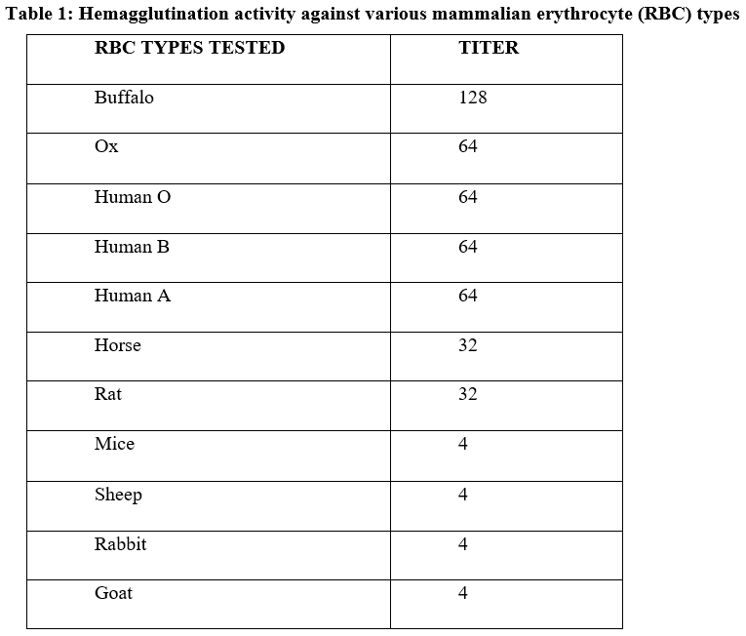

3.2 Cross adsorption assay
Table 2 shows that the hemagglutination test lost agglutinin after the fourth cycle of adsorption, but the cross-adsorption assay found a single agglutinin in the serum.

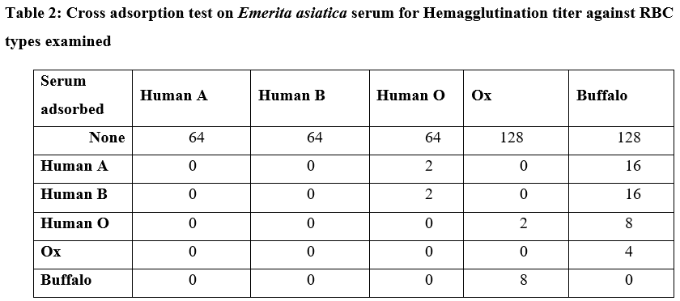

3.3 Bacterial agglutination assays
The agglutinin that was extracted from the infected germs was able to bind to every kind of bacteria that were examined. Although there was a wide range of titers seen in the reactions between the six bacterial species and the agglutinin extracted from agglutinated microorganisms (Table 3). Agglutinin from agglutinated Bacillus subtilis had a maximum titer of 16, whereas Streptococcus pyrogens had a titer of 1. At an 8-fold titer, the isolated agglutinins agglutinated Pseudomonas aeruginosa and Salmonella paratyphii (Figure 2). Figure 3 shows that the isolated agglutinins had almost little agglutinating action against E. coli and Staphylococcus auraeus, two of the other examined microorganisms.

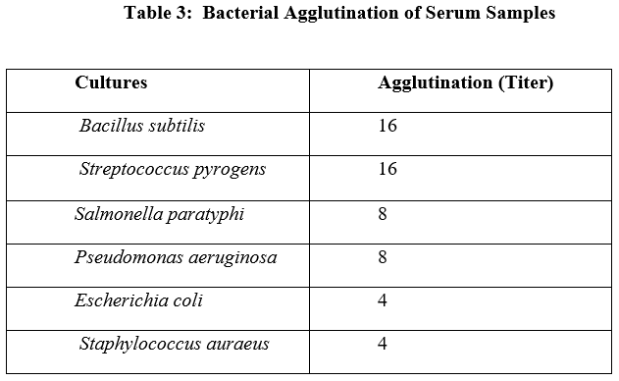

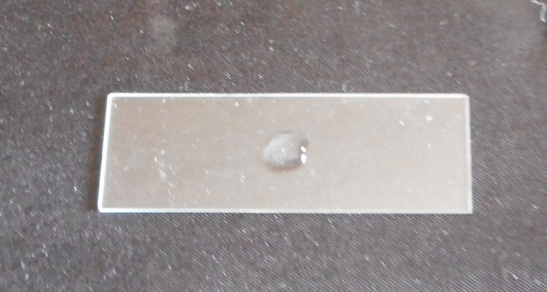

Streptococcus pyrogens

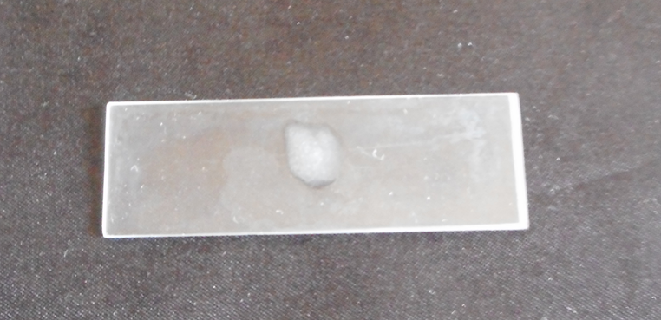

Figure 1. High Agglutination against Bacteria
Bacillus subtilis

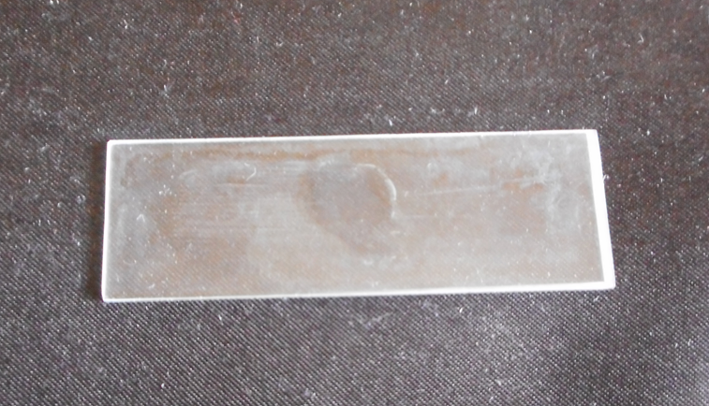

Pseudomonas aeruginosa

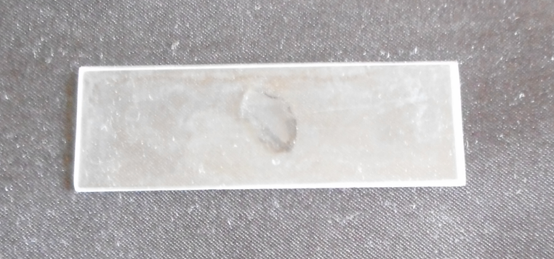

Figure 2. Moderate Agglutination against Bacteria.
Salmonella paratyphi

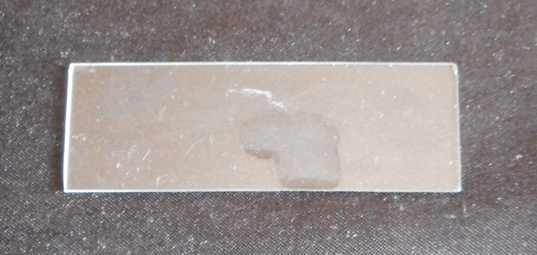

Escherichia coli

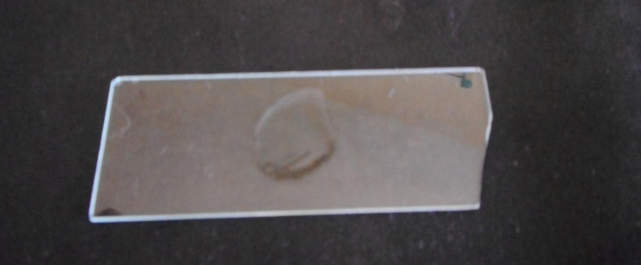

Staphylococcus auraeus

Figure 3. Least Agglutination against Bacteria

3.4 Yeast agglutination assay

Titer value for agglutination of trypsinized yeast was 128 and native yeast was 64 (Table 4).

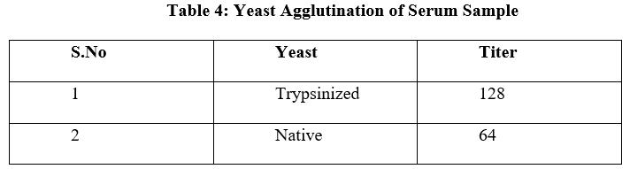

3.5 Analysis of Bacterial zone of inhibition
Figure 4 and Table 5 show the inhibition against Staphylococcus auraeus and Escherichia coli in 20µl in a 6 mm zone". In Figure 5, the suppression of Salmonella paratyphi and Pseudomonas aeruginosa in 40µl in a 7 mm zone is shown. The 60µl sample of Bacillus subtilis and Streptococcus pyrogens at a 10 mm zone of inhibition is shown in Figure 6. As a control, a maximum of 26 mm of Streptomycin (20 µg) is used.

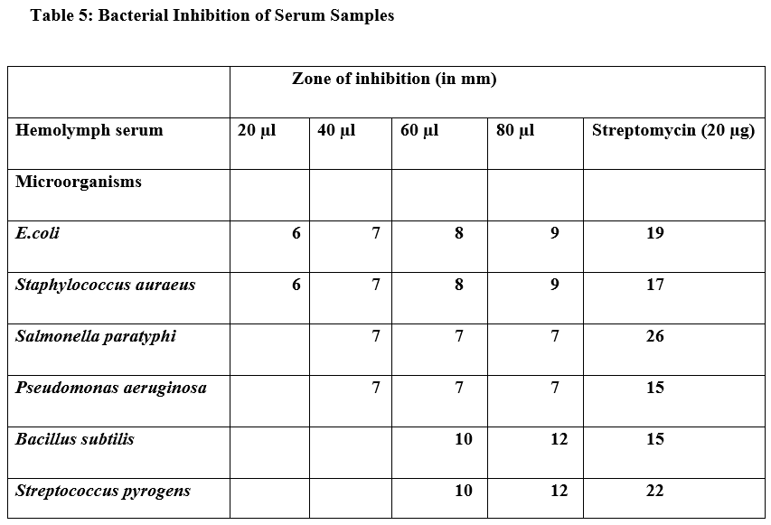

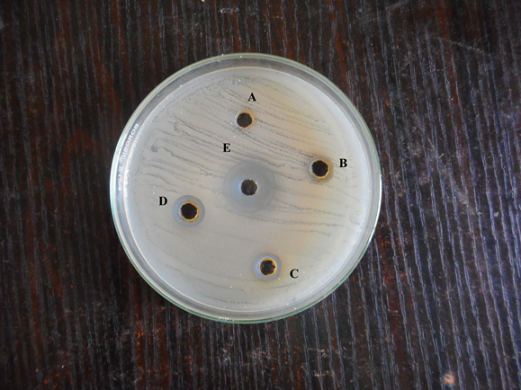

Escherichia coli

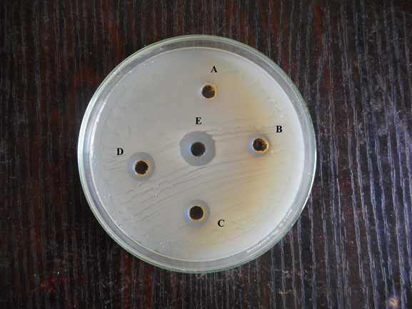

Staphylococcus auraeus

Figure 4. Inhibition against Bacteria

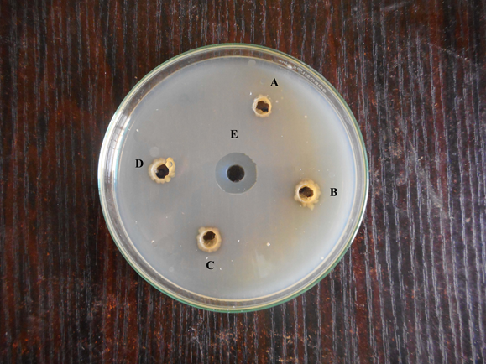

Salmonella paratyphi

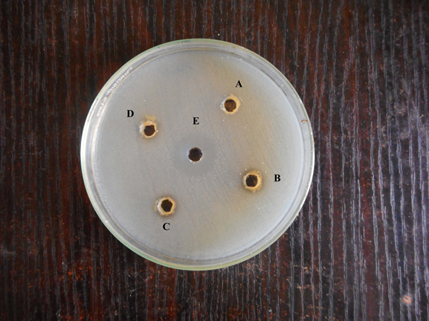

Pseudomonas aeruginosa

Figure 5. Bacterial inhibition of S. paratyphi and P. aeruginosa

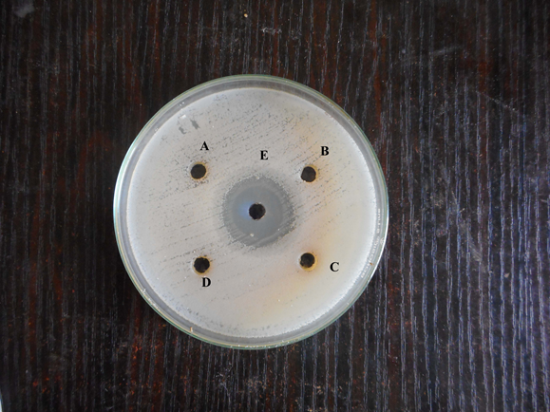

Bacillus subtilis

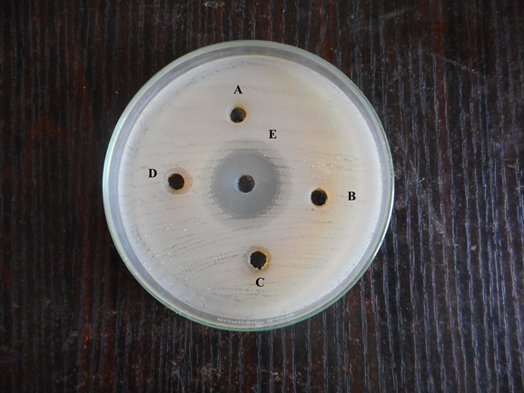

Streptococcus pyrogens

Figure 6. Bacterial inhibition zone of Bacillus subtilis and Streptococcus pyrogens

(ZONE A: 20µl of sample, ZONE B: 40 µl of sample, ZONE C: 60 µl of sample, ZONE D: 80 µl of sample, ZONE E: 20 µg of Streptomycin)

3.6 Analysis of fungal zone of inhibition
The inhibition against Candida albicans and Aspergillus niger in 20µl in a 6 mm zone is shown in Table 6 and Figure 7. Figure 8 displays the suppression of Rhizopus sp and Mucor sp in 40µl at a 7 mm zone, as well as the inhibition of Aspergillus fumigatus and Aspergillus flavus in 40l at a 9 mm zone. For the control, a maximum of 26 mm of ketocanzole (20 µl) is used.

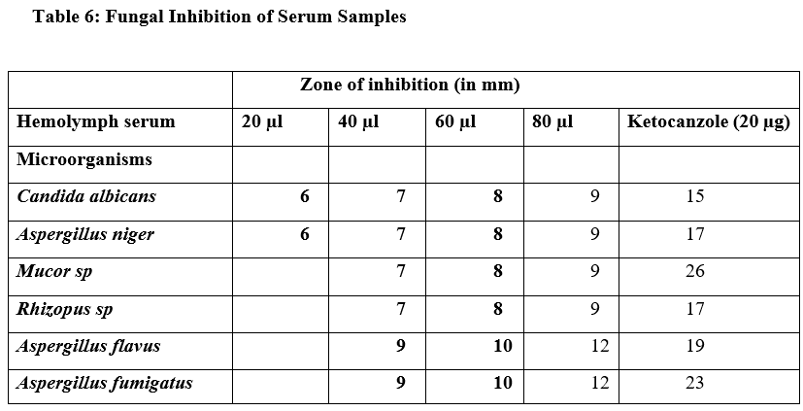

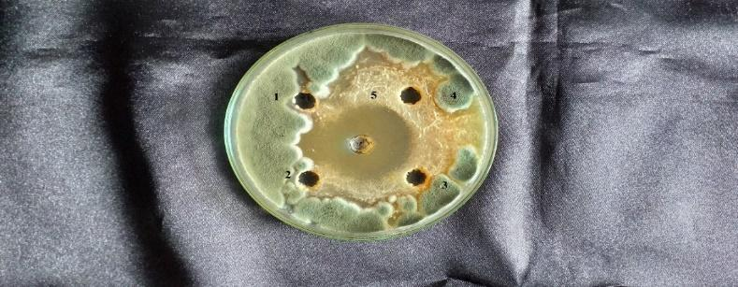

Candida albicans

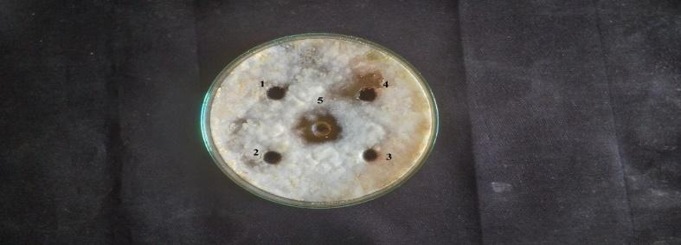

Aspergillus niger

Figure 7. Inhibition against Fungi Candida albicans and Aspergillus niger

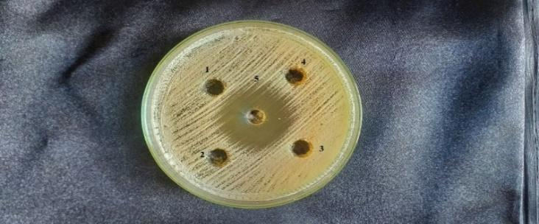

Mucor sp

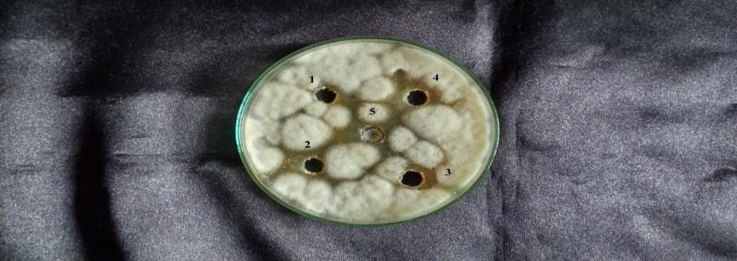

Rhizopus sp

Figure 8. Fungal inhibition of Mucor sp. and Rhizopus sp

(ZONE 1: 20µl of sample, ZONE 2: 40 µl of sample, ZONE 3: 60 µl of sample, ZONE 4: 80 µl of sample, ZONE 5: 20 µL of ketocanzole)

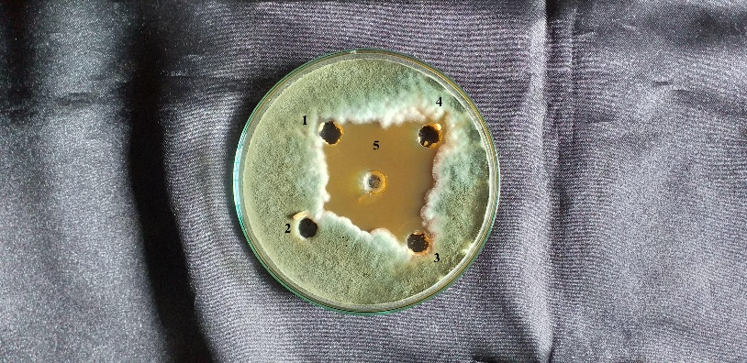

Aspergillus flavu
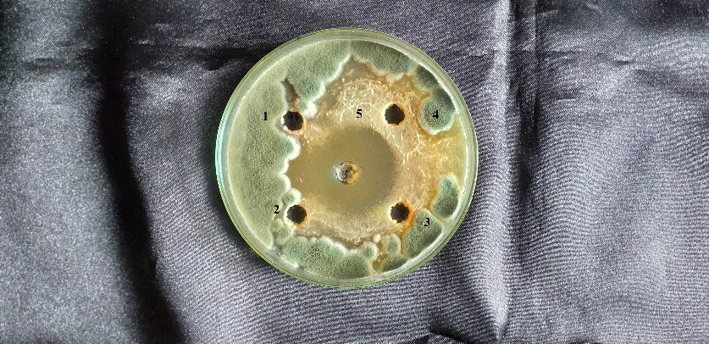

Aspergillus fumigatus

3.7 pH and temperature
Figure 9 demonstrates that the HA activity of crab serum was consistently high throughout the temperature range of 20 to 30°C and pH range of 7 to 8.

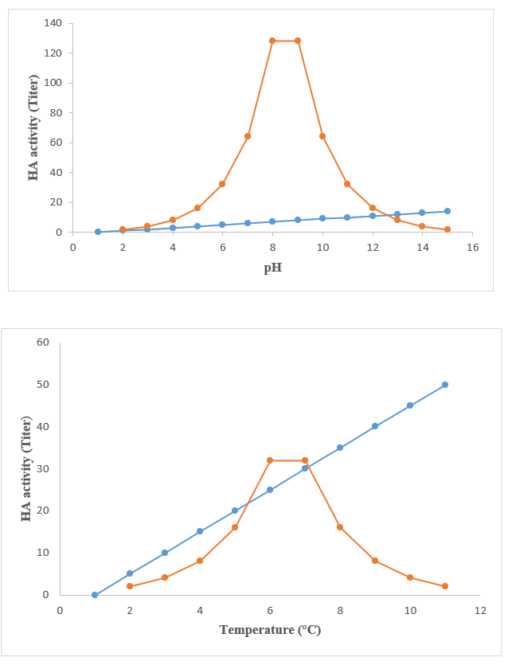

Figure 9. pH And Thermal Stability of Serum Sample of Emerita asiatica

3.8 Divalent Cation
Table 7 shows that 128 of the dialysates tested against buffalo RBC had their HA titers reduced after extensive dialysis against a divalent cation-free buffer. The test solution was supplemented with 10 mM of Ca2+, Mg2+, or Sr2+ (as chloride salts) and the titers rose to 128 for each salt, with Ca2+ showing a significant improvement in the serum agglutinating activity on both crabs. The HA activity of both serum samples was preserved when dialysed against a solution containing 10 mM CaCl2. Both serum samples showed comparable results when dialysed against the divalent cation chelator.

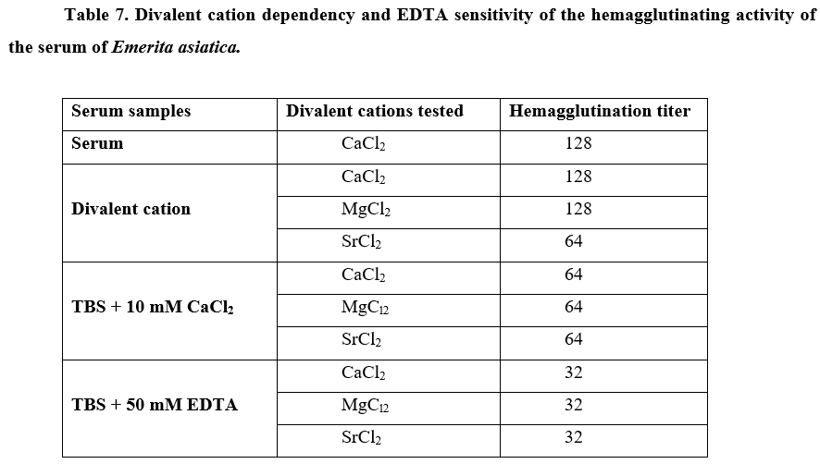

3.9 EDTA, EGTA and dose dependant effect of calcium ions
A substantial decrease in HA activity (HA titer-32) was seen in the serum sample when 50 mM EDTA was used, although the same serum showed HA activity against buffalo RBC when 10 mM EGTA and a specific calcium chelator were used. Serum from crabs had a HA activity value of 64 titer when tested in TBS with 10 mM CaCl2. Increasing the CaCl2 concentration to 100 mM resulted in an even higher HA activity value of 512 titer (Figure 10). Experiments using crab serum demonstrated a similar trend, with a HA titer of 128 at 10 mM CaCl2 and a rise in HA activity with higher CaCl2 concentrations, peaking at 1024 with 100 mM CaCl2 in the test medium.

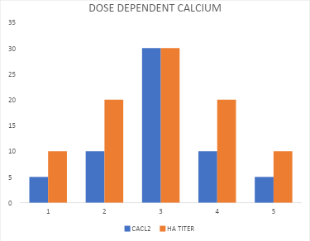

Figure 10. Dose dependent effect of calcium on the HA activity of serum of Emerita asiatica

3.10 Levels of total calcium
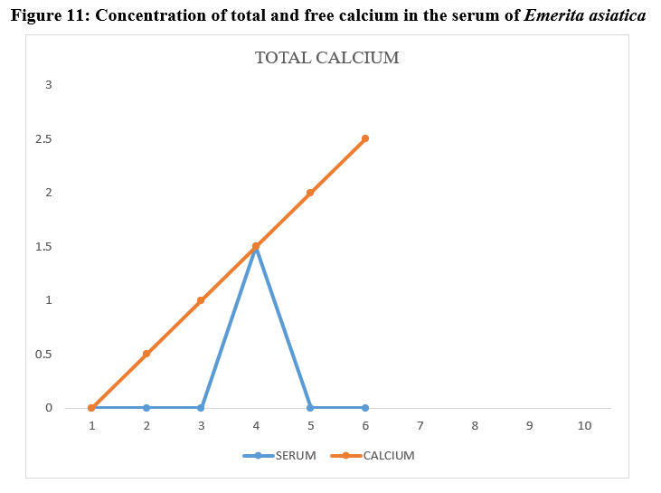
Figure 11 shows that the total calcium levels in E. asiatica serum were regulated, ranging from 1.3 to 1.9 mg ml-1. Blood calcium levels in crabs were found to vary between an initial estimate of 1.3 mg ml-1 to a maximum of 1.9 mg ml-1. eventually, serum total calcium levels started to decline and eventually reached 1.4 mg/ml or below. Statistical analysis using the one-way ANOVA test revealed a significant outcome (p<0.05) for the data. In a similar vein, E. asiatica serum had free calcium levels between 0.9 and 1.7 mg/ml, making up around 80 to 89% of the total calcium. Serum free calcium levels in crabs ranged from 0.9 mg/ml at the beginning of the experiment to 1.7 mg/ml at the end. A lower amount of serum free calcium was detected later on.

Figure 11. Concentration of total and free calcium in the serum of Emerita asiatica
3.11 Hemagglutination-inhibition
Multiple HA-inhibition experiments were conducted against buffalo RBCs utilising a panel of carbohydrates and a glycoprotein to investigate the qualitative nature of agglutinins in crab serum. The inhibitory efficacy on the HA activity of crab serum is exclusively shown by the N-acetylated analogues of the three hexosamines, out of all the simple sugars that were studied (Table 8).

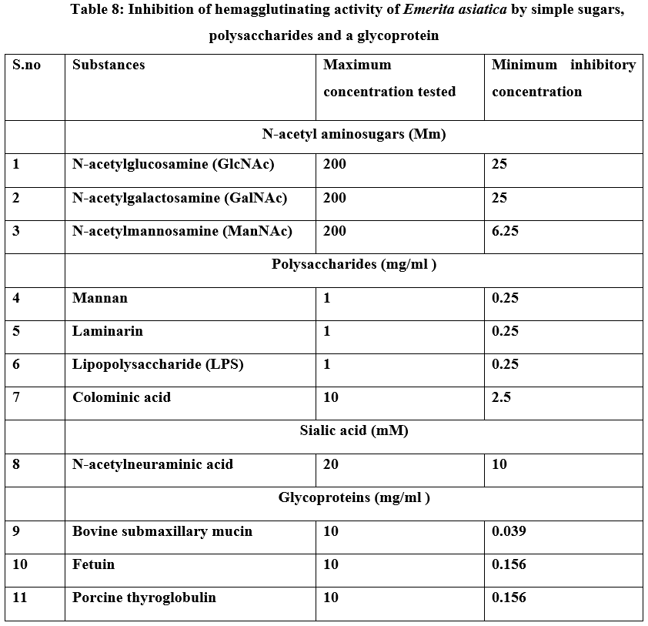

3.12 Discussion
In recent years, the exotic Emerita asiatica, a species native to the Pacific Ocean, has supplanted the black tiger prawn for commercial production in India, thanks to its severe bacterial susceptibility. While living in the Pacific, this mole crab encountered bacteria in a quite different manner in Indian waters. Hence, the mole crab's ability to accurately identify bacterial diseases is crucial (India). Blood proteins in crustaceans are mostly hemocyanins, making up around 90–95% of the total(Balaji, Mullainadhan, & Arumugam, 1989; Bretting & Kabat, 1976; Bruyninckx, Gutteridge, & Mason, 1978). It seems that these findings have aroused interest in studying the structural and functional variations of hemocyanin in different crab groups. Based on the results of this investigation, the mole crab's defence mechanism against bacterial inhibition is bacterial agglutination. We have already looked at the protein makeup of mole crab serum. The slow-moving proximal bands were the only exception among the two protein bands that tested positive for BCS(Cassels, Marchalonis, & Vasta, 1986). These results suggest that the two BCS-positive bands in the serum of Emerita asiatica are copper-containing proteins, namely hemocyanin, phenol oxidase, and prophenoloxidase. Hemocyanin from mole crabs showed three separate bands of protein.(Cornick & Stewart, 1968; Voll & Voit, 1990) discovered that various genes express different components of hemocyanin, which may differ in structure, in the arthropod Eurypelma californicum. Measuring blood protein concentration at different infection time periods was one of the first stages. Prior studies found that bacterially infected P. monodon had a serum protein concentration that was 11% to 13% higher than uninfected fish. Factors contributing to this increase include a surge in viral proteins and proteins released by infected host tissues (Citarasu, Sivaram, Immanuel, Rout, & Murugan, 2006; Devi, Basil-Rose, & Pallaty, 2013; Meiyalagan & Arumugam, 2015). However, research by (Zhao et al., 2017) indicated that WSSV infection causes a gradual decrease in serum protein concentration, culminating in a 50% total serum protein depletion, in Fenneropenaeus chinensis and Marsupenaeus japonicus. Examining these three factors is crucial for understanding why there are inconsistent results in the research. One possible explanation is that there is less hemocyanin in the blood, which affects serum osmolality. Finding the physiochemical characteristics of haemagglutinins and bacterial agglutinins in serum (Lynch & Webb, 1973) and identifying and characterising antibacterial proteins in serum (Ravindranath, 1975) were the goals of the present investigation. A hemagglutinin value of 4 indicates strong agglutination, a value of 32 indicates moderate agglutination, a value of 64 indicates low agglutination, a value of 128 indicates very low agglutination, and a value of 128 occurs in the yeast hemagglutination control. Additional investigation into bacterial infections may provide light on hemocyanin components and their role in non-specific immunity. Agglutinins are present in serum from all anomuran animals. However, the agglutination experiment showed that different species and kinds of vertebrate erythrocytes had different HA titers. Incubation with Emerita asiatica serum resulted in a strong agglutination reaction in horse erythrocytes expressing 4-O-acetyl NeuAc. The intriguing part is that it resembles the o-acetyl sialic acid lectins found in crab serum, including Cancer antennarius (Amirante & Basso, 1984), Liocarcinus depurator (Guary & Negrel, 1980), and Paratelphusa jacquemontii (Vidal, Granja, Aranguren, Brock, & Salazar, 2001), which have been shown to specifically agglutinate horse erythrocytes. The identification of self and non-self cells in immunological and defensive processes is the most significant physiological function ascribed to agglutinins. Before the agglutinin could be purified and molecularly characterised, it had to be chosen as a model anomuran crab. This was done to support and clarify the protective function of agglutinins in these crabs. We conclude that agglutinins bind specifically to erythrocytes and exhibit a wide variety of erythrocyte specificities, reflecting the roles thought to play these molecules in recognition. Clearly, agglutinin has a unique recognition function in disease progression. The immunological function of agglutinins in anomuran crabs was therefore investigated using the agglutinin isolated from the serum of Emerita asiatica. Among the examined kinds of red blood cells, the serum of the marine mud crab S. serrata had the greatest reactivity with rabbit RBC, suggesting that it has naturally occurring agglutinating activity. According to our findings, the red blood cell types that are agglutinated by S. serrata serum likely have a similar surface receptor, although the number of HA binding sites varies quantitatively. According to (Equidius, 1987) and (Vargas-Albores, Guzmán, & Ochoa, 1993), the tested Vibrio species are the most common opportunistic pathogens of aquatic crustaceans. The serum agglutinated both Gramme + and Gramme- types of bacteria. The plasma agglutinated trypsinised yeast cells the most effectively (S. S. Jayaraj, Thiagarajan, Arumugam, & Mullainadhan, 2008). The humoral agglutinins may play a role in the host defence response, as S. serrata serum may agglutinate bacteria, especially those that might be harmful. Serum agglutinin was sensitive to changes in temperature and acidity. The stability of its pH was similar to what was seen in a previous study(Nalini et al., 1994) and the proteinaceous nature of agglutinin has been extensively shown(Acton, Bennett, Evans, & Schrohenloher, 1969; McKay & Jenkin, 1969; Miller, Ballback, Pauley, & Krassner, 1972). Dialysis against cation-free TBS and testing without cations resulted in the serum losing the majority of its HA activity. The addition of Ca2+ was the only factor that restored full activity to this sample, whereas dialysis against TBS containing Ca2+ had no effect on the serum HA titer. These results proved that Ca2+ is essential for the HA activity of S. serrata serum agglutinin. Additionally, the activity was susceptible to EDTA treatment; a substantial decrease in the HA activity was seen when serum was dialysed against TBS containing EDTA. It seems that the HA of S. serrata is irreversibly sensitive to EDTA, unlike other crustacean agglutinins(Hall & Rowlands Jr, 1974b; Kamiya, Muramoto, & Goto, 1987; Ravindranath, Higa, Cooper, & Paulson, 1985), since none of the cations tested could restore the HA activity, although Ca2+ somewhat rescued the activity in these samples. The specificity of crustacean serum agglutinins for glucose(Kamiya et al., 1987; Umetsu, Yamashita, & Suzuki, 1991) , GalNAc(Amirante & Basso, 1984; Vargas-Albores et al., 1993), or sialic acids like NeuAc(Cassels et al., 1986; Hall & Rowlands Jr, 1974b; Ratanapo & Chulavatnatol, 1990; Vasta & Cohen, 1984; Vasta et al., 1983) According to previous research(Amirante & Basso, 1984; Mercy & Ravindranath, 1993; Vargas-Albores et al., 1993), this study used a hemagglutination-inhibition test that included various carbohydrates, including various unrelated monosaccharides and their derivatives, in addition to serum. No inhibition of S. serrata serum HA activity was seen by the tested amino sugar. However, mannose, L-sorbose, D-fucose, and L-fucose were the simple hexoses that hindered it. Prior research has shown that fucose(Amirante & Basso, 1984) and glucose(Umetsu et al., 1991) are examples of simple hexoses that decrease agglutinating action, lending credence to our current discovery. Based on these findings, it is evident that agglutinin interactions require a position on hexosamines with a free hydroxyl group or an amino group substituted for it, rather than a position with an acetyl group at C-2.

4. Conclusion
The study is about the the Immunological Characterization of the Serum of the Mole Crab Emerita asiatica. Likewise, the study examined the mole crab's immune reaction and determined the hemagglutinin value of the Emerita asiatica. Also, the study conducted the hemagglutination and the cross adsorption experiments for the serum separation and the microbe agglutinating activity. The mole crab's defensive system against the bacterial infection has been exposed by the bacterial inhibition and the bacterial agglutination. By utilizing the human erythrocytes (RBC), the variety of bacteria, and the yeast as the indicator cells, the naturally occurring hemagglutinin (HA) with action against the bacteria and yeast cells was discovered in the serum of the mole crabs. The study also analysed the Bacterial zone of the inhibition and the fungal zone of the inhibition. Also, the study provided the better results and the valuable insights about the Immunological Characterization of the Serum of Mole Crab Emerita asiatica.

COMPETING INTERESTS DISCLAIMER:
Authors have declared that they have no known competing financial interests OR non-financial interests OR personal relationships that could have appeared to influence the work reported in this paper.

6. References
Acton, R., Bennett, J., Evans, E. E., & Schrohenloher, R. (1969). Physical and chemical characterization of an oyster hemagglutinin. Journal of Biological Chemistry, 244(15), 4128-4135.
Adiyodi, R. (1968). Protein metabolism in relation to reproduction and moulting in the crab Paratelphusa hydrodromous (Herbst). Part I. Electrophoretic studies on the mode of utilization of soluble proteins during vitellogenesis. Indian J. Exp. Biol, 6(3), 144-147.
Alpuche, J., Pereyra, A., Agundis, C., Rosas, C., Pascual, C., Slomianny, M.-C., . . . Zenteno, E. (2005). Purification and characterization of a lectin from the white shrimp Litopenaeus setiferus (Crustacea decapoda) hemolymph. Biochimica et Biophysica Acta (BBA)-General Subjects, 1724(1-2), 86-93.
Amirante, G., & Basso, V. (1984). Analytical study of lectins in Squilla mantis L.(Crustacea stomatopoda) using monoclonal antibodies. Developmental & Comparative Immunology, 8(3), 721-726.
Balaji, R., Mullainadhan, P., & Arumugam, M. (1989). In vivo binding of exogenous copper to haemolymph fractions of estuarine crab Scylla serrata (Forskal). Journal of experimental marine biology and ecology, 128(3), 241-255.
Barondes, S. H. (1988). Bifunctional properties of lectins: lectins redefined. Trends in biochemical sciences, 13(12), 480-482.
Bretting, H., & Kabat, E. A. (1976). Purification and characterization of the agglutinins from the sponge Axinella polypoides and a study of their combining sites. Biochemistry, 15(15), 3228-3236.
Bruyninckx, W., Gutteridge, S., & Mason, H. (1978). Detection of copper on polyacrylamide gels. Analytical biochemistry, 89(1), 174-177.
Cassels, F. J., Marchalonis, J. J., & Vasta, G. R. (1986). Heterogeneous humoral and hemocyte-associated lectins with N-acylaminosugar specificities from the blue crab, Callinectes sapidus Rathbun. Comparative Biochemistry and physiology. B, Comparative Biochemistry, 85(1), 23-30.
Citarasu, T., Sivaram, V., Immanuel, G., Rout, N., & Murugan, V. (2006). Influence of selected Indian immunostimulant herbs against white spot syndrome virus (WSSV) infection in black tiger shrimp, Penaeus monodon with reference to haematological, biochemical and immunological changes. Fish & shellfish immunology, 21(4), 372-384.
Coombe, D. R., Ey, P. L., & Jenkin, C. R. (1984). Self/non-self recognition in invertebrates. The Quarterly Review of Biology, 59(3), 231-255.
Cornick, J. W., & Stewart, J. E. (1968). Interaction of the pathogen Gaffkya homari with natural defense mechanisms of Homarus americanus. Journal of the Fisheries Board of Canada, 25(4), 695-709.
Devaraj, H., Kumar, D. S., Thanislass, J., & Niranjali, S. (1995). Isolation and characterization of high molecular weight glycoproteins from embryonated eggs of Emerita asiatica. Comparative Biochemistry and Physiology Part B: Biochemistry and Molecular Biology, 110(1), 175-181.
Devi, V., Basil-Rose, M., & Pallaty, M. (2013). The biological role of hemolymph lectins in Episesarma tetragonum. Invertebrate Survival Journal, 10(1), 162-171.
Djangmah, J. (1970). The effects of feeding and starvation on copper in the blood and hepatopancreas, and on blood proteins of Crangon vulgaris (Fabricius). Comparative Biochemistry and Physiology, 32(4), 709-IN708.
Du, H.-H., Li, W.-F., Xu, Z.-R., & Kil, Z.-S. (2006). Effect of hyperthermia on the replication of white spot syndrome virus (WSSV) in Procambarus clarkii. Diseases of Aquatic Organisms, 71(2), 175-178.
Equidius, E. (1987). Vibriosis: pathogenicity and pathology. Rev. Aquacul, 67, 15-28.
Fragkiadakis, G. A., & Stratakis, E. K. (1997). The lectin from the crustacean Liocarcinus depurator recognizes O-acetylsialic acids. Comparative Biochemistry and Physiology Part B: Biochemistry and Molecular Biology, 117(4), 545-552.
Granja, C. B., Aranguren, L. F., Vidal, O. M., Aragón, L., & Salazar, M. (2003). Does hyperthermia increase apoptosis in white spot syndrome virus (WSSV)-infected Litopenaeus vannamei? Diseases of Aquatic Organisms, 54(1), 73-78.
Guan, Y. (2003). The effects of temperature on white spot syndrome infections in Marsupenaeus japonicus. J. Invertebr. Pathol., 83, 257-260.
Guary, J., & Negrel, R. (1980). Plutonium and iron association with metal-binding proteins in the crab Cancer pagurus (L.). Journal of experimental marine biology and ecology, 42(1), 87-98.
Hall, J. L., & Rowlands Jr, D. T. (1974a). Heterogeneity of lobster agglutinins. I. Purification and physicochemical characterization. Biochemistry, 13(4), 821-827.
Hall, J. L., & Rowlands Jr, D. T. (1974b). Heterogeneity of lobster agglutinins. II. Specificity of agglutinin-erythrocyte binding. Biochemistry, 13(4), 828-832.
Impellitteri, F., Curpăn, A.-S., Plăvan, G., Ciobica, A., & Faggio, C. (2022). Hemocytes: A Useful Tool for Assessing the Toxicity of Microplastics, Heavy Metals, and Pesticides on Aquatic Invertebrates. International Journal of Environmental Research and Public Health, 19(24), 16830. Retrieved from https://www.mdpi.com/1660-4601/19/24/16830
Jayaraj, S., Thiagarajan, R., Arumugam, M., & Vincent, S. (2010). Physico-chemical characterization of bacterial and hemagglutinins from the serum of the mud crab Scylla serrata. Invertebrate Survival Journal, 7(1), 79-88.
Jayaraj, S. S., Thiagarajan, R., Arumugam, M., & Mullainadhan, P. (2008). Isolation, purification and characterization of β-1, 3-glucan binding protein from the plasma of marine mussel Perna viridis. Fish & shellfish immunology, 24(6), 715-725.
Jayasree, S. (2001). Biological properties of a natural agglutinin in the hemolymph of Indian white prawn, Penaeus indicus H. Milne Edwards. Aquaculture, 194(3-4), 245-252.
Kamiya, H., Muramoto, K., & Goto, R. (1987). Isolation and characterization of agglutinins from the hemolymph of an acorn barnacle, Megabalanusvolcano. Developmental & Comparative Immunology, 11(2), 297-307.
Lillie, R. D. (1954). Histopathologic technic and practical histochemistry.
Lynch, M., & Webb, K. (1973). Variations in serum constituents of the blue crab, Callinectes sapidus: free amino acids and total ninhydrin positive substances. Comparative Biochemistry and Physiology Part B: Comparative Biochemistry, 45(2), 407-418.
Mantelatto, F. L., Paixão, J. M., Robles, R., Teles, J. N., & Balbino, F. C. (2023). ﻿ Evidence using morphology, molecules, and biogeography clarifies the taxonomic status of mole crabs of the genus Emerita Scopoli, 1777 (Anomura, Hippidae) and reveals a new species from the western Atlantic. ZooKeys, 1161, 169.
McKay, D., & Jenkin, C. (1969). Immunity in the invertebrates: II. Adaptive immunity in the crayfish (Parachaeraps bicarinatus). Immunology, 17(1), 127.
Meiyalagan, V., & Arumugam, M. (2015). Detection and preliminary characterization of antibacterial protein (s) in the serum of mud crab, Scylla serrata. Invertebrate Survival Journal, 12(1), 287-295.
Mercy, P., & Ravindranath, M. H. (1993). Purification and characterization of N‐glycolylneuraminic‐acid‐specific lectin from Scylla serrata. European journal of biochemistry, 215(3), 697-704.
Miller, V. H., Ballback, R. S., Pauley, G. B., & Krassner, S. M. (1972). A preliminary physicochemical characterization of an agglutinin found in the hemolymph of the crayfish Procambarus clarkii. Journal of Invertebrate Pathology, 19(1), 83-93.
Nalini, M., Mullainadhan, P., & Arumugam, M. (1994). Characterization of a natural hemagglutinin in the serum of a freshwater crab Parathelphusa hydrodromus (Herbst). Archives internationales de physiologie, de biochimie et de biophysique, 102(5), 259-264.
Pillai, A., & Munusami, A. (2017). Isolation and characterisation of moult related agglutinins from the serum at intermoult (C) and postmoult (A 2 ) stages of the intertidal mole crab Emerita asiatica.
Ponce-Palafox, J., Martinez-Palacios, C. A., & Ross, L. G. (1997). The effects of salinity and temperature on the growth and survival rates of juvenile white shrimp, Penaeus vannamei, Boone, 1931. Aquaculture, 157(1-2), 107-115.
Ratanapo, S., & Chulavatnatol, M. (1990). Monodin, a new sialic acid-specific lectin from black tiger prawn (Peneaus monodon). Comparative Biochemistry and Physiology Part B: Comparative Biochemistry, 97(3), 515-520.
Ravindranath, M. (1975). Effects of temperature on the morphology of hemocytes and coagulation process in the mole-crab Emerita (= Hippa) asiatica. The Biological Bulletin, 148(2), 286-302.
Ravindranath, M., Higa, H., Cooper, E. L., & Paulson, J. (1985). Purification and characterization of an O-acetylsialic acid-specific lectin from a marine crab Cancer antennarius. Journal of Biological Chemistry, 260(15), 8850-8856.
Smith, V. J., & Chisholm, J. R. (1992). Non-cellular immunity in crustaceans. Fish & shellfish immunology, 2(1), 1-31.
Umetsu, K., Yamashita, K., & Suzuki, T. (1991). Purification and carbohydrate-binding specificities of a blood Type B binding lectin from hemolymph of a crab (Charybdis japonica). The Journal of Biochemistry, 109(5), 718-721.
Vargas-Albores, F., Guzmán, M.-A., & Ochoa, J.-L. (1993). A lipopolysaccharide-binding agglutinin isolated from brown shrimp (Penaeus californiensis Holmes) haemolymph. Comparative Biochemistry and Physiology Part B: Comparative Biochemistry, 104(2), 407-413.
Vasta, G. R., & Cohen, E. (1984). Carbohydrate specificities of Birguslatro (coconut crab) serum lectins. Developmental & Comparative Immunology, 8(1), 197-202.
Vasta, G. R., Warr, G. W., & Marchalonis, J. J. (1983). Serological characterization of humoral lectins from the freshwater prawn Macrobrachiumrosenbergii. Developmental & Comparative Immunology, 7(1), 13-20.
Vidal, O. M., Granja, C. B., Aranguren, F., Brock, J. A., & Salazar, M. (2001). A profound effect of hyperthermia on survival of Litopenaeus vannamei juveniles infected with white spot syndrome virus. Journal of the world aquaculture society, 32(4), 364-372.
Voll, W., & Voit, R. (1990). Characterization of the gene encoding the hemocyanin subunit e from the tarantula Eurypelma californicum. Proceedings of the National Academy of Sciences, 87(14), 5312-5316.
Yoganandhan, K., Thirupathi, S., & Hameed, A. S. (2003). Biochemical, physiological and hematological changes in white spot syndrome virus-infected shrimp, Penaeus indicus. Aquaculture, 221(1-4), 1-11.
Zhao, W., Wang, L., Liu, M., Jiang, K., Wang, M., Yang, G., . . . Wang, B. (2017). Transcriptome, antioxidant enzyme activity and histopathology analysis of hepatopancreas from the white shrimp Litopenaeus vannamei fed with aflatoxin B1 (AFB1). Developmental & Comparative Immunology, 74, 69-81.

