**EFFECT OF DIFFERENT FERTILIZERS LIKE VERMICOMPOST, COW DUNG, COCOPEAT, AND SAND SOIL ON GERMINATION OF JOWAR AND BAJRA**

ABSTRACT

|  |
| --- |
| **Aims:** The primary objective of this study is to evaluate the effects of different organic and inorganic soil amendments—specifically vermicompost, cow dung, cocopeat, and sand soil—on the germination performance of jowar (*Sorghum bicolor*) and bajra (*Pennisetum glaucum*) seeds under controlled conditions.  Study design: Mention the design of the study here.  **Place and Duration of Study:** Sample: Department of Botany, Mata Jijabai Govt PG Girls College, Indore, Madhya Pradesh,India, between April 2025 and may 2025.  **Methodology:** This study investigates the effects of different organic and natural growing media—vermicompost, cow dung, cocopeat, sand soil, and their combinations—on the germination and early seedling development of two drought-tolerant cereal crops: jowar (*Sorghum bicolor*) and bajra (*Pennisetum glaucum*). The experiment, conducted under controlled laboratory conditions, evaluated parameters such as germination percentage, germination speed, root and shoot length, and seedling vigor index.  **Results:** Results revealed that the combination of vermicompost and cocopeat significantly enhanced germination performance and seedling vigor, exhibiting synergistic effects of high nutrient availability and moisture retention. Vermicompost alone demonstrated strong support for root/shoot growth, while cocopeat maintained fast germination rates. Cow dung, though rich in organic matter, resulted in comparatively lower germination percentages but supported moderate to strong seedling growth. Sand soil exhibited the highest initial germination but failed to support subsequent seedling development due to its poor nutrient and water-holding capacity. The findings underscore the importance of selecting appropriate growing media for optimal seedling performance and suggest that a vermicompost and cocopeat mix offers a sustainable, low-cost alternative for improving germination and crop establishment in low-input and rainfed agricultural systems.  **Conclusion:** These insights can inform organic farming practices and enhance the productivity of resilient crops in marginal soils |

*Keywords: Germination, Seedling Vigor, Jowar (Sorghum bicolor), Bajra (Pennisetum glaucum), Vermicompost, Cow Dung, Cocopeat, Sand Soil, Organic Amendments, Growing Media, Sustainable Agriculture, Seed Emergence, Rainfed Cropping Systems, Soil Fertility.*

1. INTRODUCTION

Germination is a fundamental phase in a plant’s life cycle that significantly influences subsequent growth and productivity. Successful germination ensures uniform crop establishment, which is crucial for optimal yield. The process is influenced by both intrinsic factors (such as seed viability) and extrinsic environmental conditions, especially the physical and chemical properties of the soil or growing medium (Bewley et al., 2013). Among the external factors, the nutrient availability, moisture retention, aeration, and microbial activity in the germination medium are particularly vital for seed emergence and seedling vigor.

Cereal crops like jowar (*Sorghum bicolor*) and bajra (*Pennisetum glaucum*) are staple grains cultivated in semi-arid and arid regions. These crops are drought-resistant and require minimal inputs, making them ideal for rainfed agriculture (Rao et al., 2014). However, their germination and early seedling development can be significantly enhanced by improving soil fertility and structure through organic amendments. Poor germination due to degraded soils or unfavorable media can lead to low plant population density and reduced yields, even in otherwise resilient crops like jowar and bajra.

**Importance of Organic Amendments and Growing Media**

The use of organic fertilizers and alternative growing media has received increasing attention as a sustainable means to improve germination and early growth. Among these, vermicompost, cow dung, cocopeat, and sand soil are commonly studied for their influence on seed germination.

**Vermicompost**

Vermicompost is an organic fertilizer derived from the decomposition of organic waste by earthworms. It contains readily available nutrients, plant growth-promoting substances like auxins and cytokinins, and a beneficial microbial population. These components improve soil structure and nutrient availability, leading to improved seed germination and seedling vigor (Arancon et al., 2004). Vermicompost also enhances moisture retention and aeration in the root zone, both of which are critical during the initial stages of crop establishment.

**Cow Dung**

Cow dung, a traditional organic manure, is rich in organic carbon and beneficial microbes. It provides a slow but sustained release of essential nutrients such as nitrogen, phosphorus, and potassium. Well-decomposed cow dung improves the physical properties of the soil by enhancing aeration and water-holding capacity. Studies have shown that cow dung positively influences the germination and early growth of cereals by promoting microbial activity and improving root zone conditions (Sahu & Mittra, 2017).

**Cocopeat**

Cocopeat is a spongy material derived from coconut husk and is widely used as a soil-less growing medium in horticulture and seedling production. It is characterized by its high water retention, excellent aeration, and low bulk density. Although it is low in nutrients, cocopeat serves as a neutral, disease-free medium ideal for seed germination, especially when supplemented with nutrient-rich materials like vermicompost or cow dung (Yadav et al., 2018). Its inert nature helps maintain a stable environment around the seed, minimizing water stress during imbibition and radicle emergence.

**Sand Soil**

Sand soil has large particles with high permeability and low water-holding capacity. Although not ideal as a standalone growing medium due to its poor nutrient content, it can support germination when combined with organic materials. The loose texture of sandy soil improves drainage and prevents waterlogging, which can otherwise hinder germination and promote fungal infections. Its effectiveness improves significantly when amended with compost or manure (Lehmann & Joseph, 2009).

The primary objective of this study is to evaluate the effects of different organic and inorganic soil amendments—specifically vermicompost, cow dung, cocopeat, and sand soil—on the germination performance of jowar (*Sorghum bicolor*) and bajra (*Pennisetum glaucum*) seeds under controlled conditions.

2. material and methods

2.1. **Experimental Site and Duration**

The experiment was conducted under controlled conditions in the laboratory at Department of Botany, Mata Jijabai Govt PG Girls College, Indore during the 2025. The study was carried out for a period sufficient to capture germination and early seedling development (typically 10–15 days).

2. 2**. Plant Material**

Certified seeds of two cereal crops:

* Jowar (*Sorghum*)
* Bajra (*Pennisetum glaucum*) were obtained from a reputable agricultural seed supplier or local agricultural university. All seeds were uniform in size, free from visible defects, and tested for viability before sowing.

2.3. **Growing Media** (Treatments)

Four different growing media were prepared using the following materials:

* Vermicompost (well-decomposed and mature)
* Cow dung manure (air-dried and decomposed)
* Cocopeat (washed to remove salts)
* Sand soil (sterilized and sieved to remove impurities)

2.5. **Experimental Design**

The experiment was laid out in a with 3 replications per treatment, for both jowar and bajra separately.

2.6. **Sowing Procedure**

* Seeds were surface sterilized using 1% sodium hypochlorite solution for 1–2 minutes and rinsed with distilled water.
* In each replicate, 10 seeds were sown uniformly in seed pots.
* Pots were kept under ambient room temperature conditions.
* Watering was done regularly using distilled water to maintain optimum moisture levels (without waterlogging).

**Table 1: The experiment included the following six treatment groups:**

|  |  |  |
| --- | --- | --- |
| S. No | Treatment Code | Composition |
|  | T1 | 100% Vermicompost |
|  | T2 | 100% Cow dung |
|  | T3 | 100% Cocopeat |
|  | T4 | 100% Sand soil |
|  | T5 | 50% Vermicompost + 50% Cocopeat |

**2.7 Observations Recorded**

The following parameters were recorded at regular intervals:

a) Germination Parameters

* Germination percentage (%) – Number of seeds germinated / Total seeds × 100
* Mean Germination Time (MGT) – Average time taken for seeds to germinate
* Germination rate – Seeds germinated per day

3. results and discussion

**Fig 1: Germination with different composition**

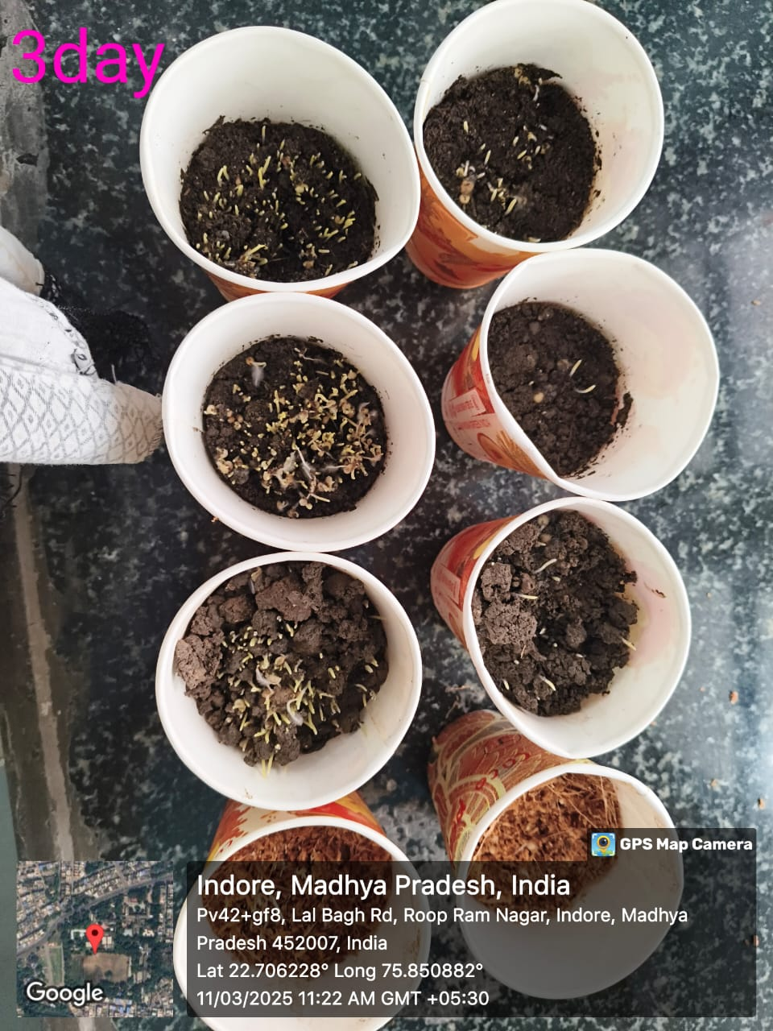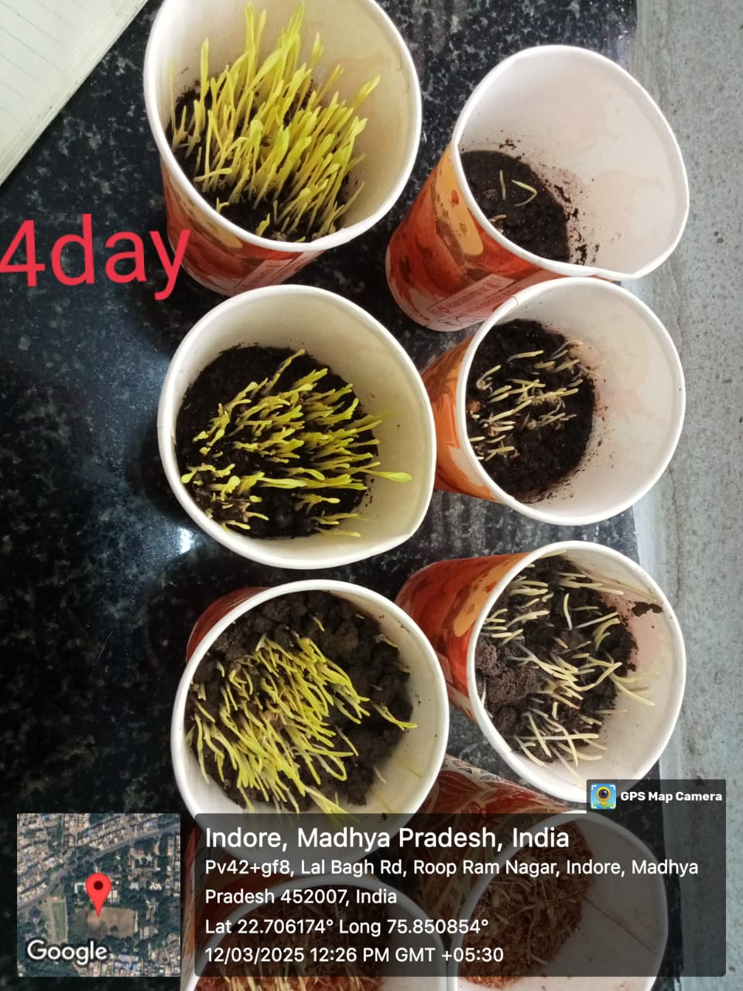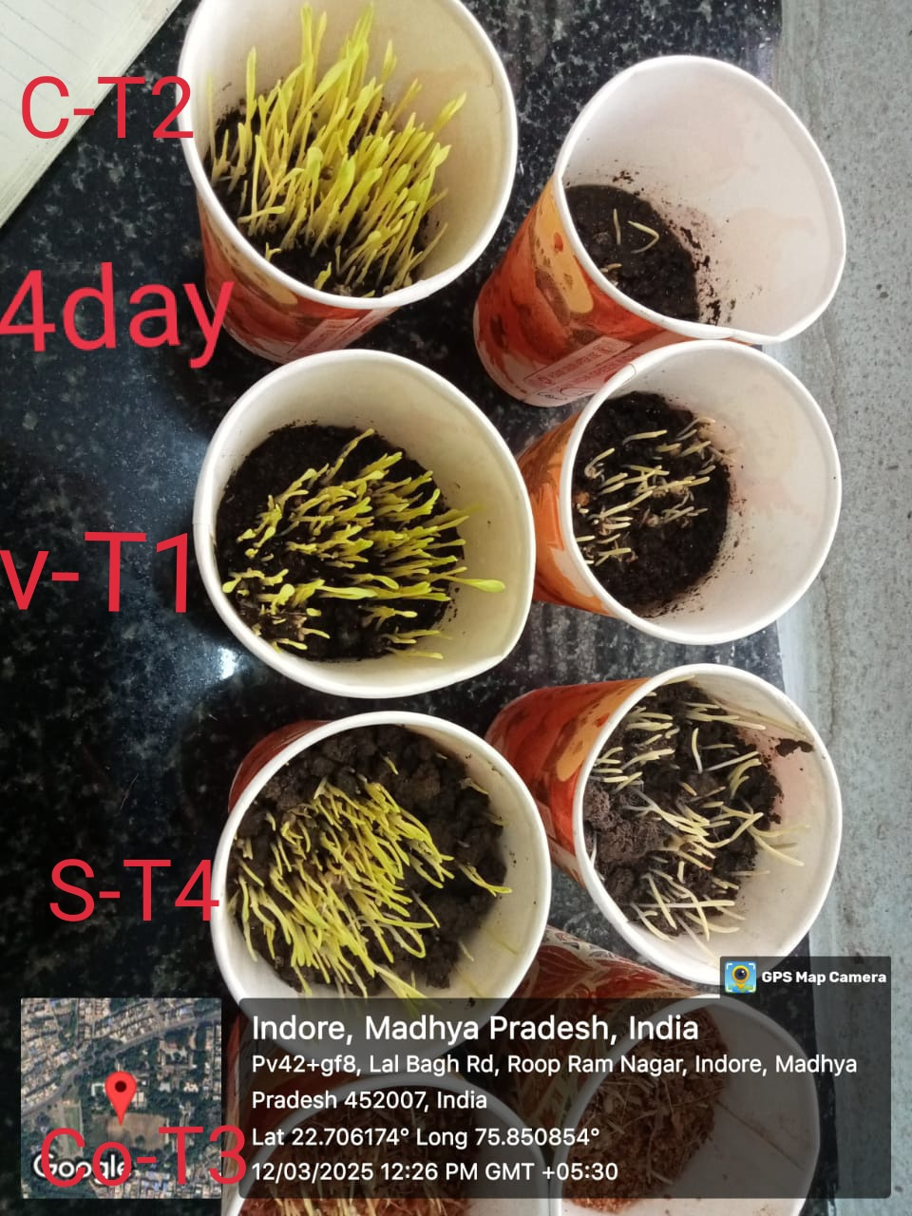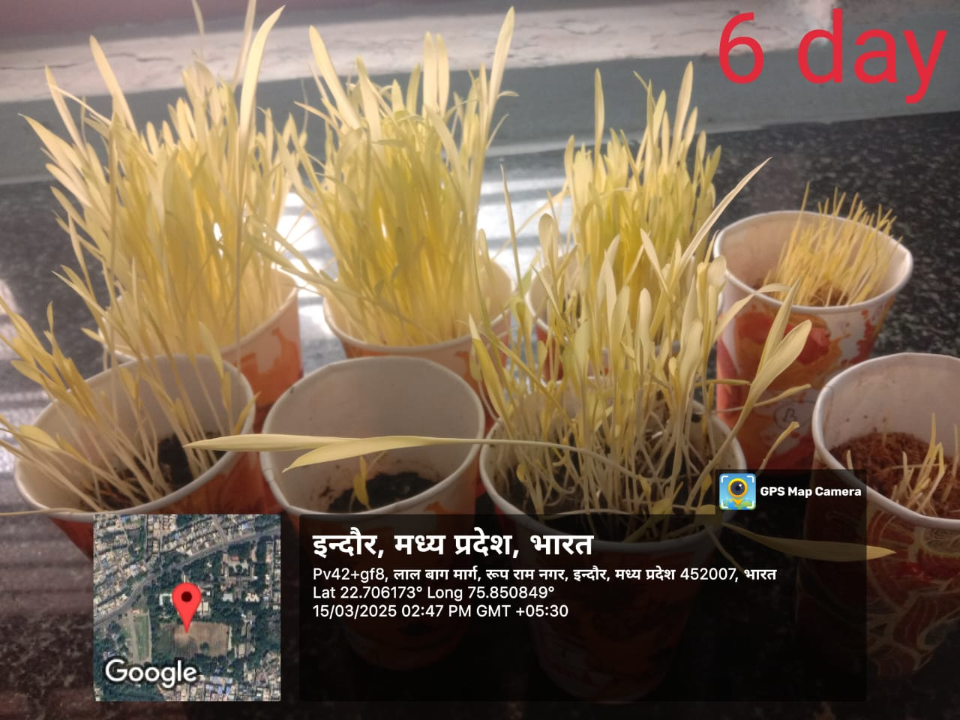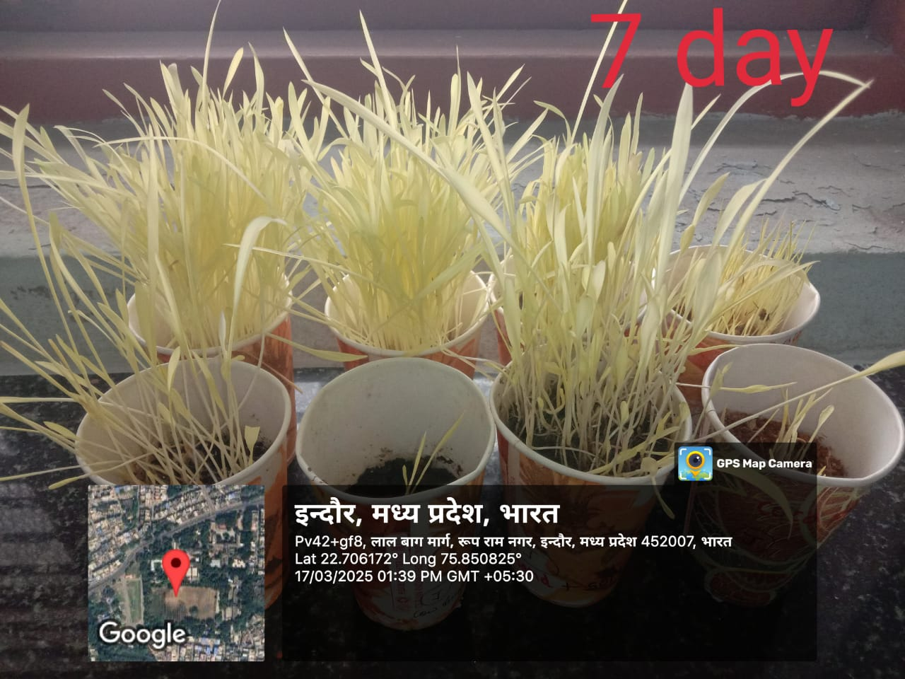

Among the five treatments, the combination of **vermicompost and cocopeat (T5)** emerged as the most effective medium. This treatment resulted in the **highest germination percentage**, **fastest germination rate**, and **strongest root and shoot development**, leading to the **maximum seedling vigor index**. The synergistic effect can be attributed to the complementary properties of both materials: vermicompost contributed readily available nutrients and beneficial microbes, while cocopeat enhanced moisture retention and aeration. These findings are consistent with previous reports by Arancon et al. (2004) and Kavitha & Subramanian (2007), who noted improved seedling emergence and vigor in organic media combinations.

**Vermicompost alone (T1)** showed moderately high germination and supported strong seedling growth due to its rich nutrient content and microbial activity. Similarly, **cocopeat alone (T3)** exhibited a fast germination rate, although seedling development was comparatively weaker than with vermicompost, likely due to its low nutrient content. These observations align with the findings of Singh et al. (2014), who emphasized the need for nutrient supplementation in cocopeat-based media.

**Cow dung (T2)** resulted in the **lowest germination percentage** despite promoting relatively robust shoot and root growth. This suggests that while cow dung supports post-germination development, it may contain inhibitors or lack immediate nutrient availability required for early sprouting. This pattern is supported by Sahu & Mittra (2017), who emphasized the slow-release nature of nutrients in cow dung.

Interestingly, **sand soil (T4)** recorded a **high germination percentage**, but seedlings showed **poor vigor** and **weak root/shoot growth**. The high drainage and low nutrient-holding capacity of sand may lead to inadequate support for seedling development, confirming findings by Maheswarappa et al. (2002) regarding the limitations of sand as a standalone growing medium.

Overall, the data underscore the importance of balanced media for optimal seedling performance. The combination of vermicompost and cocopeat not only improved germination dynamics but also enhanced seedling robustness, offering a promising, sustainable alternative for nursery practices and low-input farming systems.

**Table 2: Germination with different composition**

|  |  |  |  |  |  |
| --- | --- | --- | --- | --- | --- |
| S.No | Treatment | Germination % | Germination Speed | Root/Shoot Growth | Seedling Vigor |
| 1 | **Vermicompost** | **Moderate** | **Fast** | **Strong** | **High** |
| 2 | **Cow Dung** | **Low** | **Moderate** | **Moderate–Strong** | **Moderate–High** |
| 3 | **Cocopeat** | **Moderate** | **Fast** | **Moderate** | **Moderate** |
| 4 | **Sand Soil** | **High** | **Slow** | **Weak** | **Low** |
| 5 | **Vermicompost**  **+**  **Cocopeat** | **Very High** | **Very Fast** | **Very Strong** | **Very High** |

**Conclusion**

The study demonstrates that the type of growing medium significantly influences seed germination, growth rate, and overall seedling vigor. Among the treatments tested, the combination of Vermicompost and Cocopeat proved to be the most effective, supporting very high germination percentage, very fast germination speed, and very strong root and shoot development, resulting in very high seedling vigor.

While Vermicompost and Cocopeat individually showed moderate effectiveness, their combination produced a synergistic effect that enhanced overall performance. In contrast, Cow Dung supported strong growth but failed to promote efficient germination, and Sand Soil, though supporting high germination, lacked the capacity to sustain healthy seedling development.

Therefore, the study concludes that using a composite medium of Vermicompost and Cocopeat offers the best results for seed germination and seedling growth, making it a superior choice for nursery and agricultural applications.

COMPETING INTERESTS DISCLAIMER:

Authors have declared that they have no known competing financial interests OR non-financial interests OR personal relationships that could have appeared to influence the work reported in this paper.

References

1. Arancon, N. Q., Edwards, C. A., Bierman, P., Welch, C., & Metzger, J. D. (2004). Influences of vermicomposts on field strawberries: Part 1. Effects on growth and yield. *Bioresource Technology*, 93(2), 145–153. https://doi.org/10.1016/j.biortech.2003.10.014
2. Bansal, S., & Kapoor, K. K. (2000). Vermicomposting of crop residues and cattle dung with Eisenia fetida. *Bioresource Technology*, 73(2), 95–98. https://doi.org/10.1016/S0960-8524(99)00137-1
3. Bewley, J. D., Bradford, K., Hilhorst, H., & Nonogaki, H. (2013). Seeds: Physiology of Development, Germination and Dormancy (3rd ed.). Springer.
4. Edwards, C. A., Arancon, N. Q., & Sherman, R. (2007). Vermiculture Technology: Earthworms, Organic Wastes, and Environmental Management. CRC Press.
5. Joshi, R., Singh, J., & Vig, A. P. (2016). Vermicompost as an effective organic fertilizer and biocontrol agent: Effect on growth, yield and quality of plants. *Reviews in Environmental Science and Bio/Technology*, 15, 137–159. https://doi.org/10.1007/s11157-015-9390-3
6. Kavitha, P., & Subramanian, P. (2007). Effect of Vermicompost on the growth and yield of sorghum. *Journal of Ecobiology*, 21(4), 361–365.
7. Kumar, S., Bhargava, R., & Singh, D. (2015). Effect of organic and inorganic fertilizers on growth and yield of wheat. *Annals of Agricultural Research*, 36(3), 259–264.
8. Lehmann, J., & Joseph, S. (2009). Biochar for Environmental Management: Science and Technology. Earthscan Publications Ltd.
9. Maheswarappa, H. P., Nanjappa, H. V., & Hegde, M. R. (2002). Influence of organic manures on the yield of bajra and ragi under rainfed condition. *Indian Journal of Agronomy*, 47(2), 185–188.
10. Mishra, A., & Singh, R. (2012). Effect of vermicompost on growth parameters of wheat and jowar. *Journal of Environmental Science*, 28, 95–99.
11. Rao, S. S., Singh, R., & Shetty, S. V. (2014). Dryland Agriculture in India: Issues and Perspectives. *Indian Journal of Agronomy*, 59(3), 405–412.
12. Ramesh, P., Singh, M., & Subba Rao, A. (2010). Organic farming: Its relevance in India. *Current Science*, 88(4), 561–568.
13. Sahu, P. K., & Mittra, B. N. (2017). Effect of farmyard manure and cow dung on growth and productivity of cereals. *International Journal of Agricultural Sciences*, 9(2), 569–573.
14. Sharma, D., & Mehta, P. (2013). Comparative evaluation of media for seedling growth in bajra. *Agricultural Science Digest*, 33(4), 287–290.
15. Singh, R., & Singh, A. (2016). Influence of different organic media on germination and seedling growth of bajra (Pennisetum glaucum). *Journal of Eco-Friendly Agriculture*, 11(2), 153–156.
16. Singh, A., Yadav, P. K., & Kumar, A. (2014). Comparative study of cocopeat and soil media on seed germination of cereals. *Research Journal of Agricultural Sciences*, 5(3), 521–524.
17. Thakur, A., Sharma, R., & Kaur, S. (2015). Effect of seed priming and soil amendments on germination and growth of sorghum and pearl millet. *Journal of Applied and Natural Science*, 7(2), 829–834. https://doi.org/10.31018/jans.v7i2.723
18. Yadav, M., Yadav, J. P., & Singh, A. (2018). Cocopeat as an effective growing medium for horticultural crops: A review. *Plant Archives*, 18(2), 2151–2158.
19. Arancon, N. Q., Edwards, C. A., Bierman, P., Welch, C., & Metzger, J. D. (2004). Influences of vermicomposts on field strawberries: Part 1. Effects on growth and yield. *Bioresource Technology*, 93(2), 145–153. <https://doi.org/10.1016/j.biortech.2003.10.014>

.

1. Kavitha, P., & Subramanian, P. (2007). Effect of vermicompost on the growth and yield of sorghum. *Journal of Ecobiology*, 21(4), 361–365.
2. Singh, A., Yadav, P. K., & Kumar, A. (2014). Comparative study of cocopeat and soil media on seed germination of cereals. *Research Journal of Agricultural Sciences*, 5(3), 521–524.
3. Sahu, P. K., & Mittra, B. N. (2017). Effect of farmyard manure and cow dung on growth and productivity of cereals. *International Journal of Agricultural Sciences*, 9(2), 569–573.
4. Maheswarappa, H. P., Nanjappa, H. V., & Hegde, M. R. (2002). Influence of organic manures on the yield of bajra and ragi under rainfed condition. *Indian Journal of Agronomy*, 47(2), 185–188.
5. Joshi, R., Singh, J., & Vig, A. P. (2016). Vermicompost as an effective organic fertilizer and biocontrol agent: Effect on growth, yield and quality of plants. *Reviews in Environmental Science and Bio/Technology*, 15, 137–159. https://doi.org/10.1007/s11157-015-9390-3