*Case report*

Treating a co-existence of hidradenitis suppurativa and psoriasis with Secukinumab

.

ABSTRACT

|  |
| --- |
| **Background:** Hidradenitis suppurativa (HS) and psoriasis are chronic inflammatory diseases that may coexist and share IL-17–mediated pathogenic pathways. Secukinumab, an anti–IL-17A monoclonal antibody, is effective in psoriasis and has shown promise in HS.  **Case report:** We report a 47-year-old man with annular pustular psoriasis (PASI 38, DLQI 16) and moderate HS (Hurley II). Previous treatments were ineffective. Secukinumab led to complete skin clearance (PASI 100 by week 8) and only one HS flare over 10 months.  **Discussion:** Given the failure of previous therapies, secukinumab (300 mg weekly for 5 weeks, then monthly) was initiated. The patient achieved complete clearance (PASI 100) by week 8, with a significant improvement in quality of life (DLQI 2), and experienced only one mild HS flare over a 10-month follow-up. This dual efficacy reinforces the central role of IL-17 in the pathogenesis of both conditions and supports the use of secukinumab as a potential therapeutic option in coexisting HS and psoriasis.  **Conclusion:** Recognizing This case highlights the effectiveness of secukinumab in treating both annular pustular psoriasis and hidradenitis suppurativa. IL-17 inhibitors may offer a valuable therapeutic strategy in patients with overlapping inflammatory dermatoses. |

*Keywords:* *Hidradenitis suppurativa, pustular psoriasis, secukinumab, IL-17, biologic therapy.*

1. INTRODUCTION

Hidradenitis suppurativa (HS) and psoriasis are chronic, immune-mediated inflammatory diseases that share overlapping pathogenic pathways, notably involving the IL-23/IL-17 axis and TNF-α signaling (Fletcher JM, et al., 2020). Their coexistence is increasingly recognized, and both conditions can significantly affect patients’ quality of life.

Biologic therapies, particularly monoclonal antibodies targeting IL-17, have revolutionized psoriasis treatment and are showing promising results in HS as well (Buchanan L, 2023). Secukinumab, an IL-17A inhibitor, is approved for psoriasis and has demonstrated off-label efficacy in HS, especially in refractory cases (Wei K,et al, 2024), (Martora F, et al., 2024).

We present a case of coexisting annular pustular psoriasis and moderate HS that responded rapidly and sustainably to secukinumab, supporting its role in the management of dual inflammatory dermatoses.

2. PRESENTATION OF CASE

A 47-year-old male with oculocutaneous albinism, ischemic heart disease (stent placement), and diabetes had longstanding psoriasis since age 14, previously managed with corticosteroids, methotrexate, and acitretin, with partial response. He presented with a severe generalized flare of annular pustular psoriasis of the Bloch-Lapierre type, with dry erythroderma covering approximately 90% of the body surface, collarette scaling and whitish pustules (Figure 1 & 2). The PASI score was 38 with a DLQI score of 16.

Additionally, the patient had a history of moderate hidradenitis suppurativa (Hurley II), with four flares per year characterized by recurrent abscesses with fistulas and purulent discharge. Examination revealed a few abscesses in the axillary folds, nape, and inguinal folds, along with a small firm nodule without purulent discharge (Figure 3 & 4).

Given prior treatment failures, secukinumab (300 mg weekly for five weeks, then monthly) was initiated, achieving PASI 100 by week 8, a DLQI of 2, and only one HS flare in 10 months.

3. discussion

Hidradenitis suppurativa (HS) is a chronic inflammatory skin disease that remains challenging to treat. HS patients exhibit imbalances in the T-helper 17 (Th17) pathway similar to those seen in psoriasis, with elevated serum levels of the pro-inflammatory cytokine interleukin (IL)-17A. This leads to neutrophil recruitment and a positive feedback loop maintaining pro-inflammatory Th17 cells (Tampouratzi E, et al., 2020), (Molinelli, E, et al., 2023).

Secukinumab is a human IgG1 kappa monoclonal antibody that selectively binds to IL-17A (Cada DJ, et al., 2015). It has been widely used for inflammatory skin conditions such as psoriasis. Currently, the only FDA-approved drug for HS is adalimumab, a TNF-α inhibitor. However, secukinumab, which directly targets IL-17A and prevents its interaction with the IL-17 receptor, has recently been FDA-approved for HS treatment (Sabat R, et al., 2025), (Pinto Salgueiro, et al. 2025).

Clinical trials and case reports have shown promising results for secukinumab in HS management (Christos C Zouboulis, et al. 2024), (Rachel G. Casseres, et al., 2020), (Giuseppe P, et al., 2018), (Seung Min Lee, et al., 2023). Secukinumab effectively reduces disease severity, inflammation, and improves quality of life in HS patients, with no severe adverse effects reported. It serves as a valuable alternative to anti-TNF therapy, though caution is needed for patients with inflammatory bowel disease (Pinto Salgueiro, et al. 2025).

4. Conclusion

Secukinumab is a promising biologic therapy for both psoriasis and HS. Given its demonstrated efficacy and tolerability, it represents a potential breakthrough in managing these difficult-to-treat conditions, warranting further research for broader clinical application.

Consent

All authors declare that ‘written informed consent was obtained from the patient’s legal guardian for publication of this case report and accompanying images. A copy of the written consent is available for review by the Editorial office/Chief Editor/Editorial Board members of this journal.

Ethical approval

All authors hereby declare that all experiments have been examined and approved by the appropriate ethics committee and have therefore been performed in accordance with the ethical standards laid down in the 1964 Declaration of Helsinki.

Disclaimer (Artificial intelligence)

Authors hereby declare that NO generative AI technologies such as Large Language Models (ChatGPT, COPILOT, etc.) and text-to-image generators have been used during the writing or editing of this manuscript.

References

Fletcher JM, Moran B, Petrasca A, Smith CM. IL-17 in inflammatory skin diseases psoriasis and hidradenitis suppurativa. Clin Exp Immunol. 2020 Aug;201(2):121-134. doi: 10.1111/cei.13449. Epub 2020 Jun 8. PMID: 32379344; PMCID: PMC7366742.

Buchanan L. Understanding biologic therapy switching patterns in psoriasis and psoriatic arthritis patients. Dermatology Times. 2023 Oct 22.

Wei K, Li P, He X, Yang D, Lang J, Lai L and Xiao M (2024) Clinical efficacy and safety of secukinumab in the treatment of generalized pustular psoriasis in the pediatric population: a systematic review of the literature. Front. Med. 11:1377381. doi: 10.3389/fmed.2024.1377381

Martora F, Annunziata MC, Potestio L, Battista T, Ruggiero A, Megna M. Secukinumab for Severe Hidradenitis Suppurativa in a Patient on Haemodialysis: Efficacy and Safety on 300 mg Every 2 Weeks Administration - A Case Report. Clin Cosmet Investig Dermatol. 2024 May 30;17:1275-1279. doi: 10.2147/CCID.S468268. PMID: 38831783; PMCID: PMC11146343.

Tampouratzi E, Kanni T, Katsantonis J and Douvali T. Case report: Treating a co-existence of hidradenitis suppurativa and psoriasis with different therapeutic approaches [version 2; peer review: 3 approved] F1000Research 2020, 8:2002

Molinelli, E, et al. New Insight into the Molecular Pathomechanism and Immunomodulatory Treatments of Hidradenitis Suppurativa. Int. J. Mol. Sci. 2023, 24, 8428.

Cada DJ, et al. Secukinumab. Hosp Pharm. 2015;50(8):714–27.

Sabat R, et al. Hidradenitis suppurativa. Lancet. 2025 Feb 1;405(10476):420-438. Epub 2025 Jan 22. PMID : 39862870.

Pinto Salgueiro, et al. Interleukin-17 Inhibitors in the Treatment of Hidradenitis Suppurativa. BioDrugs 39, 53–74 (2025).

Christos C Zouboulis, et al. Secukinumab in patients with moderate-to-severe hidradenitis suppurativa based on prior biologic exposure: an efficacy and safety analysis from the SUNSHINE and SUNRISE phase III trials, British Journal of Dermatology, Volume 190, Issue 6, June 2024, Pages 836–845

Rachel G. Casseres, et al. Secukinumab in the treatment of moderate to severe hidradenitis suppurativa : Results of an open-label trial. Volume 82, Issue 6p1524-1526June 2020.

Giuseppe P, et al. A Case of Moderate Hidradenitis Suppurativa and Psoriasis Treated with Secukinumab. Ann Dermatol. 2018 Aug ;30(4):462-464.

Seung Min Lee, et al. A Case of Psoriasis and Hidradenitis Suppurativa Treated with Secukinumab. Journal of the Korean Society for Psoriasis Vol. 20, No. 2, 115-119, 2023

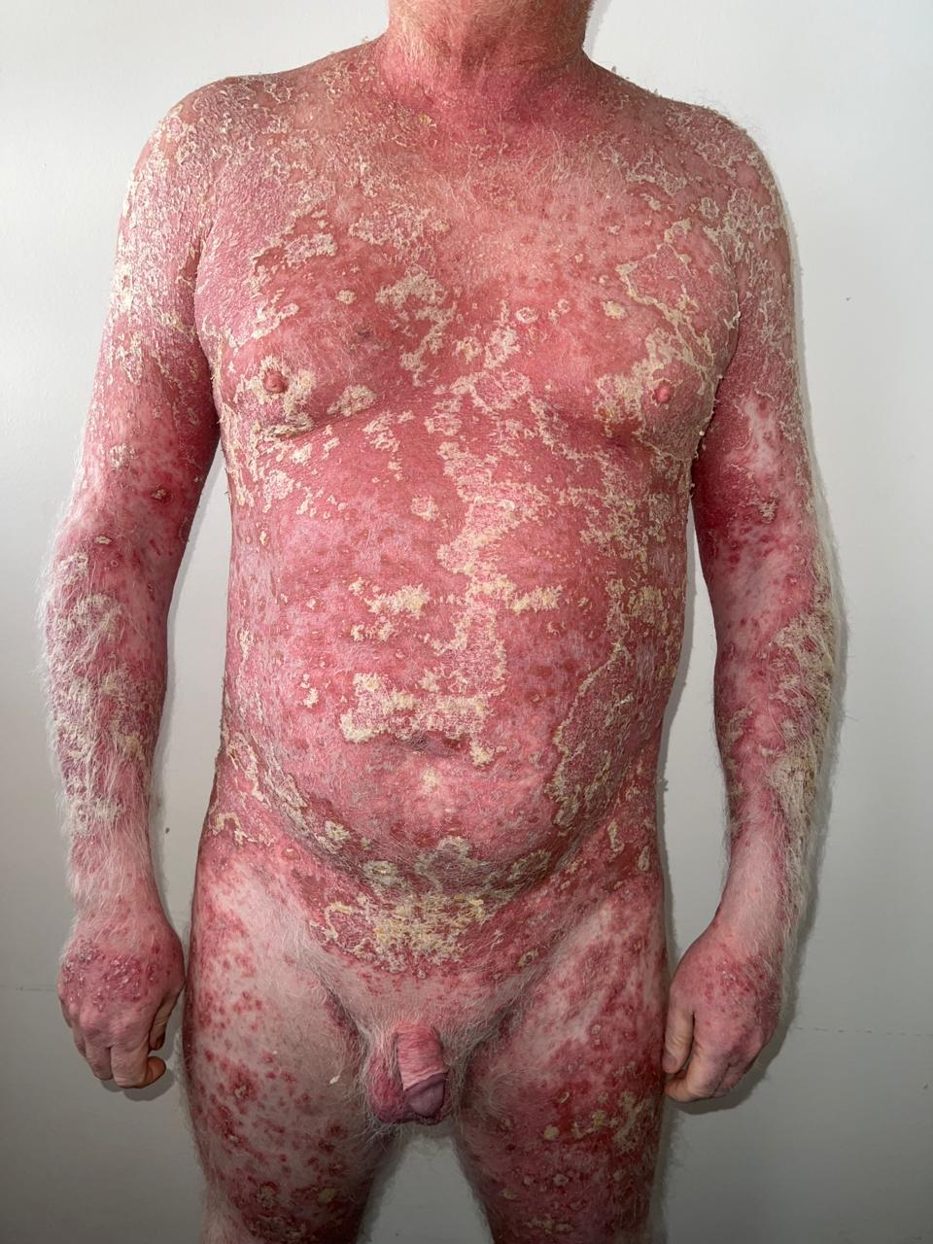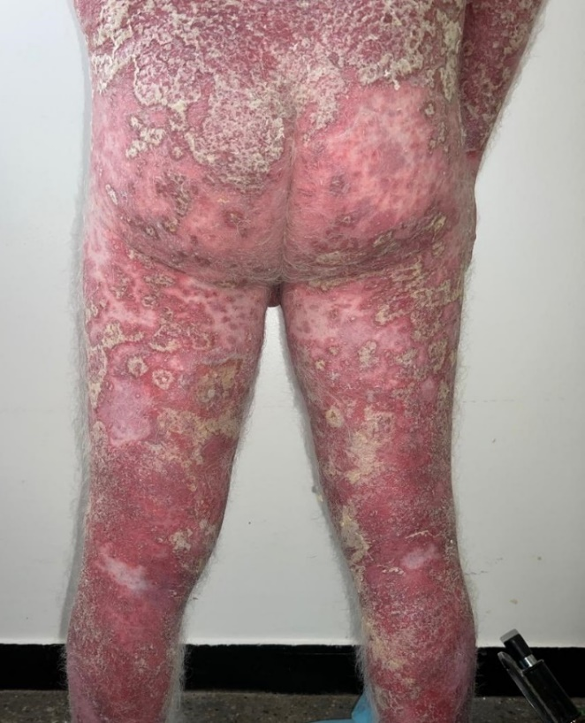

Figure 1 & 2 : Generalized flare of annular pustular psoriasis of the Bloch-Lapierre type.

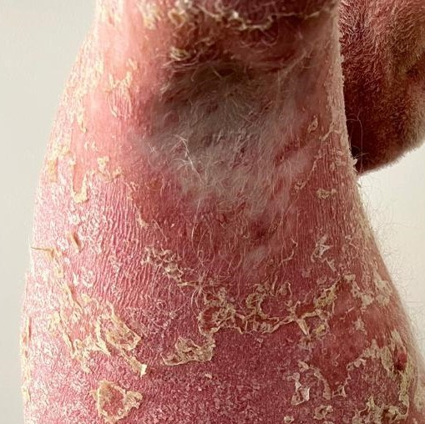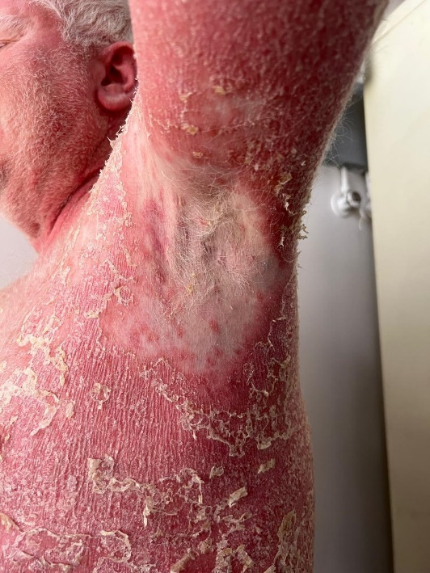

Figure 3 & 4 : Moderate hidradenitis suppurativa (Hurley II) in the axillary folds.

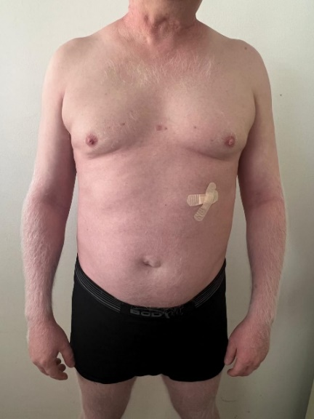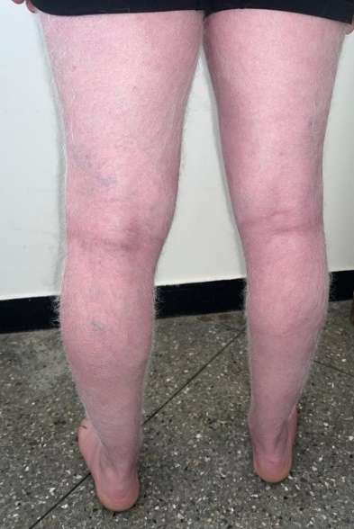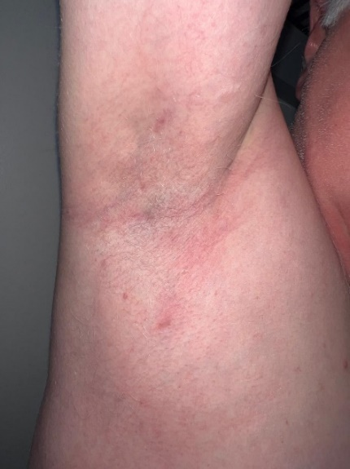

Figure 5, 6 & 7 : Complete regression of psoriasis and hidradinitis suppurativa lesions on treatment.