*Case report*

Desmoplastic Trichoepithelioma: A Case Report with Familial Context

.

ABSTRACT

|  |
| --- |
| **Background:** Desmoplastic trichoepithelioma (DTE) is a rare, benign adnexal tumor derived from follicular germinative cells. It predominantly affects young females and commonly presents on the face as annular plaques or papules with a depressed center. The tumor poses diagnostic challenges due to its resemblance to malignant lesions such as morpheaform basal cell carcinoma (BCC) and microcystic adnexal carcinoma (MAC). Diagnosis is confirmed by histological examination.  **Case report:** We report the case of a 29-year-old woman presenting with multiple facial DTEs and a similar presentation in her sister, suggesting a familial predisposition.  **Discussion:** Desmoplastic trichoepithelioma can closely mimic aggressive skin cancers both clinically and histologically, necessitating biopsy for accurate diagnosis. The unusual occurrence of multiple lesions and familial involvement in this case raises the possibility of a genetic predisposition, although this remains rare. Early recognition is essential to avoid overtreatment.  **Conclusion:** This case highlights the importance of considering DTE in the differential diagnosis of facial papules, especially when lesions are multiple or familial, and confirms the role of histology in establishing a definitive diagnosis. |

*Keywords: Desmoplastic trichoepithelioma, adnexal tumor, follicular neoplasm, basal cell carcinoma mimic, facial papules, histopathology, familial predisposition.*

1. INTRODUCTION

Desmoplastic trichoepithelioma is a rare benign skin tumor of follicular origin. It typically affects young women and appears as indurated, annular, skin-colored or hyperpigmented papules on the face (Taylor A, et al., 2025), (Hoonjan P., et al., 2023) Though benign, its clinical presentation can mimic malignant neoplasms, leading to unnecessary and aggressive treatments. Accurate diagnosis relies on histological examination, which remains the gold standard. Histologically, DTE is characterized by narrow strands and small nests of basaloid cells within a desmoplastic stroma, accompanied by keratinous cysts and focal calcification (Taylor A, et al., 2025).

2. PRESENTATION OF CASE

A 29-year-old woman with a dark phototype (Fitzpatrick type IV) and no significant medical history presented with hyperpigmented papular lesions on both cheeks since puberty. Her sister displayed similar cutaneous features. The lesions measured a few millimeters in diameter and were firm, painless, non-pruritic, and without associated symptoms (Figure 1). Dermoscopic evaluation revealed network-like pigmentation on an erythematous background, milia-like cysts, and telangiectasias (Figure 2). A skin biopsy confirmed the diagnosis of desmoplastic trichoepithelioma (Figure 3). Histopathological examination showed basal layer hyperpigmentation and a cystic dermal proliferation composed of keratin lamellae, bordered by a double epithelial layer with small, non-atypical nuclei. In some areas, epithelial cords embedded in a hyaline fibrous stroma were noted. Therapeutic options considered included electrosurgery, radiofrequency ablation, dermabrasion, cryosurgery, and laser therapy. The patient received an initial session of Erbium:YAG laser therapy, which yielded only minimal improvement.

3. discussion

Desmoplastic trichoepithelioma accounts for less than 1% of all cutaneous tumours and predominantly affects females in their second to fourth decade while multiple trichoepitheliomata typically start to develop in early childhood or around puberty (Taylor A, et al., 2025), (Hoonjan P., et al., 2023), (Khan H, et al., 2024). The exact etiology remains unclear, but it is believed to arise from the outer root sheath of the hair follicle (Satter EK, et al., 2022).

Clinically, DTE manifests as a slow-growing, indurated papule or plaque, most commonly on the cheeks or forehead for solitary shapes. Multiple trichoepitheliomas typically present as numerous painless, well-circumscribed papules that are skin-colored, pink, or bluish, symmetrically distributed on the face particularly in the central areas such as the nose, nasolabial folds, and cheeks. Less commonly, lesions may also appear on the forehead, ears, eyelids, scalp, neck, and upper trunk (Hoonjan P., et al., 2023). Dermoscopy may assist in differentiating DTE from other lesions. Features include arborizing vessels, white structures, milia-like cysts, and network-like pigmentation, though these findings are not specific (Lallas A, et al., 2023).

DTE can occur sporadically or in familial syndromes such as Brooke-Spiegler syndrome or multiple familial trichoepithelioma, conditions linked to mutations in the CYLD gene (Rajan N, et al., 2022). These should be suspected when multiple lesions are present, especially with a positive family history. The main differential diagnoses include morpheaform BCC, which often exhibits peripheral palisading and retraction artifacts histologically, and microcystic adnexal carcinoma, which tends to be more deeply infiltrative (Hoang MP, et al., 2008). Immunohistochemistry can help: CD10 is typically positive in DTE stroma but not in tumor cells, while BerEP4 is often negative or focally positive in DTE but diffusely positive in BCC (Kumar P, et al., 2012), (Ansai S, et al., 2005). The report highlights the diagnostic challenge of facial papular lesions in darker phototypes, to our knowledge, few cases with familial clustering and detailed dermoscopic-histologic correlation have been reported in the literature, particularly in darker skin types.

Therapeutic options range from observation to surgical excision and laser treatment. While surgical excision remains definitive, it may be impractical in cases with multiple lesions or for aesthetic concerns. Laser modalities like CO₂ and Erbium:YAG lasers have demonstrated good cosmetic outcomes with minimal invasiveness (Thomas LW, et al., 2020), however, recurrence or the emergence of new lesions remains a challenge. Current evidence does not support a single superior treatment, but laser therapy is favored for its cosmetic benefits and reduced morbidity.

4. Conclusion

Desmoplastic trichoepithelioma is a rare, benign tumor that can be challenging to distinguish from malignant skin tumours. Histological confirmation is essential. While multiple treatment options are available, laser therapy represents an effective and cosmetically appealing choice, especially in young patients. A thorough clinical and familial assessment is key to ensuring appropriate diagnosis and management.

Consent

All authors declare that ‘written informed consent was obtained from the patient’s legal guardian for publication of this case report and accompanying images. A copy of the written consent is available for review by the Editorial office/Chief Editor/Editorial Board members of this journal.

Ethical approval

All authors hereby declare that all experiments have been examined and approved by the appropriate ethics committee and have therefore been performed in accordance with the ethical standards laid down in the 1964 Declaration of Helsinki.

Disclaimer (Artificial intelligence)

Authors hereby declare that NO generative AI technologies such as Large Language Models (ChatGPT, COPILOT, etc.) and text-to-image generators have been used during the writing or editing of this manuscript.

References

Taylor A, Rice AS. Desmoplastic Trichoepithelioma. StatPearls [Internet]. Treasure Island (FL): StatPearls Publishing; 2025 Jan. https://www.ncbi.nlm.nih.gov/books/NBK608006/

Hoonjan P. Trichoepithelioma. DermNet. October 2023. https://dermnetnz.org/topics/trichoepithelioma

Khan H, Mpyisi L, Azzam MJ, Braudis K. Infiltrative Basal Cell Carcinoma Adjacent to a Desmoplastic Trichoepithelioma: A Case Report and Review. Cureus. 2024;16(6):e12345.

Satter EK, et al. Histopathologic Differential Diagnosis of Basaloid Lesions. J Cutan Pathol. 2022;49(10):847–859.

Lallas A, et al. Dermoscopic Patterns of Desmoplastic Trichoepithelioma. Int J Dermatol. 2023;62(3):341–345.

Rajan N, et al. Brooke-Spiegler Syndrome. Clin Exp Dermatol. 2022;47(2):187–193.

Hoang MP, et al. Microcystic Adnexal Carcinoma: An Immunohistochemical Reappraisal. Mod Pathol. 2008;21(2):178-185.

Kumar P, et al. CD10 Expression in Basal Cell Carcinoma and Trichoepithelioma. J Cutan Pathol. 2012;39(5):744-9.

Ansai S, et al. BerEP4 in Basal Cell Carcinoma and Desmoplastic Trichoepithelioma. Am J Dermatopathol. 2005;27(6):453–457.

Thomas LW, et al. Erbium:YAG Laser Treatment of Trichoepitheliomas. J Clin Aesthet Dermatol. 2020;13(7):41-44.

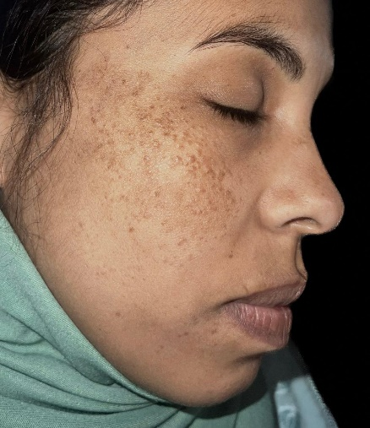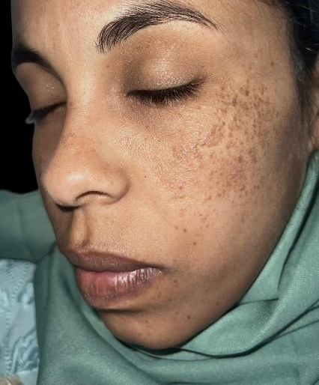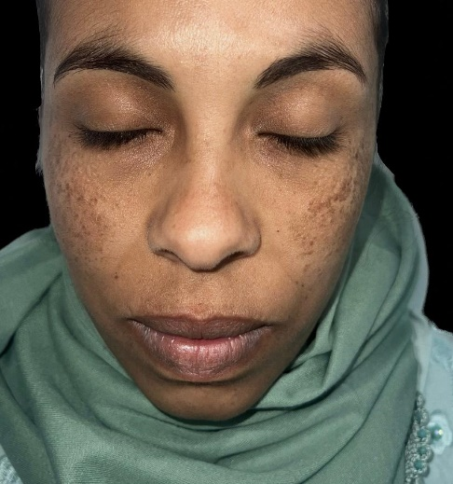

Figure 1 : Multiple pigmented to skin-collored papules on both cheeks without erosion or scaling.

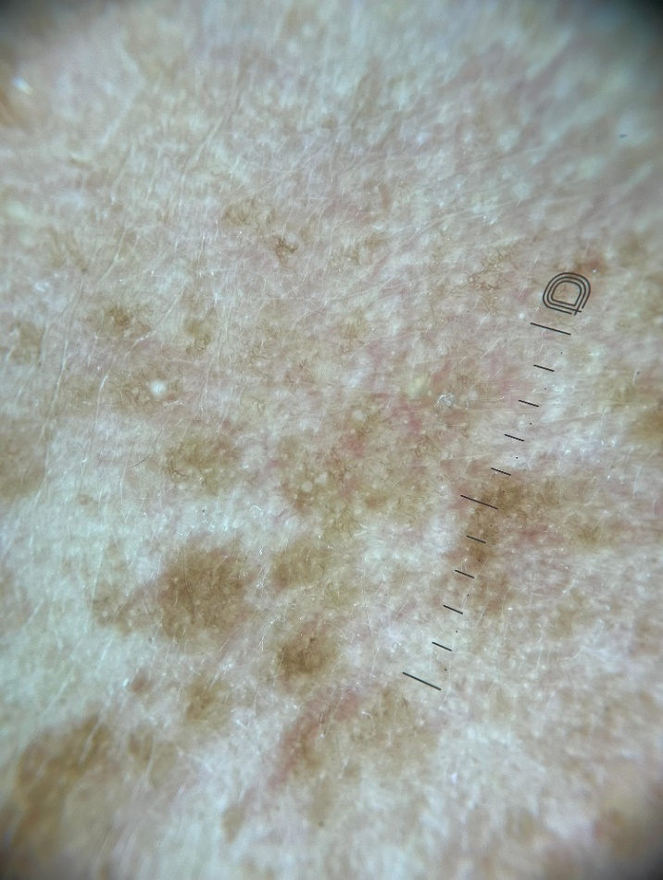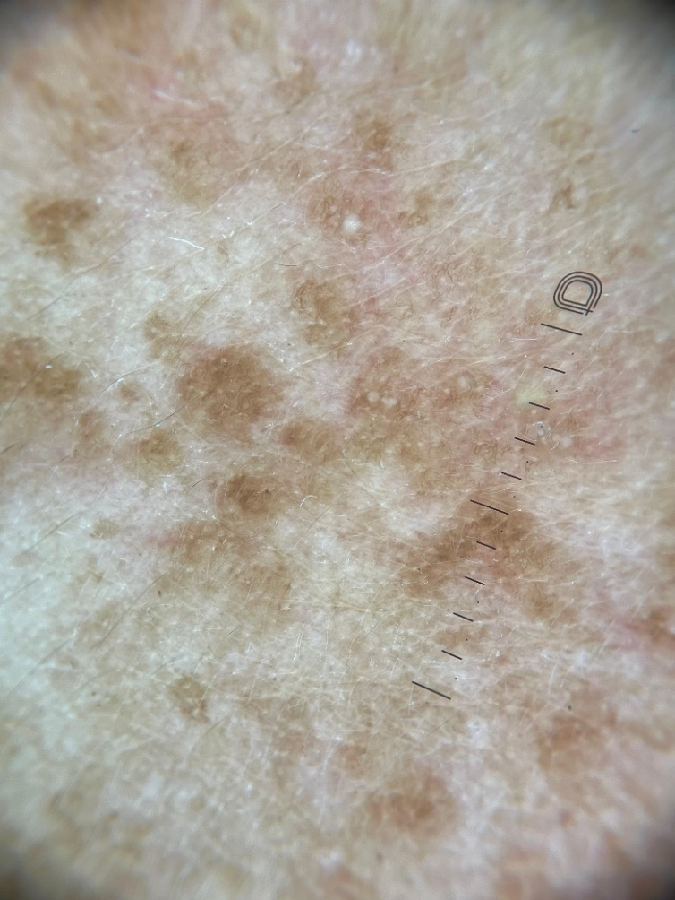Figure 2 : Dermoscopy of lesions showed network-like pigmentation, millia-like cyst and telangiectasis.

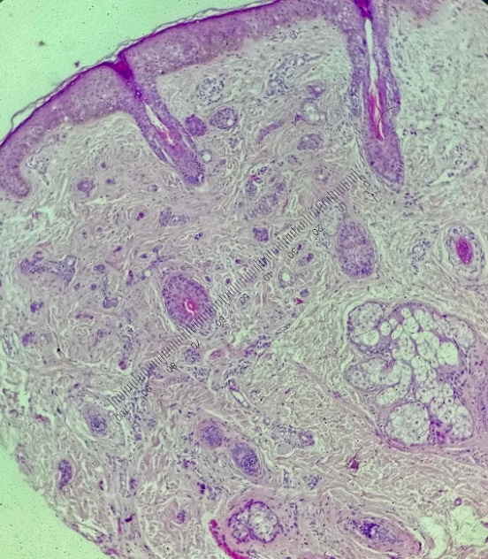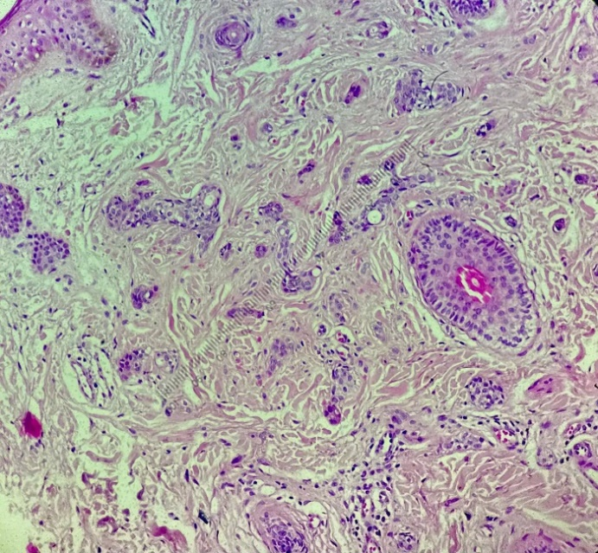

Figure 3 : Histological features of desmoplastic trichoepithelioma. (a) : At low magnification (Gx4), the biopsy reveals a tumoral proliferation composed of nests and narrow cords of basaloid cells, displaying a characteristic *tadpole-like* configuration.  
(b) : At higher magnification (Gx40), the basaloid cells show no cytonuclear atypia. The surrounding stroma is dense and fibrous, consistent with a desmoplastic reaction.