*Case report*

The Trichoscopic Hallmarks of Pressure Alopecia: A Case-Based Study

ABSTRACT

|  |
| --- |
| Pressure alopecia is a rare and often underrecognized form of hair loss caused by prolonged ischemia of the scalp. Frequently misdiagnosed, it requires a high index of suspicion and a careful clinical and dermoscopic assessment.  In this case-based study, we highlight the distinctive trichoscopic hallmarks that can aid in the timely diagnosis of this condition. Through an illustrative clinical scenario following prolonged immobilization, we demonstrate how trichoscopy—combined with histopathology—can be instrumental in distinguishing pressure alopecia from other alopecic disorders.  This report emphasizes the diagnostic value of trichoscopy and the importance of simple preventive strategies to mitigate this avoidable complication. The case sheds light on a condition that remains underreported, urging clinicians to be aware of its subtle but telling signs. |

*Keywords: Pressure alopecia; trichoscopy; scarring alopecia; hair loss diagnosis.*

1. INTRODUCTION

Pressure alopecia is an uncommon form of alopecia that present as either scarring or non-scarring hair loss. It typically occurs as a result of prolonged immobilization of the head leading to localized ischemia.

This condition often manifests as a localized area of alopecia and can be easily misdiagnosed as other forms of hair loss, especially when the temporal relationship with the triggering event is not forthcoming, or if the clinician is unfamiliar with its presentation (Neema S et al., 2022; Loh SH et al., 2015). Trichoscopy plays a pivotal role in its diagnosis.

In this report, we present a case of scarring pressure alopecia that developed after an intensive care unit (ICU) stay, highlighting the key trichoscopic findings that guided the diagnosis.

2. Presentation of Case

We report the case of a 31-year-old female patient with a history of epileptic encephalopathy since childhood. She was admitted to the ICU for two months due to status epilepticus and was treated with several medications, including oxcarbazepine and levetiracetam. During her ICU stay, she required prolonged intubation, sedation, and immobilization.

Upon referral to the dermatology department, the patient presented with aphasia and intellectual disability. She exhibited confluent alopecic plaques on the parietal and vertex scalp regions, with a negative hair pull test (Fig. 1). Heel pressure sores were also noted.

Polarized trichoscopy revealed multiple comedone-like black dots, yellow and black dots, dystrophic and miniaturized hairs (Fig. 2). Linear fine vessels and white scarred area were observed in some areas (Fig. 3).

To further assess potential systemic involvement, periungual dermoscopy was performed, which showed normal capillary patterns without avascular areas

Given the clinical and trichoscopic findings, two main differential diagnoses were considered: pressure alopecia, due to the prolonged immobilization in the ICU, and drug-induced lupus, given the recent introduction of anticonvulsants (oxcarbazepine and levetiracetam), both of which are known to potentially induce lupus-like syndromes.

To confirm the diagnosis, a skin biopsy was performed, revealing features consistent with pressure-induced ischemia and scarring. Additionally, direct immunofluorescence ruled out lupus by showing no immune complex deposition in the affected areas. The rest of the lupus workup was negative.

The final diagnosis of scarring pressure alopecia was established based on the clinical history, trichoscopic findings, and histopathological confirmation. The patient was started on minoxidil, with good hair regrowth observed in the non-scarring areas.

3. discussion

Pressure alopecia was first described by Abel and Lewis in 1959, who reported eight cases during the annual meeting of the American Dermatological Society (Abel RR et al., 1960). It is a rare condition resulting from ischemic obstruction of scalp capillaries, leading to alopecic areas.

Cases of pressure alopecia have been reported following various extended surgical procedures, such as cardiothoracic, gynecological, reconstructive, genitourinary, and neurosurgical operations, as well as prolonged intensive care unit (ICU) stays. It has also been documented in association with external devices, including electroencephalogram (EEG) electrodes, orthodontic headgear, and cervical collars (Loh SH et al., 2015).

Recently, Corona-Rodarte et al. classified pressure alopecia into two types:

Type 1: Resulting from sustained external pressure on the scalp, primarily over bony prominences.

Type 2: Induced by cosmetic procedures, associated with pressure exerted by the volume of injectable products (Corona-Rodarte et al., 2024).

Clinically, pressure alopecia may present with erythema, swelling, and tenderness; however, alopecia may be the only manifestation. The presence of crusting and ulceration is associated with a worse prognosis and a higher likelihood of scarring alopecia (Corona-Rodarte et al., 2024).

Depending on the degree of pressure-induced ischemia, the condition may result in scarring or non-scarring alopecia. Milder ischemia leads to non-scarring alopecia, whereas prolonged ischemia results in ulcers and scarring (Ravaioli GM et al., 2019).

Loh et al. in their series reported that operation time is the most critical factor in determining reversibility of hair loss and duration of more than 10 h in general anesthesia was associated with scarring alopecia (Loh SH et al., 2015).

Alopecia typically affects the convex areas of the scalp, such as the vertex and occiput, appearing 3–28 days after the inciting event. The prognosis is generally favorable with hair regrowth observed within 1–4 months (Neema S et al., 2022).

The diagnosis is based on a characteristic history of prolonged surgery or immobilization, along with clinical findings of occipital alopecia and associated ulceration or scarring.

Trichoscopy plays a vital role in diagnosing pressure alopecia, particularly when the triggering event is not immediately apparent. A unique trichoscopic feature, "comedone-like black dots," has been reported in 66% of cases. Other findings include yellow dots, miniaturized hairs, broken hairs, and scarring. However, exclamation mark hairs, a hallmark of alopecia areata, are absent in pressure alopecia (Neema S et al., 2022).

Pressure alopecia remains a preventable condition. Simple interventions, such as regularly repositioning the patient’s head, can significantly reduce the risk. Early recognition, facilitated by trichoscopy, allows for timely intervention and minimizes the impact of the condition.

In our case, the combination of trichoscopic findings and histological confirmation underscores the utility of trichoscopy in diagnosing pressure alopecia.

4. Conclusion

Pressure alopecia is a rare but significant complication, particularly following prolonged surgical procedures or immobilization. Early recognition—facilitated by trichoscopy, especially through identifying comedone-like black dots—can optimize management. Close monitoring and preventive measures can mitigate its impact and improve outcomes.

Consent (where ever applicable)

All authors declare that written informed consent was obtained from the patient for the publication of this case report and accompanying images.

Ethical approval (where ever applicable)

All authors have obtained all necessary ethical approval and have therefore been performed

Disclaimer (Artificial intelligence)

Authors hereby declare that NO generative AI technologies such as Large Language Models (ChatGPT, COPILOT, etc.) and text-to-image generators have been used during the writing or editing of this manuscript.

References

Neema S, Vashisht D, Yadav AK, Sinha A, Radhakrishnan S. Trichoscopy of pressure‑induced alopecia and alopecia areata: A comparative study. Int J Trichol 2022;14:17-20.

Loh SH, Lew BL, Sim WY. Pressure alopecia: Clinical findings and prognosis. J Am Acad Dermatol 2015;72:188‑9.

Abel RR, Lewis GM. Postoperative (pressure) alopecia. Arch Dermatol 1960;81:34-42.

Corona-Rodarte, E., Cano-Aguilar, L. E., Baldassarri-Ortego, L. F., Tosti, A., & Asz-Sigall, D. (2024). Pressure alopecias : A review. Journal of the American Academy of Dermatology, 90(1), 125‑132. https://doi.org/10.1016/j.jaad.2023.07.009

Ravaioli GM, Starace M, Alessandrini AM, Guicciardi F, Piraccini BM. Pressure alopecia in pediatric and adult patients: Clinical and trichoscopic findings in 12 cases. J Am Acad Dermatol 2019;81:1021‑3.

Definitions, Acronyms, Abbreviations

Here is the Definitions section. This is an optional section.

**Term**: Definition for the term

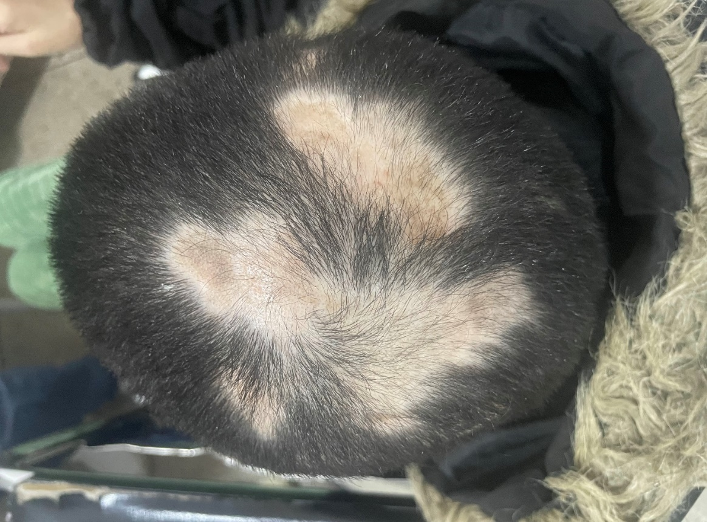

Fig.1 : Multiple confluent alopecic plaques on the vertex.

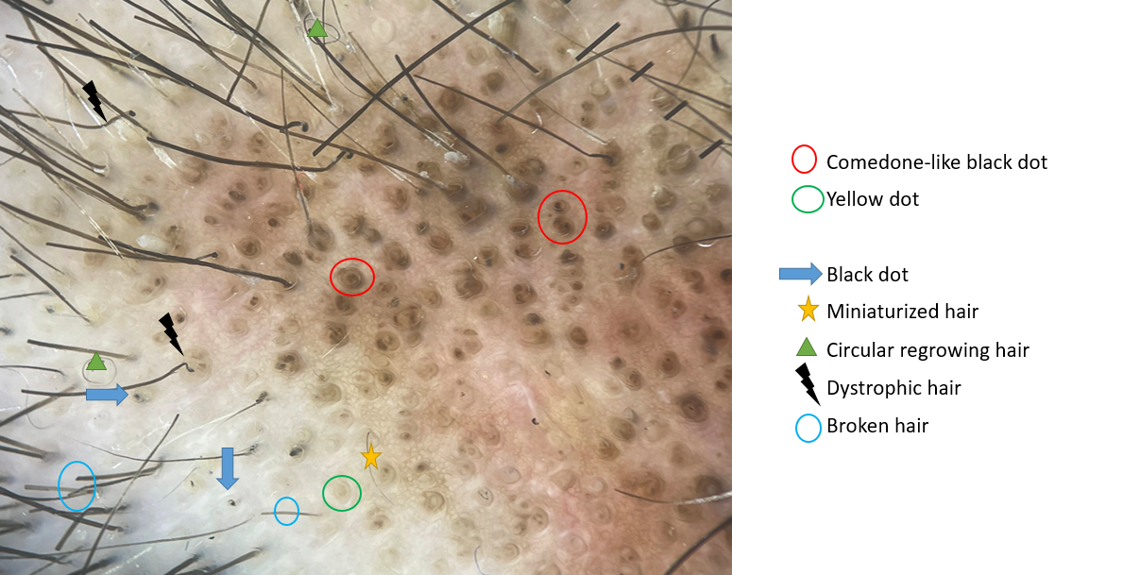

Fig. 2: Polarized trichoscopy of the alopecic plaques revealed multiple comedone-like black dots, yellow and black dots, dystrophic and miniaturized hairs.

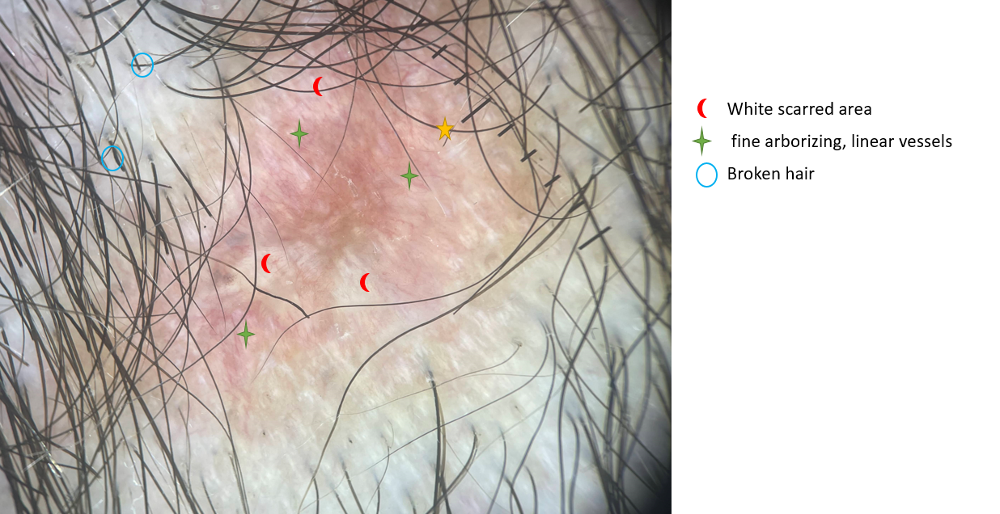

Fig. 3 : Polarized trichoscopy revealed linear fine vessels and white scarred area in some areas of the alopecic plaques.