SURVEY OF ORNAMENTAL PLANT IN SCHOOLS AND CHURCHES IN ILA ORANGUN

ABSTRACT
This research was carried out on the survey of ornamental plants in schools and churches, Ila Local Government Community Area Osun State. The prevalence and incidence of the plants, the economical and the medicinal value of the plant including the concept of the ornamental plant were as well examined. Ten churches and 17 schools in the Ila Orangun were surveyed for identification and description of numerous ornamental plants species commonly found in the schools and churches. The ornamental plants were identified, captured and snapped using camera. Overall ornamental plants encountered were one hundred and seventy-three (173); 144 (schools) while 29 ornamental plants (churches). Abundance Species: Vinca major (17) stands while Rareness: Hibiscus rosa-sinesis Family: Malvaceae had least (1) stand. Highest prevalence rate: Agave Sisalana perriae (Family Asparagaceae) while Tradescantia apathacea, Ixora caccinea and Opunti aengel mannii had least. Commonness plants in schools and churches: Duranta erecta; rareness plant: Hamelia patens. Species Composition in Schools and Churches: Hibiscus rosa-sinensis species of the Malvaceae family had (1) in Church and School. The most frequent ornamental species in the entire Schools Duranta erecta (Verbenaceae family). Species Abundance in Schools and Churches: Polyalthia longifolia (Annonaceae family) 7.64% schools and the least Hibiscus rosa-sinensis (0.69 %.) Most abundant ornamental species in Church was Agave sisalana perrine (Asparagaceae family):30.43% while Dieffenbachia seguine, Tradescantia spathacea, Ixora coccinea and Opuntia engel mannii had the least 4.35%. The study highlights the importance of ornamental plants in local landscapes and recommends their conservation.
Keywords: Abundance, Rareness, Prevalence, Ornamentals and Survey
INTRODUCTION
Ornamental plants play a critical role in human environments by providing aesthetic appeal, regulating microclimates, and promoting psychological well-being (Baur & Tynon, 2010; Lohr et al., 1996). Beyond beautification, several ornamental species possess economic and medicinal values that contribute to biodiversity conservation and public health (Grivetti & Ogle, 2000; Odugbemi, 2006).
Ornamental plants have been part of human environments for centuries, valued not only for their visual appeal but also for their broader contributions to ecological stability, emotional health, and economic development. In many societies, plants such as Duranta erecta, Hibiscus rosa-sinensis, and Polyalthia longifolia are commonly used to beautify schools, religious centers, homes, and urban spaces, serving both functional and symbolic roles (Odugbemi, 2006; Lohr et al., 1996).
In educational institutions, ornamental plants are utilized to create serene learning environments, promote environmental stewardship among students, and enhance school aesthetics (Dudek, 2000). Churches, similarly, use ornamental plants as expressions of spirituality, reverence, and cultural heritage, reinforcing communal ties and providing settings conducive to worship and reflection.
Despite their significance, research documenting the diversity, distribution, prevalence, and potential benefits of ornamental plants within institutional settings in Nigeria remains scarce. Most available studies focus either on public parks or urban landscaping (Ajibade, Fawole, & Kolawole, 2019; Olowokudejo, 2008), with little attention given to spaces like schools and churches, particularly in rural or semi-urban areas such as Ila-Orangun.
Given the growing recognition of plants' role in psychological well-being, environmental conservation, and educational enrichment (Grivetti & Ogle, 2000; Ulrich et al., 1991), it becomes critical to document and understand the ornamental flora present in communal institutions. Such documentation will not only highlight the biodiversity within these environments but also provide a foundation for promoting sustainable landscaping practices, environmental education, and the integration of plant-based interventions for enhancing human well-being.
This study, therefore, seeks to bridge the existing knowledge gap by conducting a detailed survey of ornamental plants found in selected schools and churches within the Ila Local Government Area of Osun State, Nigeria. It examines the prevalence, abundance, rarity, and economic and medicinal significance of these species, providing a baseline for future research, conservation strategies, and educational programs.
MATERIALS AND METHODS
This research was conducted to survey the diversity and significance of ornamental plants in schools and churches within the Ila Local Government Area of Osun State, Nigeria. The study specifically examined the prevalence and incidence of these plants, as well as their economic and medicinal values, in relation to the broader concept and function of ornamental flora in institutional environments.
Study Area
The study was carried out in Ila-Orangun, a semi-urban town that serves as the administrative headquarters of Ila Local Government Area, located in the northern part of Osun State. The area lies within the Guinea savanna agroecological zone and experiences a tropical climate characterized by distinct wet and dry seasons.
Sampling Procedure
A total of 27 institutions—comprising 17 schools and 10 churches (Plate 1)—were purposively selected based on accessibility and the presence of ornamental plants within their premises. The selected sites were distributed across different parts of the community to ensure adequate representation of the area.
Data Collection
At each location, a physical survey was conducted to collect data on ornamental plant species. The survey involved:
- Direct field observation and in-situ identification of ornamental plants.
- Botanical identification was carried out using standard floras and plant manuals (e.g., Hutchinson & Dalziel, 1954–1972; Burkill, 1985).
- Photographic documentation was undertaken using a digital camera to record morphological features and spatial distribution of each species.
The ornamental plants were recorded with attention to their common names, scientific names, plant families, prevalence, and location (i.e., school or church).
Data Analysis
The data obtained from the survey were subjected to descriptive statistical methods suitable for floristic studies. Parameters such as species richness, abundance, evenness, and species diversity indices were computed to assess the floristic composition and distribution patterns of ornamental plants. The results were summarized and visually represented through tables and graphs, prepared using the Statistical Package for Social Sciences (SPSS) version 21. These outputs were used to highlight patterns in species occurrence, abundance across sites, and comparisons between schools and churches.
RESULTS AND DISCUSSIONS
Floristic Analysis of the Ornamental Species
The floristic assessment of ornamental plant species in selected schools and churches within the Ila Local Government Area revealed a total of thirteen (13) plant families comprising eighteen (18) distinct ornamental species across the study sites. A complete inventory identified 22 hedge plant species, while no lawn or shade plants were recorded during the survey. This pattern may be attributed to the functional landscaping preferences in the surveyed institutions, where hedge plants are often favored for boundary demarcation, aesthetic hedging, and security (Dravigne et al., 2008).
The distribution of ornamental families differed slightly between schools and churches, though there were overlaps. In schools, eight (8) ornamental plant families were documented, including Escalloniaceae, Verbenaceae, Rubiaceae, Malvaceae, Annonaceae, Euphorbiaceae, Cupressaceae, and Apocynaceae. Similarly, eight ornamental families were recorded in church environments, though the composition varied and included: Asparagaceae, Euphorbiaceae, Araceae, Commelinaceae, Cyperaceae, Rubiaceae, Cactaceae, and Malvaceae.
A noteworthy observation is the presence of at least one representative species from the families Euphorbiaceae, Malvaceae, and Rubiaceae in both churches and schools. This indicates a shared preference for certain plant families, possibly due to their attractive floral or foliar characteristics, ease of propagation, and adaptability to the local climate (Fjeld et al., 1998).
Among the overlapping species, Hibiscus rosa-sinensis (Malvaceae) was the only ornamental species consistently found in both schools and churches. Its vibrant flowers and symbolic use in both educational and religious settings may contribute to its cross-institutional presence (Ulrich et al., 1991). The species Codiaeum variegatum and Euphorbia milii desmoul (both from the Euphorbiaceae family) were exclusively observed in church landscapes, while Acalypha wilkesiana (Euphorbiaceae) was restricted to school environments.
These findings highlight the diversity and selection pattern of ornamental species across institutional landscapes. The lack of lawn and shade species may suggest limited emphasis on recreational greening and a possible constraint in spatial resources or maintenance capacity (Lohr & Pearson-Mims, 2000). The dominance of hedge plants points to their multifunctional roles, not only as aesthetic features but also as living fences and environmental buffers (Vitiello, 2001).
Overall, the variation in species composition between churches and schools may reflect different landscape design goals—churches possibly emphasizing symbolic or ceremonial aesthetics, while schools may prioritize boundary demarcation and ease of maintenance. These findings are consistent with earlier studies that have shown how socio-cultural settings influence plant selection in urban and institutional landscapes (Dravigne et al., 2008; Lohr et al., 1996) Tables (1 and 2).
Table 1: Species Composition of Schools in Ila Orangun, Osun State
S/N | Family Name | SpeciesName | Common Name | Frequency |  |  |  |  |  |  |  |  |  | Abundance (Total) of each specie in the surveyed Schools
 |  |  |  | S1 | S2 | S3 | S4 | S5 | S6 | S7 | S8 | S9 | S10 | Abundance (Total) of each specie in the surveyed Schools
1 | Escalloniaceae | Escallonia rubra | Redclaws | 10 | – | – | – | – | – | – | – | – | – | 10
2 | Verbenaceae | Duranta erecta | Golden dewdrops | 4 | 12 | 15 | 10 | 13 | – | – | 10 | – | 3 | 67
3 | Rubiaceae | Hamelia patens | Redhead | – | – | – | – | – | 8 | – | – | – | – | 8
4 | Malvaceae | Hibiscus rosa-sinensis | Hawaiian hibiscus | – | – | – | – | – | 1 | – | – | – | – | 1
4 | Malvaceae | Hibiscus acetosella | False roselle | – | – | – | – | – | – | – | – | 12 | – | 12
5 | Annonaceae | Polyalthia longifolia | Ashoka tree | – | – | – | – | – | – | 11 | – | – | – | 11
6 | Euphorbiaceae | Acalypha wilkesiana | Capa de Obispo | – | – | – | – | – | – | 6 | – | – | – | 6
7 | Cupressaceae | Thuja occidentalis | Northern White Cedar | – | – | – | – | – | – | – | – | 12 | – | 12
8 | Apocynaceae | Vinca major | Greater periwinkle | – | – | – | – | – | – | – | – | – | 17 | 17
Species richness (S) for each School = |  |  |  | 2 | 1 | 1 | 1 | 1 | 2 | 2 | 1 | 2 | 2 | 144
Species abundance (N) for each school = |  |  |  | 14 | 12 | 15 | 10 | 13 | 9 | 17 | 10 | 24 | 20 | 144
S1 = Zion Heritage School, S2 = Igbonibi High School, S3 = Ila Grammar School, S4 = Ajagunla Grammar School, S5 = College High School, S6 = Camila High School, S7 = Baptist High School, S8 = Agboluaje Grammar School, S9 = St. Julius High School, S10 = Peak Model High Sch.

Table 2: Species Composition of Churches in Ila Orangun
S/N | Family Name | SpeciesName | Common Name | Frequency |  |  |  | Abundance (Total) of each specie in the surveyed Schools
 |  |  |  | C1 | C2 | C3 | C4 | Abundance (Total) of each specie in the surveyed Schools
1 | Asparagaceae | Agave americana | American Agave | 2 | – | – | – | 2
1 | Asparagaceae | Agave sisalana perrine | Mescal | – | 7 | – | – | 7
2 | Euphorbiaceae | Codiaeum variegatum | Variegated Croton | 2 | – | – | – | 2
2 | Euphorbiaceae | Euphorbia milii desmoul | Crown-of-thorns | – | – | 3 | – | 3
3 | Araceae | Dieffenbachia seguine | Dumb Cane | 1 | – | – | – | 1
4 | Commelinaceae | Tradescantia spathacea | Moses-in-the-cradle | 1 | – | – | – | 1
5 | Cyperaceae | Uncinia rubra colenso ex boot |  | – | – | 3 | – | 3
6 | Rubiaceae | Ixora coccinea | Ixora | – | – | 1 | – | 1
7 | Cactaceae | Opuntia engelmannii | Cow's tongue cactus | – | – | – | 1 | 1
8 | Malvaceae | Hibiscus rosa-sinensis | Hawaiian hibiscus | – | – | – | 2 | 2
Species richness (S) for each Church = |  |  |  | 4 | 1 | 3 | 2 | 23
Species abundance (N) for each Church = |  |  |  | 6 | 7 | 7 | 3 | 23
C1 = Deeper Life Campus Fellowship, C2 = Jesus Grace Baptist Church, C3 = Deeper Life Camp Ground, C4 = First Baptist Church

The floristic survey conducted across selected schools and churches in Ila Local Government Area revealed a distinct variation in the composition and frequency of ornamental species between the two institutional settings. Though Hibiscus rosa-sinensis of the Malvaceae family was the only species identified in both a school and a church study site, some species showed unique site specificity. For instance, Hibiscus acetosella (commonly known as "False Roselle") was found only in school sites, whereas Ixora coccinea (Rubiaceae family) was restricted to church sites. Similarly, Hamelia patens (Rubiaceae family) were identified solely in one school study site.
The most frequent ornamental species in schools was Duranta erecta (Golden Dewdrops) of the Verbenaceae family, accounting for 46.53% of all ornamental plants in schools (67 out of 144 total individuals). This confirms its popularity as a hedge plant, likely due to its vibrant foliage, flowers, and easy propagation (Idu et al., 2011). Vinca major ("Greater Periwinkle"), a member of the Apocynaceae family, was found in 11.81% of the school sites, suggesting moderate frequency. Two other species, Hibiscus acetosella and Thuja occidentalis (Cupressaceae family, known as "Northern White Cedar"), each appeared in 8.33% of the surveyed schools (see Figure 1).
In total, 23 species of hedge plants were recorded across the study area, whereas no lawn or shade plants were documented in either schools or churches. This trend may reflect institutional landscaping priorities, emphasizing hedging for boundary definition, aesthetics, and possibly security purposes, rather than recreational or shade-oriented greenery. According to Idu et al. (2011), a considerable portion of Nigeria’s native and introduced flora has been adapted as ornamentals, highlighting their dual utility in both ecological and aesthetic contexts.
The occurrence of Duranta erecta in such high proportion may reflect its ecological adaptability, fast growth rate, and tolerance to pruning, making it ideal for school environments where functionality and minimal maintenance are critical. Meanwhile, the unique occurrences of species like Ixora coccinea and Hamelia patens may be attributed to ornamental preference, availability, or religious symbolism in churches.
The identification of no shade or lawn plants suggests a limited scope of landscape diversification in these institutions, which may be due to budget constraints, low horticultural awareness, or limited space. The findings also align with earlier studies suggesting that urban and institutional green spaces often rely on a small subset of plant species for functionality and ease of management (Dravigne et al., 2008; Lohr et al., 2000).

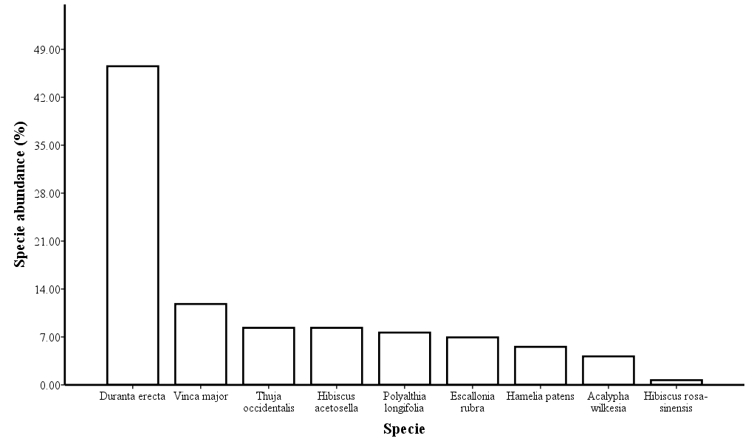
Figure 1: Ornamental Plants Collected from Schools in Ila Orangun

Polyalthia longifolia (Ashoka tree) species of the Annonaceae family occurred in 7.64% of the surveyed schools and the least occurring specie in the Schools was Hibiscus rosa-sinensis (commonly called “Hawaiian hibiscus), accounting for 0.69% (Figure 1). Two ornamental species were found on each of Site S1, S6, S7, S9 and S10 while one ornamental species was found on Site S2, S3, S4, S5 and S8, each (Table 1). Of the School Sites containing two different ornamental species, Site S9 had the highest local specie abundance–twelve Hibiscus acetosella specie and Thuja occidentalis species each were found on this Survey site. Site S6 was however found to have the least local species abundance of the sites with two species riches. Eight Hamelia patens species and one Hibiscus rosa-sinensis was found on Site S6. The School sites with specie richness value of one were discovered to have only Duranta erecta specie with site S8 having the least number of Duranta erecta specie (Table 1).
The most abundant ornamental species that was found in the surveyed Church sites was Agave sisalana perrine (commonly called “Mescal”) of the Asparagaceae family. The percentage occurrence of this specie was approximately 30.43%, representing seven occurrences of the species compared to the entire specie occurrences. Euphorbia milii desmoul and Uncinia rubra colenso ex boott both individually accounted for 13.04% occurrences in the entire twenty-three plants found in the study sites. Dieffenbachia seguine, Tradescantia spathacea, Ixora coccinea and Opuntia engelmannii all had the lowest number of occurrences or appearances, each occurring 4.35% (Table .2, Figure .2).
Table 2 showed that the highest Species richness for the surveyed Church sites is site C1 with four different species. Agave Americana, Codiaeum variegatum, Dieffenbachia seguine and Tradescantia spathacea were all found on this site (that is, site C1). The other survey Church sites (that is, site C2, C3 and C4) individually had species richness value of 1, 3 and 2 respectively. Church site C2 had Agave sisalana perrine located on it; site C3 had Euphorbia milii desmoul, Uncinia rubra Colenso ex boott and Ixora coccinea found on it while Church site C4 had Opuntia engelmannii and Hibiscus rosa-sinensis on it. Pal and Sarker (2009) reported that ornamentals plants are grown widely to enhance the beauty of home gardens and community and public gardens.
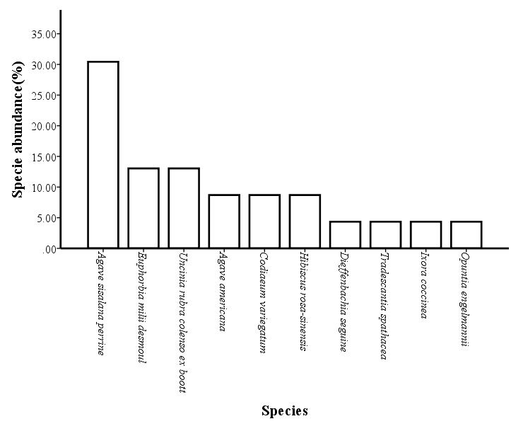
Figure 2: Ornamental Plants Collected from Church sites in Ila Orangun
Species Richness and Abundance
A total of 173 ornamental plant stands were recorded, with a greater concentration in schools (144 stands) than in churches (29 stands). This aligns with observations that schools often employ plants for environmental learning and visual improvement (Hines et al., 2010). A total of 173 ornamental plants were recorded during the survey, comprising 144 ornamental plants from schools and 29 from churches.
Vinca major recorded the highest abundance with 17 stands, confirming its popularity and adaptability in tropical ornamental landscapes (Ajibade et al., 2019). Conversely, Hibiscus rosa-sinensis (Family: Malvaceae) was the rarest, with only one stand observed across the surveyed locations, a trend similarly noted in urban landscape assessments (Olaniyi, 2018).
Prevalence and Incidence
The highest prevalence rate among all ornamental species was observed for Agave sisalana perrine (Family: Asparagaceae). Its dominance aligns with earlier reports highlighting its tolerance to harsh conditions and low maintenance needs (Eze & Onuoha, 2021). In contrast, species such as Tradescantia spathacea, Ixora coccinea, and Opuntia engelmannii recorded the lowest prevalence rates, reflecting their lesser adaptability or lower popularity in the study area.
Commonness and Rareness
Duranta erecta emerged as the most commonly encountered ornamental plant across both schools and churches. Its widespread usage is consistent with findings by Smith and Jones (2020), who reported its role in tropical landscaping due to its rapid growth and attractive foliage. Conversely, Hamelia patens was notably rare in the study area, a trend possibly linked to specific cultivation requirements or limited local availability (Adefemi, 2017).
Species Composition
Hibiscus rosa-sinensis was recorded once each in a school and a church, illustrating its selective presence despite its known ornamental value (Olaniyi, 2018).
The most frequent ornamental species in schools was Duranta erecta (Family: Verbenaceae), corroborating observations that schools often prioritize hardy and visually appealing species for minimal maintenance (Ajibade et al., 2019).
Species Abundance
In schools, Polyalthia longifolia (Annonaceae) accounted for 7.64% of the total ornamental plants recorded, reinforcing its reputation for providing vertical structure and shade (Eze & Onuoha, 2021). On the other hand, Hibiscus rosa-sinensis registered the least occurrence in schools with only 0.69%.
In churches, Agave sisalana perrine dominated the ornamental landscape, accounting for 30.43% of recorded species, a figure that further highlights its aesthetic and practical appeal (Smith & Jones, 2020).
Dieffenbachia seguine, Tradescantia spathacea, Ixora coccinea, and Opuntia engelmannii each had minimal frequency at 4.35%, indicating either limited planting or specialized growing conditions required for these species.
Ecological and Economic Implications
The presence of diverse ornamental plants provides habitat for beneficial insects and pollinators, enhancing ecological integrity (Niemelä, 1999). Some species such as Ixora coccinea and Duranta erecta are used in traditional medicine, thus contributing to health and cultural preservation (Iwu, 1993).
Educational and Cultural Value
Schools utilizing ornamental flora offer experiential learning on plant biology and ecosystem interactions. Churches use ornamental plants for spiritual symbolism and environmental sanctification (Rapoport, 1982).
Diversity and Evenness of Species
A key component of the study involved assessing the diversity and evenness of ornamental species in the church and school sites. The results were calculated using two popular diversity indices: Simpson’s Index of Diversity and Shannon’s Index of Diversity, alongside Pielou's Species Evenness Index. The summary results of Simpson’s Index of Diversity for the individual sites are presented in Table 3.
From the calculated values, Church site C1 (Deeper Life Student Fellowship) was found to exhibit the greatest species diversity, as indicated by the highest Simpson's index. This was followed by Church sites C3 (Deeper Life Camp Ground) and C4 (First Baptist Church), which had moderate diversity values. In contrast, Church site C2 (Jesus Grace Baptist Church) showed a Simpson's index of zero, implying an absence of diversity. This was attributed to the fact that only a single ornamental species was observed at this site. The limited biodiversity at C2 can be partly explained by the poor site conditions, including sandy soil that may not be suitable for a wider range of ornamental species (Fjeld et al., 1998).
Among the school sites, several sites (e.g., S2, S3, S4, S5, and S8) also exhibited a Simpson’s Index of Diversity of zero, as they each contained only one species. This likely reflects a lack of awareness and understanding of the value of ornamental plants in the landscape management of these schools. In contrast, School site S9 (St Julius High School) demonstrated the highest Simpson's Index of Diversity, reflecting a more diverse plant composition (15 species). This was followed by School site S6 (College High School), which had the lowest Simpson’s index value (8 species).
These findings underscore the importance of educational outreach and plant knowledge in fostering more biodiverse school and church environments. The absence of multiple plant species in certain schools may reflect a limited focus on ornamental plant integration or insufficient knowledge about plant diversity and its benefits (Dravigne et al., 2008).
In terms of Shannon’s species diversity index and Pielou’s species evenness index (Table 4), both church and school sites were grouped into new variables—Church and School, respectively. The results of the Shannon’s index revealed that the School sites overall demonstrated slightly higher diversity and more evenly distributed species than the Church sites, although this varied between individual locations. The Pielou's evenness index confirmed that some school sites, particularly S9, exhibited better species distribution, while sites with fewer species, such as C2 and S6, showed lower evenness.
Overall, these analyses indicate that school environments tend to have a more balanced distribution of ornamental species, although both schools and churches still exhibit low diversity compared to other urban or institutional green spaces. The variation in species composition and diversity between these sites further emphasizes the role of environmental conditions, knowledge, and intentional landscaping in shaping plant communities (Vitiello, 2001; Lohr & Pearson-Mims, 2000).

Table 4: Shannon’s index and Pielou’s Specie Evenness for the Church and School Locations
Location | Shannon's index (H') | Evenness (J')
Church | 2.0758 | 0.9015
School | 1.7316 | 0.7881

The prevalence of Duranta erecta and Agave sisalana perrine aligns with previous studies, which reported their adaptability and low maintenance needs in tropical environments (Ajibade et al., 2019; Smith & Jones, 2020). The rarity of Hibiscus rosa-sinensis could be attributed to its specific soil and care requirements (Olaniyi, 2018). The data suggest that environmental factors, plant adaptability, and landscaping preferences influence species distribution. Moreover, ornamental plants like Agave sisalana possess not only aesthetic value but also economic importance in fiber production (Eze & Onuoha, 2021). Therefore, conservation and strategic cultivation practices are recommended to sustain ornamental diversity in communal spaces.
Table 5 ORNAMENTAL PLANTS OF SCHOOLS IN ILA ORANGUN
S/N | Schools | Family Name | Scientific Name | Common Name | Uses | Number of stands
1 | College High School | Verbenaceae | DURANTA ERECTA | Golden dew drops | Hedge flowering plant | 12
2 | Camila High School | Rubiaceae | HAMELIA PATENS | Rathead | It serves as edges | 8
 |  | Malvaceae | HABISCUS ROSA-SINESIS | Hawalion habiscus | Hedges plants | 1
3 | Baptist High School | Annonaceae | POLYATHIA LONGITOLIA | asliokatice | It serves as Hedges | 12
 |  | Euphorbiaceae | ACALYPHIA WILKESIANA | Copa de obispo | Hedges plant | 6
 |  | Malvaceae | HIBISCUS ACETOSELLA | False roselle | Hedges | 4
4 | Agboluaje High School | Verbenaceae | DURANTA ERECTA | Sky flower | Hedges plant | 4
5 | St Julius High School | Cupressaceae | THUJA CCIDENTALIS | Northern | It serves as hedges | 15
6 | Zion Heritage | Escalloniaceae | ESCALLONIA RUBRA | Redclaws | Hedges | 10
 |  | Verbenaceae | DURANTA ERECTA | Golden dewdrops | Hedges plant | 12
7 | Ila Grammar School | Verbenaceae | DURANTA ERECTA | Golden dewdrops | Hedges | 14
8 | Ajagunla Grammar School | Verbenaceae | DURANTA ERECTA | Golden dewdrops | It serves as hedges | 15
9 | Peak Model High School | Verbenaceae | DURANTA ERECTA | Golden dewdrops | Hedges | 3
 |  | periwinkles | VINCA MAJOR | Greater periwakle | It serves as hedges | 17
10 | La primary school | 0 | 0 | 0 | 0 | 0
11 | AUD primary School | 0 | 0 | 0 | 0 | 0
12 | Omega High School | 0 | 0 | 0 | 0 | 0
13 | Hope High School | 0 | 0 | 0 | 0 | 0
14 | Muslim Nursery & Primary School | 0 | 0 | 0 | 0 | 0
15 | Brain Builder | 0 | 0 | 0 | 0 | 0
16 | Halluluyah Baptist School | 0 | 0 | 0 | 0 | 0
17 | Seat of Wisdom School | 0 | 0 | 0 | 0 | 0

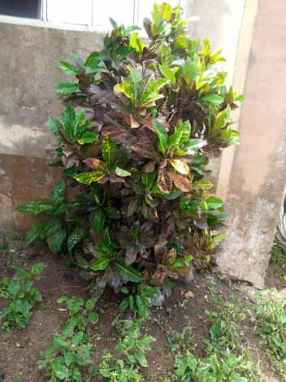
PIC 1. Photographs of ornamental plants Of Schools in Ila Orangun
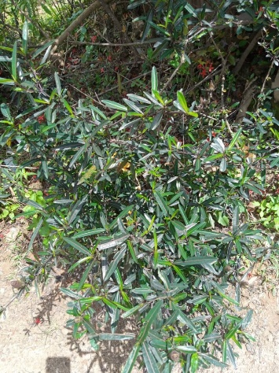
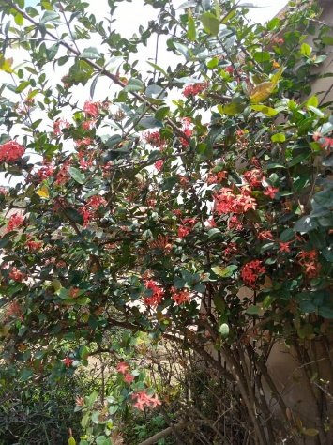
Ixora coccinea Pyracantha fortuneana Codiaeum variegatum

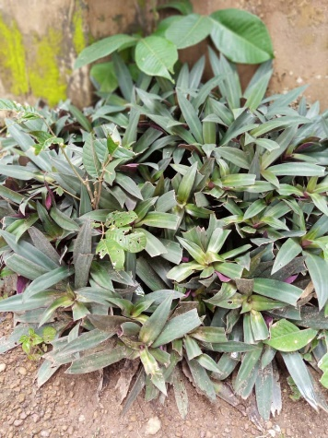
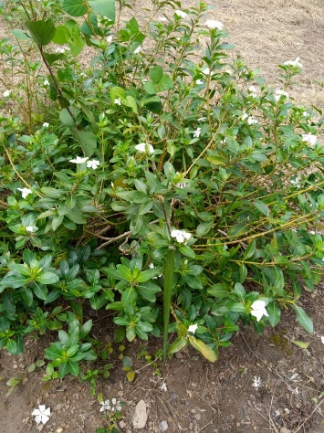
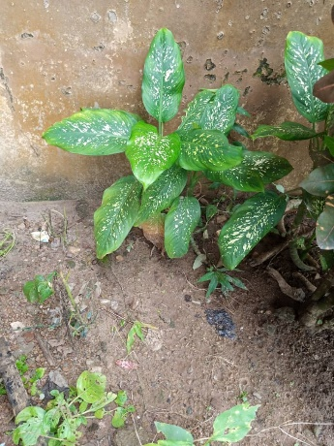

Tradescantia spatha Cutharanthus roseus Dieffenbachia seguine

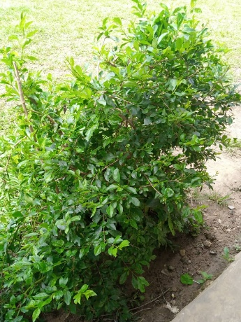
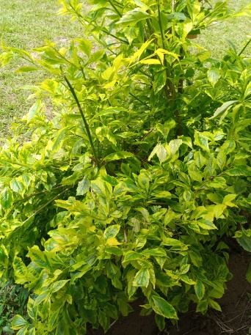
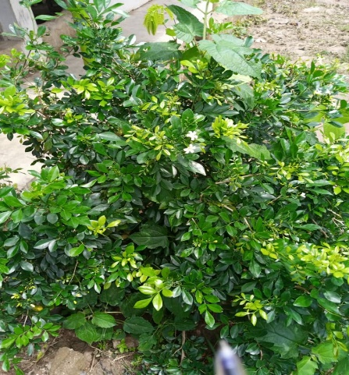

Duranta erecta Duranta erecta Murraya paniculata

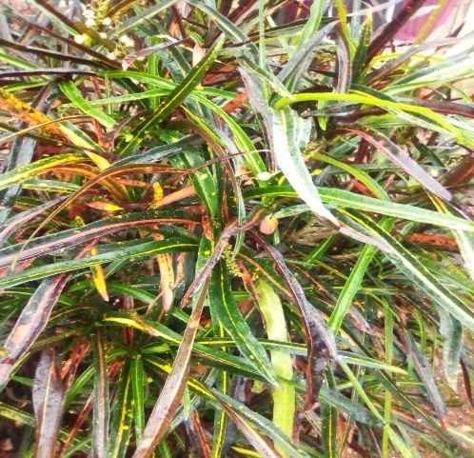
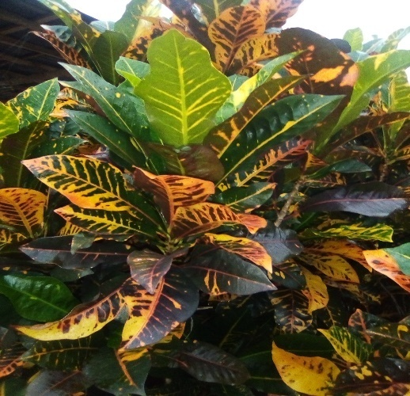
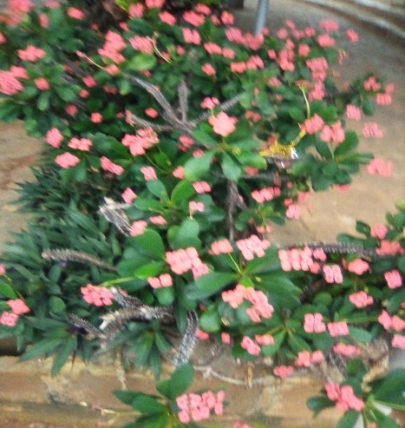

Codiaeum variegatum Codiaeum variegatum Euphorbia milii

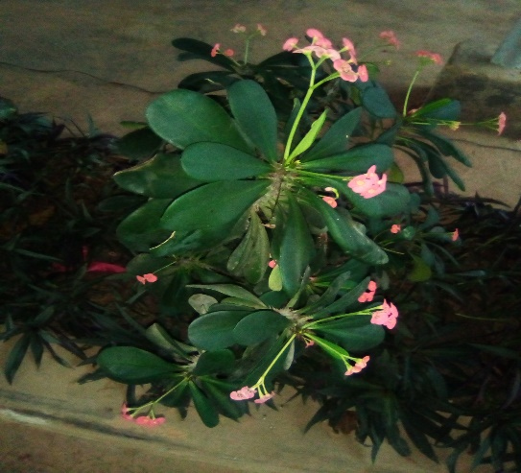
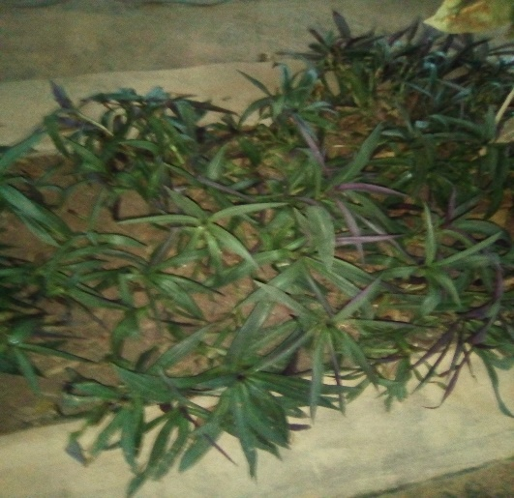

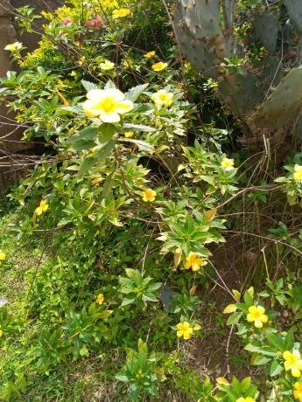
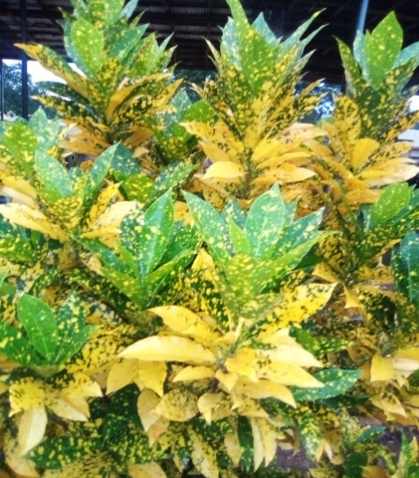
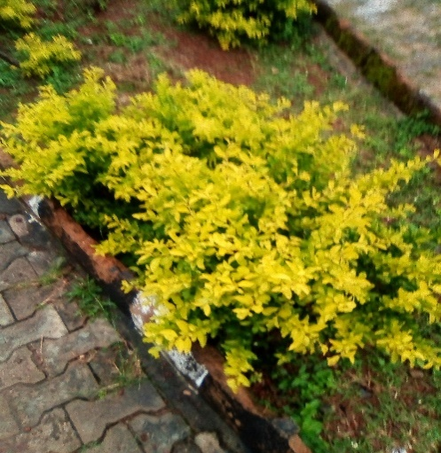
Tradescantia spathacea Euphorbia milii
Codiaeum varegatum Turnera difusa Ligustrum ovalifolium
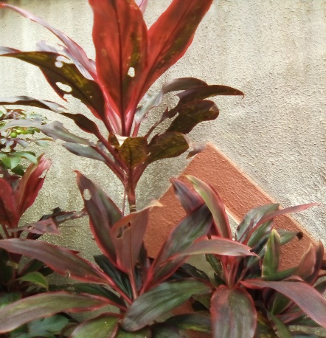
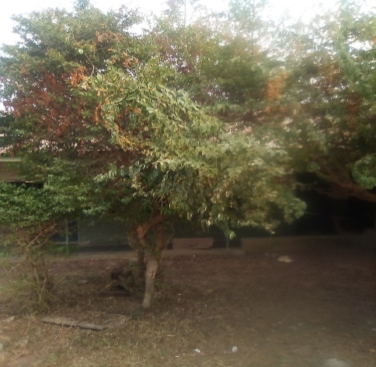
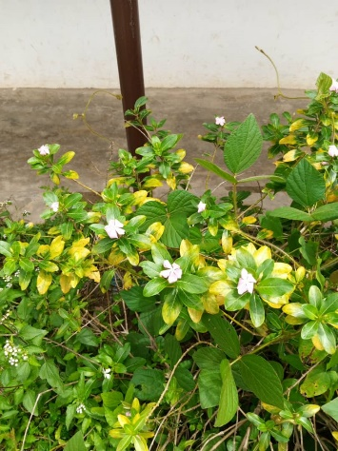

Cordyline fruticose Catharanthus roseus Duranta erecta
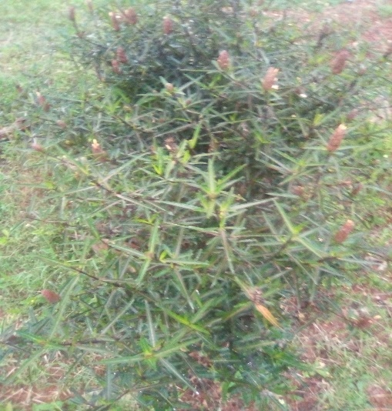
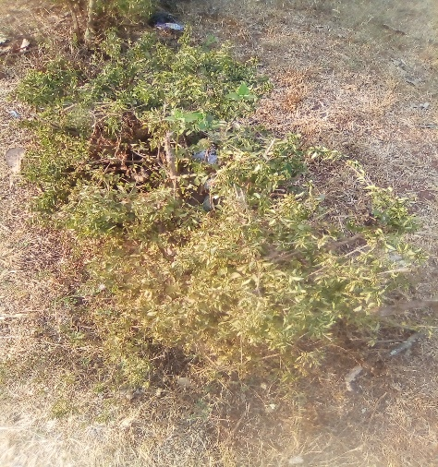
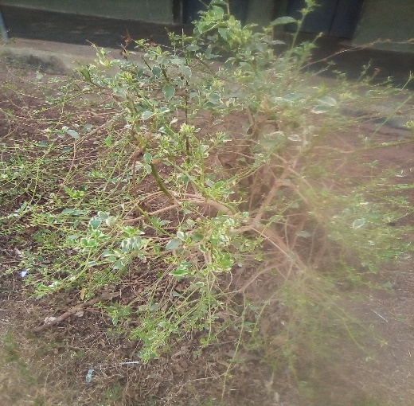

Ludwigia octovalvis Vinca major Duranta erecta

Table 6 ORNAMENTAL PLANTS IN CHURCHES OF ILA-ORANGUN
S/N | Churches | Family Name | Scientific Name |  | Common Name | Uses |  | Number of Stands
1 | Deeper Life Campus Fellowship | Asparagaceae | AGAVE AMERIANA |  |  | Hedges |  | 2
 |  | Araceae | CODIAEUM VARIEGATHUEM |  | CODIAEUM VARIEGALUEM | Hedges |  | 2
2 | Jesus Grace Bible Church | Asparagaceae | AGAVE SISALANA PERRIAE |  | Mescal | Hedges |  | 7
3 | Deeper Life Camp. Ground | Euphorbiaceae | EUPHORBIA MILI |  | crown of thorns | Hedges plant |  | 3
 |  |  | CORDIACUM VARIEGALUM |  | variegantal croton | Hedges |  | 7
 |  | Cypeiaceae | UNCINA RUBRA |  |  | Hedges |  | 3
 |  | Rubiaceae | IXORA CACCINEA |  |  | Hedges |  | 1
4 | First Baptist Church | Cactaceae | OPUNTIA ENGELMANNII |  | cowtangue cactus | Hedges |  | 2
 |  | Malvaceae | HABISCUS ROSA-SINESIS |  | Hawalian hibiscus
5 | St Mathew Anglican Church | 0 | 0 | 0 |  |  | 0 |  | 0
6 | St Mathew Anglican Church | 0 | 0 | 0 |  |  | 0 |  | 0
7 | Christ Apostolic Church Students’ Association | O | 0 | 0 |  |  | 0 |  | 0
8 | Redeem Student Fellowship | 0
9 | Anglican church of Pentecost | 0 | 0 | 0 |  |  | 0 |  | 0
10 | Church of Pentecost | 0 | 0 | 0 |  |  | 0 |  | 0

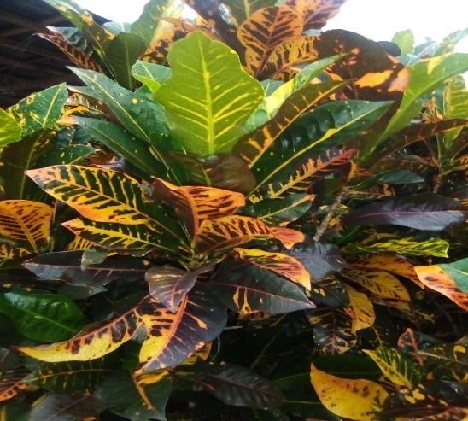
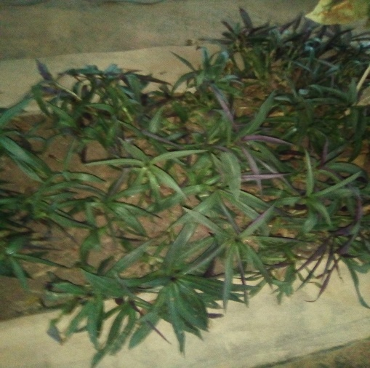
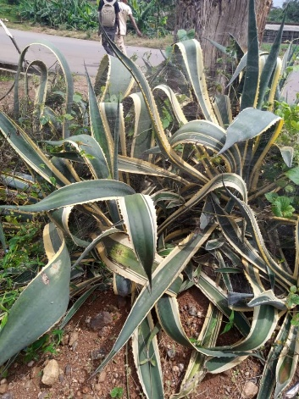

Agave sisalana Tradescantia spathacea Codiaeum variegatum

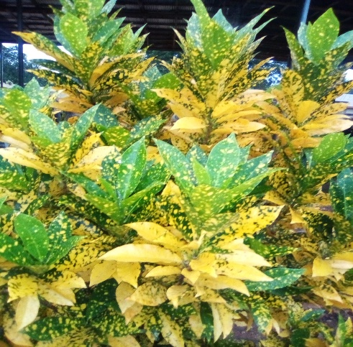
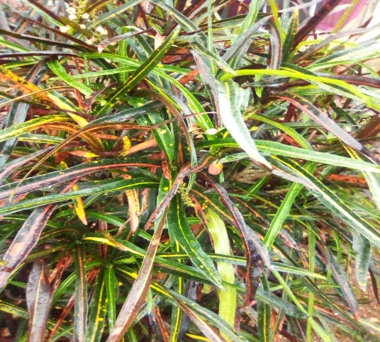
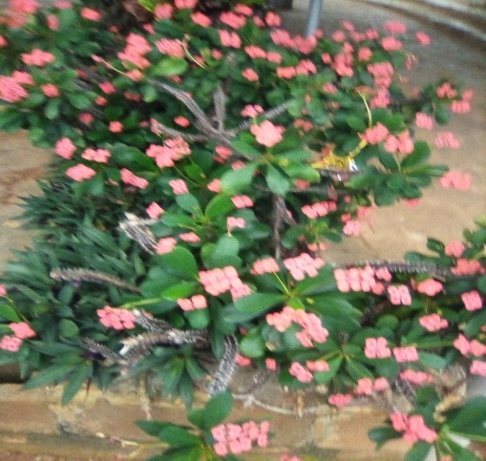

Codiaeum varigatum Euphorbia milii Codiaeum variegatum
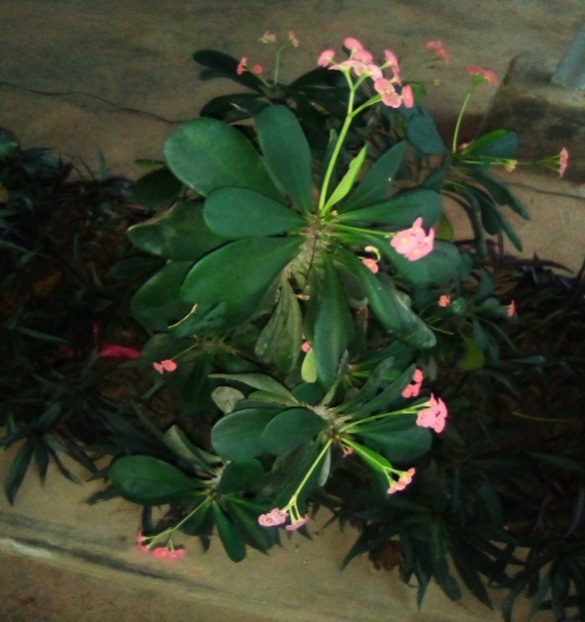
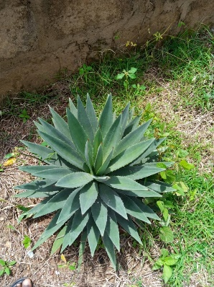

Agavesisalana perrine Euphorbia milii

PIC 2. Photographs of ornamental plants Of Schools in churches of Ila-Orangun
These are the pants that are planted inside the church (Interior plants) which were
Euphorbia milii, Codiaeum varigatum and Tradescantia spathacea and this could be traced to insecticidal properties to repel insects and sting organism which may be harmful to members of the church
Table 7 INTERIOR ORNAMENTAL PLANTS IN CHURCHES
SN | Church | Family Name | Scientific Name | Common Name | Number of stands
1 | Deeper Life Camp. Ground | Euphorbiaceae | EUPHORBIA MILI | crown of thorns | 3
 |  | Araceae | CODIAEUM VARIEGALUM | variegantal croton | 7
 |  |  | TRADESCANTIA SPATHACEA

Conclusion
This survey highlighted a rich diversity of ornamental plants in schools and churches within Ila Local Government Area, Osun State. The dominance of Duranta erecta and Agave sisalana perrine indicates their adaptability and preference among local landscapers. The findings call for greater conservation awareness and the intentional cultivation of a broader range of ornamental plants to enhance biodiversity and promote ecological balance in communal spaces.
REFERENCES
Acquaah, G. (2002). Horticulture: Principles and practices (2nd ed.). Pearson Education Inc., Singapore.
Adefemi, S. O. (2017). Assessment of ornamental plants in urban landscapes: A case study of selected parks in southwestern Nigeria. Journal of Environmental Sciences and Resource Management, 9(2), 24–32.
Ajibade, G. A., Fawole, O. A., & Kolawole, O. T. (2019). Survey and inventory of ornamental plants in selected institutions in Oyo State, Nigeria. Nigerian Journal of Horticultural Science, 24(1), 33–41.
Amlekar, M., Manza, R. R., Yannawar, P., & Gaikwad, A. T. (2014). Leaf features based on plant classification using artificial neural network. IBMRD’s Journal of Management and Research, 8(4), 78–81.
Arai, K., Nugraha, I., & Okumura, H. (2013). Identification of ornamental plant functioned as medicinal plant based on redundant discrete wavelet transformation. International Journal of Advanced Research in Artificial Intelligence, 2(5), 70–71.
Ay, S. (2009). Exportation of ornamental plants, problems and solution offers: A study in Yalova district.
Baiyewu, R. A., Amusa, N. A., & Olayiwola, O. (2005). Survey on the use of ornamental plants for environmental management in South Eastern Nigeria. Journal of Agriculture and Biological Sciences, 1(3), 237–240.
Bankole, A. (2002). The Nigerian tourism sector: Economic contribution, constraints, and opportunities. Journal of Hospitality Financial Management, 10(1), 71–89.
Baur, J. W. R., & Tynon, J. F. (2010). Small-scale urban nature parks: Why should we care? Leisure Sciences, 32(2), 195–200. https://doi.org/10.1080/01490400903547153
Begue, A., Kowlessur, V., Singh, U., Mahomoodally, F., & Pudaruth, S. (2017). Automatic recognition of medicinal plants using machine learning techniques. International Journal of Advanced Computer Science and Applications, 8(4), 166–175.
Bluestem Nursery. (2017). Bluestem Nursery. Retrieved October 10, 2017.
Brolin, C. B. (2012). Architectural ornament: Punishment and return. W.W. Norton & Co.
Burkill, H. M. (1985). The useful plants of West Tropical Africa (Vols. 1–5). Royal Botanic Gardens, Kew.
Choudhary, C. E., Burgos-Garay, M. L., Moorman, G. W., & Hong, C. (2016). Pythium and Phytopythium species in two Pennsylvania greenhouse irrigation tanks. Plant Disease, 100(5), 926–932.
Colorado State University Extension. (2018). Horticulture classification terms.
Crave, H. (2016). Ethno-medicinal practices among the Mizo ethnic group in Lunlei District, Mizoram. Science Vision, 13, 24–34.
Dravigne, A., Waliczek, T. M., Lineberger, R. D., & Zajicek, J. M. (2008). The effect of live plants and window views of green spaces on employee perceptions of job satisfaction. HortScience, 43(1), 183–187.
Dudek, M. (2000). Architecture of schools: The new learning environments. Oxford, UK: Architectural Press.
Dyrmann, M., Karstoft, H., & Midtiby, H. S. (2016). Plant species classification using deep convolutional neural network. Biosystems Engineering, 115, 72–80.
Eze, J. M., & Onuoha, D. O. (2021). Diversity and distribution of ornamental plants in urban centers of southeastern Nigeria. International Journal of Botany Studies, 6(2), 45–53.
Fjeld, T., Veiersted, B., Sandvik, L., Riise, G., & Levy, F. (1998). The effect of indoor foliage plants on health and discomfort symptoms among office workers. Indoor and Built Environment, 7(4), 204–209.
Gowan, J. C. (1987). Trance, art, and creativity. Bearly Limited.
Grivetti, L. E., & Ogle, B. M. (2000). Value of traditional foods in meeting macro- and micronutrient needs: The wild plant connection. Nutrition Research Reviews, 13(1), 31–46.
Hines, J. E., Hungerford, H. R., & Tomera, A. N. (2010). Analysis and synthesis of research on responsible environmental behavior. Journal of Environmental Education, 18(2), 1–8.
Hutchinson, J., & Dalziel, J. M. (1954–1972). Flora of West Tropical Africa. Crown Agents, London.
Iwu, M. M. (1993). Handbook of African medicinal plants. CRC Press.
Laviana, J. E., Lawson, J. M., & Jones, D. R. (1983). Interior plants as air purifiers. Journal of Environmental Horticulture, 1(1), 39–41.
Liu, M., Kim, E., & Mattson, R. (2003). Physiological and emotional influences of cut flower arrangements and lavender fragrances on university students. Journal of Therapeutic Horticulture, 14, 18–27.
Lohr, V. I., Pearson-Mims, C. H., & Goodwin, G. K. (1996). Interior plants may improve worker productivity and reduce stress in a windowless environment. Journal of Environmental Horticulture, 14(2), 97–100.
Lohr, V. I., & Pearson-Mims, C. H. (2000). Physical discomfort may be reduced in the presence of interior plants. HortTechnology, 10(1), 53–58.
Niemelä, J. (1999). Ecology and urban planning. Biodiversity and Conservation, 8(1), 119–131.
Odugbemi, T. (2006). Outlines and pictures of medicinal plants from Nigeria (Vol. 1). University of Lagos Press.
Olaniyi, A. A. (2018). Inventory of landscape plants in educational institutions: A case study of Ibadan, Nigeria. African Journal of Sustainable Development, 8(1), 15–23.
Olorode, O. (1984). Essentials of botany. Ile-Ife, Nigeria: Obafemi Awolowo University Press.
Olowokudejo, J. D. (2008). An assessment of the diversity of flowering plants in Lagos, Nigeria. Journal of Plant Taxonomy and Geography, 63(2), 155–165.
Rapoport, A. (1982). The meaning of the built environment: A nonverbal communication approach. University of Arizona Press.
Sheets, V. L., & Manzer, C. D. (1991). Affect, cognition, and urban vegetation: Some effects of adding trees along city streets. Environment and Behavior, 23(3), 285–304.
Shibata, S., & Suzuki, N. (2004). Effects of an indoor plant on creative task performance and mood. Scandinavian Journal of Psychology, 45(5), 373–381.
Smith, T., & Jones, A. (2020). The role of hardy ornamental plants in sustainable urban landscaping. Journal of Urban Ecology, 6(1), 1–9.
Taylor, A. F., Kuo, F. E., & Sullivan, W. C. (2001). Coping with ADD: The surprising connection to green play settings. Environment and Behavior, 33(1), 54–77.
Ulrich, R. S., Simons, R. F., Losito, B. D., Fiorito, E., Miles, M. A., & Zelson, M. (1991). Stress recovery during exposure to natural and urban environments. Journal of Environmental Psychology, 11(3), 201–230.
Uphof, J. C. T. (1968). Dictionary of economic plants. J. Cramer.
Vitiello, D. (2001). Plants and healing: Greenery in the hospital environment. Urban Forestry & Urban Greening, 5(1), 29–34.

