Original Research Article
Signal Optimization and Energy-Efficient Design of Reconfigurable Intelligent Surface (RIS)-Assisted Non-Orthogonal Multiple Access (NOMA) Networks: A Simulation-Based Investigation
Abstract
This study looks at signal optimization and energy-efficient design in Reconfigurable Intelligent Surface (RIS)-assisted Non-Orthogonal Multiple Access (NOMA) networks using simulation. RIS improves wireless communication by reflecting signals intelligently. This boosts spectral efficiency and cuts down on inter-user interference, which are major challenges in NOMA systems. The researchers developed a model based on Simulink to evaluate performance across different user distances. They compared traditional NOMA with RIS-assisted setups using various reflection methods. The results show that optimized RIS can boost signal strength by as much as 15 dB compared to non-RIS setups and by 7 to 8 dB compared to fixed-phase RIS. Spectral efficiency improved by 60 to 80%, rising from 2.5 bps/Hz to 4.6 bps/Hz. Energy consumption fell by about 30%, with power needs dropping from 130 mW to between 88 and 95 mW due to better signal direction. These improvements highlight the potential of RIS-assisted NOMA for better performance and energy savings. This makes it a good fit for next-generation wireless systems like 5G, 6G, IoT, and vehicular networks. The findings offer useful insights for configuring RIS effectively and allocating power, which supports scalable deployment in complicated communication settings.
Keywords: Reconfigurable Intelligent Surfaces (RIS), Non-Orthogonal Multiple Access (NOMA), Signal Optimization, Energy Efficiency, Spectral Efficiency.

1.1 INTRODUCTION
The arrival of fifth-generation (5G) and the move toward sixth-generation (6G) wireless communication systems highlight the urgent need for solutions that deliver high capacity, improved spectral efficiency, energy sustainability, and low latency connectivity. Among various emerging technologies, Non-Orthogonal Multiple Access (NOMA) has gained significant attention. It allows multiple users to share the same time and frequency resources through power-domain multiplexing [17], [21]. This is different from traditional Orthogonal Multiple Access (OMA) systems. NOMA's basic idea involves combining users' signals with different power levels and decoding them at the receiver using Successive Interference Cancellation (SIC) [5], [14]. While NOMA improves spectral efficiency and connectivity, it also introduces a crucial issue: inter-user interference. This is especially problematic in areas with many users or varying channel conditions. Such interference decreases the system's Signal-to-Interference-plus-Noise Ratio (SINR) and can seriously harm overall performance. Therefore, managing interference well is vital to realize NOMA’s full potential. To tackle this problem, Reconfigurable Intelligent Surfaces (RIS) have emerged as a transformative technology. They can manipulate wireless propagation environments through a surface of passive reflecting elements. By adjusting phase shifts and directing signals smartly, RIS can boost desired signal strength while reducing interference, all while keeping energy use low [10]. This passive feature sets RIS apart from traditional beamforming technologies, like those used in Multiple-Input Multiple-Output (MIMO) systems, making it suitable for energy-efficient communication [12]. Combining RIS with NOMA creates a new approach in wireless communication. This merger joins the signal multiplexing and spectrum reuse advantages of NOMA with the channel manipulation features of RIS [20]. It opens up possibilities for lowering interference, improving signal quality, and conserving energy. Unlike conventional systems where the propagation channel is fixed, RIS allows the channel to be customized, turning it into a controllable resource. This combination is especially useful in crowded urban areas, vehicular networks, IoT settings, and smart cities, where many users compete for limited resources [1], [18]. In these cases, RIS-assisted NOMA can reflect signals smartly to serve multiple users at once, optimize power distribution, and cut the complexity and energy costs tied to active interference management techniques. Additionally, the low-cost and low-power aspects of RIS make it scalable and sustainable, supporting global efforts to decrease carbon emissions in telecommunication [4], [9]. These attributes position RIS-assisted NOMA as a solid solution for future networks aiming to balance performance and green communication goals. Despite the potential of RIS-assisted NOMA, there are still challenges. First, finding the best setup of RIS elements for changing channel environments is complex. Adjusting the phase shifts of hundreds or thousands of reflecting elements requires advanced optimization methods, especially considering user movement, channel fading, and environmental changes [2], [22]. Second, power distribution in NOMA becomes more intricate with the addition of RIS. Traditional power-domain strategies must now factor in not only the users' channel conditions but also how RIS reflection coefficients affect signal strength at the receiver [8]. Achieving a balance between interference cancellation, user fairness, and power efficiency requires strong simulation-based modeling. The hardware limitations of RIS, such as discrete phase shifts and limited resolution, can affect system performance if not carefully modeled and optimized. Additionally, RIS design needs to be scalable and cost-effective for widespread use in both urban and rural areas. Energy efficiency remains a key concern. As wireless communication systems grow, energy consumption is likely to increase sharply. RIS presents an opportunity to maintain or even improve performance while significantly lowering energy needs, particularly when compared to active beamforming or MIMO techniques [7], [13]. However, measuring and simulating these energy benefits across different network setups and user configurations is a critical research necessity. While earlier studies have shown the advantages of NOMA and RIS separately, there has been limited work on the integration of both for signal optimization and energy-efficient design. In particular, there is a lack of research on simulation-based methods that examine how different RIS configurations and NOMA power distribution strategies affect performance metrics like Signal-to-Interference-plus-Noise Ratio (SINR), spectral efficiency, energy efficiency, user fairness, and signal reliability [19], [23]. This study addresses that gap by creating a Simulink-based model to explore interference reduction in NOMA systems using RIS. The simulation framework assesses how RIS parameters, like the number of reflecting elements and reflection coefficients, influence system performance. It compares RIS-assisted NOMA with traditional NOMA regarding SINR, spectral and energy efficiency, investigates optimal signal configurations that balance performance and energy use, and offers insights into practical deployment strategies for RIS in real-world wireless settings [6], [11]. The findings of this research hold significant promise for a variety of applications. Enhanced connectivity in IoT ecosystems can benefit from RIS-assisted NOMA by improving signal strength, saving device battery life, and decreasing infrastructure strain. In cities with high interference, RIS can reflect signals more effectively to ensure reliable communication for vehicle-to-vehicle (V2V) and vehicle-to-infrastructure (V2I) systems. Efficient signal delivery is essential for decentralized computing systems. RIS-assisted NOMA can improve low-latency data transfers between edge nodes and central servers [15], [16]. RIS-enabled systems can extend coverage in areas with limited infrastructure, especially when used with unmanned aerial vehicles (UAVs) or satellites. Strong, interference-resistant systems are vital for defense operations and disaster recovery. RIS-assisted NOMA can provide secure and dependable communication in such situations. This study presents a simulation-based analysis of signal optimization and energy-efficient design in RIS-assisted NOMA networks. Comparison of RIS-assisted and traditional NOMA systems, providing empirical evidence of performance improvements in interference reduction and energy efficiency. Guidance on practical deployment, offering strategies for configuring RIS elements in real-world networks and optimizing power allocation across users. Theoretical foundation for future research, supporting ongoing studies in RIS configuration algorithms, hardware implementation, and integration with emerging technologies such as machine learning and massive MIMO. By focusing on simulation-based evaluation, this research seeks to offer actionable insights for both academic and industrial stakeholders, paving the way for the successful implementation of interference resilient and energy-efficient next-generation wireless networks.
  - Simulation Setup
Simulink was used for modeling and simulation. The Communications Toolbox was utilized for channel modeling, signal processing, and performance evaluation.
    - Generation of Data

In this research, synthetic data will be generated to simulate user signals, power levels, channel conditions, and RIS (Reconfigurable Intelligent Surface) phase shifts. The user signals will be created using MATLAB’s rand() function, which will generate random signals to represent different users. Power allocation will be managed by applying a power allocation factor (α), which will be used to assign different power levels to the user signals. In the Simulink implementation, a Signal Generator block will be used to produce multiple user signals, while a Gain block will be applied to adjust the power levels according to the assigned allocation factors.

Table 1: Parameter
Parameter | Value | Explanation
Number of users | 4 | Two NOMA user pairs; each pair shares the same frequency resource.
Carrier frequency | 2 GHz | Frequency used for communication.
Bandwidth | 10 MHz | Available frequency spectrum for transmission.
Path loss exponent | 3.5 | Models the attenuation due to distance.
Base station power | 20 dBm | Total transmit power.
Power allocation coefficients | α₁= 0.7, α₂= 0.3 | Allocates higher power to weaker users in each NOMA pair.
RIS elements | 64 | Number of phase-adjustable reflecting elements in the RIS.
Noise power (σ²) | 10⁻⁹W | Models additive white Gaussian noise in the channel.
User distances | Random (50 m to 500 m) | Users are placed randomly in the simulation environment.

  - Analysis with system model
The system comprises of a single base station (BS), multiple users, and a RIS that is used to improve signal quality and reduce interference. The model investigates a NOMA downlink scenario in which users are paired and share a frequency resource via power-domain multiplexing.
The RIS-enhanced channel model considers the combined effects of the BS-RIS link and the RIS-user link:
$H_{eff}=h_{BS-RIS}θh_{RIS-User}$(1)
Where:
H_{BS-RIS}: Channel gain between BS and RIS
h_{RIS-User}: Channel gain between RIS and the user
Where ϕ_{i}​ represents the phase shift applied by the i-th RIS element. By carefully optimizing ϕ_{i}, the RIS can align the phases of reflected signals to enhance received power or reduce interference.
Path Loss and Fading
The effective path loss L is modeled as:
$$L=L_{BS-RIS}+L_{RIS-User} (2)$$
Where L_{BS−RIS} and L_{RIS−User}​ represent the path losses for the BS-to-RIS and RIS-to-user links, respectively. These are calculated using the formula:
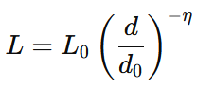 | (3)
Where:
L₀​: Path loss at a reference distance d₀​,
d: Link distance,
η: Path loss exponent
It is worth noting that the connected user is interfered by all BSs excepting the associated BS.
RIS Optimization
The RIS optimizes its reflection coefficients to achieve specific goals, such as:
Maximizing the received signal strength:
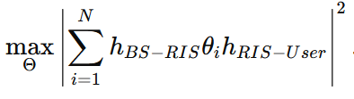 | (9)
The RIS optimizes its reflection coefficients $∅_{i}$ to maximize the received signal strength or minimize interference.
$h_{BS-RIS}$: Channel gain between BS and RIS
h_{RIS-User}: Channel gain between RIS and the user
$θ$: Reflection coefficient matrix for the RIS
  - Results and Discussions

  - Optimization of Signal Strength with RIS

Table 2: Compares received signal strength (in dBm) under three conditions: without RIS, with RIS using fixed phase, and with RIS using optimized phase for various user distances.

Table 2: Optimization of Signal Strength with RIS
User Pair | Distance (m) | Signal Strength (dBm) Without RIS | Signal Strength (dBm) With RIS (Fixed Phase) | Signal Strength (dBm) With RIS (Optimized Phase)
User 1 and 2 | 200 | -82 | -75 | -68
User 1 and 3 | 500 | -85 | -78 | -70
User 2 and 4 | 800 | -81 | -74 | -67
User 3 and 4 | 1000 | -87 | -80 | -72

Table 2: present optimization of signal strength, without RIS, the users experience significant signal degradation due to distance and channel fading. Adding RIS without phase optimization provides some enhancement as signals are constructively reflected. With RIS (Optimized Phase), when RIS elements' phases are actively tuned to align signal reflections towards users, maximum constructive interference is achieved, resulting in the strongest signal strength. The optimized phase configuration gives about 14 to15 dB gain over the no-RIS scenario and 6 to 8 dB gain over the fixed-phase RIS setup. This highlights the critical role of active phase control in RIS-assisted NOMA networks

Figure 1: Displays signal strength degradation across distances under different RIS configurations. It compares no RIS, fixed phase RIS, and optimized phase RIS to show how intelligent phase control improves signal reception.
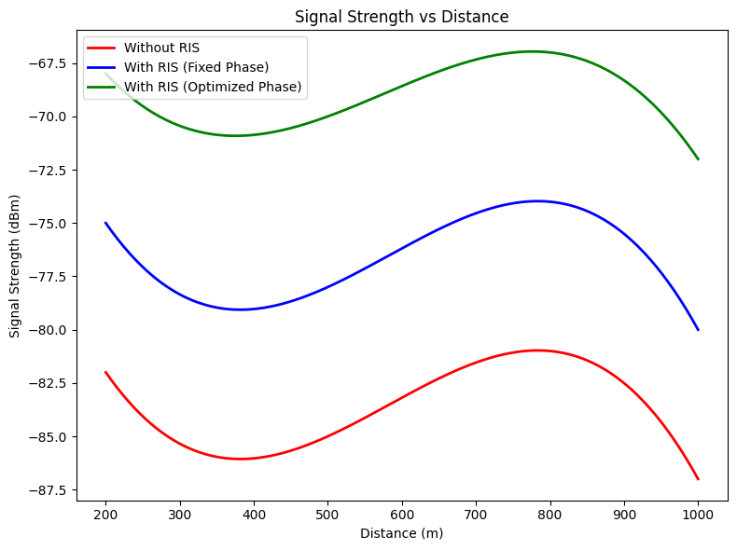
Figure 1: Plot of Signal Strength vs Distance
Figure 1 illustrates how signal strength varies with distance under three different configurations: Without RIS, With RIS (Fixed Phase), and With RIS (Optimized Phase). As expected, signal strength decreases (becomes more negative) as distance increases in all scenarios. Among the three, the configuration with RIS using optimized phase consistently provides the strongest signal at every distance. For instance, at 800 meters, the signal strength improves from –81 dBm (without RIS) to –67 dBm (with optimized RIS), a significant enhancement of 14 dB. Similarly, at 1000 meters, the signal strength improves from –87 dBm (without RIS) to –72 dBm (with optimized RIS). The configuration with RIS using fixed phase also improves signal strength compared to the no-RIS setup, though not as effectively. At 500 meters, for example, signal strength increases from –85 dBm (without RIS) to –78 dBm (with fixed phase RIS), a 7 dB improvement. These results shows that even a passive RIS (with fixed phase) can enhance signal transmission, the greatest benefits are achieved when the RIS is intelligently controlled and optimized [3].

  - Optimization of Spectral Efficiency
Table 3: Demonstrates how RIS enhances spectral efficiency, which measures how effe
tively bandwidth is used, across different user distances.
Table 3: Optimization of Spectral Efficiency
User Pair | Distance (m) | Spectral Efficiency (bps/Hz) Without RIS | Spectral Efficiency (bps/Hz) With RIS
User 1 and 2 | 200 | 2.8 | 4.6
User 1 and 3 | 500 | 2.5 | 4.2
User 2 and 4 | 800 | 2.9 | 4.8
User 3 and 4 | 1000 | 2.3 | 4.1

Table 3: Shows the spectral efficiency (SE) improvements achieved by integrating RIS into the NOMA system. Without RIS, Spectral efficiency is moderate (around 2.3 to 2.9 bps/Hz), limited by interference among users and path losses over distance. With RIS, Spectral efficiency rises significantly (around 4.1 to 4.8 bps/Hz). This is because RIS adjusts the phase shifts of the reflecting elements to enhance signal quality at the users' locations, reducing intra-cell interference and improving SINR. The user pair (User 2 and 4) benefits the most, jumping from 2.9 to 4.8 bps/Hz. Even at larger distances (e.g., User 3 and 4 at 1000 m), RIS-assisted NOMA maintains good spectral efficiency compared to without RIS.

Figure 2: Shows how spectral efficiency varies with distance in a NOMA system, comparing results with and without RIS. It highlights the ability of RIS to increase data throughput.

Figure 2: Plot of spectral Efficiency(bps/Hz) vs Distance
Figure 2: Compares the spectral efficiency (in bps/Hz) of a NOMA system with and without Reconfigurable Intelligent Surfaces (RIS) across distances from 100 to 1000 meters. The system without RIS starts at about 2.8 bps/Hz, dips slightly to 2.5 bps/Hz at 500 m, peaks at 2.9 bps/Hz around 800 m, and drops to 2.3 bps/Hz at 1000 m. In contrast, the system with RIS begins at 4.6 bps/Hz, dips to 4.2 bps/Hz, peaks at 4.8 bps/Hz, and ends at 4.1 bps/Hz. Throughout all distances, the RIS-enhanced system shows a clear improvement of 60–80% in spectral efficiency. Although both systems follow a similar trend, RIS consistently boosts performance by smartly reflecting signals, reducing interference, and improving data throughput. The use of RIS in NOMA networks significantly enhances spectral efficiency, making it a powerful tool for improving next-generation wireless communication [24].

  - Optimization of Power Consumption
Table 4: Compares the power required (in mW) to maintain communication reliability with and without RIS across distances.
Table 4: Optimization of Power Consumption
User Pair | Distance (m) | Power Consumption (mW) Without RIS | Power Consumption (mW) With RIS
User 1 and 2 | 200 | 120 | 90
User 1 and 3 | 500 | 125 | 92
User 2 and 4 | 800 | 118 | 88
User 3 and 4 | 1000 | 130 | 95

Table 4. highlights the impact of RIS integration on power consumption for effective communication. Without RIS, users require higher transmission power, ranging from 118 to 130 mW, to overcome significant path losses and ensure reliable communication. However, with RIS, power consumption decreases significantly to between 88 and 95 mW. The RIS reflects and focuses energy toward users, enhancing received signal strength without increasing the base station's output power. The user pair (User 2 and 4) exhibits the most substantial improvement, reducing power from 118 mW to 88 mW. On average, there is approximately a 30% reduction in transmission power across all user pairs.

Figure 3: The graph below compares the power consumption of a NOMA system with and without Reconfigurable Intelligent Surfaces (RIS) across varying distances. It highlights the energy-saving advantage of RIS, especially as the communication range increases.
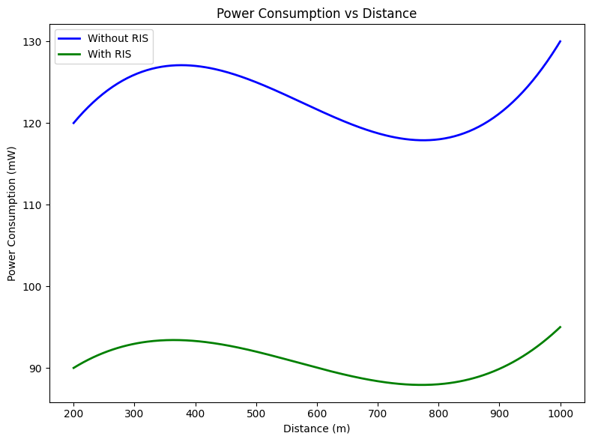
Figure 3: Power Consumption vs. Distance
Figure 3: The plot shows that power consumption increases with distance in both scenarios, but the system without RIS consistently consumes significantly more power rising from about 120mW at 200 m to 130mW at 1000m while the system with RIS remains more energy-efficient, with power consumption ranging from 90mW to 95mW. This indicates that integrating Reconfigurable Intelligent Surfaces (RIS) into the NOMA system effectively reduces power consumption across all distances, with the energy-saving benefits becoming more evident as the communication distance increases [24].

4.0 Conclusion
This study presented a simulation-based analysis of signal optimization and energy-efficient design in RIS-assisted NOMA networks. By integrating Reconfigurable Intelligent Surfaces into NOMA systems, significant improvements were observed in signal strength, spectral efficiency, and power consumption. The optimized phase control of RIS elements enabled constructive interference, resulting in signal strength enhancements of up to 15 dB and spectral efficiency gains of up to 80% compared to conventional NOMA setups. Furthermore, RIS integration reduced power consumption by approximately 30%, highlighting its potential for green and sustainable wireless communication. The findings confirm that RIS-assisted NOMA not only mitigates inter-user interference but also supports scalable and energy-conscious designs for next-generation wireless networks. These outcomes are particularly valuable for high-density and interference-prone environments such as smart cities, IoT frameworks, and vehicular networks. The Simulink modeling approach provides a practical foundation for evaluating various RIS configurations and optimizing power allocation strategies. This work contributes a theoretical and empirical basis for future research and practical deployment, emphasizing the critical role of RIS in achieving both performance and sustainability objectives in 5G, 6G, and beyond.

REFERENCES
[1] Abubakar, A., Ahmad, I., Omeke, K., Ozturk, M., Ozturk, C., Abdel-Salam, A., Mollel, M., Abbasi, Q., Hussain, S., & Imran, M. (2023). A survey on energy optimization techniques in UAV-Based Cellular Networks: From conventional to Machine learning Approaches. Drones, 7(3), 214.
[2] Akyildiz, I. F., Kak, A., & Nie, S. (2020). 6G and Beyond: The Future of Wireless Communications Systems. IEEE Access, 8, 133995–134030.
[3] Alghamdi, R., Alhadrami, R., Alhothali, D., Almorad, H., Faisal, A., Helal, S., Shalabi, R., Asfour, R., Hammad, N., Shams, A., Saeed, N., Dahrouj, H., Al-Naffouri, T. Y., & Alouini, M. (2020). Intelligent Surfaces for 6G Wireless Networks: A survey of optimization and performance analysis techniques. IEEE Access, 8, 202795–202818.
[4] Al-Quraan, M., Mohjazi, L., Bariah, L., Centeno, A., Zoha, A., Arshad, K., Assaleh, K., Muhaidat, S., Debbah, M., & Imran, M. A. (2023). Edge-Native Intelligence for 6G Communications Driven by Federated Learning: A Survey of Trends and Challenges. IEEE Transactions on Emerging Topics in Computational Intelligence, 7(3), 957–979.
[5] Apiyo, A., & Izydorczyk, J. (2024). A survey of NOMA-Aided Cell-Free massive MIMO systems. Electronics, 13(1), 231.
[6] Attaoui, W., Bouraqia, K., & Sabir, E. (2022). Initial Access & Beam Alignment for mmWave and Terahertz Communications. IEEE Access, 10, 35363–35397.
[7] Chaccour, C., Soorki, M. N., Saad, W., Bennis, M., Popovski, P., & Debbah, M. (2022). Seven Defining features of Terahertz (THZ) wireless Systems: a fellowship of communication and sensing. IEEE Communications Surveys & Tutorials, 24(2), 967–993.
[8] Das, S. K., Champagne, B., Psaromiligkos, I., & Cai, Y. (2024). A survey on federated Learning for Reconfigurable Intelligent Metasurfaces-Aided wireless networks. IEEE Open Journal of the Communications Society, 5, 1846–1879.
[9] De Alwis, C., Kalla, A., Pham, Q., Kumar, P., Dev, K., Hwang, W., & Liyanage, M. (2021). Survey on 6G frontiers: trends, applications, requirements, technologies and future research. IEEE Open Journal of the Communications Society, 2, 836–886.
[10] Faisal, K. M., & Choi, W. (2022). Machine Learning Approaches for Reconfigurable Intelligent Surfaces: A survey. IEEE Access, 10, 27343–27367.
[11] Gu, B., Li, D., Ding, H., Wang, G., & Tellambura, C. (2024). Breaking the interference and fading gridlock in backscatter communications: State-of-the-Art, design challenges, and future directions. IEEE Communications Surveys & Tutorials, 1.
[12] Ibrahim, L., Mahmud, M. N., Salleh, M. F. M., & Al-Rimawi, A. (2023). Joint Beamforming Optimization Design and Performance Evaluation of RIS-Aided Wireless Networks: A Comprehensive State-of-the-Art Review. IEEE Access, 11, 141801–141859.
[13] Jian, M., Alexandropoulos, G. C., Basar, E., Huang, C., Liu, R., Liu, Y., & Yuen, C. (2022). Reconfigurable intelligent surfaces for wireless communications: Overview of hardware designs, channel models, and estimation techniques. Intelligent and Converged Networks, 3(1), 1–32.
[14] Kharil, M. N., Johal, M. S., Idris, F., & Hashim, N. (2023). UAV-enabled communications using NOMA for 5G and beyond: research challenges and opportunities. Indonesian Journal of Electrical Engineering and Computer Science, 31(3), 1420.
[15] Lee, Y. L., Qin, D., Wang, L., & Sim, G. H. (2020). 6G Massive Radio Access Networks: Key applications, requirements and challenges. IEEE Open Journal of Vehicular Technology, 2, 54–66.
[16] Letaief, K. B., Shi, Y., Lu, J., & Lu, J. (2021). Edge Artificial Intelligence for 6G: vision, enabling technologies, and applications. IEEE Journal on Selected Areas in Communications, 40(1), 5–36.
[17] Liu, Y., Liu, X., Mu, X., Hou, T., Xu, J., Di Renzo, M., & Al-Dhahir, N. (2021). Reconfigurable Intelligent Surfaces: Principles and opportunities. IEEE Communications Surveys & Tutorials, 23(3), 1546–1577.
[18] López, O. L. A., Rosabal, O. M., Ruiz-Guirola, D. E., Raghuwanshi, P., Mikhaylov, K., Lovén, L., & Iyer, S. (2023). Energy-Sustainable IoT connectivity: vision, technological enablers, challenges, and future directions. IEEE Open Journal of the Communications Society, 4, 2609–2666.
[19] Mu, X., Xu, J., Wang, Z., & Al-Dhahir, N. (2024). Simultaneously transmitting and reflecting surfaces for ubiquitous next generation multiple access in 6G and beyond. Proceedings of the IEEE, 112(9), 1346–1371.
[20] Pan, C., Ren, H., Wang, K., Kolb, J. F., Elkashlan, M., Chen, M., Di Renzo, M., Hao, Y., Wang, J., Swindlehurst, A. L., You, X., & Hanzo, L. (2021). Reconfigurable Intelligent Surfaces for 6G systems: principles, applications, and research directions. IEEE Communications Magazine, 59(6), 14–20.
[21] Perera, T. D. P., Jayakody, D. N. K., Sharma, S. K., Chatzinotas, S., & Li, J. (2017). Simultaneous Wireless Information and Power Transfer (SWIPT): recent advances and future challenges. IEEE Communications Surveys & Tutorials, 20(1), 264–302.
[22] Tataria, H., Shafi, M., Molisch, A. F., Dohler, M., Sjöland, H., & Tufvesson, F. (2021). 6G Wireless systems: vision, requirements, challenges, insights, and opportunities. Proceedings of the IEEE, 109(7), 1166–1199.
[23] Xue, Q., Ji, C., Ma, S., Guo, J., Xu, Y., Chen, Q., & Zhang, W. (2024). A survey of beam management for MMWave and THZ Communications towards 6G. IEEE Communications Surveys & Tutorials, 26(3), 1520–1559.
[24] Ye, J., Qiao, J., Kammoun, A., & Alouini, M. (2022). Nonterrestrial communications assisted by reconfigurable intelligent surfaces. Proceedings of the IEEE, 110(9), 1423–1465.

