*Case report*

**Challenging the Guidelines: Successful Percutaneous Mitral Valvuloplasty in a Case of Left Atrial Thrombus**

.

Abstract

|  |
| --- |
| **Aims:** Mitral stenosis is strongly associated with atrial fibrillation and consequent thrombus formation in the left atrial appendage (LAA), posing a significant risk for cardioembolic stroke. Oral anticoagulation remains the standard of care; however, challenges such as persistent thrombus, bleeding risks, and patient non-compliance have prompted investigation into alternative strategies, including percutaneous LAA closure. Traditionally considered a contraindication, the presence of LAA thrombus is now being reevaluated in light of emerging techniques and procedural safeguards.  **Presentation of Case:** A 57-year-old woman with rheumatic mitral stenosis presented with progressive exertional dyspnea and orthopnea. Examination revealed signs consistent with severe mitral stenosis, and TTE confirmed a valve area of 0.7 cm² without thrombus. She was scheduled for PBMV, but pre-procedural TEE revealed a small left atrial thrombus (1.2 × 1.1 cm), leading to temporary postponement. After three days of intravenous heparin, follow-up TEE showed thrombus reduction, and PBMV was successfully performed using a 25-mm Inoue balloon. Post-procedure, the mitral valve area improved to 1.5 cm² with no complications. The patient was discharged on warfarin and remained symptom-free on follow-up.  **Discussion and Conclusion:** Left atrial (LA) thrombus occurs in 10–25% of patients with rheumatic mitral stenosis and is often associated with atrial fibrillation and left atrial enlargement. In this case, type of LA thrombus responsive to iv anticoagulant, allowing safe PBMV using a modified over-the-wire technique that minimized thrombus disturbance. This suggests that, with careful assessment and technique, LA thrombus may not be an absolute contraindication to PBMV. |

*Keywords: Left atrial appendage, thrombus, mitral stenosis, percutaneous balloon mitral valvulopasty*

1. INTRODUCTION

Percutaneous balloon mitral valvuloplasty (PBMV) is a safe approved procedure in patients with severe mitral stenosis (Coisne, Augustin, et al. 2023). One of the contraindications of the procedure is presence of a left atrial thrombus, seen on transesophageal echocardiogram (TEE) (Sharma S, Kolekar SS. 2015). However, there have been report that PBMV, using can be performed safely in patients with left atrial appendage thrombus who are on anticoagulation therapy. It has also been reported that intense warfarin therapy may lead to dissolution of left atrial thrombus, following which successful PBMV can be performed. The authors report a patient who was referred for PBMV and was found to have a left atrial thrombus. After intense warfarin therapy, successful PBMV was undertaken without complications

2. PRESENTATION OF CASE

A 57-year-old woman with a history of rheumatic mitral stenosis was referred to our facility for percutaneous balloon mitral valvuloplasty (PBMV) due to worsening exertional dyspnea and orthopnea that had developed over the past six months. Her physical examination showed no signs of jugular venous distention; lung auscultation revealed mild pulmonary rales at the lung bases, while cardiac auscultation indicated an increased intensity of the first heart sound, an opening snap, and a mid-diastolic rumble. There was no pedal edema noted. The electrocardiogram demonstrated atrial fibrillation at a rate of 70 beats per minute, along with nonspecific ST and T wave changes.

At the initial evaluation, her medication regimen included 5 mg of warfarin daily, with an average INR of approximately 2.0. A transthoracic echocardiogram (TTE) was performed, revealing severe mitral stenosis, with a calculated mitral valve area of 0.7 cm². The mitral leaflets were slightly thickened yet highly mobile with minimal restriction, and there was a trivial degree of mitral regurgitation. No calcification was observed in the leaflets or subvalvular structures, and no thrombus was present in the left atrial appendage at that time (**Figure 1**).

The patient was scheduled for PBMV. Before the procedure, she was admitted to the hospital for a transesophageal echocardiogram (TEE), which detected a small mass consistent with thrombus in the left atrial cavity of size 1.2 cm x 1.1 cm (**Figure 2**). Consequently, the procedure was postponed, and anticoagulation therapy was transitioned from warfarin to intravenous heparin for three days. A follow-up TEE showed that the thrombus had decreased in size compared to the initial observation, allowing PBMV to proceed. Undergoing PBMV with a 25-mm Inoue balloon, the procedure had no complications. (**figure 3**). The mitral valve area improved from 0.7 cm² to 1.5 cm², and the left atrial to left ventricular gradient decreased from 7 mmHg to 2 mmHg. She remained hospitalized for an additional 48 hours, during which period her warfarin therapy was restarted. During subsequent follow-up, the patient reported being symptom-free with no signs of embolic events

3. discussion

The occurrence of left atrial thrombi in patients with rheumatic mitral stenosis varies from 10% to 25% in pathological and surgical series. (Hasan, 2021). The transthoracic echocardiogram has a sensitivity of 59% and a specificity of 99% for detecting left atrial thrombi. False-negative results are often due to thrombi that are situated in the left atrial appendage or laminated, organized thrombus that is adhered to the atrial wall. TEE is highly accurate for diagnosing left atrial thrombi and is currently the preferred method. Such thrombus formation can occur in patients with atrial fibrillation, mitral stenosis, enlarged left atrial cavities, and low cardiac indices, all of which promote blood stasis. (Ashraf, T.et al. 2024). Additional risk factors for thromboembolic events, aside from the presence of left atrial thrombus, include advanced age, atrial fibrillation, previous valve surgery, and a history of thromboembolic incidents. The natural course and mechanisms underlying left atrial thrombus formation remain uncertain. Experimental studies have indicated that echogenic contrasts are linked to red blood cell aggregation and require fibrinogen's presence. (Branco, Luísa Moura. 2024).

The hemostatic conditions within the right and left atria in patients with mitral stenosis noted that fibrinopeptide A and thrombin-antithrombin III complex levels in the left atrium were significantly elevated compared to those in the right atrium or peripheral circulation, concluding that the coagulation system is activated in the left atrium of mitral stenosis patients, even while on anticoagulation. In another study, showed that anticoagulation with warfarin in mitral stenosis not only reduces systemic coagulation activity but is associated with greater reduction in the left atrial coagulation activity. (Gupta, A. V.2019).

It is known that, in mitral stenosis, atrial thrombi may be in multiple locations in the left atrium (LA), and may even be loose and mobile in the atrial cavity, but in around half of cases are located in the LAA. (Miika, K. 2017). Their presence is considered a contraindication for percutaneous mitral valvotomy, as they carry the risk of causing periprocedural thromboembolism, with its associated morbidity and mortality. Atrial thrombi are considered an indication for surgery in mitral stenosis. However, a period of anticoagulation can be tried, which may last up to six months. There was some clinicians studied the clinical features of intracardiac thrombi based on echocardiography and the effect of anticoagulant therapy. They found that thrombi were reduced in 29% cases and concluded the effect of anticoagulant therapy on the regression of thrombi depends on its age. (Ashraf, T.et al. 2024)

In this report, we found thrombus at left atrial cavity and given intravenous heparin for three days with result a little bit decrease of thrombus size. Though from guideline, left atrial thrombus is one of contraindication, in selected patients of mitral stenosis with LA thrombus (type Ia, Ib, and IIa), BMV can be performed safely with the modified over the wire technique. Our patient is LA thrombus type Ia, which still acceptable been performed BMV with successful rate. The BMV technique is another thing for this type of mitral stenosis could be done. The transseptal technique is the most common technique used to perform BMV, with using one large balloon (Inoue balloon) comes with less complication. We adopted a modification of the over the wire technique , LA was virtually excluded from the track of septal dilator and balloon catheter exchanges and hence the possibility of disturbing the thrombus was negligible. (Manjunath, C. N.2009)

We demonstrate that left atrial thrombus may resolve following anticoagulation with warfarin and maintenance of the INR between 3 and 4. Thus, PBMV can be safely performed without complications even in individuals with a left atrial thrombus. A left atrial thrombus should not be an absolute contraindication for PBMV. (Marroquin, L.2022)

4. Conclusion

This case highlights the importance of thorough pre-procedural evaluation for left atrial thrombus in patients with mitral stenosis undergoing percutaneous balloon mitral valvotomy (PBMV). The presence of LA thrombus, although a contraindication to BMV, may be managed effectively with appropriate anticoagulation and careful patient selection. Timely diagnosis using transesophageal echocardiography and individualized treatment planning are crucial for minimizing thromboembolic risk and optimizing procedural outcomes. This case reinforces the need for vigilance and multidisciplinary collaboration in managing complex valvular heart disease with coexisting thromboembolic risk.

Consent

All authors declare that ‘written informed consent was obtained from the patient (or other approved parties) for publication of this case report and accompanying images. A copy of the written consent is available for review by the Editorial office/Chief Editor/Editorial Board members of this journal

Ethical approval

N/A

**DISCLAIMER (ARTIFICIAL INTELLIGENCE)**

Author(s) hereby declares that NO generative AI technologies such as Large Language Models (ChatGPT, COPILOT, etc.) and text-to-image generators have been used during the writing or editing of this manuscript.

References

1. Coisne, Augustin, Patrizio Lancellotti, Gilbert Habib, Madalina Garbi, Jordi Sanchez Dahl, Marco Barbanti, Mani A. Vannan et al. (2023). ACC/AHA and ESC/EACTS guidelines for the management of valvular heart diseases: JACC guideline comparison." *Journal of the American College of Cardiology* 82 (8): 721-734.
2. Sharma S, Kolekar SS. (2015). Role of Echocardiographic Imaging in Percutaneous Balloon Mitral Valvotomy. Cardiovascular Journal. 7(2):128-36.
3. Hasan, M. R. D., A. Andrianto, and A. Subagjo. (2021). Heart Failure with Reduced Ejection Fraction, Multiple-Valve Diseases, And Left Atrial Thrombus: A Case Report of Determining Whether to Do Intervention Strategies or Conservative Medical Therapies Only. *Heart Failure with Reduced Ejection Fraction, Multiple-Valve Diseases, And Left Atrial Thrombus: A Case Report of Determining Whether to Do Intervention Strategies or Conservative Medical Therapies Only* 85(1): 8-8.
4. Ashraf, T., Aamir, K.F., Nadeem, A., Murtaza, S., Akhtar, P., Haque, S.Y., et al. (2024). Left atrial appendage thrombus with severe mitral stenosis: Responders and non-responders to anticoagulation. *Revista Portuguesa de Cardiologia*, *43*(9):477-484.
5. Branco, Luísa Moura. (2024). Left atrial appendage thrombus in severe mitral stenosis: Can chamber morphology and thrombus location influence therapeutic choice?. *Revista Portuguesa de Cardiologia* 43(9): 485-486.
6. Gupta, A. V., G. Singh, V. Patil, and N. Bansal. (2019). "Balloon Mitral Valvotomy in Patients with Mitral Stenosis and Left Atrial Thrombus." *Abstracts/Indian Heart Journal* 71, no. S30eS97: S31.
7. Miika, K., Johannes, P., Marja, H., Antti, M., Juha, O., Pirjo, M., ... & Mikko, T. (2017). Morphological features of the left atrial appendage in consecutive coronary computed tomography angiography patients with and without atrial fibrillation
8. Manjunath, C. N., Srinivasa, K. H., Ravindranath, K. S., Manohar, J. S., Prabhavathi, B., Dattatreya, P. V., ... & Dhanalakshmi, C. (2009). Balloon mitral valvotomy in patients with mitral stenosis and left atrial thrombus. *Catheterization and Cardiovascular Interventions*, *74*(4), 653-661.
9. Giannini, C., Mazzola, M., Pugliese, N. R., & Petronio, A. S. (2022). Mitral valve stenosis in the current era: a changing landscape. *Journal of Cardiovascular Medicine*, *23*(11), 701-709.
10. Marroquin, L., Tirado-Conte, G., Pracoń, R., Streb, W., Gutierrez, H., Boccuzzi, G., ... & Franco, L. N. (2022). Management and outcomes of patients with left atrial appendage thrombus prior to percutaneous closure. *Heart*, *108*(14), 1098-1106.

Abbreviations

INR : International Normalized Ratio

LAA : left atrial appendage

PBMV : Percutaneous balloon mitral valvuloplasty

TEE : transesophageal echocardiogram

TTE : transthoracic echocardiogram

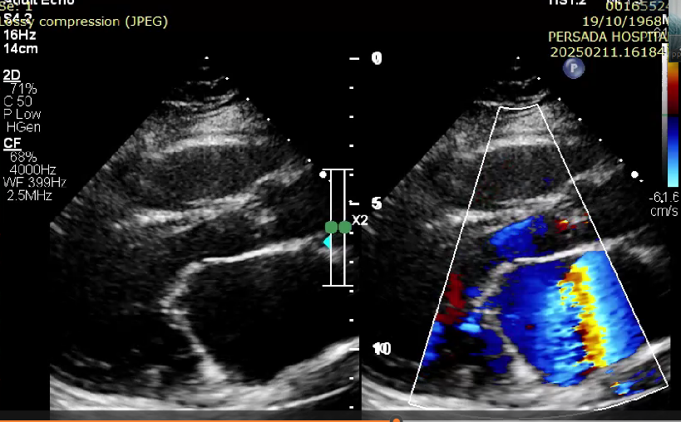

**Figure 1.** Transthoracic echocardiogram showed severe mitral stenosis with no calcification leaflet or subvalvular structures

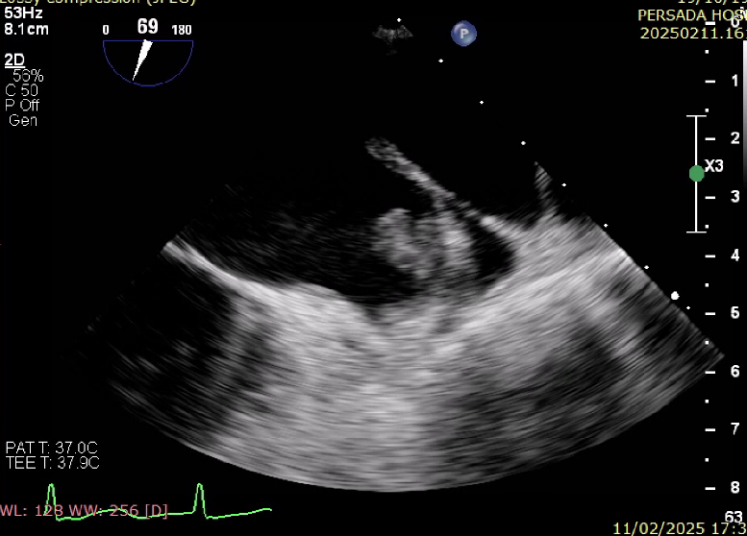

**Figure 2**. Transesophageal echocardiography showed left atrial thrombus

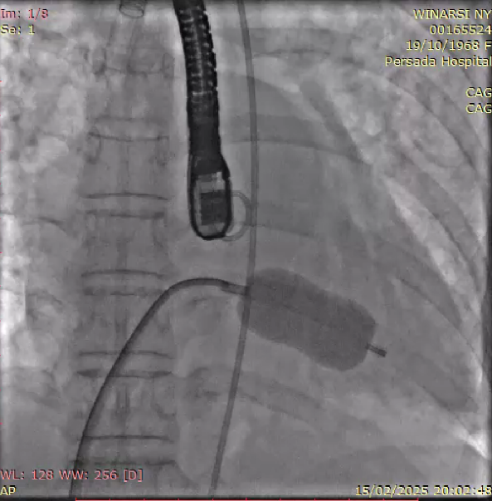

**Figure 3**. PBMV was successfully inserted with 25mm Inoue Balloon