Original Research Article

Expert opinion on the use of rosuvastatin and its combinations for managing dyslipidemia in Indian settings

.
ABSTRACT

Objective: To evaluate clinicians' perspectives on dyslipidaemia management in Indian settings, specifically focusing on the use of rosuvastatin and its combinations.
Methods: A cross-sectional study was conducted among clinicians across India, focusing on hypertension management and the use of rosuvastatin and its combinations. Participants independently completed a 23-item questionnaire after giving informed consent. The data was analyzed using descriptive statistics, with categorical variables expressed as percentages and visualized through pie and bar charts in Excel.
Results: Approximately 68% of participants indicated that dyslipidaemia is more prevalent in the urban population. Over half (57.64%) of the clinicians reported that high-risk patients with atherosclerotic cardiovascular disease (ASCVD) prefer high-dose statins. Nearly all (95.22%) participants preferred rosuvastatin as the statin of choice for dyslipidaemia patients. A majority (75.8%) of the participants commonly prescribed a 10 mg daily dose of rosuvastatin for dyslipidaemia. Around 67% of the clinicians stated that rosuvastatin is used for both primary and secondary prevention of cardiovascular events. About 76% of the participants preferred combining fibrates and statins for treating dyslipidaemia. Around 63% of the respondents reported that 11-20% of patients are prescribed the rosuvastatin and fenofibrate combination, while 66.4% of the participants indicated frequent use of the fixed-dose combination of rosuvastatin, clopidogrel, and aspirin in clinical practice.
Conclusion: The study highlights the clinical management of dyslipidaemia in high cardiovascular risk populations, emphasizing rosuvastatin use, often combined with fibrates or antiplatelet agents. It underscores rosuvastatin's role in both primary and secondary prevention of cardiovascular events, while suggesting that lifestyle factors and comorbidities, like diabetes, should guide treatment.

Keywords: Dyslipidaemia, cardiovascular disease, Statins, rosuvastatin, fenofibrate, dual antiplatelet therapy

1. INTRODUCTION

Dyslipidaemia is a significant public health concern, affecting millions of individuals worldwide, with prevalence rates among adults ranging from 20% to 80% [1]. The prevalence varies by region, age, gender, and ethnicity, and in 2019, it was identified as the 8th leading risk factor for death [2,3]. The nationwide ICMR-INDIAB study, which is one of the largest cardiovascular risk assessments in India, reported that 24.0% of individuals had hypercholesterolemia (≥200 mg/dl), 20.9% had high low-density lipoprotein (LDL)-C (>130 mg/dl), 66.9% had low high-density lipoprotein (HDL)-C, and 32.1% had hypertriglyceridemia [4]. Similarly, a Jaipur-based study of over 67,000 participants found that 30.5% had total cholesterol levels ≥200 mg/dl, while 31.8% had high LDL-C levels (>130 mg/dl). According to the Global Burden of Disease Studies, there has been an alarming increase in LDL and non-high-density lipoprotein (non-HDL) cholesterol in the country [4].
Statins are the first-line treatment for dyslipidaemia, primarily lowering LDL-C levels while also improving other lipid parameters, such as triglycerides and HDL-C. In addition to their lipid-lowering effects, statins have lipid-independent pleiotropic benefits, including anti-inflammatory properties, improved endothelial function, and plaque stabilization, all of which contribute to enhanced vascular health [5]. Rosuvastatin, a newer and more potent statin, is specifically used to reduce elevated total cholesterol, LDL-C, and triglycerides, while increasing HDL-C levels. It is indicated for patients with primary hypercholesterolemia, mixed dyslipidemia, and homozygous familial hypercholesterolemia, providing comprehensive lipid management and cardiovascular risk reduction [6]. It acts as a competitive inhibitor of HMG-CoA reductase, the enzyme responsible for converting HMG-CoA to mevalonate, a crucial step in cholesterol synthesis. By lowering cholesterol levels, it upregulates LDL receptors and enhances hepatic LDL clearance from the bloodstream. Additionally, it inhibits the production of very LDL (VLDL), leading to a further reduction in plasma levels of both LDL and VLDL [7]. Fenofibrate, a commonly used FDA-approved fibrate for treating hypertriglyceridemia, confers synergistic effects when combined with rosuvastatin for comprehensive dyslipidaemia management [8,9]. By targeting complementary lipid pathways, rosuvastatin inhibits cholesterol synthesis, while fenofibrate activates PPAR-α to enhance lipid metabolism, resulting in improved overall lipid control [10].
In cardiovascular disease management, adding a statin to dual antiplatelet therapy (DAPT) helps reduce the risk of thrombosis. Clopidogrel and aspirin are widely used in DAPT, and the fixed-dose combination (FDC) of rosuvastatin (10 mg or 20 mg), clopidogrel (75 mg), and aspirin (75 mg) is expected to enhance patient adherence, lower treatment costs, and reduce adverse cardiovascular events [11]. The current study aims to assess experts’ perspectives on managing dyslipidemia in Indian settings, with a particular emphasis on the use of rosuvastatin and its combinations.
2. materialS and methods

A cross-sectional study was conducted among experts in managing dyslipidemia in Indian settings from June 2024 to December 2024. The study was performed after obtaining approval from Bangalore Ethics, an Independent Ethics Committee, which was recognized by the Indian Regulatory Authority, the Drug Controller General of India.

An invitation was sent to clinical professionals across India based on their expertise and experience in treating dyslipidemia in the month of March 2024 for participation in this Indian survey. About 628 clinicians from major cities of all Indian states, representing the geographical distribution, shared their willingness to participate and provide necessary data. Clinicians had the discretion to skip questions they did not wish to answer. Written informed consent was obtained from all participants, who were required to independently complete the questionnaire without consulting peers. Unanswered questions were treated as non-attempts.

The questionnaire booklet titled CARE (ClinicAl Perspectives On Rosuvastatin in DyslipidaEmia Patients) was sent to the doctors who were interested in participating in this study. The CARE study questionnaire comprised 23-questions 23 questions designed to gather feedback, clinical insights, and experiences related to dyslipidemia management, with a particular focus on rosuvastatin and its combinations.

Descriptive statistics were carried out to analyze the data, with categorical variables expressed as percentages to show their distribution. The frequency and percentage of each variable were calculated, and pie and bar charts were created using Microsoft Excel 2013 (version 16.0.13901.20400) to visually represent the results.

3. results

The study included 628 clinicians, with approximately 39% identifying a sedentary lifestyle as a key factor contributing to the increasing disease burden of dyslipidemia in India. Around 68% of participants indicated that dyslipidemia is more common in the urban population (Fig. 1).

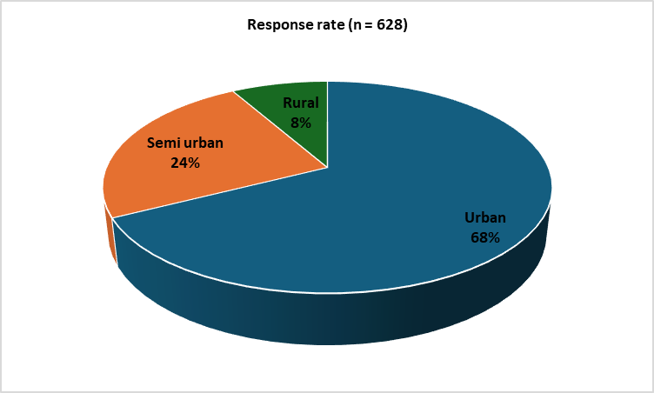

Fig. 1: Distribution of responses to the most common subgroup affected by dyslipidemia in clinical practice

About 32% of participants reported regularly treating patients with familial hypercholesterolemia in their clinical practice, ranging from once a week to a few times a week. Around 46% stated that dyslipidemia is more common among men than women in the young population under <40 years of age. Nearly half (46.82%) of the clinicians reported that dyslipidemia is more prevalent in the middle-aged population.
According to 50% of respondents, diabetes is the most common condition observed in patients with hyperlipidemia in clinical practice. About 46% of participants indicated that 11–20% of patients with dyslipidemia experience cardiovascular events, such as myocardial infarction or stroke. Nearly half of the experts (49.52%) reported that 11–20% of patients are aware of dyslipidemia and its complications. Nearly 58% stated that high-risk patients with atherosclerotic cardiovascular disease (ASCVD) prefer using high-dose statins (Table 1).

Table 1: Distribution of responses to the preferred patient subgroups for high-dose statin therapy

Preferred patient subgroups | Response rate (n = 628)
High-risk patients with atherosclerotic cardiovascular disease | 57.64%
For secondary prevention | 23.41%
Adult patients with homozygous familial hypercholesterolemia | 5.73%
All of the above | 13.22%

Most (88.22%) participants agreed that high-dose statins reduce cardiovascular events more effectively than low-dose statin therapy. Approximately 47% of experts stated that fewer than 10% of patients fail to respond to the maximal dose of statins. Nearly 95% of participants reported that rosuvastatin is the preferred statin for patients with dyslipidemia in clinical practice (Fig. 2). Around 76% of clinicians indicated that a daily dose of 10 mg rosuvastatin is commonly prescribed for dyslipidemia patients.

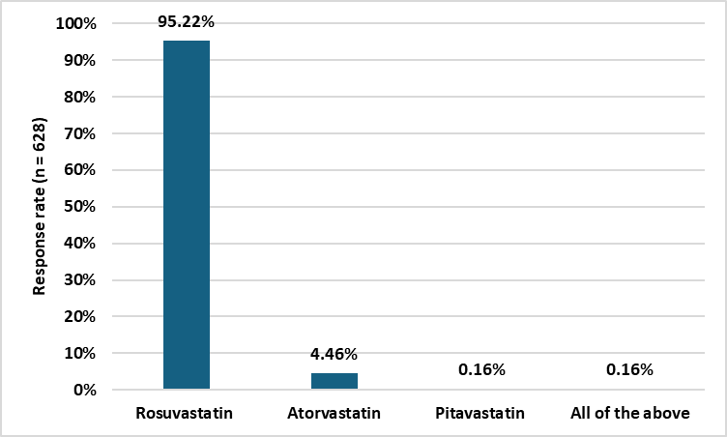

Fig. 2: Distribution of responses to the preferred statin for dyslipidemia patients in clinical practice

According to 33% of the participants, rosuvastatin should be initiated in patients with dyslipidemia and an LDL-C level of 160 mg/dL for high-risk individuals. Approximately 67% of the participants stated that rosuvastatin is prescribed for both primary and secondary prevention of cardiovascular events (Fig. 3). About 47% of the participants reported that 21–30% of patients with dyslipidemia require combination therapy with statins. Around 76% of the participants indicated that the combination of fibrates and statins is the preferred treatment for dyslipidemia (Fig. 4).

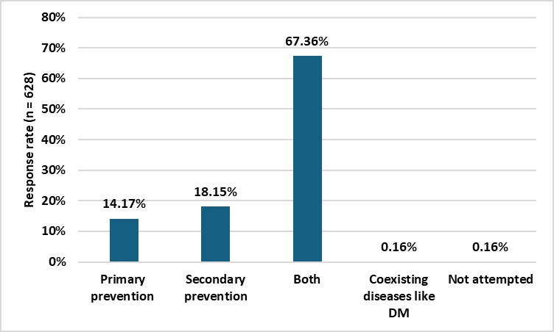

Fig. 3: Distribution of responses to the use of rosuvastatin for primary vs. secondary prevention of cardiovascular events

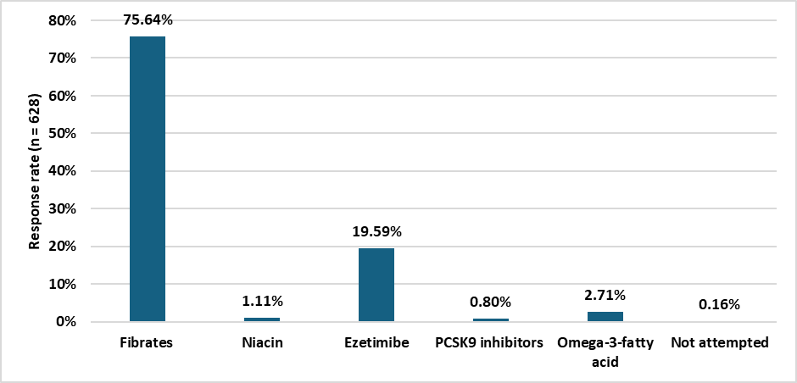

Fig. 4: Distribution of responses to the preferred statin combinations in clinical practice

Approximately 63% of the participants stated that 11–20% of patients are prescribed a combination of rosuvastatin and fenofibrate (Table 2). About 66% of the clinicians reported that combination therapy is often needed to manage the lipid triad, and they stated that the combination of rosuvastatin and fenofibrate reduces LDL, triglycerides, and high-sensitivity C-reactive protein (hs-CRP). Around 66% of the participants stated that the FDC of rosuvastatin, clopidogrel, and aspirin is frequently used in clinical practice.

Table 2: Distribution of responses to the proportion of patients prescribed rosuvastatin and fenofibrate combination
Proportion (%) | Response rate (n = 628)
<10 | 12.74%
11-20 | 62.58%
21-30 | 24.2%

About 47% of the participants reported that 10–20% of patients presenting in routine settings require the rosuvastatin + clopidogrel + aspirin combination. Around 44% of the participants reported that this combination therapy is considered for patients at high cardiovascular risk (Table 3). About 61% of the participants stated that they monitor patients with dyslipidemia receiving a combination of rosuvastatin every three months.

Table 3: Distribution of responses to the subset of patients for whom rosuvastatin+ clopidogrel+ aspirin combination therapy is considered

Subset of patients | Response rate (n = 628)
High cardiovascular risk | 43.79%
History of acute coronary syndrome (ACS) | 33.28%
Post percutaneous coronary intervention (PCI) and coronary artery bypass grafting (CABG) | 21.18%
All of the above | 1.59%

4. discussion

The study findings emphasize the need for individualized therapy, particularly for patients with complex dyslipidemia or established cardiovascular disease. Many participants noted that dyslipidemia is more prevalent in urban populations, a trend supported by existing research. Raj et al. reported a higher prevalence of dyslipidemia in urban areas (74.5%) compared to rural areas (68.8%) [12]. Similarly, Groot et al. found that total cholesterol, LDL cholesterol levels, and triglycerides were consistently elevated in urban residents compared to their rural counterparts [13].
The study findings suggest that clinical practice largely aligns with current guidelines for secondary prevention and high-risk primary prevention of cardiovascular disease (CVD). The majority of participants reported that high-risk patients with ASCVD are commonly prescribed high-dose statins. This aligns with evidence from a meta-analysis, which found that statin therapy significantly reduces major vascular events across all age groups. However, the evidence remains limited for patients over 75 years old without existing signs of occlusive vascular disease, highlighting a potential gap in research for this population [14].
Nearly all participants reported that rosuvastatin is the preferred statin for patients with dyslipidaemia in clinical practice. In a similar study, the current authors found that 90% of clinicians recommended rosuvastatin as a first-line lipid-lowering therapy. Notably, 95% of clinicians preferred rosuvastatin for patients with dyslipidaemia, especially those with comorbid conditions such as hypertension or diabetes [15]. This preference is supported by findings from Berne et al., who conducted a comparative study demonstrating rosuvastatin’s superior efficacy over atorvastatin in reducing LDL-C levels and achieving European LDL-C targets in patients with type 2 diabetes mellitus (T2DM) [16].
Most of the current study participants indicated that a 10 mg daily dose of rosuvastatin is commonly prescribed for patients with dyslipidemia. In a similar study, the current authors reported that 64% of clinicians favored prescribing this dose for diabetic patients, regardless of their lipid levels [15]. Barakat et al. demonstrated that rosuvastatin effectively reduced LDL-C levels in diabetic patients with dyslipidemia [17]. The URANUS study reinforced these findings, showing that a significantly higher proportion of patients with T2DM achieved the 1998 European LDL-C goal with rosuvastatin 10 mg compared to atorvastatin 10 mg [16]. Additionally, Aleem et al. assessed the impact of rosuvastatin at both 5 mg and 10 mg doses in patients with T2DM and dyslipidemia, concluding that the 10 mg dose led to more substantial reductions in lipid levels [18].
The majority of study respondents indicated that rosuvastatin is commonly prescribed for both primary and secondary prevention of cardiovascular events. Mehta et al. demonstrated the effectiveness of rosuvastatin (5–40 mg) in preventing cardiovascular events in the Indian population, supporting its widespread clinical use. A primary prevention strategy with statins has been shown to reduce cardiovascular events, as well as associated morbidity and mortality [19]. Further reinforcing these findings, the JUPITER trial revealed that a 20 mg dose of rosuvastatin significantly lowers the incidence of major cardiovascular events in men and women with elevated hsCRP levels and an "intermediate risk," defined as a 10-year cardiovascular risk of 5% to 20% [20]. These results highlight the broad applicability of rosuvastatin across various risk profiles, making it a valuable option for both early intervention and long-term cardiovascular risk management.
The majority of current clinicians indicated that the combination of fibrates and statins is the preferred treatment for dyslipidemia. A systematic review and meta-analysis by Zheng et al. found that statin-fibrate combination therapy was more effective in modifying lipid levels and generally well tolerated, though it showed no significant impact on cardiovascular disease prevention [21]. Jacobson and Zimmerman concluded that combination therapy with a fibrate and a statin could be an effective treatment for patients with atherogenic lipid profiles, recommending fenofibrate as a more suitable option due to its lower risk of myopathy [22]. Similarly, Athyros et al. found that the statin-fibrate combination provided better control of multiple lipid parameters compared to either therapy alone, with a safety profile comparable to individual treatments. As a result, this combination may be a viable therapeutic option for selected patients with mixed dyslipidemia [23].
Many participants reported that 11–20% of patients are prescribed the rosuvastatin and fenofibrate combination. Gopal et al. highlighted that using a combination of rosuvastatin (10 mg) and fenofibrate (145 mg) is often necessary to effectively treat the lipid triad, leveraging rosuvastatin’s potency in lowering LDL-C and fenofibrate’s effectiveness in reducing triglycerides for managing mixed diabetic dyslipidemia [24]. Ferdinand et al. demonstrated that a 1-year therapy with rosuvastatin combined with fenofibric acid is well tolerated. They also found that increasing the rosuvastatin dose from 10 mg to 20 mg in the combination provided additional benefits on key lipid parameters in patients with mixed dyslipidemia [25]. Similarly, Roth et al. found that in patients with high LDL-C and triglyceride levels, combination therapy with rosuvastatin and fenofibric acid was well tolerated. Each dose of the combination led to greater reductions in LDL-C and improved efficacy parameters compared to simvastatin 40 mg [26].
Most participants reported that the FDC of rosuvastatin, clopidogrel, and aspirin is considered for high-risk cardiovascular patients. Pillai et al. concluded that the usage pattern of this FDC for treating ACS and post-coronary intervention is well-defined, with a typical regimen involving 10 mg of rosuvastatin, 75 mg of clopidogrel, and 75 mg of aspirin, usually administered in the evening over a treatment duration of 1–3 years. Dyslipidemia was a common comorbidity in about half of the cases, emphasizing the clinical role of statins for their complementary effects and the importance of reaching new lipid targets in such high-risk populations [27]. Additionally, Deng et al. found that intensive rosuvastatin therapy combined with a 7-day DAPT using aspirin and clopidogrel significantly reduced the risk of recurrent ischemic stroke within 90 days for patients with mild to moderate acute ischemic stroke, compared to rosuvastatin plus single antiplatelet therapy. This treatment approach did not result in an increase in bleeding events, statin-induced liver injury, or myopathy associated with systemic anticoagulant medication. These benefits were particularly noticeable in high-risk subgroups, including elderly patients (>68 years old), those with hypertension, diabetes, hyperlipidemia, prior stroke history, or those not on antiplatelet therapy before the study [28].
The current study, involving a significant and diverse representation of clinicians across various settings in India, provides valuable insights into clinician preferences for rosuvastatin, its dosage, and combination therapies such as statin-fibrate and statin-antiplatelet regimens. While the study offers actionable insights to optimize treatment strategies, it has certain limitations. The results rely on self-reported data, introducing potential response bias, and do not include long-term patient outcome data to validate treatment efficacy. Additionally, the study lacks a detailed exploration of lifestyle modifications and the influence of comorbidities, such as diabetes, on treatment decisions and outcomes.
4. Conclusion

The study findings highlight the widespread use of rosuvastatin, often in combination with fibrates or antiplatelet agents, as the preferred therapeutic approach. A significant proportion of clinicians reported that statin therapy, particularly rosuvastatin, plays a crucial role in both primary and secondary prevention of cardiovascular events. While the study underscores the effectiveness of combination therapies, it also emphasizes the need to consider lifestyle factors and comorbidities, such as diabetes, in treatment strategies.

COMPETING INTERESTS DISCLAIMER:
Authors have declared that they have no known competing financial interests OR non-financial interests OR personal relationships that could have appeared to influence the work reported in this paper.

References

- Mohamed-Yassin MS, Baharudin N, Abdul-Razak S, Ramli AS, Lai NM. Global prevalence of dyslipidaemia in adult populations: a systematic review protocol. BMJ Open. 2021;11(12):e049662.
- Pirillo A, Casula M, Olmastroni E, Norata GD, Catapano AL. Global epidemiology of dyslipidaemias. Nat Rev Cardiol. 2021;18(10):689-700.
- Pappan N, Awosika AO, Rehman A. Dyslipidemia. In: StatPearls [Internet]. Treasure Island (FL): StatPearls Publishing; 2025 [cited 2025 Mar 6]. Available from: http://www.ncbi.nlm.nih.gov/books/NBK560891/
- Sharma S, Gaur K, Gupta R. Trends in epidemiology of dyslipidemias in India. Indian Heart Journal. 2024;76:S20–8.
- Ray S. Role of statins in the management of dyslipidaemia. Indian Heart J. 2024;76(Suppl 1):S33-S37.
- Cheng JW. Rosuvastatin in the management of hyperlipidemia. Clin Ther. 2004;26(9):1368-87.
- Luvai A, Mbagaya W, Hall AS, Barth JH. Rosuvastatin: a review of the pharmacology and clinical effectiveness in cardiovascular disease. Clin Med Insights Cardiol. 2012;6:17-33.
- Sidhu G, Tripp J. Fenofibrate. In: StatPearls [Internet]. Treasure Island (FL): StatPearls Publishing; 2025 [cited 2025 Mar 6]. Available from: http://www.ncbi.nlm.nih.gov/books/NBK559219/
- Filippatos T, Milionis HJ. Treatment of hyperlipidaemia with fenofibrate and related fibrates. Expert Opin Investig Drugs. 2008;17(10):1599-614.
- Strain JD, Farver DK, Clem JR. A review on the rationale and clinical use of concomitant rosuvastatin and fenofibrate/fenofibric acid therapy. Clin Pharmacol. 2010;2:95-104.
- Magarkar V, Bafna A, Gupta A, Motiramani N, Sharma S, Gaurav K. Positioning of the fixed dose combination of Rosuvastatin + Clopidogrel + Aspirin in the Treatment of Cardiovascular Diseases. J Indian Med Assoc. 2022; 120(11): 63-8.
- Raj SA, Sivakumar K, Sujatha K. Prevalence of dyslipidemia in South Indian adults: an urban-rural comparison. Int J Community Med Public Health. 2016;3:2201-10.
- de Groot R, van den Hurk K, Schoonmade LJ, de Kort WLAM, Brug J, Lakerveld J. Urban-rural differences in the association between blood lipids and characteristics of the built environment: a systematic review and meta-analysis. BMJ Glob Health. 2019;4(1):e001017.
- Grundy SM, Stone NJ, Blumenthal RS, Braun LT, Heidenreich PA, Lloyd-Jones D, et al. High-Intensity Statins Benefit High-Risk Patients: Why and How to Do Better. Mayo Clin Proc. 2021;96(10):2660-2670.
- Manjula S, Krishna Kumar M. Expert Opinion on the Prescription Practice of Statins in Lipid Management with a Specific Focus on Rosuvastatin 06 Use in Indian Settings. Indian J Cardio Biol Clin Sci. 2024;7(1): 114.
- Berne C, Siewert-Delle A; URANUS study investigators. Comparison of rosuvastatin and atorvastatin for lipid lowering in patients with type 2 diabetes mellitus: results from the URANUS study. Cardiovasc Diabetol. 2005;4:7.
- Barakat L, Jayyousi A, Bener A, Zuby B, Zirie M. Comparison of Efficacy and Safety of Rosuvastatin, Atorvastatin and Pravastatin among Dyslipidemic Diabetic Patients. ISRN Pharmacol. 2013;2013:146579.
- Aleem M, Zainab A, Hameed A, Khan AB, Ali SZ, Younus S. Comparison of the Efficacy of Rosuvastatin 5 mg and 10 mg in Patients of Type 2 Diabetes Mellitus With Dyslipidemia. Cureus. 2022;14(2):e22595.
- Mehta A, Jain P, Patil R, Sashi Kant T, Indurkar SA, Kota SK, et al. Real-World Clinical Experience of Rosuvastatin as a Lipid-Lowering Therapy for Primary and Secondary Prevention of Cardiovascular Events (REAL ROSE). Cureus. 2022;14(11):e31468.
- Ridker PM, Macfadyen JG, Nordestgaard BG, Koenig W, Kastelein JJ, Genest J, Glynn RJ. Rosuvastatin for primary prevention among individuals with elevated high-sensitivity c-reactive protein and 5% to 10% and 10% to 20% 10-year risk. Implications of the Justification for Use of Statins in Prevention: an Intervention Trial Evaluating Rosuvastatin (JUPITER) trial for "intermediate risk". Circ Cardiovasc Qual Outcomes. 2010;3(5):447-52.
- Zheng S, Li YX, Han TT, Zhang Y, Jiang DD, Hu YM. Systematic review and meta-analysis of Statins-Fibrates therapy in diabetic dyslipidemia patients. World Journal of Meta-Analysis. 2014;2(4):194–203.
- Jacobson TA, Zimmerman FH. Fibrates in combination with statins in the management of dyslipidemia. J Clin Hypertens (Greenwich). 2006;8(1):35-41; quiz 42-3.
- Athyros VG, Tziomalos K, Karagiannis A, Mikhailidis DP. Statin-fibrate combination for mixed dyslipidaemia: a limited option? Curr Med Res Opin. 2010;26(9):2137-40.
- Madhana Gopal K, Meganathan M, Vithiavathi S, Prabhu Shankar S, Balamurugan K, Deepa Kameswari P. Rosuvastatin plus fenofibrate in diabetic dyslipidemia: a hospital record based study. Int J Basic Clin Pharmacol. 2018;7:2297-301.
- Ferdinand KC, Davidson MH, Kelly MT, Setze CM. One-year efficacy and safety of rosuvastatin + fenofibric acid combination therapy in patients with mixed dyslipidemia: evaluation of dose response. Am J Cardiovasc Drugs. 2012;12(2):117-25.
- Roth EM, McKenney JM, Kelly MT, Setze CM, Carlson DM, Gold A, et al. Efficacy and safety of rosuvastatin and fenofibric acid combination therapy versus simvastatin monotherapy in patients with hypercholesterolemia and hypertriglyceridemia: a randomized, double-blind study. Am J Cardiovasc Drugs. 2010;10(3):175-86.
- Pillai KB, Kavathiya K, Jha PK, Korukonda K. Cross-sectional, Case Cohort, Observational Study to Assess Drug Utilization of Rosuvastatin, Clopidogrel, and Aspirin Fixed-dose Combination in Indian Patients with Stable Acute Coronary Syndrome – R-GOLD Study. Int J Sci Stud. 2020;8(8):154-163.
- Deng T, Zhang T, Lu H, Chen J, Liu X, He W, Yao X. Evaluation and subgroup analysis of the efficacy and safety of intensive rosuvastatin therapy combined with dual antiplatelet therapy in patients with acute ischemic stroke. Eur J Clin Pharmacol. 2023;79(3):389-397.

