**Short communication**

**Supplemental feeding of poultry to ameliorate climate change impact and to promote sustainable farming in integrated system approach of farming in north east India.**

**Abstract**

Climate change has had a significant impact on the northeastern region of India, especially Meghalaya. This includes rising mean annual temperatures, unpredictable rainfall patterns, and deteriorating soil health, etc. In spite of these challenges, the locals have followed sustainable agricultural practices that allow for improved adaptation to climate change, reduced environmental degradation caused by agriculture, and better utilization of natural resources. One such approach is the integrated farming system (IFS) of agricultural practice that combine crops, livestock, fisheries, and agroforestry to maximize resource use and diversify farmer’s income. The principle of IFS is based on the effective recycling of resources, whereby the waste generated from one component is recycled and used as a resource for the other component. Here, we present the study on the utilisation of locally grown weed (Alligator weed) and herb (Peppermint) as feed supplement for enhanced production and improved health in grower chickens where it was found the beneficial effects of supplementation in grower chicken with alligator weed (1%) in winter season and peppermint (1%) in summer season in Umiam, Meghalaya weather condition when the ambient temperature varies with the thermal comfort zone of the poultry birds for its optimal production. The weed and herb are easily grown and available resources in the traditional bun cultivation system of agriculture practice by the state’s tribal communities or the bench terracing on hilly slopes by levelling out slopes to enhance water retention and lessen soil erosion. Effective utilisation of plant resources (weed and herb) grown in the cultivation system which otherwise would have compete with other cultivated crops be use for enhancing poultry production is an implementable intervention for ameliorating food security, sustainability, and resilience in integrated system approach of agriculture. Therefore, climate adaptive management can serve to overcome the challenges in promoting sustainable practices in agriculture.

**Introduction**

Climate change has had a significant impact on the northeastern region of India, especially Meghalaya. This includes rising mean annual temperatures, unpredictable rainfall patterns, and deteriorating soil health. The state's weak economy, humid monsoon climate, and delicate geoenvironmental setting make it difficult to adjust to the effects of climate change. The economy of Meghalaya is primarily based on agriculture. But because of the climate change, agricultural sector has been greatly disturbed which results in reduced crop yield and low food productivity. Poultry farming is also one of the sources of employment and livelihood for the inhabitants of Meghalaya, not only it has economical values in terms of food security but also offers social, cultural and religious values. It economically benefits the people by providing source of income to the small holders, the women; it provides highly nutritious meat and eggs for household consumptions; and also, in some communities it is used in ritual offerings and is subjected to various traditional beliefs. However, climate changes threaten not only the agricultural productivity but also livestock’s performance. Increase in daily temperatures, higher humidity, and changed precipitation patterns creates unfavourable conditions for poultry farming. These conditions affect their body weight gain, their feed intake, health and productivity.

**Impacts of climate change on Poultry performance**

Climate change has become a major threat in poultry production. It affects their health, productivity and management. High ambient temperatures, changes in humidity, and extreme weather events have adverse consequences on poultry production systems.

*Heat stressed and productivity loss*:Heat stress is one of the major climatic problems which affects the production and growth performance of poultry. With increase in temperature, the chickens consume more water and less feed and also affects the utilization of nutrients by redirects energy from processes related to growth. This result in slower weight gain, low body weight and heightened vulnerability to various diseases. Heat stressed have also been shown investigations to reduce egg production and quality.

*Immune suppression and susceptibility to infections*: As temperature rises, relative humidity drops which creates a favourable environment for bacteria and virus to grow, which can lead to outbreak of poultry diseases.

*Scarcity of food and water*: Agricultural sector has been greatly disturbed by climate. The hilly nature of the state, excessive dependence on the natural resources, poor land management practices, and subsequent soil degradation make it more vulnerable to the effects of climate change. In addition, the uneven distribution of rainfall has led to frequent floods and droughts, which have resulted in reduced growth of fodder/grains. Thereby, the cost of the available feed increases.

Therefore, with rising in environmental stressor, feed strategies that support their health, resilience and locally sustainable and without increasing any input cost are critically needed to enhance poultry production. Several practices have been followed to adapt to these changes; one such practice is the integrated farming system (IFS).

**Integrated farming system (IFS): a sustainable approach**

IFS is an agricultural practice that combine crops and livestock to maximize resource use and diversify farmer’s income. This practice effectively recycles resources, whereby the waste generated from one component (like weeds) is recycled and used as a resource to support another (like feed for poultry). Therefore, by cultivating locally adaptable herb such as peppermint on buns and utilizing the naturally growing and invasive alligator plant that grows on the edges of the bench terracing, farmers can develop sustainable poultry feeding strategies.

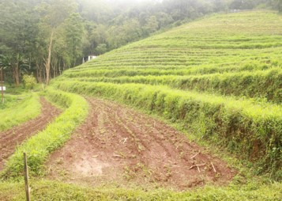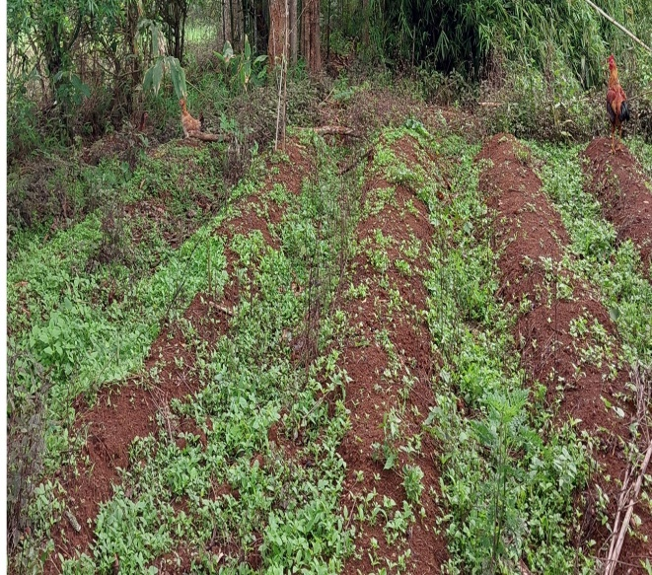

**A**

**B**

Figure 1. Practices of bun cultivation (A) and bench terracing (B) in integrated farming system of agriculture in Meghalaya.The bun cultivation is a traditional system practice by the state’s tribal communities including Khasi and Jaintia tribes, is an example of sustainable agriculture that shows resilience to climate change. In this type of farming, dried vegetations such as weeds, branches, twigs, etc. are placed on elevated beds, then covered with soil, this is followed by burning the plant residue and other vegetation after drying, and planting the crops. This approach manages water flow by channelling the water flow through the furrows, thereby minimizing soil erosion, it utilizes limited biomass, land resources, and it is rain-fed conditions, therefore, this approach makes the system sustainable. In this setup garden kitchen herbs such as peppermint can be grown.

Another agricultural practices that followed by the locals is bench terracing. The hilly nature and the slope terrain of the region, makes the farmers face difficulty in managing natural resources and water run-off from their agricultural land, therefore in this technique, benches are made on hilly slopes by levelling out slopes to enhance water retention and lessen soil erosion, both of which are essential for sustainable agriculture in places like Meghalaya, that experience high rainfall and soil deterioration. These same environment supports the natural growth of weeds such as alligator weed along their edges. So, rather than treating them just as a kitchen garden herb or weeds, they can be repurposed into nutritive feed supplement, and support resource recycling in integrated farming systems.

**B**

**A**

**Potential of Alligator weed and** **Peppermint as herbal feed supplements in Poultry**

Alligator weed *(Alternanthera philoxeroides)*:

Alligator weed is often treated as an invasive plant, however, its potential as a resource is now being investigated in recent studies. It grows naturally on the terrace edges; therefore, there’s no need of additional input for cultivation, thus, their use support resource recycling in IFS and sustainable feed resource. Chicks supplemented with 1% alligator weed showed significantly better body weight gain and feed conversion ratio, especially during the winter months with the average temperature of 16.57 ±1.37 °C. This suggests more efficient energy use and better resilience even under climatic stress. Key immune markers particularly- iNOS, IL-1β, IL-6, IL-12 and IFN-γ revealed upregulation in the alligator weed fed group, which indicates enhanced immunity, which could improve resistance to infections and environmental stress. Antioxidant enzymes activity, including SOD and CAT was elevated in supplemented birds, indicating antioxidant defence. Also, liver enzyme like AST and ALT remained within normal ranges, confirming that 1% supplementation was within the safe limits for the birds. Thus, rather than treating them just an unwanted weed, these plants can be repurposed into nutritive feed supplements.

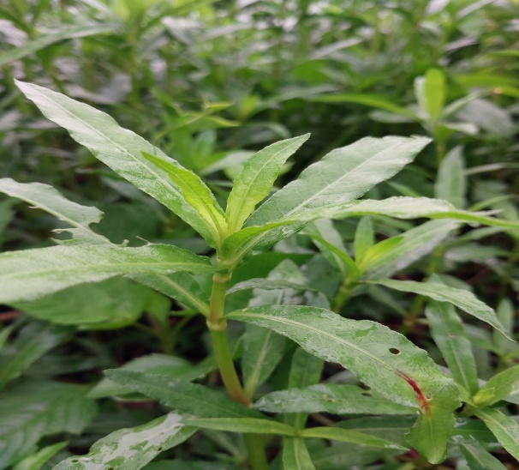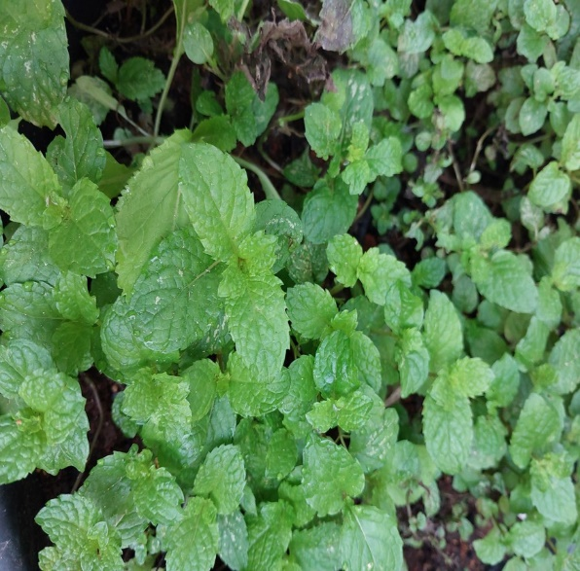

**A**

**B**

**Figure 2.** Alligator weed (A) and Peppermint (B)

Peppermint *(Mentha piperita)*:

Peppermint is known to have antimicrobial, anti-inflammatory, and anti-oxidative properties, they contain bioactive compounds like flavonoid, polyphenol, which support digestion, and may boost immunity. They are abundant and locally available in many rural and hilly regions and easy to cultivate. 1% peppermint-fed birds performed well, showing improved body weight gain and feed conversion efficiency, especially during the summer months with the average ambient temperature of 25.47 ±1.17 °C. This aligns with the studies that it can enhance poultry performance through its digestive and antioxidant properties. The supplemented birds also showed upregulation of immune markers like iNOS, IL-12, suggesting immunomodulatory effect. These changes maybe especially helpful during seasonal transitions and environmental stress. The peppermint group also showed elevated SOD and CAT levels, with a corresponding reduction in cortisol, a stress hormone. This indicates stronger antioxidant defence and reduced stress, which supports overall well-being in poultry.

**Discussion**

The study explores the use of Alligator weed and Peppermint as herbal feed supplements in poultry and focus on how these herbs may enhance production performance and support poultry health particularly in the context of climate change and sustainable integrated farming systems. The findings of the study offer several valuable insights. The use of alligator weed and peppermint as feed supplements for poultry shows measurable benefits in terms of growth performance, immune modulation, and antioxidant defense in poultry. These effects were more prominent at the 1% inclusion level, showing that even small additions of these herbs can produce meaningful outcomes. This approach is highly relevant in the context of climate change. With rising environmental stressors, feed strategies that support resilience without increasing input cost are critically needed. These herbs are not only effective but also locally available and abundant, making them practical for rural and hill-area farmer. This study highlights the importance of exploring other local, natural resources especially those that are invasive and grow unmanaged, their integration into farming system can promote resource use efficiency and long-term sustainability. These results also open doors for further research into a broader range of locally available herbs and weeds in livestock systems. Investigating their nutritional, medicinal, and economic potential could uncover new strategies for sustainable animal production. With just a modest level of awareness and basic management, these underutilized resources can be transformed into natural feed additives for long-term agricultural productivity. This aligns closely with the principles of Integrated farming System, where nothing goes to waste and every component contributes to overall farm health.

**Conclusion**

In conclusion, climate change will continue to threaten poultry farming system**,** especially for smallholder’s farmer. Integrating poultry farming with agricultural bund-based peppermint and alligator weed from the edges of the bench terrace offers a promising sustainable solution. These plant not only improve the health or performance of poultry but it also supports climate resilience by efficient use of existing landforms.

**Reference**

1. Attia YA, Aldhalmi AK, Youssef IM, et al. Climate change and its effects on poultry industry and sustainability. *Discover Sustainability*. 2024;5(1). doi:10.1007/s43621-024-00627-2
2. Caroprese M, Bradford BJ, Rhoads RP. Editorial: Impact of climate change on immune responses in agricultural animals. *Frontiers in Veterinary Science*. 2021;8. doi:10.3389/fvets.2021.732203
3. Das, Tarun & Borah, Sagarika & Mahanta, Joyoshree & Sangma, Jakrimra. (2023). Climate Resilient Varieties of Paddy Boost the Production of Farmers under NICRA Project in West Garo Hills District of Meghalaya.
4. Didal, Vijay & Bhooshan, Brij & Todawat, Anita & Choudhary, Kamlesh. (2017). Weather Forecasting in India: A Review. *International Journal of Current Microbiology and Applied Sciences*. 6. 577-590. 10.20546/ijcmas.2017.611.070.
5. Kresphulin W. A Study on Impact of Climate Change on Average Yields and their Variability of the Principal Crops in Meghalaya. *Journal of emerging technologies and innovative research* ISSN:2349-5162, Vol.12, Issue 1, page no.d414-d422, January-2025, Available :http://www.jetir.org/papers/JETIR2501343.pdf
6. Kumar M, Ratwan P, Dahiya SP, Nehra AK. Climate change and heat stress: Impact on production, reproduction and growth performance of poultry and its mitigation using genetic strategies. *Journal of Thermal Biology*. 2021;97:102867. doi:10.1016/j.jtherbio.2021.102867
7. Medhi, S & Islam, Mokidul & Barua, Utpal & Sarma, M & Das, M & Syiemlieh, E & Bordoloi, Popiha & Mukhim, Bankitkupar. (2018). Impact of Climate Resilient Practices under NICRA Project in Ri Bhoi District of Meghalaya. *Economic Affairs*. 63. 653-664.
8. Osuji E, Ahamefule B, Ben-Chendo G, et al. Effect of climate variables on poultry production efficacy in Nigeria. *Online Journal of Animal and Feed Research*. May 2024. doi:10.51227/ojafr.2024.23
9. Oke OE, Akosile OA, Uyanga VA, et al. Climate change and broiler production. *Veterinary Medicine and Science*. 2024;10(3). doi:10.1002/vms3.1416
10. Pretty, Jules & Toulmin, Camilla & Williams, Stella. (2011). Sustainable intensification in African agriculture. *International Journal of Agricultural Sustainability*. 9. 5-24. 10.3763/ijas.2010.0583.
11. Puro K-u, Abedin SN, Hussain Z, Wankhar JBM, Doley S, Aochen C, Choudhury BU, Singh M, Katiyar R, Deori S. Effect of Alligator Weed (*Alternanthera philoxeroides*) Supplementation on Production Performance, Immune Response and Antioxidant Function of Improved Rural Chicken. *Animals*. 2025; 15(5):742. https://doi.org/10.3390/ani15050742
12. Saleem, A., Anwar, S., Nawaz, T. *et al.* Securing a sustainable future: the climate change threat to agriculture, food security, and sustainable development goals. *J.Umm Al-Qura Univ. Appll. Sci.* (2024). https://doi.org/10.1007/s43994-024-00177-3
13. Sarma, Hridesh Harsha & Borah, Santanu & Dutta, Niharika & Sultana, Nazmin & Nath, Hrishikesh & Das, Bikash. (2024). Innovative Approaches for Climate Resilient Farming: Strategies against Environmental Shifts and Climate Change*. International Journal of Environment and Climate Change*. 14. 217-241. 10.9734/ijecc/2024/v14i94407.
14. Selvan, Thiru & Kumar, Sanjeev. (2017). Agroforestry in the North-Eastern Himalayas.
15. Singh, S.B. (2001). Valuation of soil erosion effects in bench terrace, Puertorican terrace and shifting cultivation systems in Meghalaya state. *Indian Journal of Agricultural Economics*. 56. 335-345.
16. Upadhaya, K., Barik, S.K., Kharbhih, V.M. *et al.* Traditional bun shifting cultivation practice in Meghalaya, Northeast India. *Energ. Ecol. Environ.* **5**, 34–46 (2020). https://doi.org/10.1007/s40974-019-00144-3