*Original Research Article*

Survival of sperm of Mpwapwa bulls in ambient-temperature diluents in the climatic conditions of Tanzania

.

ABSTRACT

|  |
| --- |
| The survival of sperm of Mpwapwa breed bulls in ambient temperature diluents was examined, to determine whether such diluents might be appropriate for use in a local artificial insemination (AI) program. Two studies were undertaken: in Year 1 semen (n=3 bulls) was diluted 1:1 in Tris-egg yolk (Tris), Optixcell or coconut water diluents and incubated at 20°C, 27°C and 33°C. In Year 2 (n=35 bulls), the range of temperatures was 8°C, 17°C and 33°C. In both years, straws (n=1 per ejaculate) were removed after 6, 24, 48, 72 and 120 h of incubation to assess the proportion of sperm demonstrating progressive motility (surviving). In Year 1, sperm survival was better at 20oC than 33oC, and was better in Optixcell and Tris than coconut water. In Year 2, sperm survival was better at 8oC than 32oC and was much poorer in coconut water than in Tris and Optixcell. Using a threshold of 50% survival as being adequate for use in AI, mean motility was above this threshold at 48 h for sperm stored in Optixcell at 8 or 17oC, but only at 8oC for sperm stored in Tris. In conclusion, sperm survival was, as expected, better at lower than higher temperatures, but a sufficient number of sperm survived for long enough at 17oC to be compatible with use in a local AI service based on ambient temperature diluents. |

*Keywords: AI breeding programme, ambient temperatures diluents, Mpwapwa breed bulls, Sperm survival*

1. INTRODUCTION

Cattle artificial insemination (AI) services in Tanzania in areas other than the principal dairying regions have largely fallen into abeyance. The historical reasons for this have been described elsewhere [8, 13], but the result has been that, for beef cattle in general, and the Mpwapwa breed in particular, AI is a rarely used method of breeding [8, 13]. Consequently, local beef cattle remain largely unimproved *Bos indicus* (Tanzanian Short Horn and crosses), whose productivity is severely limited [10, 13]. Even the Mpwapwa breed, which was created in the post-colonial period as a means of improving local beef animals, has been subject to minimal selection for production or fertility traits in the intervening period. Re-establishing an AI service for Tanzanian smallholder beef farmers is seen as a way to remedy this situation [9, 8] providing that the difficulties of sustaining an AI service can be met. Foremost amongst these is the difficulty and expense of procuring liquid nitrogen for cryopreservation of semen. Hence, an alternative method of preserving and disseminating semen is needed, which circumvents the difficulties of cryopreservation.

The ability of sperm to survive and retain the capacity to fertilise after ejaculation is a key determinant of the success of any AI regimen [6, 41, 4, 44]. For cattle AI, sperm survival is primarily determined by the provision of diluents/extenders that will prolong the life of sperm in vitro. In turn, this depends upon reducing the metabolic demands of sperm for the duration of their storage, either by reducing temperature or by directly inhibiting their metabolism [33, 6, 41, 4]. Cryopreservation takes this to an extreme, whereby the metabolic activities of the sperm are completely suspended. It does so, however, at the price of losing 40-60% of viable sperm during the freezing and thawing processes. Ambient-temperature and chilled diluents maintain much higher proportions of viable sperm, at least initially, but are only able to sustain sperm in the short term, as their effectiveness is limited by time and temperature.

Assessment of sperm survival is therefore a critical step in the processing of bovine semen. It is needed to determine the number of sperm that are required per insemination dose; primarily to ensure that there are sufficient sperm to result in a high probability of conception [33, 6, 41, 44], and it is needed to optimise preservation conditions for storage. For cryopreserved semen, this is relatively straightforward, as frozen semen does not deteriorate as long as it is maintained at 196oC, but for non-frozen semen, conditions of temperature and diluents/extenders [41, 4, 17, 44] are critical. Included in these latter assessments are the duration for which extended semen can sustain numbers of viable sperm that are sufficient to cause pregnancy, and, therefore, the rate of decline of numbers of viable sperm in different diluents under different conditions of temperature and time [41].

The length of time over which unfrozen semen can be stored is mainly affected by temperature and diluents/extenders [41]. The literature on bovine AI, particularly that emanating from before the widespread introduction of cryopreservation contains a plethora of potentially useable techniques [5]. In general, these have been based upon relatively simple diluents (buff plus either milk or egg yolk) that maintain viability at ~4oC for 24-48 h, or more complex diluents, particularly those based on the Illinois Variable Temperature diluent that have been developed into a range of chilled- or ambient-temperature diluents whose modus operandi is either end-point inhibition of metabolism of the creation of a sufficiently hypoxic environment that sperm metabolism is markedly attenuated. Which of these dilution and storage regimens is the most appropriate depends upon the environment in which the semen is to be used (especially the climate), the AI service that is provided (e.g. technician vs owner-inseminator), and the supply chain logistics between collection and insemination.

Despite the substantial literature on semen preservation in general, including from *B. indicus* cattle [34, 3], in order to provide an effective AI service for Mpwapwa bulls, specific information is needed on the optimisation of survival characteristics of the semen of Mpwapwa bulls. Given that cryopreservation is not a feasible option, the two key questions are i) identifying whether the use of an ambient-temperature diluent is feasible; and, depending on that outcome, ii) which diluent is most suitable for use. This present study therefore aimed to evaluate sperm survival in semen produced from Mpwapwa breed bulls to determine the optimum temperatures, time, and diluents/extenders for ambient temperature preservation of semen for use in a putative AI and program.

2. materialS and methods

**Animals**

This study was at the TALIRI Mpwapwa research centre, Dodoma, Tanzania. All bulls came from the TALIRI Mpwapwa research herd. There were a total of 120 mature (≥2 years old) Mpwapwa breed bulls available for selection, of which breeding soundness examination was undertaken on the heaviest 53 (Kabuni et al., submitted for publication), and 35 were selected for examination of the response of their semen to extension and preservation in different diluents. The study was conducted over 2 years: in Year 1, a pilot study was undertaken with 3 of these bulls, and in Year 2, all 35 bulls were studied.

**Semen collection, evaluation and processing**

Semen was collected by electroejaculation and immediately evaluated for volume, sperm density, mass and individual motility and morphology (see Table 1), as previously described by Kabuni et al., (submitted for publication). Thereafter, each ejaculate divided into three aliquots and, within 5 min of collection, was diluted with one of three diluents: i) coconut water [43, 20]; ii) Egg yolk-TRIS diluent (Minitube, Tiefenbach, Germany); or iii) Optixcell diluent (IMV, L’Aigle, France). in a one-step dilution protocol [1]. Each aliquot was diluted at a constant ratio of 1:1, regardless of the sperm concentration of the initial ejaculate. Semen samples were diluted at the ambient temperature of 32°C. After dilution, semen was loaded into 0.25 mL French straws (IMV, L’Aigle, France), which were then then maintained in water baths set to three different temperatures. In Year 1, straws were incubated at 20°C, 27°C and 33°C; in Year 2, they were incubated at 8°C, 17°C and 33°C. Straws (n=1 per ejaculate) were removed after 0, 6, 24, 48, 72 and 120 h incubation for evaluation of sperm motility. Time zero evaluations were performed immediately after dilution. Sperm motility was evaluated using computer-assisted sperm analysis (CASA, Microptic Automatic Diagnostic Systems, Barcelona, Spain) [37]. The study methodology is summarised in Figure 1.

**Statistical methods**

Data were initially summarised by using descriptive statistics. Thereafter sperm survival data were analysed with respect to diluent, temperature, time and bull. In these analyses, sperm motility data were treated as count data (i.e. number of motile sperm counted per 100 total sperm). The presence of high numbers of zeros in the data and a variance that was greater than the mean (over-dispersion) meant that a two-stage zero-inflated negative binomial model had to be used. In the first component, excess structural zeroes were modelled using a repeated-measures binary logistic model, with the presence/absence of motile sperm as the outcome; with diluent, incubation temperature, time and all two-way interactions as the fixed predictor variables and bull as a random effect. The second component was a repeated measures negative binomial model, with motile sperm as the outcome; and diluent, incubation temperature, time and all two-way interactions as fixed predictor variables and bull as a random effect. In this component, the outcome (motile sperm) could still be zero (sample zero) even if the logistic model identified an absence of a structural zero). For both models, a backward selection procedure was used with fixed predictors, and their two-way interactions removed when p>0.05.

3. results and discussion

In Year 1, overall mean survival at each time point was 76.9%, 75.6%, 36.3%, 22.9%, 8.4% and 3.0%, respectively. Overall mean survival at 20oC, 27oC and 33oC from 0 to 48 h was 66.2%, 58.8% and 33.1% respectively. Survival in coconut water was substantially poorer than in the other two diluents, with mean values for survival at 6-48 h being 77.9%, 57.9% and 31.0% for Optixcell, Tris and Coconut water, respectively. The main findings of the Year 1 study were that sperm remained viable for up to 48 h (72 h in Optixcell) and that there was a progressive decline of motility with time in all diluents, with this decline being more marked as temperature increased. The reduction in the proportion of motile sperm was markedly worse in coconut water than in other diluents.

Results for Year 2 are summarised in Table 2. Results were consistent with those of Year 1, with sperm survival being higher at lower storage temperatures (with the data for 17°C in Year 2 being broadly comparable with those from 20°C in Year 1). Similarly, survival in coconut water was poorer than for the other diluents at all temperatures, whereas survival rates in Tris and Optixcell were largely similar to each other. Survival results for individual bulls averaged across the three storage temperatures but separated by diluent, are illustrated in Figure 2.

***Results from the zero-inflated negative binomial model***

The model confirmed that the data did not fit the Poisson distribution with the dispersion parameter being affected by both time and temperature (p<0.001). The zero-inflated component of the model identified that increasing temperature and time both increased the odds of motility being 0% (Table 3a). The backward selection procedure did not identify diluent or any of the interactions as being a statistically significant in this component of the model. For the negative binomial component, the model identified that temperature, time and diluent were all significantly associated with the proportion of motile sperm, and that there was an interaction between diluent and time (Table 3b). Based upon the models in Table 3a, predicted survival rates over time for sperm in different diluents and different storage temperatures were calculated. These are illustrated in Figure 3.

***Evaluating individual bulls for potential use as AI sires***

Based on the criteria of [33] of requiring a minimum number of sperm per AI dose of 2 106 and the criteria of [12] of requiring a minimum of 50% viable sperm in an AI dose, mean motility was above this threshold at 48 h for sperm stored in Optixcell at 8 or 17oC, but only at 8oC for sperm stored in Tris. However, some individual bulls had markedly better survival than the mean values: 3 bulls had >50% survival for 72 h at 32oC; 5 bulls for 72 h at 17oC; and 4 for 120 h at either 8o or 17oC (Table 4).

Sperm survival at temperatures at which their metabolism is not completely inhibited is crucial for an AI service based on methods of semen preservation other than cryopreservation. Sperm not only have to survive the processes of dilution and processing but also have to survive the vagaries of storage conditions through the semen supply chain. Only if the diluents are robust enough to protect the sperm through the supply chain to the point of insemination can the use of the AI service result in the advancement of animal fertility, genetics and health [40]. The current study aimed to determine whether there were preservation conditions (i.e. with respect to time, diluent and temperatures) for ambient storage of liquid/fresh Mpwapwa bulls’ semen that would be compatible with a local AI service to smallholder farmers in Tanzania. Non-cryopreserved semen was the mainstay of pioneering bovine AI services [25, 26, 31, 30], but has largely been superseded by cryopreserved semen, although a significant precedent for present-day use of non-cryopreserved semen remains in the dairy AI service of New Zealand, which is based on the Caprogen-based ambient-temperature diluent [34]. The fundamental difference between both the present-day use of ambient temperature diluents in New Zealand and most of the earlier work with chilled/ambient temperature diluents is that the ‘ambient temperatures’ in Tanzania are commonly >30oC, whereas most of the other studies have been undertaken in temperate climates. Mean survival rates at 32oC were >40% only at 24 h in Optixcell and Tris diluents, and had declined to ~20% by 48 h. Mean survival at 72 h was <20% at 17oC and only around 25% at 8oC in Optixcell and Tris (noting that coconut water was not an effective diluent in this study). On the other hand, semen of individual bulls showed >50% survival at 48, 72 and, in a few cases, 120 h in Optixcell and Tris diluents. Taken together, these results suggest that, even at the high ambient temperature of 32oC, the semen of most bulls showed adequate survival for use in AI for 24oh, and, if the temperature could be dropped at little (i.e. to ~17oC) semen viability could be extended, with a reasonable level of assurance, to 48 h.

Regardless of appearing to be a relatively low figure, 50% survival is regarded as a threshold for survival in cryopreserved semen [12]. If that threshold is satisfactory for the relatively damaged cells that survive freezing and thawing, cells that have been preserved in chilled/ambient temperature diluents are likely to be less damaged than those that have been cryopreserved, so 40% survival should be a reasonable threshold for the ambient temperature semen. The modelling process in this study that indicates that sperm survival should be maintained at above 40% until 48 h after dilution in Optixcell and Tris, but would not be maintained above 60% much beyond 24 h. However, survival of more than 60% of sperm is seldom achieved through cryopreservation [27], so this might be regarded as too stringent a standard to apply to the semen in the present study. Thus, of the storage times that were examined, 48 h seemed to be an achievable maximum across all semen samples in Optixcell and Tris (although not Coconut water) across the range of ambient temperatures (i.e. 8°C, 17°C, 32°C and 33°C) that were studied.

However, temperature had a substantial effect on survival, such that survival decreased as storage temperature increased from 8oC to 32oC. Temperature-dependent decreases in survival were, of course, not unexpected, given the well-established effects of temperature on the metabolic rate of cells. Interestingly, there are studies in the literature [1, 40] that have used Optixcell with reasonable success up to 22oC but no studies were found that had used it at temperatures as high as those commonly found in Tanzania (i.e. 32oC, the maximum incubation temperature used in the present study). It was important therefore, in the present study, to note that the predicted survival of sperm in Optixcell at 48 h at 32oC was substantially less than its survival at 17oC, and had declined to well below the 40% threshold that has been previously discussed. The implications of this effect of temperature on the distribution network of a potential AI service are discussed below.

There are, however, other approaches to managing ambient-temperature dilution that might mitigate the high ambient temperatures of Tanzania. Dilution at the ambient temperature of 32oC is unlikely to have contributed to loss of sperm viability [34, 18, 19], inasmuch as close synchrony between the temperature of the semen and temperature of the diluent minimises the risk of cold- or diluent-related loss of viability. Only when glycerol is used (i.e. in cryopreservation diluents) is there a significant risk to sperm of adding that component at too high a temperature [34, 23]. Semen that is to be stored in a chilled format would, of course, be rapidly reduced in temperature from 32oC to ~5oC after dilution, but the temperature at which extension is performed does not appear to have an adverse effect upon sperm survival *per se.* Indeed, sudden change in temperature (such as might occur if semen at body temperature were suddenly added to a diluent at ~5oC) would undoubtedly be harmful [30], so taken together, there seems to be little evidence that extension at 32oC would be harmful of itself.

In New Zealand, the ambient-temperature/liquid semen AI service is based on the Caprogen diluent. That diluent, as well as having the usual properties of an ambient temperature diluent (i.e. carbonation-based suppression of metabolic activity), further suppresses motility by creating very low oxygen tension by saturating the diluent with N2 gas [42]. In that diluent, the achievable preservation period in the ambient temperatures of New Zealand is, as reported by [42], 72‑120 hours (i.e. 3‑5 days). This period of is rather better than the duration of sperm survival recorded in both Tris and Optixcell diluents (i.e. up to 48 h) in the present study. Differences between the present results and those reported elsewhere for Caprogen diluent are worth consideration. As pointed out by [42], minimising oxidative stress by decreasing the oxygen tension through adding antioxidant and chelating agents is pivotal to extending sperm shelf life and storage period whilst maintaining its motility at ambient environment. However, as used in New Zealand, ambient temperatures rarely exceed mid-20soC during the AI season, so, again, the potential for differences in preservation qualities at higher temperatures remains largely unexplored.

Extending the shelf life for semen in the face of high ambient temperatures therefore remains an important topic for research. In the present study, storage at 8°C produced the best sperm survival performance followed by 17°C, 20°C, 27°C and 33°C; an effect that was most significant at 48 h. On the other hand, when the survival of sperm of individual bulls (rather than mean survival) is examined, some rather different conclusions might be drawn. Three bulls (14755, 14836, 14841 and 14869) had >50% sperm survival at 120 h at 8oC and 8 bulls had >50% survival at 72 h. Interestingly, also, although Optixcell had the best overall performance, based upon the *mean* survival of sperm, most of the bulls that achieved survival at 72 or 120 h did so in the *Tris* diluent. The number of such bulls in the present study is, of course, small, and generalisation on larger numbers of bulls and more repeats per bull would be necessary to establish this as a trait that could be exploited. Nonetheless, if repeatable, these results might mean that because, unlike dairy bulls in developed countries, these Mpwapwa bulls are entirely unselected for semen quality and/or the ability of sperm to survive extension, there could be sufficient genetic variation in sperm ‘quality’ to allow for the possibility of selecting animals as AI sires on the basis of the ability of their sperm to survive for (e.g.) 72 h at 17oC. Such considerations could be important when determining the feasibility of an ambient-temperature AI service.

However, regardless of whether some of the semen of some bulls survives for a little longer than others, it is important to determine whether it is feasible within the infrastructural capabilities of the Mpwapwa region of Tanzania, to introduce some form of temperature control for the diluted semen. Under the conditions that pertain in the beef-producing regions of the country, the use of cryopreservation is not feasible, but more modest cooling might be. Basic refrigeration in the semen processing centre (i.e. to mitigate temperature effects after dilution) or in the distribution network (which could be as simple as ‘chilly bins’ and ice packs, or as complicated as vehicle-mounted mini-fridges) would probably be sufficient to maintain temperatures at ~17oC, at which temperature sperm survival at 48 h is well above a 40% threshold. Whether a combination of reducing temperatures to 8oC and selecting bulls whose semen survives for 72-120 h, would confer additional advantages would be a matter for further exploration.

The dilution rate is dependent upon the volume and the number of sperm an insemination dose should have and, hence, the volume and density of the initial ejaculate. In practice, of course, the constant dilution rate used in the present experiment would not be repeated for field use. In the early days of cattle AI, there was much concern that the process of dilution *per se* caused damage to sperm [30]. This notion of a ‘dilution effect’ was largely discredited in subsequent practice [2, 7, 39, 24], but there still seems to be a critical minimum dilution ratio that is needed for sperm to be exposed to adequate quantities of the components of the diluent. By analogy with the sheep, in which semen for intra-cervical insemination commonly has very low dilution rates [46] the low dilution rate (1:1) used in the present study might have impaired the responses of the sperm at higher temperatures and/or longer durations of study. On the other hand, the sperm densities of the ejaculates used in the present study were relatively low (all <800 x106/mL), so the opportunity for high dilution rates (and, hence, exposure to high concentrations of beneficial diluent components) was reduced. Even so, if insemination doses of 5 x106 sperm [33] were achievable with Mpwapwa bulls, dilution rates of ~1:20 for even low density ejaculates of might be achievable: a figure that is commensurate with that used to good effect for cryopreserved ejaculates.

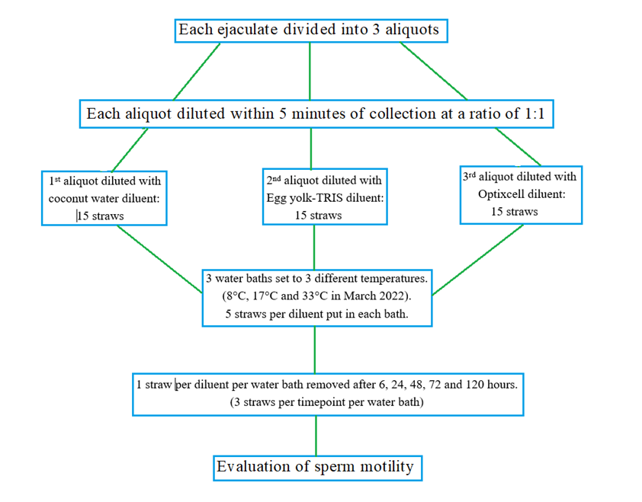

**Figure 1** Straw creation, dilution, incubation and selection process for sperm survival study

**Table 1.** Range of semen scores of the bulls that were selected from the population of 35 for use in the study

|  |  |  |  |  |
| --- | --- | --- | --- | --- |
| Volume (mL) | Mass activity  (0 – +++) | Individual motility (%) | Morphology (% normal) | Sperm x106/mL |
| 2.8 – 8.0 | ++ – +++ | 75 – 90 | 75 – 80 | 734 – 966 |

**Table 2:** Effect of time, storage temperature and diluent on the proportion of motile sperm

(Year 1, pilot study, n = 3 bulls)

|  |  |  |  |  |
| --- | --- | --- | --- | --- |
| Time (hours) | Diluent | Proportion of motile sperm (%) | | |
|  |  | Temperatures (°C) | | |
| 20 | 27 | 33 |
| 0 | Optixcell | 94.7 | 83.9 | 84.8 |
| Tris | 93.5 | 83.0 | 80.1 |
| Coconut | 76.1 | 68.5 | 27.9 |
| 6 | Optixcell | 93.3 | 82.5 | 82.9 |
| Tris | 92.2 | 81.4 | 90.7 |
| Coconut | 74.2 | 67.8 | 15.6 |
| 24 | Optixcell | 86.5 | 78.1 | 5.7 |
| Tris | 61.3 | 61.7 | 9.6 |
| Coconut | 13.6 | 10.2 | 0.0 |
| 48 | Optixcell | 66.3 | 60.8 | 0.0 |
| Tris | 32.5 | 18.0 | 0.0 |
| Coconut | 10.7 | 9.4 | 0.0 |
| 72 | Optixcell | 32.8 | 9.3 | 0.0 |
| Tris | 27.0 | 6.7 | 0.0 |
| Coconut | 0.0 | 0.0 | 0.0 |
| 120 | Optixcell | 6.7 | 7.7 | 0.0 |
| Tris | 12.6 | 0.0 | 0.0 |
| Coconut | 0.0 | 0.0 | 0.0 |

**Table 3a:** Effect of time, storage temperature and diluent on the proportion of motile sperm

(Year 2, n = 35 bulls)

|  |  |  |  |  |
| --- | --- | --- | --- | --- |
| Time (hours) | Diluent | Proportion of motile sperm (%) | | |
|  |  | Temperatures (°C) | | |
| 8 | 17 | 33 |
| 0 | Optixcell | 96.7 | 89.5 | 85.0 |
| Tris | 94.1 | 87.2 | 81.3 |
| Coconut | 77.5 | 73.8 | 49.9 |
| 6 | Optixcell | 85.2 | 77.5 | 69.6 |
| Tris | 81.5 | 73.0 | 66.8 |
| Coconut | 70.1 | 59.8 | 42.8 |
| 24 | Optixcell | 79.7 | 72.0 | 62.1 |
| Tris | 65.4 | 56.5 | 44.6 |
| Coconut | 43.2 | 33.4 | 23.3 |
| 48 | Optixcell | 63.2 | 54.6 | 22.9 |
| Tris | 46.9 | 37.8 | 21.4 |
| Coconut | 23.3 | 14.7 | 4.9 |
| 72 | Optixcell | 24.2 | 14.7 | 0.0 |
| Tris | 24.6 | 17.6 | 0.0 |
| Coconut | 0.0 | 0.0 | 0.0 |
| 120 | Optixcell | 11.4 | 8.0 | 0.0 |
| Tris | 14.0 | 0.0 | 0.0 |
| Coconut | 0.0 | 0.0 | 0.0 |

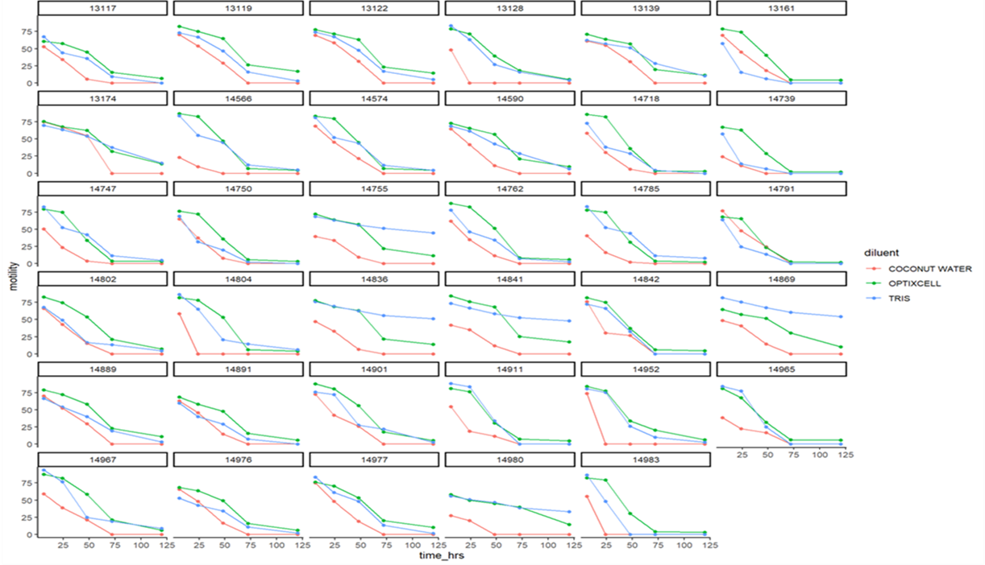

**Figure 2** Effect of time (6-120 h) and diluent on % motile sperm for samples from individual (Data are for 35 bulls with results averaged across three temperatures: 8, 17 and 33 °C).

Table 3b: Effect of time and temperature on odds of sperm motility being 0% (structural zero from zero-inflated part of model). Example interpretation of odds ratio: the odds of a semen sample having a structural count of zero) was 6.33 (95%CI 4.11-9.75) times higher for semen stored at 32°C than for semen stored at 8°C.

|  |  |
| --- | --- |
|  | Odds Ratio (95% CI) |
| *Reference temperature 8°C* |  |
| Temperature 17°C | 1.34 (0.88 – 2.04) |
| Temperature 32°C | 6.33 (4.11 – 9.75) |
|  |  |
| *Reference time 6 hours* |  |
| Time 24 hours | 5.25 (1.87 – 14.75) |
| Time 48 hours | 28.73 (10.79 – 76.5) |
| Time 72 hours | 131.53 (48.65 – 355.6) |
| Time 120 hours | 131.92 (45.88 – 379.33) |

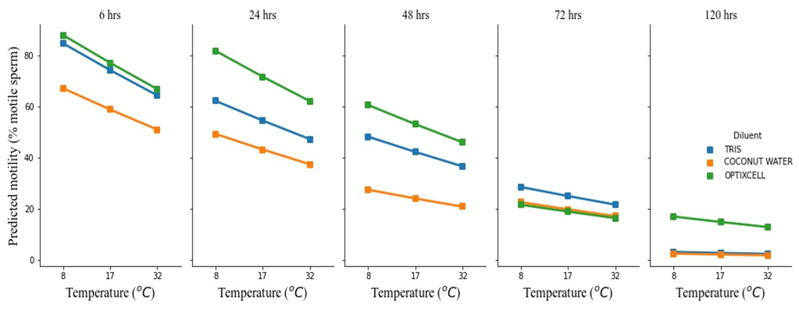

**Figure 3** Predicted survival (linear prediction) of sperm (% motile sperm) at different durations of incubation, with respect to diluent and incubation temperature

|  |  |  |  |  |
| --- | --- | --- | --- | --- |
| Table 4. Individual bull motility exceeding 40% threshold at different times and temperatures, in Tris and Optixcell diluents. | | | | |
| Bull ID | Diluent | Temperature (°C) | Time (h) | Motility (%) |
| 13139 | Tris | 8 | 72 | 51 |
| 13174 | Tris | 8 | 72 | 54 |
| Optixcell | 17 | 72 | 54 |
| 14755 | Tris | 8 | 72 | 59 |
| 8 | 120 | 52 |
| 17 | 72 | 52 |
| 14802 | Optixcell | 8 | 72 | 50 |
| 14836 | Tris | 8 | 72 | 60 |
| 8 | 120 | 56 |
| 17 | 72 | 55 |
| 17 | 120 | 50 |
| 32 | 72 | 53 |
| 14841 | Tris | 8 | 72 | 57 |
| 8 | 120 | 53 |
| 17 | 72 | 52 |
| 32 | 72 | 50 |
| 14869 | Optixcell | 8 | 72 | 53 |
| Tris | 8 | 72 | 72 |
| 8 | 120 | 66 |
| 17 | 72 | 57 |
| 17 | 120 | 53 |
| 32 | 72 | 52 |
| 14967 | Optixcell | 8 | 72 | 50 |
| 14980 | Optixcell | 8 | 72 | 50 |

4. Conclusion

The present study has shown that Tris-egg yolk and Optixcell diluents, when used at a 1:1 dilution ratio can successfully sustain sperm survival for up to 48 h, and in some individuals for up to 72 or even 120 h. Coconut water, despite a promising showing in the literature, was ineffective. Sperm survival was also dependent upon temperature, with survival declining in nearly linear manner from 8oC to 32oC. To manage these effects in an AI service based upon liquid (or ambient) temperature semen, a number of further possibilities could be considered; namely, (i) higher dilution rates; (ii) use of alternative diluents (notably Caprogen); (iii) making initial dilutions at a lower ambient temperature and (iv) provision of low-cost refrigeration/cooling in the distribution chain. Despite these caveats, the results of the present experiment show that simple diluents are capable of sustaining sperm survival for a sufficient period of time to be usable in a local AI service.

Ethical approval

Research ethical clearance was obtained from the Tanzania Livestock Research Institute (TALIRI) (Feb 2022).

References

[1] Arif AA, Maulana T, Kaiin EM, Purwantara B, Arifiantini RI and Memili E (2020) Comparative analysis of various step-dilution techniques on the quality of frozen Limousin bull semen. Veterinary World. 13: 2422-2428

[2] Cheng P, Casida LE and Barrett GR (1949) Effects of dilution on motility of bull spermatozoa and the relationship between motility in high dilution and fertility. Journal of Animal Science. 8: 81-88

[3] Crespilho AM, Papa FO, Zahn FS, Guasti PN and Dell’Aqua JA (2009) Influence of different preservation methods on fertility of bovine semen. Biology of Reproduction. 81: 459

[4] De Pauw IMC, Van Soom A, Mintiens K, Verberckmoes S and De Kruif A (2003) In vitro survival of bovine spermatozoa stored at room temperature under epididymal conditions. Theriogenology. 59: 1093-1107

[5] Dziekonska A and Partyka A (2023) Current status and advances in semen preservation. Animals. 13: 2-4

[6] Foote RH and Kaproth MT (1997) Sperm numbers inseminated in dairy cattle and nonreturn rates revisited. Journal of Dairy Science. 80: 3072-3076

[7] Garner DL, Thomas CA and Allen CH (1997) Effect of semen dilution on bovine sperm viability as determined by dual-DNA staining and flow cytometry. Journal of Andrology. 18: 324-331

[8] Kabuni KT, Komba EVG, Kabululu M, Mwalingo M, Matimya G, Laven R, Parkinson T, Peters A (2023) Application, utilisation and uptake of artificial insemination technology to smallholder farmers in the traditional agro-pastoral livestock farming system: A case of Mpwapwa district in the central zone of Tanzania. Journal of Veterinary Science and Medical Diagnosis. 12(4)

[9] Kabuni KT, Masao DF, Laven R and Parkinson TJ (2022) Comparison of Fixed-time Artificial Insemination and Natural Mating on Pregnancy rates in Mpwapwa Breed Cattle. Tanzania Veterinary Journal. 36 (2)

[10] Kanuya NL, Matiko MK, Kessy BM, Mgongo FO, Ropstad E and Reksen O (2006) A study on reproductive performance and related factors of zebu cows in pastoral herds in a semi-arid area of Tanzania. Theriogenology. 65: 1859-1874

[11] Kim S and Lee KM (1972) Conception rates with minimum spermatozoa counts. International Congress on Animal Reproduction and Artificial Insemination, Munich, Vol II: 1449-1452

[12] Mandal DK, Tyagi S and Mathur AK (2005) Semen production performance of Sahiwal bulls. Indian Journal of Animal Sciences. 75: 17-19

[13] MLFD (2011) The Tanzania Dairy Industry: Status, Opportunities and Prospects. In 7th African Dairy Conf. and Exhibition held at Moven Pick Palm Hotel. Ministry of Livestock and Fisheries Development Tanzania, Dar es Salaam, Tanzania. 25-27 May 2011.

[14] MLFD (2010) Livestock sector development strategy. United Republic of Tanzania Ministry of Livestock and Fisheries Development. Dar es Salaam. At: https://www.mifugouvuvi.go.tz/wp-content/.../Livestock-Sector-Development-Strategy. Retrieved on 12th February, 2024

[15] MLD (2006) National livestock policy. United Republic of Tanzania Ministry of Livestock Development. Dar es Salaam. At: https://www.tva.or.tz/images/Livetock_Policy_2006.pdf Retrieved on 12th February, 2024

[16] Msalya G, Lutatenekwa D and Chenyambuga SW (2017) Possibilities of utilising biotechnology to improve animal and animal feeds productivity in Tanzania – review of past efforts and available opportunities. Journal of Dairy Veterinary and Animal Research. 5: 161-167

[17] Murphy EM, Murphy C, O’Meara C, Dunne G, Eivers B, Lonergan P and Fair S (2016) A comparison of semen diluents on the in vitro and in vivo fertility of liquid bull semen. Journal of Dairy Science. 100: 1541-1554

[18] Murphy EM, Kelly KA, O’Meara C, Eivers B, Lonergan P and Fair S (2018a) Influence of bull age, ejaculate number and season of collection on semen production and sperm motility parameters in Holstein Friesian bulls in a commercial insemination centre. Journal of Animal Science. 96: 2408-2418

[19] Murphy EM, O’Meara C, Eivers B, Lonergan P and Fair S (2018b) Optimizing storage temperature of liquid bovine semen diluted in INRA96. Journal of Dairy Science. 101: 5549-5558

[20] Odrada PMS, Purnamasari L and Cruz JFD (2023) The effects of water-based coconut extenders on semen preservation: A review. Journal of Sain Peternakan Indonesia. 18: 20-26

[21] Oliveira LZ, Monteiro FM, Arruda RP and Celeghini ECC (2013) The importance of semen quality in programs and advances in laboratory analyses for semen characteristics assessment. Success in artificial insemination: quality of semen and diagnostics employed. Intech Rijeka. 1-16

[22] Pace MM, Sullivan JJ, Eliot FI, Graham EF and Coulter GH (1981) Effects of thawing temperature, number of spermatozoa and spermatozoa quality on fertility of bovine spermatozoa packaged in 5-ml French straws. Journal of Animal Science. 53: 693-701

[23] Papa P, Maziero R, Guasti P, Junquera C, Freitas CP, Papa FO, Vianna FP, Alvarenga MA, Crespilho AM and Dell’Aqua JA (2014) Effect of glycerol on the viability and fertility of cooled bovine semen. Theriogenology. 83: 107-113

[24] Patil S, Kumar P, Singh G, Bala R, Jerome A, Patil CS, Kumar D, Singh S and Sharma RK (2020) ‘Semen dilution effect’ on sperm variables and concentration rate in buffalo. Animal Reproduction Science. 214:10.1016

[25] Phillips PH (1939) The preservation of bull semen. Journal of biological chemistry. 130: 415

[26] Phillips PH and Lardy HA (1940) A yolk-buffer pabulum for the preservation of bull semen. Journal of Dairy Science. 23: 399-404

[27] Pon-Rejraji H, Bailey JL and Leclerc P (2009) Cryopreservation affects bovine sperm intracellular parameters associated with capacitation and acrosome exocytosis. Reproduction Fertility and Development. 21: 525-537

[28] Raseona AM, Ajao OA, Nethengwe LD, Madzhie LR, Nedambale TL and Barry DM (2017) Viability of bull semen extended with commercial semen extenders and two culture media at 24°C. South African Journal of Animal Science. 47

[29] Salamon S, Gareth E and Maxwell WMC (1952) Artificial insemination of sheep and goats. Sydney: Butterworths

[30] Salisbury GW, VanDemark NL and Lodge JR (1978) Extenders and extension of unfrozen semen. In: Physiology of reproduction and artificial insemination in cattle. W.H. Freeman and Co., San Francisco. 442-493

[31] Salisbury GW, Fuller HK and Willett EL (1941) Preservation of bovine spermatozoa in yolk-citrate diluent and field results from its use. Journal of Dairy Science. 24: 905-910

[32] Shannon P and Curson B (1984) Effects of storage temperature on the viability and fertility of bovine sperm diluted and stored in Caprogen. New Zealand Journal of Agricultural Research. 27: 173-77

[33] Shannon P, Curson B and Rhodes AP (1984) Relationship between total spermatozoa per insemination and fertility of bovine semen stored in caprogen at ambient temperature. New Zealand Journal of Agricultural Research. 27: 35-41

[34] Shannon P (1978) Factors affecting semen preservation and conception rates in cattle. Journal of Reproduction and Fertility. 54: 519-527

[35] Shannon P (1972) The effect of egg yolk level and dose rate on conception rate of semen diluted in caprogen. International Congress on Animal Reproduction and Artificial Insemination, Munich, Vol II: 1441-1442

[36] Shannon P and Curson B (1972) Toxic effect and action of dead sperm on diluted bovine semen. Journal of Dairy Science. 55: 614-620

[37] Tanga BM, Qamar AY, Raza S, Bang S, Fang X, Yoon K and Cho J (2021) Semen evaluation: methodological advancements in sperm quality-specific fertility assessment-A review. Animal Bioscience. 34: 1253-1270

[38] Thacker DL, Flipse RJ and Almquist JO (1954) Diluters for bovine semen II, effect of milk proteins upon spermatozoa livability. Journal of Dairy Science. No. 1814: 220-227

[39] Vera-Munoz O, Amirat-Briand L, Diaz T, Vasquez L, Schmidt E, Descherces S, Anton M, Bencharif D and Tainturier D (2009) Effect of semen dilution to low-sperm number per dose on motility and functionality of cryopreserved bovine spermatozoa using low-density lipoproteins (LDL) extender: Comparison to Triladyl and Bioxcell. Theriogenology. 71: 895-900

[40] Verberckmoes S, Van Soom A, De Dewulf J, De Pauw I and de Kruif A (2004) Storage of fresh bovine semen in a diluent based on the ionic composition of cauda epididymal plasma. Reproduction in Domestic Animals. 39: 410-416

[41] Vishwanath R and Shannon P (2000) Storage of bovine semen in liquid and frozen state. Animal Reproduction Science. 62: 23-53

[42] Vishwanath R and Shannon P (1997) Do sperm cells age? A review of the physiological changes in sperm during storage at ambient temperatures. Reproduction, Fertility and Development. 9: 321-331

[43] Wadood F, Aleem M, Ijaz A, Mughal DH and Gondal MA (2022) Comparative efficiency of coconut water diluent with different semen extenders for cryopreservation of Nili Ravi buffalo bull semen. Buffalo bulletin. 41: 363-372

[44] Yang DH, Standley NT and Xu ZZ (2018) Application of liquid semen technology under the seasonal dairy production system in New Zealand. Animal Reproduction Science. 194: 2-10

[45] Yoon JW, Lee SE, Kim WJ, Kim DC, Hyun CH, Lee SJ, Park HJ, Kim SH, Oh SH and Lee DG (2022) Evaluation of semen quality of Jeju black cattle (JBC) to select bulls optimal for breeding and establish freezing conditions suitable for JBC sperm. Animals. 535: 1-12

[46] Evans G, Maxwell WMC. Salamon’s artificial insemination of sheep and goats. Sydney: Butterworths; 1987