**Nutrient and Plant Response: A Sustainable Approach for Pest Management**

**Abstract**

Nutrients are collectively referred as the substance (may be chemical) which an organism often requires for growth, tissue maintenance, and reproduction. It may also be a determine pest resistance or susceptibility. There are 17 essential nutrients that are required by the plants for healthy growth and development. Insects need these nutrients for energy production, growth, tissue repair and reproduction. They consume vegetation in order to meet their nutrient demands. Individual insect performance is positively impacted by nitrogen, most likely as a result of modifications in host plant chemistry brought about by deposition. Among these enhancements are higher amounts of nitrogen and lower quantities of defence compounds based on carbon. Potassium offers strong defence against pests and insects. Elevated potassium levels improve the metabolism of secondary compounds, lessen the build-up of carbohydrates, and prevent insect pests from damaging plants. Additionally, phosphorus reduces the host's compatibility for several insect infestations. Pest populations are also decreased by secondary macronutrients and micronutrients such as calcium, zinc, and sulphur. Silicon is one of the mineral elements that helps plants resist damage from insects and pests. Plant resistance to numerous insect pests has been found to be influenced by the indirect impacts of fertilization techniques, which alter the crop's nutritional composition. Techniques to make plants more resistant to phytophagous insects are being developed in response to the need for healthier diets.

**Keywords:** ***Nutrients, pest management, silicon, NPK, micronutrients***

1. **Introduction**

According to **Simpson et al. (2015),** Insects represent the majority of the animals that consume plants, which dominate terrestrial eukaryotic biodiversity. The production of agricultural yield in field or after harvest is threatened by insect infestations. They have an impact on crop quality, productivity, and in the perceived value of the crop. One of the primary factors in phytophagous insects' selection of host plants is the nutritional value of plant tissue (**Bernays and Chapman 1994**). It has a substantial impact on the predisposition of plants to insect-pests. The application of "healthy" nutrients to increase plant resistance and tolerance lags short of its promise, in contrast to human nutrition, where the impact of diet on "health" has gained significant relevance. Plant nutrition is the scientific study of the chemical elements required by plants for optimal growth and development. It encompasses the roles of these elements, their interactions, availability in the soil, uptake by plant roots, transport within the plant, and their utilization in physiological processes. These essential elements, commonly known as plant nutrients, are vital for plant growth and reproduction. The term "essential element" is often used synonymously with plant nutrients. These nutrients are classified based on their mineral composition, concentration in plants, and physiological functions. In addition to carbon, hydrogen, and oxygen sourced from carbon dioxide and water plants require 14 essential mineral nutrients. These include the primary macronutrients (nitrogen, phosphorus, potassium), secondary macronutrients (calcium, magnesium, sulphur), and micronutrients (iron, manganese, zinc, copper, boron, molybdenum, chlorine, and nickel). The availability and balance of these nutrients directly influence plant health and also affect herbivores, whose bodies generally contain higher concentrations of certain elements than plants (**Boswell et al. 2008**). Insects, which rely on plants for nourishment, require various nutrients such as carbohydrates, proteins, amino acids, fatty acids, vitamins, and minerals to meet their dietary needs.

The scientific discipline of insect nutrition studies the way various foods and nutrients affect insect's biological functions, especially those related to growth, development, reproduction, and health. Nutrient intake, digestion, absorption, assimilation, metabolism (catabolism and anabolism), and excretion are all studied in this field of study (**Nation, 2015**). Insects consume a variety of diets having its source from plants, animals and decaying debris to receive vital elements like proteins, carbohydrates, amino acids, fatty acids, vitamins, and minerals (**Chapman, 2013**). Enzyme activity, hormone biosynthesis, cuticle formation and energy production all depend on variety of such nutrients. Physiological characteristics and performance at various developmental stages are directly impacted by the amount and quality of food consumed. In addition, insect nutrition is essential for both ecological adaptability and successful evolution. For example, by influencing growth rates, fecundity, immunological function, and lifespan, the nutritional profile of host plants can have a substantial impact on insect fitness. (**Simpson & Raubenheimer, 2012**). Insects sometimes depend on symbiotic microorganisms, such as endosymbionts or gut bacteria, to augment their diet, especially when consuming foods that lack nutrients like phloem sap or decomposing wood. In assisting to synthesize important nutrients including B-complex vitamins and crucial amino acids, these symbionts allow insects to flourish in adverse environments (**Douglas, 2009**).

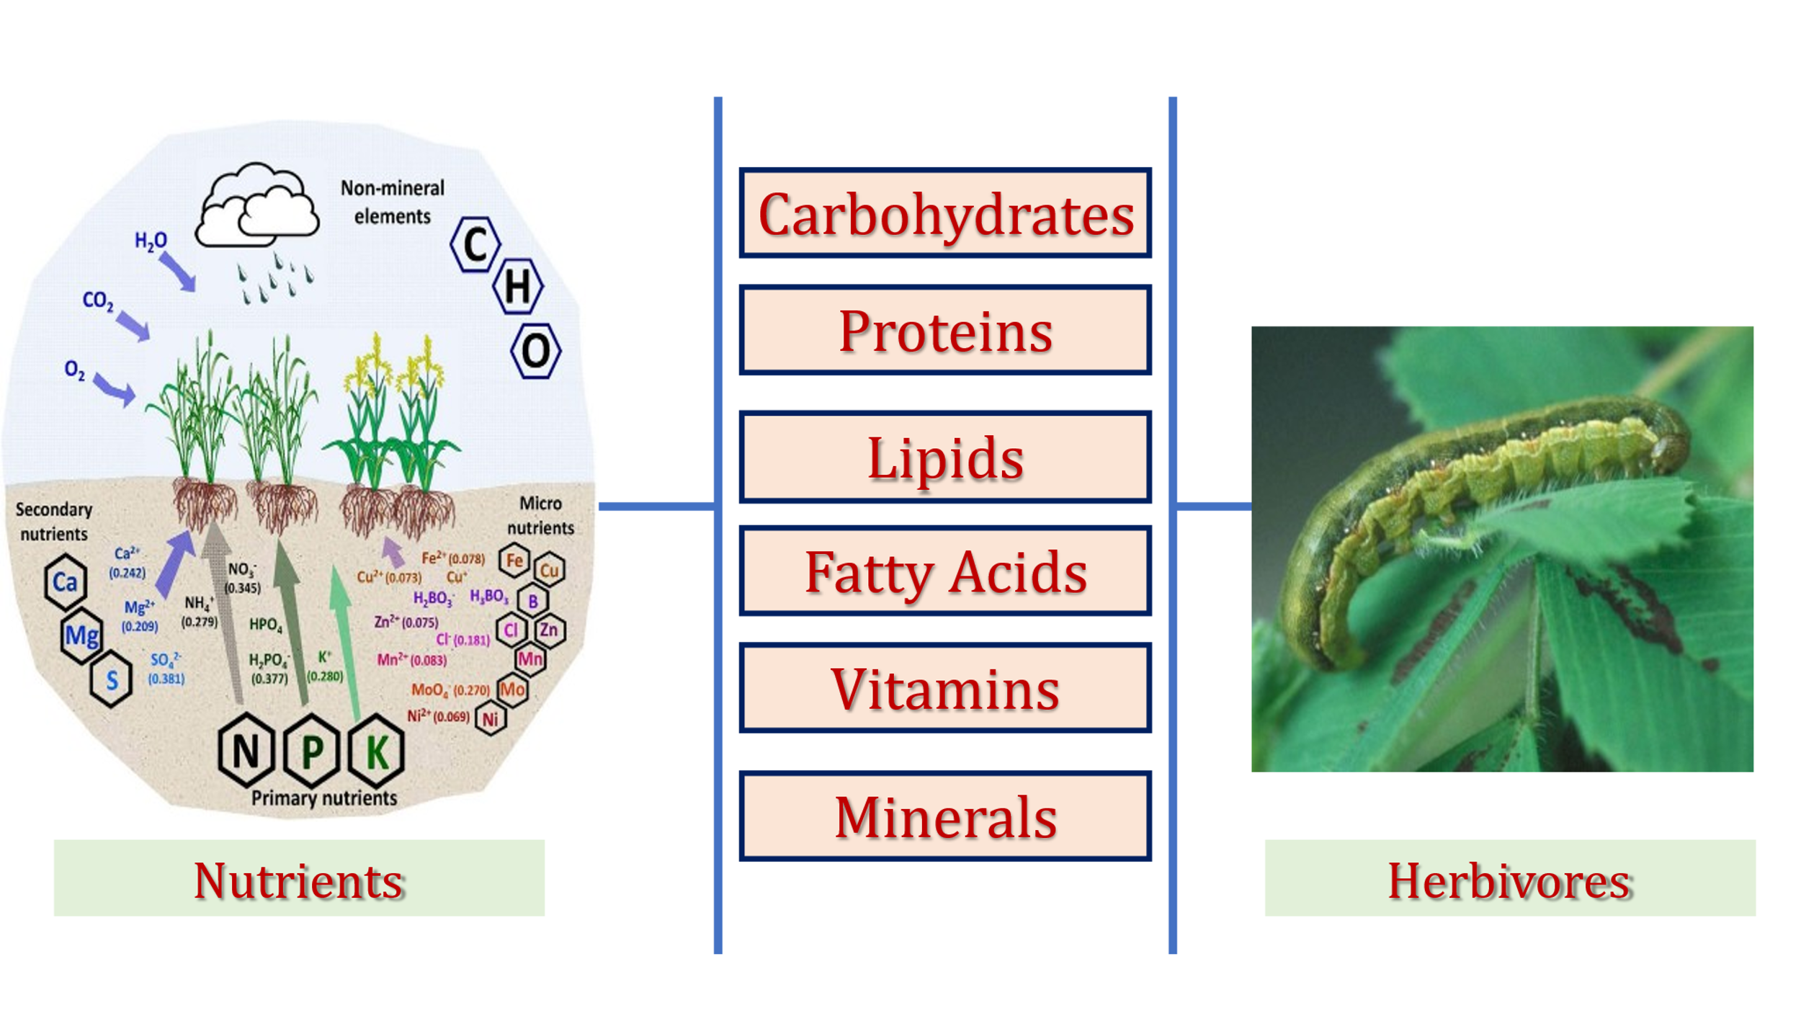

**Figure 1: Nutrient chain from plants to herbivores**

1. **Nutritional Requirements of Insects**

Insects have a wide range of nutritional needs that are essential for their development, reproduction, survival, and ecological interactions. Important elements of insect cell membranes that maintain structural integrity and support cellular processes are sterols, phospholipids, and fatty acids. Diglycerides, triglycerides, and derivatives of polyunsaturated fatty acids are examples of compounds that are essential for signalling and energy storage, especially during reproductive activities. Acetylcholine and phosphatidylcholine are two examples of phospholipids that are essential for nerve transmission and membrane integrity. Since insects cannot synthesize sterols, they must get vital sterols from plant tissues, particularly cholesterol, which is necessary for the development and synthesis of hormones. The hardening of the cuticle, particularly in mandibles, is greatly aided by trace elements like as iron (Fe), zinc (Zn), and manganese (Mn), which increase the mechanical strength needed for protection and food intake. In insect physiology, amino acids also have specific functions. For example, tryptophan helps to synthesize visual screening pigments that are necessary for ocular function, and tyrosine is important for cuticular sclerotization. While a lack of vitamin C can result in abortive ecdysis and death, water-soluble vitamins such as beta-carotene, vitamin E, biotin, folic acid, and others assist a variety of metabolic and physiological processes. Additionally, sugars are the only source of nourishment for many adult insects and also affect feeding behavior and host plant recognition. Dietary carbohydrates are the main sources of energy and aid in the synthesis of fat and glycogen.

|  |  |
| --- | --- |
| **Table 1: Essential Nutrients: Their Roles and Functions in Insects**  **Bala et al. 2018** | |
| **Essential Nutrient Classes** | **Role and Function in Insect** |
| **Fatty Acids** | Fatty acids, phospholipids, and sterols are vital components of the cell membrane in insects, contributing to its structure and function. Compounds such as diglycerides, triglycerides, and derivatives of polyunsaturated fatty acids play significant roles in insect reproduction, serving as energy reserves and signaling molecules. Among phospholipids, acetylcholine and phosphatidylcholines are especially important for nerve function and membrane integrity. Since insects cannot synthesize sterols de novo, they acquire them particularly cholesterol by feeding on plant tissues, which is essential for hormone production and development. |
| **Minerals** | Elements such as iron (Fe), zinc (Zn), and manganese (Mn) play a crucial role in the hardening of the cuticle, particularly in the mandibles of many insects. These metals are often incorporated into the cuticular matrix, enhancing its mechanical strength and durability, which is essential for feeding, defense, and other physical activities. |
| **Proteins and Amino Acids** | Enzymes and morphogenesis in insects are closely linked to specific amino acids. For example, tyrosine plays a crucial role in cuticular sclerotization, the process that hardens and darkens the insect exoskeleton. Similarly, tryptophan is involved in the formation of visual screening pigments, which are essential for proper visual function and protection of photoreceptor cells. |
| **Vitamins** | Water-soluble vitamins such as beta-carotene, vitamin E, biotin, folic acid, and others play essential roles in various metabolic and physiological functions in insects. These vitamins support growth, reproduction, and overall health. A deficiency in certain vitamins, particularly vitamin C, can lead to severe consequences such as abortive ecdysis (incomplete or failed molting) and ultimately death, highlighting their critical importance in insect development and survival. |
| **Carbohydrates** | Dietary carbohydrates primarily serve as energy sources and are involved in the synthesis of fat and glycogen. In some adult insects, sugars are the only form of nourishment and also influence their feeding behavior and help certain plant-feeding insects locate and recognize their host plants. |

* 1. **Effect of Nitrogen on Plants and Insects**

In addition to reducing the effectiveness of pesticide spray coverage, high nitrogen fertilization frequently causes abundant vegetative growth, which also produces vibrant, green foliage that tends to draw pest populations. Grain production, chlorophyll content, leaf area, and plant dry weight are all greatly increased by nitrogen application. Additionally, high nitrogen levels encourage the production and buildup of proteins, free amino acids, and carbohydrates, which can increase the nutritional value of plants for insect pests like whiteflies on okra. While applying phosphorus and potassium together, with or without nitrogen, has been shown to decrease pest accumulation, some studies have shown that nitrogen alone, particularly at larger dosages, enhances aphid population densities. Interestingly, despite a rise in pest numbers, the application of 120 kg ha⁻¹ of nitrogen was associated with a significant increase in crop yield, indicating a complex trade-off between nutrient input and pest pressure. **Jauset et al. (1998)** demonstrated that in tomatoes (*Solanum lycopersicum*), the nitrogen content of plants directly reflected the level of fertilization and significantly influenced the distribution and egg-laying behavior of *Trialeurodes vaporariorum* (greenhouse whitefly) adults, with females aggregating and ovipositing more on leaves of plants with higher nitrogen and water content. Similarly, **Cisneros and Godfrey (1998)** suggested that excessive nitrogen in cotton may alter plant quality and reduce its resistance to aphid infestations, further reinforcing the role of nitrogen in pest attraction and susceptibility.

It has been observed that chrysanthemum plants with lower nitrogen fertilizer dosages have higher levels of chlorogenic acid, a substance that serves as a natural defense against insect pests. In particular, thrips-resistant chrysanthemum varieties had greater quantities of phenylpropanoids such feruloyl quinic acid and chlorogenic acid, indicating that a moderate nitrogen regime may promote pest resistance by enhancing defensive secondary metabolites. Similarly, it has been demonstrated that controlling insect herbivores such as the cotton aphid (*Aphis gossypii*) can be achieved with the proper application of nitrogen fertilizers. Establishing an ideal nitrogen regime in irrigated paddy fields reduces environmental contamination while simultaneously increasing nitrogen use efficiency. Field studies have also demonstrated that cotton aphid population density is significantly influenced by the interaction between nitrogen and potassium fertilizers. Potassium application, particularly when combined with nitrogen at balanced ratios like K:N = 1:0.9 or 1:1.2 kg/ha, successfully suppressed aphid populations at the seedling stage over the course of two years of field trials. This suggests that balanced fertilization techniques can support both pest control and plant development in *Bt* cotton fields (**Ai et al., 2011**). Moreover, free amino acid concentrations in the leaves of nitrogen-fertilized potato plants have been found to positively correlate with the population growth rate of the green peach aphid (*Myzus persicae*) (**Jansson & Smilowitz, 1986**) indicating that higher nitrogen levels can improve host plant quality, which in turn supports aphid proliferation.

|  |  |  |  |  |
| --- | --- | --- | --- | --- |
| **01** | **Common Name** | **Scientific Name** | **Effect of Nitrogen on the Insect** | **Source** |
| Hemiptera | Cotton aphid *or* Melon aphid | *Aphis gossypii* | The aphid population exhibited the shortest mean generation time and the highest finite rate of increase (λ) when fed on chrysanthemum plants that had been fertilized at 150% of the recommended fertilizer level. This suggests that elevated nutrient availability in the host plant significantly enhanced the aphids' developmental rate and reproductive potential, thereby accelerating population growth under these conditions. | Rostami et al. 2011 |
| Potato aphid | *Macrosiphum euphorbiae* | Several studies have demonstrated a positive relationship between nitrogen concentration and aphid performance, with increased nitrogen availability leading to higher fecundity and improved survival rates. Elevated nitrogen levels in host plants enhance their nutritional quality, thereby supporting more robust aphid development and reproduction. In contrast, aphids reared on unfertilized or nitrogen-deficient plants exhibit significantly lower performance, indicating the critical role of nitrogen in promoting aphid fitness. These findings collectively highlight the importance of nitrogen as a key factor influencing aphid population dynamics and their interactions with host plants. | Johanna et al. 2009 |
| Cereal or Rose-grain aphid | *Metopolophium dirhodum* | Increased fertilization levels have been shown to significantly enhance aphid fecundity and intrinsic rate of increase, while longevity remained largely unaffected by the amount of fertilizer applied. This suggests that nutrient enrichment primarily influences reproductive capacity and population growth rather than lifespan. Additionally, aphids reared under controlled glasshouse conditions exhibited greater longevity compared to those reared in field environments, likely due to the more stable and favorable environmental conditions that reduce stress and mortality. These observations underscore the combined influence of plant nutritional status and environmental factors on aphid biology and population dynamics. | Gash 2012 |
| Green peach aphid | *Myzus persicae* | Aphid population dynamics in response to varying nitrogen (N) levels demonstrated a non-linear, parabolic pattern. Populations increased progressively over time at intermediate nitrogen levels, indicating optimal conditions for growth and reproduction. However, at the lowest nitrogen level, aphid numbers remained relatively stable, suggesting limited nutritional support for population expansion. Interestingly, at the highest nitrogen level, aphid populations declined, possibly due to negative effects such as toxicity or imbalanced nutrient uptake by the plant. Four weeks after infestation, aphid numbers exhibited a parabolic response to nitrogen availability, highlighting the complex relationship between plant nitrogen content and aphid population performance. | Sauge et al.  2010 |
| Thysanoptera | Western flower thrips | *Frankliniella occidentalis* | Host plants receiving higher rates of nitrogen fertilization supported a greater increase in thrips population, particularly during peak infestation periods. Elevated nitrogen levels in the plants not only enhanced overall nutritional quality but also altered the amino acid composition of flowers, which coincided with increased thrips abundance. Notably, the abundance of adult female thrips was strongly correlated with flower concentrations of phenylalanine, suggesting that specific amino acids may play a critical role in supporting reproductive success and driving population growth. These findings emphasize the influence of host plant nitrogen status and biochemical composition on thrips population dynamics. | Chen et al.  2004 |
| Lepidoptera | Yellow Stem Borer and Rice Leaf Folder | *Scripophaga incertulas* and  *Cnaphalocrocis medinalis* | The highest incidence of pest infestation was recorded in the Punjab Bas-2 variety of rice, particularly under conditions of elevated nitrogen fertilization. An increase in nitrogen levels was associated with a corresponding rise in the incidence of key pests, notably leaf folder and stem borer. This suggests that higher nitrogen availability may enhance host plant suitability or attractiveness, thereby promoting greater pest colonization and damage. These observations highlight the potential trade-off between nutrient management and pest susceptibility in rice cultivation. |  |
| Diamond back moth | *Plutella xylostella* | Excessive nitrogen fertilization has been shown to increase the feeding preference of insect pests on cabbage plants. Elevated nitrogen levels likely enhance the plant’s nutritional quality, making it more attractive and palatable to herbivorous insects. This increased preference can lead to higher levels of infestation and feeding damage, underscoring the role of nitrogen in influencing host plant selection and pest pressure in cabbage cultivation. |  |
| Coleoptera | Heather beetle | *Lochmaea suturalis* | Recent studies suggest that the destabilizing effect of nitrogen deposition on plant–herbivore interactions is a key factor contributing to the increased frequency of periodic pest outbreaks. Elevated nitrogen levels can alter plant nutritional profiles, often enhancing palatability and suitability for herbivores, which in turn promotes more rapid population growth and reproduction. These changes can disrupt the natural balance between plants and herbivores, reducing plant resistance and triggering more frequent and severe pest infestations in various agroecosystems. | Brunsting et al.  1982 |

**Table 2: Influence of Nitrogen Fertilization on Various Insect Orders**

|  |  |  |  |  |
| --- | --- | --- | --- | --- |
| **02** | **Common Name** | **Scientific Name** | **Effect of Nitrogena, NPKb on the Mites** | **Source** |
| Acari | European red mite | ***a****Panonychus ulmi* | Mite populations increased significantly with higher nitrogen levels, likely due to improved host plant quality enhancing feeding and reproduction. | Bala et al. 2018 |
| Strawberry spider mite | ***a****Tetranychus telarius* | Elevated nitrogen fertilization resulted in greater mite abundance, indicating a positive correlation with plant nitrogen content. |
| Increased nitrogen levels stimulated a rise in mite population density, suggesting enhanced suitability of the host plant. |
| Two-spotted spider mite | ***b****Tetranychus urticae* | Application of NPK fertilizers led to a noticeable increase in mite populations, reflecting the combined effect of macronutrients on host plant palatability and pest performance. |

**Table 3 : Combined Impact of NPK on Mite (Acari) Populations (Adapted from Bala et al., 2018)**

* 1. **Influence of phosphorus on insects:**

According to **Huberty and Denno, 2006** it can be stated that in the tissue of Phytophagous insects the content of Nitrogen and Phosphorus is significantly higher when compared to their host plants, which create a challenge to meet the nutritional demand by plant feeding alone therefore, creating an inherent elemental imbalance. Thus, this imbalance highlights the importance of increasing the Herbivory performance. Recent studies have also indicated that the pest population can be influenced by the application of phosphorus whether it is applied alone or in a combination with nitrogen. In Mustard, the application of phosphorus led to a significant reduction in population of Mustard aphid (*Lipaphis erysimi*). With higher application rate the suppression of the population was also observed. Moreover, the grain yield also increased with the application of phosphorus at the rate of 40 and 60kg/ha. Highlighting the agronomic benefits with main focus on pest reduction. In rice, with the increase in application of phosphorus dose, enhancing the nutritional status of the plant, simultaneously providing an ambient condition to increase the Population of *Nilaparvata lugens*. Thus, luxurious growth of plant was observed when the dose or application of the phosphorus was increased. This luxurious growth led to an elevated rise in number of insect population. Thus, with prior findings it can be concluded that phosphorus can have a positive or detrimental influence on different insect pest species and host crop. Existing literature in the field have demonstrated that the phosphorus application in potato have reduced the host suitability for insects. Influencing the biosynthesis of secondary metabolites like phenols and terpenes. Phenolics such as tannins and lignin exerts insecticidal or antifeedant effects on herbivores (**Facknath and Lalljee,2005**). These phenols interfere with physiological process in insects, reducing the fitness and making it susceptible to the harsh environment. Terpenes like sesquiterpenes, monoterpenes and other polymers disrupt the physiological systems by hindering neural transmission and blocking phosphorylation pathways leading to death of the insect. Furthermore, excessive dietary phosphorus in the diet of *Schistocera americana* can have negative impact on its growth and survival. Elevated phosphorus can not only alter the chemistry of plant defense but may also have toxic effect on herbivory.

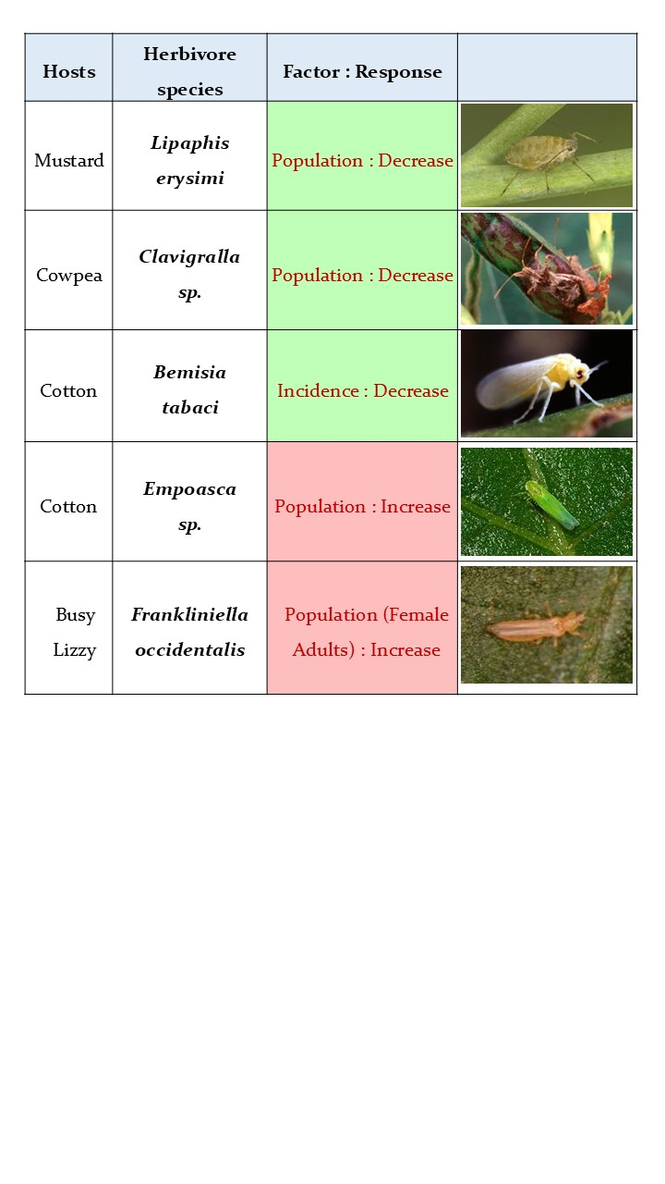

Figure 2: Responses of Herbivorous Insects to Phosphorus Availability

* 1. **Influence of Potassium on insects:**

Potassium plays a major role in enhancing plant resistance among most insect orders i.e. Hemiptera, Lepidoptera, Coleoptera and Thysanoptera. Beneficial effects of potassium are most evidently seen among plant hoppers, beetles. In Lepidoptera and mites both stimulatory and suppressive efforts are observed. Increase in availability of potassium among plants enhance resistance against insects or herbivory. Resistance is enhanced due to synthesis of secondary metabolites and minimal carbohydrate accumulation indicating low damage to plant. Existing literatures, have revealed that potassium significantly influence plant growth. At high potassium level, root and shoot biomass is observed to be increased. In case of *Nilaparvata lugens*, high potasium fertilisation is linked with reduction in pest population (**Rashid et al.2013**). Increased potassium levels have been also associated with low survival of larvae, body weight and population density of *Chilo suprressalis, Cnaphalocrocis* *medinalis.*

Incorporation of Potassium silicate into nutrient fertilisation didn’t report any resistance benefits. For instance, neither resistance was conferred in *poinsettia* against *Trialeurodes vaporarium* nor any improvement of plant performance was seen. For potassium to be effective in pest management, the application method and the form should be kept in prior consideration.

The uptake of nitrogen can be reduced with higher dose of potassium; this can affect the biology and behaviour of the Herbivory adversely. High potassium level decrease assimilation and uptake of food by insects, thereby limiting the growth and reproduction. These changes which attribute to quantitative changes in plant nutrients can alter plant’s internal chemical environment, making the host non palatable. The unpalatable and hampered nutritional quality of host plant reduce the pest population. Under optimum conditions, high amount of potassium levels in plants is regarded as an insurance strategy. This insurance strategy enhances the ability to withstand harsh environmental conditions. This aids in an adaptive feature in plants which contributes to plant resilience and supports natural pest suppression indirectly by creating an unsuitable or low suitable condition for herbivore survival and proliferation

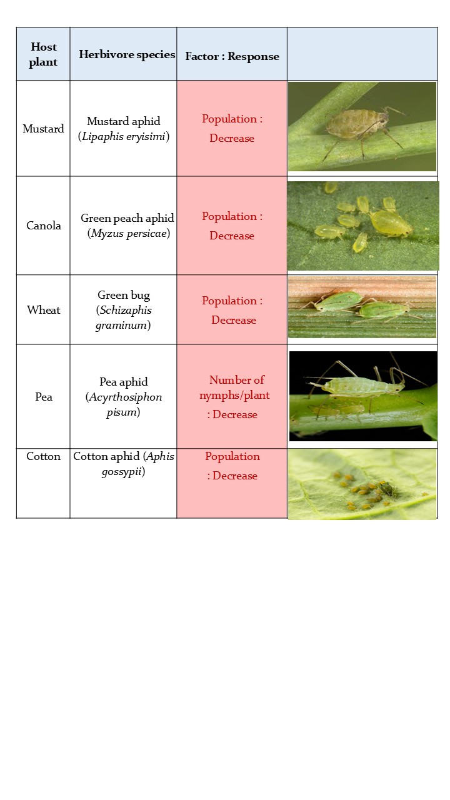

Figure 3: Effect of Potassium on various Aphid species

### Influence of Secondary Macronutrients and Micronutrients

In addition to the primary macronutrients (nitrogen, phosphorus, and potassium), secondary macronutrients such as calcium, magnesium, and sulphur, and micronutrients like zinc, iron, and silicon play important roles in modulating insect-pest interactions with host plants. These nutrients influence plant physiology, structural defenses, and the biosynthesis of insect-deterring compounds. For instance, calcium enhances cell wall stability, which can reduce insect penetration and feeding efficiency. Zinc and sulphur have been observed to exert antibiosis effects in crops such as rice by lowering the population of brown planthopper, possibly through the production of toxic secondary metabolites or by improving overall plant health.

Silicon, although not traditionally classified as an essential nutrient, has gained attention for its unique ability to enhance plant resistance against a broad range of insect pests. It is deposited in plant tissues as opaline phytoliths, increasing tissue toughness and abrasiveness. This physical defence reduces palatability and feeding efficiency for many herbivorous insects. In crops like sugarcane and rice, silicon application has significantly reduced larval damage caused by shoot and stem borers (*Chilo infuscatellus, Eldana saccharina,* and *Diatraea saccharalis*). Additionally, calcium silicate application in tomato has been shown to reduce thrips populations by increasing nymphal mortality. These examples highlight the dual role of silicon as both a physical barrier and an inducer of biochemical defenses, with the added benefit of leaving no pesticide residue.

The effectiveness of secondary macronutrients and micronutrients also extends to their interaction with plant metabolic pathways, which can result in the production of toxic compounds such as alkaloids and glucosides, further deterring insect feeding. Iron and zinc, when present in sufficient levels, are linked to improved pest resistance through enhanced nutritional balance and defence signalling. Moreover, these nutrients are easily integrated into Integrated Pest Management (IPM) strategies due to their compatibility with other control methods and lack of harmful residues. Thus, the strategic application of secondary and micronutrients not only supports plant health and productivity but also contributes significantly to ecologically sustainable insect pest management [ **Leroy et al.2019** ]

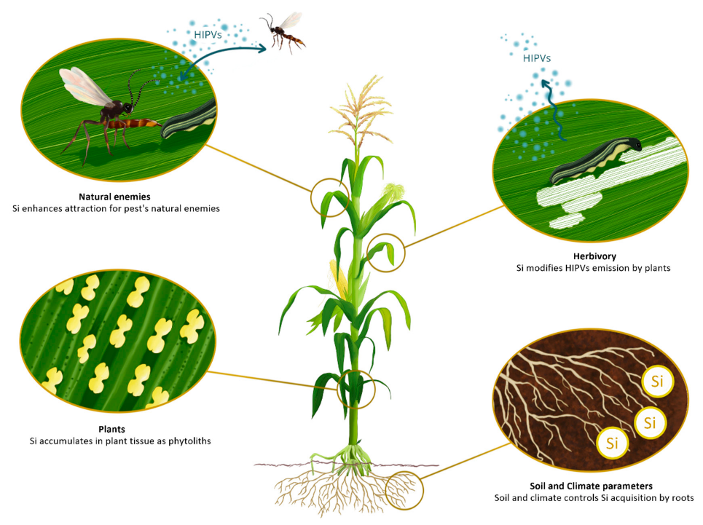

**Fig .4 Functional Role of Silicon**

[**https://www.mdpi.com/2223-7747/8/11/444 Leroy et al.2019**](https://www.mdpi.com/2223-7747/8/11/444%20%20%20%20%20%20%20Leroy%20et%20al.2019)

**Conclusion**

Nutrients play vital role not only in plant growth, tissue maintenance, and reproduction but also in influencing pest resistance or susceptibility. Among the 17 essential nutrients required for plant development, elements like nitrogen, potassium, and phosphorus significantly affect herbivorous insect interactions. Nitrogen tends to enhance insect performance by altering plant chemistry, while potassium strengthens plant defenses by improving secondary metabolite production and reducing carbohydrate accumulation. Phosphorus lowers host compatibility for various pests, and other nutrients such as calcium, zinc, sulfur, and silicon contribute to reduce pest populations and enhance plant resilience. Fertilization practices that modify the nutritional profile of crops can indirectly influence plant resistance to insect pests. Therefore, nutrient management emerges as a strategic, eco-friendly approach in integrated pest management, offering a pathway to healthier crops with reduced reliance on chemical pesticides.

**REFERENCES**

1. Ai TC, Liu ZY, Li CR, Luo P, Zhu JQ. Impact of fertilization on cotton aphid population in Bt. cotton production system. Ecological Complexity. 2011; 8:9-14
2. Bala, K., Sood, A. K., Pathania, V. S., & Thakur, S. (2018). Effect of plant nutrition in insect pest management: A review. *Journal of pharmacognosy and phytochemistry*, *7*(4), 2737-2742.
3. Bernays EA, Chapman RF. Host-Plant Selection by Phytophagous Insects. New York: Chapman & Hall. 1994; 95-165.
4. Boswell AM, Provin T, Behmer ST. The relationship between body mass and elemental composition in nymphs of the grasshopper Schistocerca americana. Journal of Orthoptera Research. 2008; 17:307-313.
5. Brunsting, A. M. H. (1982, March). The influence of the dynamics of a population of herbivorous beetles on the development of vegetational patterns in a heathland system. In *Proceedings of the 5th Conference on Insect-plant relationships* (pp. 215-223).
6. Chapman, A.D. (2013). *The Insects: Structure and Function* (5th ed.). Cambridge University Press.  
   <https://doi.org/10.1017/CBO9781139035512>
7. Chen, I. J., & Paulraj, A. (2004). Towards a theory of supply chain management: the constructs and measurements. *Journal of operations management*, *22*(2), 119-150.
8. Cisneros, J. J., & Godfrey, L. D. (1998). Agronomic and environmental factors influencing control of cotton aphids with insecticides.
9. Douglas, A.E. (2009). The microbial dimension in insect nutritional ecology. *Functional Ecology*, 23(1), 38–47.  
   <https://doi.org/10.1111/j.1365-2435.2008.01442.x>
10. Facknath S, Lalljee B. Effect of soil-applied complex fertilizer on an insect–host plant relationship: Liriomyza trifolii on Solanum tuberosum. Entomologia Experimentalis et Applicata. 12005; 15(1):67-77.
11. Gash AF, Carter N, Bale JS. The Influence of Nitrogen Fertilizer Applications on the Cereal Aphids Metopolophium dirhodum and Sitobion avenae. In Proceeding of the Brighton Crop Protection Conference, Brighton, UK, BCPC: Farnham, Surrey, UK, 1996; 209 214.
12. Huberty AF, Denno RF. Consequences of nitrogen and phosphorus limitation for the performance of two planthoppers with divergent life-history strategies. Oecologia. 2006; 149:444-455.
13. Jansson RK, Smilowitz, Z. Influence of nitrogen on population parameters of potato insects: Abundance, ~ 2742 ~ population growth, and within-plant distribution of the green peach aphid, Myzus persicae (Homoptera: Aphididae). Environmental Entomology. 1986; 15:49-55.
14. Jauset AM, Sarasúa MJ, Avila J, Albajes R. The impact of nitrogen fertilization on feeding site selection and oviposition by Trialeurodes vaporariorum Entomologia Experimentalis et Applicata. 1998; 86:175-182.
15. Leroy, N., de Tombeur, F., Walgraffe, Y., Cornélis, J.-T., & Verheggen, F. J. (2019). Silicon and Plant Natural Defenses against Insect Pests: Impact on Plant Volatile Organic Compounds and Cascade Effects on Multitrophic Interactions. *Plants*, *8*(11), 444. <https://doi.org/10.3390/plants8110444>
16. Nation, J.L. (2015). *Insect Physiology and Biochemistry* (3rd ed.). CRC Press.  
    <https://www.routledge.com/Insect-Physiology-and-Biochemistry/Nation/p/book/9781466585255>
17. Rashid MM, Jahan M, Islam KS. Impact of nitrogen, phosphorus and potassium on brown planthopper and tolerance of its host rice plants. Rice Science. 2016; 23(3):119-131.
18. Rostami M, Zamani AA, Goldastech S, Shoushtari RV, Kheradmand K. Influence of nitrogen fertilization on biology of Aphis gossypii. Journal of Plant Protection Research. 2016; 52(1):118-121.
19. Sauge MH, Grechi I, Poessel JL. Nitrogen fertilization effects on Myzus persicae aphid dynamics on peach: Vegetative growth allocation or chemical defence? Entomologia Experimentalis et Applicata. 2010; 136:123-133.
20. Simpson SJ, Clissold FJ, Lihoreau M, Ponton F, Wilder SW, Raubenheimer D. Recent Advances in the Integrative Nutrition of Arthropods Annual Review of Entomology. 2015; 60:16.1-16.19.
21. Simpson, S.J., & Raubenheimer, D. (2012). *The Nature of Nutrition: A Unifying Framework from Animal Adaptation to Human Obesity*. Princeton University Press.  
    <https://press.princeton.edu/books/hardcover/9780691143326/the-nature-of-nutrition>