**A Review on Understanding the Influence of Climate Change on Agriculture and Insect Pest**

**Abstract**  
Recent decades have witnessed significant advancements in science and technology, driving economic growth and increased agricultural productivity. Rapid global population growth, particularly since the 20th century, poses serious challenges to environmental stability and food security. Meeting the projected food demand by 2050 necessitates a substantial increase in agricultural output through enhanced crop production and improved crop management, rather than land expansion. Climate change manifested through global warming, elevated atmospheric CO₂ levels, increased drought frequency, and erratic weather patterns continues to affect crop yields directly as well as indirectly. One of the most critical indirect effects involves changes in insect pest biology, ecology, population dynamics, and interactions with crops and natural enemies. These changes can lead to increased pest outbreaks, further threatening crop productivity. This review explores the current and projected impacts of climate change on insect pests, with a focus on elevated CO₂, temperature shifts, and drought.

**Keywords:** climate change, carbon sequestration, insect pest, environment, entomology, global warming

1. **Introduction:**

According to Intergovernmental Panel on Climate Change, it is defined as the change due to natural variability or as a result of human activity on climate over due course of time. Global change is natural as well as anthropogenic. The term Climate Change refers to the steady or gradual rise in the mean temperature of the Earth's atmosphere and its related oceans, which has been reported to be constantly affecting the global climatic conditions. Since 1900, the global temperature has been gradually increasing, rising by roughly 1°C. India has experienced a temperature rise ranging from 0.2°C and 1°C, while northwest North America has seen the most increase**.** Furthermore, the rate of global warming is accelerating over the past 50 years, the temperature has risen twice more rapidly as it did over the previous 100 years. By 2070, the average rainfall in India is predicted to rise by 10%, while the average temperature is predicted to rise by 1.7ºC during the kharif (July to October) and 3.2ºC during the rabi (November to March) seasons (Gupta, 2011). It is also predicted that by 2100 the global temperature would rise in the range of 1.4-5.8 degree Celsius along with 10-15% of precipitation and rise of C02 level in the range of 540-970 ppm [IPCC,2014]. In India a drastic temperature rise of 0.7 degree Celsius in between 1901-2018 year is seen. GHG’s are primarily to be blamed for this temperature rise. Climate change, marked by rising global temperatures, altered rainfall patterns, and an increase in extreme weather events, is having a profound impact on insect pest populations. These abiotic changes influence key biological processes such as development, survival, reproduction, and dispersal. Temperature, in particular, plays a central role in shaping pest population dynamics, with studies showing that higher temperatures can reduce the survival rates of certain pests, like the brown planthopper and rice leaf folder, while simultaneously favouring multivoltine species by enabling more generations per year. This shift in voltinism may also lead to changes in pest distribution, allowing them to colonize new regions. Additionally, elevated atmospheric CO₂ can indirectly affect pest abundance by altering the nutritional quality of host plants, potentially increasing herbivore feeding and population pressure. Overall, climate change is expected to significantly reshape the behaviour, abundance, and geographical spread of insect pests. The global distribution, abundance and ecology of plants and animals will be impacted and affected by these shifts in climatic change [**Khadioli et al.2014**]. Insects are ectothermic {Ectothermic organisms rely on external environmental conditions to regulate their body temperature} and are precipitation sensitive so they will be directly or indirectly impacted by climate change [**Bale et al. 2002**]. Such impacts can indirectly mediate the host plants and natural enemies. It is also seen that the change in climatic conditions can also affect the physiology and behaviour of insects. The change in climate can outbreak the density of pest which are limited to a small area or available in low densities, eventually increasing their population densities **[Porter et al.1991].** The modification in dispersal and development of insect species is directly linked with seasonal weather effects. As already stated the change in temperature ignites the fact that there will be alteration in development rates, voltinism and survival of insects. This also act on the size, density and genetic compositions of populations as well as the extent of host plant exploitation [Bale et al. 2002].

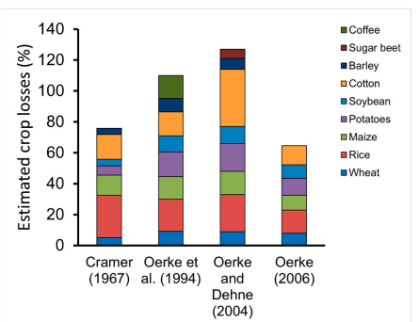

Figure1**: Global estimated loss caused by Pests** [ **Subedi et al.2023**]

1. **Response of Insect Pests to Increased Temperature**

The biology of insect pests is greatly impacted by temperature, which affects the insects' growth, survival, reproduction, and geographic range. As they are poikilothermic, insects depend on the temperature of their surroundings to regulate body functions. Insect metabolism is accelerated by a general rise in temperature, which results in quicker development, greater fecundity, shorter generation times, and wider dispersal ranges. However not every species reacts in the same way. Aphids and whiteflies, for example, may become more prevalent in temperate zones as temperatures rise because they provide ideal circumstances for reproduction and lower death rates. On the other hand, higher temperatures may lower pest growth rates and survival in tropical regions, where insects already reside close to their thermal limitations. Furthermore, whiteflies and aphids have shown increased population build-up in conditions of high temperature and humidity. However, extreme temperatures can sometimes reduce insect performance or lead to range contractions in temperature-sensitive species (**Lehmann et al., 2021**). The net effect of warming on pest severity is often species- and region-specific, but a general trend toward earlier infestations and increased voltinism is expected. (**Skendžić et al., 2021**).

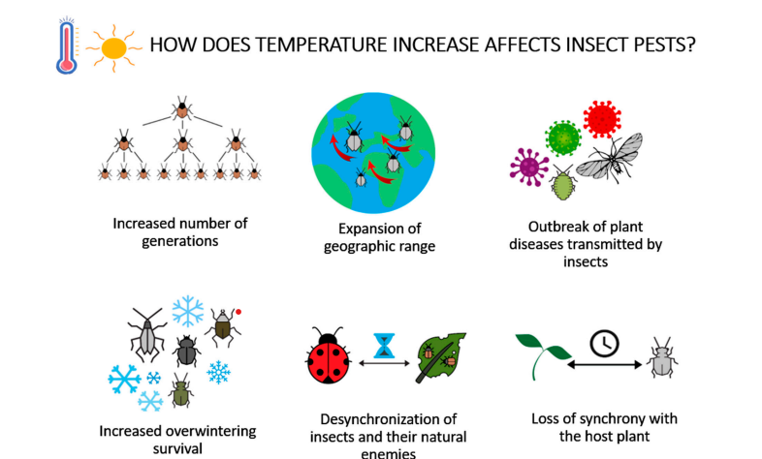

**Figure 2: Effects of temperature rise on agricultural insect pests.[ Skendžić et al., 2021]**

1. **Response of Insect Pests to Increased CO₂ Concentration**

Insect pests are impacted by elevated atmospheric CO₂ both directly and indirectly through modifications to the physiology of their host plants. Plant photosynthesis, growth, and carbon buildup are all accelerated by elevated CO₂, especially in C₃ crops like soybean, rice, and wheat. The carbon-to-nitrogen (C:N) ratio in leaves is changed by this change, which lowers the leaves' nutritional value for herbivores and frequently causes insects to eat additional plant material in order to meet their nitrogen requirements, this procedure known as compensatory feeding. For instance, compared to control plants, soybeans cultivated in environments with higher CO₂ levels displayed 57% more insect damage from pests such leafhoppers and Japanese beetles **(Hamilton et al., 2005**). Although more leaves are consumed as a result, the loss of nutritional value may not be entirely compensated for, which could have an impact on the growth and development of insects. Analysis has shown increased consumption rates (~17%), longer development time (~4%), and reduced growth efficiency (~9%) among chewing insects under elevated CO₂ (**Stiling & Cornelissen, 2007** ; **Skendžić et al., 2021**). Responses vary by feeding type: chewers often show stronger reactions than sap-suckers, whose fecundity and abundance may still increase depending on the host-plant changes.

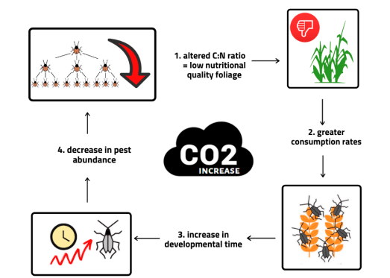

**Figure 3:** Impact of atmospheric CO2 increase on agricultural insect pests [**Skendžić et al., 2021**]

1. **Response of Insect Pests to Changeable Precipitation Pattern**

Insect pests are impacted by altered precipitation, which is characterized by heavier but less frequent rainfall, in both direct mortality and habitat relevance. In addition to disrupting soil-dwelling insect stages by flooding and lowering oxygen availability, heavy rains can physically displace or kill soft-bodied insects such as aphids, mites, and jassids, which can impair diapause and overwintering survival (**Skendžić et al., 2021**). On the other hand, certain insects prefer wetter or moist environments. For instance, under increasing summer rainfall, wireworm (*Agriotes lineatus*) populations grew in the higher soil layers, perhaps as a result of better moisture conditions that were conducive to larval development (**Staley et al., 2007**). On the other hand, drought also shapes pest dynamics by weakening plant defenses. Drought-stressed plants become more attractive to pests, both through reduced secondary metabolite production and physical signals like cavitation noise, which can attract pests like bark beetles (**Skendžić et al., 2021**). This dual nature where both excess and shortage of rainfall can either suppress or enhance pest populations highlights the complex and unpredictable role of precipitation changes in pest ecology.

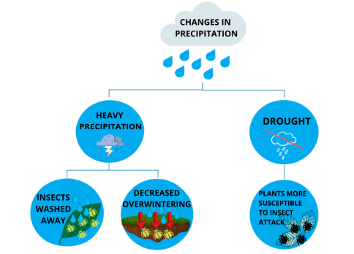

**Figure 4:** Impact of heavy precipitation and drought on agricultural insect pests [**Skendžić et al., 2021**]

1. **Direct effect of rising temperature on Insect pest** 
   1. **Effect of Temperature on Survival Rate of Insects**

Insect pests' ability to survive is significantly impacted by temperature, which affects various stages of lifecycle. As seen with the spruce beetle (*Dendroctonus rufipennis*), warmer temperatures typically shorten the time required for insect reproduction**.** A 2°C increase in temperature may trigger one to five additional life cycles per season for pests like aphids. Extreme heat, however, can have negative effects. For instance, the adult survival rate of the brown planthopper (*Nilapavata lugens*) is consistent between 25 and 35°C but drastically decreases at 40°C. The rice leaffolder (*Cnaphalocrocis medinalis*) exhibits a significant decrease in egg survival and overall reproductive success at 35°C, suggesting an upper temperature limit for viability (**Karuppaiah & Sujayanad, 2012**).

* 1. **Effect of Temperature on Growth Rate of Insects**

Insect growth rates are accelerated by rising temperatures because they facilitate faster development. Higher temperatures cause population growth ratios of 3 to 4 in pests like *Nephotettix cincticeps*, which are more sensitive than species like *Chilo suppressalis* because they produce more generations annually. Furthermore, higher winter temperatures promote pest survival; for example, *Nezara viridula* and *Halyomorpha halys* show a 15% decrease in winter mortality for every 1°C increase. Degree-day accumulation is also associated with growth; for example, in mustard aphids, lower heat accumulation is associated with increased infestation (**Karuppaiah & Sujayanad, 2012**).

* 1. **Effect of Temperature on Voltinism**

Rising surface temperatures have a significant impact on voltinism, or the number of generations an insect may produce annually. Multivoltine species are typically favored by warmer conditions, which allow them to generate several generations each year. *Leptocorisa acuta*, for example, showed a drop in egg length from 10.4 days at 25°C to 7.9 days at 27–28°C, while maintaining over 75% egg viability at higher temperatures. Increases in surface temperature beyond 2°C can drastically change voltinism patterns by modifying oviposition times, according to models for species like *Paralobesia viteana*. This is especially true in cases where diapause is regulated by photoperiod (**Karuppaiah & Sujayanad, 2012**).

* 1. **Global Warming vs Species Distributions**

The geographic distribution of insect pests is changing due to climate-induced changes in temperature and precipitation patterns. Under warmer conditions, a number of forest pests, such as the eastern and western spruce budworms (*Choristoneura fumiferana* and *C. occidentalis*), are spreading toward higher latitudes. Similarly, more than fifty butterfly species have migrated north, and migratory butterflies have made their permanent home in the Nansei Islands in Japan. Depending on the species and area, this change may increase or decrease pest concerns (**Karuppaiah & Sujayanad, 2012**).

* 1. **Precipitation and Drought**

Insect populations are affected in many ways by altered rainfall patterns, such as heavier summer rains and more frequent droughts. High summer rainfall is ideal for soil-dwelling pests like wireworms (*Agriotes lineatus*), but severe drought can significantly reduce the viability of eggs, as demonstrated by *Scopelosaurus lepidus*. Variable rainfall patterns are changing the movement of desert locusts (*Schistocerca gregaria*) in Sub-Saharan Africa, while higher November rainfall in India has been associated with a greater infestation of *Helicoverpa armigera* (**Karuppaiah & Sujayanad, 2012**).

* 1. **Effect of Climate on Pest Population via Natural Enemies**

By affecting their natural enemies, insect populations may be indirectly impacted by climate change. Temperature affects predator efficiency. For instance, up to 32°C, the egg predator *Cyrtorhinus lividipennis*, a natural enemy of BPH, shows increased attack rates and shorter handling times; but, at 35°C, efficiency starts to decrease. In the same way, the parasitoid *Campoletis chlorideae* thrives at temperatures between 12 and 22°C, with higher temperatures reducing both survival and output from reproduction. Temporal asynchrony and decreased biological control effectiveness might result from these variations in the temperature responses of pests and their enemies (**Karuppaiah & Sujayanad, 2012**).

1. **Direct effects of climatic parameters on population dynamics of Insect Pest**

Direct effects of climatic parameters on population dynamics may be alteration in development, reproduction, diapause, winter mortality as well as flight and dispersal **[Wareen et al. 2001]**

* 1. **Development and Reproduction**

It can be stated that until the limit of a particular species is not exceeded, slight rise in temperature can be proved beneficial. Such is the case in *Ips typographus* where there is enhanced reproductive potential due to rise in temperature conditions. It also enhances the developmental rate allowing for earlier completion of the lifecycle [Lange et al. 2006; Jonsson et al. 2009]. In general, the temperature rise above the optimum level may also lead to decreased growth rates, reduced fecundity and increased rate of mortality for many insect species [**Rouault et al. 2006**]. In mild winters the decreasing frequencies of temperature may also enhance the reproductive capacity. Temperature rise when reduce the snowfall can decrease the overwintering survival of species particularly the ones which hibernate under the snow [**Ayres et al. 2000**]

* 1. **Diapause and Mortality**

In temperate regions a phase of dormancy in many species is essential to complete the lifecycle and to tolerate the harsh winter conditions. The species with low frost resistance and the active feeding species can be benefited with the increase in temperature. It is detrimental for the species which donot need low temperature to initiate the diapause procedure.

* 1. **Migration and Movement (Flight dispersal)**

Dispersal and onset of flight are the essential parameters in phenology of insect herbivores which affect the timing and intensity of mating, host finding and colonisation and their establishment. The temperature threshold for insect flight may vary among regions and also in seasons. Threshold temperature varies according to the phase of flight activity. In case of *Aphis fabae* a temperature of 17 degree Celsius is required to initiate or take of the flight, for sustained upward flight the temperature desired is about 15 degrees Celsius, in case of horizontal flight it is 13 degree Celsius and 6.5 degree Celsius in wing reflux or beating mechanism [Johnson and Taylor, 1957].

1. **Impact of Climate change on Rice Pest**
   1. **Brown Planthopper (*Nilaparvata lugens*):**

Rising temperatures and increased CO₂ levels have a significant impact on the brown planthopper (BPH), with varying effects on its biology and population dynamics. While it may shorten nymphal life and adult longevity, studies show that a combined rise in temperature and CO₂ (about 3°C above ambient and 570 ppm CO₂) considerably enhances BPH multiplication and fecundity. Adult survival is not significantly impacted by temperatures above 35 °C, but exposure to 40 °C causes a considerable amount of mortality. It's interesting to note that although female oviposition is higher at 35 to 40 °C, egg survival significantly decreases at these temperatures, indicating that development is constrained beyond specific thresholds. Additionally, higher winter temperatures may hasten the development of BPH and lower mortality, which would increase the population in later seasons. In addition, BPH’s tolerance to heat varies by region, and it is considerably more heat-tolerant than its natural predator *Cyrtorhinus lividipennis*, potentially disrupting predator-prey dynamics in warmer conditions (**Krishnaiah & Varma, 2011**).

* 1. **Rice Leaffolder (*Cnaphalocrocis medinalis*):**

The biology and growth patterns of rice leaf folders are greatly impacted by climate change, especially warmer temperatures. Increased pest development, reproduction rates, and population growth have all been associated with warmer temperatures. According to a long-term model, leaf folder populations significantly rose in November, coinciding with rising temperatures rather than precipitation, indicating that recent outbreaks are mostly caused by thermal conditions (**Ali et al., 2019**). According to laboratory research, temperatures beyond 30 to 35 °C, which seems to be the species' upper thermal limit, have a detrimental impact on adult survival and reproduction while speeding up development. Furthermore, predator efficiency is impacted by warming temperatures. *Cyrtorhinus lividipennis*, for instance, exhibits peak predation rates at 32°C, but its effectiveness declines with increasing temperatures, which may allow pests to proliferate in warmer climates.

* 1. **Yellow Stem Borer (*Scirpophaga incertulas*):**

Additionally, the yellow stem borer (YSB) behaves differently to changes in the climate, with rainfall and heat having complicated consequences. According to studies, high temperatures and CO₂ levels change the stages of development of YSB, prolonging the larval and pupal phases and decreasing the incubation period and adult lifespan (**Mohapatra et al., 2021**). When combined with heavy rainfall, the entire effect may be harmful to the insect's population, even though increased temperature alone has a positive impact on its development and abundance (**Ali et al., 2020**). According to climate models, warmer winters could improve survival, result in more generations per year, and induce pests to arrive earlier in the crop cycle (**Patel et al., 2017**). But historical patterns indicate that YSB numbers have decreased over the past three decades, maybe as a result of mortality linked to climate change

* 1. **Other Pest**

Climate change has caused changes in the presence and severity of a number of other rice pests. As warming trends continue, the White Backed planthopper (WBPH), which had only moderate presence since 2000, is expected to become more problematic, especially in irrigated environments (**Paramasiva et al., 2024**). Similar to this, the gall midge (*Orseolia oryzae*) is still a prevalent pest, but future outbreaks may be more severe due to the establishment of new biotypes brought on by changing climatic circumstances (**Paramasiva et al., 2024**). Due to rising temperatures and climatic fluctuation, panicle mites (*Steneotarsonemus spinki*), which were formerly thought to be inconsequential, have suddenly gained regional significance (**Krishnaiah & Varma, 2011, Paramasiva et al., 2024**). Furthermore, previously localized or minor pests including caseworms, Hispa, and whorl maggots are becoming more common since the early 2000s, indicating a change in pest status that is probably caused by environmental changes. Prior to the 1980s, leaf and panicle mites in particular were not even thought of as minor pests; however, they are now acknowledged as significant threats in rice ecosystems, highlighting the impact of changing weather patterns and rising temperatures on pest dynamics (**Krishnaiah & Varma, 2011; Paramasiva et al., 2024**).

1. **Impact of Climate change on the Invasive Fall armyworm, *Spodoptera frugiperda*: A Case study [Zanzana et al. 2024]**

Invasive alien insects can reproduce quickly, adapt to new environments and spread widely, posing severe threats to agriculture, biodiversity and ecosystem functioning. The fall armyworm (FAW) Spodoptera frugiperda (JE Smith) (Lepidoptera: Noctuidae) is a major concern due to its devastating impact on maize fields worldwide, resulting in significant yield losses [**Panigrahi et al. 2023**]. Climate change has significantly influenced the infestation dynamics of the fall armyworm (FAW), intensifying its threat to global agriculture. Although the initial invasion of FAW in Africa was primarily facilitated by human activities such as international trade and air travel, its rapid spread and successful establishment across the continent have been largely driven by changing climatic conditions. Rising temperatures have enhanced the pest's biological performance, including faster development, higher survival rates, and increased reproductive capacity. These thermal conditions enable FAW to complete more generations per year and expand into regions previously unsuitable for its survival. In tropical and subtropical zones—especially in sub-Saharan Africa—these favourable conditions have supported the year-round persistence of FAW, transforming it from a migratory to a resident pest in many areas. In addition to temperature, other climatic factors such as rainfall and humidity also play a role in shaping FAW infestation patterns. For example, suitable humidity levels and rainfall variability can either promote or hinder pest development and dispersal. Furthermore, extreme weather events like droughts and floods becoming more frequent due to climate change stress host plants and disrupt natural ecosystems, making crops more susceptible to pest damage **[Zanzana et al. 2024]**.

1. **Strategies for managing Insect Infestations due to Climate Change:**

The core components of remedial measures implemented to counteract the negative effects of climate change are adaptation, mitigation, and natural resource management. Natural resource management uses a comprehensive strategy to reduce the negative effects of climate change by managing insect pests using an environmentally friendly method. India urgently needs to implement climate-resilient policies and initiatives for insect pest management in order to counteract the negative effects of climate change on insect pests. The main approaches for managing climate-resilient insect pests include possible adaptation, mitigation, and natural resource management. Varietal improvement, production augmentation, weather forecasting, indigenous technical knowledge, and sustainable pest management should be the main focuses of these efforts. The following addresses these well-known strategies in the Indian context.

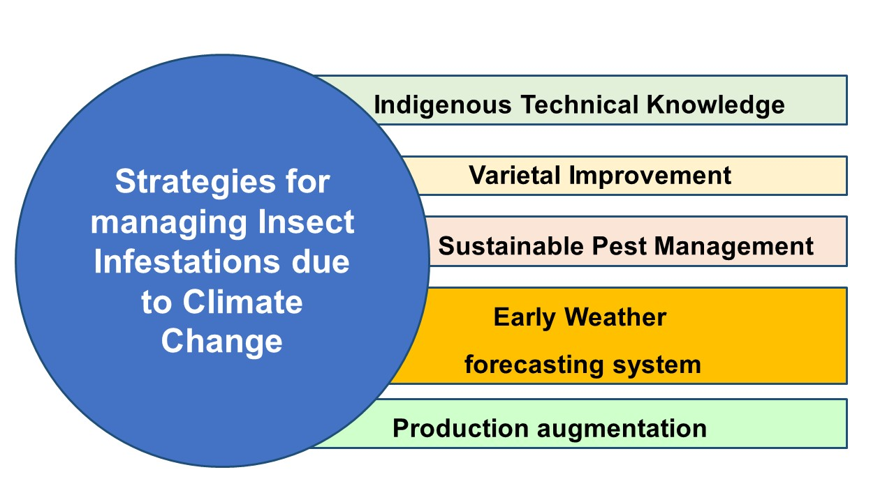

**Fig 5- Strategies for managing Insect infestations due to Climate Change**

* 1. **Varietal Improvement:**

With varietal improvement, the negative effects of climate change on insect pest management can be managed or reduced. The development of new crop varieties with increased yield potential and resistance to diverse stresses via the reinforcement of germplasm improvement programs is known as varietal improvement. Through increasing farm revenues, the varietal enhancement reduces the adverse impacts of seasonality on crop yield potential and stress tolerance. Yield and varietal potential condition will positively impact the germplasm that has diverse biotic stress resistances, such as resistance to frostbite and antibiosis, as well as tolerance to pest and diseases. Multiple biotic stress-resistant crop varieties appear to be a viable way to lessen the infestation of insect pests. In India's most diversified climatic conditions, the short-duration crop varieties mature before the peak infestation of pest and diseases. They can be introduced under crop improvement to compensate production loss during the growing season **[Vanaja et al.2019; Morya and Hasan,2023].**

* 1. **Production augmentation**

Enhancing farm output with a larger yield potential at a reasonable cost by reinforcing technology-induced farming systems is known as production augmentation. Production augmentation may mitigate the negative effects of climate change on yields from agriculture. Production augmentation helps to reduce the negative impact of climate change on crop production potential by complementing it with the technology-induced increase in farm production **[Vanaja et al.2019; Morya and Hasan,2023].** Optimizing new technologies for farm production, increasing net profit and sustainable farming will be explored to introduce in the farming systems to complement and synergize the productivity and income under changing climatic conditions.

* 1. **Early Weather forecasting system**

In the rich ecosystem of India, the monitoring of changes in biotic and abiotic stresses of farm production can be brought under weather forecasting by minimising the cope of changing climatic conditions. Weather forecasting could be used as an effective tool to reduce the negative effects of climate change and insect pest on agricultural output. In order to reduce the hazards associated with climatic shifts weather forecasting can be used as an early warning system. Higher yield potential and livelihood status will be impacted by early warning systems which will track and monitor seasonal variations in farm productivity. Agromet advice services and seasonal weather forecasts appear to be a useful way to reduce the impact of climate change. For an instance, implementing a strategy in which outbreak of an insect pest can be monitored should be added under the forecasting system so early management can be done **[Vanaja et al.2019; Morya and Hasan,2023]**.

* 1. **Indigenous Technical Knowledge**

Even the greatest of scientist will agree to the point that farmers are itself a living store house of knowledge. They have driven this path all alone, even when there was no scientific involvement or adaption of tactics in agriculture. Implementing this knowledge with scientific findings could serve beneficial to mitigate the negative effect. The combination of traditional agricultural knowledge with scientific justification for sustainable agricultural output is known as indigenous technical knowledge in agriculture. The negative effects of seasonality and climate change on farm production potential and insect pest management are lessened when indigenous technical knowledge is applied in agriculture. Applying scientifically supported traditional agricultural knowledge appears to be a viable solution for proper management of insect pest under shifting climatic conditions **[Vanaja et al.2019; Morya and Hasan,2023].**

**9.5. Sustainable Pest Management**

In the rich ecosystem of India, the integrated pest management, biointensive pest management, ecofriendly insecticide technology and ecological engineered pest management can be brought under sustainable pest management by minimising the cope of climate change on natural resources of pest management. Sustainable pest management minimizes the negative effects of pest management on natural resources while increasing agricultural yield potential and cost-effective crop production. Sustainable pest management could reduce the negative effects of climate change on crop productivity. The quality yield potential and cost-effectiveness of pest control would be impacted by enhanced eco-friendly pest management techniques **[Vanaja et al.2019; Morya and Hasan,2023].**

**Conclusion:**

Insect pests are increasingly influenced by the ongoing shifts in global climate, with rising temperatures, fluctuating CO₂ levels, and unpredictable precipitation patterns altering nearly every aspect of their biology and behavior. Understanding how pests respond to these changes is essential for safeguarding agricultural productivity. Temperature plays a particularly dominant role, directly affecting insect survival, growth rates, reproduction, and voltinism, while also pushing species into new geographic areas. The broader impacts of global warming such as changes in species distribution, rainfall variability, and interactions with natural enemies further complicate pest population dynamics. These environmental stressors influence key life processes like development, diapause, and migration, making pest outbreaks more frequent and widespread. Rice pests like the brown planthopper, rice leaf folder, and yellow stem borer have already shown noticeable shifts in their population patterns and severity due to climate change. Additionally, invasive pests such as the fall armyworm serve as a stark reminder of how rapidly changing environments can facilitate the spread and establishment of new threats. Given these challenges, it becomes increasingly important to develop and adopt dynamic strategies for pest management. Climate-resilient approaches, including enhanced monitoring, early warning systems, adaptive integrated pest management (IPM), and ecological research, will be key to sustaining crop health and productivity in an uncertain climatic future. A proactive and informed response will help ensure food security and agricultural resilience in the face of a rapidly changing world.

COMPETING INTERESTS DISCLAIMER:

Authors have declared that they have no known competing financial interests OR non-financial interests OR personal relationships that could have appeared to influence the work reported in this paper.

**References**

1. Ali MP, Mir MMK, Afrin S, Nowrin F, Haque SS, Haque MM, Hashem A, Tabassum B, Abd-Allah EF, Pittendrigh BR. Increased temperature induces leaffolder outbreak in rice field. J Appl Entomol. 2019;1–8.
2. Ayres, M. P., & Lombardero, M. J. (2000). Assessing the consequences of global change for forest disturbance from herbivores and pathogens. *Science of the Total Environment*, *262*(3), 263-286.
3. Bale JS, Masters GJ, Hodkinson ID. Herbivory in global climate change research: direct effects of rising temperature on insect herbivores. Glob Chang Biol. 2002;8:1–16.
4. Bijay Subedi, Anju Poudel, Samikshya Aryal, The impact of climate change on insect pest biology and ecology: Implications for pest management strategies, crop production, and food security, Journal of Agriculture and Food Research, Volume 14, 2023, 100733, ISSN 2666-1543, <https://doi.org/10.1016/j.jafr.2023.100733>.
5. Gupta, H.S. 2011. Climate change and Indian Agriculture : Impacts, mitigation and adaptation. In: *Proceedings of Xth Agricultural Science Congress on Soil, Plant and Animal Health for Enhanced and Sustained Agricultural Productivity*, 10-12th February 2011, ICAR-NBFGR, Lucknow, India, pp.73-81.
6. Gyan Prakash Morya and Wajid Hasan 2023. Scenario of climate change impact on insect pests in India. International Journal of Agricultural and Applied Sciences, 4(1): 79-84. <https://doi.org/10.52804/ijaas2>
7. Hamilton, J.G.; Dermody, O.; Aldea, M.; Zangerl, A.R.; Rogers, A.; Berenbaum, M.R.; DeLucia, E.H. Anthropogenic changes in tropospheric composition increase susceptibility of soybean to insect herbivory. Environ. Entomol. 2005, 34, 479–485.
8. IPCC. Climate Change, Synthesis Report. Contribution of Working Groups I, II and III to the Fifth Assessment Report of the Intergovernmental Panel on Climate Change. Pachauri RK, Meyer LA, editors. Geneva. 2014. p. 151
9. Johnson, C. G., Taylor, L. R., & Haine, E. (1957). The analysis and reconstruction of diurnal flight curves in alienicolae of Aphis fabae Scop. *Annals of Applied Biology*, *45*(4), 682-701.
10. Jönsson, A. M., Appelberg, G., Harding, S., & Bärring, L. (2009). Spatio‐temporal impact of climate change on the activity and voltinism of the spruce bark beetle, Ips typographus. *Global Change Biology*, *15*(2), 486-499.
11. Karuppaiah, V., & Sujayanad, G. K. (2012). Impact of climate change on population dynamics of insect pests. *World Journal of Agricultural Sciences*, *8*(3), 240-246.
12. Khadioli N, Tonnang Z, Ongamo G, Achia T, Kipchirchir I, Kroschel J. Effect of temperature on the life history parameters of noctuid lepidopteran stem borers, Busseolafusca and Sesamiacalamistis. Ann Appl Biol. 2014a;165(3):373–86
13. Krishnaiah K, Varma NRG. Changing pest scenario in the rice ecosystem – A National perspective. Rice knowledge management portal (RKMP). IIRR, Rajendra nagar, Hyderabad. 2011.
14. Lange, H., Økland, B., & Krokene, P. (2006). Thresholds in the life cycle of the spruce bark beetle under climate change. *Interjournal for Complex Systems*, *1648*, 1-10.
15. Lehmann, J., Cowie, A., Masiello, C. A., Kammann, C., Woolf, D., Amonette, J. E., ... & Whitman, T. (2021). Biochar in climate change mitigation. *Nature Geoscience*, *14*(12), 883-892.
16. Mohapatra M, Mohapatra SD, Patro B. Effect of increasing carbon dioxide on biology of a major rice pest yellow stem borer. The Pharma Innovation Journal. 2021;SP-10(9):545-547.
17. Paramasiva, I., Sreelakshmi, C., Madhusudhan, P., Sameera, S. K., & Vineetha, U. SEASONAL INCIDENCE OF RICE GALL MIDGE, ORSEOLIA ORYZAE (WOOD-MASON) AND ITS CORRELATION WITH WEATHER FACTORS.
18. Patel S, Singh CP. Seasonal incidence of rice stem borer, Scirpophaga incertulas (Walker) on different varieties of rice in relation to weather parameters. J Ent. Zoo Sudies. 2017;5(3):80-3.
19. Porter, J.H., M.L. Parry and T.R. Carter, 1991. inversely correlated with temperature in the range of The potential effects of climatic change on 12–37°C. The percentage pupal mortality of C. chlorideae agricultural insect pests. Agrl and Forest Meteorol, increased above and below 22°C, with the highest 57: 221-240.
20. Rouault, G., Candau, J. N., Lieutier, F., Nageleisen, L. M., Martin, J. C., & Warzée, N. (2006). Effects of drought and heat on forest insect populations in relation to the 2003 drought in Western Europe. *Annals of Forest Science*, *63*(6), 613-624.
21. Skendži´c, S.; Zovko, M.; Živkovi´c, I.P.; Leši´c, V.; Lemi´c, D. The Impact of Climate Change on Agricultural Insect Pests. Insects 2021, 12, 440. https://doi.org/10.3390/ insects12050440
22. Staley, J. T., Hodgson, C. J., Mortimer, S. R., Morecroft, M. D., Masters, G. J., Brown, V. K., & Taylor, M. E. (2007). Effects of summer rainfall manipulations on the abundance and vertical distribution of herbivorous soil macro-invertebrates. *European Journal of Soil Biology*, *43*(3), 189-198.
23. Stiling, P., & Cornelissen, T. (2007). How does elevated carbon dioxide (CO2) affect plant–herbivore interactions? A field experiment and meta‐analysis of CO2‐mediated changes on plant chemistry and herbivore performance. *Global change biology*, *13*(9), 1823-1842.
24. Vanaja, M., Bal, S.K., Nagasree, K., Boini. N., Raju, B.M.K., Reddy, K.S., Prasad, J.V.N.S., Chary G.R., Tewari, G., Shirur, M., and Rao, B.K. (eds.) 2019. Climate Smart Agriculture. ICAR- Central Research Institute for Dryland Agriculture, Hyderabad, India. 242 pp.
25. Warren, M. S., Hill, J. K., Thomas, J. A., Asher, J., Fox, R., Huntley, B., ... & Thomas, C. (2001). Rapid responses of British butterflies to opposing forces of climate and habitat change. *Nature*, *414*(6859), 65-69.
26. Zanzana, K., Dannon, E.A., Sinzogan, A.A. et al. Fall armyworm management in a changing climate: an overview of climate-responsive integrated pest management (IPM) strategies for long-term control. Egypt J Biol Pest Control 34, 54 (2024). <https://doi.org/10.1186/s41938-024-00814-3>