**Temperature-Dependent Study of Optical, Electrical, and Structural Properties of Gadolinium-Doped Zirconium Sulphide Thin Films Fabricated by Electrostatic Spray Deposition Technique for Optoelectronic Applications**

**Abstract**

This study investigates the structural, optical, morphological, and electrical properties of gadolinium-doped zirconium sulphide (ZrS/Gd) thin films created using the Electrostatic Spray Deposition (ESD) method with respect to the effects of deposition temperature. Thin films deposited at 30°C, 34°C, and 36°C were compared to undoped ZrS. All samples exhibited a significant UV absorbance peak in the range of 340 to 400 nm during optical characterization; the absorbance was minimal at 36°C and maximum at 30°C, indicating a reduction in absorbance due to heat. In the visible and near-infrared ranges, transmittance rose with temperature, peaking at 36°C. Reflectance also increased with the deposition temperature, exhibiting a temperature-dependent trend. Non-linear temperature dependency was indicated by the optical band gap energies of 3.19 eV (pristine), 3.27 eV (30°C), 3.18 eV (34°C), and 3.58 eV (36°C). Electrical studies showed that when conductivities increased at 1.65 S/m, 1.78 S/m, 1.75 S/m, and 1.68 S/m, respectively, resistivity reduced from 0.6058 Ω·m (pristine) to 0.5614 Ω·m (30°C), increased slightly to 0.5717 Ω·m (34°C), and subsequently decreased to 0.5938 Ω·m (36°C). As the temperature rose, X-ray diffraction (XRD) examination revealed increased crystallinity and grain development, while SEM micrographs revealed a uniform distribution of nanoparticles free of pinholes. These findings highlight the significant role of deposition temperature in optimizing the optoelectronic performance of ZrS/Gd thin films for potential applications in photonic sensors, solar cells, and display technologies.

**Keywords:** Gadolinium, Zirconium-Sulphide, Electrostatic-Spray, Optoelectronics, Bandgap, Thin film, Characterization.

**1.0 Introduction**

A viable solution to the problems caused by excessive global electricity demand is alternative energy [21]. These alternative energy sources include solar, hydro, marine, wind, geothermal, biomass, and other types of energy. Solar cells can be used to generate direct current (DC) power from solar energy. Large-scale manufacturing at lower costs is a critical development in the creation of solar cells. Scaling up the current technology for making solar cells is challenging ([24][15][28]). The primary problems are the high cost of materials and the difficulties in manufacturing solar cells. Currently, it is thought that semiconductor nanostructured materials have technical applications in photodiodes, electroluminescent devices, and light-emitting screens. One field of research that is expanding quickly is the chemical production of nanoparticles, which has a lot of potential for producing useful and cutting-edge materials. By adding an impurity in a quantum-confined structure, the main pathway for recombination from surface states to impurity levels can be transferred [16][11]. The radiative efficiency of the impurity-induced emission greatly rises if, as in the case of transition metals or rare earth elements, the impurity-induced transition can be contained.

The energy band gap of a semiconductor material affects the operational wavelength of an optoelectronic device [18]. Realizing any desired band gap, or even spatially graded band gaps, is essential for applications such as detectors, LEDs, solar cells, and lasers [6]. Unlike most electrical devices, which are based on silicon, III-V semiconductor materials and their alloys are widely employed to construct optoelectronic devices since they have a direct band gap [23][19][20][6]. The creation of optoelectronic devices has been greatly aided by our understanding of these materials’ characteristics. Optoelectronic devices are widely used in fields such as computer science, entertainment, lighting, and medicine. In optical fibre communications, they are used, which enabled the affordable and high-quality transmission of voice and data throughout the world, and may have provided the greatest benefit to humanity [1]. As a result of optical communications, semiconductor optical amplifiers, vertical-cavity surface-emitting lasers, optical modulators, and avalanche photodiodes were all developed. Designing effective and high-performance emitters and detectors is the focus of research into carrier-photon interactions [4][12][25][17]. Through the use of different metal dopants, precursor concentration, temperature, and voltage with a time constant, device attributes can be improved.

Currently, optoelectronic equipment is readily accessible and used in a wide range of applications. Photo-detectors, optical amplifiers, and optical modulators are a few of the components of these devices, along with laser and light-emitting diode sources. These tools enable the detection, control, generation, and switching of photons like how electrons behave in an electrical circuit [17][8][5][7] examined the physical characteristics of zirconium-doped chromium sulphide (CrS) thin films, with particular emphasis on the effect of precursor temperature during electrochemical deposition for photovoltaic applications. Optical absorption spectra indicated a decrease in absorbance within the 300–600 nm visible range and an increase in the 650–1100 nm infrared region, reflecting enhanced transparency of the CrS films upon Zr doping. This transparency was especially pronounced when precursor temperatures ranged from 45 °C to 55 °C. Furthermore, the bandgap energies of both pristine and Zr-doped CrS films were found to vary between 2.35 eV and 3.33 eV. An increase in precursor temperature was associated with an increase in crystallite size, suggesting improved grain growth and overall material quality. These results demonstrate that precursor temperature plays a critical role in influencing the crystallinity, phase composition, and grain structure of CrS and Zr-doped CrS thin films.

The electrostatic spray atomizer, as a microfluidic technology, has shown to be a potent instrument, allowing for precise control through the manipulation of fluidic materials over certain parameters. As a result, a wide range of technological advancements and applications for electrostatic spray atomization are anticipated. Related applications have been growing quickly in tandem with the theoretical study of electrostatic spray becoming more in-depth. There is, nevertheless, an ongoing and expanding promise. An emerging technology that expands the range of applications for nanomaterials is the ability of electrostatic spray devices to produce droplets with a size distribution as small as the nanometer level [27]. By applying a high voltage to liquids passing through tiny capillaries, electrospray deposition (ESD) creates monodisperse generations of droplets with a diameter of hundreds of nanometers, each of which carries a small quantity of the supplied solute. The automotive, pharmaceutical, and agricultural industries are just a few of the manufacturing sectors that have made extensive use of electrostatic sprays. One type of electrostatic spraying that has gained popularity recently for micro- and nanoscale manufacturing is electrospray deposition (ESD), which is relatively easy to regulate [3]. ESD works by creating one or more generations of charged, monodisperse droplets by balancing an electrostatic force with the surface tension of the liquid. Before pushing the resulting solution through a high-voltage nozzle, the components to be sprayed are first diluted in a solvent. The charged solution creates a "Taylor cone" at the nozzle's tip and splits into tiny droplets at its high-field apex [9].

The electrical, crystal structure, optical, and morphological properties of thin films can be altered for particular purposes by varying the electrolyte pH level, applied voltage, deposition temperature, concentration, annealing, and, most recently, doping. Gadolinium-doped zirconium sulphide, a material with remarkable optical, structural, and electrical properties, among other semiconductor families, is a particularly interesting material with potential usage in optoelectronic devices such as solar cells, liquid crystal displays, and touchscreens. Gadolinium-doped zirconium sulphide materials were synthesized in this manuscript using the electro-spray deposition technique at different dopant temperatures ranging from 30℃ to 36℃. Then, the morphology, structural analysis, elemental composition, and electrical properties of the materials were investigated using reliable characterization tools.

**2.0 Materials**

The materials used for the deposition and characterization of Zirconium sulphide doped with Gadolinium (ZrS/Gd) thin films are; Zirconium (IV) oxychloride octahydrate (ZrOCl2.8H2O), Gadolinium Oxide (Gd2O3), Thioacetamide (C2H5NS), hydrochloric acid (HCl), distilled water, Heating mantle, Power supply, Fluorine doped tin oxide as substrate (FTO), A digital weighing balance, Digital hand-held pH meter (HL7300) with a pH value of 7.0, Magnetic stirrer, Stopwatch, Voltmeter, Digital multimeter, Ammeter, Thermometer 0-500oC, Electrostatic Spray Atomization, UV-1800 Visible Spectrophotometer, Bruker D8 Advance X-ray diffractometer with Cu-Kα line (λ = 1.54056 Å) in 2θ range from 10° - 90°, Four point probe (Model T345) and Scanning Electron Microscopy.

**3.0 Method**

In this study, the Electrostatic Spray Deposition (ESD) technique was employed. It describes the use of an external force, an electric field, to split droplets. Jets of various shapes emerged from the meniscus at the nozzle when a strong enough electric field force was applied to the ZrS/Gd solution. To fragment into smaller droplets, the charged liquids or solutions experienced nonuniform fission and ellipsoidal deformation. As a microfluidic technology, electrostatic spray is a potent instrument that can be precisely controlled by adjusting fluidic materials according to certain criteria. Distilled water, a source of the anion (thioacetamide, C2H5NS), and a source of the cation (zirconium (IV) oxychloride octahydrate, ZrOCl2.8H2O) make up the electrostatic spray system. An electric field containing the solutions to the fluorine-doped tin oxide (FTO) substrate was produced by the power supply. Finally, using the electrostatic spray deposition technique, thin compounds were uniformly deposited.

**3.1 Substrate Cleaning Procedure**

Conducting glasses were used as the substrate. The substrates were soaked in methanol and acetone, rinsed with distilled water, and then ultrasonically sonicated for half an hour in an acetone solution. They were then washed with purified water and left in an oven to dry.

**4.0 Results**

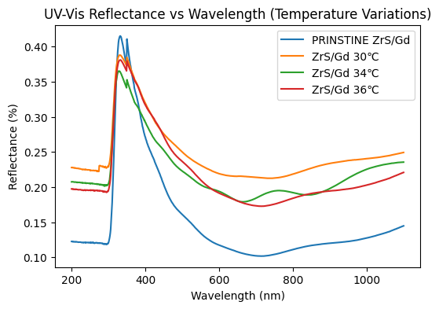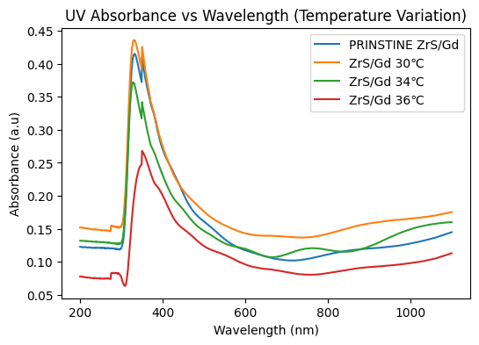**4.1 Optical Study of ZrS and ZrS/Gd Material Deposited at Different Deposition Temperatures**

(b)

(a)

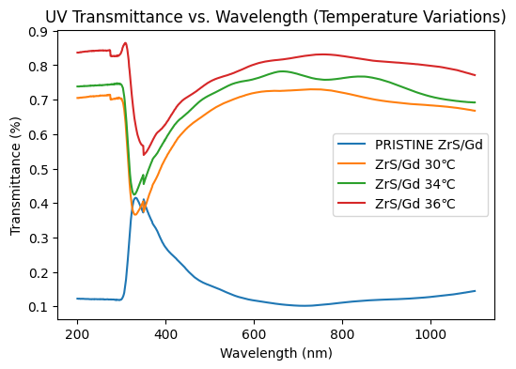

(c)

Figure 1: (a) Absorbance, (b) Reflectance, and (c) Transmittance vs Wavelength

Plots of the absorbance, transmittance, and reflectance of gadolinium-doped ZrS and undoped ZrS are shown in Figure 1 for various deposition temperatures of 30℃, 34℃, and 36℃. Figure 1a shows the optical absorbance property of ZrS/Gd nanomaterials over a wavelength range of about 200 to 1100 nm, under different temperature conditions. All samples present an absorbance peak at 340–400 nm, which is sharp and points towards strong UV absorbance corresponding to band-to-band electronic transitions. Maximum absorbance is observed at 30°C, followed by the pristine sample, 34°C, and minimum at 36°C. This trend states that increased temperature causes a remarkable reduction in absorbance across the UV and visible regions. Thermally induced reductions in absorbance imply thermally induced changes in electronic structure or surface topography that may reduce the light absorption capacity of the material. Consequently, temperature becomes a crucial factor in determining the optical properties of ZrS/Gd with consequential implications for its potential use in temperature-sensitive optoelectronic materials or devices [14].

The graph in Figure 1(b) shows the UV-Vis reflectance spectra of ZrS/Gd under different temperature conditions. The pristine sample of ZrS/Gd exhibits the lowest reflectance in the entire spectrum, but rising temperature (30°C, 34°C, and 36°C) reveals reflectance intensity changes. A strong peak can be observed between 300 and 400 nm, and temperature-dependent oscillations are observed beyond this interval. The temperature increase is seen to enhance reflectance at longer wavelengths, signifying alterations in the material's optical properties, which are probable outcomes of structural or electronic changes. This result is critical in temperature-sensitive optical device applications such as optical temperature sensors, fibre-optic temperature sensors, thermal lensing devices, and liquid crystal displays (LCDs) [13].

Figure 1(c) represents the relation between UV transmittance and wavelength for ZrS/Gd at various temperatures. The pristine ZrS sample shows lesser transmittance through the entire wavelength range, signifying strong absorption of UV light. It was observed that as the temperature increases by 30°C, 34°C, and 36°C, transmittance improves, especially in the visible and near-infrared regions. There exists a sharp transmittance decline within the range of 250-400 nm, indicating substantial absorption of UV light. Beyond this range, transmittance increases and levels off, with the highest temperature (36°C) showing a clear light transmission. This indicates that the temperature rise improves the optical properties of ZrS/Gd, making it more transparent to visible and near-infrared light; this could be used for various applications, such as temperature-dependent sensors and coatings [7]

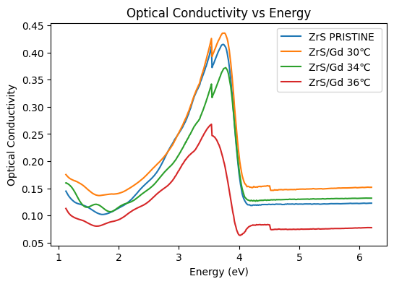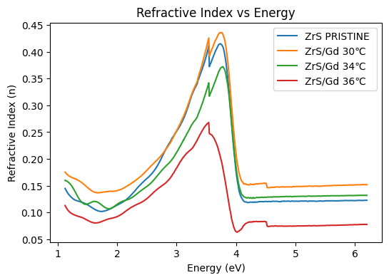

(b)

(a)

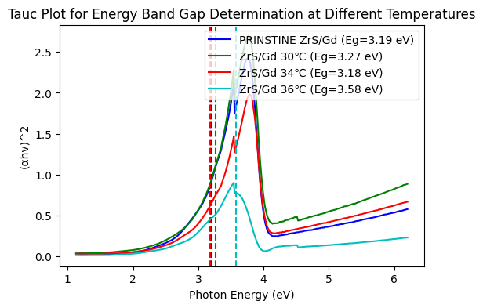

(c)

Figure 2: (a) Optical Conductivity, (b) Refractive Index, and (c) Band Gap Vs Photon Energy

The graph in Figure 2(a) depicts the variation of optical conductivity as a function of energy (eV) for different samples of ZrS (Zirconium Sulphide), including a pristine sample and Gd (Gadolinium)-doped ZrS at different temperatures (30°C, 34°C, and 36°C). The optical conductivity generally increases with energy, peaking between approximately 3–4 eV, followed by a sharp decline beyond this range. The pristine ZrS sample exhibits a high optical conductivity peak, while Gd doping and increasing temperature lead to a systematic reduction in optical conductivity. The sample at 36°C shows the most significant drop, indicating that higher temperatures suppress optical conductivity. The trend indicates that Gd doping and temperature variation influence the electronic transitions within ZrS, likely altering its optical absorption properties. The optical conductivity behaviour of ZrS and Gd-doped ZrS at different temperatures demonstrates several potential applications in optoelectronic and photonic devices, such as optical sensors, photodetectors, solar cells, and thermo-optic switches [2].

Figure 2(b) demonstrates the refractive index of zirconium sulphide and zirconium sulphide doped gadolinium (ZrS/Gd). The pristine ZrS sample exhibits a moderate refractive index, with a prominent peak between 3 eV - 4 eV, indicating strong optical transitions. As the temperature increases, the refractive index behaviour changes significantly. At 30°C, the refractive index is slightly higher than the pristine sample, showing that temperature enhances optical response at lower levels. However, at 34°C, the refractive index reduces slightly but still maintains a strong peak in the same energy range. At 36°C, the refractive index decreases significantly across all energy levels, suggesting that higher temperatures negatively impact the optical properties, possibly due to increased phonon interactions or structural changes that reduce light interaction. This trend implies that temperature plays a crucial role in modulating the refractive index, making it an important parameter for temperature-sensitive optical devices such asphotonic integrated circuits (PICs), optical switches, and modulators for dynamic light control [22].

The band gap energy (Eg) of ZrS/Gd at various temperatures is found using the Tauc graph in Figure 2(c) above. Vertical dashed lines indicate the band gap values, which are measured from the point where the x-axis and the extrapolated line connect. Pristine (ZrS) was measured at 3.19 eV, 3.27 eV at 30°C, 3.18 eV at 34°C, and 3.58 eV at 36°C. The trend indicates a temperature dependence of the band gap. In particular, because of lattice expansion and electron-phonon interactions, semiconductors tend to have a smaller band gap as their temperature rises. But in this instance, the band gap decreased (from 30°C to 34°C) before sharply increasing at 36°C. This implies that the band structure at high temperatures is influenced by structural, electrical, or phase transition processes. The temperature dependence of the band gaps enables the creation of devices such as thermoelectric generators, tunable LEDs, and temperature-sensitive photodetectors [26].

**4.2 The Resistivity and Conductivity Study of ZrS and Gadolinium Doped Zirconium Sulphide (ZrS/Gd)**

This table highlights how varying deposition temperatures affect the electrical performance of ZrS/Gd films. It includes parameters like resistivity and carrier mobility.

Table 1: Electrical Properties of Zirconium Sulphide (ZrS) Doped Gadolinium at Various Deposition Temperatures.

|  |  |  |  |
| --- | --- | --- | --- |
| Samples | Thickness (nm) | Resistivity (Ω.m) | Conductivity (S/m)-1 |
| ZrS (Pristine) | 101.99 | 0.60584371 | 1.65059071 |
| ZrS/Gd 30℃ | 110.06 | 0.561421043 | 1.781194368 |
| ZrS/Gd 34℃ | 108.08 | 0.571706144 | 1.749150348 |
| ZrS/Gd 36℃ | 104.06 | 0.593792043 | 1.684091277 |

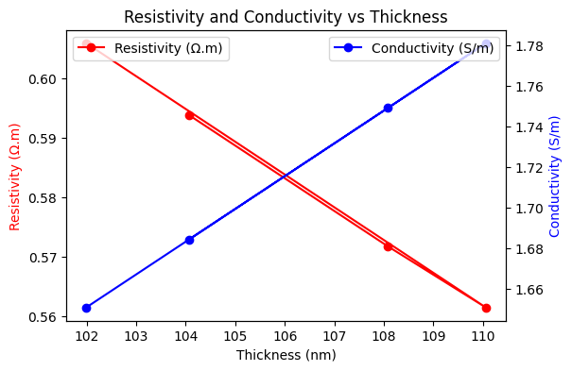

Figure 3 (a) Resistivity and Conductivity vs Thickness

The graph (Figure 3a) illustrates the variation of resistivity (Ω·m) and conductivity (S/m) as a function of thickness (nm) in a material, showing an inverse relationship between the two properties. As the thickness increases, resistivity decreases, while conductivity increases, highlighting the fundamental relationship where conductivity is the reciprocal of resistivity. Initially, at lower thickness values (~102 nm), the resistivity is relatively high (~0.60 Ω·m), indicating increased electron scattering and grain boundary effects. However, as the thickness increases (~110 nm), the resistivity drops to approximately 0.56 Ω·m, indicating a reduction in surface scattering and structural defects, which allows for improved charge transport. In contrast, conductivity follows an increasing trend, rising from ~1.66 S/m at 102 nm to ~1.78 S/m at 110 nm, confirming that thicker films offer a more continuous pathway for electron movement, enhancing electrical conduction. This result is useful in microelectronics, thin-film coatings, sensors and energy storage, etc [10].

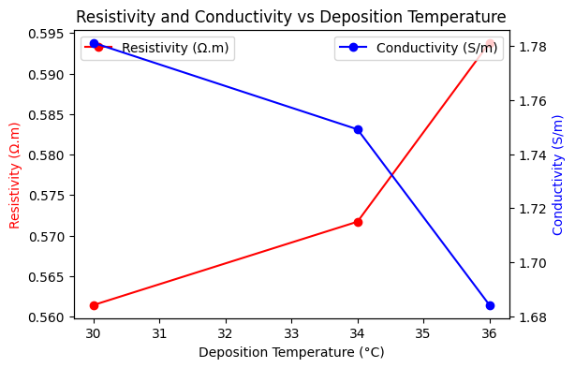

Figure 3(b) Resistivity, Conductivity vs Deposition Voltage.

It was observed in Figure 3(b) that as the deposition temperature increases from 30°C to 34°C, resistivity increases slightly, while conductivity decreases, indicating an initial deterioration in electrical performance. However, beyond 34°C, the trend reverses, showing a sharp drop in resistivity and a steep rise in conductivity at 36°C. At lower deposition temperatures (30°C - 34°C), the increasing resistivity shows that the film structure may contain more defects, impurities, or grain boundary scattering, which hampers the free movement of charge carriers, leading to reduced conductivity. This could be due to poor crystallinity, increased porosity, or incomplete atomic bonding during the deposition process at lower temperatures. On the other hand, as the deposition temperature exceeds 34°C, the film quality improves, leading to larger grain sizes, fewer defects, and better atomic ordering, which results in lower resistivity and higher conductivity. This proves that 36°C is an optimal deposition temperature where the material exhibits superior electrical conductivity. The observed behaviour is significant for various thin-film applications in microelectronics, photovoltaics, and sensor technologies [10].

**4.3 ZrS and Gadolinium Doped Zirconium Sulphide (ZrS/Gd) Structural Analysis**

The table below includes XRD data for ZrS/Gd films at various deposition temperatures. It shows how heat treatment affects crystal quality and orientation.

Table 2: ZrS/Gd XRD Result for Temperature Variations

|  |  |  |  |  |  |  |
| --- | --- | --- | --- | --- | --- | --- |
| Sample | 2θ (degrees) | Spacing d  (Å) | Lattice  Constant a (Å) | FWHM (°) | Crystalline  Size D (nm) | Dislocation  Density (1/nm²) |
| ZrS Pristine | 15 | 5.901497522 | 5.901497522 | 0.1 | 801.2839969 | 1.5575E-06 |
|  | 15.0343 | 5.88811063 | 5.88811063 | 0.1 | 801.3156101 | 1.55737E-06 |
|  | 15.0686 | 5.874784858 | 5.874784858 | 0.1 | 801.3472975 | 1.55725E-06 |
| ZrS/Gd 30 ℃ | 15 | 5.901497522 | 5.901497522 | 0.1 | 801.2839969 | 1.5575E-06 |
|  | 15.0343 | 5.88811063 | 5.88811063 | 0.1 | 801.3156101 | 1.55737E-06 |
|  | 15.0686 | 5.874784858 | 5.874784858 | 0.1 | 801.3472975 | 1.55725E-06 |
| ZrS/Gd 34 ℃ | 15 | 5.901497522 | 5.901497522 | 0.1 | 801.2839969 | 1.5575E-06 |
|  | 15.0343 | 5.88811063 | 5.88811063 | 0.1 | 801.3156101 | 1.55737E-06 |
|  | 15.0686 | 5.874784858 | 5.874784858 | 0.1 | 801.3472975 | 1.55725E-06 |
| ZrS/Gd 36 ℃ | 15 | 5.901497522 | 5.901497522 | 0.1 | 801.2839969 | 1.5575E-06 |
|  | 15.0343 | 5.88811063 | 5.88811063 | 0.1 | 801.3156101 | 1.55737E-06 |
|  | 15.0686 | 5.874784858 | 5.874784858 | 0.1 | 801.3472975 | 1.55725E-06 |

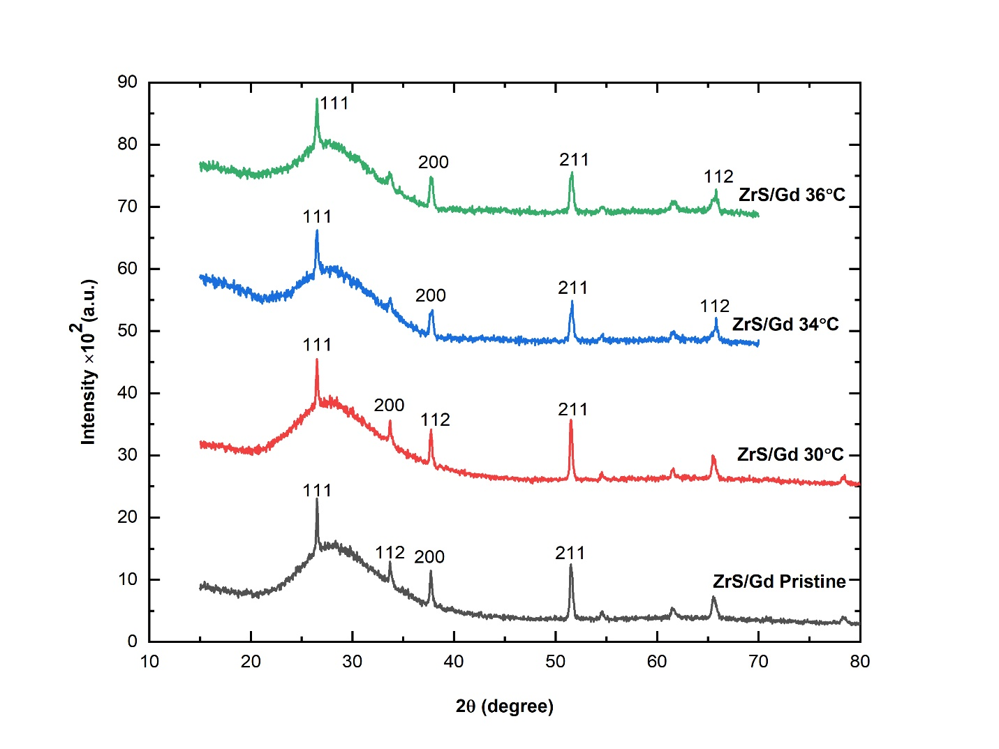

Figure 4: XRD Study of ZrS and ZrS Doped Gadolinium (ZrS/Gd) at Various Dopant Temperatures

The X-ray diffraction (XRD) pattern in Figure 4 presents the crystalline structure of ZrS doped with Gd (ZrS/Gd) at varying synthesis temperatures: pristine, 30 °C, 34 °C, and 36 °C. All patterns display characteristic peaks corresponding to the (111), (200), (211), and (112) planes, indicating a consistent crystalline phase across all samples. The pristine ZrS sample exhibits relatively low peak intensities, with the (111) peak near 28°, the (112) around 33°, the (200) near 38°, and the (211) close to 43°, demonstrating poor crystallinity or limited grain growth. As the synthesis temperature increases, there is a clear enhancement in peak sharpness and intensity. The sample synthesized at 30 °C shows moderate improvement in intensity, especially for the (111) and (211) reflections. At 34 °C, a substantial increase in crystallinity is observed, with sharper and more intense peaks, particularly in the (111) and (200) planes. The best crystallinity is seen at 36 °C, where the highest and sharpest peaks appear, notably for the (111) and (211) planes.

This trend indicates that increasing the synthesis temperature improves crystal growth, reduces defects, and enhances the structural order of the ZrS/Gd material. The (111) peak consistently dominates across all temperatures, but its intensity and sharpness improve with temperature, reflecting improved crystallite size and reduced microstrain. High-crystallinity ZrS/Gd (as at 36 °C) is suitable for applications in optoelectronics, sensors, and catalysis, where charge transport and surface activity benefit from well-ordered structures [22]. Table 2 includes additional characteristics and the crystallite size of the films, in addition to the computed crystallite or grain sizes, dislocation density, and dopant molarity for the films deposited at various gadolinium dopants were estimated using equations (1–4)

D = kλ/βcosθ (1)

d = λ/2sinθ (2)

a = d√ ̅̅̅̅̅̅̅̅̅̅̅̅̅̅̅̅̅̅̅̅̅̅h2+k2+l2 (3)

δ =1/D (4)

**4.4 SEM Analysis**

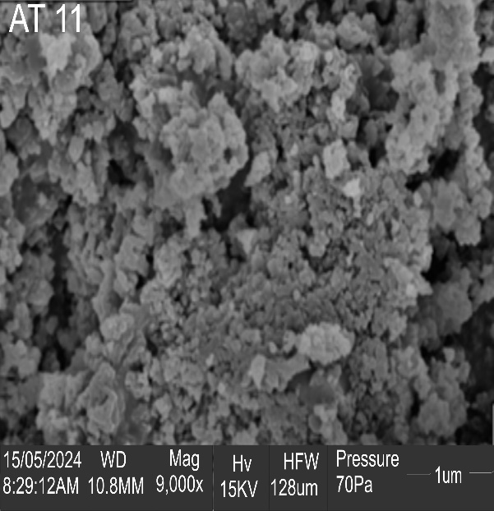

**150 nm**

**ZrS**

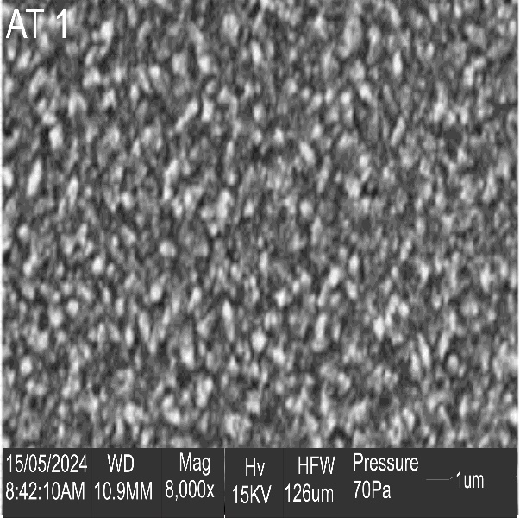

**Gd0.03ZrS 34oC**

**150 nm**

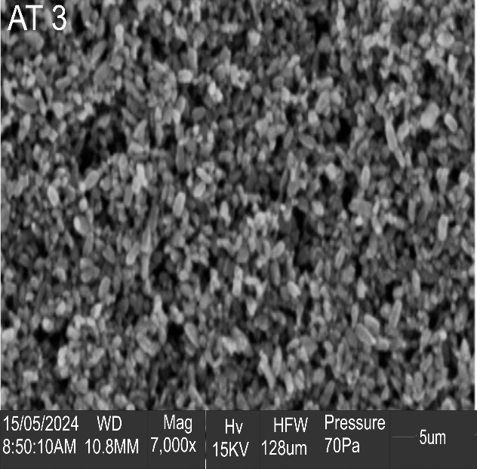

**Gd0.03ZrS 30oC**

**150 nm**

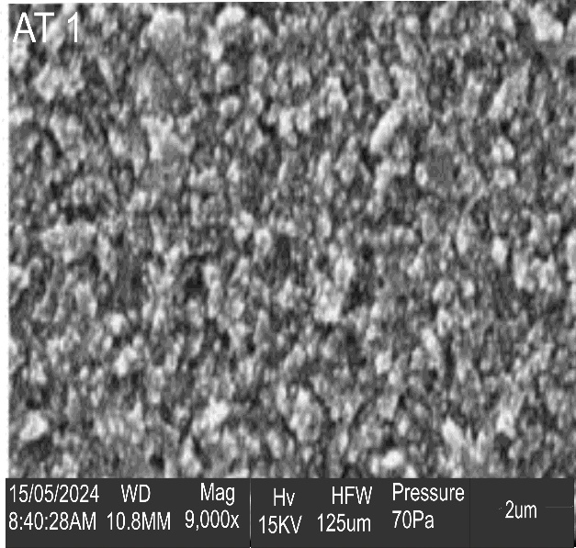

**Gd0.03ZrS 36oC**

**150 nm**

Figure 5: SEM Micrograph

The micrograph of ZrS and gadolinium-doped zirconium sulphide (ZrS/Gd) in Figure 5 demonstrates agglomeration on the films with no pinholes and a big grain size, or nanoparticles. The ZrS surface morphology is Clove-like, with precipitate visible in the ZrS micrograph; photon absorption is visible, but pinholes are absent due to the substrate's huge grain size. The surface micrograph of the films under study shows that the addition of gadolinium as a dopant significantly changed the ZrS precursor. The surface morphology of the film showed a precipitate that resembled clouds. As the dopant temperature increased, the cloudlike precipitate for the material deposited at 11V gradually cleared out, creating a dense cloud in one spot on the surface. The doped ZrS material showed consistent nanoparticle deposition throughout the whole substrate for optoelectronic-photonic applications. Because the surface micrograph of the gadolinium-doped films is well-structured on the surface of the FTO substrate used for the synthesis, with no cracks or lattice strain, they will be a formidable contender for optoelectronic-photonic and other applications in the electronics and communication sectors [16].

**5.0 Conclusion**

The study successfully demonstrated that deposition temperature critically influences the structural, optical, and electrical characteristics of Gadolinium-doped Zirconium Sulphide (ZrS/Gd) thin films. At 30°C, films exhibited maximum UV absorbance and high conductivity, while 36°C yielded the widest band gap (3.58 eV), highest transmittance, and enhanced crystallinity. Optical properties such as absorbance, transmittance, reflectance, refractive index, and optical conductivity showed a clear temperature dependence, with performance peaks and declines influenced by thermal changes in film morphology and electronic structure. XRD and SEM analyses confirmed the progressive improvement in crystal quality and uniform grain distribution with temperature, especially at 36°C. Additionally, electrical studies indicated a non-linear trend in conductivity and resistivity, with 30°C and 36°C yielding superior electrical performance. These results affirm that electrostatic spray-deposited ZrS/Gd films are highly tunable via temperature control and are promising candidates for use in optoelectronic devices, including photovoltaic cells, photodetectors, and smart optical coatings.

**REFERENCES**

1. Akpu NI, Asiegbu AD, Nnanna LA, Ikhioya IL, Mgbeojedo TL. Investigation on the influence of varying substrate temperature on the physical features of yttrium doped cadmium selenide thin films materials. SSRG International Journal of Applied Physics. 2021;8(2):37-46.
2. Aslam Z, Lone AR, Shoab M, Zulfequar M. Investigation of electrical conduction and optical properties of amorphous Se88Zn10Bi2 chalcogenide thin film. Chemical Physics Letters. 2023;814:140321.
3. Geremew T. Thin film deposition and characterization techniques. J. 3D Print. Appl. 2022;1(2):1-24.
4. Ikhioya IL, Nkele AC, Ezema SN, Maaza M, Ezema F. A study on the effects of varying concentrations on the properties of ytterbium-doped cobalt selenide thin films. Optical Materials. 2020;101:109731.
5. Ikhioya IL, Onoh EU, Okoli DN, Ekpunobi AJ. Impact of bismuth as dopant on ZnSe material syntheses for photovoltaic application. Materials Research Innovations. 2023;27(6):411-9.
6. Ikhioya IL, Whyte GM, Nkele AC. Temperature-modulated nanostructures of ytterbium-doped Cobalt Selenide (Yb-CoSe) for photovoltaic applications. Journal of the Indian Chemical Society. 2023;100(1):100848.
7. Ikhioya LI, Ugwu LU, Ekpunobi AJ. Influence of Precursor Temperature on the Bandgap Engineering of Zr-doped CrS for Photovoltaic Application. Journal of Nano and Materials Science Research. 2024;3(1):7-14.
8. Josephine EN, Ikponmwosa OS, Ikhioya IL. Synthesis of SnS/SnO nanostructure material for photovoltaic application. East European Journal of Physics. 2023;2(1):154-61.
9. Lei L, Gamboa AR, Kuznetsova C, Littlecreek S, Wang J, Zou Q, Zahn JD, Singer JP. Self-limiting electrospray deposition on polymer templates. Scientific reports. 2020;10(1):17290.
10. Li SL, Tsukagoshi K, Orgiu E, Samorì P. Charge transport and mobility engineering in two-dimensional transition metal chalcogenide semiconductors. Chemical Society Reviews. 2016;45(1):118-51.
11. Lucky II, Ugbo FC, Ijabor BO. Growth and characterization of manganese sulphide (MnS) thin films. International Journal for Research in Applied and Natural Sciences. 2018;4(1):1-9.
12. Ogonnaya OC. The Influence of precursor temperature on the properties of Erbium-Doped Zirconium Telluride thin film material via electrochemical deposition. Int. J. Appl. Phys. 2020;102.
13. Ojegu EO, Ikhioya IL. Electrochemically Deposited Iron Sulphide Material by Adjusting the Deposition Time for Photovoltaic Application. Physics Access. 2024 Jul 30;4(1):55-63.
14. Othmane M, Attaf A, Bouaichi F, Saidi H. An approach to the description of the correlation between the electrical conductivity and the band gap of F-doped zinc oxide thin films. Journal of Materials Science: Materials in Electronics. 2025;36(2):119.
15. Priyadarshini P, Das S, Naik R. A review on metal-doped chalcogenide films and their effect on various optoelectronic properties for different applications. RSC advances. 2022;12(16):9599-620.
16. Samuel SO, Lagbegha-ebi MF, Ogherohwo EP, Ikhioya IL. Improve physical properties of zirconium doped strontium sulphide for optoelectronic purpose. Results in Optics. 2023;13:100518.
17. Samuel SO, Frank ML, Ogherohwo EP, Ekpekpo A, Zhimwang JT, Ikhioya IL. Influence of deposition voltage on strontium sulphide doped silver for optoelectronic application. East European Journal of Physics. 2023;2(1):189-96.
18. Samuel SO, James FE, JT Z, EP O, Ekpekpo A, Ikhioya IL. Effect of dopant on the energy bandgap on strontium sulphide doped silver for optoelectronic application. Materials Research Innovations. 2024;28(1):8-18.
19. Samuel SO, Ojegu EO, Ikhioya IL. Investigating the Impact of Voltage on Optoelectronic Features of Silver Incorporated into the Lattice of Zirconium Sulphide Nanostructured Material. Physics Access. 2024;4(2):126-38.
20. Samuel SO, Ojoba CK, Ogherohwo EP, Ikhioya IL. Impact of deposition voltage on the physical properties of rare earth element doped strontium sulphide for optoelectronic application. Nigerian Journal of Technological Development. 2023;20(4):25-32.
21. Seo JH, Swinnich E, Zhang YY, Kim M. Low dimensional freestanding semiconductors for flexible optoelectronics: materials, synthesis, process, and applications. Materials Research Letters. 2020;8(4):123-44.
22. Shaka OS, Olisenekwu C, Ikhioya IL. Analyzing the structural, optoelectronic, and optical properties of ZrS nanostructured material by adding silver (Ag) dopant to its lattice. Nigerian Journal of Science and Environment. 2024;22(3):74-90.
23. Shao Y, Shi X, Pan H. Electronic, magnetic, and catalytic properties of thermodynamically stable two-dimensional transition-metal phosphides. Chemistry of Materials. 2017;29(20):8892-900.
24. Stephen J. Optoelectronic Devices and Materials. Scotland, UK: Springer International Publishing AG. 2017:897-932.
25. Udofia KI, Ikhioya IL, Agobi AU, Okoli DN, Ekpunobi AJ. Effects of zirconium on electrochemically synthesized tin selenide materials on fluorine-doped tin oxide substrate for photovoltaic application. Journal of the Indian Chemical Society. 2022;99(10):100737.
26. Ullah M, Manzoor RA, Ahmed E. Electrical Conductivity of CVD Diamond Thin Films. InMicro and Nanomanufacturing. 2024;2:331-407.
27. Wang J, Zhang Y, Zhang W, Fan Z. Research progress of electrostatic spray technology over the last two decades. Journal of Energy Engineering. 2021;147(4):03121003.
28. Zaikova VE, Melnikova NV, Tebenkov AV, Mirzorakhimov AA, Shchetnikov OP, Babushkin AN, Sukhanova GV. Electrical properties of polycrystalline materials from the system Cu-As-Ge-Se under high-pressure conditions. In Journal of Physics: Conference Series 2017;917(8):082009.