Short Research Article

Clinical Variants of Cutaneous Mastocytosis in Children : Experience from a Single Center

.

ABSTRACT

|  |
| --- |
| **Background:** Cutaneous mastocytosis (CM) is a rare pediatric dermatosis characterized by the abnormal proliferation and accumulation of mast cells in the skin. It typically presents in early childhood and is most often confined to the skin, with a generally favorable prognosis.  **Material and methods:** We conducted a retrospective study over two years, including children diagnosed with CM. Data included clinical presentation, histological and immunohistochemical findings, and serum tryptase levels.  **Results:** Nineteen patients were included (11 girls, 8 boys), with a mean age at onset of 2.7 years. Maculopapular CM was the most frequent form (15 cases), followed by diffuse CM (3 cases, including 2 bullous forms) and one mastocytoma. Darier’s sign was positive in all cases. CD117 immunostaining confirmed diagnosis, and serum tryptase was elevated in most patients. No systemic involvement was detected.  **Conclusion:** CM in children is most often skin-limited and benign. Histology with CD117 and tryptase levels remain key diagnostic tools, especially in atypical or bullous forms. |

*Keywords: Pediatric mastocytosis; Cutaneous mastocytosis; Maculopapular mastocytosis; Bullous mastocytosis; CD117; Darier sign; Serum tryptase; Skin biopsy; Childhood dermatoses.*

1. INTRODUCTION

Mastocytosis is a rare disorder characterized by the accumulation of clonal mast cells in various tissues, most frequently the skin. In children, the disease is almost exclusively limited to cutaneous involvement and is often self-limiting, with spontaneous regression commonly observed before or during adolescence (Lange M, et al., 2021). The clinical manifestations of cutaneous mastocytosis (CM) are variable and include three main forms: maculopapular cutaneous mastocytosis (MPCM), solitary mastocytoma, and diffuse cutaneous mastocytosis (DCM) (Swarnkar B, et al., 2023 ). Although pediatric CM typically follows a benign course, certain presentations, such as bullous lesions, elevated serum tryptase levels, or atypical clinical morphology, can raise concern for a higher mast cell burden or potential systemic progression (Lee EH, et al., 2010)

Diagnosis is primarily clinical, supported by the presence of Darier’s sign and characteristic skin lesions, but should be confirmed by histopathology and immunohistochemistry. CD117 (KIT) staining highlights the mast-cell infiltrate and remains a key diagnostic tool (Di Raimondo C, et al., 2021). Baseline serum tryptase can aid in assessing disease burden, though levels may be normal in many children with isolated skin involvement (Alvarez-Twose I, et al., 2012). Despite its rarity, early recognition of CM is essential to avoid misdiagnosis and unnecessary interventions, especially in cases with unusual morphology or severe symptoms.

In this context, we present a descriptive study of 19 pediatric cases of cutaneous mastocytosis observed over a two-year period, highlighting the clinical variants, diagnostic features, and outcomes, and comparing our findings with the existing literature.

2. material and methods

We conducted a retrospective, descriptive, monocentric study over a two-year period at the Department of Dermatology of Ibn Sina University Hospital in Rabat, Morocco. The study included all pediatric patients (under 18 years of age) with a confirmed diagnosis of cutaneous mastocytosis (CM).

The diagnosis was established based on a combination of clinical features, histopathological examination, and immunohistochemical confirmation:

* Clinically, all patients presented characteristic cutaneous lesions suggestive of CM (maculopapular, mastocytoma, or diffuse bullous variants), and Darier’s sign was systematically tested and recorded. The age of onset, distribution of lesions, and the presence of pruritus or bullous manifestations were noted.
* Skin biopsies were performed in all cases and examined under standard haematoxylin–eosin staining. Diagnosis was confirmed by the presence of dense dermal mast-cell infiltrates, most often perivascular and interstitial in distribution.
* Immunohistochemical staining for CD117 (KIT) was used in all samples to confirm mast-cell lineage and support the diagnosis.

Additionally, serum tryptase levels were measured in all patients to assess mast-cell burden. A tryptase value above 15 ng/mL was considered elevated. In patients with atypical forms (e.g., bullous DCM), further investigations (complete blood count, liver function tests, abdominal ultrasound, or bone marrow biopsy if needed) were performed to rule out systemic involvement.

All collected data were retrieved from patients’ medical records, including demographic details, clinical type of CM, histological findings, CD117 immunostaining results, serum tryptase levels, and any systemic workup.

2. RESULTS

Over a two-year period, we conducted a descriptive study involving 19 pediatric patients diagnosed with cutaneous mastocytosis. The cohort included 11 girls and 8 boys, with ages ranging from 8 months to 22 years. The average age at disease onset was 2.7 years.

Clinically, various forms of cutaneous mastocytosis were observed. A single case of solitary mastocytoma was recorded, as well as one case of diffuse cutaneous mastocytosis (DCM). Two additional patients presented with the bullous form of DCM (Figurer 1), characterized by the presence of spontaneous or inducible blistering. The majority of patients—15 in total—had maculopapular cutaneous mastocytosis (MPCM), the most frequent clinical variant in children. Notably, two of these MPCM cases exhibited a distinctive "leopard skin" appearance (Figure 2).

The Darier sign, elicited by mechanical rubbing of lesional skin, was positive in all patients, supporting the diagnosis of mast cell-related dermatosis. None of the patients showed clinical signs or laboratory evidence suggestive of systemic mastocytosis. However, a few reported exacerbation of symptoms following the ingestion of certain foods, indicating a possible role of exogenous triggers in symptom aggravation.

In all cases, the diagnosis was confirmed by histopathological examination of skin biopsies, which demonstrated dense dermal mast cell infiltrates and immunohistochemistry demonstrated diffuse CD117 (KIT) positivity. Serum tryptase levels were elevated in the majority of patients, reinforcing the mast-cell origin of their disease. Additional investigations to assess systemic involvement, including hematological, biochemical, and imaging studies, did not reveal any abnormalities, thereby reinforcing the cutaneous-limited nature of the disease in our study.

4. Illustrative Case – Maculopapular Cutaneous Mastocytosis with Leopard-like Pattern

A 3-year-old girl was referred for gradually progressive pigmented skin lesions that had appeared since infancy. Clinical examination revealed multiple, discrete to coalescent brownish macules and papules scattered over the trunk and limbs, giving the skin a "leopard-like" appearance (Figure 2). The lesions were asymptomatic except for occasional pruritus, particularly triggered by heat and friction. A positive Darier’s sign was noted on rubbing several lesions.

There were no systemic complaints, and the child’s growth and development were normal. A skin biopsy demonstrated a perivascular and interstitial dermal infiltrate composed of mast cells. CD117 (KIT) immunostaining confirmed the diagnosis. Serum tryptase level was mildly elevated at 17.2 ng/mL.

No systemic involvement was found on laboratory and imaging studies. The diagnosis of maculopapular cutaneous mastocytosis (MPCM) was retained. The patient was managed with oral antihistamines and emollients, with good symptom control. Parents were advised on avoiding common triggers such as hot baths and certain foods.

5. discussion

Cutaneous mastocytosis (CM) in childhood represents the most frequent presentation of mast-cell disease and usually follows a benign course (Lange M, et al. 2021). Our two-year series of 19 paediatric cases reinforces several well-established epidemiological and clinical features while highlighting a few uncommon phenotypes that deserve attention.

The mean age of appearance in our cohort was 2.7 years, confirming the infancy-to-early-childhood peak described in larger paediatric studies, where >80 % of cases manifest before the fifth birthday (Ługowska-Umer H, et al., 2023). Although most reports show no clear sex predilection, we observed a slight female predominance (11/19), a finding echoed in some contemporary series (Durmaz A, et al., 2024) and probably attributable to sample size rather than a true biological difference.

Maculopapular cutaneous mastocytosis (MPCM) accounted for 79 % of our cases, matching the 70-90 % frequency consistently reported in the literature (Swarnkar B, et al., 2023), (Ługowska-Umer H, et al., 2023). Solitary mastocytoma and classic diffuse cutaneous mastocytosis (DCM) each occurred once, figures that fall within the expected 10-20 % and 1-13 % ranges, respectively (Swarnkar B, et al., 2023). Of particular note, we documented two blistering DCM cases (10.5 %), a proportion higher than most series but in line with recent case-based evidence that bullous lesions, although rare, can dominate the clinical picture in infants (Durmaz A, et al., 2024), (Mendiratta Vibhu, et al., 2025). The “leopard-skin” pattern observed in two MPCM patients is scarcely mentioned in paediatric cohorts and likely reflects confluent pigmented macules overlying diffuse dermal mast-cell infiltrates; its recognition is important to avoid confusion with pigmentary mosaicism or incontinentia pigmenti.

A positive Darier sign in all patients underscores its pathognomonic value and near-universal sensitivity in paediatric CM (Ługowska-Umer H, et al., 2023), (Durmaz A, et al., 2024). Several children reported pruritic flares after ingesting tomatoes, chocolate, strawberries or spicy foods, supporting the view that exogenous factors, heat, friction, medication and certain foods, can precipitate mediator release even in purely cutaneous disease (Durmaz A, et al., 2024), (Gangireddy M, et al., 2025).

Skin biopsy remains the diagnostic cornerstone ; in our series routine haematoxylin–eosin sections demonstrated dense, dermal mast-cell infiltrates that stained diffusely for CD117 (KIT) on immunohistochemistry, in keeping with current recommendations for confirming mast-cell lineage (Gu Y, et al., 2024). Baseline serum tryptase was elevated (>15 ng/mL) in the majority but not all children, mirroring observations that paediatric CM often shows only modest or even normal tryptase levels, unlike adult systemic disease (Ługowska-Umer H, et al., 2023). This finding highlights the limited negative predictive value of a single normal tryptase in excluding mast-cell disorders in children.

No patient fulfilled World Health Organization (WHO) criteria for systemic mastocytosis (SM). This is consistent with epidemiological data indicating that >90 % of paediatric cases are skin-limited and frequently remit spontaneously by adolescence (Lange M, et al., 2021). Nevertheless, the presence of bullous DCM and higher tryptase levels in some patients warrants continued vigilance, as these features have been linked to greater mast-cell burden and, albeit rarely, evolution toward SM (Ługowska-Umer H, et al., 2023), (Mendiratta Vibhu, et al., 2025).

Our findings reaffirm that a thorough clinical examination (including Darier sign), histology with CD117 staining, and baseline tryptase measurement are usually sufficient to establish the diagnosis and rule out systemic disease in children. Education about trigger avoidance and prompt treatment of mediator-related symptoms remain key components of care, particularly in patients with blistering variants who may experience dramatic symptom flares.

6. Limitations and perspectives

The main limitations of our study are the small sample size and the absence of KIT mutation analysis or longitudinal follow-up beyond two years. Future multicentre studies incorporating molecular testing and longer surveillance could clarify whether paediatric patients with atypical presentations (bullous DCM, leopard-skin MPCM) carry a different prognostic weight or genetic background.

7. Conclusion

This study highlights the clinical variability of pediatric CM and confirms the predominance of MPCM in early childhood. The presence of atypical forms, such as bullous lesions or leopard-like patterns, underscores the need for careful clinical evaluation. Histology with CD117 and serum tryptase measurement remain essential diagnostic tools, even though systemic involvement is rare in children.

Consent

All authors declare that ‘written informed consent was obtained from the patient’s legal guardian for publication of this case report and accompanying images. A copy of the written consent is available for review by the Editorial office/Chief Editor/Editorial Board members of this journal.

Ethical approval

All authors hereby declare that all experiments have been examined and approved by the appropriate ethics committee and have therefore been performed in accordance with the ethical standards laid down in the 1964 Declaration of Helsinki.

Disclaimer (Artificial intelligence)

Authors hereby declare that NO generative AI technologies such as Large Language Models (ChatGPT, COPILOT, etc.) and text-to-image generators have been used during the writing or editing of this manuscript.

References

Lange M, Hartmann K, Carter MC, et al. Molecular Background, Clinical Features and Management of Pediatric Mastocytosis: Status 2021. Int J Mol Sci. 2021 Mar 4;22(5):2586. doi: 10.3390/ijms22052586.

Swarnkar B, Sarkar R. Childhood Cutaneous Mastocytosis: Revisited. Indian J Dermatol. 2023 Jan-Feb;68(1):121. doi: 10.4103/ijd.ijd_264_22.

Lee EH, Kim MR, Kang TW, Kim SC. Diffuse cutaneous mastocytosis with generalized bullae. Ann Dermatol. 2010 Feb;22(1):77-80. doi: 10.5021/ad.2010.22.1.77.

Di Raimondo C, Del Duca E, Silvaggio D, et al. Cutaneous mastocytosis: A dermatological perspective. Australas J Dermatol. 2021 Feb;62(1):e1-e7. doi: 10.1111/ajd.13443.

Alvarez-Twose I, Vañó-Galván S, Sánchez-Muñoz L, et al. Increased serum baseline tryptase levels and extensive skin involvement are predictors for the severity of mast cell activation episodes in children with mastocytosis. Allergy. 2012 Jun;67(6):813-21. doi: 10.1111/j.1398-9995.2012.02812.x.

Ługowska-Umer H, Czarny J, Rydz A, Nowicki RJ, Lange M. Current Challenges in the Diagnosis of Pediatric Cutaneous Mastocytosis. Diagnostics (Basel). 2023 Dec 1;13(23):3583. doi: 10.3390/diagnostics13233583.

Durmaz, A, Özdemir, Ö. (2024). Clinical spectrum of patients diagnosed with childhood mastocytosis: a retrospective single center experience. European annals of allergy and clinical immunology. 57. 10.23822/EurAnnACI.1764-1489.348.

Mendiratta, Vibhu; Bansal, Aanchal; Singh, Smita1; Jain, Aditya. Diffuse Cutaneous Mastocytosis with Bullous Presentation: A Rare Case Report. Indian Journal of Dermatology ():10.4103/ijd.ijd_511_24, March 13, 2025. DOI: 10.4103/ijd.ijd_511_24.

Gangireddy M, Ciofoaia GA. Systemic Mastocytosis. [Updated 2023 Jul 4]. In: StatPearls [Internet]. Treasure Island (FL): StatPearls Publishing; 2025 Jan-. Available from: https://www.ncbi.nlm.nih.gov/books/NBK544345/

Gu Y, Zhang B. Disseminated cutaneous mastocytosis. Archives of Disease in Childhood 2024;109:1043. doi.org/10.1136/archdischild-2024-327820.

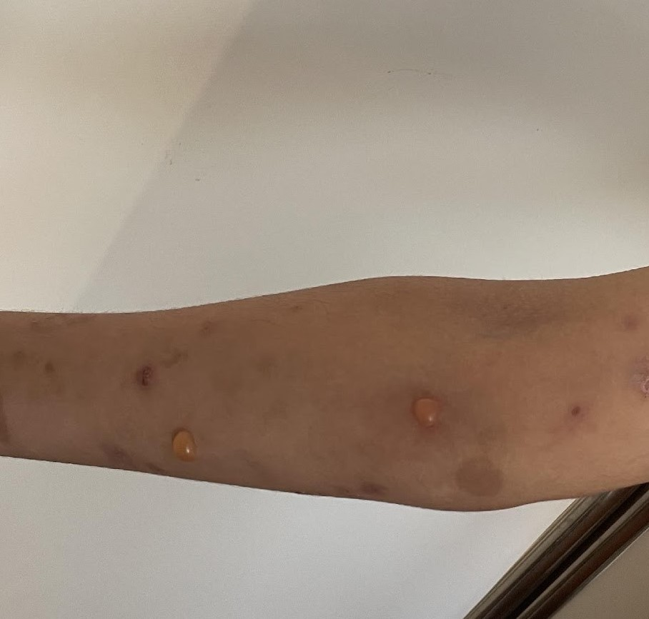

Figure 1 : Blistering variant of diffuse cutaneous mastocytosis showing bullous lesions in a child.

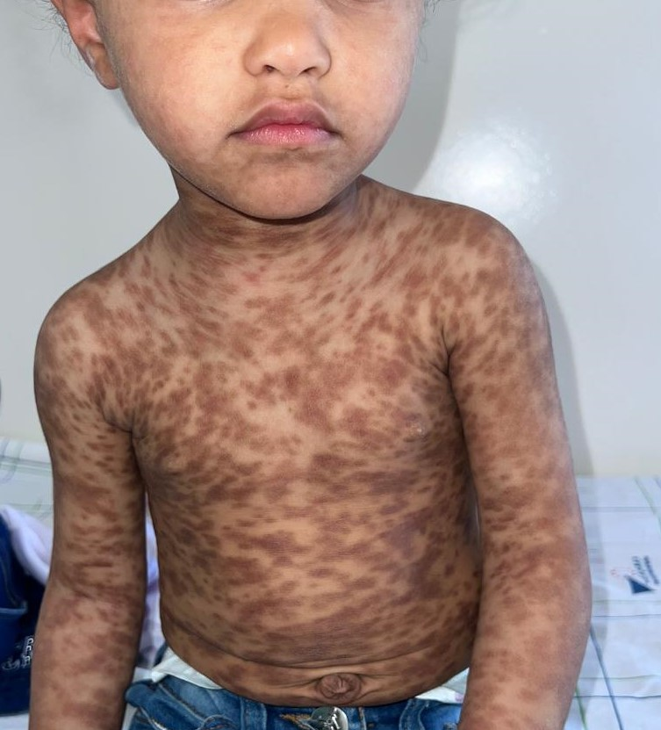

Figure 2 : Maculopapular cutaneous mastocytosis with a "leopard-skin" appearance in a pediatric patient.