Short Research Article

Clinical Spectrum of Congenital Ichthyosis in a Moroccan Pediatric Study

.

ABSTRACT

|  |
| --- |
| **Background:** Congenital ichthyoses are rare genetic skin disorders characterized by abnormal keratinization, often present at birth and associated with various extracutaneous manifestations.  **Material and methods:** We performed a retrospective study over over an 30-month, including patients diagnosed with congenital ichthyosis. Clinical subtype, distribution of skin lesions, and associated findings were analyzed.  **Results:** Forty patients were included (mean age: 3 years; 25 females, 15 males). Lamellar ichthyosis was the most common form (28 cases), with generalized scaling in 80% and palmoplantar keratoderma and nail dystrophy in 50%. Ectropion was observed in 8 patients. Netherton syndrome was identified in 6 patients, with typical pruritic erythroderma and bamboo hair in 3 cases. Two neonates had harlequin ichthyosis with severe ectropion, eclabium, and one case of limb hypoplasia.  **Conclusion:** Lamellar ichthyosis predominated in our cohort. Hair examination is crucial in erythrodermic infants to identify Netherton syndrome. Harlequin ichthyosis, though rare, remains a severe neonatal emergency. Early diagnosis and multidisciplinary care are essential. |

*Keywords: Congenital ichthyosis; Lamellar ichthyosis; Netherton syndrome; Harlequin ichthyosis; Trichoscopy; Pediatric dermatology.*

1. INTRODUCTION

Congenital ichthyoses are a rare, genetically heterogeneous group of disorders of cornification that usually manifest at birth or within the first months of life, producing generalized scaling, erythema and skin-barrier dysfunction (Mazereeuw-Hautier J, et al., 2024). The classification proposed by the First Ichthyosis Consensus Conference distinguishes non-syndromic autosomal recessive congenital ichthyosis (ARCI)—which includes lamellar and harlequin ichthyosis—from syndromic forms such as Netherton syndrome (Oji Vinzenz et al. 2009). Although next-generation sequencing now enables molecular confirmation in most patients, limited access to genetic testing in low-resource settings means that clinicians often rely on clinical phenotypes to guide supportive care and genetic counselling (Mazereeuw-Hautier J, et al., 2024). Recent genotype-phenotype studies have shown that disease burden extends beyond cutaneous scaling to include palmoplantar keratoderma, ocular complications and growth impairment, underscoring the importance of early multidisciplinary follow-up (Diociaiuti A, et al., 2024). Against this background, the present study describes the spectrum of congenital ichthyoses observed in a Moroccan paediatric cohort and highlights the extracutaneous features that drive morbidity.

2. material and methods

This was a monocentric, retrospective, and descriptive study conducted over a 30-month period at the Dermatology Department of Ibn Sina University Hospital in Rabat, Morocco. We included all pediatric patients who were clinically diagnosed with congenital ichthyosis during this period.

The diagnosis of congenital ichthyosis was based primarily on clinical examination, which assessed:

* Age at onset and mode of presentation (collodion baby, erythroderma, scaling)
* Type and distribution of cutaneous involvement (generalized vs localized)
* Associated features, including palmoplantar keratoderma, nail abnormalities, ectropion, and hair changes

When available, histopathological examination of skin biopsy specimens was performed to support the diagnosis and to exclude differential diagnoses such as atopic dermatitis or psoriasis in erythrodermic infants. Characteristic features such as orthokeratosis, parakeratosis, hypergranulosis, and psoriasiform hyperplasia were recorded.

In selected cases suspected of Netherton syndrome, trichoscopy was used to identify hair shaft anomalies such as trichorrhexis invaginata (“bamboo hair”), which is considered a diagnostic hallmark.

Genetic testing was not routinely available and was therefore not used as a diagnostic criterion in this study.

Data were collected from medical records and included demographic information (age, sex), clinical subtype, pattern of skin involvement, extracutaneous manifestations (nail, eye, hair anomalies), and disease severity.

2. RESULTS

We conducted a retrospective study involving 40 patients with congenital ichthyosis, with a mean age of 3 years and a female predominance (25 females and 15 males).

Lamellar ichthyosis was the most frequent form, observed in 28 patients. It was characterized by thick, dark scales, which were diffusely distributed over the entire body in 80% of cases (Figure 1), and limited to the extremities in the remaining 20%. Associated features included nail dystrophy and palmoplantar keratoderma, both present in 50% of patients, while ectropion was noted in 8 cases (Figure 2).

Netherton syndrome was diagnosed in 6 patients, all of whom presented with pruritic erythematosquamous lesions, caracterised by double-edged scales (Figure 3), and fragile hair. Trichoscopic examination revealed a bamboo hair appearance (trichorrhexis invaginata) in 3 of these cases.

Finally, we identified two cases of harlequin ichthyosis in female neonates. Clinical presentation included thick hyperkeratotic plates separated by deep fissures, along with severe ectropion and eclabium. One of the newborns also exhibited hypoplasia of the left hand, attributed to an associated amniotic band.

4. ILLUSTRATIVE CASE (LAMELLAR ICHTHYOSIS)

A 3-year-old girl presented with generalized thick, dark-brown scales involving the entire body surface since birth. She had bilateral ectropion, palmoplantar keratoderma, and nail dystrophy. There was no history of parental consanguinity. Histopathology showed orthokeratotic hyperkeratosis and acanthosis. A clinical diagnosis of lamellar ichthyosis was made, and treatment included intensive emollients, keratolytics, and ophthalmological follow-up.

5. discussion

Congenital ichthyoses encompass a genetically and phenotypically heterogeneous spectrum of keratinisation disorders that present early in life and require lifelong multidisciplinary care (Mazereeuw-Hautier J, et al., 2024).  
In our cohort of 40 Moroccan children, the mean age at presentation was 3 years with a female-to-male ratio of 1.7. Large European and Asian hospital-based series report similar early‐childhood onset but a slight male predominance or near-equal sex distribution; therefore, the female excess observed here may reflect local referral patterns rather than true epidemiology (Mazereeuw-Hautier J, et al., 2024), (Oji Vinzenz et al. 2009). Early recognition remains essential because delayed diagnosis is associated with growth impairment, infection, and ophthalmological morbidity.

Lamellar ichthyosis (LI) accounted for 70 % of cases, making it the dominant phenotype in our series. Although LI is among the commonest forms of autosomal recessive congenital ichthyosis (ARCI), recent multicentre studies have documented lower proportions (≈ 37 % in an Italian cohort and 36.9 % in an Indian cohort) (Oji Vinzenz et al. 2009). Our higher figure may be explained by the absence of consanguinity-related ichthyosiform erythroderma in our region or by diagnostic overlap between LI and congenital ichthyosiform erythroderma in the neonatal period. The high rates of palmoplantar keratoderma and nail dystrophy (50 %) are consistent with the recognised extracutaneous burden of LI, which is driven largely by TGM1, ALOXE3, and ALOX12B mutations that disrupt epidermal barrier lipid processing (Maritska Ziske, et al., 2024). Ectropion was present in 28 % of LI patients, aligning with the 25–40 % reported in contemporary guidelines and underscoring the need for early ophthalmological surveillance (Mazereeuw-Hautier J, et al., 2024), (Maritska Ziske, et al., 2024).

Netherton syndrome (NS) represented 15 % of our series—slightly higher than the global prevalence estimates of 1 : 200 000—but comparable with genodermatosis-referral centres where severe erythroderma is routinely screened for SPINK5 mutations. All six patients displayed pruritic erythematosquamous lesions and hair fragility, while trichoscopy confirmed bamboo hair in half of them. Trichorrhexis invaginata remains a pathognomonic clue to NS and may obviate the need for repeated scalp biopsies (Bittencourt Mde J, et al., 2015), (Bangaru H, et al., 2025). Novel biologics such as secukinumab are emerging therapeutic options for recalcitrant NS, highlighting the importance of precise molecular diagnosis (Buchukuri I, et al., 2025).

Harlequin ichthyosis (HI), the severest ARCI phenotype, was diagnosed in two neonates (5 %). Historically linked to near-universal neonatal mortality, survival has improved markedly with advances in neonatal intensive care, aggressive emollient use, and very early systemic retinoid therapy. An Indonesian case survived to age 5 on isotretinoin from day 5 of life (Tanasal H, et al., 2025), whereas a neonatal report reiterated that sepsis and respiratory failure remain leading causes of early death where resources are limited (G.V.  Vinithira Sri, et al., 2024). One of our infants showed left-hand hypoplasia associated with an amniotic band, a rarely documented limb anomaly in HI that raises questions about the role of intra-uterine mechanical factors in addition to ABCA12 dysfunction (Chiavérini C, 2009), (J. Mazereeuw-Hautiera, et al., 2009).

6. Strengths and limitations

The present study is the first Moroccan series to provide a phenotypic breakdown of congenital ichthyoses and to document trichoscopic findings in NS. Its retrospective design, modest sample size, and lack of systematic genetic testing limit genotype–phenotype correlations. Nonetheless, our data highlight the continued predominance of LI, the need for routine hair-shaft examination in erythrodermic infants, and the life-saving potential of early retinoid therapy in HI. We advocate for universal neonatal genetic panels and structured transitional care to adult services in resource-constrained settings.

7. Conclusion

This study provides an overview of the clinical spectrum of congenital ichthyoses in a North African pediatric population. Lamellar ichthyosis emerged as the predominant subtype, often accompanied by palmoplantar and ocular complications. Netherton syndrome, though less frequent, should be systematically considered in infants with erythroderma and hair shaft fragility. Harlequin ichthyosis, despite its rarity, remains a severe neonatal condition requiring prompt and intensive management. These findings emphasize the importance of early clinical recognition and multidisciplinary care, particularly in regions with limited access to genetic diagnosis.

Consent

All authors declare that ‘written informed consent was obtained from the patient’s legal guardian for publication of this case report and accompanying images. A copy of the written consent is available for review by the Editorial office/Chief Editor/Editorial Board members of this journal.

Ethical approval

All authors hereby declare that all experiments have been examined and approved by the appropriate ethics committee and have therefore been performed in accordance with the ethical standards laid down in the 1964 Declaration of Helsinki.

Disclaimer (Artificial intelligence)

Authors hereby declare that NO generative AI technologies such as Large Language Models (ChatGPT, COPILOT, etc.) and text-to-image generators have been used during the writing or editing of this manuscript.

References

Mazereeuw-Hautier J, Paller AS, O'Toole E,ret al. Management of congenital ichthyoses: guidelines of care: Part two: 2024 update. Br J Dermatol. 2025 Jun 20;193(1):28-43. doi: 10.1093/bjd/ljaf077.

Oji, Vinzenz et al. Revised nomenclature and classification of inherited ichthyoses: Results of the First Ichthyosis Consensus Conference in Sorèze 2009. Journal of the American Academy of Dermatology, Volume 63, Issue 4, 607 – 641. DOI: 10.1016/j.jaad.2009.11.020 External Link

Diociaiuti A, Corbeddu M, Rossi S, et al. Cross-Sectional Study on Autosomal Recessive Congenital Ichthyoses: Association of Genotype with Disease Severity, Phenotypic, and Ultrastructural Features in 74 Italian Patients. Dermatology. 2024;240(3):397-413. doi: 10.1159/000536366.

Maritska Ziske, Sandria Sandria, Noviyanti Nunung, et al. Genetics of lamellar ichthyosis. Egyptian Journal of Dermatology and Venereology 44(2):p 69-72, May-August 2024. DOI: 10.4103/ejdv.ejdv_38_22

Bittencourt Mde J, Moure ER, Pies OT, Mendes AD, Deprá MM, Mello AL. Trichoscopy as a diagnostic tool in trichorrhexis invaginata and Netherton syndrome. An Bras Dermatol. 2015 Jan-Feb;90(1):114-6. doi: 10.1590/abd1806-4841.20153011.

Bangaru H, Ashwini D. Trichoscopy in Unveiling the Triad of Netherton Syndrome. Clinical Dermatology Review 9(1):p 76-78, Jan–Mar 2025. DOI: 10.4103/cdr.cdr_42_23

Buchukuri I, Chalatashvili G, Gotua M, Robakidze K, Khutsishvili N, Lortkipanidze N. Secukinumab as a Novel Treatment for Chronic Netherton Syndrome in a Young Adult. Am J Case Rep. 2025 Apr 29;26:e946411. doi: 10.12659/AJCR.946411.

Tanasal H, Michaela I, Danarti R. A Case of Harlequin Ichthyosis: Improvement Survival Rate with Early Isotretinoin Therapy. *OBM Genetics* **2025**; 9(1): 281; doi:10.21926/obm.genet.2501281.

G.V.  Vinithira  Sri, Shreedevi  Kori,  Dayanand  Biradar, Rajasri Yaliwal  and Subhashchandra Mudanur, 2024. Harlequin Ichthyosis: Insights from a Neonatal Case Report.  Res.  J. Med. Sci., 18: 238‐240,  doi:  10.36478/makrjms. 2024.9.238.240

Chiavérini C; la Société française de dermatologie pédiatrique. Ichtyoses génétiques [Congenital ichtyosis]. Ann Dermatol Venereol. 2009 Dec;136(12):923-34. French. doi: 10.1016/j.annder.2009.01.021.

J. Mazereeuw-Hautiera, C. Bodemerb. Prise en charge étiologique d’une ichtyose congénitale héréditaire. Annales de dermatologie et de vénéréologie (2009) 136, 916—922. Doi : 10.1016/j.annder.2009.06.028.

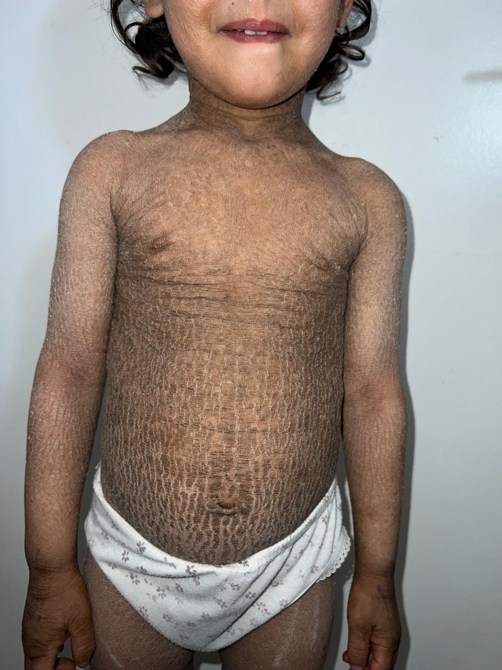

Figure 1 : Clinical features of lamellar ichthyosis in a child, showing thick, dark, plate-like scales with generalized distribution. The scaling is diffuse and adherent, predominantly involving the trunk and limbs, typical of lamellar ichthyosis with impaired epidermal turnover.

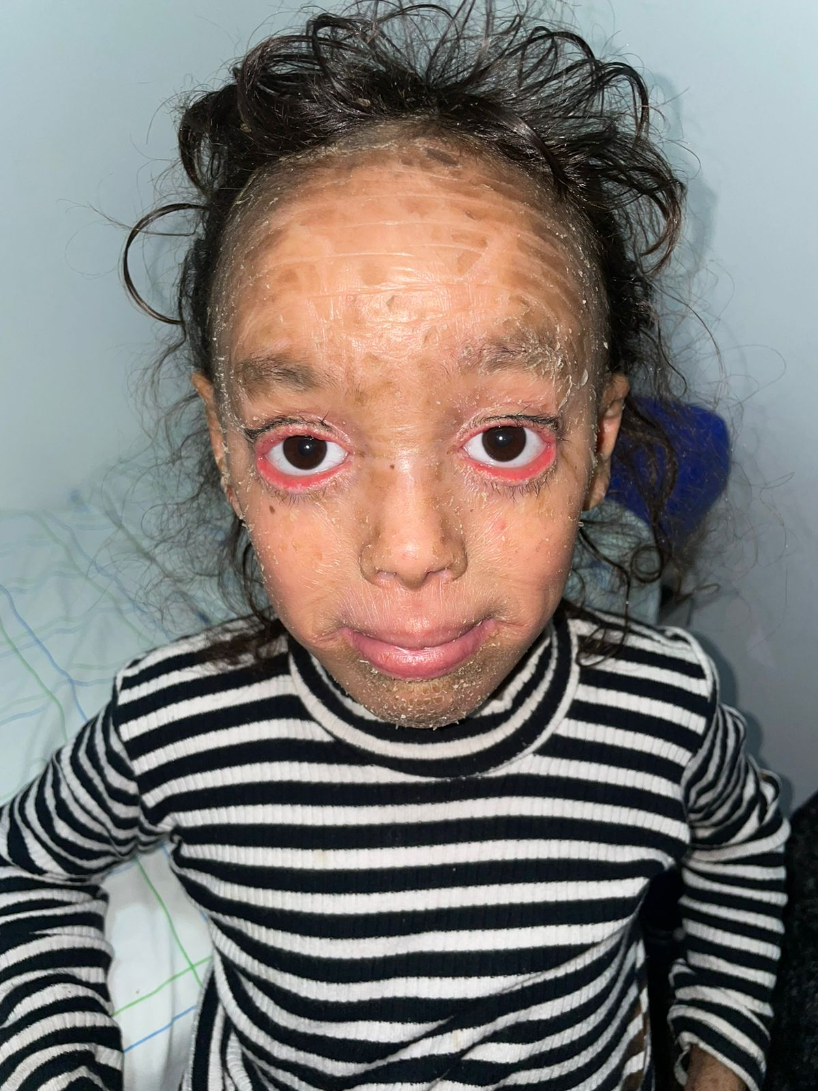

Figure 2 : Ectropion in a patient with congenital ichthyosis. The image shows bilateral eversion of both eyelids, frequently observed in severe forms of ichthyosis.

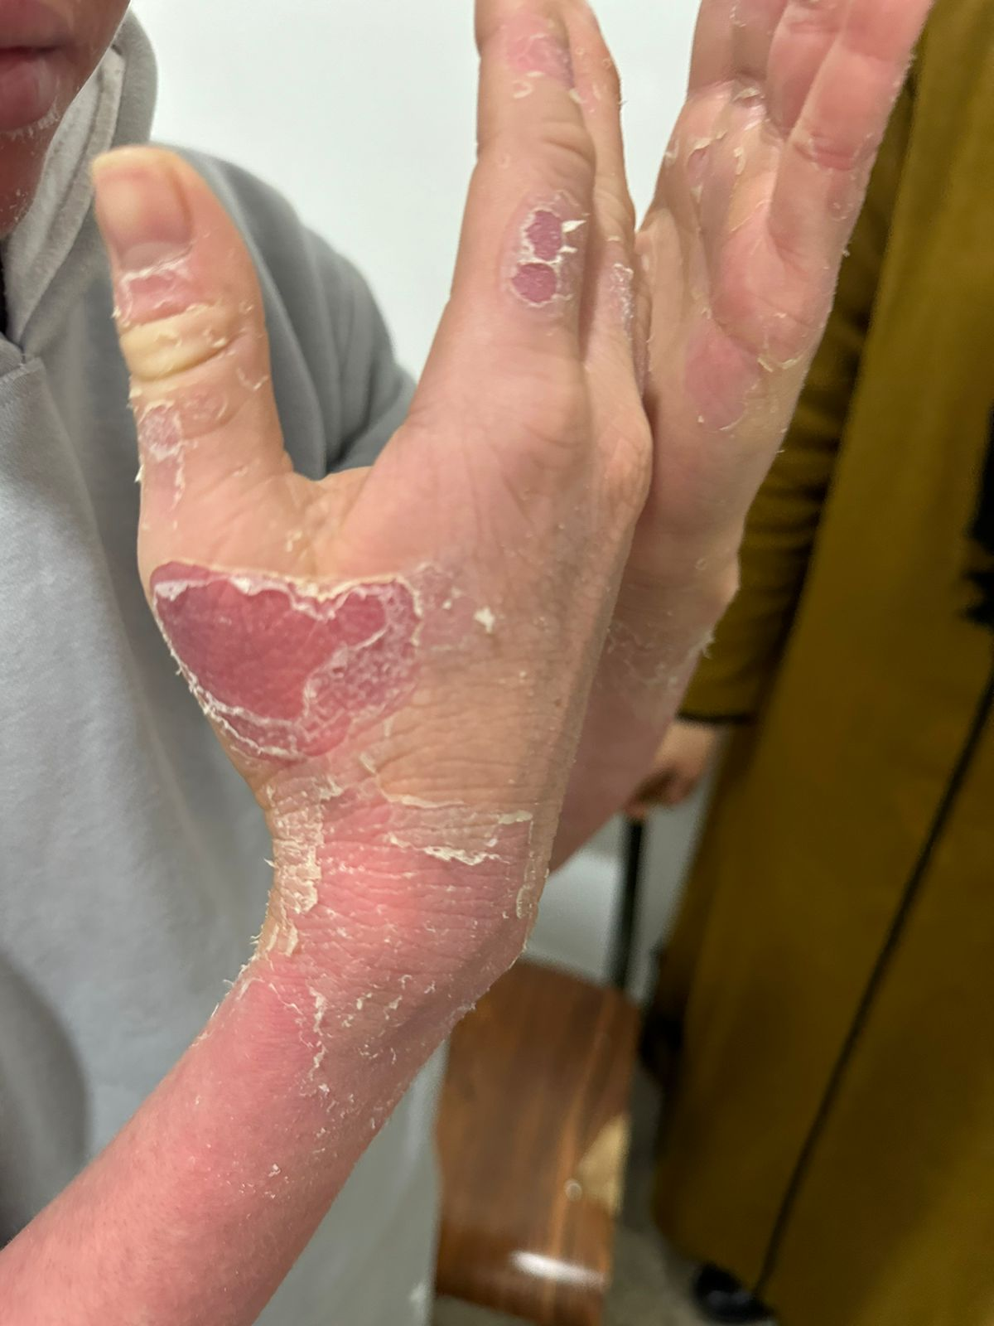

Figure 3 : Cutaneous manifestations of Netherton syndrome: erythematous, scaly plaques with a double-edged scales. These lesions are sharply demarcated, with areas of desquamation and inflammation, reflecting the chronic pruritic erythroderma characteristic of Netherton syndrome.