Case report

Anhidrotic Ectodermal Dysplasia : Report of Two Cases

.

ABSTRACT

|  |
| --- |
| **Background:** Anhidrotic ectodermal dysplasia (AED), also referred to as hypohidrotic ectodermal dysplasia, is a rare genetic condition characterized by a triad of hypotrichosis, hypodontia, and hypohidrosis.  **Case report:** This article reports two illustrative cases : an adolescent and a child, both presenting with classic AED manifestations.  **Discussion:** We describe the clinical and histological features, provide insights into the diagnostic process, and discuss recent advances in the understanding and management of AED.  **Conclusion:** AED is a rare genetic disorder that requires early diagnosis, regular follow-up, and genetic counseling. New therapies offer promising outcomes. |

*Keywords:* *Anhidrotic ectodermal dysplasia, EDA mutation, hypohidrosis, dental anomalies, prenatal therapy, recombinant EDA-A1, genetic counseling.*

1. INTRODUCTION

Anhidrotic ectodermal dysplasia (AED) is a congenital disorder affecting ectodermal-derived structures. The most frequent form is X-linked, caused by mutations in the EDA gene, although autosomal dominant and recessive forms exist, involving EDAR, EDARADD, and WNT10A genes (Agarwal S, et al., 2012), (Itin PH,et al., 2004). The cardinal clinical triad includes hypotrichosis (sparse hair), hypodontia (congenital absence of teeth), and hypohidrosis (reduced sweating), which typically emerge in early childhood. Early recognition and multidisciplinary care are essential to mitigate complications such as hyperthermia and social-emotional challenges (Clarke A, et al., 1987).

2. PRESENTATION OF CASE

We report two cases of AED: an 18-year-old adolescent and a 5-year-old child. Both patients presented since birth with signs of heat intolerance and hypohidrosis. Clinical examination revealed dysmorphic facial features including a prominent forehead, depressed nasal bridge, thick lips, and sparse scalp hair. Hair was fine and lightly pigmented, with sparse eyebrows and eyelashes.

Intraoral findings included the presence of two conical central incisors on both the upper and lower jaws, and two premolars. The remaining teeth were absent. Radiographs confirmed oligodontia.

Histopathologic analysis of a skin biopsy revealed a total absence of eccrine sweat glands and a marked reduction in pilosebaceous follicles. Genetic counseling was initiated. Both families were advised to pursue odontostomatologic rehabilitation.

3. discussion

AED is typically diagnosed based on clinical criteria and confirmed through genetic testing. Mutations in the EDA gene account for 50–60% of cases (Cluzeau C, et al. 2011). EDAR, EDARADD, and WNT10A mutations account for additional autosomal forms. While hair and tooth abnormalities are often the presenting signs, life-threatening hyperthermia due to hypohidrosis is a major concern, particularly in infants (Blüschke G, et al., 2010).

From a dermatologic perspective, dry skin and eczematous dermatitis are common. Ocular involvement such as dry eye symptoms may occur due to defective meibomian glands. ENT complications include nasal concretions, recurrent infections, and asthma-like symptoms due to dysfunctional bronchial glands (Wright JT, et al., 2025)

Dental anomalies in AED are among the most significant and consistent findings. Only a few teeth erupt, and they often appear conical and widely spaced. Treatment begins in early childhood with prosthetic solutions that evolve as the child grows. Dental implants are usually feasible after 7 years of age. Management includes fluoride application and caries prevention (Lexner MO, et al., 2007). Recent advances include the development of recombinant EDA-A1 protein therapies. Prenatal administration of Fc-EDA (ER004) has shown promising results in restoring sweat gland function in affected fetuses (Körber I, et al., 2020), (Schneider H, et al., 2018).

Surveillance recommendations include annual evaluations of hair, skin, dental, respiratory, and ophthalmologic functions, along with biannual dental visits beginning at age one [6]. Genetic counseling is essential for family planning, with options for prenatal and preimplantation diagnosis (Doolan BJ, 2021).

4. Conclusion

Anhidrotic ectodermal dysplasia is a rare but impactful condition that requires early diagnosis and ongoing multidisciplinary care. New therapeutic avenues such as prenatal protein replacement are reshaping the future of AED management. Our cases illustrate the classical presentation of AED and highlight the importance of coordinated clinical and genetic evaluation.

Consent

All authors declare that ‘written informed consent was obtained from the patient’s legal guardian for publication of this case report and accompanying images. A copy of the written consent is available for review by the Editorial office/Chief Editor/Editorial Board members of this journal.

Ethical approval

All authors hereby declare that all experiments have been examined and approved by the appropriate ethics committee and have therefore been performed in accordance with the ethical standards laid down in the 1964 Declaration of Helsinki.

Disclaimer (Artificial intelligence)

Authors hereby declare that NO generative AI technologies such as Large Language Models (ChatGPT, COPILOT, etc.) and text-to-image generators have been used during the writing or editing of this manuscript.

References

Agarwal S, Gupta S. Hypohidrotic ectodermal dysplasia. Indian Dermatol Online J. 2012 May;3(2):125-7. doi: 10.4103/2229-5178.96711. PMID: 23130287; PMCID: PMC3481883.

Itin PH, Fistarol SK. Ectodermal dysplasias. Am J Med Genet C Semin Med Genet. 2004 Nov 15;131C(1):45-51. doi: 10.1002/ajmg.c.30033. PMID: 15468153.

Clarke A, Phillips DI, Brown R, Harper PS. Clinical aspects of X-linked hypohidrotic ectodermal dysplasia. Arch Dis Child. 1987 Oct;62(10):989-96. doi: 10.1136/adc.62.10.989. PMID: 2445301; PMCID: PMC1778691.

Cluzeau C, Hadj-Rabia S, Jambou M, Mansour S, Guigue P, Masmoudi S, et al. Only four genes (EDA1, EDAR, EDARADD, and WNT10A) account for 90% of hypohidrotic/anhidrotic ectodermal dysplasia cases. Hum Mutat. 2011 Jan;32(1):70-2. doi: 10.1002/humu.21384. PMID: 20979233.

Blüschke G, Nüsken KD, Schneider H. Prevalence and prevention of severe complications of hypohidrotic ectodermal dysplasia in infancy. Early Hum Dev. 2010 Jul;86(7):397-9. doi: 10.1016/j.earlhumdev.2010.04.008. Epub 2010 Jun 1. PMID: 20682465.

Wright JT, Grange DK, Fete M. Hypohidrotic Ectodermal Dysplasia. 2003 Apr 28 [Updated 2025 Mar 20]. In: Adam MP, Feldman J, Mirzaa GM, et al., editors. GeneReviews®. Seattle (WA): University of Washington, Seattle; 1993-2025. Available from: https://www.ncbi.nlm.nih.gov/books/NBK1112/

Lexner MO, Bardow A, Hertz JM, Nielsen LA, Kreiborg S. Anomalies of tooth formation in hypohidrotic ectodermal dysplasia. Int J Paediatr Dent. 2007 Jan;17(1):10-8. doi: 10.1111/j.1365-263X.2006.00801.x. PMID: 17181574.

Körber I, Ophir D Klein, Patrick Morhart, Florian Faschingbauer, Dorothy K Grange. Safety and immunogenicity of Fc-EDA in human subjects. *Br J Clin Pharmacol*. 2020;86:2063-9.

Schneider H, Faschingbauer F, Schuepbach-Mallepell S, Körber I, Wohlfart S, Dick A, et al. Prenatal Correction of X-Linked Hypohidrotic Ectodermal Dysplasia. N Engl J Med. 2018 Apr 26;378(17):1604-1610. doi: 10.1056/NEJMoa1714322. PMID: 29694819.

Doolan BJ, Onoufriadis A, Kantaputra P, McGrath JA. WNT10A, dermatology and dentistry. Br J Dermatol. 2021 Dec;185(6):1105-1111. doi: 10.1111/bjd.20601. Epub 2021 Sep 7. PMID: 34184264.

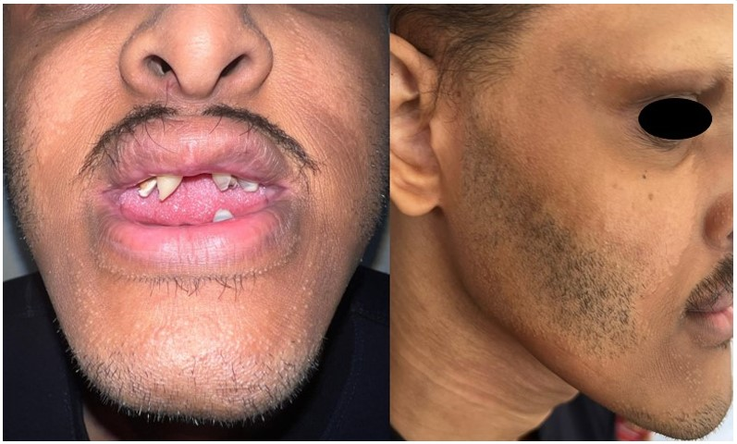

Figure 1 : 18-year-old adolescent with hypodontia, thick lips, and sparse scalp hair, eyebrows, eyelashes and beard.

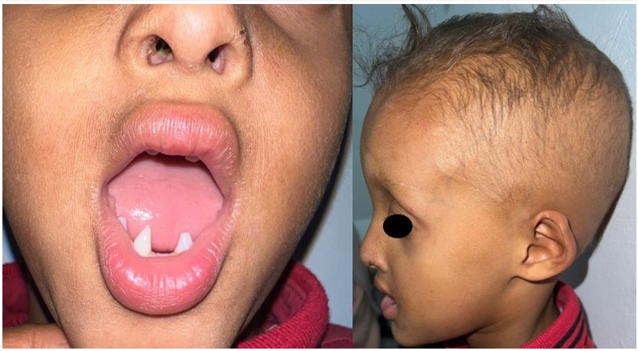

Figure 2 : 5-year-old child with hypodontia, thick lips, xerosis and sparse scalp hair, eyebrows and eyelashes.