Case report

Unusual Coexistence of Castleman's Disease and Pityriasis Lichenoides in a Child

ABSTRACT

|  |
| --- |
| **Background:** Castleman disease is a rare lymphoproliferative disorder, especially in children. Its association with pityriasis lichenoides has not been previously reported.  **Case report:** We describe a 5-year-old girl with a history of recurrent necrotic and bullous skin lesions since infancy, diagnosed as chronic pityriasis lichenoides (CD8+). One year later, she developed bilateral cervical lymphadenopathy. Imaging showed multiple well-defined necrotic nodes. Lymph node biopsy revealed hyaline-vascular Castleman disease.  **Discussion:** This case suggests a potential immunological link between chronic pityriasis lichenoides and Castleman disease. Skin lesions may precede or signal underlying lymphoproliferative conditions.  **Conclusion:** We report the first paediatric case of coexisting pityriasis lichenoides and Castleman disease, highlighting the need for systemic evaluation in chronic dermatoses with lymphadenopathy. |

*Keywords:* Castleman disease, Pityriasis lichenoides, CD8+, Hyaline-vascular, Child, Lymphadenopathy*.*

1. INTRODUCTION

Castleman disease (CD) is an uncommon lymphoproliferative disorder characterised by benign but often massive lymph-node hyperplasia (Christian Hoffmann, et al. 2024). The hyaline-vascular (HV) histological variant predominates in the unicentric form and represents roughly 80 % of cases, yet paediatric presentations are exceptionally rare, accounting for fewer than 10 % of reported series (Jiang P, et al., 2024), (Yavasoglu I, et al., 2009). Unicentric HV-CD usually manifests as a slow-growing, painless cervical or mediastinal mass and is frequently curable by complete surgical excision (Hu S, et al., 2023), (Imen BI, et al., 2020).

Pityriasis lichenoides (PL) is an equally rare spectrum of inflammatory dermatoses—including pityriasis lichenoides chronica (PLC) and pityriasis lichenoides et varioliformis acuta (PLEVA)—that classically affects children and young adults with recurrent crops of papulo-vesicular or ulceronecrotic lesions that heal with hypopigmented scars (Teklehaimanot F, et al., 2025). Histologically, PL demonstrates an interface dermatitis rich in cytotoxic CD8-positive lymphocytes, and clonal T-cell receptor rearrangements have led some authors to regard it as a cutaneous lymphoproliferative disorder.

Although PL has occasionally been described as a paraneoplastic manifestation in Hodgkin and non-Hodgkin lymphomas, its coexistence with CD has not, to our knowledge, been reported. We present what appears to be the first documented case of HV-CD associated with chronic PL in a child, discuss potential pathogenic links, and highlight the diagnostic obstacles raised by this unusual constellation.

2. PRESENTATION OF CASE

We report the case of a 5-year-old girl born to first-degree consanguineous parents, who had developed—since the age of one—recurrent pustular and bullous skin lesions that progressed to necrosis and ulceration. These eruptions appeared in flare-ups alternating with remission and eventually left hypopigmented residual scars (Figure 1).

A punch biopsy of a lesion demonstrated chronic pityriasis lichenoides with immunohistochemically dense CD8-positive lymphocytic infiltrates (Figure 2).

Over the past year the child also noted painless, bilateral cervical swellings. Examination revealed multiple firm, mobile lymph-node masses bilaterally, the largest measuring 2 cm. Cervical ultrasound and CT imaging showed numerous well-circumscribed, heterogeneous hypoechoic laterocervical nodes with central necrosis, ranging from 6 to 12 mm.

Excisional biopsy of one node revealed an atrophic nodal architecture containing only a few lymphoid follicles; several atretic follicles displayed hyalinised capillaries traversing the germinal centres. Extensive interfollicular hyaline deposits and numerous small vessels with hyalinised walls were present. This pattern is diagnostic of the hyaline-vascular variant of unicentric Castleman disease.

3. discussion

The temporal sequence in our patient—cutaneous lesions beginning at one year of age and persistent lymph-node enlargement appearing later—raises the possibility that PL acted as an early paraneoplastic or immune-dysregulatory clue to underlying CD. PL has long been thought to reflect either an aberrant immune response to infection or a low-grade clonal T-cell proliferation; CD, conversely, is driven by dysregulated cytokine signalling, notably interleukin-6, within germinal-centre B-cells and follicular dendritic cells (Sikora M, et al., 2025). A shared milieu of chronic T-cell activation and cytokine overproduction may therefore provide a mechanistic bridge between the two entities.

The HV subtype of CD is typically localised and haemodynamically silent. In children it preferentially involves cervical nodes, and complete surgical resection yields long-term remission rates exceeding 95 % (Hu S, et al., 2023), (Korbi AE, et al., 2020). Our patient’s imaging findings of well-circumscribed, heterogeneous, partly necrotic nodes measuring up to 2 cm were consistent with a localized lymphoproliferative process. Histological analysis revealed an atrophic nodal parenchyma with sparse lymphoid follicles, hyalinised blood vessels traversing atretic germinal centers, and extensive interfollicular hyaline deposits—features characteristic of the hyaline-vascular variant of Castleman disease.

Management of chronic PL remains empirical; macrolide antibiotics, narrow-band UVB phototherapy and low-dose methotrexate are most frequently employed. Interestingly, isolated reports describe improvement of PL after successful treatment of an associated haematological malignancy, supporting the paraneoplastic hypothesis (Kempf W, et al., 2005), (C. Damak, et al., 2015). Whether excision of the unicentric CD focus in our patient will attenuate her cutaneous relapses warrants close dermatological follow-up.

Consanguinity in our case may point to an inherited tendency toward immune dysregulation, as suggested for familial forms of both CD and PL, although the precise genetic drivers remain elusive. This highlights the need for genetic and cytokine-profiling studies in similar presentations.

4. Conclusion

This case underscores an unrecognised association between chronic pityriasis lichenoides and unicentric hyaline-vascular Castleman disease in a paediatric patient born of consanguineous parents. The coexistence of persistent, relapsing ulceronecrotic skin lesions with laterocervical lymphadenopathy should prompt clinicians to consider an underlying lymphoproliferative process. Early lymph-node biopsy remains pivotal for diagnosis, and complete surgical excision of the unicentric CD lesion offers an excellent prognosis. Further reports are needed to clarify whether PL may serve as a cutaneous marker of Castleman disease and to unravel the immunopathogenic links between these two rare disorders.

Consent

All authors declare that ‘written informed consent was obtained from the patient’s legal guardian for publication of this case report and accompanying images. A copy of the written consent is available for review by the Editorial office/Chief Editor/Editorial Board members of this journal.

Ethical approval

All authors hereby declare that all experiments have been examined and approved by the appropriate ethics committee and have therefore been performed in accordance with the ethical standards laid down in the 1964 Declaration of Helsinki.

Disclaimer (Artificial intelligence)

Authors hereby declare that NO generative AI technologies such as Large Language Models (ChatGPT, COPILOT, etc.) and text-to-image generators have been used during the writing or editing of this manuscript.

References

Christian Hoffmann, Eric Oksenhendler, Sarah Littler, Lisa Grant, Karan Kanhai, David C. Fajgenbaum; The clinical picture of Castleman disease: a systematic review and meta-analysis. *Blood Adv* 2024; 8 (18): 4924–4935. doi: <https://doi.org/10.1182/bloodadvances.2024013548>

Jiang P, Huang ZH, Liu WY, Pan HG. Castleman Disease Presenting in the Neck: A Report of 3 Cases and a Literature Review. Am J Case Rep. 2024 Apr 26;25:e943214. doi: 10.12659/AJCR.943214.

Yavasoglu I, Kadikoylu G, Meteoglu I, Bolaman Z. Hyaline-vascular type of Castelman's disease associated with Crohn's disease. Int J Colorectal Dis. 2009 Jan;24(1):123-4. doi: 10.1007/s00384-008-0545-6.

Hu S, Li Z, Wang H, Chen L, Ma Y, Zhu X, Li J, Dong R, Yao W, Dong C, Zhang H, Li K, Dong K, Zhai X. Clinical features and treatment outcomes of Castleman disease in children: a retrospective cohort in China. Eur J Pediatr. 2023 Dec;182(12):5519-5530. doi: 10.1007/s00431-023-05235-2.

Imen BI, Zenaidi H, Abdelwahed Y, Sabeur R, Ayoub Z. Management of isolated retroperitoneal Castelman's disease: A case report. Int J Surg Case Rep. 2020;70:24-27. doi: 10.1016/j.ijscr.2020.03.048.

Teklehaimanot F, Gade A, Rubenstein R. Pityriasis Lichenoides Et Varioliformis Acuta (PLEVA) [Updated 2023 Jan 2]. In: StatPearls [Internet]. Treasure Island (FL): StatPearls Publishing; 2025 Jan-. Available from: https://www.ncbi.nlm.nih.gov/books/NBK585135/

Sikora M, Dąbrowska-Leonik N, Buda P, Wolska-Kuśnierz B, Jahnz-Różyk K, Pac M, Więsik-Szewczyk E. Castleman Disease-Still More Questions than Answers: A Case Report and Review of the Literature. J Clin Med. 2025 Apr 18;14(8):2799. doi: 10.3390/jcm14082799.

Korbi AE, Jellali S, Jguiri M, Bellalah A, Ferjaoui M, Bouatay R, Kolsi N, Harrathi K, Koubaa J. Castelman's disease of the neck: a case report and literature review. Pan Afr Med J. 2020 Dec 22;37:369. doi: 10.11604/pamj.2020.37.369.26909.

Kempf W, Kutzner H, Kettelhack N, Palmedo G, Burg G. Paraneoplastic pityriasis lichenoides in cutaneous lymphoma: case report and review of the literature on paraneoplastic reactions of the skin in lymphoma and leukaemia. Br J Dermatol. 2005 Jun;152(6):1327-31. doi: 10.1111/j.1365-2133.2005.06457.x.

C. Damak, R. Ben Salah, F. Frikha, H. Mesrati, S. Garbaa, A. Ouahba, H., et al. Maladie de Castelman au sud tunisien : à propos de 10 cas. La Revue de Médecine Interne. Volume 36, Supplement 1, 2015, Pages A151-A152, ISSN 0248-8663, https://doi.org/10.1016/j.revmed.2015.03.168.

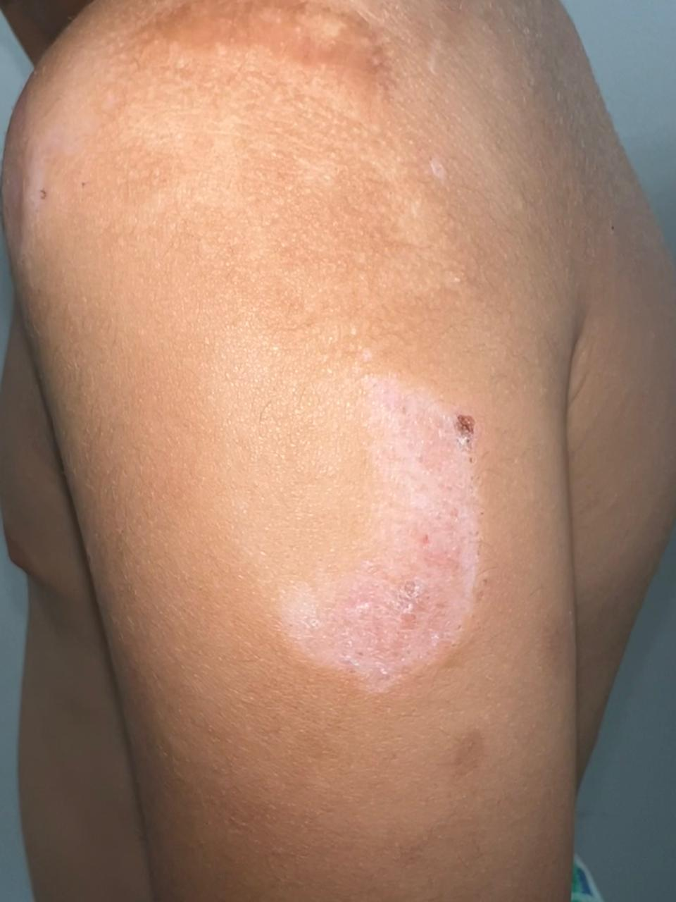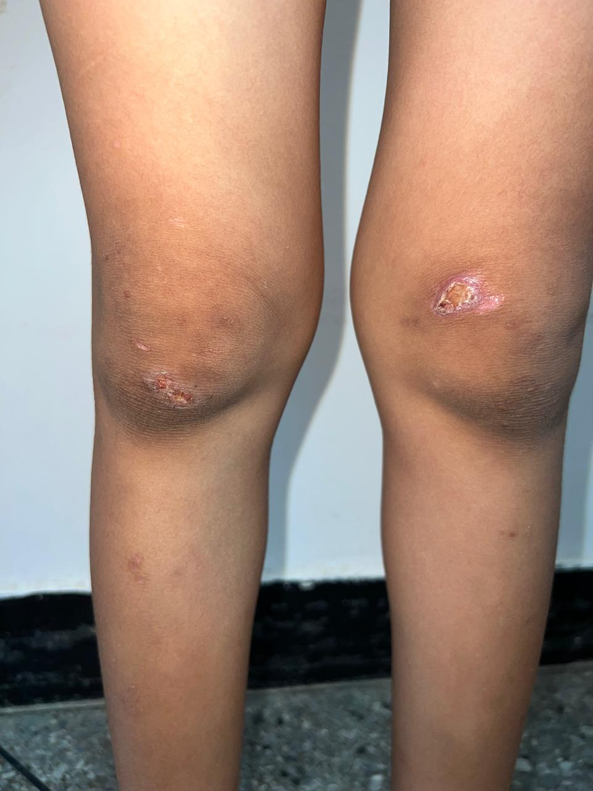

Figure 1 (a,b) : Crusted papular lesions and hypopigmented scarring in chronic pityriasis lichenoides.

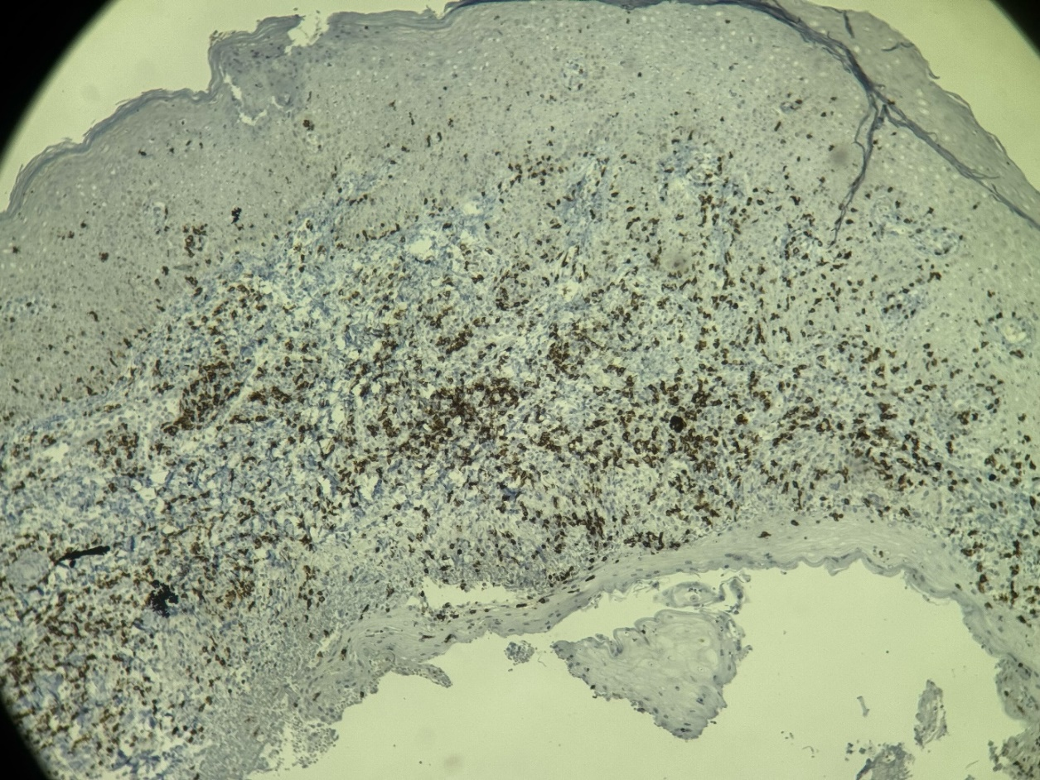

Figure 2 : Immunohistochemical staining showing strong CD8-positive lymphocytic infiltrate in chronic pityriasis lichenoides.