**Original Research Article**

**ROLE OF DIGESTIVE ENZYMES, CARMINATIVES AND PROBIOTICS (TUMMYSOFT DROPS) IN INFANTILE COLIC**

**ABSTRACT**

**Background:** To investigate the safety and efficacy of probiotics, digestive enzymes and carminatives (Tummysoft Drops) in the management of infantile colic.

**Methods:** 108 infants (aged < 6 months) fulfilling the Rome-IV diagnostic criteria for infantile colic were randomly allocated to receive 10 drops of Tummysoft Drops (Intervention group) or placebo drops (placebo group) daily for 4 weeks. The primary outcomes of the study were reduction of the duration of crying, crying frequency, defecation frequency and the number of infants whose crying duration was reduced to > 50% from the baseline.

**Results:** 100 Infants completed the study. At the end of 4 weeks, the mean crying duration changed from 261.30 ± 41.684 to 52 ± 12.857 min/day in the intervention group and from 262 ± 39.046 to 77 ± 27.408 min/day in the placebo group. The episodes of crying were reduced from 6.34 ± 2.387 to 0.20 ± 0.495 episodes/day in the intervention group and from 7.32 ± 2.453 to 1.30 ± 1.298 episodes/day in the placebo group. The number of infants with >50% decrease in crying time from baseline on day 14 was 49 infants in the intervention group and 30 infants in the placebo group (p = 0.05). By the end of 4th week, it was noted that parental satisfaction was better in the intervention group.

**Conclusion:** Administration of a comprehensive formula (Tummysoft Drops) containing *Bacillus Coagulans* GBI 30, 6086, digestive enzymes and carminatives was found to be safe and effective in the treatment of infantile colic.

**Keywords:** *Bacillus Coagulans* GBI 30, 6086, Digestive enzymes, Carminatives, Infantile colic

**INTRODUCTION**

Crying is a typical habit for infants during infancy. It is the infant's way of signalling and requesting assistance for physiological demands like hunger, temperature, diaper changes, and pain or discomfort [1, 2]. While crying is accepted as "normal behaviour," between 5% and 40% of new-borns cry uncontrollably and excessively, along with periods of fussiness and gas passing [3, 4, 5]. Wessel et al coined the term “infantile colic” to describe a fussy infant with colic as “one who is otherwise healthy and well-fed, having paroxysms of irritability, or crying, lasting for a total of three hours a day, occurring on more than three days in any one week for a period of three weeks’’ [6]. The symptoms of infantile colic can appear as early as two weeks of age. The peak period of crying and fussiness usually occurs between six and eight weeks of age, and it usually subsides between three and four months of age [7,8]. Paroxysms of crying and gassy episodes can occur and disappear without clear reason or trigger, hence treating and preventing infantile colic can be challenging [8, 9].

Infantile colic's exact cause is unknown, but a number of theories have been put forth. These include excessive gas production in the gut, hard intestinal contractions, hypersensitivity to the protein in cow's milk, temporary lactase deficiency, poor or negative mother-infant bonding, excessive parental stimulation, challenging infant behaviour, and insecure parental attachment [8,9,10]. There are significant differences in the gut microbiota between new-borns with and without colic [11,12]. Supporting that role, children with colic are more likely to be colonized by the gas-forming bacteria *Clostridium difficile, Escherichia spp*., and *Klebsiella spp.,* and may have low levels of *lactobacilli* in the early stages of infancy, which impacts intestinal fatty acid balances [13]. The absence of microbial diversity in the early gut microbiota may contribute to infantile colic in addition to the unusual colonization pattern [14].

Probiotics are the live microorganisms which offer beneficial effects when administered in adequate quantities [15]. Probiotic supplementation helps to alter the gut bacterial patterns by promoting the colonization of beneficial bacteria [16, 17]. Probiotics have the ability to reduce intestinal inflammation by inhibiting the overgrowth of inflammation-inducing microbes and gas-forming coliforms [18, 19, 20]. *Bacillus coagulans* GBI-30, 6086 is an extremely stable probiotic due to the cell’s ability to form a protective spore. This protective spore gives *Bacillus coagulans* GBI-30, 6086 the ability to survive harsh manufacturing processes, during product shelf life and finally, the journey through the digestive system. *Bacillus coagulans* GBI-30, 6086 has been shown to exert a wide range of functions on the digestive system facilitating the synthesis of digestive enzymes and aiding the breakdown of a wide range of carbohydrate substrates. [21] *Bacillus coagulans* GBI-30, 6086 has been granted Generally Recognised As Safe (GRAS) status by the US Food and Drug Administration (FDA) and is being used in infant formulas. [22]

Digestive enzymes ensure the digestion of complex food substances like carbohydrates and proteins. They reduce the accumulation of undigested food particles in the infantile gut and hence decreases the accumulation of gas in the abdomen [23]. Digestive enzymes also ensure proper utilization of food including milk (catalysed by lactase enzyme) in infants and improves overall growth and development. Alpha Amylase hydrolyzes the glycosidic bonds in starch molecules, converting complex sugars to simple sugars. The simple sugars are absorbed easily in the intestine thus reducing the accumulation of complex carbohydrates and improving overall digestive health. Papain (Proteolytic enzyme) is an enzyme found in the white fluid (latex) that occurs in raw papaya fruit. It breaks the peptide linkage present in proteins, thus converting proteins into simpler amino acids. [24]

When the body produces insufficient amounts of lactose digesting enzyme, lactase it results in lactose intolerance. Lactase is required for the digestion of lactose present in milk. Lactase deficiency causes accumulation of lactose which leads to lactose intolerance. Bacterial action on accumulated lactose in the gut causes flatulence and results in infantile colic. Milk is an important food source for infants and avoiding milk is not a practical option. Administration of lactase enzyme in infants is necessary for complete digestion of lactose and relief from colic.

Carminatives are the preparation intended to either prevent the formation of gas in the gastrointestinal tract or facilitate the expulsion of gas, thereby combatting flatulence. It leads to decreased stretching of gastrointestinal tract and reduce abdominal pain. It helps in significant decrease in colic and crying. Carminatives has an additional action of soothing the gut and helps in digestion of certain food substances.

Dill (*Anethum graveolens L.*) has been used since ancient times for relieving colic pain in babies and flatulence in young children. It relieves intestinal spasms and griping and helps to settle colic. It has a significant mucosal protective, antisecretory and anti-ulcer activities against stomach acid.In addition, dill oil is also used as stomachic, which Improves digestion and increases appetite [25]. Fennel oil is obtained from the seeds of *Foeniculum vulgare*. These are proven to be an effective remedy for many digestive disorders and ensures a healthy digestive system in growing babies. Fennel seeds have effective digestive properties that can help in easing cramps. They are packed with antioxidants that help in building the child's immunity and promote overall health. [7]

**MATERIALS AND METHODS**

This randomized, double-blind, placebo-controlled trial was carried out between September 2023 to February 2024 at the Department of Paediatrics in Chettinad Hospital and Research Institute, Kelambakkam. Before study initiation, approval was obtained from The Chettinad Institutional Human Ethics Committee and the same was registered in Clinical Trial Registry India (CTRI Number: CTRI/2023/08/056153).

After obtaining written informed consent from a parent or guardian, eligible new-borns were included to the study. The study protocol, possible risks and benefits of the study were informed to the parents. Subsequently, written informed consent were obtained. Following were the inclusion criteria (a) Crying or fussy/gassy episodes three or more hours per day during three or more days in 7 days, according to Rome-4 criteria, (b) age < 6month, (c) both breastfeed and non-breastfeed infants; (d) term delivery (≥37 weeks’ gestation at birth), and (e) birth weight ≥2500 g.

Exclusion criteria: (a) Infants with known gastrointestinal disorders, (b) previous abdominal surgery, (c) severe dehydration, (d) presence of systemic infections, (e) known immunocompromising morbidities, (f) cystic fibrosis, (g) severe acute malnutrition, (h) chronic or severe respiratory, (i) cardiovascular, (j) central nervous system, (k) endocrine, and other gastrointestinal disorders were excluded from the study.

The primary endpoints of the study were reduction in the duration of crying and crying frequency, defecation frequency, and the number of infants whose crying duration was reduced to 50% of the baseline. Secondary endpoints were parental satisfaction and adverse events. Furthermore, the visual analog scale (VAS) was used to measure the severity of colic at the beginning and the end of the study.

Eligible infants were randomly allocated to receive 10 drops of Tummysoft Drops (Intervention group) or Placebo drops (Placebo group) daily for 4 weeks. Each ml of Tummysoft drops contains 500 million CFU of *Bacillus Coagulans* GBI 30, 6086, Alpha-Amylase 20 mg, Papain 10 mg, Lactase 6 mg (600 FCC), Dill Oil 2 mg, and Fennel Oil 0.0007 ml. The placebo drops contained all the excipients except active ingredients, looked the same, and had the same taste, and texture as the study medication.

On enrolment (day 0), parents/guardians were interviewed to obtain the following information: (a) gestational age; (b) type of delivery; (c) personal medical history; (d) smoking status of parents; (e) history of gastrointestinal disease; (f) infant birth weight; and (g) description of colic symptoms. The referring paediatrician performed a medical examination and infant growth parameters on day 0 which were recorded on day 0 and on subsequent follow-up visits (days 7, 14, 21 and 28).

Parents were instructed to record the frequency of colic episodes and the daily crying and fussing time (in minutes), feeding schedule, stool frequency, and characteristics, and any adverse effects experienced (e.g., constipation, vomiting, erythema), along with the frequency and duration of each adverse event. When necessary, parents and caregivers were informed to get in touch with the study team investigators and the paediatrician who referred them.

**Statistical analysis**

Statistical analysis was done using IBM SPSS software 27 Version. Sample t-test was used to compare between the intervention and placebo group. For comparing the crying duration, frequency, and defecation, repeated measures ANOVA was used. For comparing the visual analog scale paired sample t-test was done. The p-value <0.05 was considered as a significant at 95% confidence interval.

108 participants diagnosed with infantile colic were eligible to enrol in the study. On randomization, 52 were allotted to the intervention group and 56 to the placebo group. Five infants were excluded from the study due to the unwillingness of parents, and three due to not complying with follow-up. Finally, 100 patients completed the study, including 50 infants in the intervention group and 50 infants in the placebo group (Figure 1).

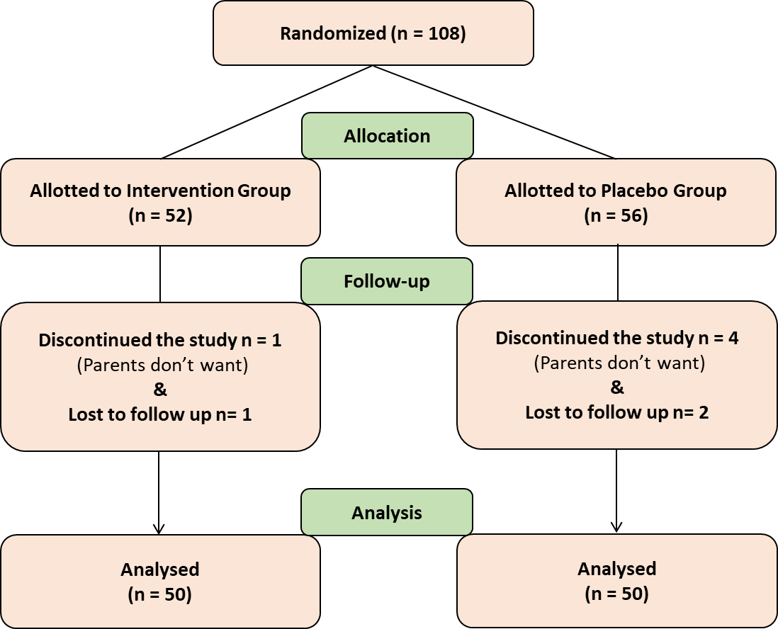

**Figure:1** Schematic diagram of participant enrolment and study progress

The demographic data of the studied infants are summarized in Table 1.

* The mean age of infants was 2.52 ± 1.4 and 2.48 ± 1.5 months in the intervention and placebo groups.
* The mean weight of infants was 2.72 ± 0.167 and 2.73 ± 0.166 kgs in the intervention and placebo groups, respectively.
* In the intervention group, 28 infants (56%) were male and 22 infants (44%) were female.
* In the placebo group, 29 infants (58%) were male and 21 infants (42%) were female.

|  |  |  |
| --- | --- | --- |
| **Variables** | **Intervention Group, n (%)** | **Placebo Group, n (%)** |
| **Gender**  Male  Female | 28 (56)  22 (44) | 29 (58)  21 (42) |
| **Type of Feeding**  Breast milk  Mixed | 39 (78)  11 (22) | 37 (74)  13 (26) |
| **Type of Delivery**  Normal Vaginal delivery  C-Section | 32 (64)  18 (36) | 29 (58)  21 (42) |

**Table 1:** Demographic characteristics of patients in intervention and placebo groups.

**RESULTS**

1. **Reduction in crying duration:** The mean crying duration changed from 261.30 ± 41.684 to 52 ± 12.857 min/day in the intervention group and from 262 ± 39.046 to 77 ± 27.408 min/day in the placebo group (Table 2).

|  |  |  |  |
| --- | --- | --- | --- |
| **Variable** | **Mean** | | **p^ value** |
| **Crying Duration (min/day)** | **Intervention Group** | **Placebo Group** |
| Day 0  Day 7  Day 14  Day 21  Day 28 | 261.20 ± 41.684  155.60 ± 29.926  62.80 ± 23.039  53.60 ± 15.454  52.00 ± 12.857 | 262.10 ± 39.046  192.80 ± 42.476  118.70 ± 32.084  90.80 ± 23.676  77.20 ± 27.408 | 0.921  <0.001 (HS)  <0.001 (HS)  <0.001 (HS)  <0.001 (HS) |
| **P^^ value** | <0.001 | <0.001 |

**Table 2:** Duration of crying in intervention and placebo groups.

P^^ - Repeated measure ANOVA p^- Independent sample t test

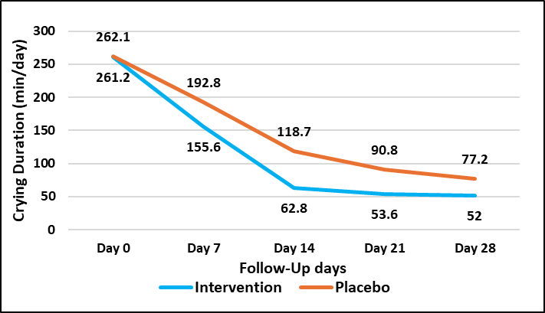

**Figure 2:** Duration of crying in intervention and placebo groups.

1. **Reduction in the frequency of crying:** The episodes of crying were reduced from 6.34 ± 2.387 to 0.20 ± 0.495 episodes/day in the intervention group and from 7.32 ± 2.453 to 1.30 ± 1.298 episodes/day in the placebo group (Table 3).

|  |  |  |  |
| --- | --- | --- | --- |
| **Variable** | **Mean** | | **P^ value** |
| **Crying Frequency (episodes/day)** | **Intervention Group** | **Placebo Group** |
| Day 0  Day 7  Day 14  Day 21  Day 28 | 6.34 ± 2.387  4.60 ± 2.295  3.12 ± 1.986  1.66 ± 1.334  0.20 ± 0.495 | 7.32 ± 2.453  5.78 ± 1.877  4.28 ± 1.938  2.62 ± 1.640  1.30 ± 1.298 | 0.046  0.006  0.004  0.002  <0.001(HS) |
| **P^^ value** | <0.001 | <0.001 |

**Table 3:** Frequency of crying in intervention and placebo groups.

P^^- Repeated measure ANOVA p^- Independent sample t test

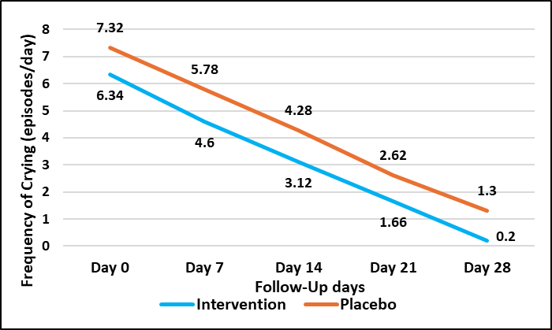

**Figure 3:** Frequency of crying in intervention and placebo groups.

1. **Reduction in crying duration of ≥50% from baseline:** A higher proportion of infants in the Intervention group responded to treatment (defined as a reduction in crying duration of ≥50% from baseline) compared with the placebo group. By day 7, statistical significance was achieved in the intervention group with p = 0.005. (Table 4)

|  |  |  |  |
| --- | --- | --- | --- |
|  | **Intervention**  **Group** | **Placebo**  **Group** | **p Value** |
| Number of infants with >50% decrease in crying time on day 7 | 7 (14%) | 0 (0%) | 0.005 |
| Number of infants with >50% decrease in crying time on day 14 | 49 (98%) | 30 (60%) | 0.05 |
| Number of infants with >50% decrease in crying time on day 21 | 50 (100%) | 46 (92%) | - |
| Number of infants with >50% decrease in crying time on day 28 | 50 (100%) | 48 (96%) | - |

**Table 4:** Number of infants with >50 % crying from the baseline during the study in both groups.

p – chi square test

1. **Reduction in defecation frequency:** The defecation frequency was decreased from 4.14 ± 1.512 to 2.24 ± 0.771 in the intervention group and from 4.18 ± 1.453 to 2.22 ± 0.790 in the placebo group (Table 5). No significant difference in defecation frequency were observed between the two groups.

|  |  |  |  |
| --- | --- | --- | --- |
| **Variable** | **Mean** | | **P^ value** |
| **Frequency of Defecation (episodes/day)** | **Intervention Group** | **Placebo**  **Group** |
| Day 0  Day 7  Day 14  Day 21  Day 28 | 4.14 ± 1512  3.28 ± 1.325  2.84 ± 1.017  2.54 ± 0.734  2.24 ± 0.771 | 4.18 ± 1.453  3.40 ± 1.262  3.04 ± 0.880  2.92 ± 0.986  2.22 ± 0.790 | 0.893  0.644  0.296  0.031  0.898 |
| **P^^ value** | <0.001 | <0.001 |

**Table 5:** Frequency of defecation in intervention and placebo groups.

P^^- Repeated measure ANOVA p^- Independent sample t test

1. **Reduction in Pain:** We used Visual analog scale (VAS) and “faces” rating pain scale for assessment of infant’s pain. On day 28, the mean rating was significantly reduced to 0.08 ± 0.274 and 1.34 ± 1.437 in the intervention and placebo groups respectively (p = <0.001 which was highly significant) (Table 6).

|  |  |  |  |
| --- | --- | --- | --- |
| **Variable** | **Mean** | | **P^ value** |
| **Visual Analog Scale** | **Intervention Group** | **Placebo Group** |
| Day 0  Day 28 | 4.68 ± 0.580  0.08 ± 0.274 | 4.68 ± 0.621  1.34 ± 1.437 | 0.868  < 0. 001 (HS) |
| **P^^ value** | <0.001 | <0.001 |  |

**Table 6:** Visual analog scale ratings for intervention and placebo groups.

P^^ - Paired sample t test P^ - Independent sample t test

1. **Parenteral Satisfaction:** By the end of 4th week, parental satisfaction in terms of infant's mood, activity, alertness, comfort, and oral intake were better in intervention group. On using Likert scale, 43 parents were ‘strongly satisfied’ with the treatment in intervention group and 26 parents in placebo group. 7 and 14 were ‘satisfied’ with the treatment in intervention and placebo group respectively. In ‘neither satisfied’ nor ‘dissatisfied’ opinion, none were in treatment group and 10 parents were in placebo group.

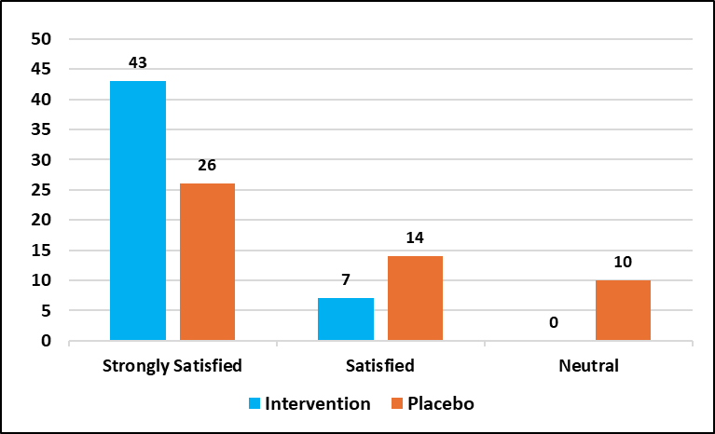

**Figure 4:** Parental satisfaction using Likert Scale

1. **Adverse events:**

No adverse events were noticed in both intervention and study group

**DISCUSSION**

Infantile colic is one of the most prevalent health problem that can arise in the first few months of infant’s life. The aetiology of infantile colic is not well understood; however, studies have suggested that changes in the intestinal microbiota, gastrointestinal immaturity or inflammation and intolerance to cow's milk protein or lactose can lead to symptoms of infantile colic. Hence probiotics, digestive enzymes and carminatives have been studied to understand their effectiveness in the treatment of infantile colic. [26]

Probiotics are beneficial microorganisms that can positively affect a child’s body by balancing the intestinal flora. Probiotics have several positive benefits such as inhibiting the adherence of pathogenic microorganism in the intestinal epithelium, production of bacteriocins and modulating the intestinal pH. YanPing Liu et al. conducted a meta-analysis of nine clinical studies and found that probiotics were effective than placebo in treating infantile colic. [27]

Carminatives like dill oil and fennel oil are being used to treat bloating, flatulence, and stomach pain in people of all ages, including new-borns since ancient times. Tripti Sethi et. al administered a multi herbal preparation containing dill oil to infants and was found to be effective and safe to use in infants. [28] Fennel oil can be used as a safe and efficient treatment for infantile colic, according to a study by Irina et. al [29] Similar conclusion on Fennel oil was made by Attarha et al. [30]

Indigestion often leads to bloating, flatulence and abdominal pain which can trigger or aggravate infantile colic. Amylase and papain are widely used digestive enzyme to breakdown carbohydrates and proteins respectively [31, 32, 33, 34]. The enzyme lactase digests milk and ensures optimal absorption of milk proteins. In a study conducted by Narang et al in infants suffering from infantile colic, it was noted that oral administration of lactase in infantile colic reduced the duration of crying and was well tolerated by infants. [35] Similar conclusion on the usage of lactase in infantile colic was made by Ahmed et al. [36]

Thus, previous studies have used probiotics, carminatives and digestive enzymes independently in infantile colic and found them to be safe and effective. In this study, we have shown for the first time that infantile colic can be safely and successfully treated with a combination of probiotics, carminatives, and digestive enzymes. In our study, the intervention group received Tummysoft drops which is a comprehensive formula containing digestive specific probiotic (Bacillus coagulans GBI-30, 6086), carminatives (dill oil & fennel oil) and digestive enzymes (alpha amylase, papain and lactase). Administration of Tummysoft drops to infants diagnosed with infantile colic proved superior to placebo in reducing the daily crying duration and frequency of crying. The number of infants who had >50% decrease in crying time from baseline on day 14 was more in the intervention group compared to the placebo group. Moreover, parental satisfaction in terms of the infant's mood, activity, alertness, comfort, and oral intake was better in the intervention group.

This study has some limitations. The different levels of education of parents, particularly mothers, were not evaluated. Using a video recording device will be preferable for better analysis of study because our data gathering was totally dependent on the mother's interview. Moreover, intestinal flora was not evaluated after our intervention in this study.

**CONCLUSION**

Our study provides evidence, that supplementation of probiotics, digestive enzymes and carminatives in early infancy is effective in managing infantile colic symptoms. It was noted that the intervention of Tummysoft Drops in infants was well tolerated and was not associated with any adverse events.

**CONSENT & ETHICAL APPROVAL**

Ethical approval was acquired from the Institutional Ethics Committee, and written informed consent was ensured from all contributors.

**COMPETING INTERESTS DISCLAIMER:**

Authors have declared that they have no known competing financial interests OR non-financial interests OR personal relationships that could have appeared to influence the work reported in this paper.

**REFERENCES**

1. Wang Z, Cai Y, Wang X, Wu S, Cao Y, Xu F, Huang M. (2025).The significance of an infant's cry: a narrative review of physiological, pathological, and analytical perspectives. Front Pediatr. May 9;13:1558951. doi: 10.3389/fped.2025.1558951..
2. Lester, B.M., Zeskind, P.S. (1982). A Biobehavioral Perspective on Crying in Early Infancy. In: Fitzgerald, H.E., Lester, B.M., Yogman, M.W. (eds) Theory and Research in Behavioral Pediatrics. Springer, Boston, MA. https://doi.org/10.1007/978-1-4899-0442-3_3
3. Anabrees J, Indrio F, Paes B, AlFaleh K. (2013). Probiotics for infantile colic: a systematic review. BMC pediatrics. Dec;13(1):1-9.
4. Lucassen PL, Assendelft WJ, Van Eijk JT, Gubbels JW, Douwes AC, Van Geldrop WJ.   
   (2001). Systematic review of the occurrence of infantile colic in the community. Archives of disease in childhood. May 1;84(5):398-403.
5. Steutel NF, Benninga MA, Langendam MW, de Kruijff I, Tabbers MM. Reporting outcome measures in trials of infant colic. Journal of pediatric gastroenterology and nutrition. (2014) Sep 1;59(3):341-6.
6. Wessel MA, Cobb JC, Jackson EB, Harris Jr GS, Detwiler AC. (1954). Paroxysmal fussing in infancy, sometimes called" colic". Pediatrics. Nov 1;14(5):421-35.
7. Barr RG. (1990). The normal crying curve: what do we really know? Developmental Medicine & Child Neurology. Apr.
8. Barr RG. (1998). Colic and crying syndromes in infants. Pediatrics. Nov 1;102 (5 Suppl E):1282-6.
9. Barr RG, Kramer MS, Boisjoly C, McVey-White L, Pless IB. (1988). Parental diary of infant cry and fuss behaviour. Archives of disease in childhood. Apr 1;63(4):380-7.
10. Poole SR. (1991). The infant with acute, unexplained, excessive crying. Pediatrics. Sep 1;88(3):450-5.
11. De Weerth C, Fuentes S, Puylaert P, De Vos WM. (2013). Intestinal microbiota of infants with colic: development and specific signatures. Pediatrics. Feb 1;131(2): e550-8.
12. Lehtonen L, Korvenranta H, Eerola E. (1994) Intestinal microflora in colicky and noncolicky infants: bacterial cultures and gas-liquid chromatography. Journal of pediatric gastroenterology and nutrition. Oct 1;19(3):310-4.
13. Savino F, Cordisco L, Tarasco V, Calabrese R, Palumeri E, Matteuzzi D. (2009) Molecular identification of coliform bacteria from colicky breastfed infants. Acta Paediatrica. Oct;98(10):1582-8.
14. De Weerth C, Fuentes S, de Vos WM. (2013) Crying in infants: on the possible role of intestinal microbiota in the development of colic. Gut microbes. Sep 28;4(5):416-21.
15. Hotel AC, Cordoba A. (2001) Health and nutritional properties of probiotics in food including powder milk with live lactic acid bacteria. Prevention. Oct 1;5(1):1-0.
16. Hill C, Guarner F, Reid G, Gibson GR, Merenstein DJ, Pot B, Morelli L, Canani RB, Flint HJ, Salminen S, Calder PC. (2014) Expert consensus document: The International Scientific Association for Probiotics and Prebiotics consensus statement on the scope and appropriate use of the term probiotic. Nature reviews Gastroenterology & Hepatology.
17. Boirivant M, Strober W. (2007) The mechanism of action of probiotics. Current opinion in gastroenterology. Nov 1;23(6):679-92.
18. Gareau MG, Sherman PM, Walker WA. (2010) Probiotics and the gut microbiota in intestinal health and disease. Nature reviews Gastroenterology & Hepatology. Sep;7(9):503-14.
19. Hochman JA, Simms C. (2005) The role of small bowel bacterial overgrowth in infantile colic. The Journal of pediatrics. Sep 1;147(3):410-1.
20. Savino F, Pelle E, Palumeri E, Oggero R, Miniero R. (2007) Lactobacillus reuteri (American Type Culture Collection Strain 55730) versus Simethicone in the treatment of infantile colic: a prospective randomized study. Pediatrics. Jan 1;119(1): e124-30.
21. David Keller, Sean Farmer, Anne McCartney & Glenn Gibson. (2010). *Bacillus coagulans* as a probiotic. Food Science and Technology Bulletin: Functional Foods 7 (7) 103–109
22. Jiang Cao, Zhiming Yu, Wenyin Liu, Jianxin Zhao, Hao Zhang, Qixiao Zhai, Wei Chen. (2020). Probiotic characteristics of *Bacillus coagulans* and associated implications for human health and diseases. Journal of Functional Foods 64;103
23. Johns Hopkins Medicine. (2022). Digestive enzymes and digestive enzyme supplements. Digestive Enzymes and Digestive Enzyme Supplements
24. Muss C, Mosgoeller W, Endler T. (20130. Papaya preparation (Caricol®) in digestive disorders. Neuro Endocrinol Lett.;34(1):38-46.
25. Jana S, Shekhawat GS. (2010) Anethum graveolens: An Indian traditional medicinal herb and spice. Pharmacogn Rev. Jul;4(8):179-84.
26. 26. Johnson JD, Cocker K, Chang E. (2015) Infantile Colic: Recognition and Treatment. Am Fam Physician. Oct 1;92(7):577-82.
27. Liu Y, Ma D, Wang X, Fang Y. (2022). Probiotics in the treatment of infantile colic: a meta-analysis of randomized controlled trials. Nutr Hosp. Oct 17;39(5):1135-1143.
28. Tripti Sethi, S. Saxena and P.P. Gupta. (1982). Bonnisan in Gastrointestinal Disturbances in Infants and Young Children. Medicine and Surgery, Sept.
29. Alexandrovich I, Rakovitskaya O, Kolmo E, Sidorova T, Shushunov S..( 2003). The effect of fennel (Foeniculum Vulgare) seed oil emulsion in infantile colic: a randomized, placebo-controlled study. Altern Ther Health MedJul-Aug;9(4):58-61.
30. M, Attarha., N, Rosbahani., P, Yosefi. (2008). Effect of fennel essence and gripe water syrup on infantile colic. Archives of Disease in Childhood, 93
31. Heitlinger LA, Lee PC, Dillon WP, Lebenthal E. (1983). Mammary amylase: a possible alternate pathway of carbohydrate digestion in infancy. Pediatr Res. Jan;17(1):15-8.
32. Sevenhuysen GP, Holodinsky C, Dawes C. (1984). Development of salivary alpha-amylase in infants from birth to 5 months. Am J Clin Nutr. Apr;39(4):584-8.
33. Dibyajyoti Saha, Swati Paul, (2013). Role of Herbs, Papain, Microorganisms in Digestion. Kathmandu University Journal of Science, Engineering and Technology Vol. 9, No. I, July, pp 234-240.
34. Tinkal Patel.( 2016). Papain Enzyme: A Digestive Aid. Int J Clin and Biomed Res.;2(1): 52-53
35. Narang M, Shah D. (2022) Oral lactase for infantile colic: a randomized double-blind placebo-controlled trial. BMC Pediatr. Aug 3;22(1):468.
36. Ahmed M, Billoo AG, Iqbal K, Memon A. (2018). Clinical Efficacy of Lactase Enzyme Supplement in Infant Colic: A Randomised Controlled Trial. J Pak Med Assoc. Dec;68(12):1744-1747.