*Case report*

High Incidence of Retinopathy of Prematurity Blindness among babies born at Private hospitals in Abuja- A growing concern.

ABSTRACT

|  |
| --- |
| ABSTRACT:  **Aims:** to increase awareness regarding risks for blindness from Retinopathy of prematurity (ROP) among unscreened preterm infants in Abuja.  **Presentation of cases**  Five (5) children who had become blind from ROP were seen. Three of them were males. The mean gestational age was 30.4 $±$ 2.6 weeks ( range 28 – 34 weeks). Mean birth weight was 1,200g $±46$ 5 g(range 850 – 2000g).. All 5 blind children received neonatal care at private hospitals.  **Discussion:** Africa has been called the new frontier of ROP blindness, with an average of 2,500 Preterm admissions in the Abuja, Nigeria, a rapidly expanding neonatal care and the grossly inadequate ROP screening services , Abuja may likely become the new frontier of ROP blindness in Nigeria. It is very worrisome that all 5 children who were blind form ROP had no ROP screening done. There is an urgent need to increase awareness and establish a comprehensive ROP services for Abuja with special focus on neonatologists especially in private hospitals to help drive the ROP services.  **Conclusion:** ROP remains a leading cause of blindness in children especially in the Federal Capital Territory of Nigeria, ROP services must expand to include private hospitals providing neonatal services in a well-coordinated manner in order to prevent blindness for ROP. |

***Keywords:*** *Retinopathy of prematurity, preterm, blindness, private hospitals.*

1. INTRODUCTION

There are about 2,500 preterm admissions annually in Abuja, many of them in private hospitals and requiring screening for retinopathy of Prematurity (ROP). However, very few institutions provide ROP screening and treatment services as such the risk of blindness from ROP is therefore likely to be high as a result of grossly inadequate ROP services. We report 5 cases of ROP blindness in the Federal Capital Territory (FCT), Abuja.

2. PRESENTATION OF CASES

Records of all preterm babies who became blind from ROP and were referred to our facility between 2020 and 2023 were extracted, information obtained included age at presentation, birth weight, gestational age and whether ROP screening was done. Data was analyzed using SPSS version 26 ( IBM SPSS Statistics for Windows, Version 26.0. Armonk, NY: IBM Corp)

Five (5) children were seen. Three of them were males. The mean gestational age was 30.4 $±$ 2.6 weeks ( range 28 – 34 weeks). Mean birth weight was 1,200g $±46$ 5 g(range 850 – 2000g). Mean age at presentation was 11.4 $±7. 4$ months. All 5 children received neonatal care at private hospitals (Table 1). Positive correlation exists between the birth weight and gestational age (Figure 1)

**Table 1: Summary of children blind from ROP**

|  |  |  |  |  |  |
| --- | --- | --- | --- | --- | --- |
| **Sex** | **Birth weight (grams)** | **Gestational Age (weeks)** | **ROP screening** | **Stage of ROP** | **Days on oxygen** |
| M  F  M  F  M | 2000  950  1200  850  1000 | 34  30  28  28  32 | No  No  No  No  No | 5  R* 4b L+ 5  5  5  5 | 30  14  14  10  Not known |

* Right eye, + Left eye

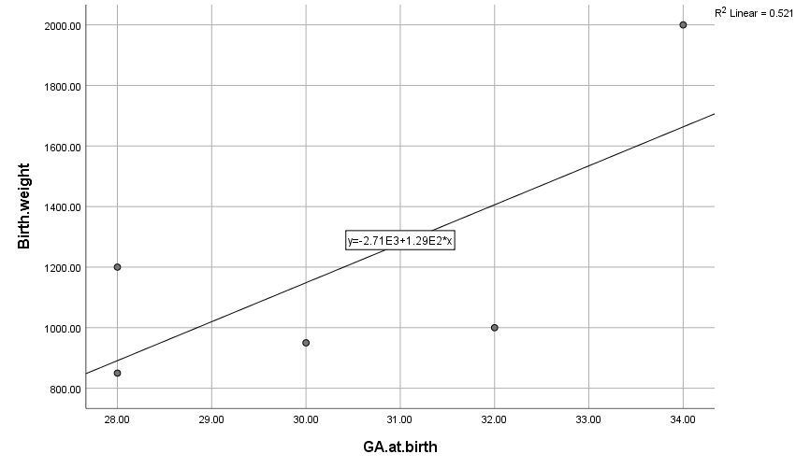

**Figure 1:** **Pearson’s correlation between Birth weight and gestational age**

**Corrélation coefficient: 0.722 (strong positive corrélation) P-Value 0.169**

3. discussion

Africa has been called the new frontier of ROP blindness,[1] with an average of 2,500 Preterm admissions in the FCT, a rapidly expanding neonatal care and the grossly inadequate ROP screening services , Abuja will likely become the new frontier of ROP blindness in Nigeria. As survival improves due to better neonatal care, the number of babies blind from ROP is likely to increase except ROP screening and treatment services also expand. All the 5 blind children in our series received neonatal care in private hospitals and had no ROP screening. Ademola-Popoola et al [2] also found in their study that 33.3% of the children received neonatal care in private hospitals and nearly all of them were not screened for ROP. 2Their study reported 18 cases of ROP related blindness in Nigeria over a 5 year period.[2]

This is worrisome considering the large number of private hospitals within the FCT providing neonatal care. There is an urgent need to increase awareness and establish a comprehensive ROP services for the FCT with special focus on neonatologists especially in private hospitals to help drive ROP services in the FCT.

A study by Herrod et al reported that ROP was estimated to be the cause of blindness for 10% of all blind children examined by ROP-involved pediatric ophthalmologists and retinal surgeons during 2019 across Africa.[3]

Jacoby et al in South Africa reported that 7 out of 238 babies with ROP were blind [4] while Melesse in Ethiopia reported that in the 66 infants reviewed, 10 (15.2%)were blind from ROP.[5]

Two of the blind children were advised to go for ROP screening but did not have screening done highlighting the need for proper counselling of care givers on ROP screening services.

Since ROP requiring treatment does not typically develop before 3rd week of life, this window provides a good opportunity for babies at risk to be transferred to centres providing ROP services, better still is to establish an easy to manage “roving” ROP screening involving all hospitals providing neonatal services for children born at or earlier than 34 weeks or with birthweight less or equal 1500g. Any such planned ROP intervention in the FCT must involve the numerous Private Hospitals providing intensive neonatal care. Stakeholders must continue to create awareness and participate in the formulation of a policy to prevent, detect and treat ROP in a timely manner.

4. Conclusion

ROP, though a preventable cause of blindness remains a leading cause of blindness in children especially in the Federal Capital Territory of Nigeria. ROP services in the FCT must expand to include all private hospitals providing neonatal services in an efficient, effective and well-coordinated manner in order to prevent blindness for ROP.

Consent

"All authors declare that ‘written informed consent was obtained from the care givers of the patients (or other approved parties) for publication of this case report . A copy of the written consent is available for review by the Editorial office/Chief Editor/Editorial Board members of this journal."

Ethical approval (where ever applicable)

This study adhered to the tenets of Helsinki declaration and the study was approved by the Health Research and Ethics committee of UATH, Gwagwalada (UATH/HREC/PR/457)

References

1. Gilbert, C, Malik, A.N.J, Nahar, N, Kumer Das, S, Visser, L, Sitati, S, et al. (2019). Epidemiology of ROP update – Africa is the new frontier. Seminar in Perinatology. 43 (6), 317–322. doi:10.1053/j.semperi.2019.05.002.
2. Ademola-Popoola, D.S, Onakoya, A.O, Ezisi, C.N, Okeigbemen, V.W, Aghaji, A.E, Musa, K.O, et al. (2021). Case series of retinopathy of prematurity blindness in Nigeria: A wakeup call to policy makers, hospitals, , ophthalmologists and paediatricians. Niger Postgraduate Medical Journal. 28 (4), 303-306. doi: 10.4103/npmj.npmj_595_21.
3. Herrod, S. K, Adio, A., Isenberg, S. J., and Lambert, S. R. (2022). Blindness Secondary to Retinopathy of Prematurity in Sub-Saharan Africa. Ophthalmic Epidemiology, 29 (2), 156 –163. doi:10.1080/09286586.2021.1910315.
4. Jacoby, M.R, Du Toit, (2016). Screening for retinopathy of prematurity in a provincial hospital in Port Elizabeth, South Africa. South African Medical Journal.106 (6). doi: 10.7196/SAMJ.2016.v106i6.10663.
5. Melesse, M.A, (2020). Retinopathy of prematurity – An emerging cause of childhood blindness in Ethiopia. Ethiopian Medical Journal.58(2):1-7